Experienced HR Professional
Human Resource
Management (Manager/Director)
Personal Info: | Sayed Bilal Haider Bokhary  DOB: Apr 09,1977  Gender: Male  House # 157, Fazlia Street 1-A, Wilayat Coloney  Rawalpindi - 44000  Pakistan  (+92.300.448.9059) (+92.51.587.8722)  bilal.bokhary@consultant.com | 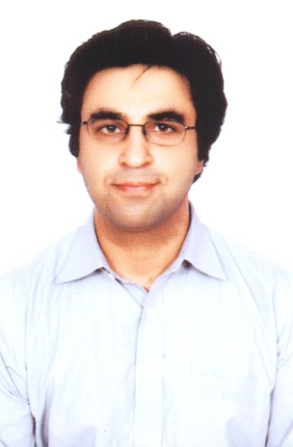

Objective: | To augment impeccable value to any progressive firm/organization by virtue of my multi-faceted experience, also contributing to my personal and professional career progression.
Experience:  4 Entry(s)
  Organisation | PricewaterhouseCoopers (A. F. Ferguson & Co.)
  Organisation Type | Management Consulting
  Employer Contact Number | +92.51.287.0045
  Designation | Manager - HR Consulting
  Location | 3rd Floor, PIA Building, 49 Blue Area, Islamabad , Pakistan
  Type of Experience | Full Time
  Tenure | Jan-2007 To Date
  Description
  Organisation | Ferguson Associates (Pvt.) Limited - Formerly PwC Consulting
  Organisation Type | Management Consulting
  Designation | Supervising Consultant - HR
  Location | 3rd Floor, SLIC, I I Chundrigar Raod, 1-C, Karachi , Pakistan
  Type of Experience | Full Time
  Tenure | May-2005 To Dec-2006
  Description
  Reason for Leaving | Low Salary
  Organisation | Abacus Consulting (PwC Consulting)
  Organisation Type | Management Consulting
  Designation | Senior Consultant - HR
  Location | Abacus House, Noon Avenue, Canal Road, Lahore , Pakistan
  Type of Experience | Full Time
  Tenure | Dec-2003 To Apr-2005
  Description
  Reason for Leaving | Low Salary
  Organisation | KPMG Pakistan
  Organisation Type | Management Consulting
  Designation | Assistant Manager-Restructuring Services
  Location | Sheikh Sultan Building, Karachi , Pakistan
  Type of Experience | Full Time
  Tenure | Apr-1999 To Nov-2003
  Description
  Reason for Leaving | Low Salary
Skill:  12 Entry(s)
  Skill Name | Level | Last Used
  HRM | Excellent | Currently Working
  Strategy Consulting | Excellent | Currently Working
  EOIs and Proposal Writing | Excellent | Currently Working
  Business Development | Excellent | Currently Working
  Public Sector Reforms | Excellent | Currently Working
  Grants Management | Excellent | Currently Working
  Business Process Re-engineering | Excellent | Currently Working
  HR Due Diligence | Excellent | Currently Working
  Code of Corporate Governance | Excellent | Currently Working
  Project Management | Excellent | Currently Working
  Change Management | Excellent | Currently Working
  Organization Design & Development | Excellent | Currently Working
Education:  1 Entry(s)
  Degree Name | AIMC
  Level Attained | Certification
  Institute | Institute of Management Consultancy
  Address | London, UK
  Session | 1999 - 2003
  Majors
Language:  3 Entry(s)
  Read | Write | Speak | Understand | Typing | Shorthand
  English
  Not Easily | Easily | Easily | Easily | (WPM) | (WPM)
  Pushto
  Not Easily | Not Easily | Easily | Easily | (WPM) | (WPM)
  Urdu
  Easily | Easily | Easily | Easily | (WPM) | (WPM)
Affiliation:  1 Entry(s)
  Organization | Institute of Management Consultancy UK
  Role | Associate member
  Session | Apr-1999 To Feb-2003
Reference:  2 Entry(s)
  Name | Title | Company | Phone/Email | Aquaintence | Type
  Mr. Farrukh Naseem | Director | Ferguson Associates (Pvt.) Limited - Formerly PwC | farrukh.naseem@ferguson-associates.org | 2 Years | Professional
  Mr. Rana Naeem | Director | KPMG Pakistan | +92.300.849.235 / rananaem@cyber.net.pk | 7 Years | Professional

