Supervisor Call Center/ Customer Service
Customer Care
Mid Career (2+ years of experience)
Personal Info: | Asif Haroon William  DOB: Jun 23,1977  Gender: Male  2j Extension,Opposite 186 C, Model Town Lahore - Same as above  Lahore - 0  Pakistan  (+923454638479) (+92425851532)  ahwilliam@hotmail.com | 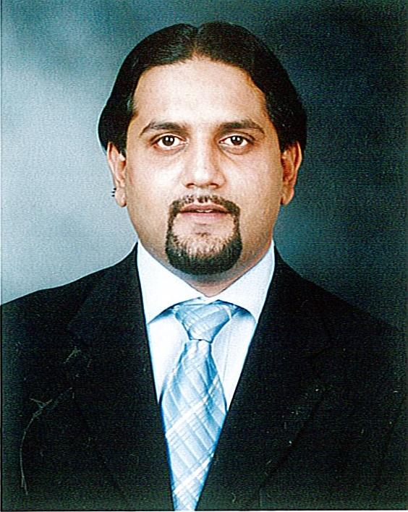

Experience:  1 Entry(s)
  Organisation | The Resource Group (TRG)
  Organisation Type | B.P.O
  Employer Contact Number | 042-111-111-874
  Designation | Team Leader
  Location | Lahore , Pakistan
  Type of Experience | Full Time
  Tenure | Feb-2006 To May-2007
  Description | â€¢ Worked as Team Leader for TRG Pakistan, the 8th largest BPO in the world. Major Responsibilities: â€¢ Making Sales Calls to Fortune 500 companies in USA, UK and Australia. â€¢ Providing customer service to multinational companies like AT&T, Verizon, Lego, Honda, BMW, Audi etc. â€¢ Providing continuous feedback to the agents. â€¢ Identifying areaâ€™s which required further training. â€¢ Ensuring timely issuance of the daily, weekly and the monthly reports.
  Reason for Leaving | Sickness of the family member was distracting me and the odd timmings was making it difficult for me to fulfill my duties as a family member.
Project:  1 Entry(s)
  Company | Telenor Pakistan
  Title | Team Leader
  Role | Making changes in the process's during the soft launch of Telenor.
  Tenure | Jan-2005 To Apr-2005
  Description | â€¢ Worked as Team Leader for Telenor Pakistan, the 13th largest Telecom Company in the world. Major Responsibilities: â€¢ Dealing with customer queries, complaints, feedback received through companyâ€™s official email, fax and internal source. â€¢ Ensuring strict adherence to the KPIâ€™s set by the company. â€¢ Ensuring maximum time and capacity utilization. â€¢ Identifying areaâ€™s for further training. â€¢ Ensuring strict adherence to the companyâ€™s Code of Conduct.
Skill:  1 Entry(s)
  Skill Name | Level | Last Used
  Internet Search engines | Good | Jan 2000
  Searching the internet for gathering data of various fortune 500 companies all over the world.
Education:  1 Entry(s)
  Degree Name | Masters in Business Administration
  Level Attained | Masters Degree
  CGPA | 3.00
  Institute | Hajvery University
  Address | Lahore, Pakistan
  Session | 1999 - 2000
  Majors | M.B.A (Marketing): From Al-Hajvery College of Business Administration. Major Subjects: â€¢ Production Operation Management. â€¢ International Business and Marketing. â€¢ Feasibility Study. â€¢ Business Communication. â€¢ Marketing Strategies. â€¢ Total Quality Management.

