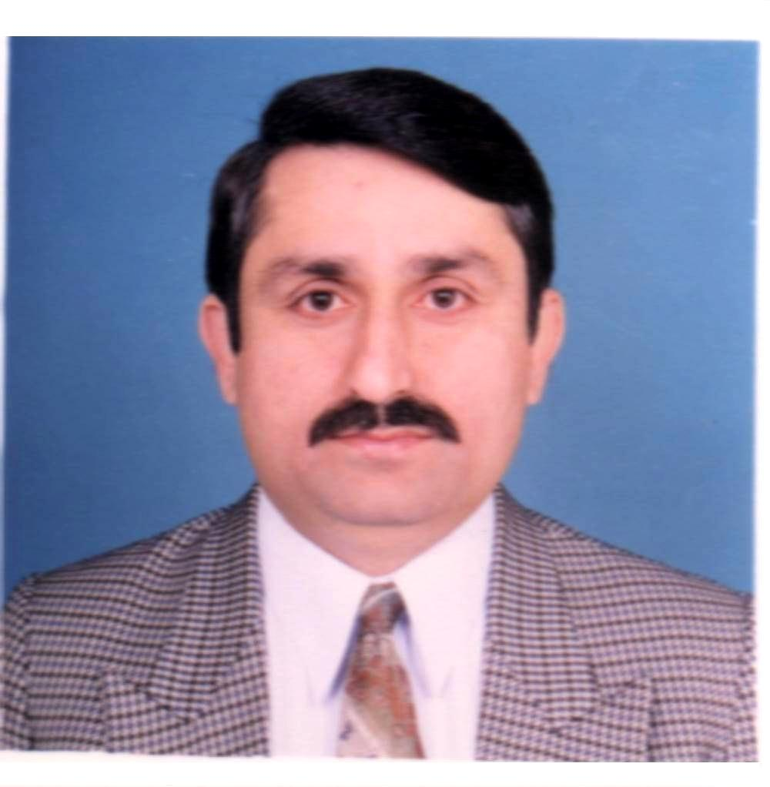
INAMULLAH KHAN
H. #113, Street # 257, G-7/3-2, Islamabad Pakistan
Tel # 051-2607995 Cell # 0334-5549355,
inamkhan70@yahoo.com

Areas of Expertise:
Programme planning, development, management, M&E, MIS, policy and governance reforms, value chain development for agriculture and EG sectors, community infrastructure up-gradation and institutional strengthening.

Synopsis:
Mr. Inamullah Khan holds Master in Economics and Project Management with over 22 years of experience in the planning, management, M&E and MIS of multi-sectoral development projects/programs for governance, infrastructure development and rehabilitation, economic growth, and strengthening social and municipal service delivery. These programs were supported by the Federal and Provincial governments and International donors’ agencies i.e. USAID, DfID, ADB, WB, SDC and UNICEF. Mr. Khan developed various project documents, proposals, plans, M&E systems, databases and MIS for WB supported CIP, ADB funded DSP, and DfID funded TAMA and USAID’s funded DTW and Firms Project.

Mr. Khan, as an acting team leader and coordination/M&E expert is working on capacity building of PDMA-PaRRSA. Mr.Khan contributed to design and implementation of SME recovery assistance program for Swat tourism, horticulture and fisheries sector, design of SMEDA-KPK SME program, sector development strategies and establishment of advisory groups, subcontractors’ management, institutional support to PaRRSA, planning, budgeting, monitoring including development of PMP/AIP, baseline surveys and project reporting (Annual/quarterly/bi-weekly reports).
Working with DTW Project, Mr. Khan designed and implemented District Support Fund Component and contributed to design of improved governance, policy reforms and service delivery systems, Mr. Khan managed a team of consultants, and worked with federal and provincial governments on design of local government reforms through holding a series of policy dialogues on key local government themes and citizens’ perceptions survey about local governments systems. The policy reports were shared with all the stakeholders. Mr.Khan managed design and implementation of infrastructure upgrading projects (schools and office buildings, water supply systems) and development of IT systems (MIS for national program for family planning, System for District Development Planning Tracking and websites etc.).

Key Courses/Trainings
Trainings/Workshop | Duration and Institution
- Training of Trainers on conflict resolution | August and December 09 by US Institute of Peace.
- PMP Certification Exam Training Course | November 6-9, 2009 by FH Dynamics; Karachi.
- Project Management and M&E | August 6-7, 04 by Planning Commission Islamabad.
- M&E Framework & Indicators-DSP | July 19-21, 2004, by ADB-ADTA at Islamabad.
- Results Based Management – CIDA | May 12 to 13, 2004, at Islamabad by CIDA.
- Monitoring & Evaluation Framework | March 10-11 and March 30-31, 04, by ADB
- Innovative Approaches to Capacity Dev. | Nov. 4-7 & Dec. 8-9, 2003 at Islamabad by ADB.
- Designing and Managing Change | Feb 22-23, Mar 15-16 & April 5-6, 03 by ICMS Peshawar
- Integrating Gender into Program M&E | October 7 – 9, 2002 by World Bank Islamabad.
- Procurement of Goods, Works/Services | February 2001 by World Bank Office Islamabad.
- Community Driven Dev. Services | July 6-7, 2000 by Ministry of LG and World Bank.
- Poverty Monitoring & Evaluation | June 8-10, 2000 at New-Delhi, India, by World Bank.
- Monitoring and Evaluation & MIS | June 3-8, 1998 at Peshawar by OPCV Australia.
- Project Analysis and Management | Dec. 12, 1996 to Jan. 2, 1997 at NIPA Karachi.

Qualification:
- Master in Project Management-COMSATS Institute of Information Technology, Islamabad Campus.
- Master in Economics and Bachelor in Computer Science from University of Peshawar Pakistan.
- Bachelor Degree in Computer Science from University of Peshawar Pakistan.
- One year diploma in Computer Programming from NWFP Board of Technical Education.
- MCP from Microsoft Corporation, Visual Basic programming, Microsoft Certified System Engineer & Oracle Certified Professional (Dev.) from Frontier Institute of Science & Tech. Institute, Peshawar.
- Project Planning & Management and MS-Project from Abasyn Institute, Peshawar.

Languages: English, Urdu and Pushto (read, write and speak – Very Good).
Employment Record
From: May, 2012 Till-date
Employer: Institute of Management Sciences/USAID Assessment and Strengthening Program on Capacity Building of Provincial Disaster Management Authority/Provincial Reconstruction and Rehabilitation Settlement Authority at Peshawar
Position held: Coordination and Monitoring Expert
After the occurrence of October 2005 earthquake, the National and Provincial Disaster Management Authorities were established under NDMA ordinance 2006. The KP-PDMA has been established in 2008 with the mission to minimize disaster risks within KPK through formulation of comprehensive disaster risk management strategies and their efficient and effective implementation. Under PDMA, the PaRRSA has been established by KPK Govt. to drive the recovery effort and provide a “one window” facilitation point to Government, donors and partner organizations at requisite speed, ease, facilitation, coordination, supervision and linkages development. My role and responsibilities include support to PaRRSA in design, development and implementation supervision of efficient systems for coordination and M^E, besides supervising work of a team of experts in financial management, HR & institutional development, training, engineering services, procurement, and information technology. The experts are responsible for institutional assessment and development of manuals and IT systems and capacity building of PDMA-PaRRSA.

From: June 2010 to May 2012
Employer: Semiotics Consultants on USAID Pakistan FIRMS Project, Islamabad.
Position held: Program Manager
The objective of USAID FIRMS Project is to improve government service delivery and develop dynamic, internationally competitive firms to accelerate sales, investment, and job growth to undercut the basis of extremism. USD 90 million Firms Project focuses on SME competitiveness, a key element of USAID/Pakistan’s Economic Growth strategy. My responsibilities include support in development and implementation supervision of the Project KPK component.
Key achievements
- Contributed largely in development of a post conflict Malakand recovery assistance program framework and Technical Assistance, Procurement, Grants and M&E plans and managed implementation of the program.
- Supported the over 239 hotels and 20 fishery sector business in reconstruction/rehabilitation of their businesses.
- Developed project plans and tracked plans on MS Project and AID project system, Bi-weekly & quarterly to USAID.
- Developed Award Monitoring Plans and Performance Monitoring Plans, Baseline surveys of Swat tourism, fisheries and horticulture sector (peaches and potatoes). Field monitoring of project activities, including training evaluations.
- Developed scope of works for subcontractors and contract management to produce the deliverables/products.
- Managed development of Swat tourism promotion campaign & tourism web portal www.tourswat.com
- Contributed to the development of KPK Industry and tourism vision documents and plans.
- Developed and largely implemented project plans for Swat horticulture sector (peaches and potatoes) including farmers training, provision of tools/machinery and market linkages dev. with multinational companies, processors.
- Coordinated work of institutional and technical support to PDMA-PaRRSA.

From: January 2008 to May 2010
Employer: Urban Institute, on USAID-Pakistan Districts That Work (DTW), Project, Islamabad.
Position held: Project Manager/Project Management Specialist
USAID’s DTW was a US$ 26 million programme supporting responsive and accountable local governance in 45 districts and 55 TMAs in Pakistan. DTW provided technical assistance, training, and limited in-kind support through DSF component (US$ 5.4 million); to improve public service delivery and promote participatory decision making, management innovations in budgeting, service delivery and monitoring. My responsibilities and contributions consisted of the following:
Key achievements
- Lead a team of 12 consultants; and worked with the federal/provincial governments in the planning, implementation and management of reviews of provincial LG systems including service delivery functions in all provinces through holding 23 policy dialogues at provincial levels and 3 at national levels. National Policy reports on Local Govt. reforms, Provincial policy reforms reports, 2 volumes each for Punjab, Sindh, NWFP and Balochistan. Managed drafting of revised Punjab LGO 2001 accordingly.
- Assisted in development and implementation of DTW work plans and progress reports.
- Developed and implemented project investment proposals for strengthening health, education, municipal services delivery and infrastructure and goods/equipment for 32 Districts, 32 Tehsils and 4 Provincial LG Training Academies.
- Developed monitoring mechanism/database for DSF/grants management, websites for Khanewal and Mansehra and Developed/implemented System for development planning and tracking (SDPT) for 7 districts in 3 provinces.
- Managed procurement and work of consulting firm for Engineering Design and Supervision for physical works and construction firm for construction/rehabilitation works (progress reports/reviews) in selected districts.
- Developed monthly and quarterly performance monitoring plans for DSF & Policy reforms components.

From: August 2005 to January 2008
Employer: Options Consultancy Services Limited on TAMA for Ministry of Health & Population Welfare Islamabad.
Position held: Monitoring and Evaluation Specialist and Programme Coordinator
Technical Assistance Management Agency (TAMA), DfID funded project was a consortium of consultancy firms led by Options UK. TAMA was a technical arm of DFID funded National Health & Population Facility for improving health of poor people of Pakistan. TAMA assisted its client programmes in developing supportive policies, multi-year strategies and plans, and improving their technical, organizational & systems development capacities at all levels by providing over 200 technical assistance projects. My contributions as M&E Specialist & Program Coordinator included the following:-
Key achievements
- Developed guidelines on TA sourcing, selection contracting and management for TAMA.
- Coordinated TA needs assessment and strengthening of health & population welfare programs/dept. and ministries.
- Developed Quarterly Work Plans consisting of TA proposals for approval of TAMA Advisory Committees
- Developed M&E framework and templates for TA need identification, appraisals and implementation.
- Developed a database system for TA performance monitoring against plan targets and quality of deliverables/reports.
- Facilitated mid-term review & TA products utilization/client perception regarding TAMA efficiency/effectiveness.
- Placed large number of the national/international consultants and successfully managed development of TA products, reports and systems development (MIS for LHW, M&E for M&E for TB and Malaria Programmes, HRM Databases for health departments in Balochistan and Punjab). Also prepared periodic progress reports.
- Coordinated consultative/trainings events for population and health service providers with logistics arrangements etc.

From: October 2003 to August 2005
Employer: Decentralization Support Programme, National Office, Ministry of Finance & Economic Affairs, Islamabad
Position held: Deputy Director Monitoring & Evaluation and Deputy Director Technical Assistance Loan
DSP; an initiative of GoPakistan & ADB (US$ 327 m) aimed at fiscal restructuring to support legal, institutional and capacity-building costs of decentralization and related reforms. DSP focused on the local government performance enhancement, accountability and service delivery; fiscal decentralization and devolution related reforms and implementation of Gender Reform Action Plan. My responsibilities (as head of M&E/TA) consisted of the following:-
Key achievements
- Contributed in Identification, development, monitoring of over 250 national TA projects at national, provincial and district levels for enhancing capacity and performance of local governments in Pakistan.
- Developed M&E framework for DSP, formulating and implementing M&E policies and priorities;
- Compiled & analyzed proposed work plans & cash flows for consideration of project steering committee.
- Assisted in design and implementation of Annual Performance Reviews.
- Managed development of MIS and preparation of progress reports on implementation of annual work plans.
- Carried out M&E reviews and follow up of activities against milestones contained in policy matrix and annual plans. Prepared consolidated TA and project progress reports for monthly/quarterly reviews.
- Contributed in Implementation supervision of technical assistance projects and TA products, reports & systems.
- Designed and implemented sub-projects on enhancing accountability in partnership with 15 national NGOs.
- Prepared briefs, working papers, progress update on activities, work plans & their tracking, cash-flows/project funds disbursements & periodic monitoring reports. Also trained staff in data collection, monitoring/reporting.

From: August 1997 to 28 October 2003
Employer: Community Infrastructure Program, Local Govt. & Rural Development Dept. NWFP (KPK), Peshawar.
Position held: Deputy Director Monitoring & Evaluation/MIS (Head of M&E/MIS Department)
NWFP-CIP, a multi-sectoral and multi-donor (WB, SDC, UNICEF, GoNWFP, TMA & communities) community based, aimed to increase productivity of low-income communities through infrastructure upgrading and capacity building of communities and LG institutions. Mr. Khan initially joined as AD MIS/M&E and was promoted to DD-M&E. Mr. Khan contributions includes the following:
Key achievements
- Developed M&E System including indicators and reporting formats.
- Managed development of MIS/database for component wise physical, financial & community development progress compilation, analysis and reporting for each project/community.
- Developed work plan, monitored progress against plan and prepared progress reports.
- Monitored partner NGOs, communities & TMAs in providing infrastructure and capacity building programs.
- Contributed to the design and implementation of Institutional Strengthening Program of local government.
- Coordinated Third party project evaluation. Also developed project document/PC-1 for CIP-II with 600 schemes.
- Developed working papers, presentation, progress reports & minutes of Project Review Board/Steering Committee, Govt. and donors’ supervisory mission review and papers on community driven development for its up-scaling.
- Provided support in design/implementation of program for health hygiene & special support to women/children.
- Trained staff in data collection, monitoring and reporting.

From: February 1990 to July 1997
Employer: Second Urban Development Project, Physical Planning & Housing Department. NWFP (KPK) Peshawar.
Position held: Computer Programmer and Incharge Computer Wing
- Developed and implemented databases with data processing for compilation of survey results, personnel information system, payroll and accounting information system, progress reports, database for engineering BOQs.
- Supervised data processing work through computer operators and data analysts and also worked as a network administrator for day to day trouble shootings. Also trained the professionals’ project staff (engineers/planners) in basic computer skills. Assisted in preparation of project briefings, reviews and M&E reports, presentations.
References: Available on request.

Provided working capital, rehabilitation cash grants, in-kind assistance through provision of production inputs, operating equipment, technical assistance/trainings to 261 SMEs.
Facilitated/managed large number of consultative & training workshops for Ministries of Health & Population

