# Chapter 2:

## Analysis

Analysis means the organized examination and the evaluation of any information or data breaking it into its components parts to discover and understand cause effect of their relationships, therefore providing the decision making and problem solving. In the development of the system it is important part. Before starting, we should analysis the project if it is feasible or not, how can we make it easy to do or to analyses available opportunities, weakness, threats and its remedies.

## Analysis Methodology

Grocery store management system uses soft system methodology (SSM) for the analysis phase. I choose soft approach methodology because it focuses in the people needs and requirements and that helps us to gain more customers. It is very easy to do in small-scale business so; it is perfect for my project.

**Finding:** I have done some observations, interviews to find out current problem and solutions for the store. The different steps of SSM has been done in the following ways.

**Stage 1**

**Finding out problem**

This step involves activities of finding out problem that the project will be going to solve. It is carried out by using activities like interviews and observations. Some question asked during interviews are:

* How often people do their grocery shopping?
* What method do they often used for grocery shopping? Online or manual? Why?

The data collected from those interviews are:

* People often do their shopping once a day.
* People usually take manual approach for shopping and they mostly prefer online shopping.

**Stage 2**

Expressing the problem

This steps includes, indicating the problem found out in the previous stage by diagrammatic representation such as the use pictures.

**Stage 3:**

**Rich picture:** Rich picture is the way of discovering and acknowledgement of the current situation of the system in the graphic form. It is the drawing of any situation that illustrate the main elements and the relationships that’s need to be considered in trying to create some improvement. It consists of pictures, text, symbols and icons. Rich picture was initially developed from soft system methodology which covers two steps:

* Finding the issues as wished to address.
* Developing the shapeless explanation of the conditions.

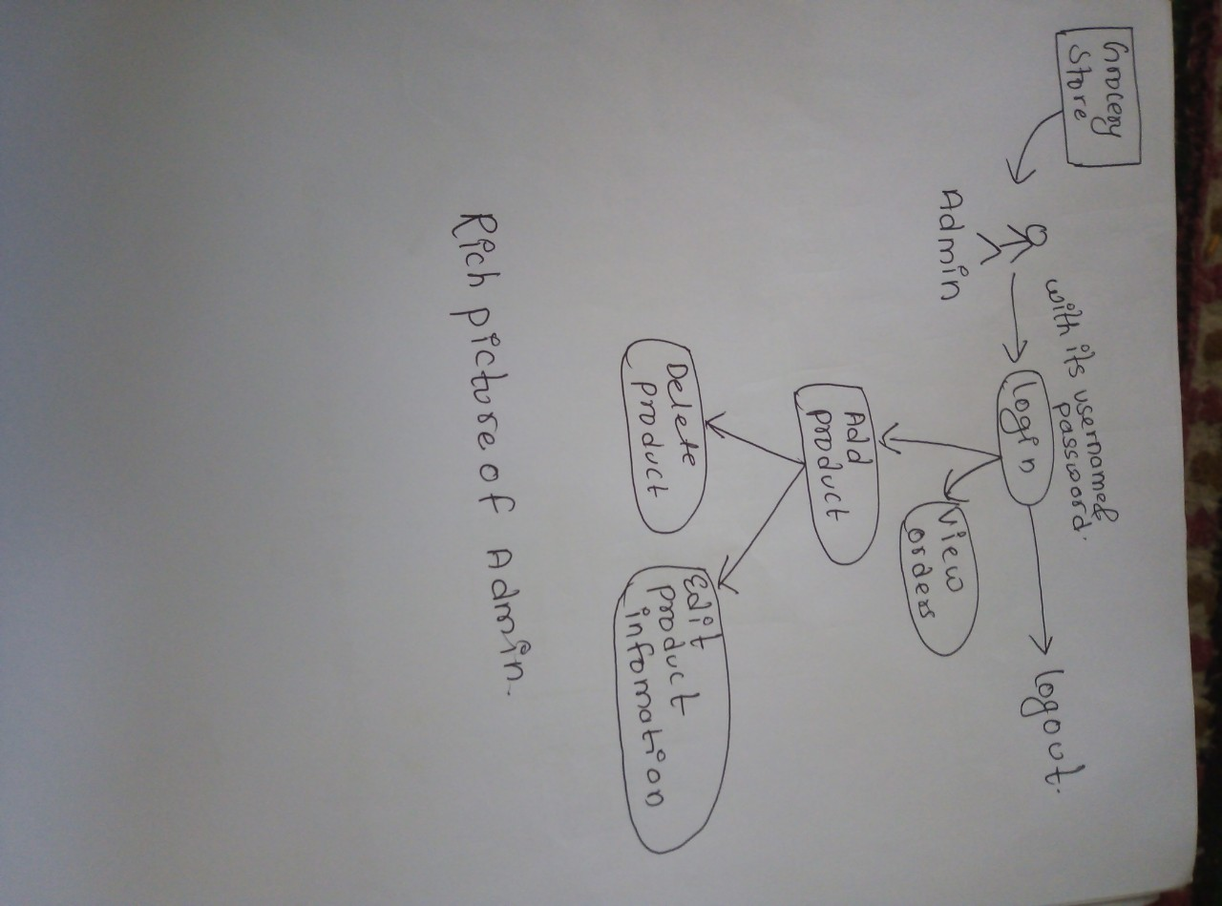

Figure 1 Rich picture of admin

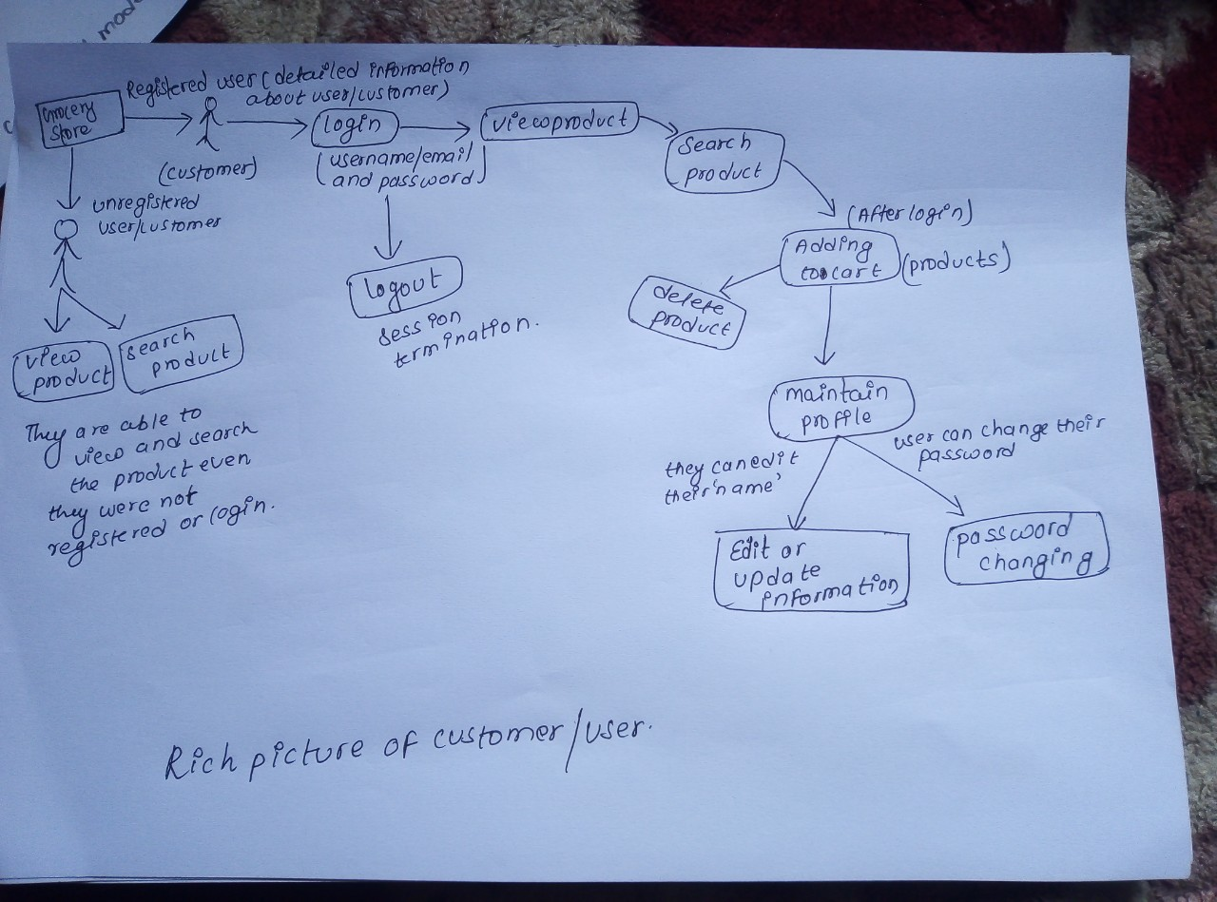

Figure 2 Rich picture of customer

**Root definition:**

Root definition is the part of soft system methodology. It is usually a single sentence starting a system and it should mention of all the key elements of the system.

CATWOE analysis help in proper formulation of the root definition. It is SSM, used to identify the problem of the current system and implement the solution. It also helps to identify stakeholder and impact of the stakeholders.

Customer = customer

Actor = Seller

Transformation = It allows customers to directly buy grocery product from the sellers

World view = customers does not have to spend their time and money for manually buying the product.

Owner = project Owner

Environment = Education on Environment

**Root definition**

A system owns by project owner where customers can directly make a shopping of grocery product from the seller through online system to eliminate time and money used to manually make the grocery shopping.

**Conceptual model:**

It is a representation of a system that uses concepts and ideas to form said representation.it used in any project to provides the point of references for system designers to gather system specification.

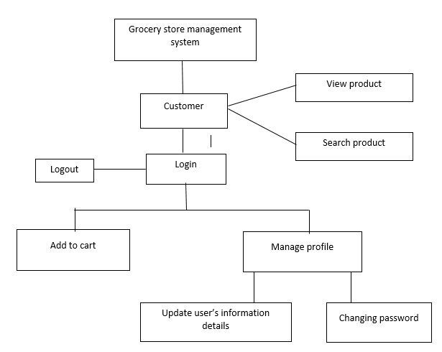

Figure 3 conceptual model of the customer

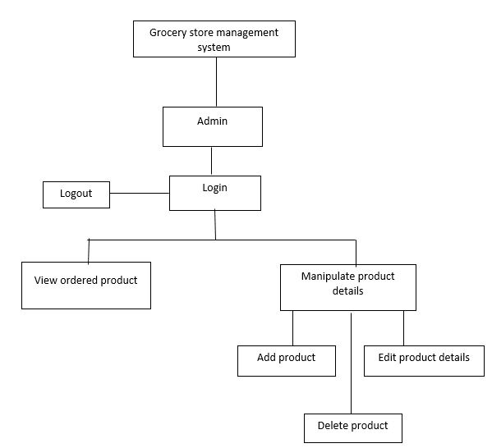

Figure 4 conceptual model of admin

**Comparing the concept of the system with the actual system.**

The following steps compares the different aspect of the conceptual model with the actual system.

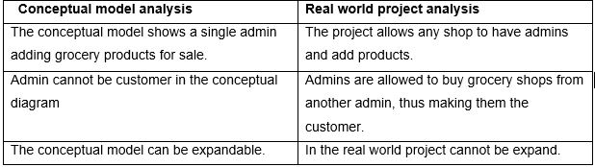

# Feasibility study:

Feasibility study is the early study stage of any project, which brings together elements of knowledge that indicate if a project is possible/feasible or not. It might uncover new ideas that could completely change a project’s scope. It aids decision making in the project, helps to set your goals, helps to develop the plan, helps to execute the plan in the business. Conducting a feasibility study is always helpful to the project. In this project we ensure whether it is technically, economically, legally, etc. being feasible.

There are several types of feasibility study, described below:

**Technical feasibility:**

This assessment helps to determine whether the technical resources are available to compete the project or not. It also involves evaluation of the hardware, software, and other technology requirements of the system. In my project there is no extra need of the hardware and software. It is the web-based application so, the minimum requirements will be needed for the project.

**Economic feasibility:**

It is also one of the most important part in the project management system It deals with the financial transaction of the project. we can say that my project did not need any extra financial helps or any other cost charge because it is web-based application and does not need expensive hardware or software to create this project its only need my laptop and some software to create it. There is no need of extra devices so, it is feasible as economically. It helps the store to calculate the cost to develop the software and if it’s costing development will be high then it will help to stability the amount of the company then later finds the solution.

**Legal feasibility:**

It deals with the legal issues for the system development. It shows the if the development system is fulfilling the rules and regulation of the government. There is no problem with the legal issues because it is a simple project for the peoples which make their life’s easy and graceful. It will not affect anything in the government’s rules and regulations.

**Scheduling feasibility:**

It is the most important assessment for the business or the project for the success because if we do not do right scheduling project will fail. In this feasibility we decide about the time table of the project or estimated the time to complete the project. The time table are:

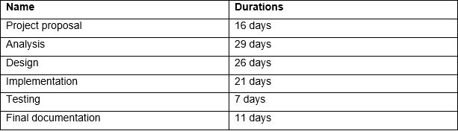

It takes 110 days to complete the whole project and this project completed because of the proper planning and scheduling. It shows that scheduling is an important part in my project.

**Operational feasibility:**

It involves undertaking a study to analyse and determine whether and how well the organisation need can be met by implementation the project. It also studies how a project plan satisfies the requirements identified in the requirements analysis phase of the system development.

# Requirements analysis:

## Functional requirements:

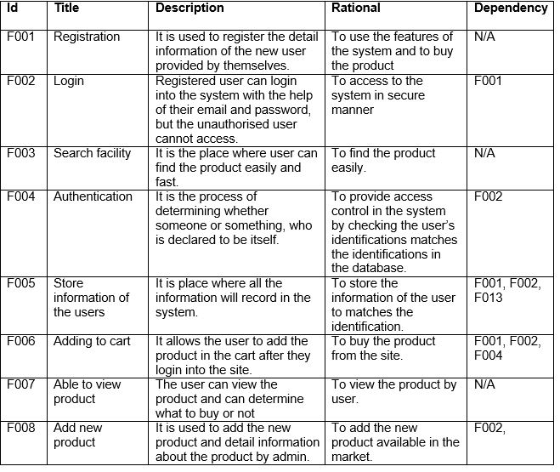

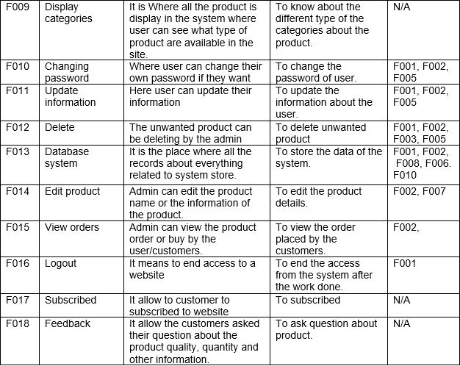

## Non-functional requirements:

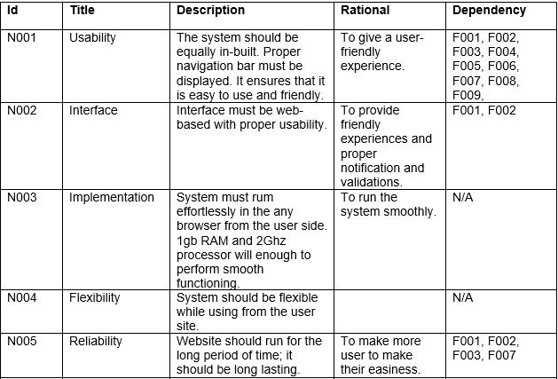

# 

# MoSCoW prioritization:

Prioritization is the process of deciding the relative importance of the project or any other things. MoSCoW as a prioritization method used to decide which requirements to complete first, which come later and which to eliminate. MoSCoW stands for Must have, should have, could have and Won’t have.

M – must have these requirements to meet business needs.

S – should have these requirements if it’s possible and it may add in the future.

C – could have these requirements if it does not affect anything else in the project.

W – would have these requirements later but delivery won’t be this time.

It is important to have clear set of prioritized and agreed requirements if we are going to deliver successful project. The recommended method for setting priorities is MoSCoW.

The MoSCoW table are shown below:

**Functional requirements:**

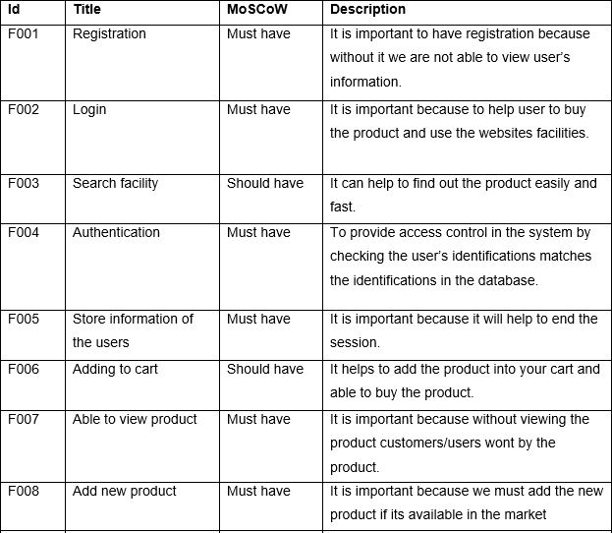

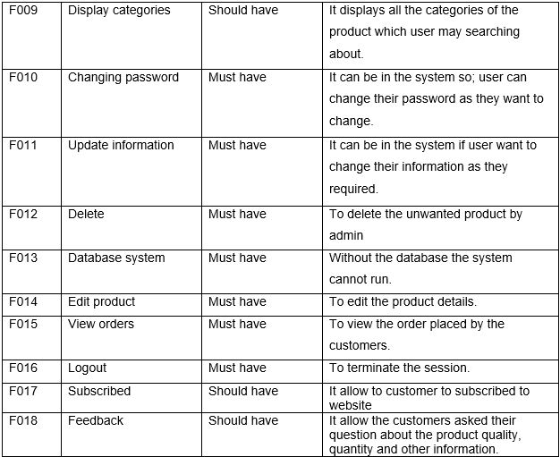

**Non-Functional requirements:**

# 

# Software and hardware specifications:

Hardware requirements

|  |  |  |
| --- | --- | --- |
| **S.N.** | **Hardware** | **Description** |
|  | Server | Either Xampp, Apache or web server is required. |
|  | Laptops, pc, phones etc | Devices like this is required from where portal can be assessed. |
|  | RAM and processor | 4 Gb RAM and Intel core processor will enough for this system |
|  | Internet | Router, Wi-Fi, LAN |

Software requirements

|  |  |  |
| --- | --- | --- |
| **S.N.** | **Software** | **Description** |
|  | Operating system | Operating system like windows |
|  | Browser | Need any browser like, chrome, Firefox, edge etc. |
|  | Front end | Sublime for the front-end design |
|  | Back end | MySQL Xampp for the database/back end |

# Use case diagram

Use case diagram is the primary of the system/software requirements for new software program under developed. Use cases specify the expected behaviour (what), and not the exact of making it happen (how).

The advantages of planning use case is to recognize the user and the functional requirements of the website.

In my project there are new user who can view the website, search the product and register in the website and there is another actor who is already register and they are able to view, add the product to their cart and order the product. User can update their profile, password.

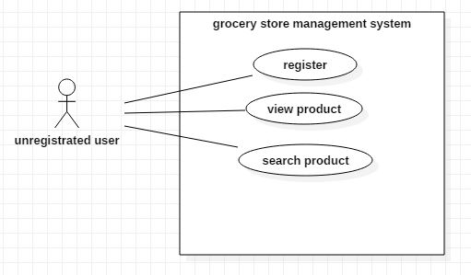

Figure 5 Use case of unregistered customer

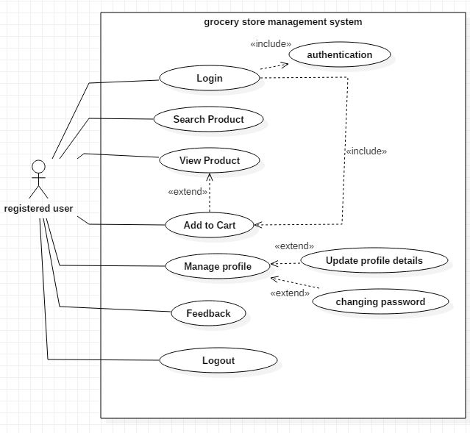

Figure 6 Use Case of registered customer

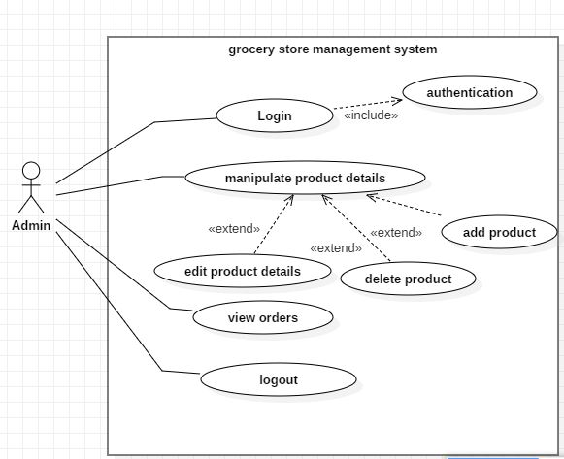

Figure 7 Use Case of admin

In above use case there are work of registered user, unregistered user and the admin. Unregistered user can view the website and they are able search product, registered into the website with their detailed information, email and password.

Registered user/customer can add the product to their cart and able to buy the product. They can manage their profile, editing their information, changing the password and give feedback/ ask queries about the product of the store about its quality and quantity.

Admin’s use case described about the work done by the admin just like adding the product to the website with detailed amount of information, they are able to view the order placed by the customer and they are able to edit, delete the product from the website.

**Registration:**

It is the important part in my project to register into the system to buy the grocery product. It will allow the customer to login into the system and provides detail information about customers.

**Login:**

After the registration they will have their email and the password so, they use the website. With the correct password and email they can login into the system. Likewise, admin will also have the email and password of their own.

**Manage profiles:**

After login into the system they will have their own profile where they can update their password and other details of the themselves. They will able to edit their details.

**Manipulate product details:**

This part is done by the admin where they can add the product, delete product and edit the details of the products.

## Natural language analysis:

Grocery store management system is a project focus on the grocery product, how to manage the sales, customer’s details, keeping the records of orders placed by the customer. It is the online record keeping system, which help manage day-to-day activities of the store. There will different type of category in the store.

This store wants the better performance on the market and make life easier. In this system admin are able add the product, view the order placed by the customer, delete product, edit the details of the product, manage user in this system there is proper database system where admin and customer/user store all the records of the product, customer details. Admin have provided with the username and the password where they login into the system and able to perform.

Registered/login user/customer can add the product list on their cart and able to search the product on the website, view the product, change the password, edit/update their profile. They can contact with them through message and the phone number provided by the store. They can able to manage their profile. Unregistered/ new user can view the product and they are also able to search and they can subscribe through their emails. Different category of the product is available in the store. There are some details for the system which are highly efficient and they are given below.

* Email, First name, Last name, phone number, Address
* Product name, detailed information about product, adding product to the shopping cart, checking order list
* Admin

|  |  |
| --- | --- |
| Nouns | verbs |
| Customer, first name, last name, address, admin, system, password, username, email, product, category, phone number, shopping cart, location | Register, add product, delete product, checking order list, view product, update, edit, manage user, manage profile |

From the above table there are possible noun and verb, final list of the class and the functionality are mentioned below:

|  |  |
| --- | --- |
| **Class** | **functionality** |
| Customer | Register |
| Admin | Login |
| Product | Add product |
| Feedback | Delete |
|  | search |
|  | View |
|  | Check orders |
|  | Manage user |
|  | Add to cart |
|  | Manage profile |

# Initial class diagram:

Initial class diagram is the simple static view of my project and give the overview structure of the system in terms of classes, attributes, methods and relationship between classes. It’s used to illustrate and create a functional diagram of the system classes.

In this class diagram there are four classes in the initial phase, they are customer, admin, product, and feedback. This only the initial class diagram of my project which have limited classes which will be extent later in the project.

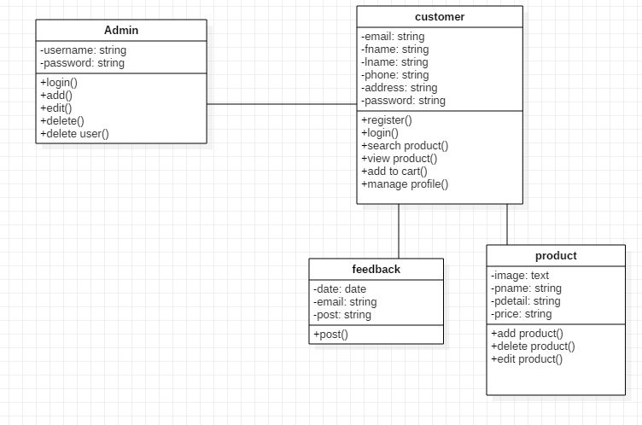

Figure 8 Initial class diagram