# Chapter 3:

# 3.1 Design:

Project design is early phase of the project where key’s features, structure, criteria for the success and all the major deliverable are planned out. By using different types of tools, technique, models first implemented in the paper or in the design tool and later implemented in the real system. we have design the system for the grocery store. Design is the most important part and its play the vital role in my project.

In my project design phase generate a variety of different output, including final class diagram, behavioral model, data flow diagram, database modelling, prototype of the system, and architectural modelling.

# 3.2 structural model:

Structural modelling of the software displays the group of the system in terms of the works that make up their system or attributes. It may be static models which show the structure of the system or the dynamic models which show the group of system when its executing.

## 3.2.1 class diagram:

Class diagram is static diagram which represent static view of the application. It describes the attributes and the operation of a class and also constraints on the system. It is more describable then the initial phase class diagram. Its shows a collection of classes, interfaces, association and constraints. It referred as the blueprint of the system.

The main purpose of the class diagram is:

* Analysis and design of the static view of an application.
* Describes the responsibilities of a system and act as a structural base for writing the codes.

Notation used in the class diagram:

|  |  |
| --- | --- |
| **Notation used** | **Description** |
| Association | It is used to attach an association class to an association relationship to provide an information about the relation ship |
| Dependency |  |
|  |  |

## 3.2.2 Dataflow diagram

A dataflow diagram maps out the flow of the data for any process or system. It is the traditional visual representation of the data flow in the system. Its show how the information enters and leaves the system, what changes the information and where does the data stores.

The reason why I create a Data flow diagram in my project are as follow:

* It is easy to understand what the system represents by people because it is well-organized.
* It can be understanding by both technical and non-technical side of the people.

Here are the data flow diagram notation used in my project.

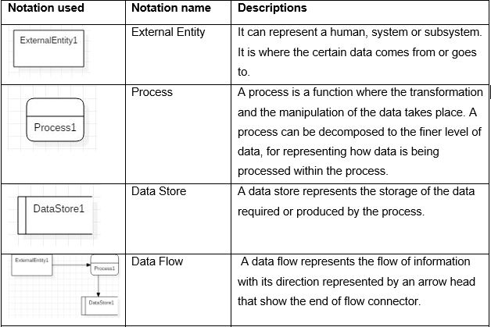

Table 1 DATA FLOW DIAGRAM NOTAION

Here are the dataflow diagrams of my system:

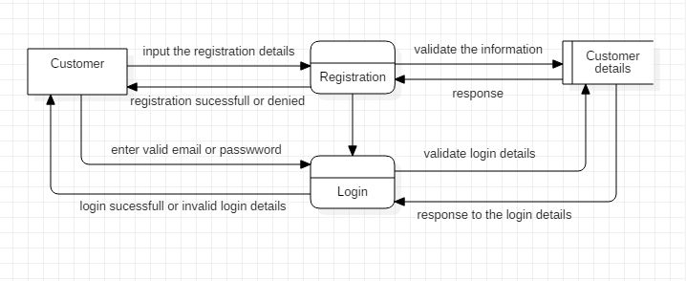

Figure: DFD Login and registration

Above mentioned **DFD** is defined about the data flow in the system about registration and login system in my project where customer inputs their registration details and gets their username and password to gets login into the system. If the valid details or the unique emails were input by the customer, then registration will success if not, login will have denied or username already exist. Then, in the login system if the correct username or password is filled then login successful otherwise invalid login details.

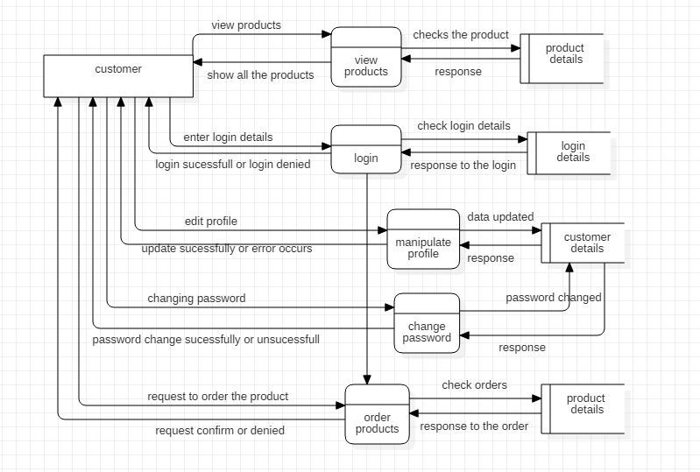

Figure- functionality_customer

Above mentioned **DFD** defined about system flow from the customer side where customer can view the product on the website and if they are registered into the website then they are able to login into it with their email and password after login into the system they can edit their profile like, update their name, address, phone number. They are also able to change their password. They are able to order the product if they want after login into the system.

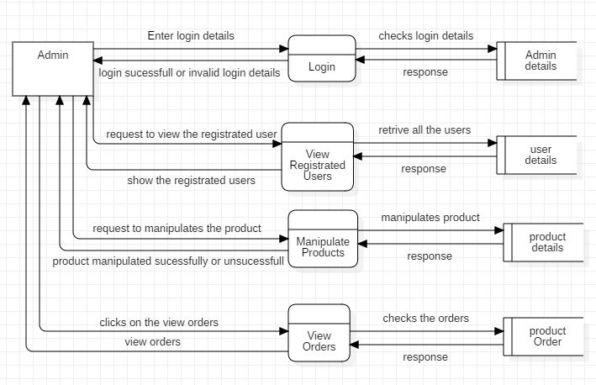

Figure- functionality_admin

Above **DFD** describe about the functionality of the admin after login, they are able to change the product or add the new one with details information about it. They will able to view the registered user and able to manipulates the products. They can update the product details and add the new product and delete the unwanted product from the site. Check the orders made by the customers.

# Behavioral diagram

Behavioral diagram visualizes, specify, construct, and document the dynamic aspects of a system. There are different categories of the behavioral diagram but I have used activity and sequences diagram for my project.

# Activity diagram:

Activity diagram is another important part of UML diagram to describe the dynamic aspect of the system. It is important part in the project, it shows the dynamic representation of the system in my project. It shows the flow of one activity to another activity in the system. It can be described as the operation of the system.

Notation used in activity diagram.

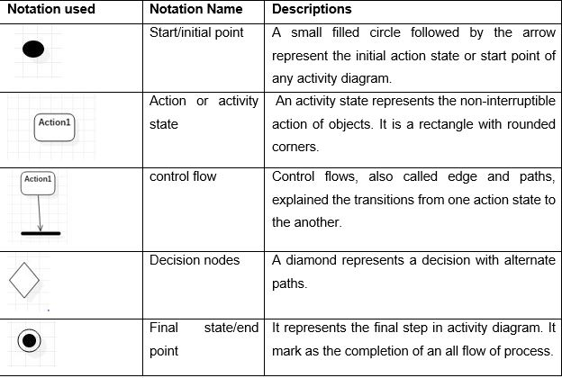

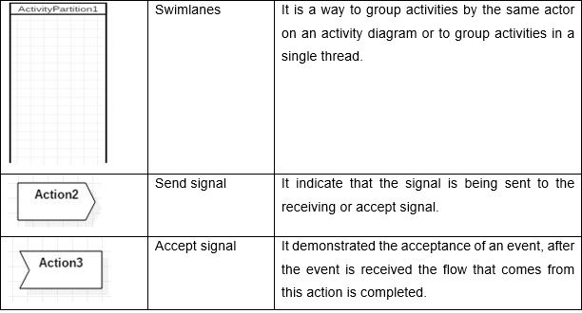

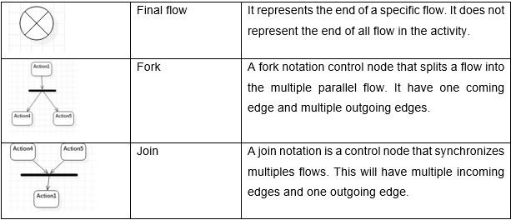

Table 2 ACTIVITY DIAGRAM NOTATION

.

Here is the picture of activity diagram of my project:

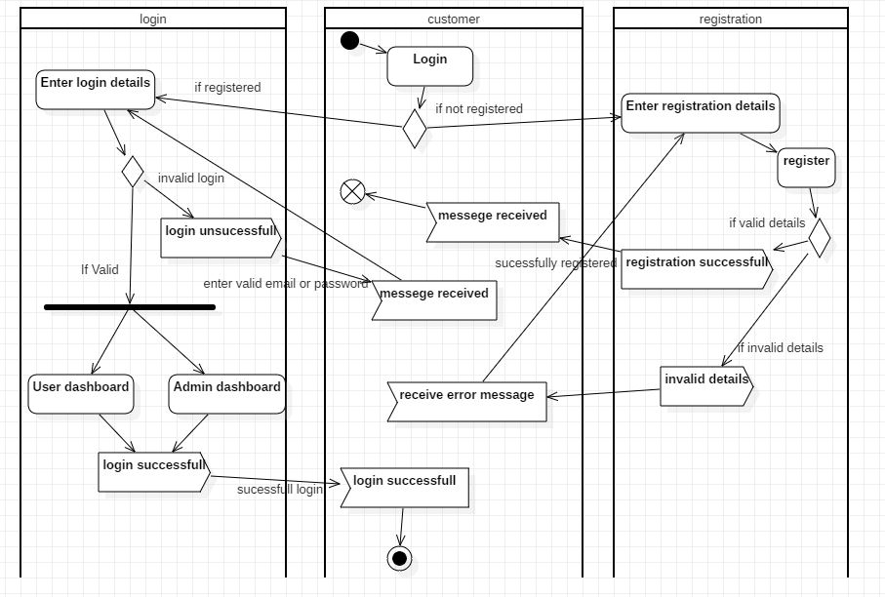

Figure- activity diagram_login&registration

In above **activity diagram**, its describe about how the customer or admin able to login or register. Where if they were register or they have their password and email then they are able to login into the website if not then they have to register first with the appropriate details. If they enter valid details they will enter into their dashboard. If not, then error message will come and they will get back into the login or registered page again.

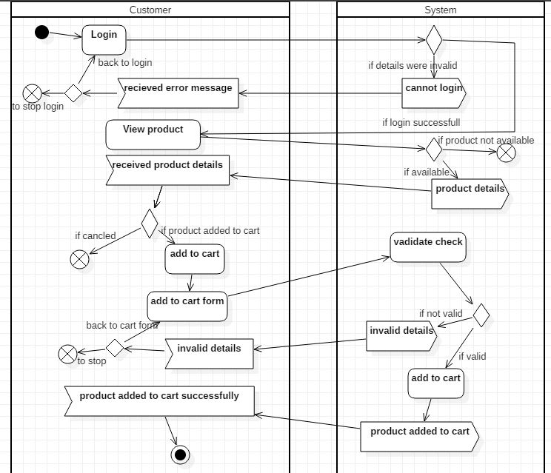

Figure- activity diagram_customer_functionality

Above **activity diagram** describe about the flow of activity by the customer after login into the website. They are able to view the product and added into the cart if they want otherwise they can cancel it. They will check its validation if customer enter the validate details about the product then it will add to their cart otherwise it will not.

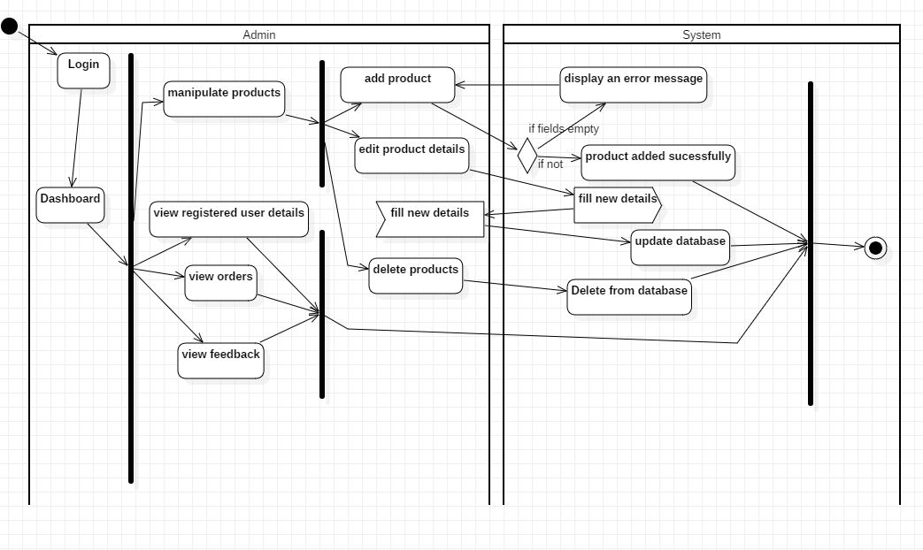

Figure-Activity diagram admin_functionality

Above **activity diagram** describe about the functionality of the admin where after login, admin can able to enter into the dashboard and manipulates the product such as by adding new product or editing the details of the already exists and also delete the unwanted product from the database. Admin can also able to view the details of the customers and orders made by them. They can also view the feedback given by the customers.

## sequence diagram:

sequence diagram are interaction diagrams that detailed how operation are carried out. it displays and explain the object relationship and interaction between them. It helps to represent the details of use case diagram. The purpose of the sequence diagram is used to show the relations between objects in the sequential order that those interactions occur.

Notation used in sequences diagram:

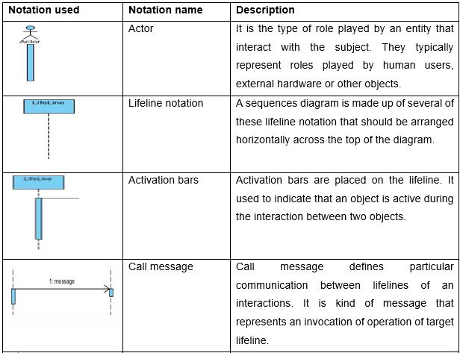.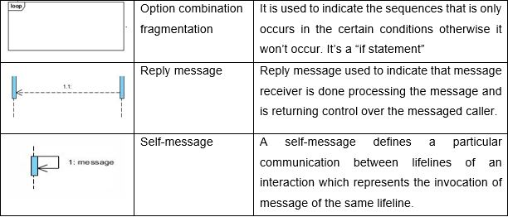

Table 3 SEQUENCE DIAGRAM NOTATION

Here are the pictures of sequences diagram of my project.

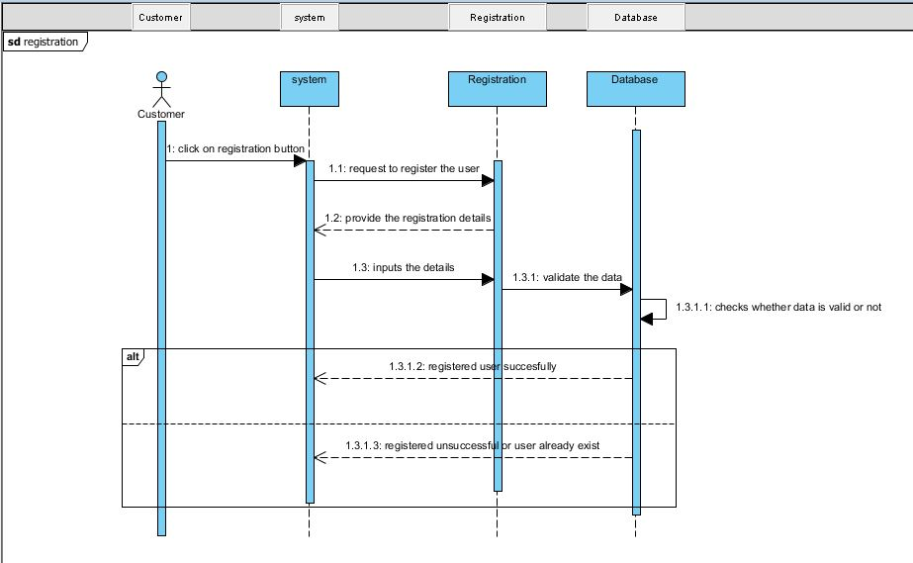

Figure- Registration

This **sequence diagram** represents dynamic system of the registration in my project where the customer request to register the user details and inputs the valid details of themselves and if the valid input is given then user gets registered, if not then error message is displayed.

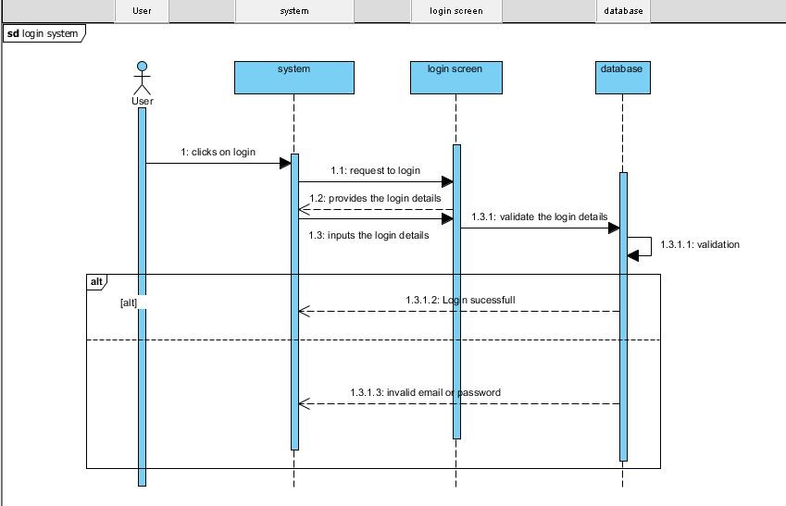

Figure- Login sequence

Above mentioned **sequences diagram** show the sequences of login where registered user inputs their validated email or password. If valid inputs are given to the login system then login will successful, if not then the error message is displayed.

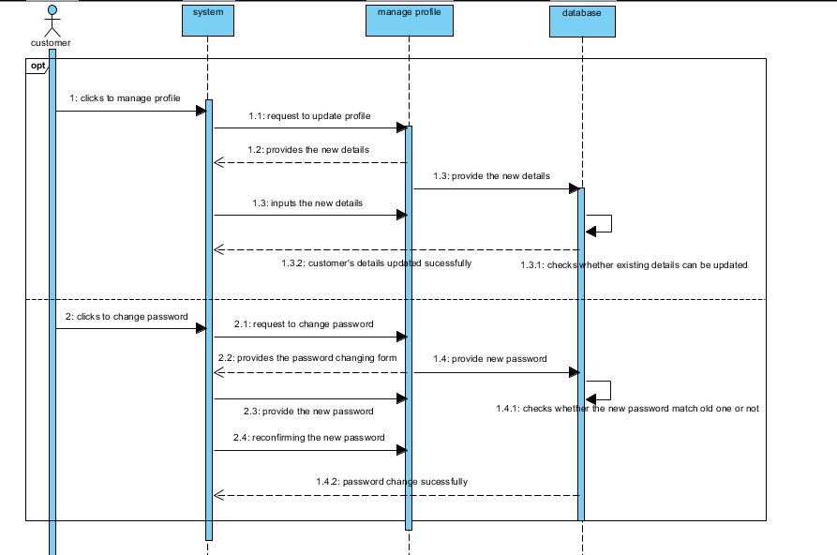

Figure- Manage profile sequence

Above mentioned **sequence** show the sequence of the customer managing their profile by updating their details and changing their password. After login into the system customer are allows to edit their profile like, changing their names, address etc. and they are also allowing to change their password with the new one.

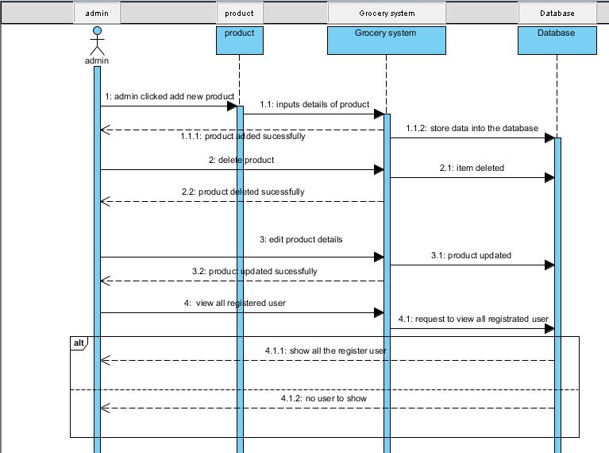

Figure- Admin sequence

Above mentioned **sequence diagram** show the sequence of the admin added the product and can view the registered user. Its show that the admin can add the products, edits the product detail and delete the product and also admin can view the registered user if there is any registered user in the system.

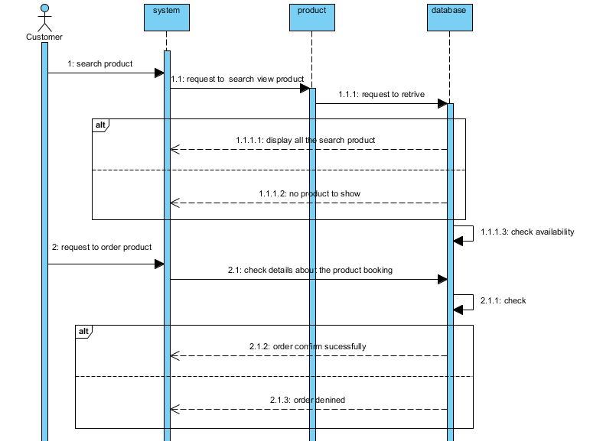

Figure- Customer functionality sequence

Above **sequence diagram** described about the searching and the ordering of the product where they can view the product if they were available and they order it when if they have login into the website.

# 3.4 Database design:

It is a collection of processes that facilitates the designing, developing, implementation and maintenance of the data management system. A good database is important in ensuring reliable data, elimination of data redundancy, efficient execution of queries and high performance application.

## 3.4.1 Data dictionary:

Data dictionary consists of database metadata i.e. data about the database. It records about object in the database. It consists of table name, relationships, keys and the explanation the function elements. It is important as it contain information such as details about all database tables and their representations, physical information about the tables such as where they stored and how.

Why I used data dictionary? Here are the reasons:

* It is use to define format, relationships, meaning of my system.
* It used to manage the all the table in my project like, user registration, product, order etc.

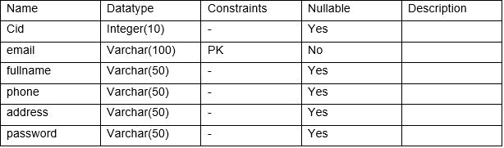

Table 4 registration table

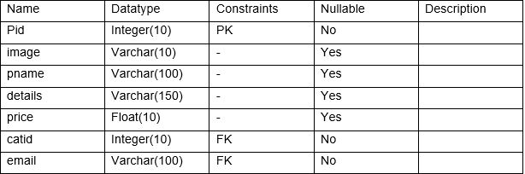

Table 5 product table

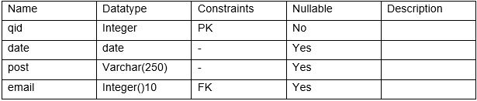

Table 6 question table

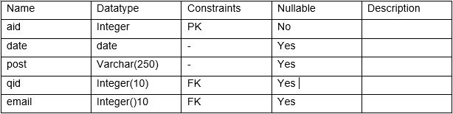

Table 7 answer table

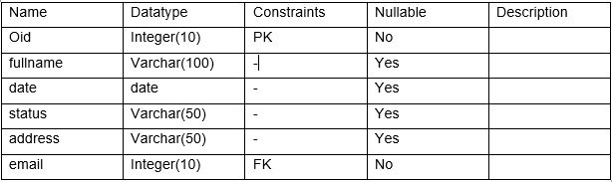

Table 8 order table

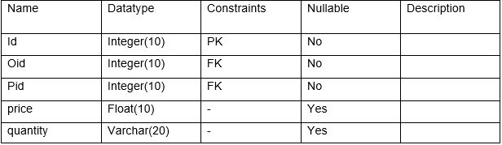

Table 9 order_product

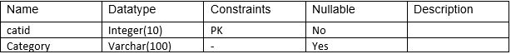

Table 10 category_type table

## 3.4.2 Entity relationship diagram

An entity relationship diagram shows relationships entity sets stored in the database. Its defines the entities, their attributes and showing the relationship between them. It’s often used debug or design relational database. I have used crow’s foot ERD. The elements of entity relationship diagram are:

* Entities
* Relationships and
* Attributes

Steps to create the entity relationship diagram are:

* First of all, we have identified or define the entities.
* Then, we have to determine the interaction between the entities.
* And after that analyzing the nature of interactions/ determining the cardinality of the relationships.
* At last create, Entity relationship diagram.

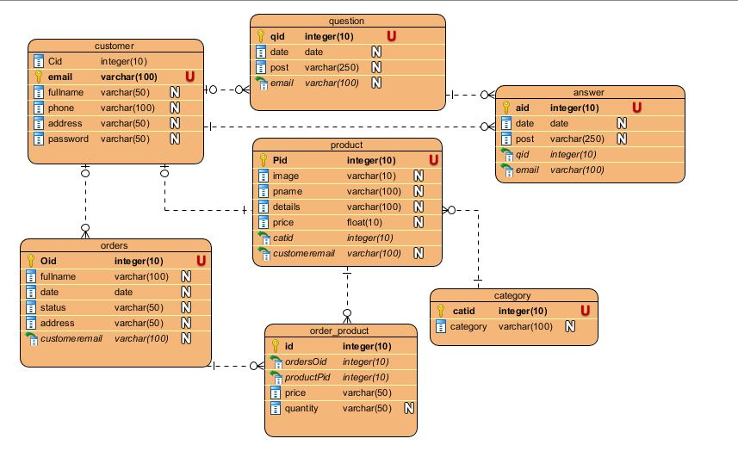

FIGURE- Entity relationship diagram

Above ER-diagram contain all the tables that will used to create the database system in my project.

# Architectural modelling

Three-tier architecture is a client server architecture in functional process logic, data access, computer data storage and user interface are developed and maintained as independent modules on separated platforms. Consists of three pattern and they are presentation, application and data tier. Its advantage is it would be increase efficiency, each tier has its own function which spread out the work over several systems. (techopedia.com, 2019).

**Presentation tier:**

This tier, which built using HTML5, CSS and JavaScript, is organised to computing device through a web browser and web-based system. This will have used on front-end layer of the system in my project. This create a view that user sees.

**Application tier:**

This also called as middle tier, logic tier; it is pull from the presentation tier and control the application functionality by performing detailed processing. This process the logic and the all the calculation in my project. Where we write the code and function to run the application.

**Data tier:**

It is the database server where information where store and retrieve. In here we found all the data of the project. Data in this tier keeps independent of application server. It manages all the data store in the database in my project. It includes all the database tables of my project such as, registration table, product table, and others. (techopedia.com, 2019)

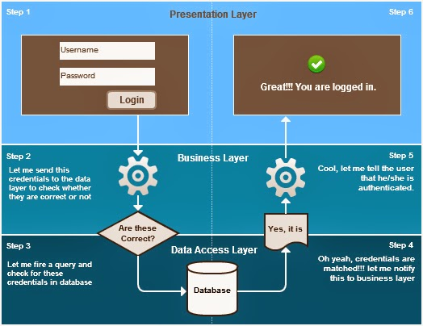

Figure- three tier architecture

# 3.6 prototyping

A prototype is a basic working sample, model, mock-up or just an imitation of the actual product based on which the others forms are developed. Motive behind prototyping is to validate the design of the actual product. It may also have called as it is first step of transforming the virtual or conceptualized design into the real physical form.

Here is some prototype of my project:

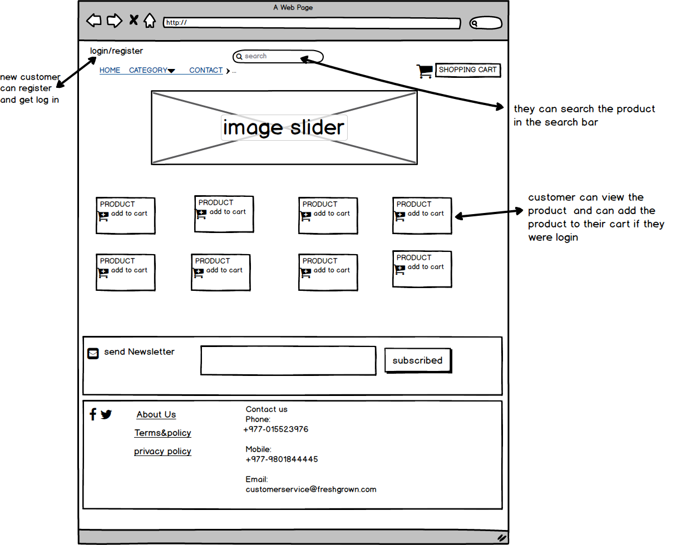

Figure- home page of website

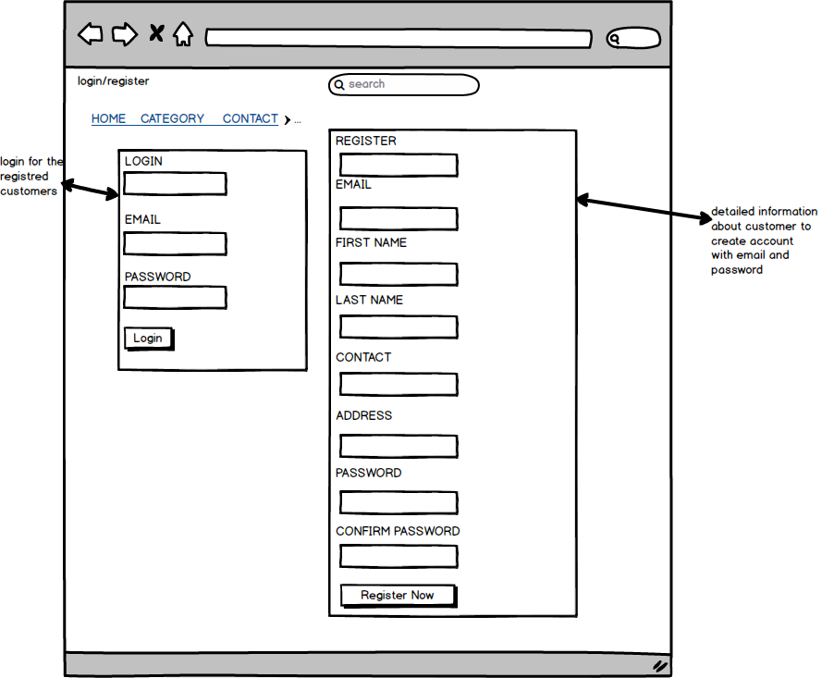

Figure- login and registration form

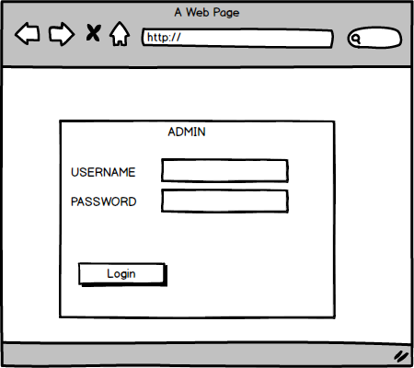

Figure- admin login page

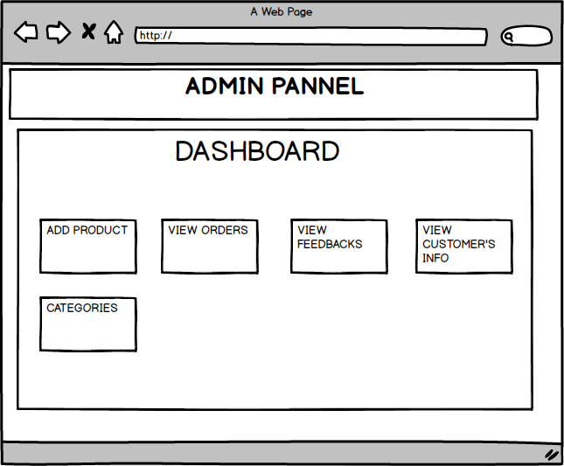

Figure- admin dashboard

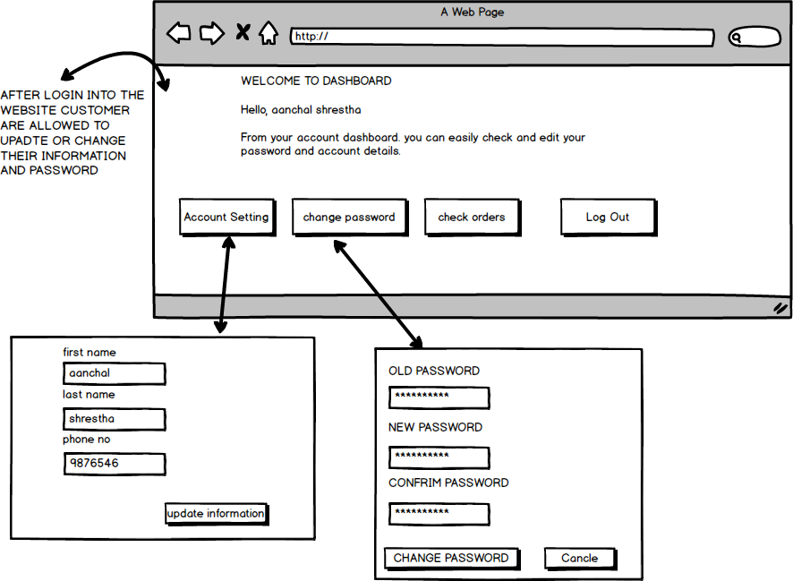

Figure- customer manage profile

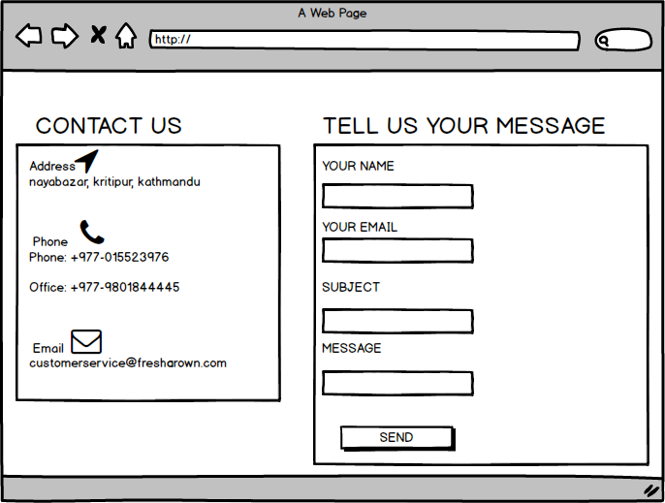

Figure- contact page

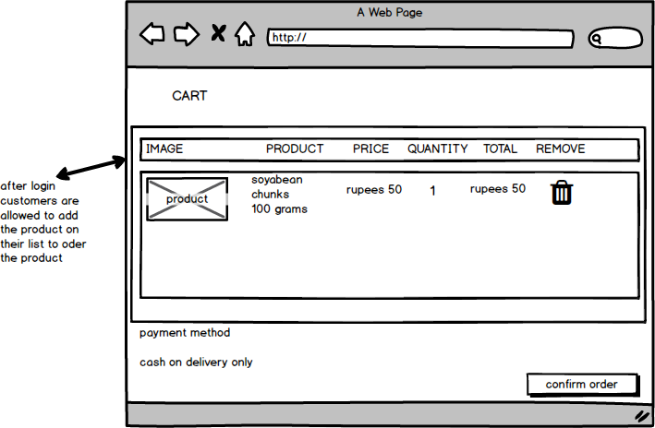

Figure- add to cart form

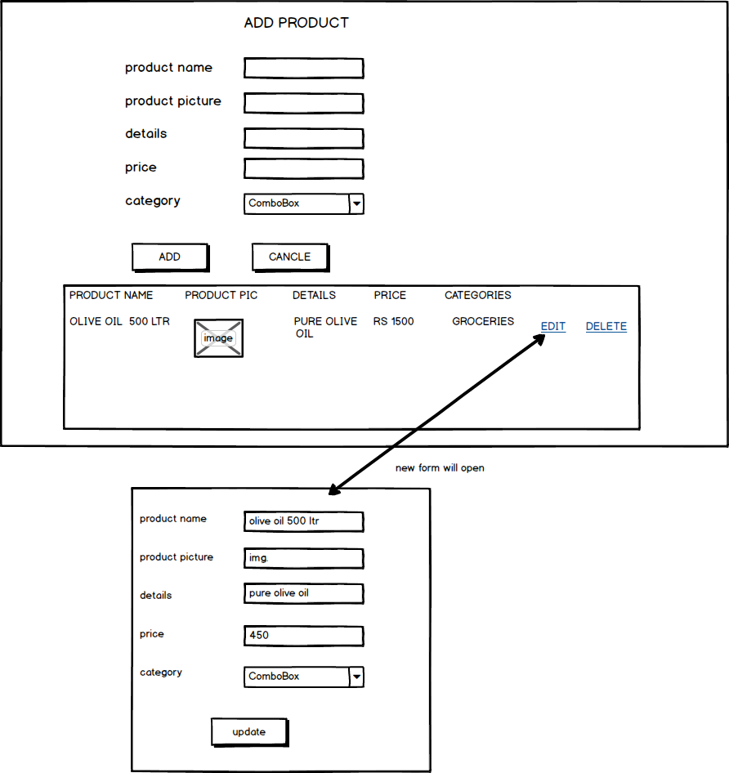

Figure- manage product by admin