# Chapter-4

# Implementation

## 4.1 Introduction

In system development lifecycle implementation comes under 3rd phase where the project member actually builds the product bringing them to the being based upon the design and analysis done in the previous stage of cycle. After all the requirements gathering and design phase, analysis using various tool and methods we are going to build the project.

## Programming language

For the project I have choose **PHP, JAVASCRIPT** and for the database I have used MySQL. And for the front end design I have used **HTML and CSS.** Design pattern is MVC (**model view controller).**

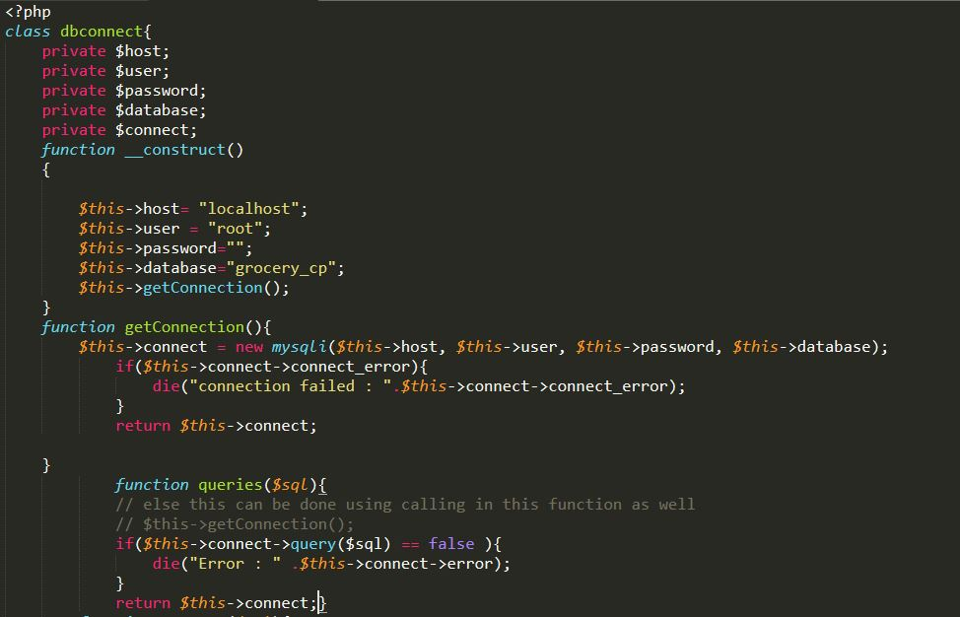

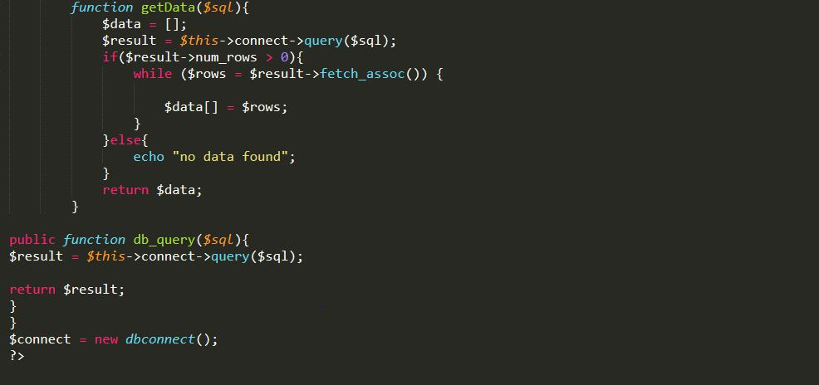

Figure 1 Database connection

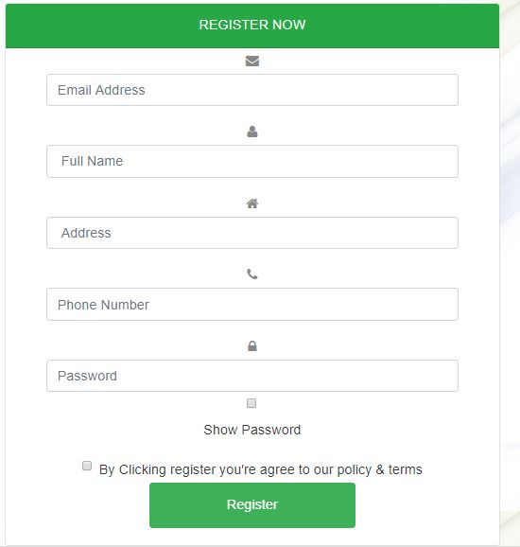

Figure 2 Registration form

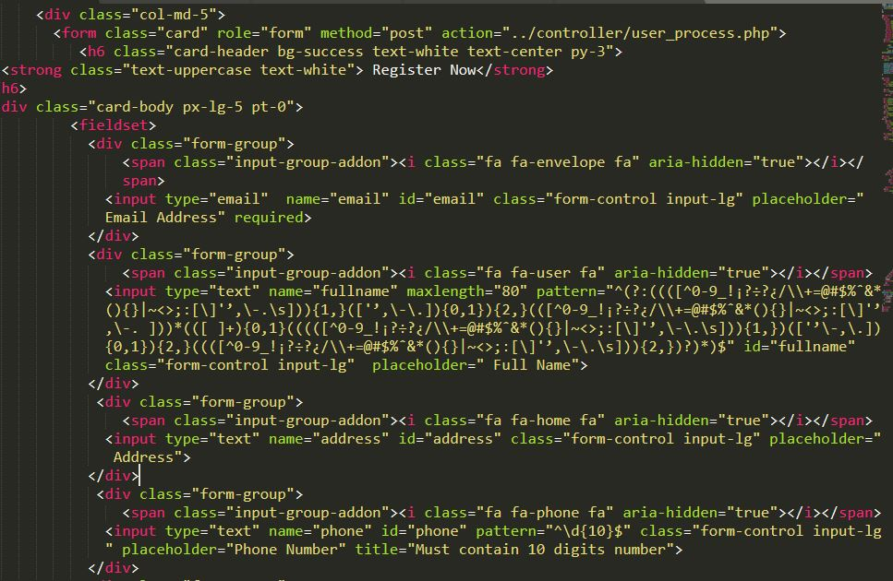

Figure 3 Registration form view code

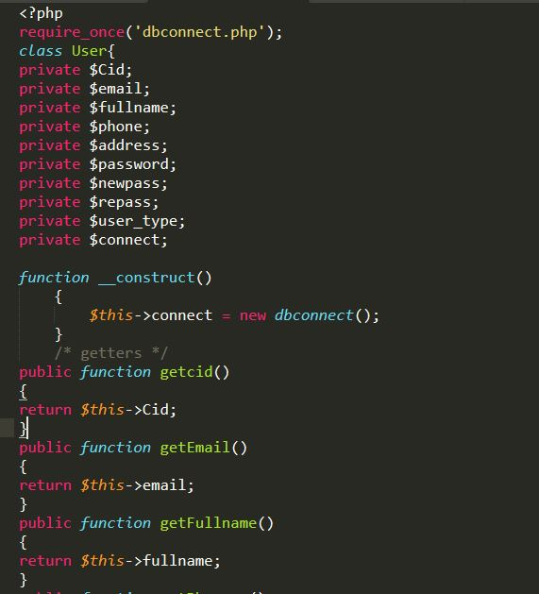

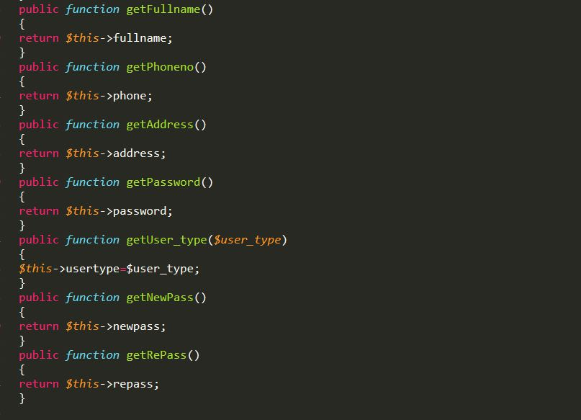

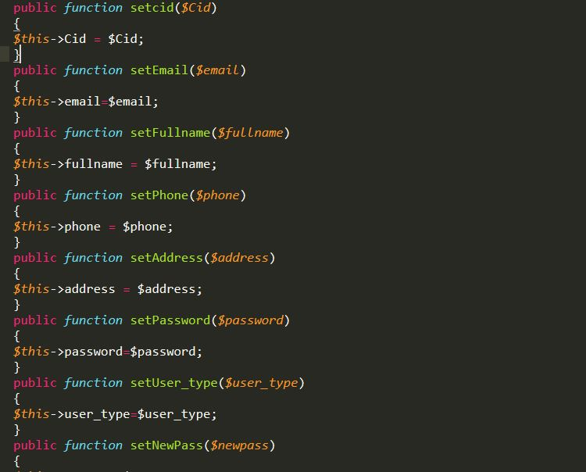

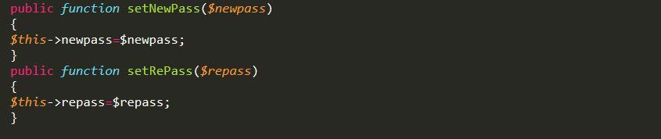

Figure 4 Setter Getter for registration

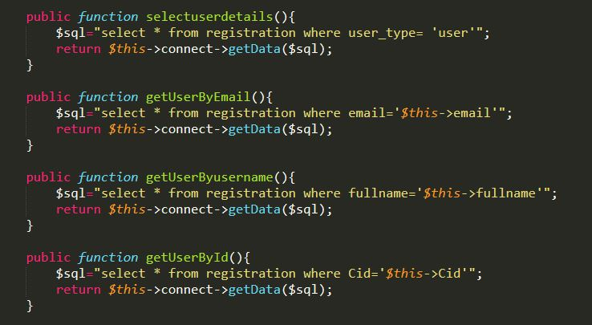

Figure 5 Select Query of User

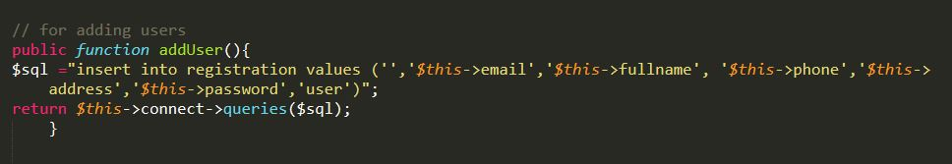

Figure 6 Insert Query for Registration

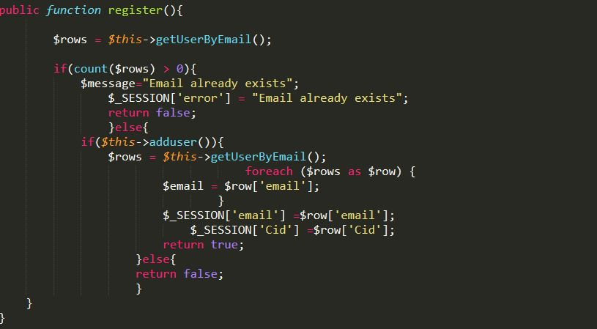

Figure 7 Email validation query

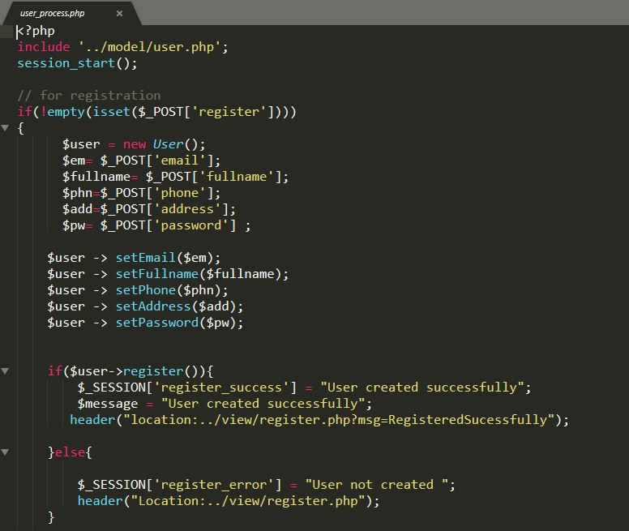

Figure 8 model and controller of registration form

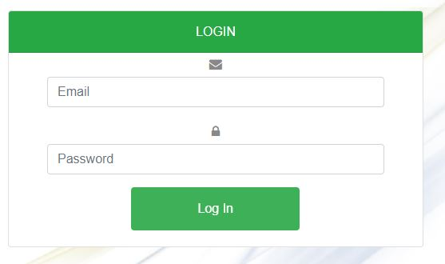

Figure 9 Login Form

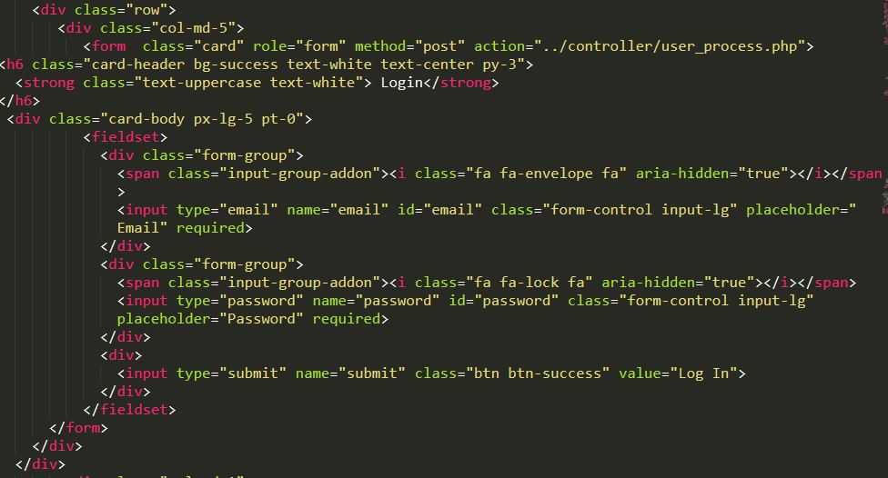

Figure 10 View of Login Form

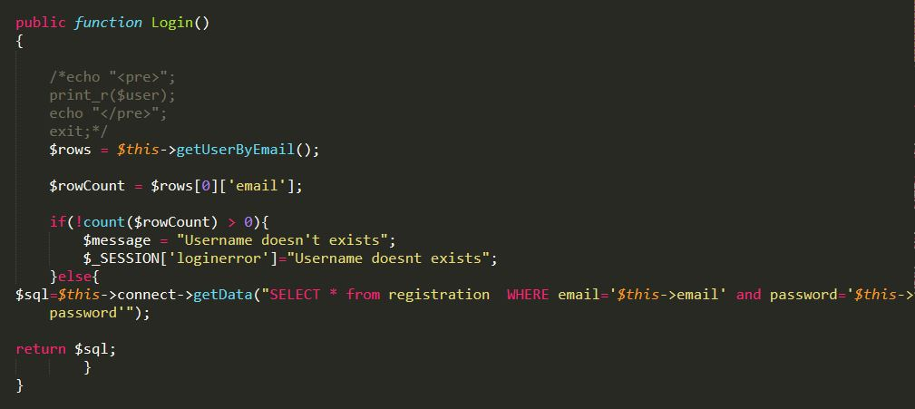

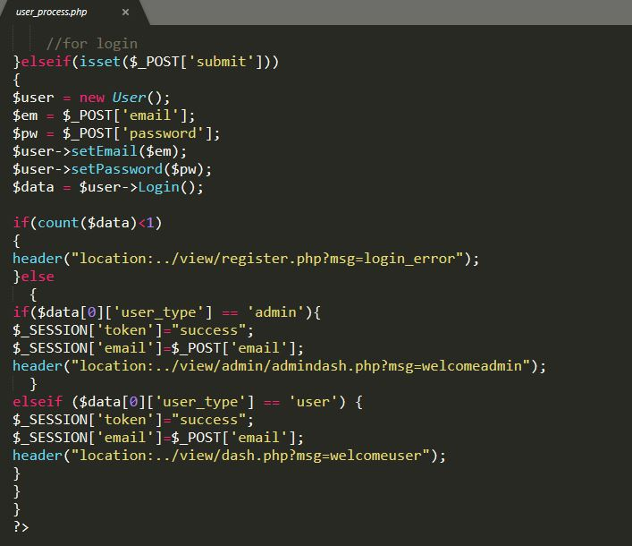

Figure 11 Login code

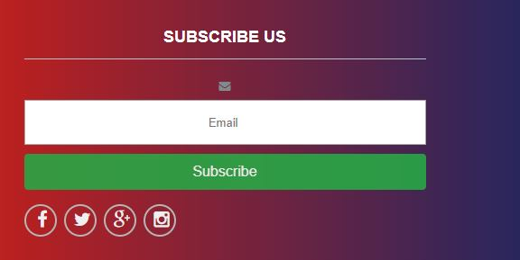

Figure 12 Subscribe Form

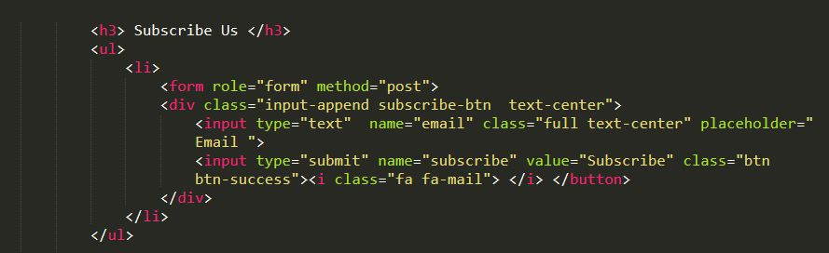

Figure 13 View of Subscribe

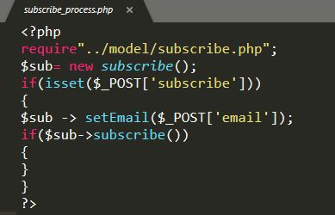

Figure 14 Subscribe Controller

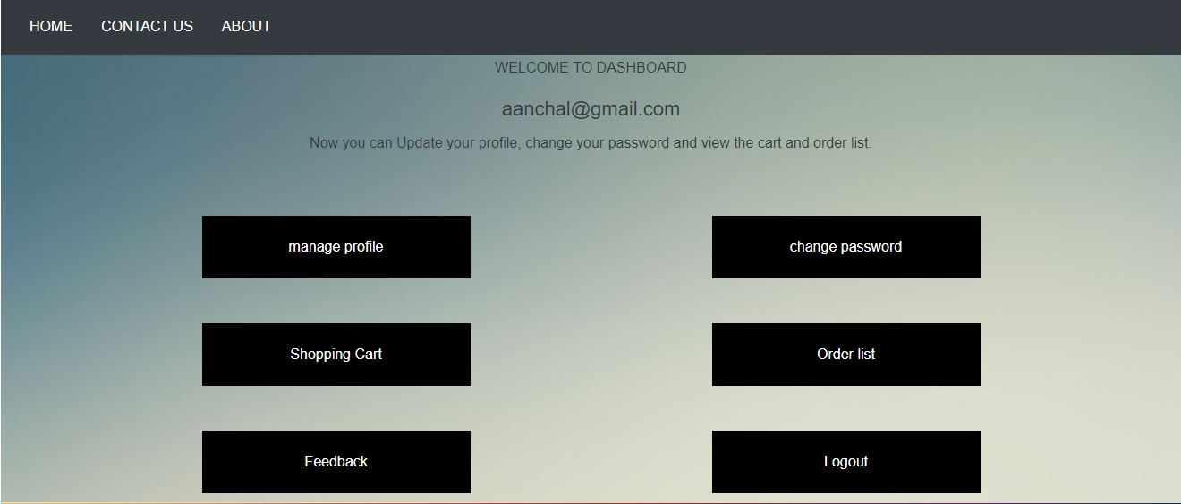

Figure 15 User Dashboard

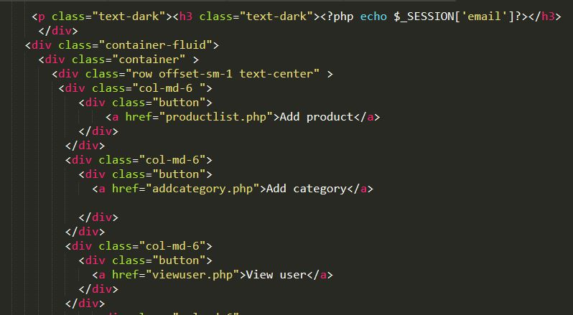

Figure 16 Dashboard view code

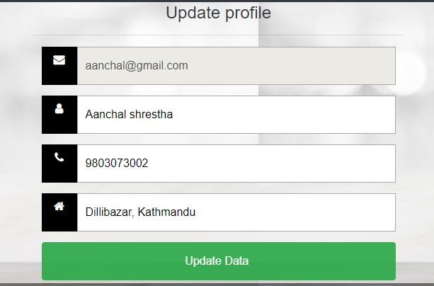

Figure 17 Update profile form

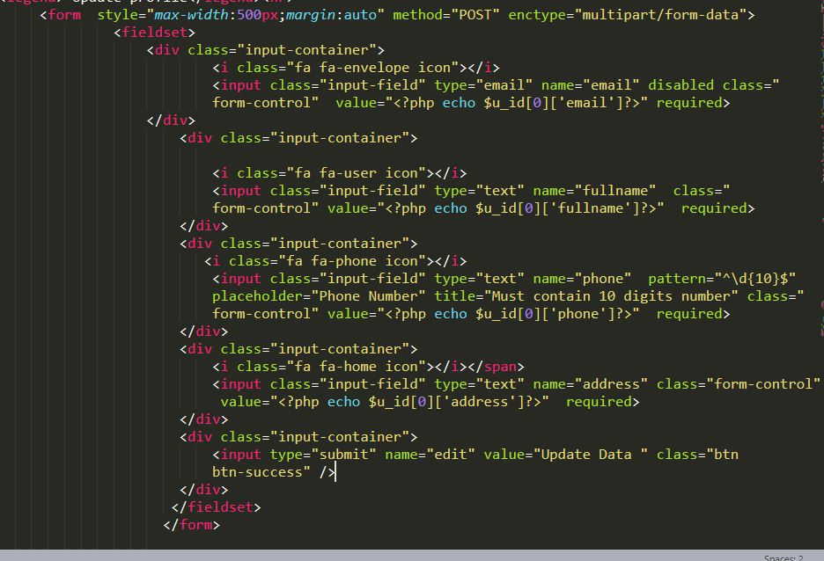

Figure 18 View of Update profile form

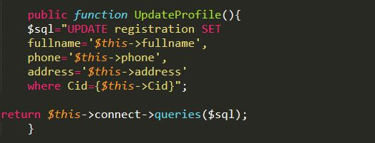

Figure 19 Update profile code

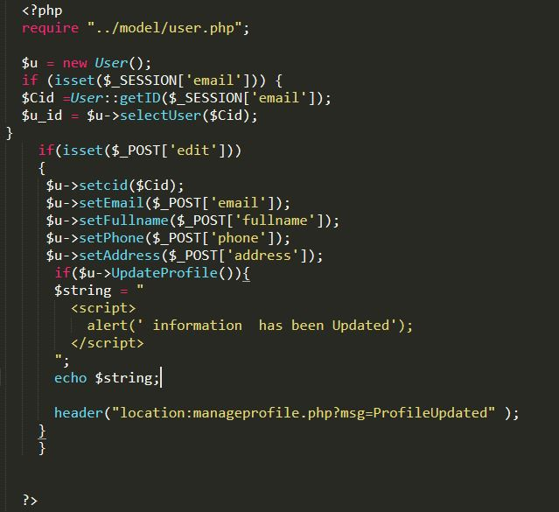

Figure 20 Update profile controller

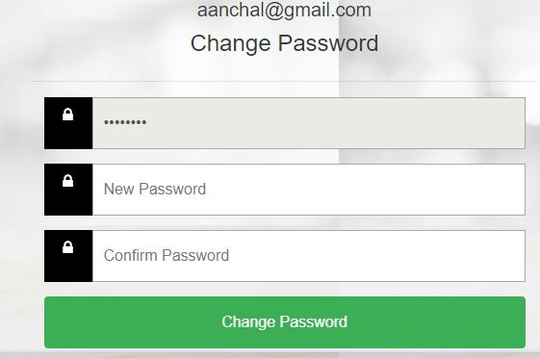

Figure 21 Change password Form

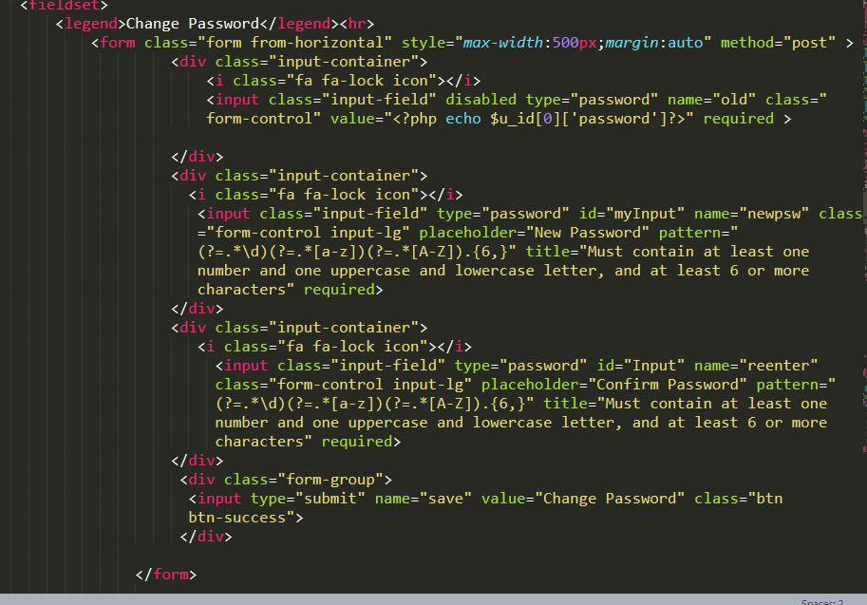

Figure View of Change Password

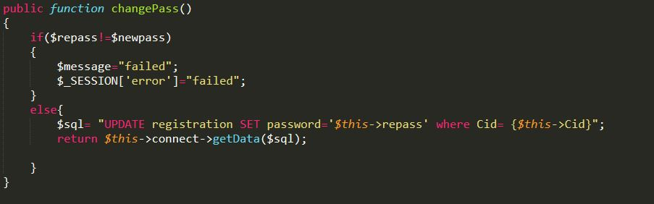

Figure 23 Change password code

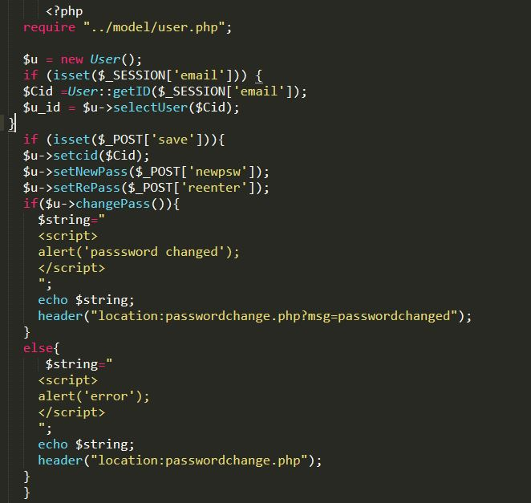

Figure 24 Change password controller

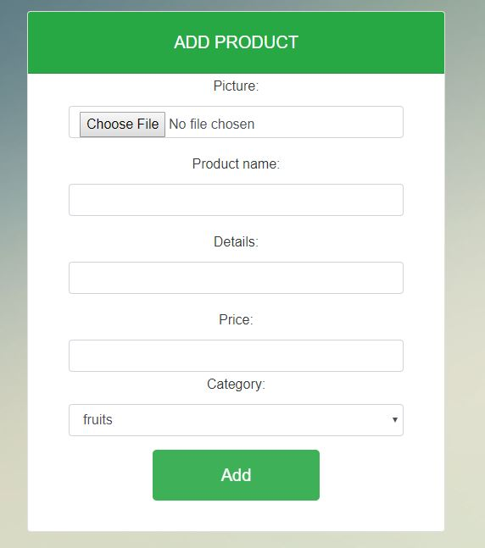

Figure 25 Add Product form

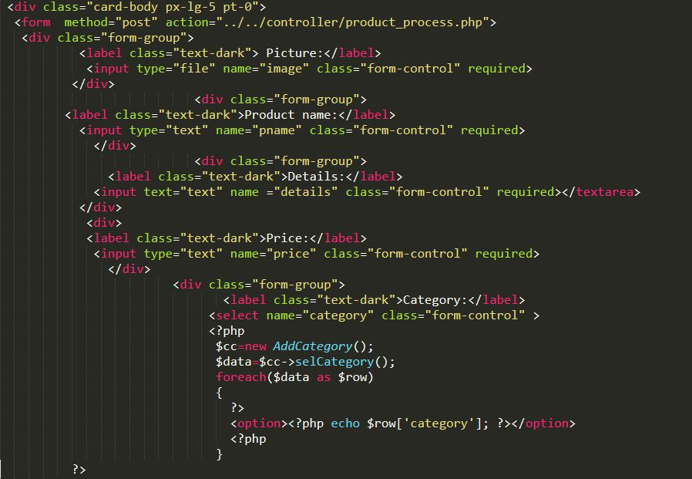

Figure 26 View of product form

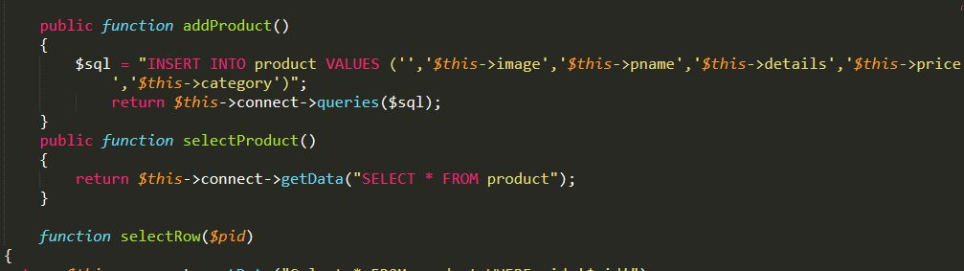

Figure 27 Insert Into product code(Model)

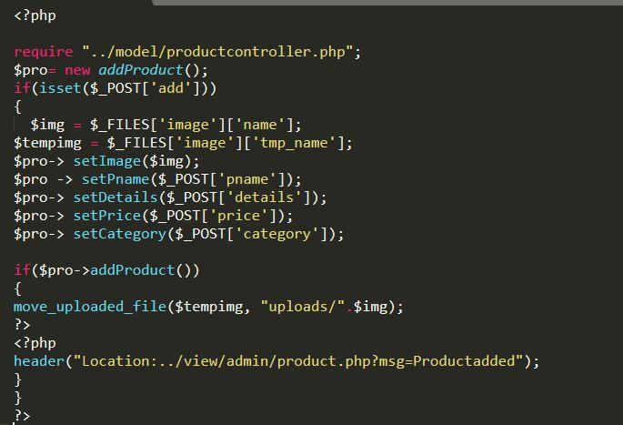

Figure 28 Insert into product controller

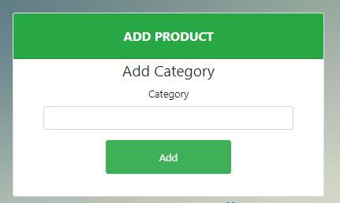

Figure 29 Add Category form

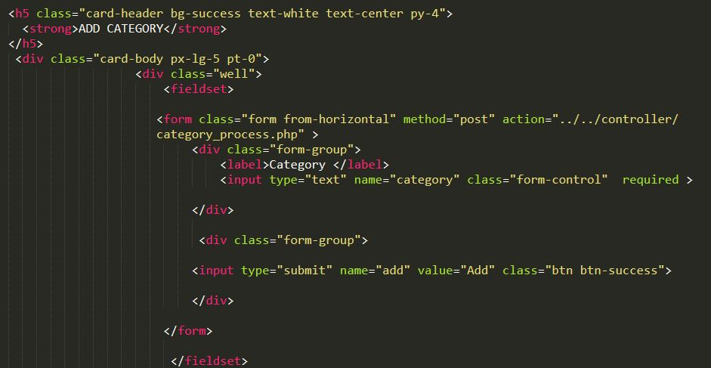

Figure 30 View of Category

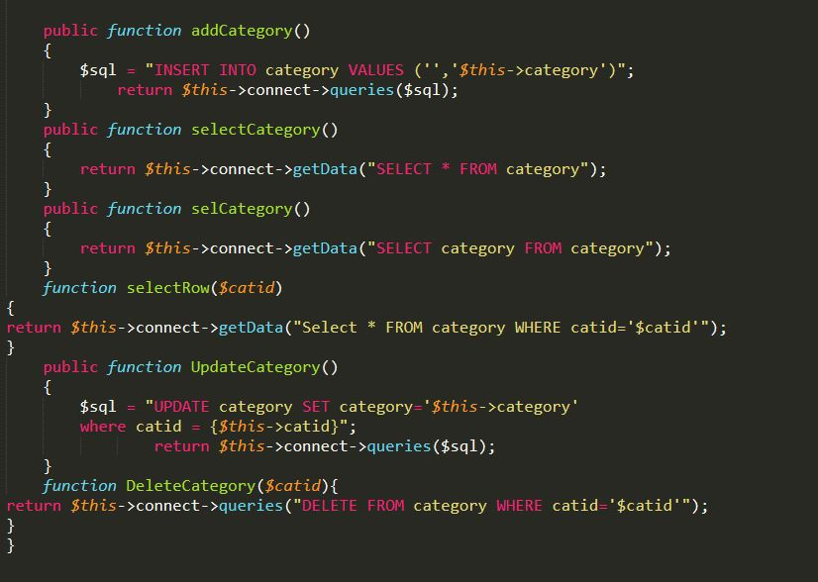

Figure 31 insert into category, select query and update, delete query

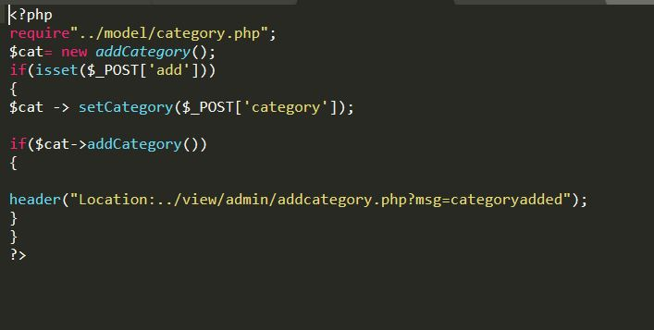

Figure 32 Category controller

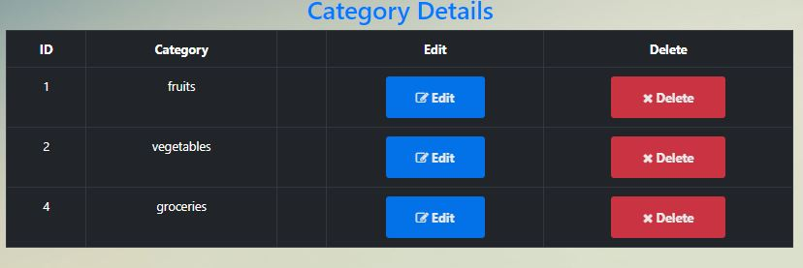

Figure 33 Category list

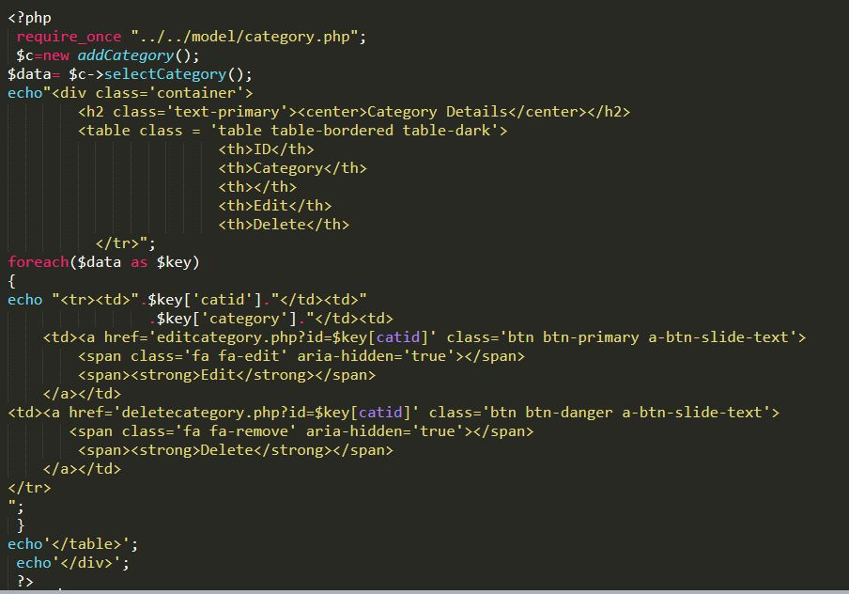

Figure 34 Category select code

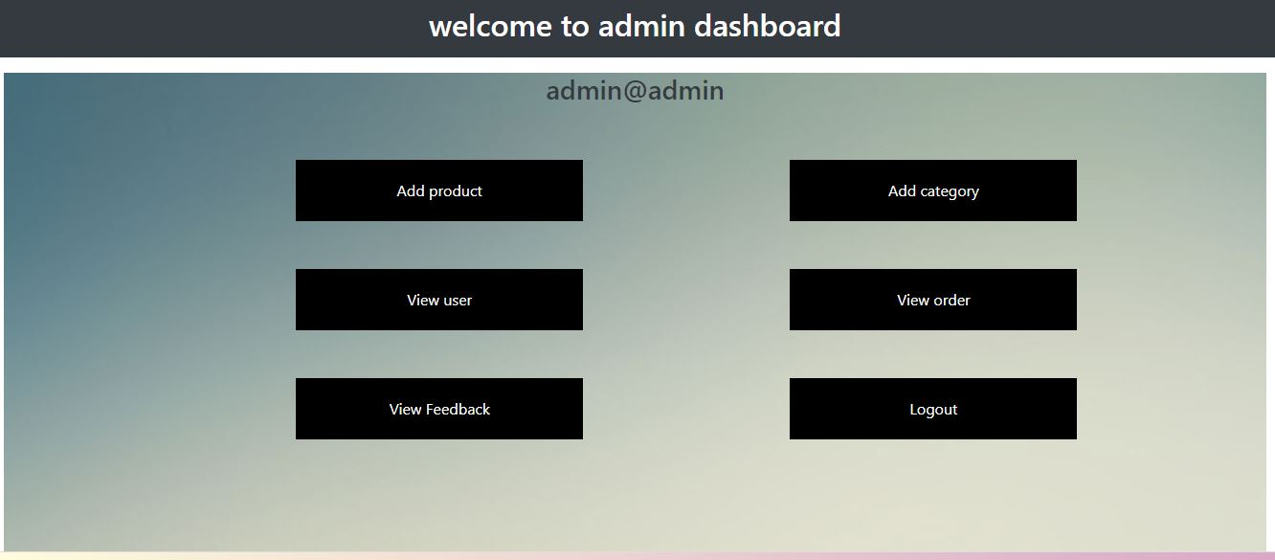

Figure 35 Admin Dashboard

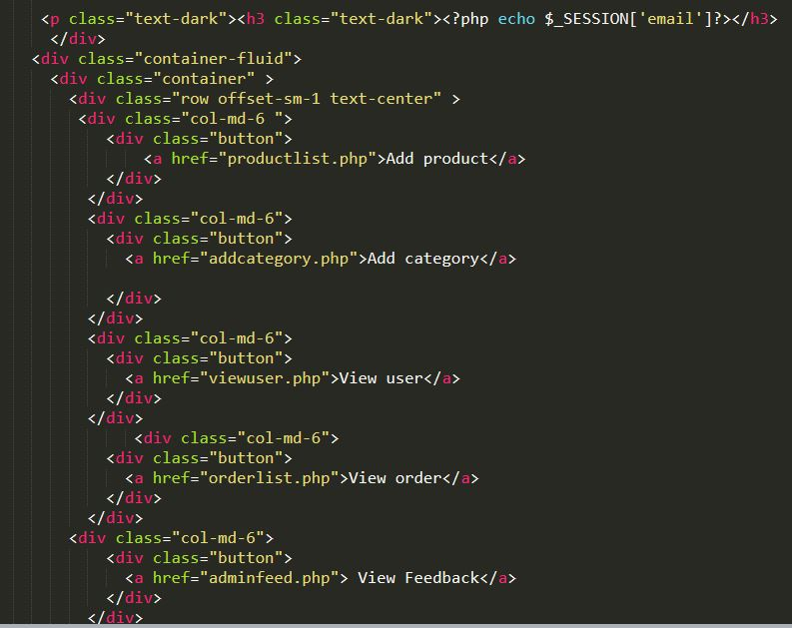

Figure 36 Admin Dashboard view

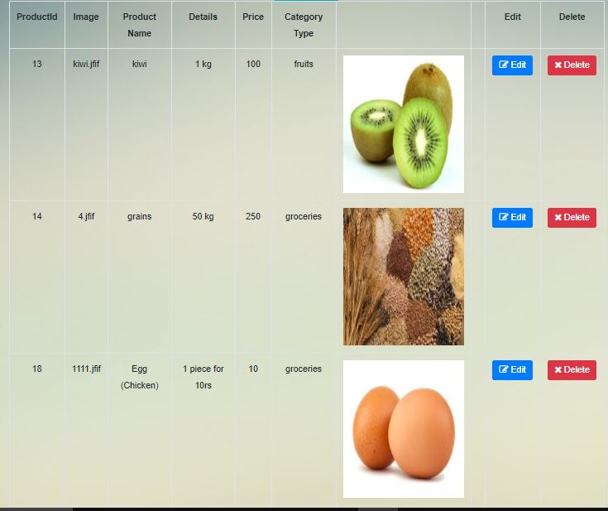

Figure 37 Product list

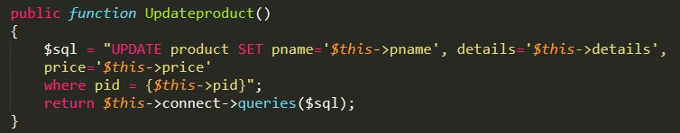

Figure 38 Edit product Code (Model)

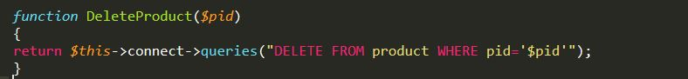

Figure 39 Delete product (Model)

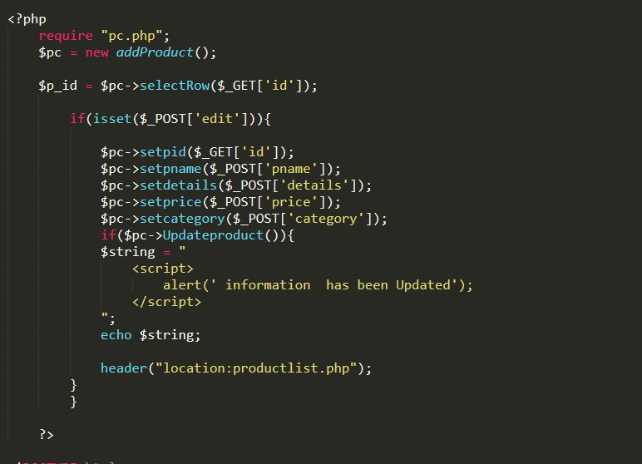

Figure 40 Update Product Controller

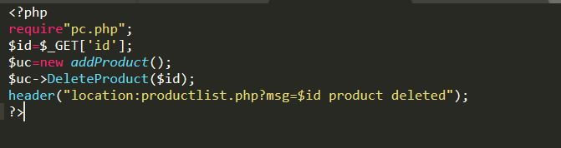

Figure 41 Delete Product Controller

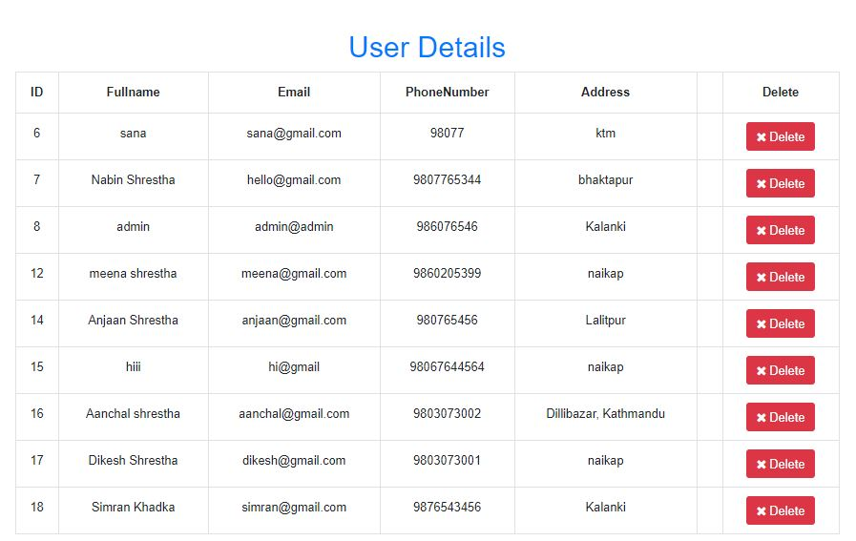

Figure 42 User Details View By Admin



Figure 43 Delete User code (Model)

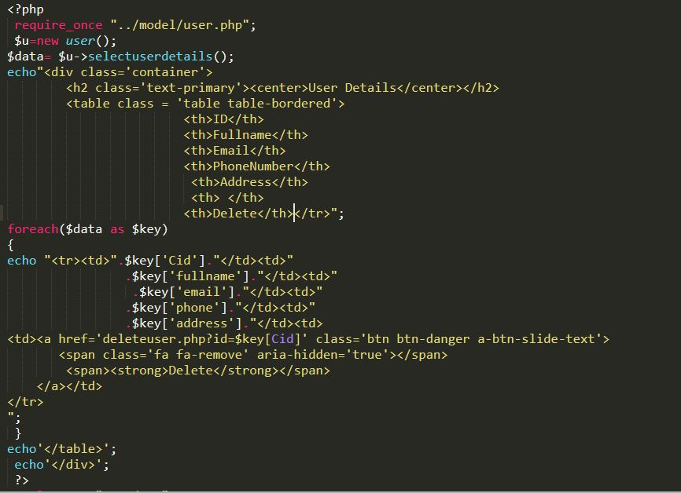

Figure 44 View User code