PizzaPoint

Introduction
Domino’s operates in a fast-paced, high-volume environment where data-driven decision-making is critical to maintaining operational efficiency and profitability. This project focuses on analyzing Domino’s store sales data to understand customer ordering patterns, pizza sales performance, revenue trends, and overall business performance. The dataset contains information on 21,350 unique orders By connecting the datasets, we can examine the business from multiple perspectives, including order volume, pizza demand, product performance, pricing, categories, sizes, and purchasing behavior. The main purpose of this analysis is to transform raw transactional data into meaningful business insights. The analysis aims to investigate several important business aspects, including total orders, total pizzas sold, revenue generation, popular pizza sizes, category-wise performance, product-level sales, ordering trends, and customer demand patterns. It also helps identify which pizzas and categories contribute significantly to sales and which products may have comparatively lower demand.
Overall, this project transforms Domino’s raw transactional data into a structured business analysis. The objective is not only to describe past sales performance but also to identify meaningful patterns that can support data-driven decision-making. The results can assist management in areas such as inventory planning, product strategy, sales forecasting, resource allocation, and customer-focused marketing.
Through exploratory data analysis and appropriate visualizations, the project presents complex sales information in an easier-to-understand format. This makes the analysis suitable for business meetings, where stakeholders can quickly understand the key findings, identify areas requiring attention, and use the information as a foundation for future business planning.

Dataset description
The Domino’s store dataset covers 21,350 unique orders placed between January 1, 2015, and December 31, 2015. It is structured across four relational text files:
- order.csv (21,350 entries): Contains the timestamped log of every customer transaction, featuring the unique order_id, along with the specific date and time the order was placed.

- order_details.csv (48,620 entries): Captures individual line items within each order, linking order_id to pizza_id and tracking the quantity of each item purchased.

- pizzas.csv (96 entries): Serves as the menu pricing catalog, mapping each unique pizza_id to its corresponding pizza_type_id, portion size (S, M, L, XL, XXL), and unit price.

- pizza_types.csv (32 entries): Provides categorical context for the menu, linking pizza_type_id to the official pizza name, its menu category (Classic, Supreme, Veggie, Chicken), and a detailed list of ingredients.

Objectives

Analyze Overall Sales and Order Performance
To evaluate the overall business performance by analyzing the total number of orders, total pizzas sold, and revenue generated during 2015, providing a clear understanding of the store's sales volume and performance.
- Identify Customer Ordering Patterns
To analyze daily, monthly, and time-based ordering trends to identify peak and low-demand periods. This can help understand when customers are most active and support better planning of staff, inventory, and store operations.

Evaluate Product and Category Performance
To identify the top-performing and lower-performing pizzas based on quantity sold and revenue, while also comparing the performance of different pizza categories such as Classic, Supreme, Veggie, and Chicken.

Analyze Pizza Size and Pricing Preferences
To examine customer preferences across different pizza sizes and analyze how pizza size, quantity, and price contribute to overall sales and revenue. This can help understand which product configurations have the highest demand.

Generate Actionable Business Insights
To convert the analyzed data into meaningful and actionable business insights that can support decision-making related to inventory management, product planning, promotions, staffing, sales strategies, and future demand forecasting.

Insights

- Retrieve the total number of orders placed.

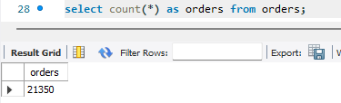

- Calculate the total revenue generated from pizza sales.

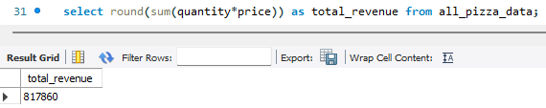

- Identify the highest-priced pizza.

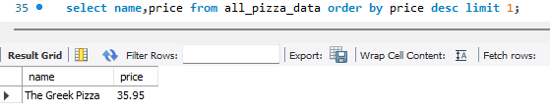

- Identify the most common pizza size ordered.

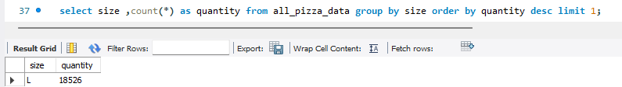

- List the top 5 most ordered pizza types along with their quantities.

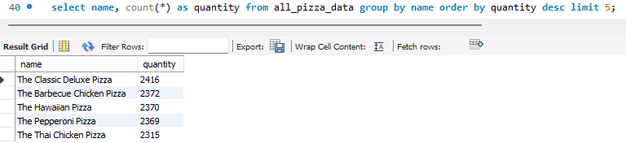

- Join the necessary tables to find the total quantity of each pizza category ordered.

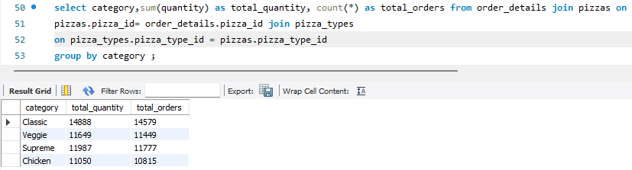

- Determine the distribution of orders by hour of the day.

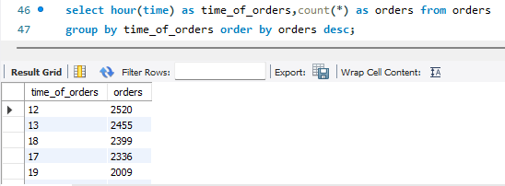

- Join relevant tables to find the category-wise distribution of pizzas.
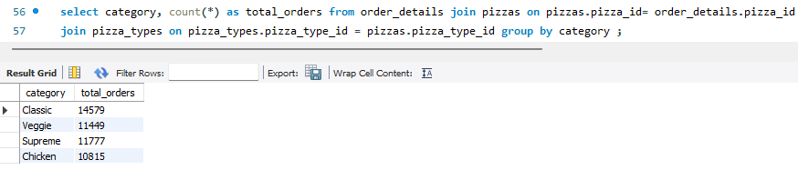

- Group the orders by date and calculate the average number of pizzas ordered per day.

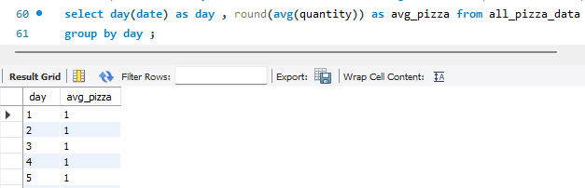

- Determine the top 3 most ordered pizza types based on revenue.

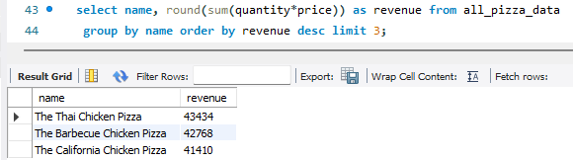

Conclusion
- Data-Driven Strategy: The analysis of Domino’s 2015 dataset ($817,860.05 total revenue across 49,574 pizzas sold) confirms that leveraging transactional data provides direct operational and financial advantages.
- Menu Dynamics: High-value specialty pizzas (The Thai Chicken Pizza and The Barbecue Chicken Pizza) drive total revenue, while high-volume baseline offerings (Classic category leading with 14,888 items sold) sustain consistent daily demand.
- Operational Readiness: Leveraging order timestamp data across all 21,350 transactions allows store managers to align workforce scheduling and dough preparation precisely with peak daily and hourly demand windows.
- Actionable Next Steps: Domino's can maximize profit margins by creating combo promotions that pair lower-volume pizzas with top-sellers, optimizing ingredient stock to match category demand, and maintaining fast fulfillment times during peak traffic hours.

