NSE

Aanchal Dusija and Arushi Chadha

10/02/2020

# Variance Ratio Tests for Random Walk Hypothesis Using NIFTY50.

By Aanchal Dusija and Arushi Chadha

## Packages and libraries

# install.packages("ReporteRs")  
# install.packages("officer")  
# install.packages("rvg")   
# install.packages("readxl")  
# install.packages("xts")  
# install.packages("PerformanceAnalytics")  
# install.packages("vrtest")  
# install.packages("export")  
# install.packages("rmarkdown")  
  
library(readxl)  
library(xts)

## Loading required package: zoo

##   
## Attaching package: 'zoo'

## The following objects are masked from 'package:base':  
##   
## as.Date, as.Date.numeric

## Registered S3 method overwritten by 'xts':  
## method from  
## as.zoo.xts zoo

library(PerformanceAnalytics)

##   
## Attaching package: 'PerformanceAnalytics'

## The following object is masked from 'package:graphics':  
##   
## legend

library(vrtest)  
library(rmarkdown)  
library(ggplot2)

## Inputting the data

PR_MarketCap<-read.csv("PR_MarketCap.csv", header = TRUE, sep = ",")  
PR_ADT<-read.csv("PR_ADT.csv", header = TRUE, sep = ",")

# Looking at the data briefly

# PR_MarketCap <- as.ts(PR_MarketCap)  
# PR_ADT <- as.ts(PR_ADT)  
  
PR_MarketCap$Date = as.Date(PR_MarketCap$Date, format = '%d-%m-%y')  
PR_ADT$Date = as.Date(PR_ADT$Date, format = '%d-%m-%y')  
head(PR_MarketCap)

## Date Decile1 Decile2 Decile3 Decile4 Decile5  
## 1 2020-12-05 0.002313716 -0.007207310 -0.009473834 -0.000464262 -0.011741226  
## 2 2020-12-06 -0.005280956 -0.010035154 -0.010906795 -0.010664091 -0.007563413  
## 3 2020-12-09 -0.003327669 0.003081740 0.000963334 -0.005500147 -0.004818321  
## 4 2020-12-10 -0.006074593 -0.004464423 -0.016142402 -0.015301596 -0.010828835  
## 5 2020-12-11 0.005120244 0.004315025 0.004538599 0.002137846 0.012111931  
## 6 2020-12-12 0.002206325 0.001026633 0.012676406 0.005235190 0.007528269  
## Decile6 Decile7 Decile8 Decile9 Decile10  
## 1 -0.017370326 -0.010065849 -0.013819699 -0.001165560 -0.018125471  
## 2 -0.005190471 -0.010114652 -0.006528150 -0.016798613 -0.022655819  
## 3 0.001123680 -0.000855738 -0.000389605 0.003655586 -0.013282559  
## 4 -0.007903630 -0.013079941 -0.013183424 -0.012324395 -0.001800642  
## 5 0.009231298 -0.004714729 0.002439068 0.007107426 -0.011522181  
## 6 0.023710852 0.022188155 0.009746288 0.008647356 0.014738368

head(PR_ADT)

## Date Decile1 Decile2 Decile3 Decile4 Decile5  
## 1 2020-12-05 -0.006465864 0.005164222 -0.001768138 -0.013538198 -0.008497608  
## 2 2020-12-06 -0.010358575 -0.002839508 -0.007910899 -0.005636180 -0.012944106  
## 3 2020-12-09 0.004655457 -0.007244723 -0.009804415 0.004203660 -0.002282461  
## 4 2020-12-10 -0.003476897 -0.009701542 -0.005811315 -0.012978937 -0.017293827  
## 5 2020-12-11 0.001318592 0.008573641 0.006000908 0.003553102 0.003152208  
## 6 2020-12-12 0.009206461 -0.000261815 0.002202754 0.019224062 0.011568312  
## Decile6 Decile7 Decile8 Decile9 Decile10  
## 1 -0.006780167 -0.005580761 -0.003069203 -0.0054112880 -0.008527517  
## 2 -0.013310529 -0.009004127 -0.002381828 -0.0093385600 -0.010307572  
## 3 -0.003355769 0.002328621 0.001157419 0.0000145936 -0.009760191  
## 4 -0.013658961 -0.008544209 -0.007964459 -0.0110986740 -0.010395572  
## 5 0.012377970 0.000686834 0.003817947 0.0025950920 -0.001628825  
## 6 0.005037282 0.009312547 0.007333119 -0.0004560150 -0.001367336

# Removing NA values, if any

PR_MarketCap <- na.omit(PR_MarketCap)  
PR_ADT<- na.omit(PR_ADT)

# Removing NA values, if any

deciles<-colnames(PR_ADT)  
deciles <- deciles[2:11]  
deciles

## [1] "Decile1" "Decile2" "Decile3" "Decile4" "Decile5" "Decile6"   
## [7] "Decile7" "Decile8" "Decile9" "Decile10"

## Summary

summary(PR_MarketCap)

## Date Decile1 Decile2   
## Min. :2020-01-01 Min. :-0.0385720 Min. :-3.337e-02   
## 1st Qu.:2020-01-23 1st Qu.:-0.0044657 1st Qu.:-5.864e-03   
## Median :2020-02-14 Median : 0.0000000 Median : 0.000e+00   
## Mean :2020-05-05 Mean :-0.0009386 Mean :-5.540e-06   
## 3rd Qu.:2020-12-09 3rd Qu.: 0.0037958 3rd Qu.: 5.989e-03   
## Max. :2020-12-31 Max. : 0.0209105 Max. : 2.043e-02   
## Decile3 Decile4 Decile5   
## Min. :-0.0250754 Min. :-0.0336487 Min. :-0.035852   
## 1st Qu.:-0.0074655 1st Qu.:-0.0066382 1st Qu.:-0.005831   
## Median :-0.0002084 Median :-0.0008657 Median :-0.001104   
## Mean :-0.0005617 Mean :-0.0014488 Mean :-0.000896   
## 3rd Qu.: 0.0057110 3rd Qu.: 0.0037354 3rd Qu.: 0.007144   
## Max. : 0.0274040 Max. : 0.0160389 Max. : 0.021594   
## Decile6 Decile7 Decile8   
## Min. :-0.0533084 Min. :-0.0439690 Min. :-0.035534   
## 1st Qu.:-0.0072248 1st Qu.:-0.0122060 1st Qu.:-0.007279   
## Median :-0.0004286 Median :-0.0008557 Median :-0.001575   
## Mean :-0.0008838 Mean :-0.0024774 Mean :-0.001827   
## 3rd Qu.: 0.0081148 3rd Qu.: 0.0045830 3rd Qu.: 0.004356   
## Max. : 0.0325006 Max. : 0.0334390 Max. : 0.025969   
## Decile9 Decile10   
## Min. :-0.0406681 Min. :-0.051105   
## 1st Qu.:-0.0048932 1st Qu.:-0.014198   
## Median : 0.0006456 Median :-0.002529   
## Mean :-0.0003633 Mean :-0.003101   
## 3rd Qu.: 0.0071580 3rd Qu.: 0.009572   
## Max. : 0.0362747 Max. : 0.027716

summary(PR_ADT)

## Date Decile1 Decile2   
## Min. :2020-01-01 Min. :-0.0355642 Min. :-0.0448907   
## 1st Qu.:2020-01-23 1st Qu.:-0.0071482 1st Qu.:-0.0052620   
## Median :2020-02-14 Median :-0.0003337 Median : 0.0011309   
## Mean :2020-05-05 Mean :-0.0013778 Mean :-0.0002902   
## 3rd Qu.:2020-12-09 3rd Qu.: 0.0054130 3rd Qu.: 0.0046992   
## Max. :2020-12-31 Max. : 0.0286939 Max. : 0.0173922   
## Decile3 Decile4 Decile5   
## Min. :-2.642e-02 Min. :-0.0387791 Min. :-0.0399697   
## 1st Qu.:-6.473e-03 1st Qu.:-0.0056362 1st Qu.:-0.0068859   
## Median :-1.909e-05 Median : 0.0002905 Median : 0.0009317   
## Mean :-7.620e-04 Mean :-0.0003467 Mean :-0.0005442   
## 3rd Qu.: 4.541e-03 3rd Qu.: 0.0042979 3rd Qu.: 0.0078974   
## Max. : 2.662e-02 Max. : 0.0269143 Max. : 0.0259779   
## Decile6 Decile7 Decile8   
## Min. :-2.989e-02 Min. :-0.030749 Min. :-0.0352519   
## 1st Qu.:-1.015e-02 1st Qu.:-0.005839 1st Qu.:-0.0038158   
## Median :-1.958e-05 Median : 0.000000 Median : 0.0008658   
## Mean :-2.397e-03 Mean :-0.000530 Mean : 0.0005466   
## 3rd Qu.: 4.146e-03 3rd Qu.: 0.005378 3rd Qu.: 0.0055149   
## Max. : 2.586e-02 Max. : 0.026835 Max. : 0.0160073   
## Decile9 Decile10   
## Min. :-0.0346506 Min. :-0.043480   
## 1st Qu.:-0.0054113 1st Qu.:-0.009587   
## Median : 0.0000000 Median :-0.001417   
## Mean :-0.0007131 Mean :-0.002733   
## 3rd Qu.: 0.0044875 3rd Qu.: 0.004371   
## Max. : 0.0207748 Max. : 0.022874

## VARIANCE RATIO FUNCTION

stat.plot <-  
 function (y, k)  
 {  
 y <- as.matrix(y)  
 n <- nrow(y)  
 m <- mean(y)  
 vr1 <- sum((y - m)^2)/n  
 # use the filter function  
 flt = filter(y, rep(1,k), method = "convolution")  
 flt = flt[!is.na(flt)]  
 summ = sum((flt - k * m)^2)  
 vr2 <- summ/(n * k)  
 vr <- vr2/vr1  
 tem1 <- 2 * (2 * k - 1) * (k - 1)  
 tem2 <- 3 * k * n  
 se <- sqrt(tem1/tem2)  
 return(list(vr = vr, se = se))  
 }  
  
  
VR.plot_new<- function (y, kvec)   
 {  
 val <- matrix(NA, nrow = max(kvec), ncol = 3)  
 for (i in 2:max(kvec)) {  
 tem1 <- stat.plot(y, i)$vr  
 tem2 <- stat.plot(y, i)$se  
 val[i, ] <- c(tem1, 1 - 1.96 * tem2, 1 + 1.96 * tem2)  
 }  
 matplot(val, type = "l", col = c(2, 4, 4), xlab = "holding period",   
 ylab = "variance ratio", lwd = c(3, 3, 3), lty = c(1,   
 2, 2))  
 abline(h = 1)  
 title(main = "Variance Ratios and 95% confidence band")  
 VAL <- as.matrix(val[2:max(kvec), 1])  
 rownames(VAL) <- paste("k=", 2:max(kvec), sep = "")  
 colnames(VAL) <- "VR"  
 return(list(VR = VAL))  
 }

## VARIANCE RATIO for Market Capital Deciles

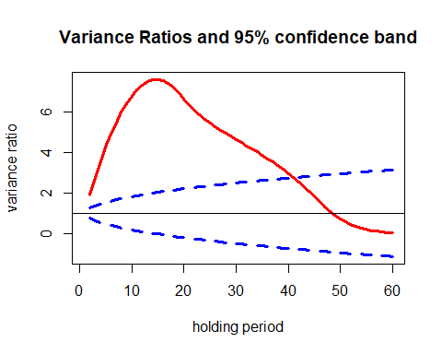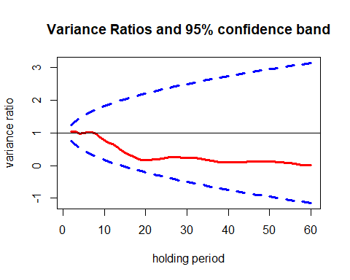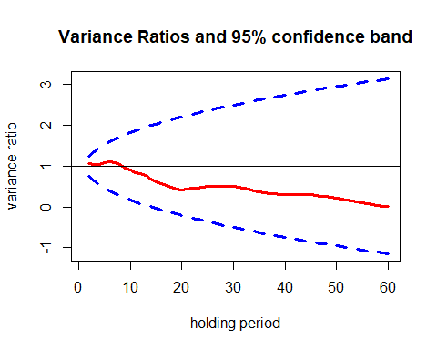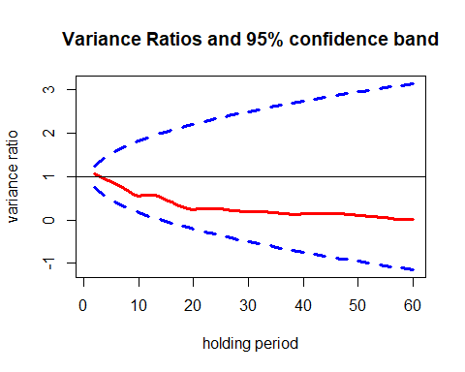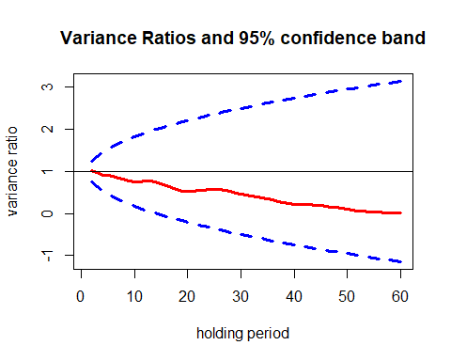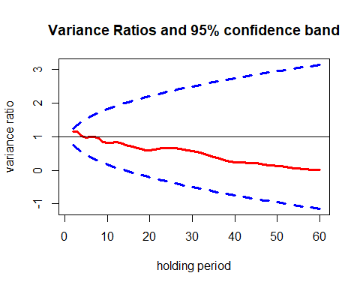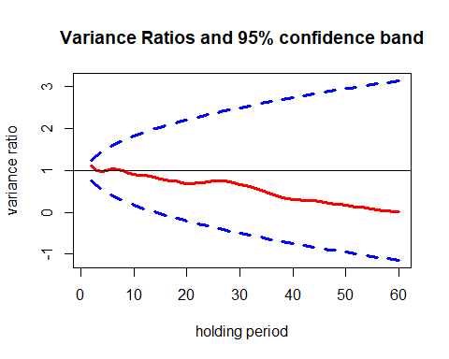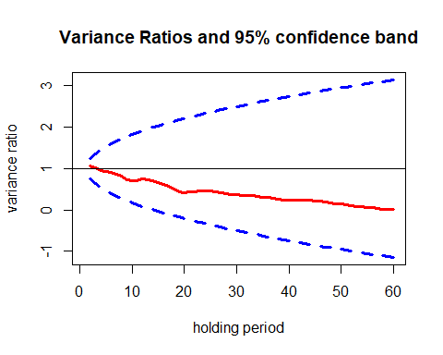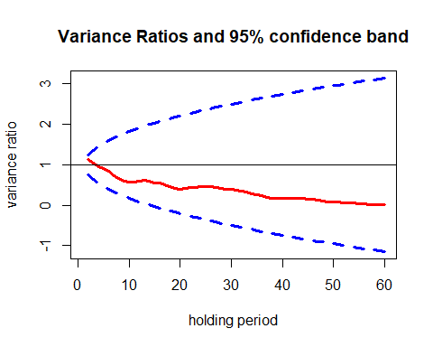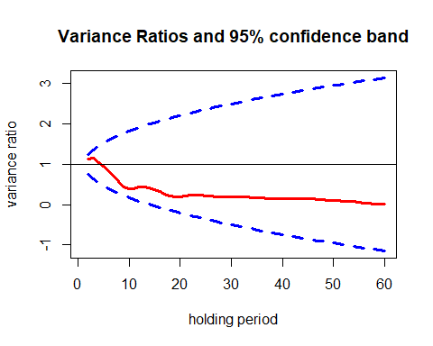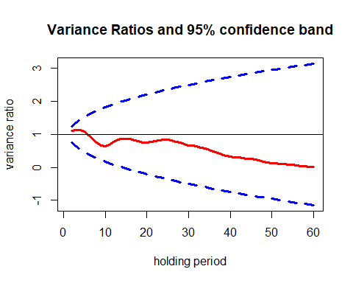

## $Date  
## $Date$VR  
## VR  
## k=2 1.91684155  
## k=3 2.76632295  
## k=4 3.54791623  
## k=5 4.26152230  
## k=6 4.90704587  
## k=7 5.48433106  
## k=8 5.99320693  
## k=9 6.43298710  
## k=10 6.80346968  
## k=11 7.10457609  
## k=12 7.33618339  
## k=13 7.49814561  
## k=14 7.58974174  
## k=15 7.61072084  
## k=16 7.56099289  
## k=17 7.44043683  
## k=18 7.24891190  
## k=19 6.98567300  
## k=20 6.65043576  
## k=21 6.35727310  
## k=22 6.09832930  
## k=23 5.86712189  
## k=24 5.65777507  
## k=25 5.46564335  
## k=26 5.28698681  
## k=27 5.11862244  
## k=28 4.95782599  
## k=29 4.80191291  
## k=30 4.64869280  
## k=31 4.49646069  
## k=32 4.34372579  
## k=33 4.18918005  
## k=34 4.03142745  
## k=35 3.86925776  
## k=36 3.70180939  
## k=37 3.52831366  
## k=38 3.34808338  
## k=39 3.16032743  
## k=40 2.96427760  
## k=41 2.75946580  
## k=42 2.54546738  
## k=43 2.32189654  
## k=44 2.08827806  
## k=45 1.84405860  
## k=46 1.58896895  
## k=47 1.32276085  
## k=48 1.09225283  
## k=49 0.89371756  
## k=50 0.72361702  
## k=51 0.57893736  
## k=52 0.45691414  
## k=53 0.35500902  
## k=54 0.27083307  
## k=55 0.20210973  
## k=56 0.14688874  
## k=57 0.10337203  
## k=58 0.06990070  
## k=59 0.04491027  
## k=60 0.02691877  
##   
##   
## $Decile1  
## $Decile1$VR  
## VR  
## k=2 1.050118200  
## k=3 1.052046649  
## k=4 0.981049179  
## k=5 0.988480346  
## k=6 1.027892028  
## k=7 1.029935378  
## k=8 0.971477077  
## k=9 0.862011260  
## k=10 0.778068981  
## k=11 0.712777481  
## k=12 0.664640948  
## k=13 0.571225232  
## k=14 0.475758767  
## k=15 0.383715057  
## k=16 0.321815490  
## k=17 0.278005167  
## k=18 0.226054316  
## k=19 0.173817603  
## k=20 0.161221526  
## k=21 0.175790088  
## k=22 0.188546342  
## k=23 0.196860074  
## k=24 0.211688996  
## k=25 0.233948816  
## k=26 0.250265732  
## k=27 0.251857418  
## k=28 0.251412250  
## k=29 0.242189791  
## k=30 0.244007920  
## k=31 0.244757518  
## k=32 0.233949238  
## k=33 0.211496213  
## k=34 0.191698680  
## k=35 0.169840563  
## k=36 0.154634134  
## k=37 0.129805471  
## k=38 0.107276244  
## k=39 0.093881625  
## k=40 0.093621222  
## k=41 0.098344184  
## k=42 0.100517759  
## k=43 0.104874384  
## k=44 0.111713962  
## k=45 0.119158801  
## k=46 0.121254068  
## k=47 0.125788681  
## k=48 0.128071504  
## k=49 0.130407392  
## k=50 0.131760304  
## k=51 0.125937350  
## k=52 0.114046971  
## k=53 0.100971706  
## k=54 0.085262160  
## k=55 0.070797108  
## k=56 0.051133684  
## k=57 0.035494990  
## k=58 0.020221319  
## k=59 0.012907949  
## k=60 0.006979033  
##   
##   
## $Decile2  
## $Decile2$VR  
## VR  
## k=2 1.06777193  
## k=3 1.05275131  
## k=4 1.03244908  
## k=5 1.08290017  
## k=6 1.10554417  
## k=7 1.07995655  
## k=8 1.03953566  
## k=9 0.96326321  
## k=10 0.90740235  
## k=11 0.84670414  
## k=12 0.81374308  
## k=13 0.76483103  
## k=14 0.69236393  
## k=15 0.62586324  
## k=16 0.57709017  
## k=17 0.53630400  
## k=18 0.49264282  
## k=19 0.44014001  
## k=20 0.42065899  
## k=21 0.43689188  
## k=22 0.45083112  
## k=23 0.46329061  
## k=24 0.48541392  
## k=25 0.50298620  
## k=26 0.50910637  
## k=27 0.51014717  
## k=28 0.50941315  
## k=29 0.50085304  
## k=30 0.49671375  
## k=31 0.48226385  
## k=32 0.46539733  
## k=33 0.43205058  
## k=34 0.39839851  
## k=35 0.37307754  
## k=36 0.35763825  
## k=37 0.33762457  
## k=38 0.31769378  
## k=39 0.30725360  
## k=40 0.30895267  
## k=41 0.31110449  
## k=42 0.31058466  
## k=43 0.31174441  
## k=44 0.31310517  
## k=45 0.30411153  
## k=46 0.28919929  
## k=47 0.27027438  
## k=48 0.25132500  
## k=49 0.23386704  
## k=50 0.21380086  
## k=51 0.19042194  
## k=52 0.16591886  
## k=53 0.14115201  
## k=54 0.11578260  
## k=55 0.09667818  
## k=56 0.07346024  
## k=57 0.05172757  
## k=58 0.03175663  
## k=59 0.02160599  
## k=60 0.01194065  
##   
##   
## $Decile3  
## $Decile3$VR  
## VR  
## k=2 1.064838956  
## k=3 0.989295917  
## k=4 0.935426341  
## k=5 0.879270116  
## k=6 0.829887550  
## k=7 0.759859152  
## k=8 0.684674117  
## k=9 0.603947445  
## k=10 0.557943993  
## k=11 0.566702728  
## k=12 0.578844946  
## k=13 0.571963487  
## k=14 0.528296494  
## k=15 0.459667274  
## k=16 0.406129708  
## k=17 0.347932455  
## k=18 0.297881695  
## k=19 0.253196040  
## k=20 0.237621054  
## k=21 0.249902946  
## k=22 0.257325963  
## k=23 0.256596374  
## k=24 0.258854803  
## k=25 0.251170575  
## k=26 0.241959233  
## k=27 0.222520071  
## k=28 0.210522784  
## k=29 0.198341590  
## k=30 0.191829623  
## k=31 0.192866749  
## k=32 0.191377851  
## k=33 0.184416324  
## k=34 0.176868471  
## k=35 0.166756266  
## k=36 0.158349483  
## k=37 0.142251959  
## k=38 0.131207831  
## k=39 0.131082708  
## k=40 0.136696068  
## k=41 0.144895838  
## k=42 0.148926235  
## k=43 0.152870681  
## k=44 0.153126518  
## k=45 0.151332032  
## k=46 0.146867453  
## k=47 0.138471973  
## k=48 0.126679069  
## k=49 0.116989315  
## k=50 0.108136744  
## k=51 0.097420341  
## k=52 0.083760416  
## k=53 0.073517482  
## k=54 0.062198166  
## k=55 0.051631990  
## k=56 0.038302190  
## k=57 0.024022717  
## k=58 0.011495363  
## k=59 0.007696692  
## k=60 0.006569089  
##   
##   
## $Decile4  
## $Decile4$VR  
## VR  
## k=2 1.009327694  
## k=3 0.973490063  
## k=4 0.913730661  
## k=5 0.900095645  
## k=6 0.877175529  
## k=7 0.849682241  
## k=8 0.820677345  
## k=9 0.771849169  
## k=10 0.759754313  
## k=11 0.761184631  
## k=12 0.783070059  
## k=13 0.783562221  
## k=14 0.748130775  
## k=15 0.702702629  
## k=16 0.655831669  
## k=17 0.607214762  
## k=18 0.570371990  
## k=19 0.529995231  
## k=20 0.519231085  
## k=21 0.532160702  
## k=22 0.546479781  
## k=23 0.561358693  
## k=24 0.573650679  
## k=25 0.580752069  
## k=26 0.570845139  
## k=27 0.550512674  
## k=28 0.521909367  
## k=29 0.483250640  
## k=30 0.458394218  
## k=31 0.440108308  
## k=32 0.423415830  
## k=33 0.398575806  
## k=34 0.373259846  
## k=35 0.345779382  
## k=36 0.318619802  
## k=37 0.282983451  
## k=38 0.250135541  
## k=39 0.229761801  
## k=40 0.224393678  
## k=41 0.221860358  
## k=42 0.217136250  
## k=43 0.206763396  
## k=44 0.200066988  
## k=45 0.189071284  
## k=46 0.175872506  
## k=47 0.157832016  
## k=48 0.136772311  
## k=49 0.117671719  
## k=50 0.100033424  
## k=51 0.082964769  
## k=52 0.068798110  
## k=53 0.056947922  
## k=54 0.044769825  
## k=55 0.037459737  
## k=56 0.027543362  
## k=57 0.017748285  
## k=58 0.007710316  
## k=59 0.006206507  
## k=60 0.005803550  
##   
##   
## $Decile5  
## $Decile5$VR  
## VR  
## k=2 1.146808245  
## k=3 1.150450957  
## k=4 1.025494309  
## k=5 0.983565729  
## k=6 1.005353343  
## k=7 0.991604658  
## k=8 0.945100987  
## k=9 0.849852764  
## k=10 0.821043497  
## k=11 0.823357762  
## k=12 0.842595835  
## k=13 0.814047402  
## k=14 0.768135674  
## k=15 0.720226954  
## k=16 0.696266226  
## k=17 0.668767893  
## k=18 0.633761031  
## k=19 0.591399462  
## k=20 0.585335232  
## k=21 0.613363799  
## k=22 0.642342131  
## k=23 0.665715233  
## k=24 0.665257689  
## k=25 0.665214206  
## k=26 0.652740070  
## k=27 0.637311534  
## k=28 0.613219390  
## k=29 0.587885886  
## k=30 0.568073501  
## k=31 0.548925373  
## k=32 0.520364435  
## k=33 0.478117983  
## k=34 0.436357551  
## k=35 0.397658310  
## k=36 0.368374679  
## k=37 0.330682649  
## k=38 0.292610466  
## k=39 0.262027198  
## k=40 0.245522816  
## k=41 0.234942295  
## k=42 0.226120105  
## k=43 0.217168147  
## k=44 0.213977689  
## k=45 0.205469215  
## k=46 0.192768152  
## k=47 0.174744150  
## k=48 0.156582472  
## k=49 0.144038372  
## k=50 0.131845472  
## k=51 0.117015241  
## k=52 0.099174998  
## k=53 0.083619603  
## k=54 0.067964383  
## k=55 0.056100986  
## k=56 0.040539436  
## k=57 0.025497617  
## k=58 0.011286717  
## k=59 0.006449798  
## k=60 0.004501077  
##   
##   
## $Decile6  
## $Decile6$VR  
## VR  
## k=2 1.103092521  
## k=3 0.996761138  
## k=4 0.964227124  
## k=5 0.993037658  
## k=6 1.031784834  
## k=7 1.023495862  
## k=8 0.987618376  
## k=9 0.930588476  
## k=10 0.898768782  
## k=11 0.878565652  
## k=12 0.879462696  
## k=13 0.869898295  
## k=14 0.838923562  
## k=15 0.793152486  
## k=16 0.776568936  
## k=17 0.760492895  
## k=18 0.741516241  
## k=19 0.699143864  
## k=20 0.682504799  
## k=21 0.689413248  
## k=22 0.704104156  
## k=23 0.715850292  
## k=24 0.736074120  
## k=25 0.753172762  
## k=26 0.757185512  
## k=27 0.748292574  
## k=28 0.727622716  
## k=29 0.698259634  
## k=30 0.671332970  
## k=31 0.641787049  
## k=32 0.614305476  
## k=33 0.569299489  
## k=34 0.520313596  
## k=35 0.482508728  
## k=36 0.445753147  
## k=37 0.401237817  
## k=38 0.356250816  
## k=39 0.326337269  
## k=40 0.311512348  
## k=41 0.302051238  
## k=42 0.288481546  
## k=43 0.281886524  
## k=44 0.274916130  
## k=45 0.260207367  
## k=46 0.238632160  
## k=47 0.217890111  
## k=48 0.198734329  
## k=49 0.185977485  
## k=50 0.168433033  
## k=51 0.150836134  
## k=52 0.132563621  
## k=53 0.117525741  
## k=54 0.100537535  
## k=55 0.084413142  
## k=56 0.066846927  
## k=57 0.046234874  
## k=58 0.025773719  
## k=59 0.015587889  
## k=60 0.009260088  
##   
##   
## $Decile7  
## $Decile7$VR  
## VR  
## k=2 1.075667242  
## k=3 1.010131624  
## k=4 0.963578412  
## k=5 0.920146437  
## k=6 0.914287555  
## k=7 0.867276074  
## k=8 0.809863727  
## k=9 0.738559714  
## k=10 0.705479045  
## k=11 0.710416754  
## k=12 0.746726272  
## k=13 0.736811345  
## k=14 0.703444478  
## k=15 0.652080036  
## k=16 0.611716085  
## k=17 0.567604418  
## k=18 0.503002484  
## k=19 0.434699789  
## k=20 0.414035747  
## k=21 0.433730816  
## k=22 0.444184918  
## k=23 0.457812881  
## k=24 0.459418225  
## k=25 0.451727515  
## k=26 0.436388107  
## k=27 0.410517417  
## k=28 0.396184290  
## k=29 0.372226692  
## k=30 0.360898880  
## k=31 0.356077574  
## k=32 0.350042960  
## k=33 0.339556697  
## k=34 0.326956892  
## k=35 0.310878004  
## k=36 0.298045024  
## k=37 0.278258001  
## k=38 0.251924548  
## k=39 0.242290150  
## k=40 0.235576572  
## k=41 0.235347738  
## k=42 0.234246549  
## k=43 0.233610770  
## k=44 0.234815793  
## k=45 0.226025974  
## k=46 0.213452135  
## k=47 0.197450654  
## k=48 0.174284946  
## k=49 0.155722183  
## k=50 0.141900483  
## k=51 0.126245218  
## k=52 0.108081509  
## k=53 0.090694073  
## k=54 0.075519294  
## k=55 0.064670975  
## k=56 0.049481510  
## k=57 0.032011453  
## k=58 0.016368935  
## k=59 0.010497665  
## k=60 0.005825856  
##   
##   
## $Decile8  
## $Decile8$VR  
## VR  
## k=2 1.122428429  
## k=3 1.052518390  
## k=4 0.957051571  
## k=5 0.912236031  
## k=6 0.830585789  
## k=7 0.739886351  
## k=8 0.655045750  
## k=9 0.588200866  
## k=10 0.572775785  
## k=11 0.571850403  
## k=12 0.602218374  
## k=13 0.617993299  
## k=14 0.602128649  
## k=15 0.560887863  
## k=16 0.539963491  
## k=17 0.506586605  
## k=18 0.453954285  
## k=19 0.410303461  
## k=20 0.403888644  
## k=21 0.418364856  
## k=22 0.428688859  
## k=23 0.439125477  
## k=24 0.452992906  
## k=25 0.459510584  
## k=26 0.453688171  
## k=27 0.437471763  
## k=28 0.425391275  
## k=29 0.404397256  
## k=30 0.383382544  
## k=31 0.365620071  
## k=32 0.350098949  
## k=33 0.318958321  
## k=34 0.285688755  
## k=35 0.257597271  
## k=36 0.228929828  
## k=37 0.195237837  
## k=38 0.171447546  
## k=39 0.165732041  
## k=40 0.165699412  
## k=41 0.168813832  
## k=42 0.168669757  
## k=43 0.169495859  
## k=44 0.165210121  
## k=45 0.154080531  
## k=46 0.139777390  
## k=47 0.123413228  
## k=48 0.106377234  
## k=49 0.091826622  
## k=50 0.079907809  
## k=51 0.070081972  
## k=52 0.059217418  
## k=53 0.052306410  
## k=54 0.047262974  
## k=55 0.042324722  
## k=56 0.033005778  
## k=57 0.022342591  
## k=58 0.013411152  
## k=59 0.009214002  
## k=60 0.006082018  
##   
##   
## $Decile9  
## $Decile9$VR  
## VR  
## k=2 1.128603754  
## k=3 1.147451554  
## k=4 1.053272084  
## k=5 0.947179306  
## k=6 0.832712575  
## k=7 0.703593098  
## k=8 0.564931262  
## k=9 0.443285238  
## k=10 0.384136107  
## k=11 0.389032359  
## k=12 0.428488681  
## k=13 0.442787278  
## k=14 0.413085281  
## k=15 0.365539621  
## k=16 0.320301634  
## k=17 0.268001685  
## k=18 0.221570454  
## k=19 0.181694051  
## k=20 0.182567386  
## k=21 0.207355115  
## k=22 0.230844789  
## k=23 0.233340808  
## k=24 0.229118394  
## k=25 0.221456437  
## k=26 0.211117519  
## k=27 0.201836199  
## k=28 0.198211720  
## k=29 0.194765122  
## k=30 0.198965156  
## k=31 0.200340204  
## k=32 0.198552667  
## k=33 0.187981688  
## k=34 0.177276051  
## k=35 0.168573132  
## k=36 0.163691084  
## k=37 0.153700651  
## k=38 0.145982178  
## k=39 0.140537778  
## k=40 0.143660683  
## k=41 0.145560347  
## k=42 0.147340763  
## k=43 0.148041674  
## k=44 0.147235625  
## k=45 0.144773397  
## k=46 0.138080684  
## k=47 0.129993351  
## k=48 0.118210969  
## k=49 0.108227163  
## k=50 0.100837400  
## k=51 0.094648401  
## k=52 0.086766701  
## k=53 0.078749509  
## k=54 0.070018047  
## k=55 0.062535538  
## k=56 0.046755172  
## k=57 0.029956882  
## k=58 0.014144930  
## k=59 0.007933634  
## k=60 0.004103186  
##   
##   
## $Decile10  
## $Decile10$VR  
## VR  
## k=2 1.10574609  
## k=3 1.13573797  
## k=4 1.12927091  
## k=5 1.09065202  
## k=6 0.98318770  
## k=7 0.86198351  
## k=8 0.74057201  
## k=9 0.65803596  
## k=10 0.64946080  
## k=11 0.69079674  
## k=12 0.77376511  
## k=13 0.83663577  
## k=14 0.87328408  
## k=15 0.86739045  
## k=16 0.85881277  
## k=17 0.82418060  
## k=18 0.78573642  
## k=19 0.74889956  
## k=20 0.75052486  
## k=21 0.77019442  
## k=22 0.79721106  
## k=23 0.82674970  
## k=24 0.83331740  
## k=25 0.83203289  
## k=26 0.81300371  
## k=27 0.77902032  
## k=28 0.74521491  
## k=29 0.70199138  
## k=30 0.66786213  
## k=31 0.65197424  
## k=32 0.62963660  
## k=33 0.60492170  
## k=34 0.57754713  
## k=35 0.53366203  
## k=36 0.49348270  
## k=37 0.44728096  
## k=38 0.39433380  
## k=39 0.35559722  
## k=40 0.32947358  
## k=41 0.31023800  
## k=42 0.29387536  
## k=43 0.27926374  
## k=44 0.26873177  
## k=45 0.25203068  
## k=46 0.23092596  
## k=47 0.20684325  
## k=48 0.17924663  
## k=49 0.15389676  
## k=50 0.13355363  
## k=51 0.11919381  
## k=52 0.10472188  
## k=53 0.09646962  
## k=54 0.08770177  
## k=55 0.07885884  
## k=56 0.06532686  
## k=57 0.04711191  
## k=58 0.03228030  
## k=59 0.02246188  
## k=60 0.01373065

## VARIANCE RATIO for Average Daily Turnover Deciles

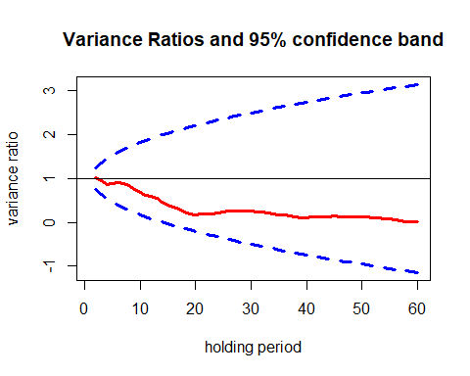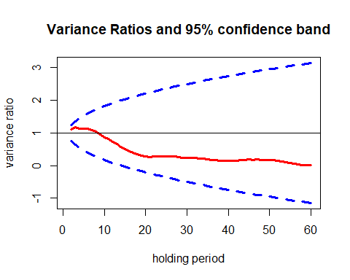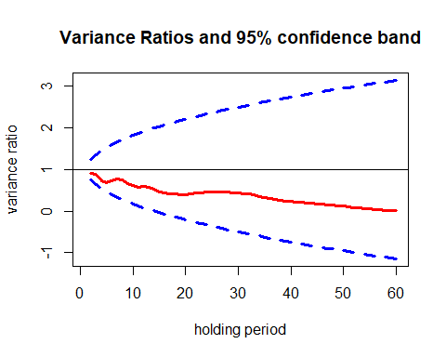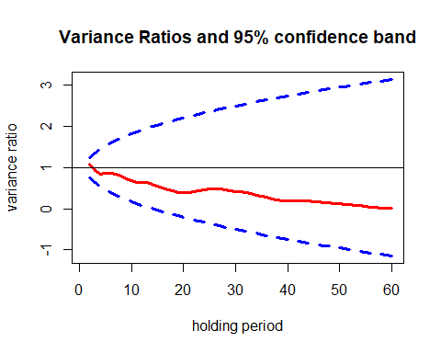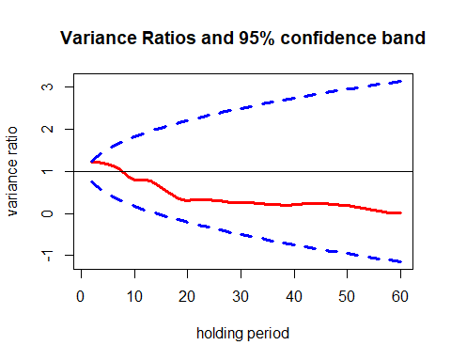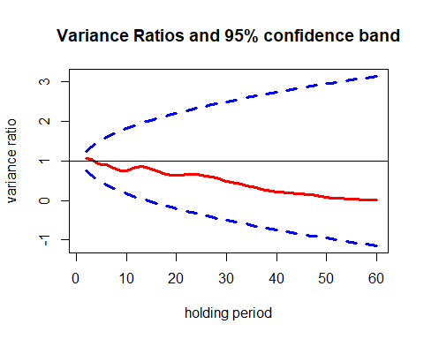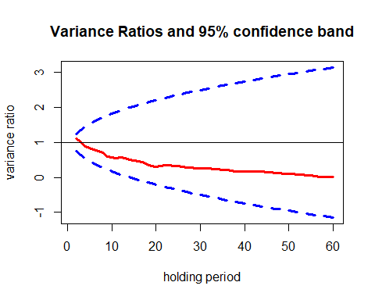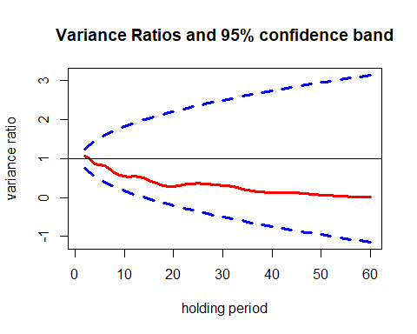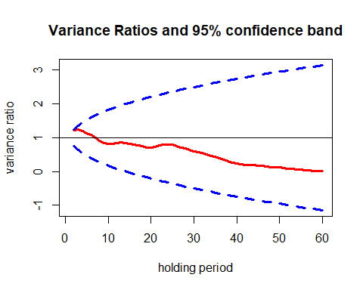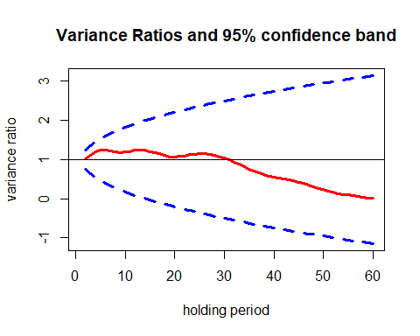

## $Date  
## $Date$VR  
## VR  
## k=2 1.91684155  
## k=3 2.76632295  
## k=4 3.54791623  
## k=5 4.26152230  
## k=6 4.90704587  
## k=7 5.48433106  
## k=8 5.99320693  
## k=9 6.43298710  
## k=10 6.80346968  
## k=11 7.10457609  
## k=12 7.33618339  
## k=13 7.49814561  
## k=14 7.58974174  
## k=15 7.61072084  
## k=16 7.56099289  
## k=17 7.44043683  
## k=18 7.24891190  
## k=19 6.98567300  
## k=20 6.65043576  
## k=21 6.35727310  
## k=22 6.09832930  
## k=23 5.86712189  
## k=24 5.65777507  
## k=25 5.46564335  
## k=26 5.28698681  
## k=27 5.11862244  
## k=28 4.95782599  
## k=29 4.80191291  
## k=30 4.64869280  
## k=31 4.49646069  
## k=32 4.34372579  
## k=33 4.18918005  
## k=34 4.03142745  
## k=35 3.86925776  
## k=36 3.70180939  
## k=37 3.52831366  
## k=38 3.34808338  
## k=39 3.16032743  
## k=40 2.96427760  
## k=41 2.75946580  
## k=42 2.54546738  
## k=43 2.32189654  
## k=44 2.08827806  
## k=45 1.84405860  
## k=46 1.58896895  
## k=47 1.32276085  
## k=48 1.09225283  
## k=49 0.89371756  
## k=50 0.72361702  
## k=51 0.57893736  
## k=52 0.45691414  
## k=53 0.35500902  
## k=54 0.27083307  
## k=55 0.20210973  
## k=56 0.14688874  
## k=57 0.10337203  
## k=58 0.06990070  
## k=59 0.04491027  
## k=60 0.02691877  
##   
##   
## $Decile1  
## $Decile1$VR  
## VR  
## k=2 1.012215194  
## k=3 0.954477375  
## k=4 0.872813036  
## k=5 0.876690736  
## k=6 0.904055893  
## k=7 0.896208336  
## k=8 0.835223839  
## k=9 0.745588978  
## k=10 0.676997939  
## k=11 0.625459378  
## k=12 0.600809348  
## k=13 0.540420482  
## k=14 0.458593175  
## k=15 0.388982694  
## k=16 0.345247228  
## k=17 0.304578266  
## k=18 0.247165204  
## k=19 0.195965173  
## k=20 0.174422880  
## k=21 0.189119217  
## k=22 0.197066637  
## k=23 0.202186258  
## k=24 0.216776864  
## k=25 0.239477687  
## k=26 0.259805445  
## k=27 0.260270850  
## k=28 0.259644513  
## k=29 0.250573428  
## k=30 0.249633948  
## k=31 0.245167142  
## k=32 0.234768001  
## k=33 0.212325703  
## k=34 0.190069474  
## k=35 0.170729835  
## k=36 0.159900950  
## k=37 0.139847668  
## k=38 0.118430980  
## k=39 0.108545856  
## k=40 0.109332979  
## k=41 0.117288475  
## k=42 0.121887238  
## k=43 0.128588906  
## k=44 0.135832783  
## k=45 0.137745605  
## k=46 0.135599955  
## k=47 0.133104077  
## k=48 0.131055344  
## k=49 0.127869253  
## k=50 0.124890171  
## k=51 0.116762074  
## k=52 0.106827363  
## k=53 0.094549817  
## k=54 0.081330964  
## k=55 0.070763690  
## k=56 0.055240306  
## k=57 0.039222722  
## k=58 0.024461347  
## k=59 0.016415748  
## k=60 0.009024156  
##   
##   
## $Decile2  
## $Decile2$VR  
## VR  
## k=2 1.112512427  
## k=3 1.174413574  
## k=4 1.135452323  
## k=5 1.136831168  
## k=6 1.133658046  
## k=7 1.093187902  
## k=8 1.039843951  
## k=9 0.949017278  
## k=10 0.869337750  
## k=11 0.807713037  
## k=12 0.739279797  
## k=13 0.658888604  
## k=14 0.576425816  
## k=15 0.498039677  
## k=16 0.438293574  
## k=17 0.393347226  
## k=18 0.344159296  
## k=19 0.293542922  
## k=20 0.271491270  
## k=21 0.270135140  
## k=22 0.274219303  
## k=23 0.279240667  
## k=24 0.287434787  
## k=25 0.292203173  
## k=26 0.286635257  
## k=27 0.270943650  
## k=28 0.257405623  
## k=29 0.243191964  
## k=30 0.242653122  
## k=31 0.244647389  
## k=32 0.238071383  
## k=33 0.225822937  
## k=34 0.211858214  
## k=35 0.193436974  
## k=36 0.178335926  
## k=37 0.160227835  
## k=38 0.146853216  
## k=39 0.141875726  
## k=40 0.147547161  
## k=41 0.153697078  
## k=42 0.158362827  
## k=43 0.167648113  
## k=44 0.175792918  
## k=45 0.182638484  
## k=46 0.181139466  
## k=47 0.181913583  
## k=48 0.179493256  
## k=49 0.178114851  
## k=50 0.173651126  
## k=51 0.163200479  
## k=52 0.145847328  
## k=53 0.128802223  
## k=54 0.107400434  
## k=55 0.084168759  
## k=56 0.059033974  
## k=57 0.038836973  
## k=58 0.021109403  
## k=59 0.013540885  
## k=60 0.008128685  
##   
##   
## $Decile3  
## $Decile3$VR  
## VR  
## k=2 0.905836513  
## k=3 0.877135848  
## k=4 0.727833569  
## k=5 0.681349930  
## k=6 0.719987222  
## k=7 0.768327524  
## k=8 0.750347149  
## k=9 0.668044731  
## k=10 0.613893088  
## k=11 0.575519556  
## k=12 0.602075730  
## k=13 0.569771110  
## k=14 0.526978851  
## k=15 0.465083728  
## k=16 0.437698993  
## k=17 0.423164318  
## k=18 0.414634111  
## k=19 0.391447308  
## k=20 0.393921829  
## k=21 0.412972509  
## k=22 0.431548366  
## k=23 0.447792367  
## k=24 0.451855095  
## k=25 0.462673557  
## k=26 0.462548867  
## k=27 0.464154331  
## k=28 0.461286509  
## k=29 0.447818241  
## k=30 0.437330823  
## k=31 0.425290259  
## k=32 0.409984383  
## k=33 0.383755517  
## k=34 0.359018866  
## k=35 0.332420442  
## k=36 0.314218860  
## k=37 0.288317508  
## k=38 0.263534446  
## k=39 0.243201495  
## k=40 0.230024430  
## k=41 0.217391820  
## k=42 0.205597412  
## k=43 0.190688271  
## k=44 0.182703978  
## k=45 0.175391355  
## k=46 0.165832043  
## k=47 0.157000791  
## k=48 0.142007407  
## k=49 0.129684329  
## k=50 0.117287227  
## k=51 0.104776906  
## k=52 0.088403868  
## k=53 0.075958678  
## k=54 0.062790881  
## k=55 0.054482240  
## k=56 0.039051108  
## k=57 0.026761603  
## k=58 0.014527021  
## k=59 0.009545503  
## k=60 0.006268936  
##   
##   
## $Decile4  
## $Decile4$VR  
## VR  
## k=2 1.08646301  
## k=3 0.92357851  
## k=4 0.85223403  
## k=5 0.86221693  
## k=6 0.85393054  
## k=7 0.83223339  
## k=8 0.80239935  
## k=9 0.73063361  
## k=10 0.68269542  
## k=11 0.64406117  
## k=12 0.64802770  
## k=13 0.63777962  
## k=14 0.60164087  
## k=15 0.54386152  
## k=16 0.50520872  
## k=17 0.47112894  
## k=18 0.43927908  
## k=19 0.40141480  
## k=20 0.38709978  
## k=21 0.40488312  
## k=22 0.41586415  
## k=23 0.43151963  
## k=24 0.45689782  
## k=25 0.47804611  
## k=26 0.48167331  
## k=27 0.47351077  
## k=28 0.45975816  
## k=29 0.43970845  
## k=30 0.42250583  
## k=31 0.40516738  
## k=32 0.39057989  
## k=33 0.36319879  
## k=34 0.32994268  
## k=35 0.29925546  
## k=36 0.27414996  
## k=37 0.24269681  
## k=38 0.21078835  
## k=39 0.19226462  
## k=40 0.18565109  
## k=41 0.18757687  
## k=42 0.18822471  
## k=43 0.18802661  
## k=44 0.18648509  
## k=45 0.17738774  
## k=46 0.16654944  
## k=47 0.15483993  
## k=48 0.14288298  
## k=49 0.13355570  
## k=50 0.12118091  
## k=51 0.10809541  
## k=52 0.09459631  
## k=53 0.08375636  
## k=54 0.07071161  
## k=55 0.05921604  
## k=56 0.04463045  
## k=57 0.02885305  
## k=58 0.01450383  
## k=59 0.01003960  
## k=60 0.00713581  
##   
##   
## $Decile5  
## $Decile5$VR  
## VR  
## k=2 1.22858497  
## k=3 1.22879298  
## k=4 1.19136980  
## k=5 1.17536290  
## k=6 1.13530016  
## k=7 1.06479274  
## k=8 0.96685188  
## k=9 0.85579676  
## k=10 0.79475267  
## k=11 0.79074144  
## k=12 0.79056605  
## k=13 0.76870012  
## k=14 0.69913686  
## k=15 0.60640503  
## k=16 0.52752746  
## k=17 0.45518440  
## k=18 0.38232910  
## k=19 0.32011207  
## k=20 0.30171546  
## k=21 0.31638398  
## k=22 0.32328157  
## k=23 0.32155943  
## k=24 0.32285323  
## k=25 0.31556653  
## k=26 0.29997564  
## k=27 0.27934650  
## k=28 0.26580022  
## k=29 0.25461164  
## k=30 0.25401131  
## k=31 0.25640621  
## k=32 0.25689296  
## k=33 0.24821658  
## k=34 0.23585813  
## k=35 0.22479232  
## k=36 0.21620870  
## k=37 0.20404208  
## k=38 0.19609884  
## k=39 0.19875737  
## k=40 0.21171487  
## k=41 0.22401164  
## k=42 0.23138448  
## k=43 0.23800619  
## k=44 0.24089115  
## k=45 0.23996048  
## k=46 0.23448734  
## k=47 0.22536780  
## k=48 0.21211061  
## k=49 0.19856027  
## k=50 0.18572425  
## k=51 0.16850593  
## k=52 0.14652786  
## k=53 0.12462514  
## k=54 0.10468087  
## k=55 0.08667755  
## k=56 0.06595791  
## k=57 0.04396855  
## k=58 0.02452729  
## k=59 0.01579299  
## k=60 0.01018936  
##   
##   
## $Decile6  
## $Decile6$VR  
## VR  
## k=2 1.069061801  
## k=3 1.040181584  
## k=4 0.961769534  
## k=5 0.907458790  
## k=6 0.897623154  
## k=7 0.851054127  
## k=8 0.789228024  
## k=9 0.741613895  
## k=10 0.740903372  
## k=11 0.790588335  
## k=12 0.838340482  
## k=13 0.864381786  
## k=14 0.842043682  
## k=15 0.793046349  
## k=16 0.749449099  
## k=17 0.697686203  
## k=18 0.666646415  
## k=19 0.633810987  
## k=20 0.631298488  
## k=21 0.647798191  
## k=22 0.658811847  
## k=23 0.661046083  
## k=24 0.664463420  
## k=25 0.647191536  
## k=26 0.626693860  
## k=27 0.594962262  
## k=28 0.564479076  
## k=29 0.526522783  
## k=30 0.494459801  
## k=31 0.468626509  
## k=32 0.446569805  
## k=33 0.414897451  
## k=34 0.382593348  
## k=35 0.349385881  
## k=36 0.320662887  
## k=37 0.285690366  
## k=38 0.252162038  
## k=39 0.229321992  
## k=40 0.214887571  
## k=41 0.205161392  
## k=42 0.193861778  
## k=43 0.185414651  
## k=44 0.176681705  
## k=45 0.166105850  
## k=46 0.156450635  
## k=47 0.142039986  
## k=48 0.121309260  
## k=49 0.103100704  
## k=50 0.083541688  
## k=51 0.068941098  
## k=52 0.056096845  
## k=53 0.047356211  
## k=54 0.039558461  
## k=55 0.034622820  
## k=56 0.025421372  
## k=57 0.015964970  
## k=58 0.005658876  
## k=59 0.002453025  
## k=60 0.002756671  
##   
##   
## $Decile7  
## $Decile7$VR  
## VR  
## k=2 1.119226593  
## k=3 1.009413537  
## k=4 0.896646534  
## k=5 0.832627557  
## k=6 0.804447013  
## k=7 0.754614281  
## k=8 0.696008565  
## k=9 0.599843794  
## k=10 0.563951632  
## k=11 0.558309767  
## k=12 0.574684845  
## k=13 0.550107341  
## k=14 0.513950153  
## k=15 0.482062230  
## k=16 0.461557820  
## k=17 0.429944063  
## k=18 0.377980848  
## k=19 0.320786669  
## k=20 0.304437399  
## k=21 0.324786592  
## k=22 0.338751651  
## k=23 0.345544967  
## k=24 0.334192811  
## k=25 0.319133396  
## k=26 0.301799561  
## k=27 0.290121134  
## k=28 0.278060859  
## k=29 0.264141861  
## k=30 0.264258187  
## k=31 0.267882633  
## k=32 0.259587149  
## k=33 0.243850791  
## k=34 0.230691699  
## k=35 0.217413677  
## k=36 0.208876372  
## k=37 0.194845444  
## k=38 0.177098753  
## k=39 0.168844924  
## k=40 0.168176080  
## k=41 0.168580428  
## k=42 0.166441976  
## k=43 0.162218503  
## k=44 0.160151149  
## k=45 0.153122062  
## k=46 0.143689665  
## k=47 0.131116450  
## k=48 0.117359532  
## k=49 0.109222548  
## k=50 0.104717302  
## k=51 0.096815164  
## k=52 0.083750533  
## k=53 0.071726839  
## k=54 0.059197015  
## k=55 0.050104427  
## k=56 0.035600539  
## k=57 0.021623282  
## k=58 0.009781336  
## k=59 0.006179919  
## k=60 0.003785441  
##   
##   
## $Decile8  
## $Decile8$VR  
## VR  
## k=2 1.072967215  
## k=3 0.991579250  
## k=4 0.869944477  
## k=5 0.850591317  
## k=6 0.808376009  
## k=7 0.732632921  
## k=8 0.639498011  
## k=9 0.568270432  
## k=10 0.540155314  
## k=11 0.528806123  
## k=12 0.542120345  
## k=13 0.535151337  
## k=14 0.497896653  
## k=15 0.445548794  
## k=16 0.400577319  
## k=17 0.359623448  
## k=18 0.314644701  
## k=19 0.280897408  
## k=20 0.287035145  
## k=21 0.310317131  
## k=22 0.334833607  
## k=23 0.347003993  
## k=24 0.354988697  
## k=25 0.362112386  
## k=26 0.352935811  
## k=27 0.340602763  
## k=28 0.331136779  
## k=29 0.318893166  
## k=30 0.313402725  
## k=31 0.303720746  
## k=32 0.289534632  
## k=33 0.254206322  
## k=34 0.219231443  
## k=35 0.195340591  
## k=36 0.178133661  
## k=37 0.155069294  
## k=38 0.137091530  
## k=39 0.127906010  
## k=40 0.129943998  
## k=41 0.130111188  
## k=42 0.128593416  
## k=43 0.126229714  
## k=44 0.124875803  
## k=45 0.119735170  
## k=46 0.109714095  
## k=47 0.099105060  
## k=48 0.087048821  
## k=49 0.076585853  
## k=50 0.066211694  
## k=51 0.056930920  
## k=52 0.048348371  
## k=53 0.039965498  
## k=54 0.032470733  
## k=55 0.028003938  
## k=56 0.020667716  
## k=57 0.013523389  
## k=58 0.006275330  
## k=59 0.004820270  
## k=60 0.003765786  
##   
##   
## $Decile9  
## $Decile9$VR  
## VR  
## k=2 1.228347127  
## k=3 1.254237365  
## k=4 1.194910531  
## k=5 1.140672435  
## k=6 1.078964177  
## k=7 0.987548129  
## k=8 0.903611595  
## k=9 0.835151279  
## k=10 0.814430343  
## k=11 0.813265284  
## k=12 0.844168359  
## k=13 0.854525239  
## k=14 0.844010532  
## k=15 0.822690104  
## k=16 0.801716927  
## k=17 0.778906381  
## k=18 0.750452514  
## k=19 0.717254401  
## k=20 0.716530849  
## k=21 0.736613212  
## k=22 0.766661933  
## k=23 0.788225223  
## k=24 0.796938150  
## k=25 0.788790412  
## k=26 0.755071786  
## k=27 0.717837532  
## k=28 0.677295437  
## k=29 0.638213072  
## k=30 0.603626108  
## k=31 0.578520453  
## k=32 0.545729004  
## k=33 0.505425391  
## k=34 0.467037737  
## k=35 0.428590810  
## k=36 0.392979119  
## k=37 0.342336706  
## k=38 0.297869005  
## k=39 0.262114451  
## k=40 0.235681580  
## k=41 0.211344383  
## k=42 0.196743295  
## k=43 0.188520013  
## k=44 0.183732419  
## k=45 0.175883410  
## k=46 0.162753066  
## k=47 0.149455384  
## k=48 0.135926478  
## k=49 0.126288380  
## k=50 0.117452901  
## k=51 0.104173130  
## k=52 0.089376796  
## k=53 0.078614452  
## k=54 0.066149621  
## k=55 0.056716932  
## k=56 0.040946131  
## k=57 0.026606351  
## k=58 0.014534359  
## k=59 0.009229081  
## k=60 0.004827402  
##   
##   
## $Decile10  
## $Decile10$VR  
## VR  
## k=2 1.01334071  
## k=3 1.10391837  
## k=4 1.20363429  
## k=5 1.23658348  
## k=6 1.24385653  
## k=7 1.22455600  
## k=8 1.20108811  
## k=9 1.18059460  
## k=10 1.19176990  
## k=11 1.19997788  
## k=12 1.24308507  
## k=13 1.24766025  
## k=14 1.23661617  
## k=15 1.20388086  
## k=16 1.17451584  
## k=17 1.14728589  
## k=18 1.10492914  
## k=19 1.06365443  
## k=20 1.06580233  
## k=21 1.07668718  
## k=22 1.09614846  
## k=23 1.12161283  
## k=24 1.13793092  
## k=25 1.15685444  
## k=26 1.15443479  
## k=27 1.13938134  
## k=28 1.11860387  
## k=29 1.07237204  
## k=30 1.03217734  
## k=31 0.98826633  
## k=32 0.94094767  
## k=33 0.87838652  
## k=34 0.81473855  
## k=35 0.75931095  
## k=36 0.70981102  
## k=37 0.65936191  
## k=38 0.60951304  
## k=39 0.57597538  
## k=40 0.54740109  
## k=41 0.52307765  
## k=42 0.49969428  
## k=43 0.47585366  
## k=44 0.45470486  
## k=45 0.42392106  
## k=46 0.39020589  
## k=47 0.35440328  
## k=48 0.30922423  
## k=49 0.26653223  
## k=50 0.23137455  
## k=51 0.19776392  
## k=52 0.16439007  
## k=53 0.13659457  
## k=54 0.11102082  
## k=55 0.09228934  
## k=56 0.06968279  
## k=57 0.04961664  
## k=58 0.03117028  
## k=59 0.01920630  
## k=60 0.01017303