Learning Inequality through GCLN

The default setting of the model is to learn only the equality. For this they used gaussian activation function, which is activation function for learning equality.

Now, two ways can be used to make the model learn inequality:

First method: Because the model has only the definition for “=”, next possible option is to manually type definition for other 4 parameters too, i.e., <, <=, >, >= and try whether the invariant works with these parameters or not.

Example, if invariant 4x+y = 0 is not adequate, next i can try is 4x + y < 0 is adequate or not.

I tried this apprach but the above approach is not scaleable. Also, in this case the activation function used is gaussian, so the coefficients learned in this case will not be tight and may not result in correct invariant.

Second method: Next what can be thought as is this method. As claimed in the paper, piecewise biased quadratic unit(PBQU) activation function can be used to learn tight inequality bounds. It’s defination is as follows:

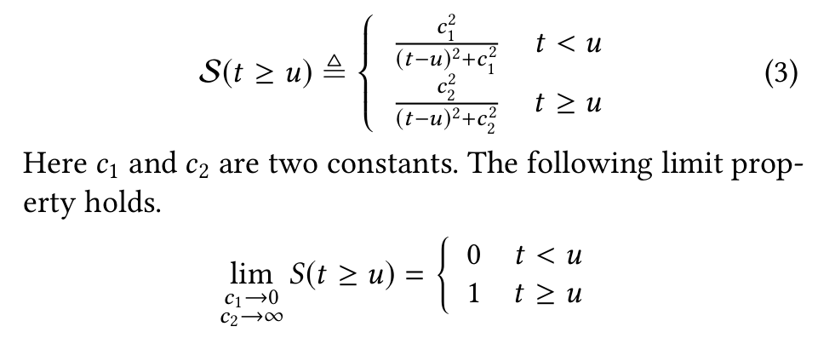
The default values for the variables which can be used are following:

c₁ = 0.5 and c₂ = 5,

Changing the activation function to PBQU. Above image cleary shows the mapping for “>=” and for “<”. For the “=” , we can still use gaussian activation function.

Accuracy

I checked the accuracy of the model, when gaussian function was used and almost all the examples give accuracy greater than 99%, except for a few but still greater than 95%.

I am trying to implement the PBQU function using the above definition and check whether the accuracy of the model is still same and high, as was with gaussian activation function.

