**ORGANISATION PROFILE**

Real Infotech was established with the aim to provide “Quality IT Training”. The tremendous progress made by the institute and the reputation it commands today is an ample testimony of its commitment to quality.

Over the years, Real Infotech has gained deep insight and expensive experience in the field of information technology. Constantly broadening and upgrading its technology base and areas of expertise, Real Infotech has vision which sees itself in the league with the best of world class IT solution providers.

During the last few years, Real Infotech has established itself as well known entity in the field of IT education. Real Infotech keeps on applying research methodology and innovative techniques to utilize the technology for training and development, which makes it a favorites training organization for Engineering graduates, MCAs and IT professionals.

Real Infotech has rich training programmes for upcoming IT professionals, which not only enables them to fulfill their academic needs, but make them technically sound for IT industry.



**Training at Real Infotech**

Real Infotech provides the most comprehensive Hi-End technology courses for IT Professionals and aspiring IT students. The objective of training programmes is to bridge the gap between the practical knowledge level of IT Professionals and the current requirements of the IT industry. Keeping this in mind, Real Infotech has chalked out some extensive training programmes, which makes students technically sound for the booming IT industry. Training programmes help students to develop analytical and problem solving capability, logical skills and practical experience in line with the latest industry standards. Its carefully designed training programmes ensure that each student should get informed of the latest infra-structure in the IT industry. Real Infotech caters to the ever growing needs of the global technically advances in the IT Sphere.

**INTRODUCTION**

**Introduction to the Project**

To Create a Web product that facilitates the administrator in managing products for various categories over the server. This part of web application deals with the Customer and provide him the facility to buy and pay for products online. The system should also provide flexibility to configure its components without much extra effort and the system should have clearly defined interfaces. The system must reflect the structure of the application it is going to server with well-defined structure processes. In addition, the system must be able to cope with well-defined structure processes.

The success of the system depends largely on how accurately a problem is defined, thoroughly investigated and properly carried out through the choice of solution. So one must know what the problem is before it can be solved. The basis for candidate system is recognition of a need for improving an information system or a procedure. This need leads to a preliminary survey or initial investigation to determine whether an alternative system can solve the problem or not.

The system should satisfy the standards and requirements of good software. A few of them are:

* **User Friendly:** The website must be user friendly in the sense that any novice can understand and work on it easily.
* **Time Element:** The system must respond in minimum time i.e. its execution time must be as little as possible.
* **Integrity:** The outputs given by the system should be accurate and reliable.
* **Modularity:** The website should be modular so that if a need for any change arises in the future then it should not require too much of an effort and change in one module should not affect the other modules. (Although there were no such major modules in SCM)
* **Generality :** The application should be a general one so that even the person who has not developed this application should be able to make the requires modifications
* **Transparency:** The applications should be transparent in nature so that the person who has to modify it should be able to understand it. For this proper documentation can b very helpful. In addition, program abstracts.

**OBJECTIVES**

E-commerce is quite simply, any method of using electronic communications and computer technology to conduct business. It ranges from small businesses receiving orders via their web site through to automated systems to control the supply chain from the initial customer contact right through to management of suppliers.

E-commerce is about buying and selling products and services on the World Wide Web. The sellers are individuals, small businesses or large corporations. The buyers are consumers or businesses. Payment can be made by credit or debit card, money order, cash, check, services or trade. The range of things that can be sold using E-Commerce is enormous and covers things that are sold today and those that are not practical to sell any other way.

**SYSTEM DEVELOPMENT LIFE CYCLE**

**THE SYSTEM CONCEPT**

**T**he term ‘system’ is derived from the Greek work ‘Systema’, which means an organized relationship among functioning units or the components. A system exists because it is designed to achieve one or more objectives

A system is an orderly grouping of interdependent component linked together according to a plan to achieve a specific objective. The word component may refer to a physical part, managerial steps, or a subsystem in a multilevel structure. Scholars in various disciplines, who are concerned about the tendency towards the fragmentation of knowledge and the increasing complexity of phenomena, have sought a unifying approach to knowledge. System Analysis and Design for the information systems were founded in the general systems theory, which emphasizes a close look at all the parts of the systems.

System Analysis user here is the application of the system approach to the study and solution of problems using Computer based systems. System thinking is integral to the system interrelated interlocking subsystems. The system approach is a way of thinking about the analysis and design of computer based application. It provides a framework of visualizing the system. System analysis and Design focus on system, process and technology.

The SDLC is how all systems are created. It is a very powerful technique user for creation of applications to solve problems using computer systems. Wit you get closest view of the system which then helps to create it because you are familiar with all sorts of components of the system. It provides a perfect outline for the system using which the system is created successfully.

**What is SDLC?**

SDLC is an acronym for System Development Life Cycle, a methodology that consists of development activities that have a prescribed order. Once a problem or opportunity for a new system is recognized a request for developing a new system is forwarded for approval. If it is approved, a study is carried out to ensure that the proposed system is feasible. If it is feasible, then the system’s requirements are specified and are followed by phases of system analysis, system design, system implementation, and post implementation. A recycling of development may occur again following system evaluation if the system still requires modification or redevelopment.

To understand SYSTEM DEVELOPMENT we need to recognize that candidate system that has a life cycle. System analysis and design are keyed to the system life cycle. For better working the task of designing a system is divided into a series of phases

**The stages of system development life cycle are:**

###### NEEDS ANALYSIS

###### FEASIBILITYSTUDY

###### SYSTEM ANLYSIS

###### SYSTEM DESIGN

###### IMPLEMENTATION

###### POST IMPLEMENTATION

SYSTEM MAINTENANCE

**PROBLEM DEFINITION**

**Recognition of the need – What the Problem is?**

One must know what the problem is before it can be solved. The basis of the system is the recognition of a need for improving an information system or a procedure. This needs leads to a primary survey or an initial investigation to determine whether an alternate system can solve the problem.

**System Study:**

**Existing System**

* Due to infrastructure facilities and human resources. It not just requires a lot of money but also requires continuous supervision. Any commercial space would cost a lot along with the salaries of the staff involved.
* There was no major source of attraction for the customers. In today’s world, marketing your things is a very important aspect of a shop which lacks the present system.

In today’s world of the web technology almost everything is made available to the user his footsteps, the customers don’t prefer to go especially to the shop to buy something is a major drawback of the present system. Hence the Present system needs to be converted into an online system through which customer can purchase various items sitting at their place. This is an advantage for the shopkeeper as it acts as a major marketing skill for him.

The present system was not automated. In the area of information technology it was the need of an hour to have an automated system capable of handling the entire database present in the shop which gives both customer and the user a complete idea of things available in the shop. The introduction of the automated system was very important which could be justified by the following limitation of the manual system.

**PROBLEM ANALYSIS**

**EXISTING SYSTEM**

The present system was the different product shop where customer shops various kind of products. The customer had to take the overview of the whole shop to find the product. There was no way of telling the customer whether the product was available or not or had to get through the files for the record. Whole work was manually done by the customer or the owner. Earlier the source of information about the latest products was available in newspaper and magazines only but now user can access the information easily through various online shopping sites.

In today’s world of the web technology almost everything is made available to the user his footsteps, the customers don’t prefer to go especially to the shop to buy something is a major drawback of the present system. Hence the Present system needs to be converted into an online system through which customer can purchase various items sitting at their place. This is an advantage for the shopkeeper as it acts as a major marketing skill for him.

The present system was not automated. In the area of information technology it was the need of an hour to have an automated system capable of handling the entire database present in the shop which gives both customer and the user a complete idea of things available in the shop. The introduction of the automated system was very important which could be justified by the following limitation of the manual system.

**DRAWBACKS**

* Time consuming process.
* Less Reliability and Maintainability of the data Cost Involvement
* Physical Company Set-ups
* Difficulty to start and manage a business
* Customer feels difficult to find a particular product
* Customers can easily select products from different providers without moving around physically.
* High operational costs and low quality of services.

**PROPOSED SYSTEM**

The proposed system is entirely a computer based using internet. A system is prepared to overcome the weakness and drawbacks of the existing system by the proposed system. The proposed system would be effective enough and feasible to the organizations using it. It would be user friendly and easy in maintenance and further enhancements could be easy without using much complication.

In the proposed system we have a central web server serving to all the requests made by the clients. All the centres are accessing the central system with their web browsers. The system gave the solution to all the problems encountered in the present system. Customers can shop various products sitting back at their places. Since it was completely automated system where complete database was maintained by the owner of the shop. The database present was very easily maintained using the search option in user interface, customer can also very conveniently search for their choice.

The system has other modules like user manage their profile, view products according to different categories, generate order check order which acts as a very good feature for further promoting the sales. Further the system proposed acted as very centralized system. Here any customer sitting in any part of the country could access this website.

**Advantages**

* Saves Time, Fuel and Energy.
* Easy Comparison of Prices.
* The 24/7 availability of online stores give you the freedom to shop at your own pace and convenience.
* No long lines you have to endure, just to buy your merchandise.
* Easy to Search Merchandise You want to buy.
* No need of physical company set-ups.
* Easy to start and manage a business.
* Faster buying/selling procedure, as well as easy to find products.
* More reach to customers, there is no theoretical geographic limitations.
* Low operational costs and better quality of services.

**REQUIREMENT ANALYSIS**

**Functional Requirements:**

* Merchants have valid username and password to login, thus creating their individual profiles to can add products.
* Customers/Users must have valid User ID and password to login thus creating their individual profiles.
* Customers can add selected products in the cart and place orders.
* Multiples orders from different customers are processed at same time.
* Asynchronous communication in the form of Emails.
* For each order Valid Tracking Numbers are provided to the customers.
* Just with one click of mouse, customer can get the previous his Order Details.
* Administrator can generate reports, log files, backup/recovery of data at any time.
* Depending on the user’s requirement, user can make the payment with three options.
* Cash on Delivery, It’s the most common mode of payment. Here the payment is made by the user after receiving the package.
* Credit Card, The second most convenient and commonly used mode of payment is with credit cards. The user enters the details of his card to make payment.
* Cheque, Here the payment is being made by the user through bank cheques. The cheque number is being added by the user to the required text field.

**Non Functional Requirements:**

* Secure access of confidential data (user’s details).
* 24 X 7 availability
* Better component design to get better performance at peak time
* Flexible service based architecture will be highly desirable for future extension

**Hardware Requirements:**

|  |  |
| --- | --- |
| **Server Side Hardware Requirements** | |
| RAM(random access memory) | 2 GB |
| Hard disk | 20 GB |
| Monitor | SVGA(video graphic adaptor) |
| Processor | 1.5 GHz or Higher Pentium-compatible CPU |

|  |  |
| --- | --- |
| **Client Side Hardware Requirements** | |
| RAM(random access memory) | 1 GB or more |
| Hard disk | 10GB |
| Monitor | SGA(video graphic adapter) |
| Processor | 800 MHz or Higher Pentium compatible CPU |

**Software Requirements:**

|  |  |
| --- | --- |
| **Server Side Software Requirements** | |
| Server | Apache Tomcat 5+ Server |
| Operating System | Windows XP or above , Linux, Mac |
| RDMS | Oracle 10g |

|  |  |
| --- | --- |
| **Client Side Software Requirements** | |
| Operating System | Windows XP or above , Linux, Mac |
| Internet Browser | Internet Explorer, Firefox, Chrome,etc |

**TECHNOLOGIES USED**

**FRONT END**

**Java**

Java was conceived by James Gosling, Patrick Naughton, Chris Warth, Ed Frank and Mike Sheridan at Sun Microsystems Inc.in 1991. It took 18 months to develop the first working version. This language was initially called “Oak” but was renamed as “Java” in 1995. Between the initial implementation of Oak in the fall of 1992 and the public announcement of Java in the spring of 1995, many more people contributed to the design and evolution of the language.

The main properties of the Java, which made Java so popular, are as follows:

1. Simple
2. Secure
3. Portable
4. Object-Oriented
5. Robust
6. Multithreaded
7. Architecture-Neutral
8. Interpreted
9. High performance
10. Distributed
11. Dynamic

**Byte Code (Key feature of Java)**

The key that allows Java to solve both the security and the portability problems just described is that the output of a Java compiler is not executable code. Rather, it is Byte code. Byte code is a highly optimized set of instructions designed to be executed by the Java runtime systems, which is called the Java Virtual Machine (JVM). That is, in its standard form, the JVM is an interpreter for Byte code. This may come has a bit of surprise.

Translating a Java program into a byte code helps and makes it much easier to run a program in a wide variety of environments. The reason is straightforward only the JVM needs to be implemented for each platform. Once the runtime package exists for a given system, any Java program can run on it. Remember, although the details of the JVM will differ from platform to platform, all interpret the same Java Byte code.

**JAVA ENVIRONMENT:**

Java environment includes a large number of development tools and hundreds of classes and methods. The development tools are the part of the system known as Java Development Kit (JDK) and the classes are methods are part of the Java standard library (JSL), also known as the Application Programming Interface (API).

**JAVA DEVELOPMENT KIT:**

The Java development kit comes with a collection of tools that are used for developing and running Java programs. They include:

1. Applet Viewer (for viewing Java Applets)

2. Javac (Java Compiler)

3. Java (Java interpreter)

4. Javap (Java Disassembler)

5. Javah (for C header files)

6. Javadoc (for creating HTML documents)

7. Jdb (Java Debugger)

**HTML (Hypertext Markup Language)**

**H**-T-M-L are initials that stand for **H**yper **T**ext **M**arkup **L**anguage. Let me break it down for you:

**Hyper** is the opposite of linear. It used to be that computer programs had to move in a linear fashion. This before this, this before this, and so on. HTML does not hold to that pattern and allows the person viewing the World Wide Web page to go anywhere, anytime they want.

**Text** is what you will use. Real, honest to goodness English letters.

**Mark up** is what you will do. You will write in plain English and then mark up what you wrote. More to come on that in the next Primer.

**Language** because they needed something that started with "L" to finish HTML and Hypertext Markup *Louie* didn't flow correctly. Because it's a language, really -- but the language is plain English.

**Features**

### Lingua Franca for the Web

### Simplicity

### Platform Independence

### Support for Cascaded Style Sheets

### Support for different ways of creating HTML

**HTML Tags**

HTML markup tags are usually called HTML tags

* HTML tags are keywords (tag names) surrounded by **angle brackets**like <html>
* HTML tags normally **come in pairs** like <b> and </b>
* The first tag in a pair is the **start tag,** the second tag is the **end tag**
* The end tag is written like the start tag, with a **forward slash** before the tag name
* Start and end tags are also called **opening tags** and **closing tags.**

**CSS (Cascading Style Sheet)**

* CSS stands for Cascading Style Sheets
* Styles define how to display HTML elements
* Styles were added to HTML 4.0 to solve a problem
* External Style Sheets can save a lot of work
* External Style Sheets are stored in CSS files
* Pages download faster, sometimes by as much as 50%
* You have to type less code, and your pages are shorter and neater.
* The look of your site is kept consistent throughout all the pages that work off the same stylesheet.
* Updating your design and general site maintenance are made much easier, and errors caused by editing multiple HTML pages occur far less often.

**Javascript**

JavaScript is most commonly used as a client side scripting language. This means that JavaScript code is written into an HTML page. When a user requests an HTML page with JavaScript in it, the script is sent to the browser and it's up to the browser to do something with it.

* It is a programming language.
* It is an interpreted language.
* It is object-based programming.
* It is widely used and supported
* It is accessible to the beginner.
* JavaScript code is case sensitive
* White space between words and tabs are ignored
* Line breaks are ignored except within a statement
* JavaScript statements end with a semi- colon ;

**JSP(Java Servlet Pages)**

Java Server Pages technology allows Web developers and designers to rapidly develop and easily maintain, information-rich, dynamic Web pages that leverage existing business systems. As part of the Java family, JSP technology enables rapid development of Web-based applications that are platform independent. Java Server Pages technology separates the user interface from content generation enabling designers to change the overall page layout without altering the underlying dynamic content.

Jsp stands for “Java server page”. JSP are built by SUN Microsystem. JSP enable the developers to directly insert java code into jsp file, this makes the development process very simple and its maintenance also becomes very easy. JSP simply place JAVA inside the HTML pages means it’s an embedded of html tag and jsp’s own tag.

The extension of jsp page is ".jsp"

Java is known for its characteristic of "write once, run anywhere." and JSP page is a combination of java code into html file so we can say that the JSP pages are platform independent means .jsp pages can run in any platform.

The key features of jsp are:

* **Portability**-The Java feature of ‘write once, run anywhere’ is applicable to JSP. JSP is platform independent, making it portable across any platform and therefore, mulit-platform. It is possible for the programmer to take a JSP file and move it to another platform, JSP Servlet engine or web server.
* **Efficiency:-**As soon as the request is received, the JSP pages gets loaded into the web servers’ memory. The following transactions are then carried out within a minimal time period, handling JSP pages with efficiency.
* **Reusability:-**JSP allow component reuse by using JavaBeans and EJBs.
* **Robust:-**JSP offers a robust platform for web development

**Servlets**

A Servlet is a Java class that is used to handle server side service. Though it is possible to write HTML code in servlet, it would require a great deal of statements for a programmer to achieve the same results as JSP. JSP handles HTML easily and converts to Servlets, enabling the functionality and features of servlet in addition to its own special features. Technically speaking, the source code of JSP runs in the JSP Servlet Engine on the web server. This JSP Servlet engine generates the HTML dynamically, displaying the output directly to the web browser of the client. Servlets are Java applications running on the server side, just like CGI and server side scripting languages such as ASP or PHP. Servlets can therefore manage HTTPrequests.   
  
Servlets have several advantages over other server-side technologies. Since they are build in Java, servlets provide a means of improving web servers on any platform, especially servlets that are independent of the web server (unlike Apache modules or Netscape Server API). Indeed, servlets run in a servlet engine, establishing the link between the servlet and the web server. The programmer does not have to worry about technical details such as the network connection*.*

* Read any data sent by the user.
* Look up any other information about the request that is embedded in the HTTP request.
* Generate the results.
* Format the results inside a document.
* Set the appropriate HTTP response parameters.
* Send the document back to the client.

**Features**

* Portable
* Secure
* Inexpensive
* Efficient
* Convenient
* Powerfu

**BACK END - ORACLE 10g**



The Oracle Database (commonly referred to as Oracle RDBMS or simply as Oracle) is an object-relational database management system produced and marketed by Oracle Corporation. Larry Ellison and his friends, former co-workers Bob Miner and Ed Oates, started the consultancy Software Development Laboratories (SDL) in 1977. SDL developed the original version of the Oracle software.

* An Oracle database system—identified by an alphanumeric system identifier or SID—comprises at least one instance of the application, along with data storage. An instance—identified persistently by an instantiation number—comprises a set of operating-system processes and memory -structures that interact with the storage Oracle documentation can refer to an active database instance as a "shared memory realm".
* If the Oracle database administrator has implemented Oracle RAC (Real Application Clusters), then multiple instances, usually on different servers, attach to a central storage array. This scenario offers advantages such as better performance, scalability and redundancy. However, support becomes more complex, and many sites do not use RAC. In version 10*g*, grid computing introduced shared resources where an instance can use (for example) CPU resources from another node (computer) in the grid.
* The Oracle DBMS can store and execute stored procedures and functions within it. PL/ SQL (Oracle Corporation's proprietary procedural extension to SQL), or the object-oriented language Java can invoke such code objects and/or provide the programming structures for writing them.

**JAVA DATABASE CONNECTIVITY (JDBC)**

The Java database connectivity Application Programming Interface (API) is an API currently being designed by Sun Microsystems that provides a Java language interface with SQL Call Level Interface standard. This standard provides a DBMS independent interface to relational databases that defines a generic SQL database access framework.

The most visible implementation of the SQL CLI is Microsoft’s ODBC (Open Database Connectivity). This API defines a common SQL syntax and function calls that can be used by developers to send SQL commands to and retrieve data from SQL databases. ODBC - enabled applications make use of database drivers (similar to other device drivers) installed on the system that allows applications to talk to a vendor’s database. Using this methodology, all of the DBMS specific code is placed inside the ODBC driver and the application developer is shielded from implementation specific problems in theory. Practically speaking, it is sometimes difficult to completely remove vendor’s specific syntax from all ODBC operations, but in most cases, it is relatively simple task to port ODBC to run on a new database server.

ODBC’s primary drawback is that it is written in C. Because of the limitations inherent in the use of native methods, the JDBC designers have designed the JDBC specification to most easily use ODBC in short-term, but they have provided the capability long-term for JDBC to be implemented in other ways.

The JDBC API is expressed as a series of abstract Java interfaces within the java.sql package. Here are the most commonly used interfaces:

* **java.sql.DriverManager**– manages the loading and unloading of database drivers from the underlying systems.
* **java.sql.Connection** – Handles the connections to a specific database.
* **java.sql.Statement** – contains an SQL statement to be passed to the database: two sub-types in this interface are the PreparedStatement (for executing a Pre-Compiled SQL statement) and the CallableStatement (for executing a database stored procedure).
* **java.sql.ResultSet** – contains the record result set from the SQL statement passed to the database.

**STEPS REQUIRED TO ACCESS A JDBC DATABASE**

The steps required to access a JDBC database should be familiar. JDBC uses the concept of a “Connection” handle to manage a program’s connection to a database.

**ESTABLISING A CONNECTION**

The first thing we need to do is establish a connection with the DBMS you want to use. This involves three steps:

1.**Create connection string**: It stores information about database. Connection string format is specific to database type.

*String str = "jdbc:oracle:thin:@localhost:1521:”;*

2.**Initialize database drivers**: Our driver documentation will give us the class name to use. It has following line of code:

*Class.forName("oracle.jdbc.OracleDriver");*

3.**Establish connection:** The final step in establishing a connection with help of connection string. It has following line of code.

*Connection c = DriverManager.getConnection(str, "admin", "admin");*

**TOOLS USED**

**DREAMWEAVER 8**

Macromedia dream weaver 8 is professional HTML editor for designing, coding and developing websites, web pages and web applications. Whether you enjoy the control of hand-coding HTML or prefer to work in a visual editing environment, Dream weaver provides us with helpful tools to enhance your web creation experience.

The visual editing features in Dream weaver quickly create pages without writing a line of code. You can view all your site elements or assets and drag them from an easy-to-use panel directly into a document. You can streamline your development workflow by creating and editing images in Macromedia Fireworks or another graphics application, then importing them directly into Dream weaver, or by adding Macromedia Flash objects.

Dream weaver also provides a full-featured coding environment that includes code-editing tools (such as code coloring and tag completion) and language reference material on CSS, JavaScript, and Cold Fusion Markup Language (CFML), among others. Macromedia Roundtrip HTML technology imports your hand-coded HTML documents without reformatting the code with your preferred formatting style.

Dream weaver also enables you to build dynamic database-backed web applications using server technologies such as CFML, ASP.NET, JSP, and PHP.

Dream weaver is fully customizable. You can create your own objects and commands, modify keyboard shortcuts, and even write JavaScript code to extend Dream weaver capabilities with new behaviors, Property inspectors, and site reports.

**NET BEANS**

## Best Support for Latest Java Technologies

NetBeans IDE is the official IDE for Java 8. With its editors, code analyzers, and converters, you can quickly and smoothly upgrade your applications to use new Java 8 language constructs, such as lambdas, functional operations, and method references.Batchanalyzers and converters are provided to search through multiple applications at the same time, matching patterns for conversion to new Java 8 language constructs.

## Fast & Smart Code Editing

An IDE is much more than a text editor. The NetBeans Editor indents lines, matches words and brackets, and highlights source code syntactically and semantically. It lets you easily refactor code, with a range of handy and powerful tools, while it also provides code templates.

## Easy & Efficient Project Management

Keeping a clear overview of large applications, with thousands of folders and files, and millions of lines of code, is a daunting task. NetBeans IDE provides different views of your data, from multiple project windows to helpful tools for setting up your applications and managing them efficiently.

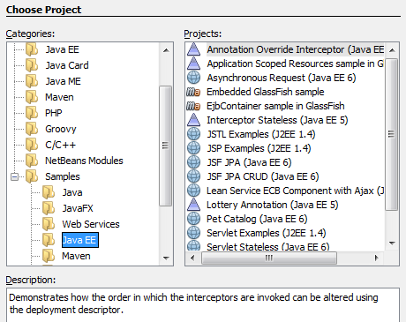

**SERVER**

**APACHE TOMCAT**

**Apache Tomcat**, often referred to as **Tomcat**, is an open-source web server developed by the Apache Software Foundation (ASF). Tomcat implements several Java EE specifications including Java Servlet, Java Server Pages (JSP), Java EL, and Web Socket, and provides a "pure Java" HTTP web server environment in which Java code can run.

Tomcat is developed and maintained by an open community of developers under the auspices of the Apache Software Foundation, released under the Apache License 2.0 license, and is open-source software.

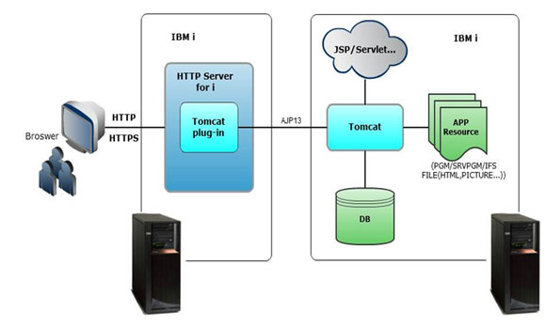

**FEASIBILITY STUDY**

Once the problem is clearly understood, the next step is to conduct feasibility study, which is high-level capsule version of the entered systems and design process. The objective is to determine whether or not the proposed system is feasible. The three tests of feasibility have been carried out.

* Technical Feasibility
* Economical Feasibility
* Operational Feasibility
* **TECHNICAL FEASIBILITY**

The technical feasibility assessment is focused on gaining an understanding of the present technical resources of the organization and their applicability to the expected needs of the proposed system. It is an evaluation of the hardware and software and how it meets the need of the proposed system

This assessment is based on an outline design of system requirements, to determine whether the company has the technical expertise to handle completion of the project.

In Technical Feasibility study, one has to test whether the proposed system can be developed using existing technology or not. E-Commerce is planned to implement the proposed system using Java technology and Web Server.

It is evident that the necessary hardware and software are available for development and implementation of the proposed system. Hence, the solution is technically feasible.

* **ECONOMICAL FEASIBILITY**

The purpose of the economic feasibility assessment is to determine the positive economic benefits to the organization that the proposed system will provide. It includes quantification and identification of all the benefits expected. This assessment typically involves a cost/ benefits analysis.

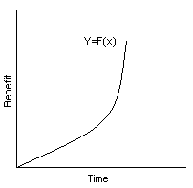As part of this, the costs and benefits associated with the proposed system compared and the project is economically feasible only if tangible or intangible benefits outweigh costs. The system development costs will be significant. So the proposed system is economically feasible.

.

* **OPERATIONAL FEASIBILITY**

Operational feasibility is a measure of how well a proposed system solves the problems, and takes advantage of the opportunities identified during scope definition and how it satisfies the requirements identified in the requirements analysis phase of system development. The operational feasibility assessment focuses on the degree to which the proposed development projects fits in with the existing business environment and objectives with regard to development schedule, delivery date, corporate culture, and existing business processes.

It is a standard that ensures interoperability without stifling competition and system is operationally feasible. Innovation among users, to the benefit of the public both in terms of cost and service quality. The proposed system is acceptable to users.

**DESIGN**

**DATA FLOW DIAGRAMS**

A graphical tool used to describe and analyze the moment of data through a system manual or automated including the process, stores of data, and delays in the system. Data Flow Diagrams are the central tool and the basis from which other components are developed. The transformation of data from input to output, through processes, may be described logically and independently of the physical components associated with the system. The DFD is also know as a data flow graph or a bubble chart.

**SYMBOLS IN DATA FLOW DIAGRAMS:**

**DATAFLOW:** Data move in a specific direction from an origin to a destination.

**PROCESS:** People, procedures, or devices that use or produce (Transform) Data. The physical component is not identified.

**SOURCE:** External sources or destination of data, which may be People, programs, organizations or other entities.

**DATA STORE:** Here data are stored or referenced by a process in the System

**ZERO LEVEL DFD**

Login

Product

Sub Category

Category

Dispatch

UserOrder

OrderDetail

**FIRST LEVEL DFD**



**SECOND LEVEL DFD**



**THIRD LEVEL DFD**



**Business to Consumer**

User

User master

Product master

Shipping_table

Order table

Login ok

Delivers product

**DATABASE DESIGN**

**Database design** is the process of producing a detailed [data model](https://en.wikipedia.org/wiki/Data_model) of a [database](https://en.wikipedia.org/wiki/Database). This [data model](https://en.wikipedia.org/wiki/Data_model) contains all the needed logical and physical design choices and physical storage parameters needed to generate a design in a [data definition language](https://en.wikipedia.org/wiki/Data_definition_language), which can then be used to create a database. A fully attributed data model contains detailed attributes for each entity. The term database design can be used to describe many different parts of the design of an overall [database system](https://en.wikipedia.org/wiki/Database_system). Principally, and most correctly, it can be thought of as the logical design of the base data structures used to store the data. In the [relational model](https://en.wikipedia.org/wiki/Relational_model) these are the [tables](https://en.wikipedia.org/wiki/Database_table) and [views](https://en.wikipedia.org/wiki/Database_view). In an [object database](https://en.wikipedia.org/wiki/Object_database) the entities and relationships map directly to object classes and named relationships. However, the term database design could also be used to apply to the overall process of designing, not just the base data structures, but also the forms and queries used as part of the overall database application within the [database management system](https://en.wikipedia.org/wiki/Database_management_system) (DBMS).

The process of doing database design generally consists of a number of steps which will be carried out by the database designer. Usually, the designer must:

* Determine the data to be stored in the database.
* Determine the relationships between the different data elements.
* Superimpose a logical structure upon the data on the basis of these relationships

**ADMIN TABLE**

Purpose: This table maintain records of administrator.

|  |  |  |  |  |
| --- | --- | --- | --- | --- |
| **Sr.** | **Field Name** | **Type** | **Constraint** | **Description** |
| 1 | User_id | Varchar2(40) | Primary Key | Admin’s Id (AutoIncrement) |
| 2 | Username | Varchar2(40) | Unique key | Username of admin |
| 3 | Password | Varchar2(40) | NOT NULL | Password for login |

**CATEGORY TABLE**

Purpose: It contains the information about the category of the product.

|  |  |  |  |  |
| --- | --- | --- | --- | --- |
| **Sr.** | **Field Name** | **Type** | **Constraint** | **Description** |
| 1 | Catcode | Varchar2(40) | PRIMARY KEY | Category’s Id (AutoIncrement) |
| 2 | catname | Varchar2(40) | NOT NULL | Name of the category |

**SUBCATEGORY TABLE**

Purpose: It contains the list of the subcategory’s.

|  |  |  |  |  |
| --- | --- | --- | --- | --- |
| **Sr.** | **Field Name** | **Type** | **Constraint** | **Description** |
| 1 | subcatcode | Varchar2(40) | PRIMARY KEY | AutoIncrement Id |
| 2 | subcatname | Varchar2(40) | NOT NULL | Name of the subcategory |
| 3 | Catcode | Varchar2(40) | FOREGIN KEY | Id of the category |

**BRAND TABLE**

Purpose: It contains the list of the available brands.

|  |  |  |  |  |
| --- | --- | --- | --- | --- |
| **Sr.** | **Field Name** | **Type** | **Constraint** | **Description** |
| 1 | Bcode | Varchar2(40) | PRIMARY KEY | Id of the brand (Auto increment) |
| 2 | Bname | Varchar2(40) | NOT NULL | Name of the brand |

**MERCHANT TABLE**

Purpose: This table stores the list of merchant’s.

|  |  |  |  |  |
| --- | --- | --- | --- | --- |
| **Sr.** | **Field Name** | **Type** | **Constraint** | **Description** |
| 1 | M_id | Varchar2(40) | PRIMARY KEY | Merchant’s Id (Auto increment) |
| 2 | M_name | Varchar2(40) | NOT NULL | Name of the merchant |
| 3 | M_username | Varchar2(40) | NOT NULL | Username of the merchant |
| 4 | M_password | Varchar2(40) | NOT NULL | Merchant’s Password |
| 5 | M_email | Varchar2(40) | NOT NULL | Merchant’s Email |
| 6 | M_number | Varchar2(40) | NOT NULL | Contact Number of merchant |
| 7 | M_address | Varchar2(40) | NOT NULL | Merchant’s mailing address |
| 8 | M_pincode | Varchar2(40) | NOT NULL | Pincode of merchant |

**PRODUCT TABLE**

Purpose: This table stores the information concerning the products that are available for sale.

|  |  |  |  |  |
| --- | --- | --- | --- | --- |
| **Sr.** | **Field Name** | **Type** | **Constraint** | **Description** |
| 1 | P_id | Varchar2(40) | PRIMARY KEY | (Auto increment) |
| 2 | subcatcode | Varchar2(40) | FOREGIN KEY | Id of the subcategory |
| 3 | M_id | Varchar2(40) | FOREGIN KEY | Id of the merchant |
| 4 | Bcode | Varchar2(40) | FOREGIN KEY | Id of the brand |
| 5 | P_name | Varchar2(40) | NOT NULL | Name of the item |
| 6 | P_price | Varchar2(40) | NOT NULL | Price of the item |
| 7 | P_description | Varchar2(40) | NOT NULL | Product’s Description |
| 8 | P_status | Varchar2(40) | NOT NULL | Approved /Rejected |
| 9 | P_image | Varchar2(40) | NOT NULL | Name of the product’s picture file |
| 10 | P_image1 | Varchar2(40) |  | Name of the product’s picture file |
| 11 | P_quality | Varchar2(40) | NOT NULL | Quantity of the product |

**USER TABLE**

Purpose: This table maintain records of customers.

|  |  |  |  |  |
| --- | --- | --- | --- | --- |
| **Sr.** | **Field Name** | **Data Type** | **Constraint** | **Description** |
| 1 | User_id | Varchar2(40) | Primary key | Auto increment id |
| 2 | Name | Varchar2(40) | NOT NULL | Name of the person |
| 3 | Username | Varchar2(40) | Unique Key | Username of the person |
| 4 | Password | Varchar2(40) | NOT NULL | Password of the person |
| 5 | Address | Varchar2(40) | NOT NULL | Address of the person |
| 6 | Email | Varchar2(40) | NOT NULL | Email Id of the person |
| 7 | Number | Varchar2(40) | NOT NULL | Phone of the person |
| 8 | Gender | Varchar2(40) | NOT NULL | Person’s Gender |
| 9 | DateOfReg | Varchar2(40) | NOT NULL | Date of registration |

**Orders Table**

Purpose: A record will be added to the Order table for each order entered by a customer.

|  |  |  |  |  |
| --- | --- | --- | --- | --- |
| **Sr.** | **Field Name** | **Type** | **Constraint** | **Description** |
| 1 | Order Id | Varchar2(40) | PRIMARY KEY | Auto increment id |
| 3 | User Id | Varchar2(40) | NOT NULL | User ID of the customer |
| 4 | Name | Varchar2(40) | FOREGIN KEY | Name of customer |
| 5 | Address | Varchar2(40) | NOT NULL | Customer’s Address |
| 6 | Contact | Varchar2(40) | NOT NULL | Customer’s Contact |
| 7 | Tax | Varchar2(40) | NOT NULL | Tax applied |
| 8 | Discount | Varchar2(40) | NOT NULL | Discount given to customer |
| 9 | Sum | Varchar2(40) | NOT NULL | Total Sum of the order |
| 10 | Status | Varchar2(40) | NOT NULL | Pending/Delivered |
| 11 | PayMode | Varchar2(40) | NOT NULL | Cheque/DD/Credit card etc |
| 12 | PayDetails | Varchar2(40) |  | Details of Payment |
| 13 | Date | Varchar2(40) | NOT NULL | Date of order |

**ORDER DETAILS TABLE**

Purpose: Each time an order is placed, one record is added to the Orders table; in addition one record is added to the Order Details table for each item requested in that order.

|  |  |  |  |  |
| --- | --- | --- | --- | --- |
| **Sr.** | **Field Name** | **Type** | **Constraint** | **Description** |
| 1 | Order_Detail_Id | Varchar2(40) | Primary key | Auto increment id |
| 2 | Order_Id | Varchar2(40) | Foregin Key | Id of the order’s table |
| 3 | P_id | Varchar2(40) | Foregin Key | Id of the product’s table |
| 4 | P_name | Varchar2(40) | Not Null | Name of Product |
| 5 | P_price | Varchar2(40) | Not Null | Total price of the product |
| 6 | R_qty | Varchar2(40) | Not Null | Required Quantity Ordered |
| 7 | TotalAmnt | Varchar2(40) | Not Null | Amount (p_price * r_qty) |
| 8 | Status | Varchar2(40) | Not Null | Approved/Rejected |
| 9 | Trackingno | Varchar2(40) |  | Tracking no to track package |

**FEEDBACK TABLE**

Purpose: It contains the information about the bill order of the product.

|  |  |  |  |  |
| --- | --- | --- | --- | --- |
| **Sr.** | **Field Name** | **Type** | **Constraint** | **Description** |
| 1 | FeedbackId | Varchar2(40) | Primary key | Id of the category |
| 2 | User_Id | Varchar2(40) | Foregin Key | Customer’s Id |
| 3 | Name | Varchar2(40) | Not Null | Customer’s Name |
| 4 | Suggestion | Varchar2(40) | Not Null | Customer’s Address |
| 5 | Phone | Varchar2(40) | Not Null | Phone number |
| 6 | E-mail | Varchar2(40) | Not Null | Email Id of the customer |
| 7 | Rating | Varchar2(40) | Varchar2 | Rating given by customer |

**ER-DIAGRAM**

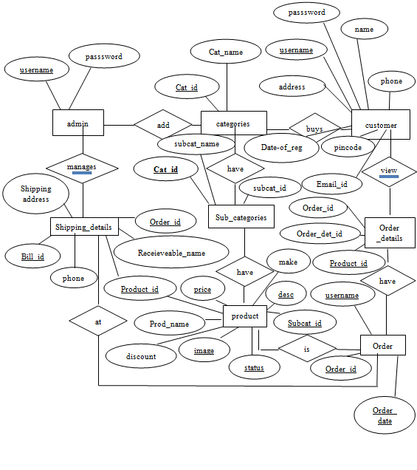

**MODULE DESIGN**

Module of a system is essentially a blueprint or a plan for a solution for a system. The proposed system can be divided into three parts:

**MODULE FOR ADMINISTRATOR**

**LOGIN**

The administrator is provided with a password and a username. After successfully login the administrator can perform his tasks.

**CATEGORY**

The administrator can add, modify, delete, search and view the categories.

**SUBCATEGORY**

The administrator can add, modify, delete, search and view the sub categories. He can also perform the mapping of category and subcategory.

**BRAND**

The administrator can add, modify, delete, search and view the brands.

**MERCHANT**

The administrator can add, modify, delete, search and view the merchants. He assigns the merchant username and default password to the merchant’s.

**MODULE FOR ADMINISTRATOR**

**LOGIN**

The administrator is provided with a password and a username. After successfully login the administrator can perform his tasks.

**CATEGORY**

The administrator can add, modify, delete, search and view the categories.

**SUBCATEGORY**

The administrator can add, modify, delete, search and view the sub categories. He can also perform the mapping of category and subcategory.

**BRAND**

The administrator can add, modify, delete, search and view the brands.

**MERCHANT**

The administrator can add, modify, delete, search and view the merchants. He assigns the merchant username and default password to the merchant’s.

**MODULE FOR MERCHANT**

**LOGIN**

The merchant is provided with a password and a username. After successfully login the merchant can perform his tasks.

**CHANGE PASSWORD**

The very first thing the merchant is said to do is to change his/her password to maintain high security.

**PRODUCTS**

The merchant is allowed to add, modify, delete, and search the products. He can perform these tasks only on the products which were added by him. He is not authorised to view the products added by other merchant’s.

**MODULES FOR USERS/CUSTOMERS:**

The users module is further subdivided into following modules:

**REGISTRATION:** The user fills registration form and gets his details added to the customer’s table

**LOGIN :** After login, the user can view, search and buy products online.

**VIEW :**The users can view all the top trending products.

**POST QUERIES :**The users can ask queries and the timely respond is given to them as well.

**CART:** The users can buy as many products as required. Once the users add the products to the cart, he can proceed to the payment section for ordering the orders to their home address.

**SHIPMENT ADDRESS:** The users can enter the address where they want their package to be delivered. After they get the approval from the merchant, they are given TRACKNG NUMBER through which they can track the current location of the package.

**MY ORDERS:** The users can always view the current order and previous orders.

**SCREENS**

**Admin/Merchant Login Page**

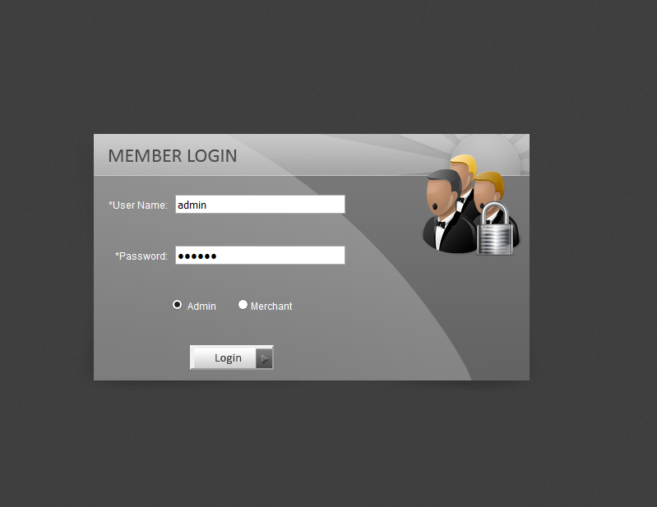

**Admin Main Page**

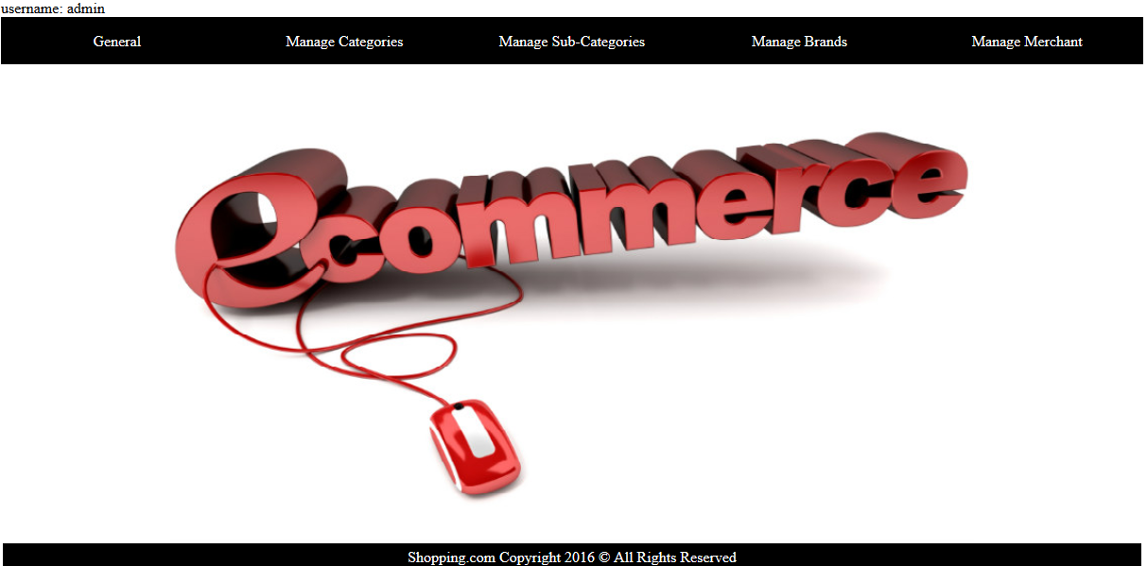

**Add Category**

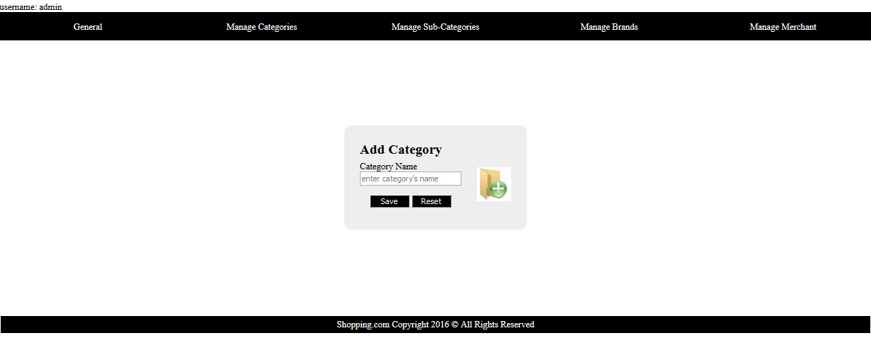

**Update Category**

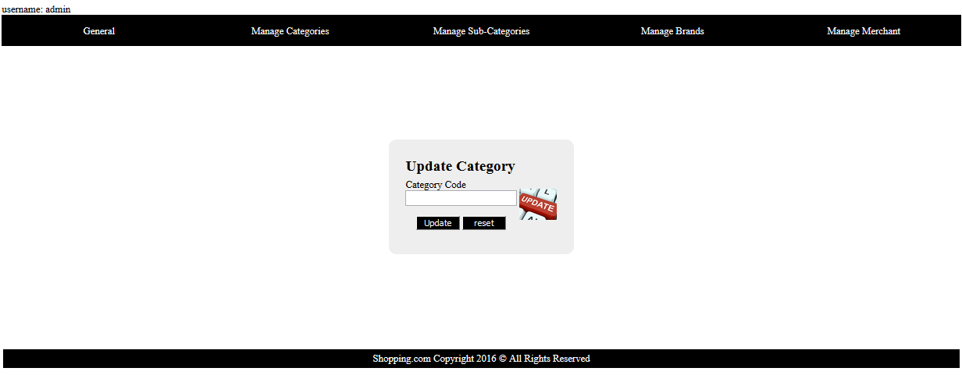

**Delete Category**

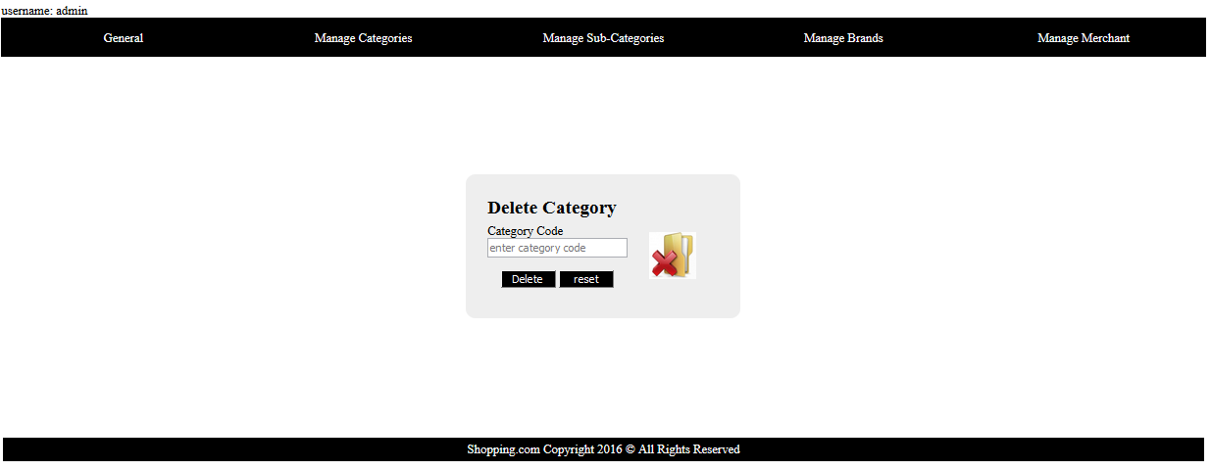

**Search Category**

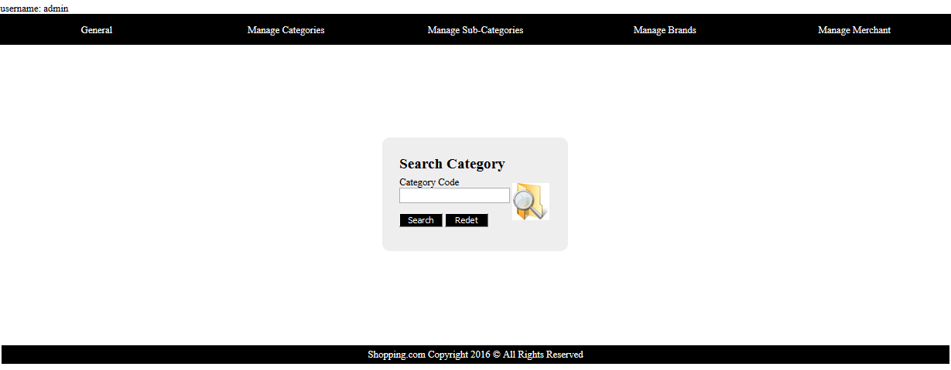

**List All Category’s**

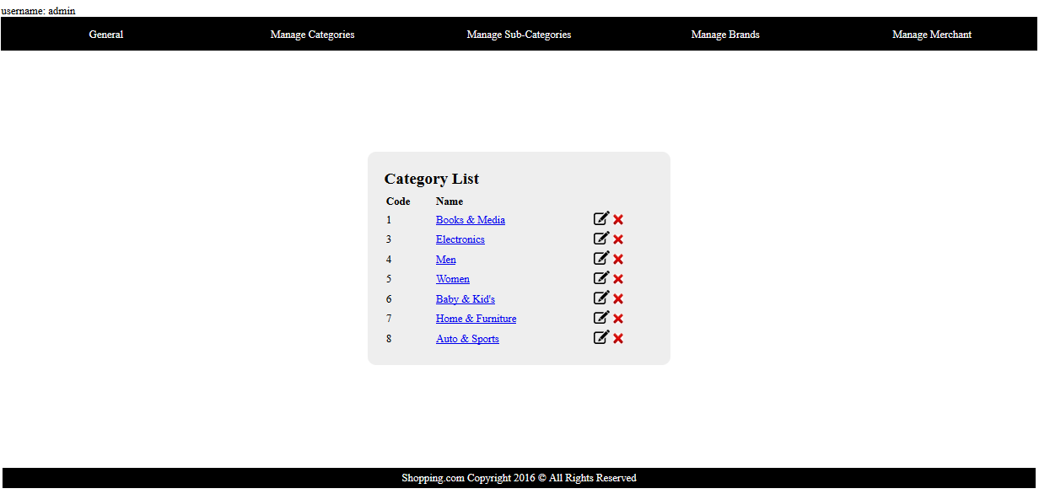

**ListAll Brand’s**

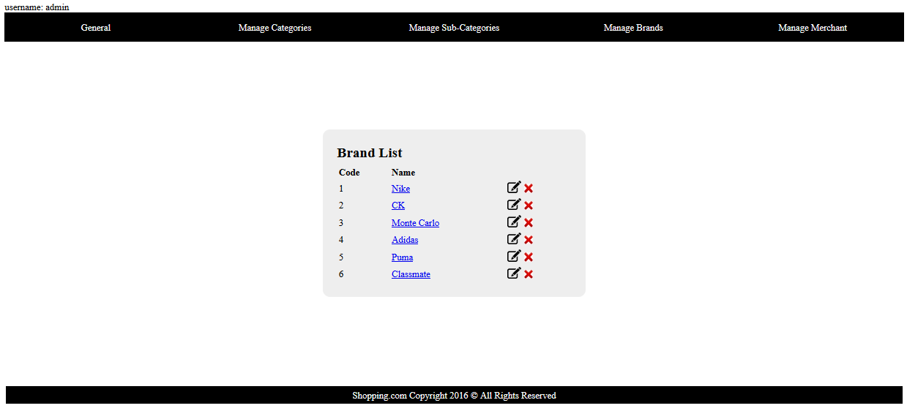

**ListAll Merchant’s**

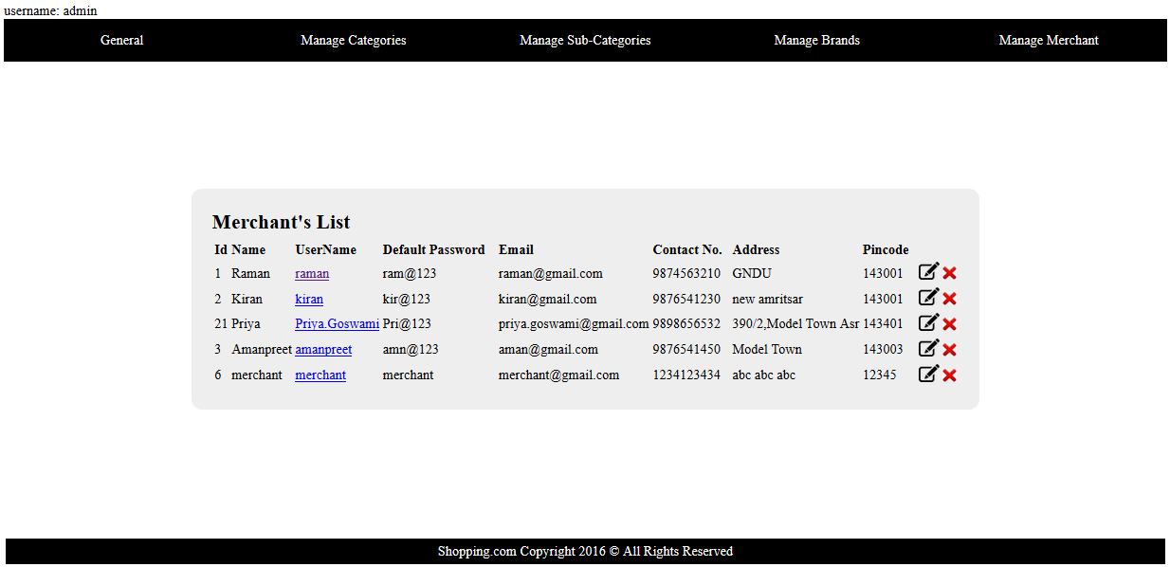

**Merchant Main Page**

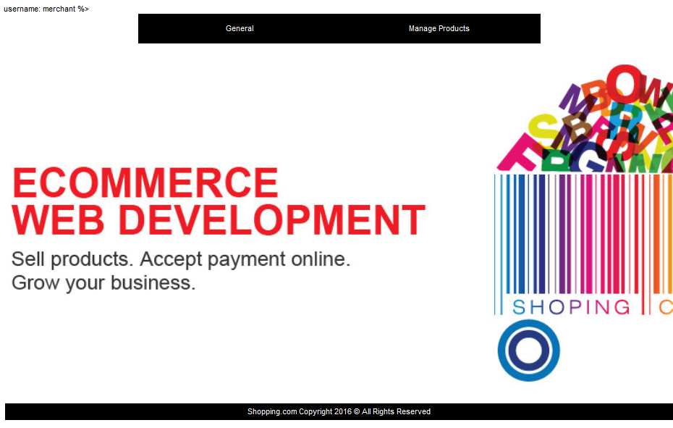

**Change Password**

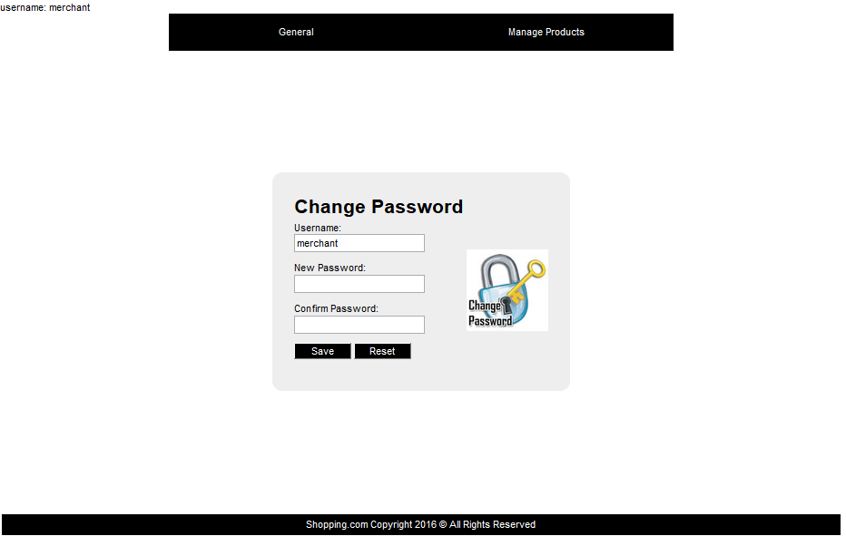

**My Products Menu**

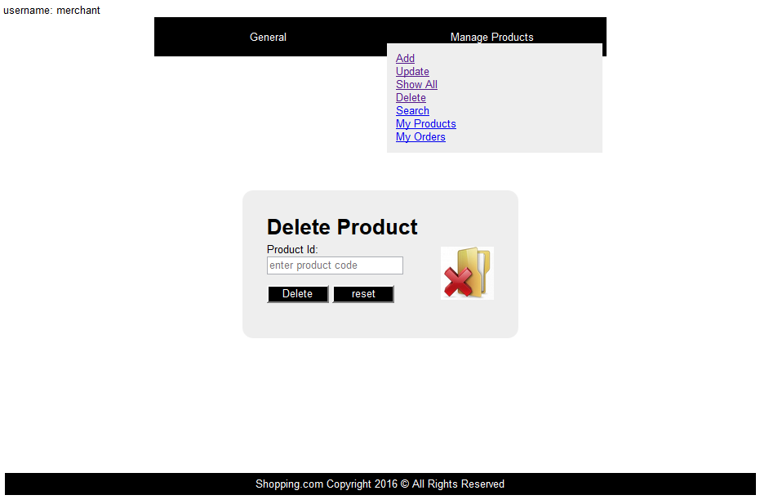

**Update Product**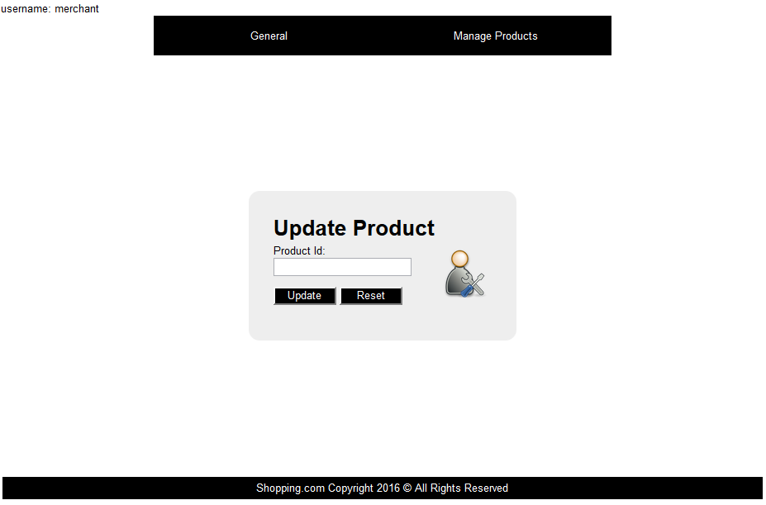

**Delete Product**



**USER’S VIEW**

**Main Page**

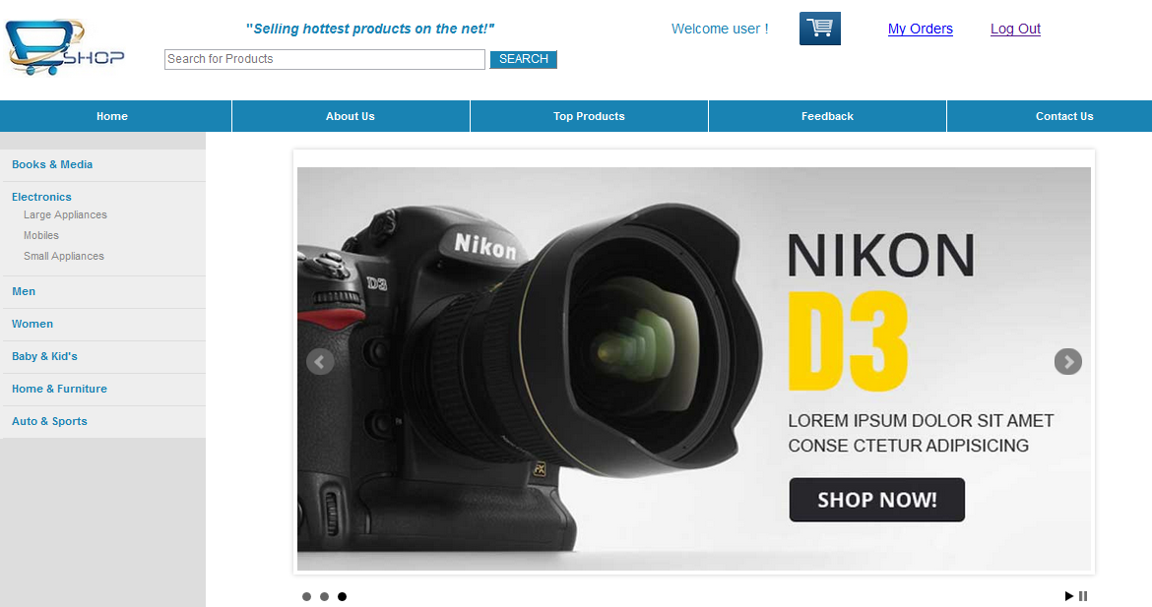

**SignUp**

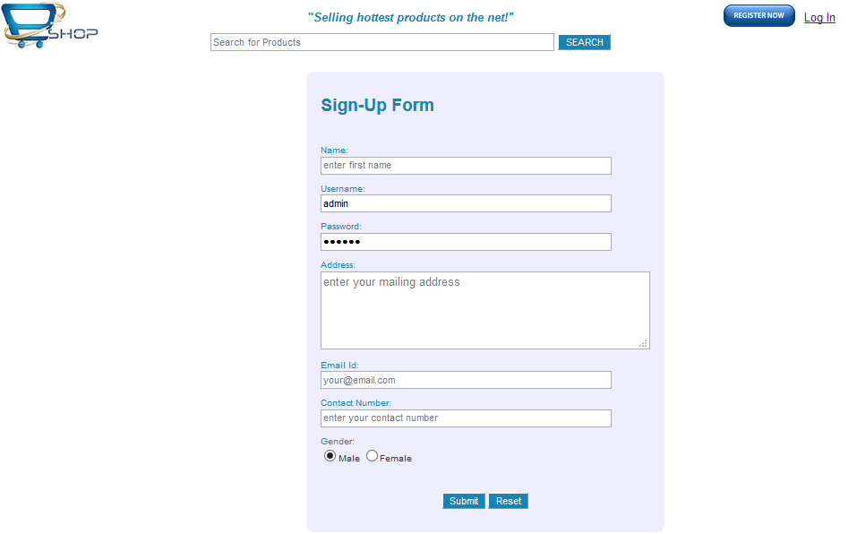

**LogIn Page**

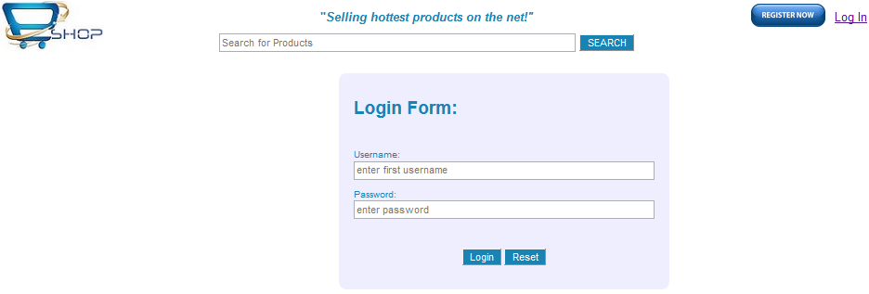

**Products**

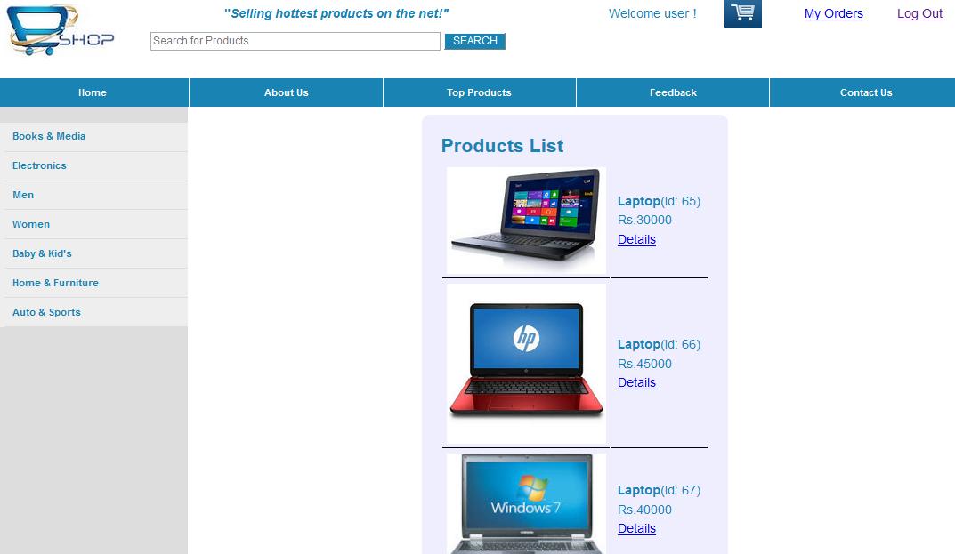

**Product Details**

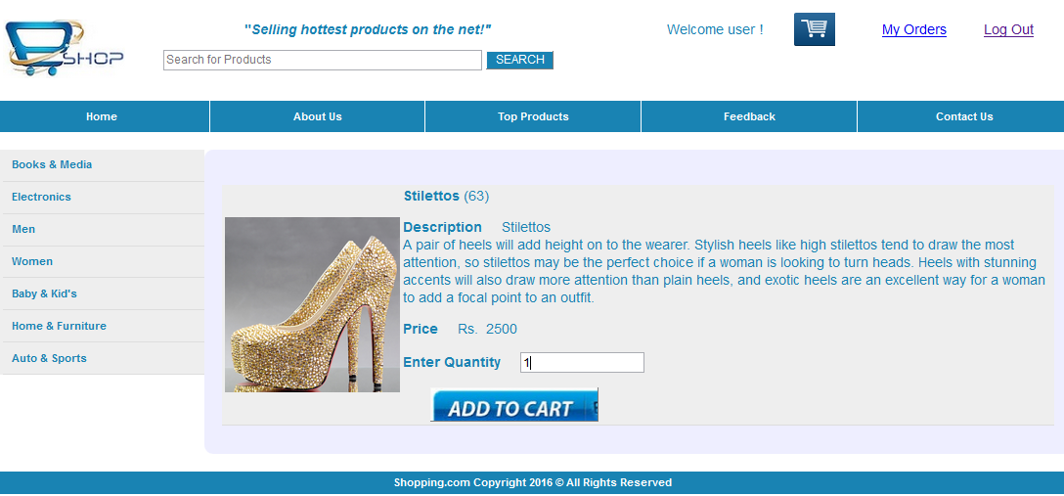

**Add To Cart**

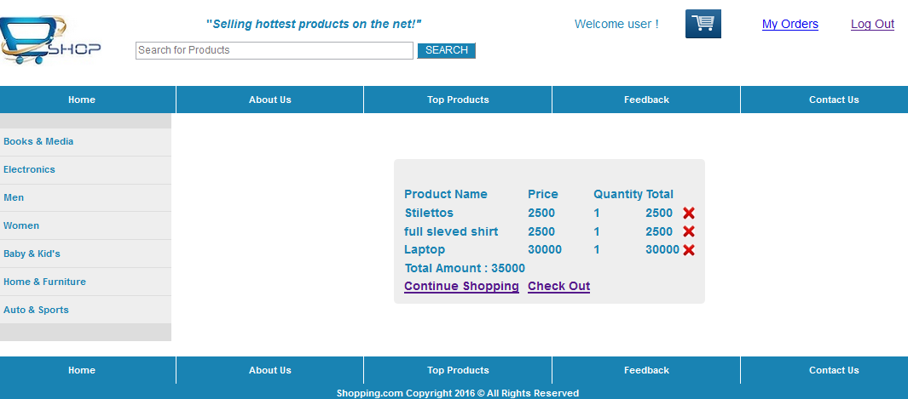

**Check Out**

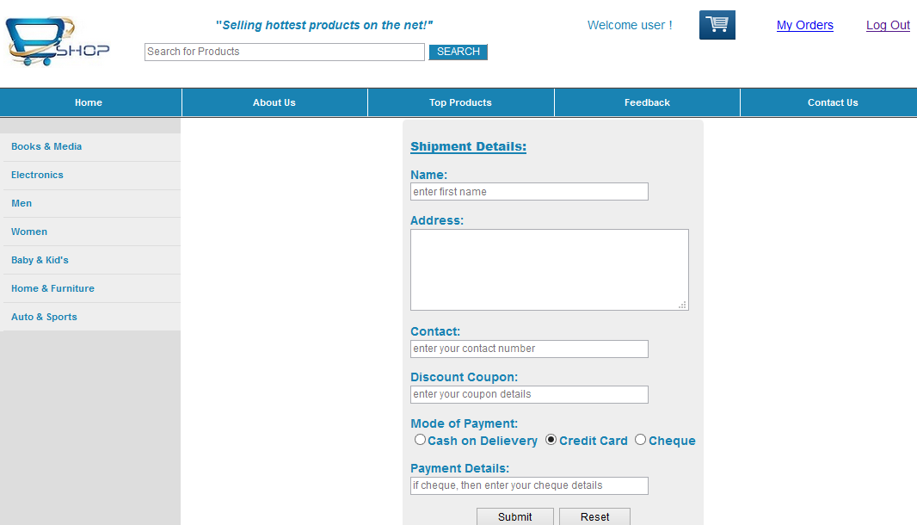

**FeedBack Page**

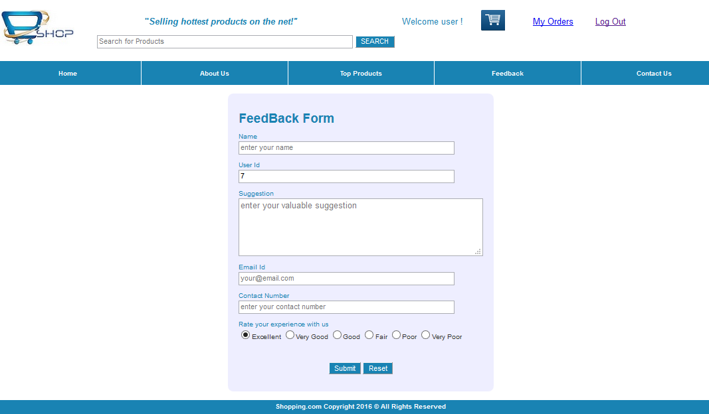

**My Orders Page**

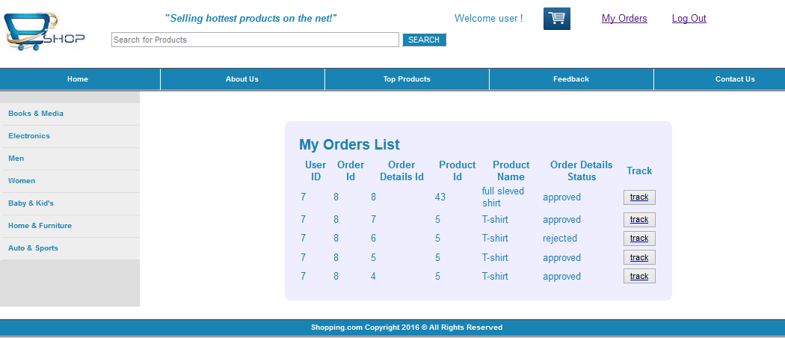

**Order Tracking**

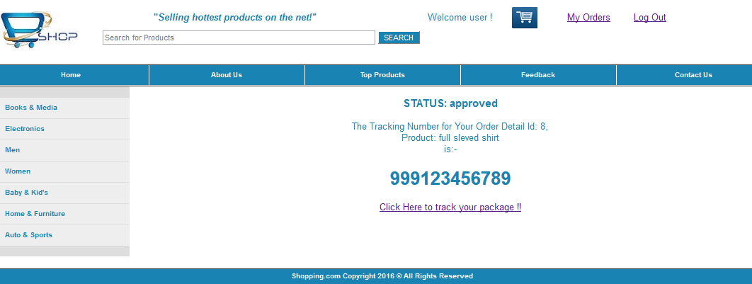

**Contact Us**

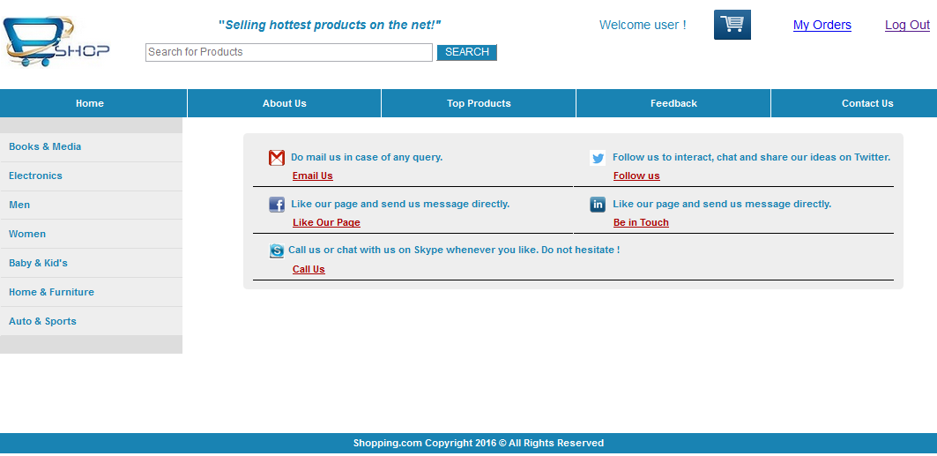

**About Us**

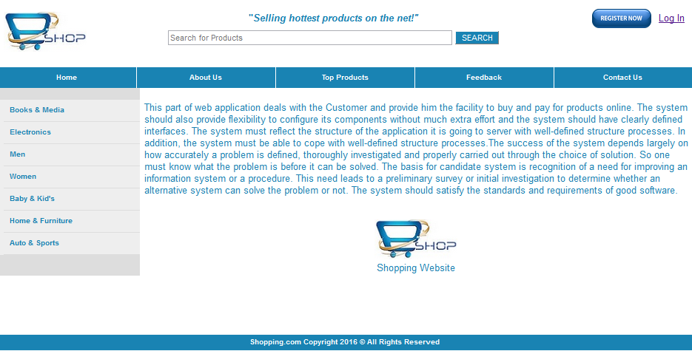

**TESTING**

Software testing is a critical element of software quality assurance and represents the ultimate review of specification, design and coding. In fact, testing is the one step in the software engineering process that could be viewed as destructive rather than constructive.

The software engineering process can be viewed as a spiral. Initially system engineering defines the role of software and leads to software requirement analysis where the information domain, functions, behavior, performance, constraints and validation criteria for software are established. Moving inward along the spiral, we come to design and finally to coding. To develop computer software we spiral in along streamlines that decrease the level of abstraction on each turn.

UNIT TESTING

MODULE TESTING

SUB-SYSTEM TESING

SYSTEM TESTING

ACCEPTANCE TESTING

Component Testing

Integration Testing

User Testing

**Unit Testing Phase:**

Unit testing is a software development process in which the smallest testable parts of an application, called units, are individually and independently scrutinized for proper operation. Unit testing is often automated but it can also be done manually. This testing mode is a component of Extreme Programming (XP), a pragmatic method of software development that takes a meticulous approach to building a product by means of continual testing and revision.

**Integrated Testing Phase:**

**Integration testing** (sometimes called **integration and testing**, abbreviated **I&T**) is the phase in software testing in which individual software modules are combined and tested as a group. It occurs after unit testing and before validation testing. Integration testing takes as its input modules that have been unit tested, groups them in larger aggregates, applies tests defined in an integration test plan to those aggregates, and delivers as its output the integrated system ready for system testing.

**System Testing Phase:**

**System testing** of software or hardware is testing conducted on a complete, integrated system to evaluate the system's compliance with its specified requirements. System testing falls within the scope of black-box testing, and as such, should require no knowledge of the inner design of the code or logic.

As a rule, system testing takes, as its input, all of the "integrated" software components that have passed integration testing and also the software system itself integrated with any applicable hardware system(s). The purpose of integration testing is to detect any inconsistencies between the software units that are integrated together (called assemblages) or between any of the assemblages and the hardware. System testing is a more limited type of testing; it seeks to detect defects both within the "inter-assemblages" and also within the system as a whole.

**Acceptance Testing Phase:**

In engineering and its various sub disciplines, **acceptance testing** is a test conducted to determine if the requirements of a specification or contract are met. It may involve chemical tests, physical tests, or performance tests.

**Login Page**

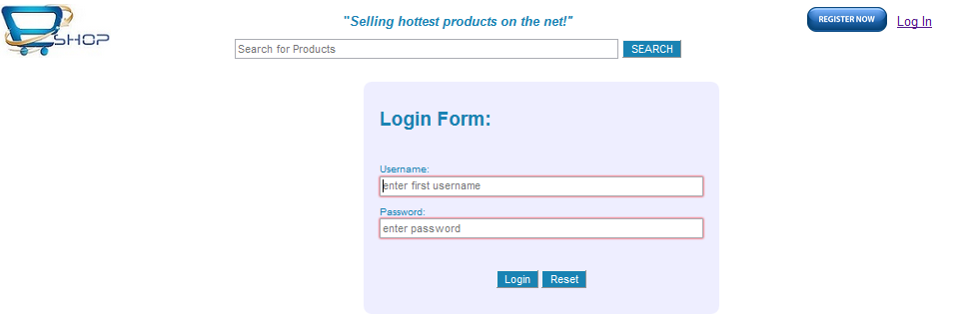

On the click of submit button when no value is entered to the text fields, they are marked in red. It indicates that the text fields can’t be set empty.

**Update Merchant Details**

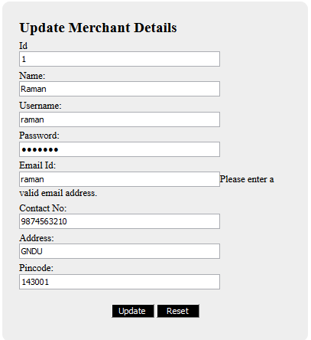

**IMPLEMENTATION**

The implementation is the final and important phase. It involves User training, system testing and successful running of the developed system. The users test the developed system when changes are made according to the needs. The testing phase involves the testing of the developed system using various kinds of data. An elaborate testing of data is prepared and system is tested using the tests data.

Implementation is the stage where theoretical design turned into a working system. Implementation is planed carefully to propose system to avoid unanticipated problems. Many preparations involved before and during the implementation of proposed system. The system needed to be plugged in to the organization’s network then it could be accessed from anywhere, after a user logins into the portal. The tasks that had to be done to implement the system were to create the database tables in the organization database domain. Then the administrator was granted his role so that the system could be accessed.

The next phase in the implementation was to educate the system. A demonstration of all the functions that can be carried out by the system was given to examination department person, who will make extensive use of the system.

**CONCLUSION:**

It has been a great pleasure for me to work on this exciting and challenging project. This project proved good for me as it provided practical knowledge of not only programming in JAVA and web based application and no some extent Windows Application and ORACLE Server, but also about all handling procedure related with **“E-Commerce”.** It also provides knowledge about the latest technology used in developing web enabled application and client server technology that will be great demand in future. This will provide better opportunities and guidance in future in developing projects independently.

**BENEFITS:**

The project is identified by the merits of the system offered to the user. The merits of this project are as follows: -

* It’s a web-enabled project.
* This project offers user to enter the data through simple and interactive forms.
* Using E-Commerce, organization can expand their market to national and international markets with minimum capital investment. An organization can easily locate more customers, best suppliers and suitable business partners across the globe.
* It improves the brand image of the company.
* E-commerce helps organization to provide better customer services.
* E-Commerce reduces paper work a lot.
* It helps in increasing the productivity of the organization. It supports "pull" type supply management. In "pull" type supply management, a business process starts when a request comes from a customer and it uses just-in-time manufacturing way.
* 24x7 support. Customer can do transactions for the product or enquiry about any product/services provided by a company any time, any where from any location. Here 24x7 refers to 24 hours of each seven days of a week.
* E-Commerce application provides user more options and quicker delivery of products.
* E-Commerce application provides user more options to compare and select the cheaper and better option.
* E-Commerce increases competition among the organizations and as result organizations provides substantial discounts to customers.
* Customers need not to travel to shop a product thus less traffic on road and low air pollution.

**FUTURE ENHANCEMENTS:**

**Electronic Commerce** is more than just buying and selling products online. It also includes the entire online process of developing, marketing, selling, delivering, servicing and paying for products and services. India has shown tremendous growth in the E-commerce segment. With an **internet user base of over 300 million**, India has third largest internet population after US & China.

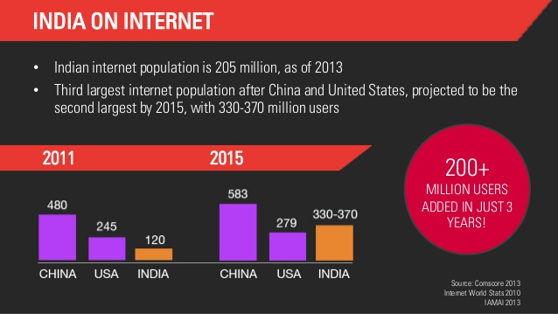

India has witnessed a major breakthrough E-commerce success stories particularly in E**-** **commerce** **in Consumer Electronics & Fashion Apparel & Home Furnishing segments**. E-commerce creates new opportunities for **entrepreneurial start-ups**. Ease of Internet access, Safe and secure payment modes coupled with aggressive marketing by E-Commerce Giants has revolutionized this segment.

**BIBLIOGRAPHY**

Books Referred

The following books were used extensively for the project development and implementation.

1. “The Complete Reference Java2” Tata McGraw-Hill publishing Company Limited By Herbert Schildt.
2. “Software Engineering, A Practitioner’s Approach” Tata McGraw-Hill Publishing Company Limited. By Roger S. Pressman.
3. “PL/SQL”. By Ivan Bayross.

WEBSITES REFERRED

The following links were searched and exploited extensively for the project development and implementation.

1. <http://www.java.sun.com/products\java>
2. <http://www.jakarta.apache.org>
3. <http://www.javaworld.com/>
4. <http://www.java2s.com/>