1.HEADINGS

Screenshot:

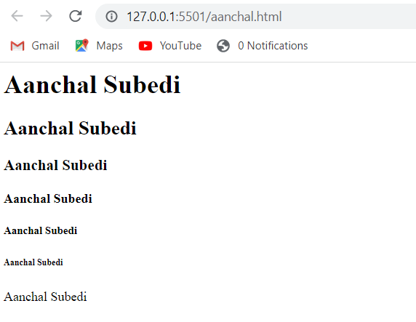

Source code:

<html>

<head>

<title>Heading in html</title>

</head>

<body>

<h1>Aanchal Subedi</h1>

<h2>Aanchal Subedi</h2>

<h3>Aanchal Subedi</h3>

<h4>Aanchal Subedi</h4>

<h5>Aanchal Subedi</h5>

<h6>Aanchal Subedi</h6>

<h7>Aanchal Subedi</h7>

</body>

</html>

2.Formatting tags

Screenshot:

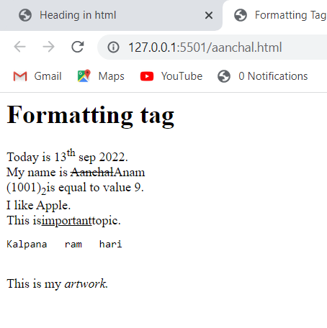

Source code:

<html>

    <head>

        <title>Formatting Tags</title>

    </head>

    <body>

        <h1>Formatting tag</h1>

        Today is 13<sup>th</sup> sep 2022. <br>

        My name is <strike>Aanchal</strike>Anam <br>

        (1001) <sub>2</sub>is equal to value 9. <br>

        I like <bold>Apple</bold>. <br>

        This is<u>important</u>topic. <br>

<pre>Kalpana   ram   hari</pre><br>

This is my <i>artwork. </i>

    </body>

</html>

3.Inserting maps, videos, audio

Screenshot:

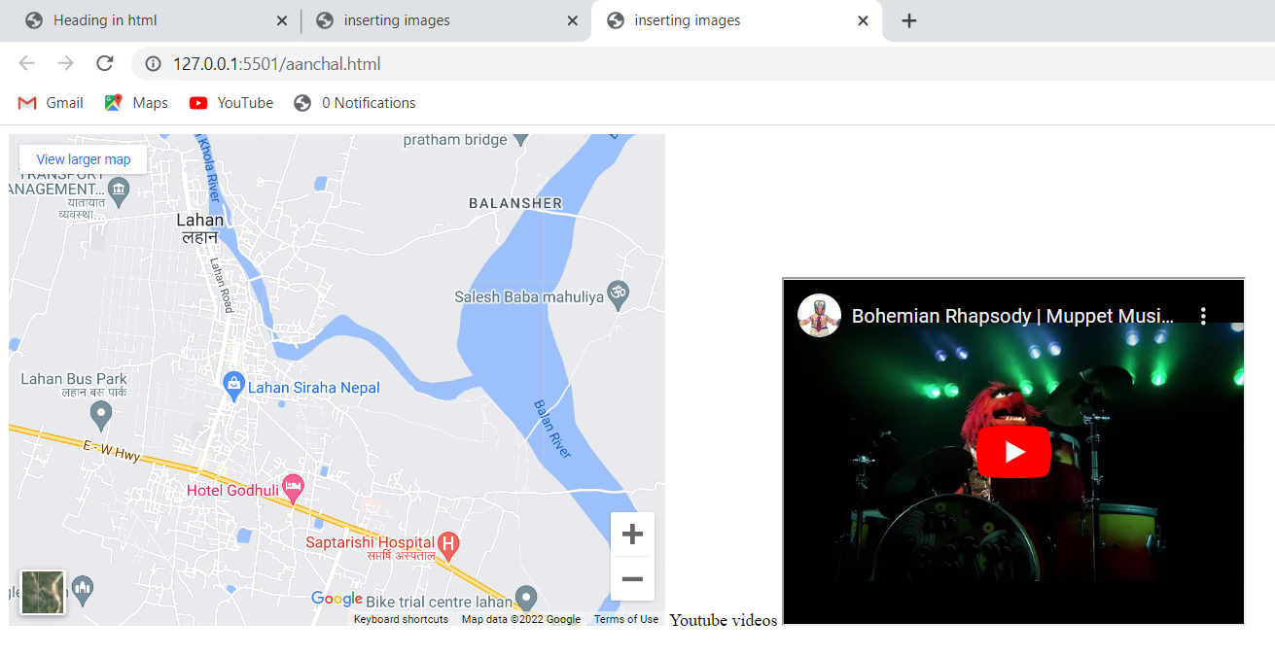

Source code:

<html>

    <head>

        <title>inserting images</title>

    </head>

    <body>

        <iframe src="https://www.google.com/maps/embed?pb=!1m14!1m12!1m3!1d14255.17600887316!2d86.49020114999999!3d26.719027200000003!2m3!1f0!2f0!3f0!3m2!1i1024!2i768!4f13.1!5e0!3m2!1sen!2snp!4v1665678647629!5m2!1sen!2snp" width="600" height="450" style="border:0;" allowfullscreen="" loading="lazy" referrerpolicy="no-referrer-when-downgrade"></iframe>

    Youtube videos

    <iframe width="420" height="315"

    src="https://www.youtube.com/embed/tgbNymZ7vqY">

    </iframe>

    </body>

</html>

4.Links in HTML

Screenshot:

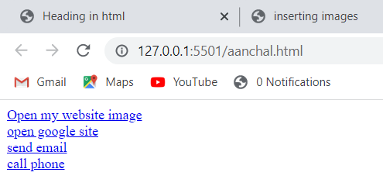

Source code:

<html>

    <head>

        <title>inserting images</title>

    </head>

    <body>

     <a href="images/second.jpg">Open my website image</a><br>

     <a href="https://www.google.com">open google site</a><br>

     <a href="mailto:abc@gmail.com"> send email</a><br>

     <a href="tel:9842605922">call phone</a><br>

    </body>

</html>

5.Making tables

Screenshot:

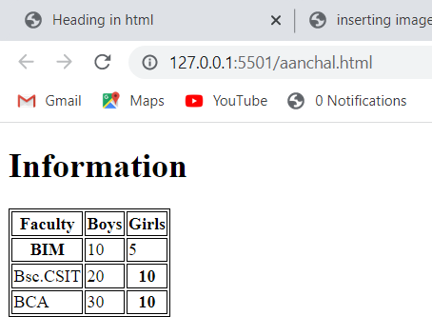

Source code:

<html>

   <head>

      <style>

         table, th, td {

            border: 1px solid black;

         }

      </style>

   </head>

   <body>

      <h1>Information</h1>

      <table>

         <tr>

            <th>Faculty</th>

            <th>Boys</th>

            <th>Girls</th>

         </tr>

         <tr>

            <th>BIM</th>

            <td>10</td>

            <td>5</td>

         </tr>

         <tr>

            <td>Bsc.CSIT</td>

            <td>20</td>

            <th>10</th>

         </tr>

         <tr>

            <td>BCA</td>

            <td>30</td>

            <th>10</th>

         </tr>

      </table>

   </body>

</html>