**Project Report on**

**Cyber Security Attacks**

Submitted by:

**Aanchal Kumari**

**&**

**Chanchal**

**In partial fulfillment of completion of the course**

**Advanced Diploma in IT, Networking and Cloud Computing.**

**Under Guidance of:**

|  |  |  |
| --- | --- | --- |
| IBM-Logo - Chicago Innovation | DGT introduces high end diploma courses - digitalLEARNING Magazine | Edunet Foundation-Delhi- CSR Organization profile |

**Year 2022-2023**

**Abstract**

The primary objectives of this research include the collection and analysis of diverse datasets encompassing various cyber-attacks types, such as malware infections, phishing attempts, ransom ware incidents, and other forms of malicious activities. Advanced data analytics and machine learning techniques will be applied to identify patterns and trends within these datasets, allowing for a nuanced understanding of attack vectors and evolving threat landscapes.The project aims to categorize cyber threats based on their characteristics, methodologies, and impacts. By examining historical attack data, we intend to identify recurring patterns and emerging trends, providing insights into the evolving tactics employed by cyber adversaries.

**Acknowledgement**

At this juncture of our journey, we wish to express our heartfelt gratitude to all those who have contributed to the creation and success of **"Cyber Security Attacks".** This project has been a labor of passion and dedication, and it would not have been possible without the unwavering support and guidance we have received.

First and foremost, we offer our thanks to the boundless creativity and inspiration that flows from the universe. We are grateful for the opportunity to embark on this venture.

We extend our sincerest appreciation to our mentors, **Mrs. Mala Mishra & Ms. Ankita Shukla**, whose wisdom and guidance have been instrumental in shaping the vision of **"Cyber Security Attacks".** Your support at every crucial turn has illuminated our path and fueled our determination to create a meaningful platform.

To our dedicated team of developers, designers, and content creators, we extend our deepest gratitude. Your tireless efforts, innovation, and creativity have breathed life into **"Cyber Security Attacks".** It is your collective dedication that has made this project a reality.

Our appreciation also goes to our colleagues and friends who provided invaluable insights and feedback during the development process. Your input has been instrumental in refining our ideas and enhancing the user experience.

We acknowledge the contributions of the broader IT community, whose open-source ethos has been a wellspring of knowledge and inspiration. The collaborative spirit of this community has been a guiding light.

Last but not least, we owe a debt of gratitude to our families and friends who have stood by us throughout this journey. Your unwavering support, encouragement, and belief in our vision have been our constant motivation.

**ADVANCE DIPLOMA IN IT NETWORKING**

**& CLOUD COMPUTING**

**_______________________________________________**

The Advanced Diploma in IT Networking and Cloud Computing program offered by NSTI (W) Noida in collaboration with Edunet Foundation is a comprehensive course designed to equip students with advanced skills in information technology and cloud computing. This program covers a wide range of topics, including Computer Networking, Database Management, Virtualization, Cloud Technologies, and Cybersecurity. Students will gain hands-on experience through practical labs, workshops, and real-world projects, enabling them to excel in the rapidly evolving IT industry. Upon completion of the program, Graduates will have a strong foundation in both IT Fundamentals and Cloud Computing, making them highly sought-after professionals in the field.

**Project Requirements**

|  |  |
| --- | --- |
| **Project Name** | **Cyber Security Attacks** |
| **Languages Used** | **Python** |
| **Editor** | **Jupyter Notebook, Google Colab** |
| **Web Browser** | **Google Chrome, Microsoft Edge** |

**Team Composition and Workload Division**

|  |  |
| --- | --- |
| Aanchal Kumari | Data Analysis, Synopsis |
| Chanchal | Data Analysis, Synopsis |

**Tables of Content**

|  |  |  |
| --- | --- | --- |
| **SNO** | **TOPIC** | **Page No** |
| 1. | PROBLEM STATEMENT | 5 |
| 2. | REQUIREMENTS SPECIFICATION | 5 |
| 3. | OVERVIEW | 6 |
| 4. | PROJECT MODULE | 6-7 |
| 5. | SAMPLE SCREENSHOTS | 7-11 |
| 6. | FUTURE SCOPE | 11 |
| 7. | CONCLUSION | 11 |
| 08. | REFERENCES | 12 |

1. **Introduction to Problem**

The increasing frequency, complexity, and severity of cybersecurity attacks present a critical challenge to individuals, organizations, and nations worldwide. Cyber threats, including malware infections, phishing attacks, ransomware incidents, and other malicious activities, exploit vulnerabilities in digital systems, leading to data breaches, financial losses, and compromised critical infrastructure. The evolving nature of cyber threats poses a significant problem, necessitating a comprehensive understanding and effective mitigation strategies.

1. **Requirements**

**3.1 Technology Stack**

**Python:** High-level programming language used for server-side scripting.

**Jupyter Notebook:** Jupyter Notebook is an open-source web application that allows you to create and share documents containing live code, equations, visualizations, and narrative text, providing an interactive and collaborative environment for data science and analysis.

**3.2 Hardware**

Laptop/ Computer

**3.3 Software**

Operating System (OS)

Version Control System

Text Editors and Integrated Development Environments (IDEs)

**3.4 Deployment Environment**

**Github**

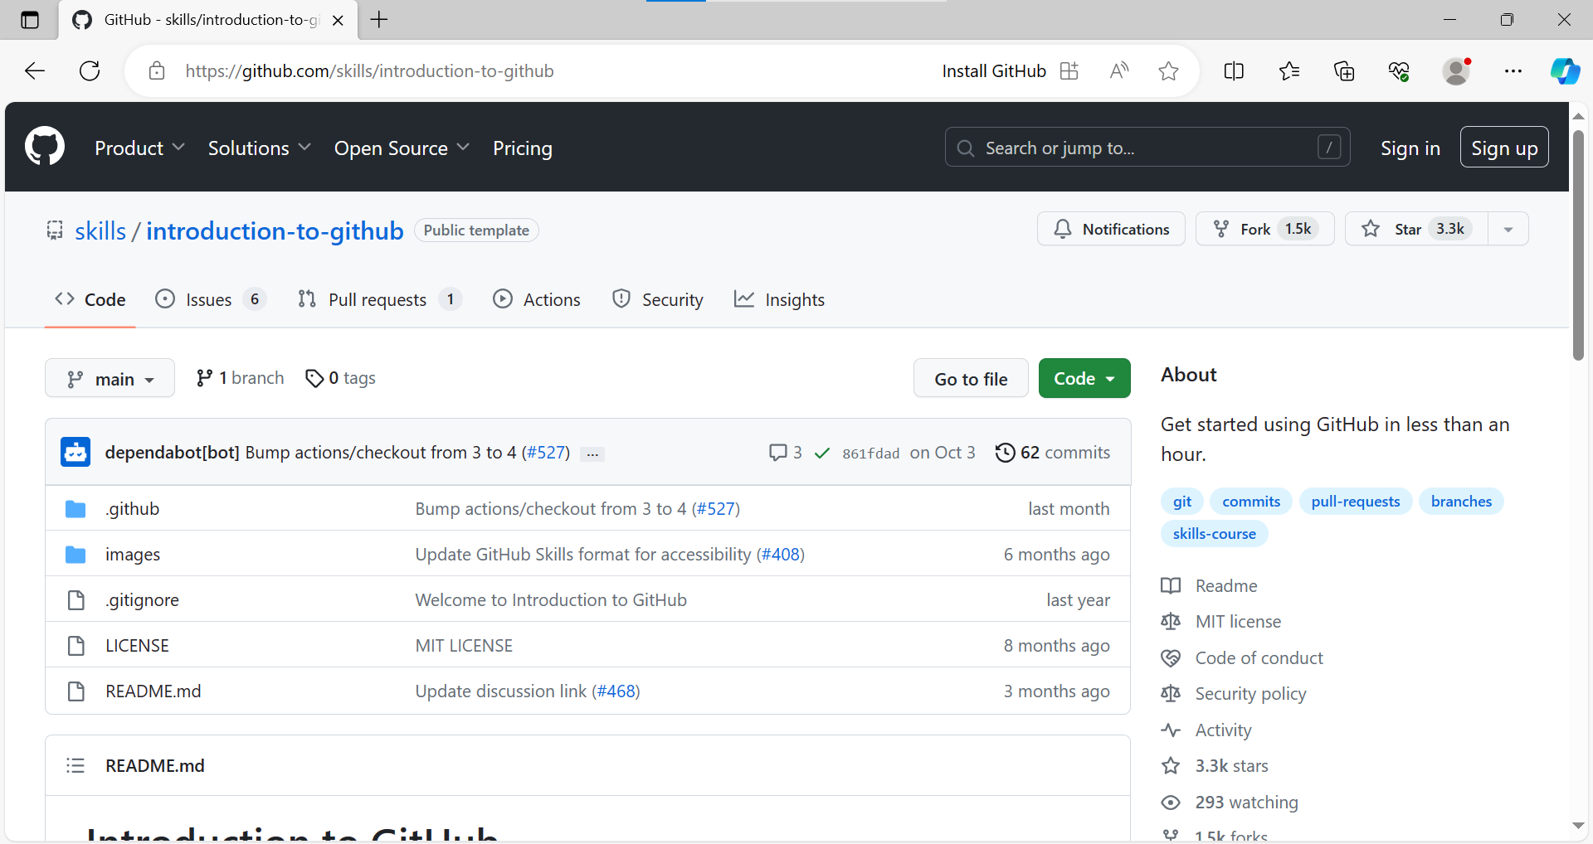

1. **Overview**

The data analysis project aims to investigate and derive meaningful insights from a specific dataset. It involves collecting, cleaning, and processing raw data to uncover patterns, trends, and correlations. Using statistical methods and visualization tools, the project seeks to provide a comprehensive understanding of the data, enabling informed decision-making. The analysis may involve exploring relationships between variables, identifying outliers, and creating predictive models. Throughout the project, a systematic approach is followed, including hypothesis testing and validation of results. The ultimate goal is to offer actionable recommendations or conclusions based on the data findings. The project typically employs programming languages such as Python or R, along with tools like Jupyter Notebooks, to facilitate a transparent and reproducible analytical workflow. Overall, the data analysis project serves to extract valuable insights, enhance understanding, and support evidence-based decision-making in a given domain.

1. **Project Module**
   1. Import the required libraries.
   2. Load/ Read the Dataset
   3. Do Visualizations
   4. Effect of different gases on different states
   5. Prepare Heatmap/ Confusion Matrix
   6. Prepare Profile Report

**6. Sample Screenshots**

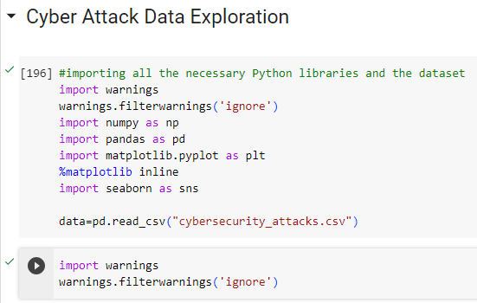

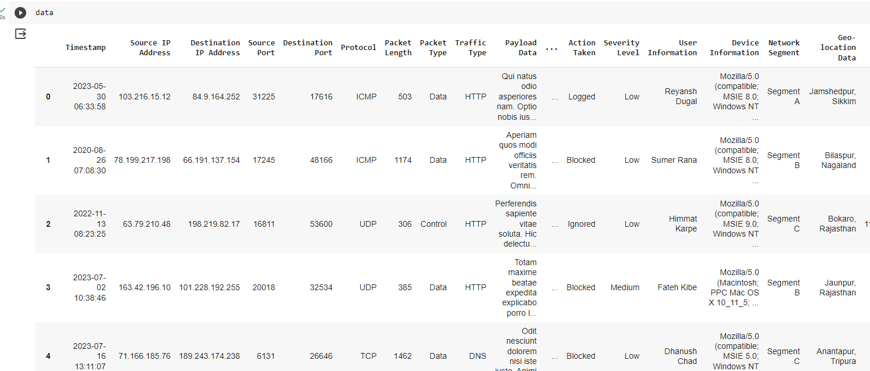

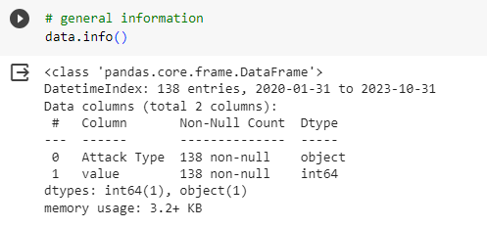

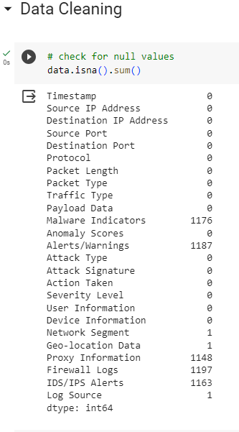

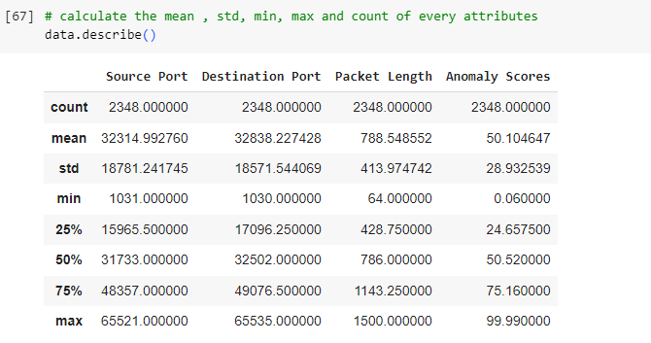

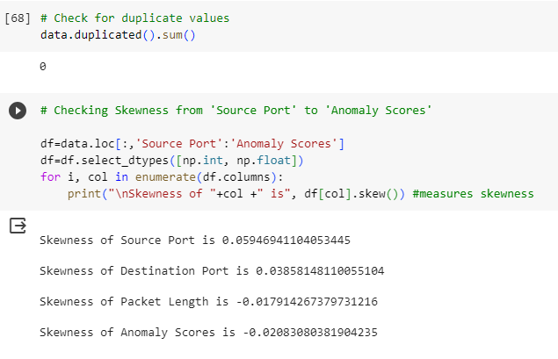

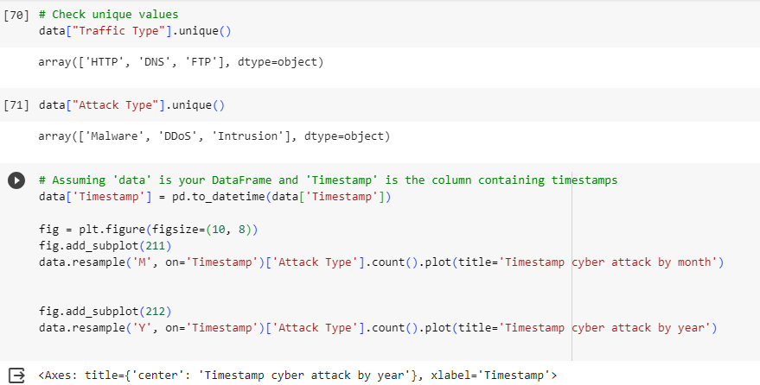

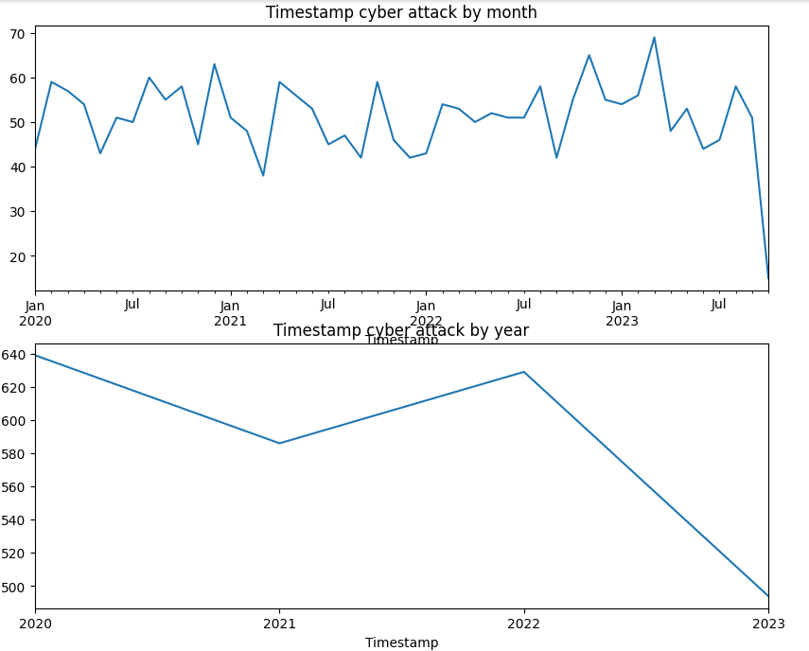

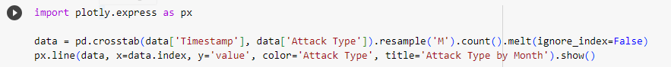

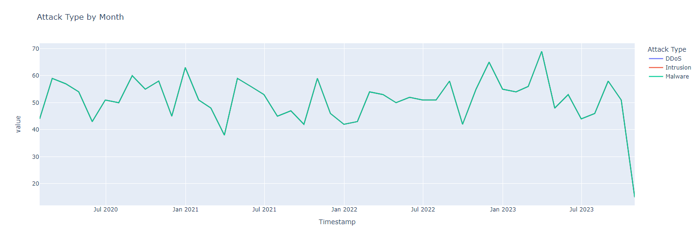

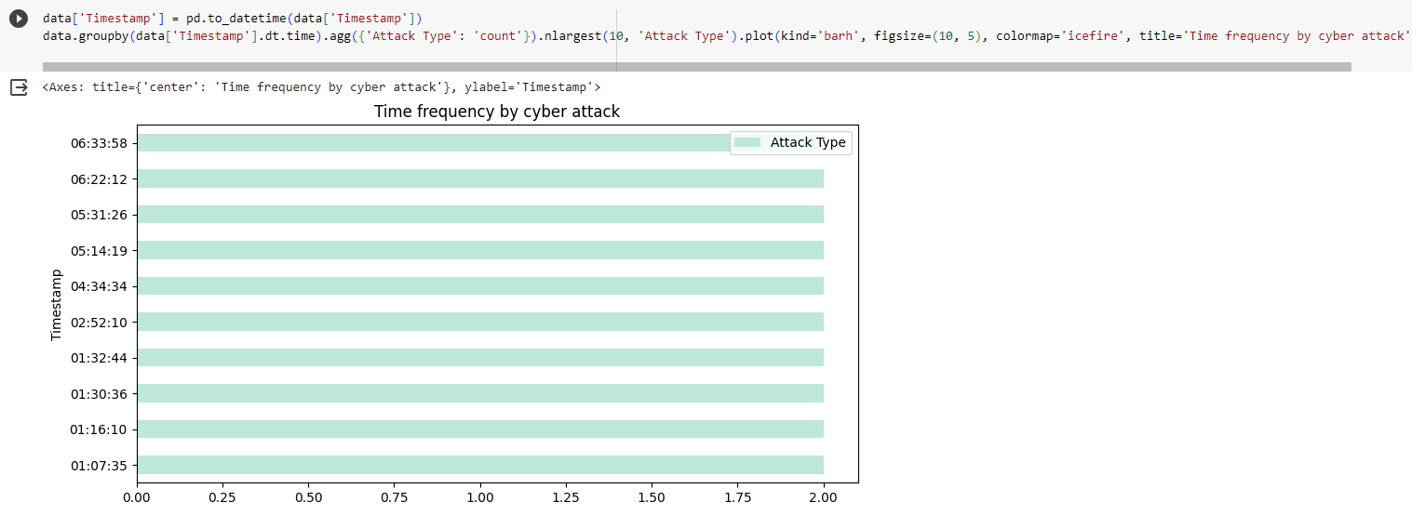

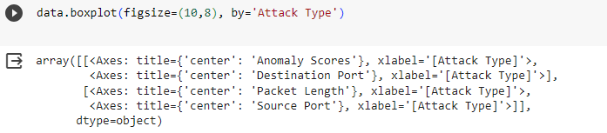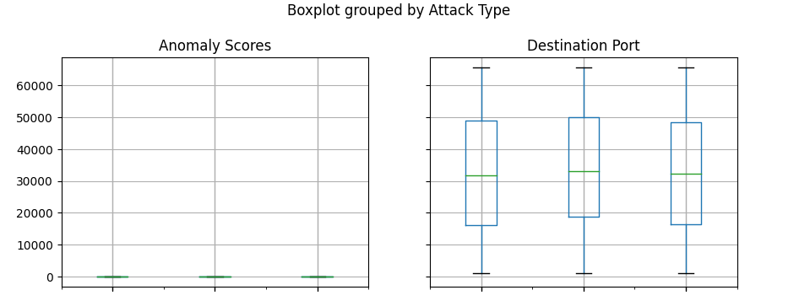

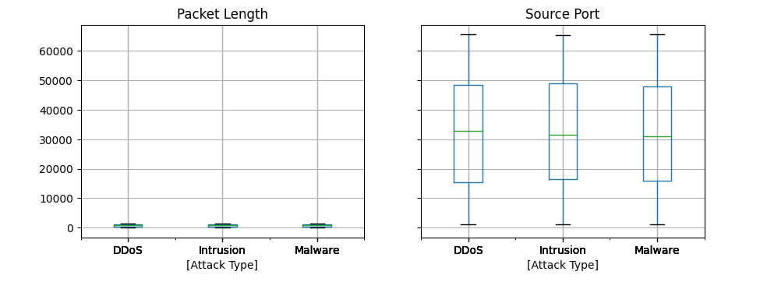

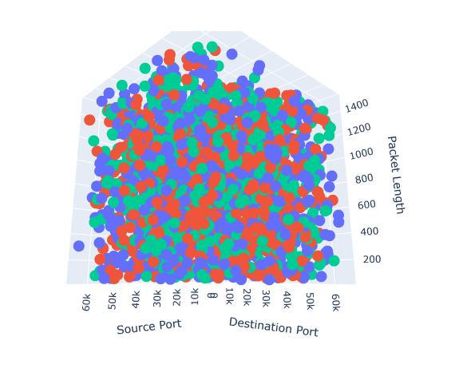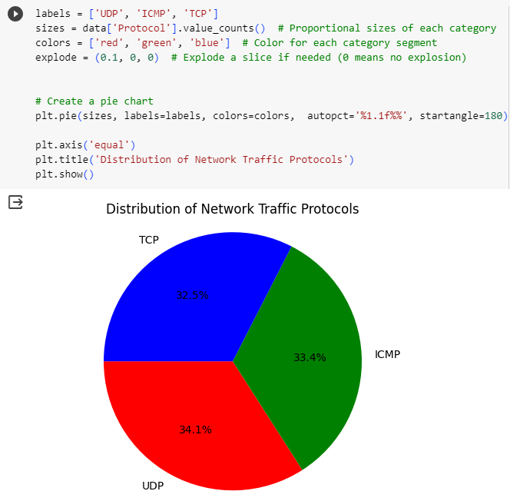

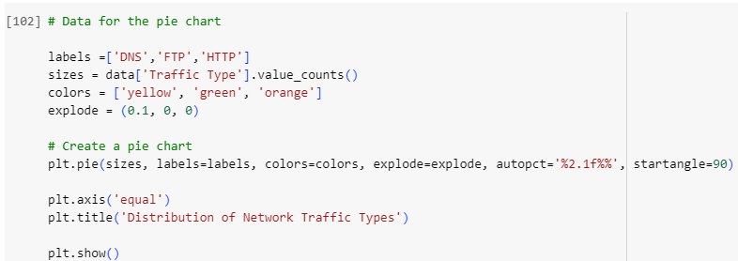

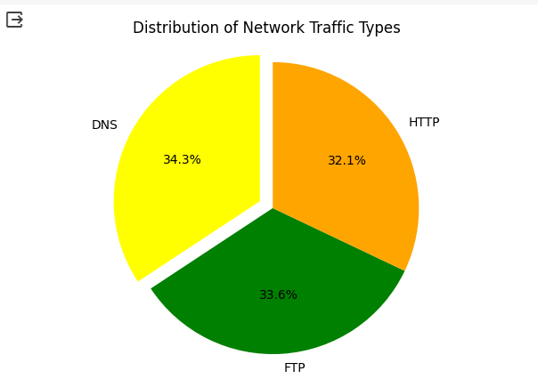

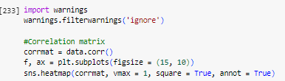

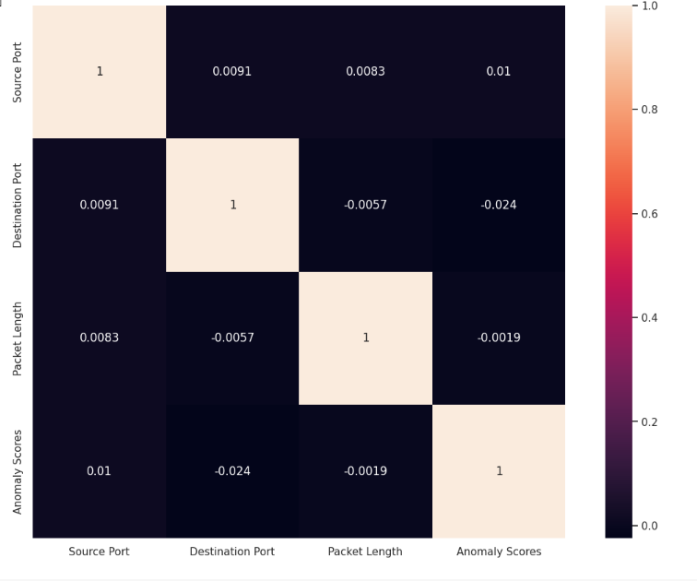

**8 Future Scope**

The future scope for a cyber security attacks data analysis project is vast, given the evolving nature of cyber threats and the increasing reliance on digital technologies. Here are several areas where such a project could have significant impact:

Implementing advanced machine learning algorithms and artificial intelligence to enhance the detection of patterns and anomalies in cyber attack data.

Analyzing user and network behavior to identify abnormal activities that may indicate a cyber attack.

**9 Conclusion**

In conclusion, this cyber security project aims to provide a comprehensive understanding of the current threat landscape, empowering organizations and individuals with the knowledge needed to safeguard their digital assets. By combining data analysis, threat intelligence, and proactive cybersecurity measures, the project seeks to contribute to the ongoing efforts to create a secure and resilient cyberspace.

**10 References**

<https://www.kaggle.com/datasets>

Thank You