Qt File Explorer – Project Description

Project Overview
Qt File Explorer is a desktop application developed using C++ and Qt 6.
The main goal of this project is to build a simple file explorer application using C++ and Qt that allows users to browse and manage files and folders through a graphical interface.
This application allows users to browse folders, manage files, and view file details in a simple and user-friendly way.

Main Features
- Browse files and folders using a tree/list view
- Open files and folders by double-clicking
- Create new files and new folders in the current directory
- Delete files and folders safely
- Rename files and folders
- Copy, cut, and paste files/folders
- Navigate back to the previous directory
- Keyboard shortcuts for faster file operations (such as delete, copy, paste, permanent delete and new file
- View file and folder properties such as:
- Name
- Location
- Type (file or folder)
- Size
- Last modified date

Technologies Used
- Programming Language: C++
- Framework: Qt 6
- Qt Modules: Widgets, QFileSystemModel, QFile, QDir
- IDE: Qt Creator

How to Run the Project
- Open Qt Creator
- Open the project using the .pro file
- Select a Qt 6 kit
- Build and run the application

Design Highlights
- Implemented using Qt Model–View architecture with QFileSystemModel to efficiently represent and manage the file system
- Separation of concerns through modular class design, isolating main UI logic and properties dialog functionality
- Extensive use of Qt’s signal–slot mechanism for handling user interactions and event-driven programming
- Utilization of QFileInfo and QDir APIs for reliable file system operations and metadata retrieval
- Recursive directory traversal for accurate folder size computation
- Context-aware QAction-based menus integrated with toolbar and right-click context menus
- Support for keyboard event handling to enable shortcut-driven file operations
- Dynamic UI updates using model index mapping to reflect real-time file system changes

Future Enhancements
- Tab support to open multiple folders
- Dark mode support
- File preview for text and images
- Drag and drop support
- ZIP and UNZIP feature for files and folders
- Undo and Redo support for file operations
- Thumbnail view for images and videos

Screenshots
Main window
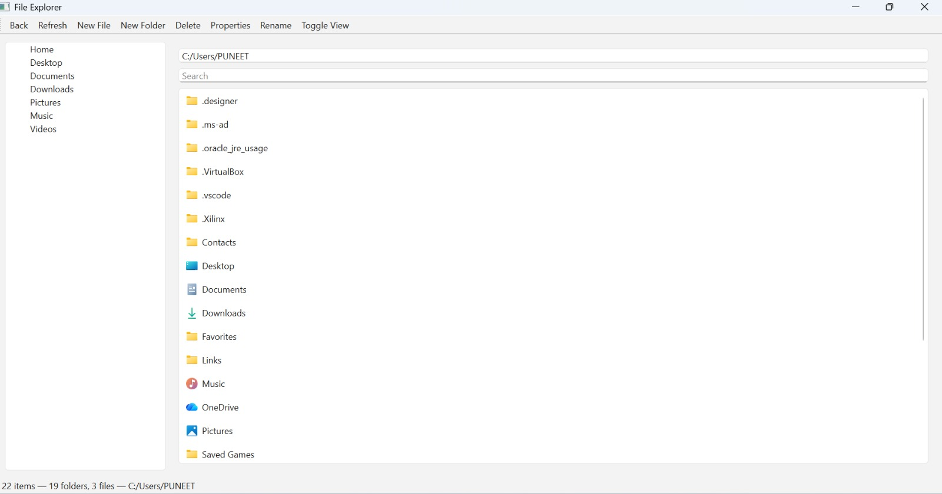
Create New File dialog box
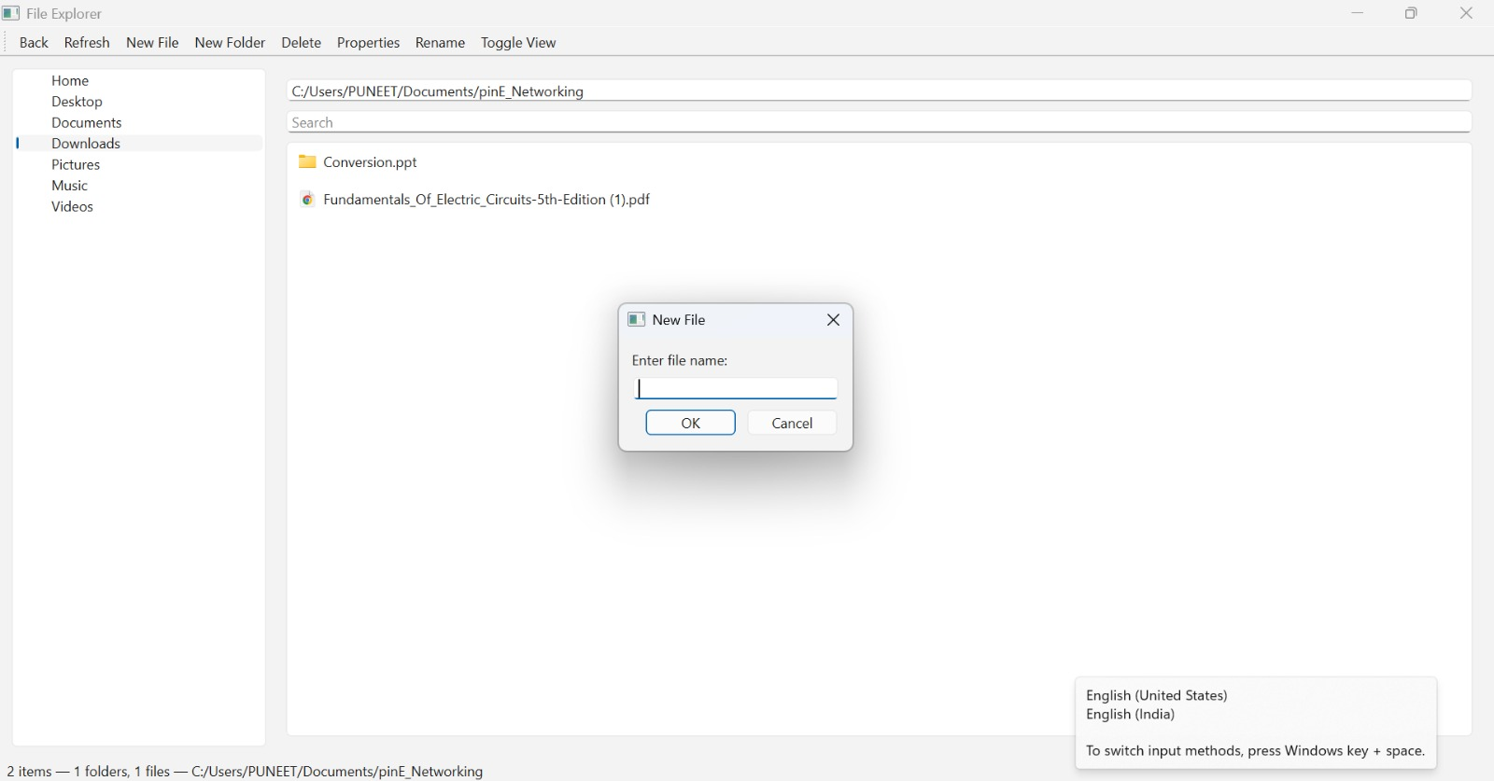

Toggle view
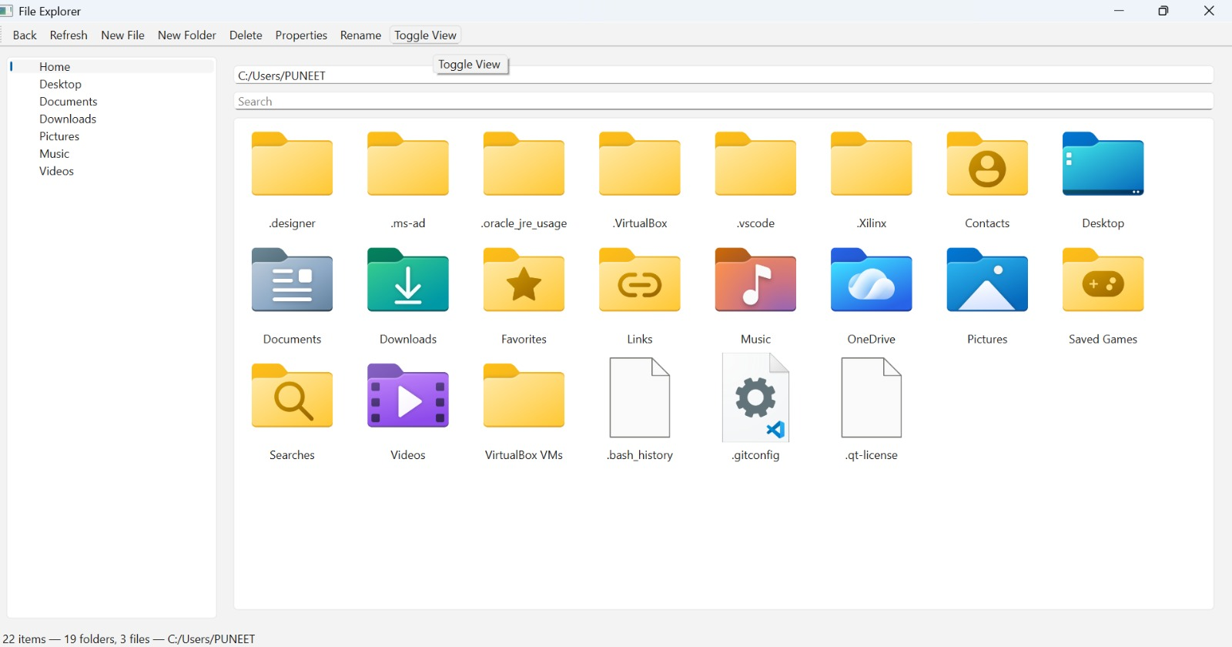
Right click menu-
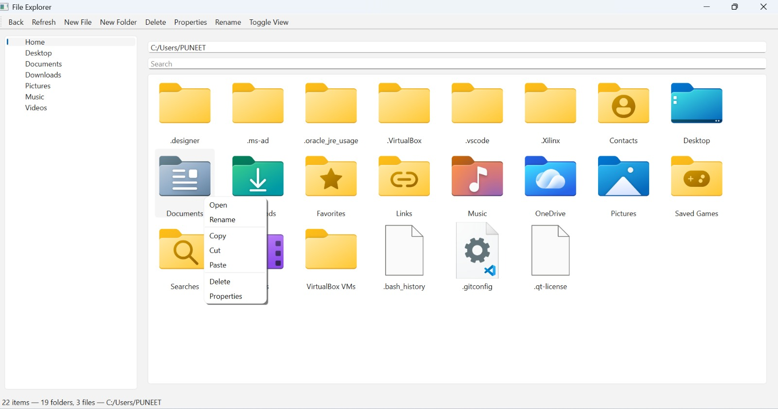

Create New folder Dialog Box
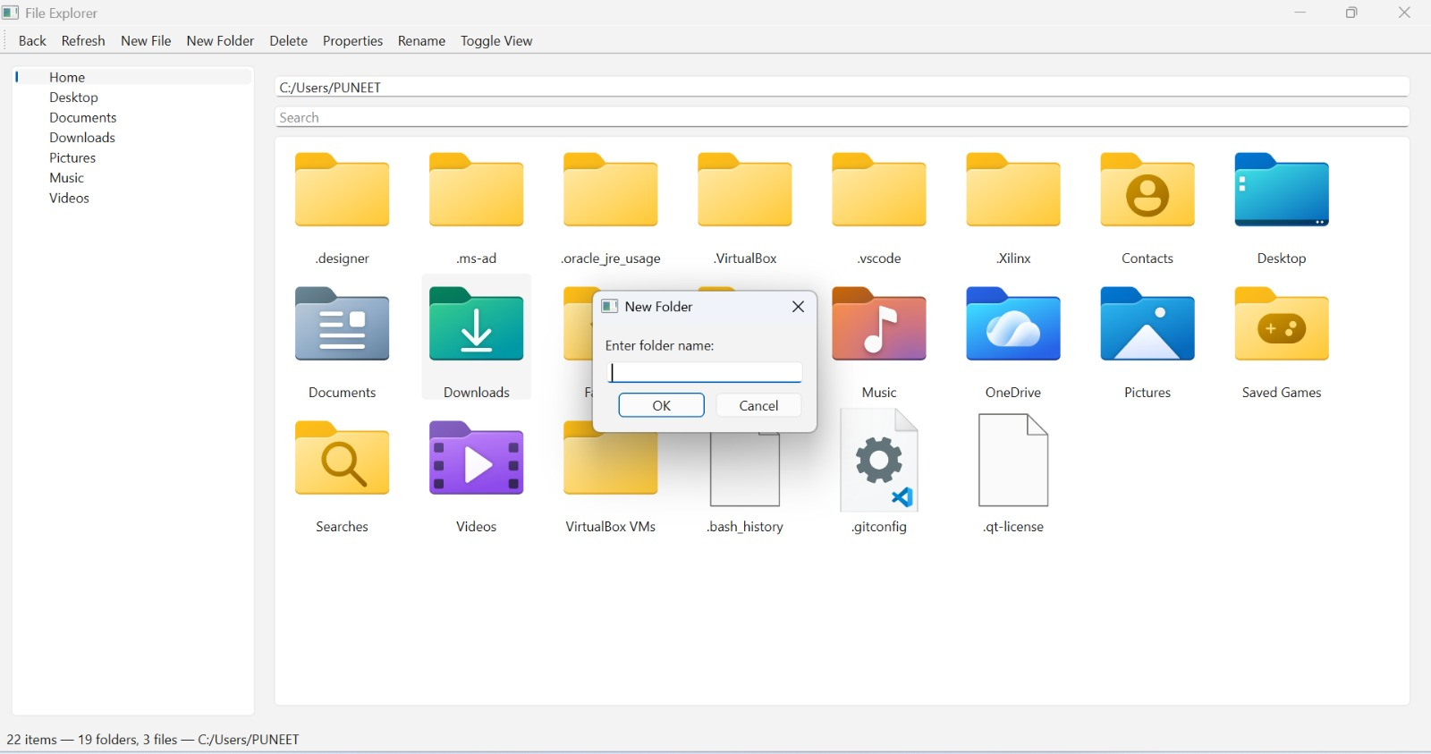
Delete operation
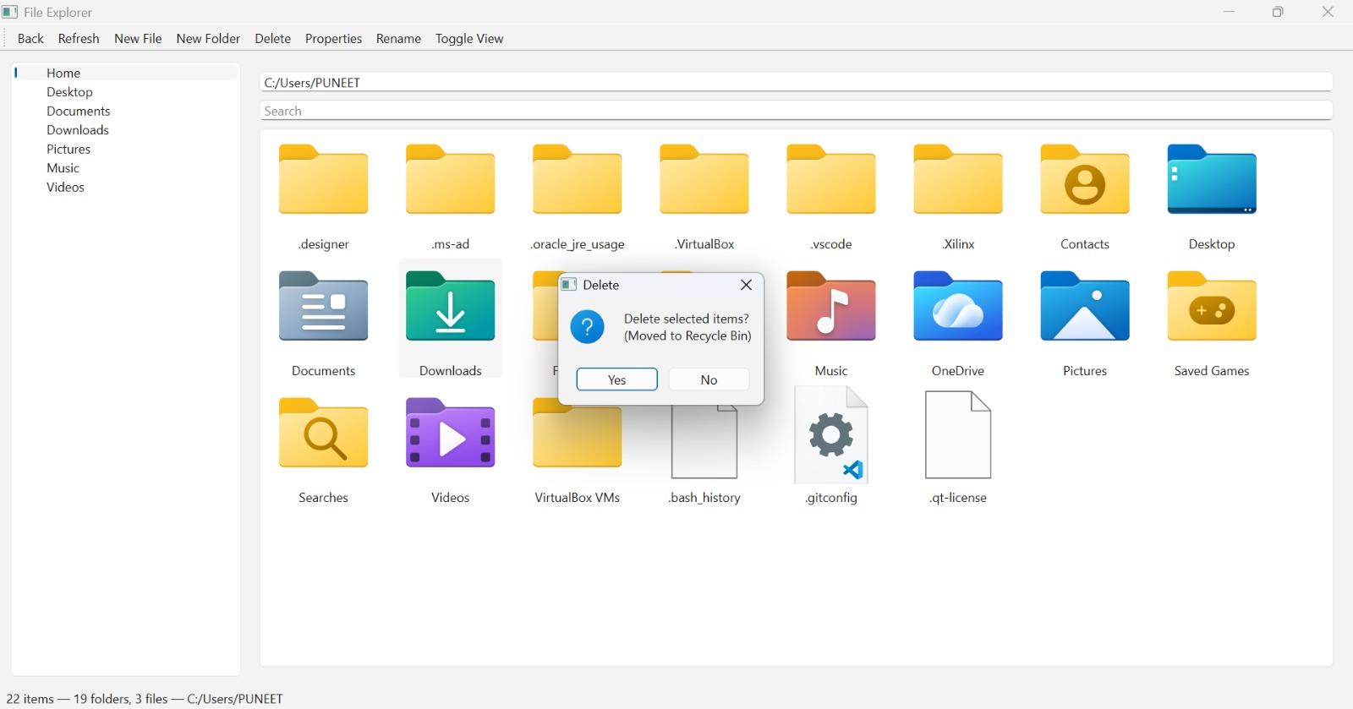

Search operation
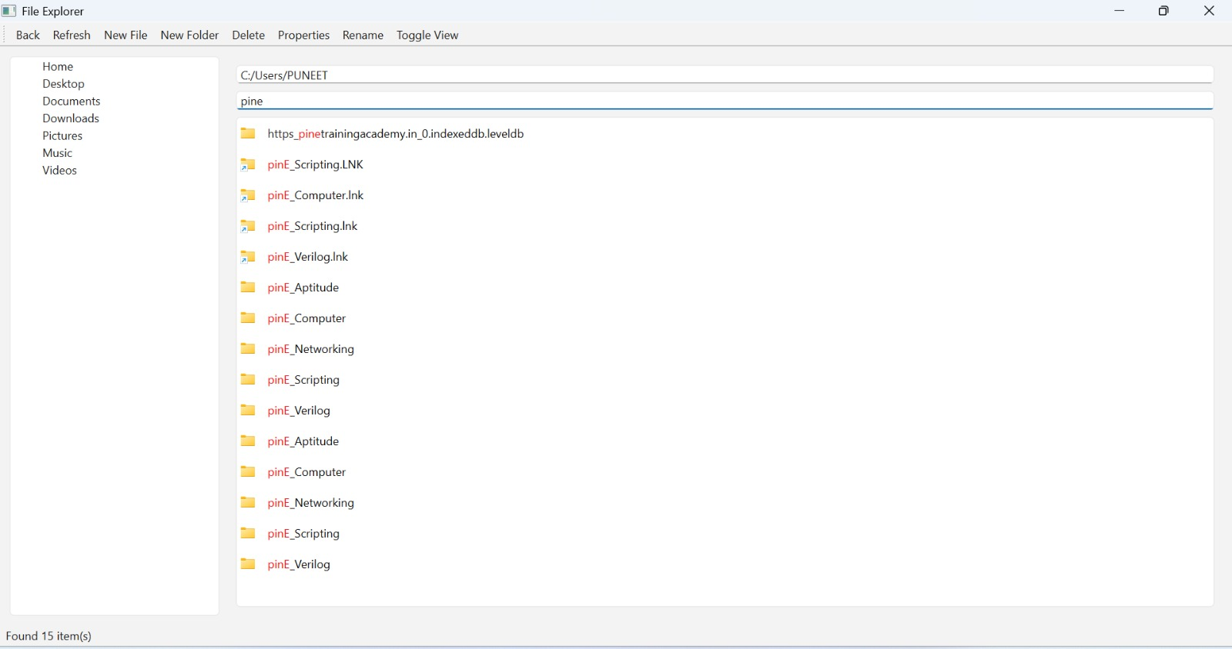
Multiple select
