
TRIBHUVAN UNIVERSITY
ASIAN SCHOOL OF MANAGEMENT & TECHNOLOGY
Final Year Project Report
On
“VOLUNTEER RESPONSE AND VERIFICATION SYSTEM”
Submitted To:
Office of Dean
Institute of Science and Technology
Under the supervision of
Mr. Surya Bam
In partial fulfillment of the requirement for the bachelor’s degree in Computer Science and Information Technology
Submitted By:
Aachal Shrestha (79010936)
Muna KC (79010964)
Roshan Shrestha (79010969)

Shrawan, 2083

SUPERVISOR’S RECOMMENDATION
It is my pleasure to recommend that a report on “Volunteer Response And Verification System” has been prepared under my supervision by Aachal Shrestha, Muna KC and Roshan Shrestha in partial fulfillment of the requirement of the degree of Bachelor of Science in Computer Science and Information Technology (B.Sc.CSIT). Their report is satisfactory to process for the future evaluation.

…………………………………
Mr. Surya Bam
Supervisor
Asian School of Management and Technology

CERTIFICATE OF APPROVAL
This is to certify that this project report entitled “Volunteer Response and Verification System”, submitted by Aachal Shrestha, Muna KC, and Roshan Shrestha, has been examined and approved for the partial fulfillment of the requirements for the degree of Bachelor of Science in Computer Science and Information Technology (B.Sc. CSIT) from Tribhuvan University.

Head / Program Coordinator  Mr. Chakra Narayan Rawal | Supervisor  Mr. Surya Bam
External Examiner | Internal Examiner

ACKNOWLEDGEMENT
We want to express our honest gratitude to all who contributed to this project. Our sincere thanks go to our supervisor, Mr. Surya Bam, who provided us with precious guidance and support throughout the project. Their invaluable expertise, encouragement, and support have been a constant source of inspiration. We would also like to thank Asian School of Management and Technology for providing us with the resources and support needed to complete this project. Finally, we would like to extend our gratitude to our families and friends for their support and encouragement throughout the completion of the project.

With respect,
Aachal Shrestha (79010936)
Muna KC (79010964)
Roshan Shrestha (79010969)

Abstract
The Volunteer Response and Verification System is a web-based platform designed to improve volunteer coordination and NGO accountability in Nepal. It addresses the limitations of fragmented communication methods by providing a structured environment where verified NGOs can publish initiatives, and volunteers can discover and apply for opportunities based on their skills, location, and availability. Built with Next.js, Laravel, and PostgreSQL, the system supports secure role-based access, task assignment, application handling, and organization verification.
The platform also includes decision-support features such as skill matching, location-based filtering, quota control, and priority ranking to improve volunteer selection and task allocation. In addition, it generates digital and a structured impact portfolio to document civic participation and community contribution. Overall, the system aims to enhance transparency, efficiency, and reliability in volunteer management while supporting both routine community programs and urgent response activities.

Keywords: Volunteer Response and Verification System, volunteer management, NGO platform, task allocation, Next.js, Laravel, PostgreSQL

Table of Contents
SUPERVISOR’S RECOMMENDATION i
CERTIFICATE OF APPROVAL ii
ACKNOWLEDGEMENT iii
Abstract iv
List of Abbreviations vii
List of Figures viii
List of Tables ix
Chapter 1: Introduction 1
1.1 Introduction 1
1.2 Problem Statement 2
1.3 Objectives 2
1.4 Scope and Limitations 2
1.4.1 Scope 2
1.4.2 Limitations 3
1.5 Development Methodology 3
Iteration 4: Application Workflow & NGO Portal 4
Iteration 5: Analytics, Optimization & Release 5
1.6 Report Organization 5
Chapter 2: Background Study and Literature Review 7
2.1 Background Study 7
2.2 Literature Review 8
Chapter 3: System Analysis 10
3.1 System Analysis 10
3.1.1 Requirement Analysis 10
3.2. Feasibility Study 14
3.2.1. Technical Feasibility 14
3.2.2. Operational Feasibility 15
3.2.3. Economic Feasibility 15
3.2.4. Schedule Feasibility 15
Chapter 4: System Design 16
4.1 System Design 16
4.1.1 System Architecture 16
4.1.2 Database Design 18
4.1.3 User Interface Design 20
4.2 Algorithm Details 21
4.2.1 Priority-Based Ranking Algorithm 21
4.2.2 Haversine Formula 23
Chapter 5: Implementation and Testing 24
5.1 Implementation 24
5.1.1 Tools Used 24
5.1.2 Frontend Implementation 24
5.1.3 Backend Implementation 25
5.2 Testing 26
5.2.1 Test Cases for Unit Testing 26
5.2.2 Test Cases for Integration Testing 26
5.2.3 Test Cases for System Testing 27
Chapter 6: Conclusion and Future Recommendations 28
6.1 Conclusion 28
6.2 Future Recommendations 28
References 30
Appendices 31

List of Abbreviations
API Application Programming Interface
CSS Cascading Style Sheets
CRUD Create, Read, Update, Delete
DBMS Database Management System
ERD Entity-Relationship Diagram
GUI Graphical User Interface
HTTPS HyperText Transfer Protocol Secure
ICT Information and Communication Technology
JWT JSON Web Token
MVC Model-View-Controller
NGO Non-Governmental Organization
ORM Object-Relational Mapping
REST API Representational State Transfer API
RBAC Role-Based Access Control
UI User Interface
UX User Experience
VRVS Volunteer Response and Verification System
SQL Structured Query Language

List of Figures
Figure 1.1 Incremental Delivery………………………. ...................................................5
Figure 2.1 Use Case for VRVS System 11
Figure 3.1 Gantt Chart…………………………………....................……………………15
Figure 4.1 System Architecture..........................................................................................16
Figure 4.2 ER Diagram ………….....................................................................................18

List of Tables
Table 3.1 Use Case Scenario for Volunteer Operations ...............................................12
Table 3.2 Use Case Scenario for Organization Operations ..........................................13
Table 5.1 Technology Stack for the VRVS System ...................……………………...23
Table 5.2 Unit Test Cases .............................................................................................25
Table 5.3 Integration Test Cases ....................................................................................25
Table 5.4 System Test Cases ..........................................................................................25

Chapter 1: Introduction

1.1 Introduction
Volunteer participation plays a vital role in strengthening social development, disaster response, and community resilience, especially in developing countries like Nepal where natural disasters such as floods, landslides, and earthquakes frequently occur. Effective volunteer coordination ensures timely assistance, efficient resource utilization, and improved community support during both emergency and non-emergency situations.
In Nepal, most volunteer coordination activities are still managed through informal communication channels such as Facebook groups, Messenger, Viber, and phone calls. Although these tools provide accessibility, they lack structured mechanisms for verifying volunteer skills, tracking participation, and ensuring accountability. As a result, organizations often face challenges such as inefficient volunteer allocation, duplicate assignments, delayed response during emergencies, and absence of proper documentation of volunteer contributions.
To address these limitations, this project introduces VRVS: Volunteer Response and Verification System, a centralized web-based platform designed to improve the way volunteers and organizations interact. The system enables NGOs to publish tasks or social initiatives, while volunteers can register, apply based on skills and location, and receive verified digital recognition upon task completion.
VRVS is developed using modern web technologies including Next.js for the frontend, Laravel for backend services, and PostgreSQL for database management. The system also integrates intelligent matching mechanisms such as skill-based filtering, geolocation-based task discovery, and priority-based volunteer selection. Additionally, it introduces a Digital Impact Portfolio, where verified volunteer activities are stored and represented through digital badges, ensuring transparency and credibility of social contributions.

1.2 Problem Statement
In Nepal, the absence of a centralized digital infrastructure for social service has led to fragmented and inefficient volunteer coordination. Currently, NGOs and local clubs rely heavily on informal social media groups for recruitment, which lack the necessary tools for verifying volunteer skills, tracking real-time participation, and validating work completion. This results in significant operational delays during emergencies, such as floods or landslides, where identifying specific expertise like first aid or logistics is critical. Furthermore, volunteers lack a credible way to document their contributions, as traditional paper certificates are easily misplaced and difficult for future employers to verify. Without a structured system like VRVS, the collective impact of civic engagement remains undocumented, and the mobilization of help remains reactive rather than organized.

1.3 Objectives
The objectives of this project are as follows:
- To develop a centralized platform for volunteer registration, NGO task posting, and application management.
- To implement skill- and location-based matching for faster and more accurate volunteer selection.
- To provide verified digital badges that build a credible volunteer impact portfolio.

1.4 Scope and Limitations

1.4.1 Scope
VRVS is a secure, web-based platform designed to connect NGOs and volunteers in a single system that simplifies coordination, task management, and participation tracking. The platform allows NGOs to create and manage volunteer opportunities, while volunteers can browse tasks, apply for opportunities, and maintain updated profiles. It provides role-based access for different user types, including admin, NGO, and volunteer users, to ensure each user can access only the features relevant to them.
The system supports NGO and volunteer profile management, task creation and assignment, category-based task organization, and application tracking. It also includes badge and skill support to help improve user engagement and task matching. The application is built as a responsive web platform using Next.js for the frontend and Laravel for the backend, with RESTful APIs enabling communication between the client and server. Data persistence is handled through a relational database, and file handling is supported for profile and document-related needs.
Security and privacy are enforced through authentication, authorization, password hashing, and protected API access. The scope of the current release is limited to core volunteer management and coordination features. Out of scope are native mobile applications, real-time chat, payment or donation processing, advanced analytics dashboards, and external integrations such as SMS notifications or third-party communication services.

1.4.2 Limitations
- Feature Scope: The current release of VRVS is limited to core NGO-volunteer coordination, including profile management, task posting, task applications, and badge/skill support.
- Communication Depth: VRVS does not provide real-time chat, video calling, or in-app messaging between users. Communication is limited to the workflow supported by the application.
- Notifications: Automated SMS alerts, push notifications, and third-party email notification services are not implemented in the current version.
- Payments and Donations: The system does not support payment collection, donations, billing, or financial transaction processing.
- Analytics and Reporting: Advanced dashboards, predictive analytics, and detailed reporting tools are outside the current scope of the project.
- Mobile Access and Integrations: VRVS is a web-based application only and does not include native mobile apps or broad third-party integrations in the current release.

1.5 Development Methodology
VRVS is developed using the Agile methodology, allowing flexibility, continuous improvement, and iterative delivery throughout the development process. The project is divided into multiple sprints, where both frontend and backend features are gradually developed and improved based on feedback. The system uses Next.js with TypeScript for the frontend, Laravel with PHP for the backend, PostgreSQL as the database, JWT for authentication, and role-based access control to manage volunteers and NGOs securely.
Iteration 1: Foundation & Authentication
- Set up the development environment with Next.js, Laravel API, and PostgreSQL.
- Configured environment variables, linting, and formatting tools.
- Created wireframes and responsive UI using Tailwind CSS.
- Developed core pages such as Home, Login/Register, Volunteer Dashboard, and NGO Dashboard.
- Implemented volunteer and NGO registration/login functionality.
- Added JWT authentication and protected routes.
- Enabled role-based navigation and access control.
Iteration 2: User Profiles & Data Models
- Developed volunteer and NGO profile management systems.
- Added volunteer skills, badges, and profile details.
- Implemented profile creation, update, deletion, and document upload features.
- Created Eloquent models for: Volunteer, NGO, Task, Application, Skill ,Badge
- Added database validation and indexing for performance optimization.
- Implemented role-aware navigation and protected frontend routes.
Iteration 3: Task Management & Search
- Developed task creation, update, deletion, and management features for NGOs.
- Added task categories, skill requirements, and quota tracking.
- Implemented search functionality using: Keywords, Categories, Districts, Skills
- Added filtering and pagination systems.
- Improved API performance and error handling.
- Conducted testing for task creation and search accuracy.

Iteration 4: Application Workflow & NGO Portal
- Enabled volunteers to apply for tasks.
- Implemented application status tracking: Pending, Accepted, Rejected, Completed
- Built NGO application management dashboard.
- Added volunteer acceptance/rejection system.
- Implemented notifications for application status updates.
- Strengthened security with: JWT role verification, bcrypt password hashing, Input validation, Prepared statements
- Improved dashboard UI/UX and mobile responsiveness.

Iteration 5: Analytics, Optimization & Release
- Enhanced volunteer dashboard with: Trending tasks, Recent applications, Engagement metrics, Skill-based recommendations
- Developed NGO analytics dashboard with: Task performance tracking, Application trends, Volunteer engagement analytics, Success rate visualization
- Finalized role permissions and secure access flows.
- Improved session handling and error messaging.
- Conducted: Unit testing, Integration testing, System testing
- Fixed bugs and optimized performance.
- Completed documentation and deployment preparation.
- Prepared the system for production release and stakeholder approval.
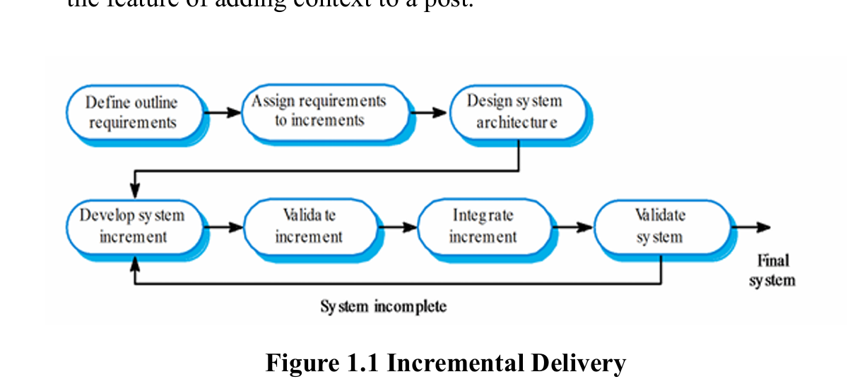
Figure 1.1 Incremental Delivery

1.6 Report Organization
This project report is divided into the following chapters:
Chapter 1: Introduces the VRVS platform, including the problem statement, objectives, scope, limitations, and development methodology. This chapter provides the overall background and purpose of the project.
Chapter 2: Reviews related literature and existing systems relevant to volunteer coordination platforms. It discusses theoretical concepts and identifies gaps in current solutions.
Chapter 3: Focuses on the system analysis of the proposed platform. It includes requirement analysis, feasibility analysis, and Use Case Diagrams showing interactions between users and the system.
Chapter 4: Describes the system design and architecture. It includes the Entity-Relationship Diagram (ERD), database structure, user interface design, and backend workflow design.
Chapter 5: Explains the tools and technologies used during development and discusses the testing methods applied to verify system functionality, performance, and reliability.
Chapter 6: Presents the final outcomes of the project, evaluates the overall system performance, and provides recommendations and future enhancements for further improvement of the platform.

Chapter 2: Background Study and Literature Review

2.1 Background Study
Volunteer coordination has significantly evolved with the advancement of digital technology. Traditionally, NGOs and community organizations relied on manual methods such as paper records, phone calls, and spreadsheets to manage volunteers and activities. However, these approaches were often inefficient, time-consuming, and difficult to scale. With the increasing growth of social impact initiatives and Corporate Social Responsibility (CSR) programs, the demand for efficient digital volunteer coordination systems has increased rapidly.
Several volunteer management solutions currently exist, including HR systems, generic task management platforms, spreadsheet-based tracking, and proprietary NGO software. Despite offering basic functionalities, many of these systems are either expensive, difficult to customize, or not specifically designed for NGO-volunteer coordination. Common limitations include poor scalability, lack of role-based management, complex interfaces, and limited volunteer engagement features. As a result, many NGOs still depend on fragmented and manual workflows.
VRVS aims to address these challenges by providing a dedicated volunteer coordination platform designed specifically for NGOs and volunteers. The system focuses on efficient task management, volunteer applications, secure authentication, role-based access control, and user-friendly interaction. It also includes search, filtering, and analytics features to improve coordination and engagement.
Modern web application development commonly uses frontend technologies such as React, Next.js, and Vue.js, along with backend frameworks like Laravel, Django, and Express.js. Relational databases such as PostgreSQL and MySQL are widely used for reliable data management. VRVS is developed using Next.js with TypeScript for the frontend, Laravel with PHP for the backend, PostgreSQL for database management, JWT for authentication, and Tailwind CSS for responsive user interface design.

2.2 Literature Review
Several digital volunteer management systems and studies have been developed to improve coordination, engagement, and efficiency in both emergency response and community service initiatives. Contemporary research highlights the increasing role of digital tools in supporting volunteer programs globally.
International platforms such as UN Volunteers, VolunteerMatch, and Red Cross Digital Volunteer Systems offer structured approaches for volunteer registration, skill-based task assignment, and contribution tracking. These platforms emphasize centralized databases, transparency, and digital documentation to strengthen accountability and engagement among volunteers and organizations [1], [2].
Studies on digital volunteer services during emergency situations show that such systems can significantly reduce response time and improve organizational trust through verified participation records [3]. Similarly, research on volunteer crowdsourcing platforms highlights the importance of skill-based and willingness-aware task assignment to improve operational efficiency when matching volunteers to tasks [6].
Platforms like Ushahidi and GoodSAM utilize technology-driven coordination models, enabling rapid mobilization of volunteers based on availability, proximity, and expertise during crisis and emergency situations [7], [8]. These systems demonstrate how automation and data-driven decision-making can improve response outcomes and resource utilization.
In the context of Nepal, volunteer coordination remains largely informal and decentralized. Most NGOs, youth clubs, and community groups depend on social media platforms such as Facebook, Messenger, and Viber for volunteer recruitment and communication. While these platforms provide wide outreach, they lack essential technical features such as skill verification, structured task allocation, real-time availability tracking, and validated record keeping [4]. Furthermore, volunteer contributions are typically documented through paper certificates or informal acknowledgments, which are difficult to authenticate and often lost over time.
Apart from simple filtering methods, some studies have used weighted scoring models to match two parties in a resource-limited platform. In such models, different factors like location match, skill match, and credibility are given separate weights, and a final score is calculated by combining all these weighted factors together. This gives a transparent way of ranking that is easy to understand and justify [9]. This idea supports the design of VRVS's Priority-Based Ranking Algorithm, which also combines skill relevance, distance, and trust score into one final score to rank volunteers for a task.
Another common problem in online platforms is how to evaluate new users who do not have any past history or record. This is known as the cold-start problem. Some research has solved this by using trust and reputation factors along with a referral system, so that new users are not unfairly ranked low just because they are new [10]. This is similar to the trust-scoring approach used in VRVS, where new volunteers can still build their trust score gradually instead of being excluded from task selection due to having no prior participation record.
Although international systems provide robust frameworks, they are not fully adaptable to Nepal's local conditions due to challenges such as difficult terrain, frequent natural disasters, inconsistent internet connectivity, and varying organizational capacities. Additionally, most global platforms do not account for Nepal-specific emergency patterns or localized community engagement practices.
This highlights a significant research and implementation gap for a localized digital volunteer coordination platform that supports verified digital credentials, disaster-oriented response mechanisms, and skill-based volunteer matching tailored to Nepal's socio-technical environment.
VRVS aims to fill this gap by offering a centralized Nepal-focused system that integrates volunteer profiling, rule-based and weighted scoring algorithms for skill matching, real-time disaster alerts, and secure digital portfolios. By enabling transparent coordination and verified contribution records, the platform seeks to improve efficiency, accountability, and trust between volunteers and organizations, transforming volunteer mobilization from reactive to structured and resilient.

Chapter 3: System Analysis

3.1 System Analysis

3.1.1 Requirement Analysis
The requirement analysis for VRVS focuses on understanding the operational needs of volunteers, NGOs, and administrators while ensuring efficient coordination and secure data management. Functionally, the platform supports user registration and authentication, role-based dashboards, task posting and management, volunteer application workflows, profile and document management, and search and filtering capabilities for volunteer opportunities. Non-functional requirements emphasize security through authenticated access and role-based permissions, along with reliability, responsiveness, usability through a modern web interface, and scalability to support multiple organizations and increasing user activity. These requirements were identified through analysis of existing volunteer coordination challenges and digital platform workflows to ensure the system remains practical, maintainable, and suitable for real-world NGO operations.

3.1.1.1 Functional Requirements
Functional requirements define what the system should do and how it should behave under specific conditions. For the system, the core functional requirements include:
- Role-Based Access Control (RBAC): The system must distinguish between three primary actors: Volunteers (Citizens), Organizations (NGOs/Clubs) and Admin.
- Volunteer Profiles: Users can create profiles highlighting their skills (e.g., First Aid, Logistics, Tech), availability, and location.
- Organization Verification: NGOs must be able to register and provide basic details to post "Social Needs."
- Impact Portfolio: A public-facing profile for volunteers.
- Campaign Management: Organizations can create, edit, and close "Social Needs" posts.
- Each post must specify: Category (Regular vs. Emergency/Disaster), Required skills, Volunteer quota (number of people needed).
- Skill-Based Filtering: Volunteers must be able to search and filter opportunities based on their specific skill sets and location.
- Application Workflow: Volunteers can "Apply" to a post, and Organizations can "Accept" or "Reject" applicants through a simple dashboard.
- Attendance Validation: A simple "Verify Completion" button for NGOs to confirm a volunteer attended and finished the task.
- Automated Badge Issuance: Upon NGO verification, the system must automatically generate a Digital Badge linked to the user's profile.

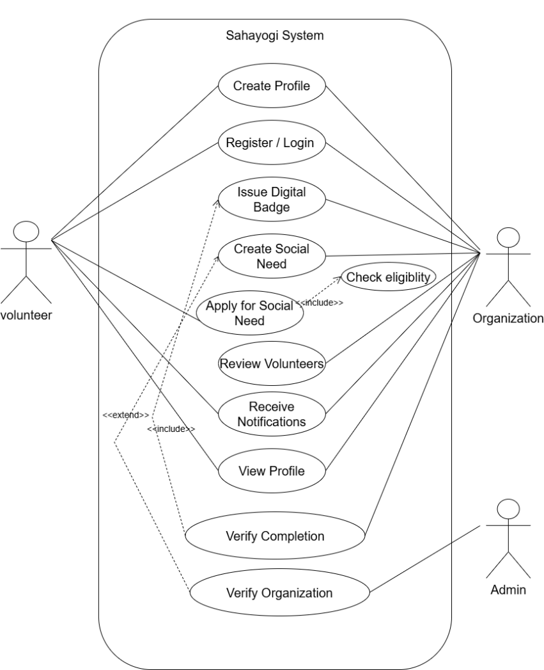
Figure 3.1 Use Case for VRVS System
Use Case | Volunteer Operations
Primary Actor | Volunteer
Flow of Events | - Volunteer needs to discover volunteer opportunities.  - Volunteer logs into VRVS.  - Volunteer opens "Discover Tasks".  - Volunteer views available social needs and opportunities.  - Volunteer applies filters by category, region, and skill requirement.  - Volunteer selects a specific task to review.  - Volunteer reads task description, requirements, and deadline. 8. Volunteer clicks "Apply" button.  - System saves application and shows confirmation message
Pre-Conditions | - The volunteer must have access to the internet.  - The volunteer must be registered and have an account in the system.  - The volunteer must be logged into the system.  - The volunteer must have skills/qualifications matching the task requirements.
Post-Conditions | - The volunteer's task list is displayed with/without filtering applied.  - Application is submitted and recorded with timestamp.  - Volunteer can track application status on dashboard.  - Organization receives notification of new application.  - System sends confirmation to volunteer.
Quality | - System provides valid responses for all actions.  - Volunteer data is secure, and access is role-restricted.
Table 3.1 Use Case Scenario for volunteer operations

Use Case | Organization Operations
Primary Actor | Organization
Flow of Events | - Organization needs to post a volunteer opportunity.  - Organization logs into VRVS.  - Organization navigates to "Create Social Need".  - Organization enters task details (title, description, category).  - Organization specifies required skills and qualifications.  - Organization sets volunteer quota and deadline.  - Organization reviews and publishes the task.  - System saves the task and makes it visible to volunteers.  - System sends confirmation message to organization.  - Organization can view applications from volunteers.  - Organization reviews volunteer profiles and applications.  - Organization approves or rejects volunteers.  - System records decision and notifies volunteer.
Pre-Conditions | - Internet access and a registered organization account with valid verification.  - Organization is logged in and verified by admin.  - Organization has defined the task requirements clearly.
Post-Conditions | - New task is published and visible to all volunteers.  - Task appears in volunteer search and discovery.  - Applications from volunteers are recorded with timestamps.
Quality | - System provides valid responses for all actions.  - Organization data is secure, and access is role-restricted.
Table 3.2 Use Case Scenario for organization operations

3.1.1.2 Non-Functional Requirements
Non-functional requirements define how the system performs rather than what it does. These ensure following things:

Performance: The system should handle multiple user requests, such as searching and applying for tasks, without slowing down.

Scalability: The system should be designed so it can support more volunteers and NGOs in the future without major changes to the architecture.

Usability: The interface should be simple and easy to use for both volunteers and NGO staff.

Security: User data and documents must be protected using JWT-based authentication and role-based access control, so users can only access features relevant to their role.

Reliability: The system should work correctly and consistently, especially when volunteers need to be matched quickly for emergency tasks.

Availability: The platform should be accessible whenever NGOs or volunteers need it, especially during disaster response situations.

Maintainability: The system should be easy to update, with a modular structure (separate frontend and backend) that supports adding new features later.

3.2. Feasibility Study
A feasibility study evaluates whether a project can be successfully developed, implemented, and maintained. It considers various factors such as technical availability, user accessibility, cost-effectiveness, and timely delivery. The key areas of feasibility assessed for this project are as follows:

3.2.1. Technical Feasibility
The project is technically viable using the selected modern web stack. Laravel 12 on the backend provides secure authentication, database migrations, and flexible API routing, which together reduce development complexity and save time. On the frontend, Next.js 15, a React-based framework, enables the creation of fast, SEO-friendly, and mobile-responsive interfaces, which is essential for volunteers accessing the platform from the field. PostgreSQL is used as a relational database to ensure data integrity for volunteer records, campaigns, and digital badges. The development team has a foundational understanding of JavaScript and PHP, and the extensive documentation and community support available for these frameworks allow technical challenges to be resolved efficiently.

3.2.2. Operational Feasibility
VRVS is designed to integrate seamlessly into Nepal’s existing social ecosystem. The platform provides clear benefits to NGOs by automating volunteer tracking and reducing coordination challenges that often arise when campaigns are managed through social media. Volunteers are motivated through the Digital Badge system, which allows them to build a verifiable Impact Portfolio that can be used for resumes, academic applications, or professional growth. The platform’s interface is designed for zero-training adoption, ensuring that even local community groups with basic technical literacy can manage campaigns effectively. By addressing both organizational and user needs, the system is operationally practical and sustainable.

3.2.3. Economic Feasibility
The project is cost-effective, making it suitable for a student-led initiative. The chosen tech stack, including Laravel, Next.js, and PostgreSQL, is entirely open-source, eliminating licensing costs. Development and initial testing can be conducted on local machines, while final deployment can use free-tier cloud hosting services such as Vercel for the frontend and Render or Railway for the backend and database. Human resources are entirely handled by the student development team, which removes the need for external labor expenses. These factors make the project economically feasible with minimal financial risk.

3.2.4. Schedule Feasibility
The project timeline is estimated to span between 1 to 3 months, depending on the availability and efficiency of the team members involved. The proposed schedule is as follows:
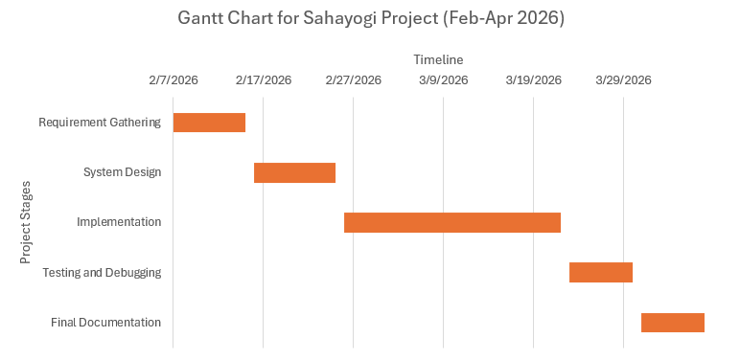
Figure 3.3 Gantt Chart
  - Analysis
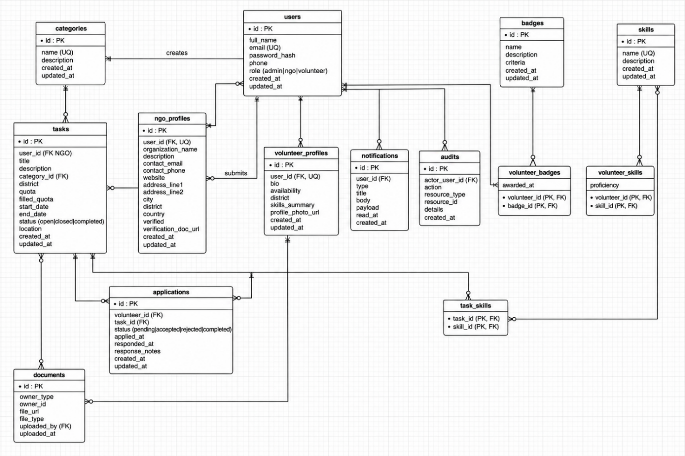
3.1.1.3 Er Diagram

Figure 3.4 : Er Diagram

3.1.1.4 DFD level-0 Diagram
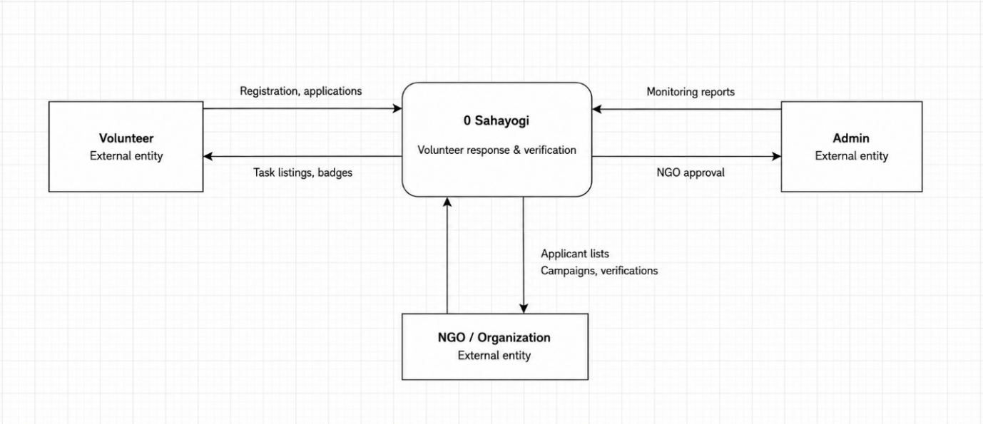
Figure 3.4 : DFD level-0 Diagram

3.1.1.5 DFD level-1 Diagram

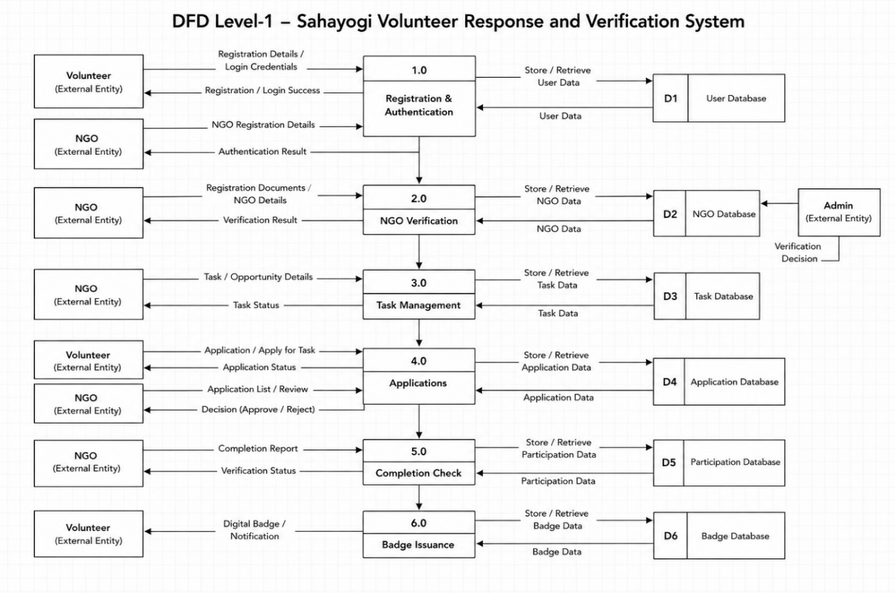
Figure 3.6: DFD level-1 Diagram

3.1.1.5 DFD level-2 Diagram
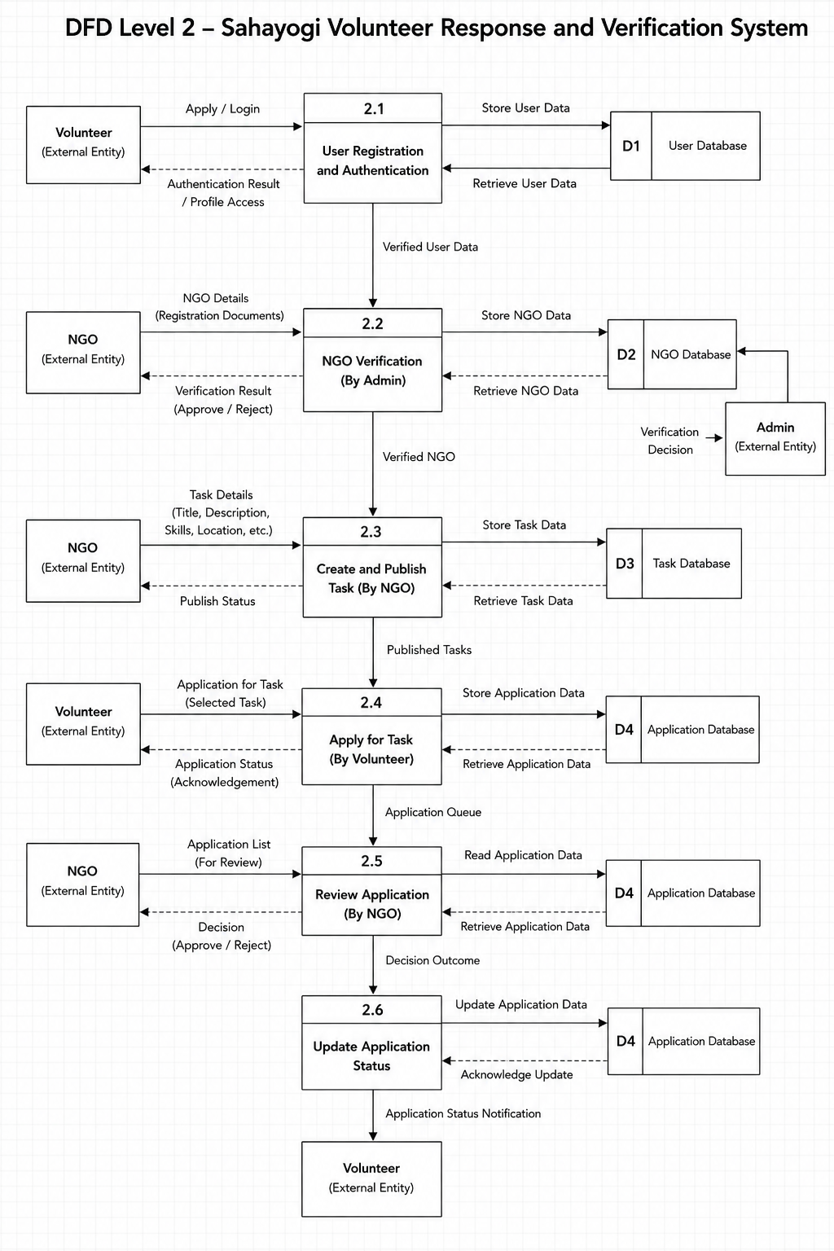

Figure 3.7: DFD level-2 Diagram
3.1.3.5 Sequence Diagram
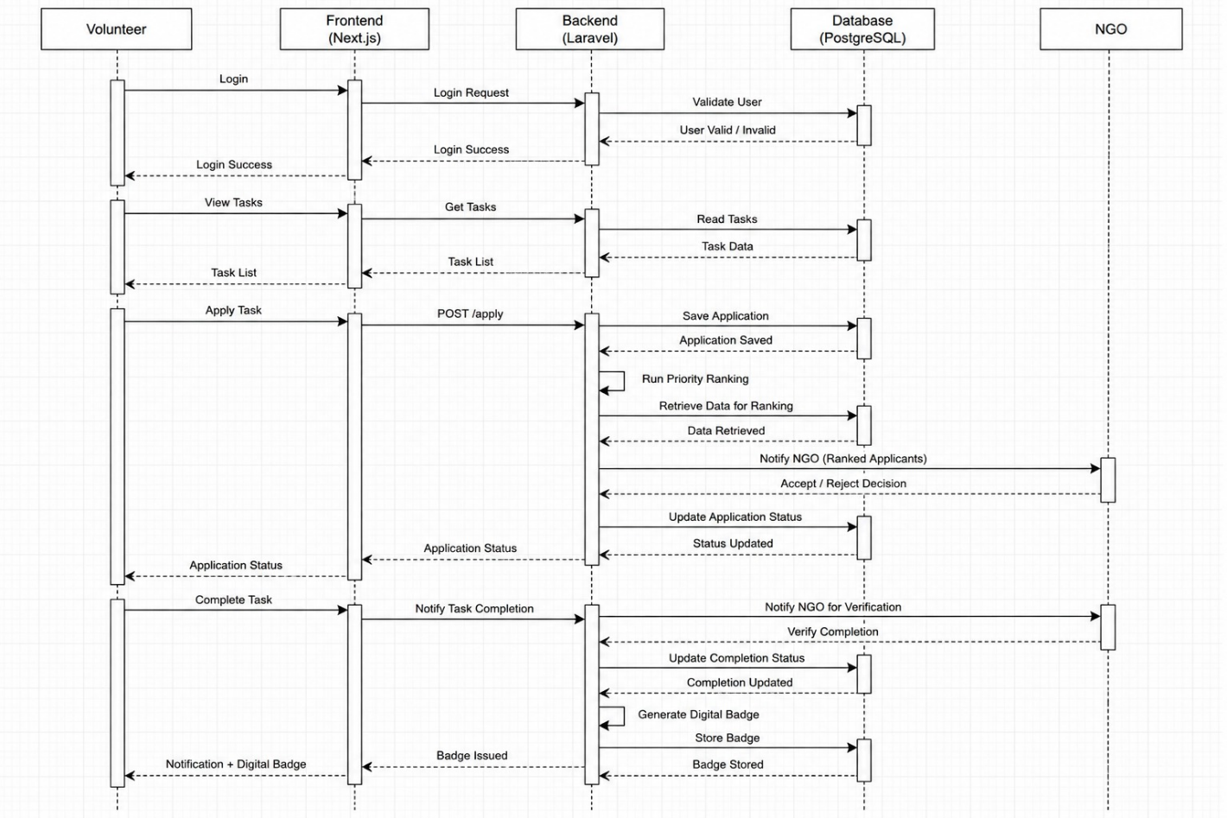

Chapter 4: System Design

4.1 System Design
System design is a crucial phase in the software development lifecycle where the overall architecture and structure of a computer-based system are conceptualized and specified. System design encompasses a thorough understanding of user needs technological considerations, and performance requirements.

4.1.1 System Architecture
VRVS follows a modular client–server architecture using a Next.js (React + TypeScript) frontend and a Laravel backend with PostgreSQL. The system architecture consists of the following layers:
- Frontend (Client-Side):
Built with Next.js, TypeScript, and Tailwind CSS, the frontend provides a responsive and user-friendly interface for both volunteers and NGOs. It includes role-based dashboards, task browsing, volunteer applications, profile management, and analytics views. The system communicates securely with the backend through REST APIs over HTTPS and manages user sessions using JWT authentication.

- Backend (Server-Side):
Developed using Laravel and PHP, the backend handles core business logic, authentication, task management, volunteer applications, and NGO operations through RESTful APIs. Security features include JWT authentication, role-based authorization, bcrypt password hashing, input validation, and secure API handling. A modular MVC architecture is used to improve scalability, maintainability, and code organization.

- Database Layer:

PostgreSQL is used as the relational database system to manage entities such as Volunteer, NGO, Task, Application, Skill, and Badge. Relationships between entities are maintained using foreign keys and relational mapping. Indexing, query optimization, validation, and pagination techniques are implemented to ensure efficient data retrieval and scalability.

- Hosting Environment (Development Phase):
The frontend can be deployed on platforms such as Vercel, while the Laravel backend can run on VPS or cloud-based hosting environments supporting PHP applications. PostgreSQL provides secure and reliable database management with backup support, while cloud storage services can be integrated for document uploads and media handling. This setup ensures scalable, secure, and maintainable system deployment.

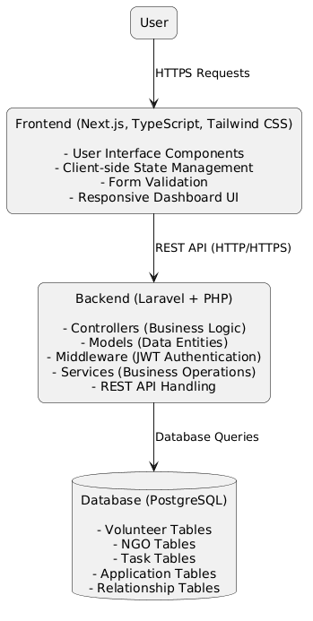
Figure 4.1 System Architecture

4.1.2 Database Design
The database for VRVS is designed using PostgreSQL, a powerful relational database management system that ensures data consistency, integrity, and scalability. It is well-suited for handling structured relationships between NGOs, volunteers, tasks, and applications while supporting secure and efficient data operations for the platform.
Key Tables:
- Users Table
Fields: id, name, email (unique), password_hash, role (Volunteer/NGO/Admin), phone, profile_photo_url, address, created_at, updated_at.
This is the base table for authentication and role management across the system.
- Volunteers Table
Fields: id, user_id (FK), skills, bio, date_of_birth, gender, experience_level, badges, availability_status.
Stores additional profile details specific to volunteers and their engagement data.
- NGOs Table
Fields: id, user_id (FK), organization_name, registration_number, description, website, location, verification_status, contact_person.
Manages NGO-specific information and verification details.
- Tasks Table
Fields: id, ngo_id (FK), title, description, category, required_skills, location, quota, deadline, status, created_at.
Represents volunteer opportunities created by NGOs with requirements and constraints.
- Applications Table
Fields: id, task_id (FK), volunteer_id (FK), ngo_id (FK), status (Pending/Accepted/Rejected/Completed), applied_at, updated_at.
Handles the workflow of volunteer applications to tasks.
- Skills Table
Fields: id, name, description.
Stores predefined skill categories used for matching volunteers with tasks.
- Volunteer_Skills Table (Junction Table)
Fields: id, volunteer_id (FK), skill_id (FK), proficiency_level.
Manages many-to-many relationships between volunteers and skills.
- Badges Table
Fields: id, volunteer_id (FK), title, description, awarded_at.
Tracks achievements and recognition awarded to volunteers.
- Notifications Table
Fields: id, user_id (FK), message, type, is_read, created_at.
Stores system notifications for application updates, task changes, and announcements.
This relational structure ensures strong data integrity through foreign key relationships, supports efficient querying through indexing, and enables scalable growth as the number of NGOs, volunteers, and tasks increases.

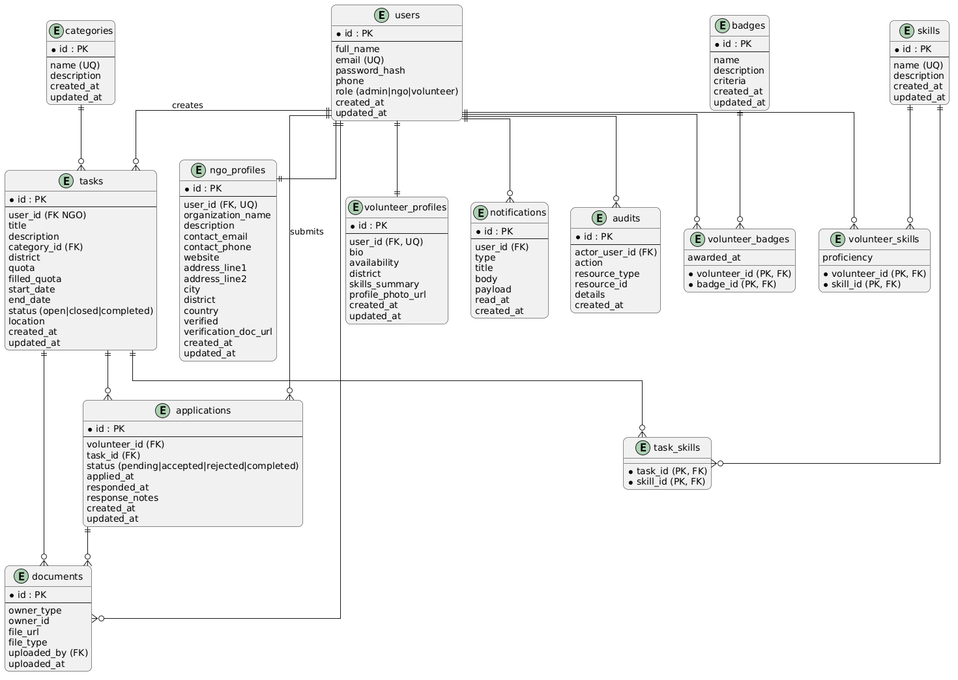
Figure 4.2 ER Diagram

4.1.3 User Interface Design
The VRVS interface is designed to provide an efficient, accessible experience for volunteers, NGOs, and administrators. Primary UI goals are clarity, quick task discovery, and streamlined application/workflow handling. Key pages include:
- Homepage: Prominent calls-to-action for Login/Register (Volunteer/NGO), featured or urgent tasks, brief platform overview, and quick links to discover opportunities.
Fig:
- Volunteer Dashboard: Shows upcoming accepted tasks, recent applications and their statuses, earned badges, recommended tasks (skill-based), and quick-actions to apply or withdraw.
Fig:
- NGO Dashboard: Displays today's and upcoming tasks, pending applications, volunteer assignment summaries, quick-create task button, and short performance KPIs (fill-rate, response time).
Fig:
- Task Discovery & Search: Unified search with keyword and advanced filters (category, district, required skills, date range), sorting, and pagination; results show concise task cards for quick scanning.
Fig:
- Task Details Page: Full task description, requirements, quota and deadlines, NGO profile summary, location map, attachments, volunteer list (for NGOs), and a clear Apply or Manage action.
Fig:
- Task Posting & Management (NGO): Multi-step form for creating/editing tasks with skill tags, category selection, quota and scheduling, document upload, draft/publish controls, and versioning notes.
Fig:
- Application Management: For NGOs: applicant list with profile previews, accept/reject actions, notes, and interview scheduling; for volunteers: application history, status timeline, and feedback entry.
Fig:
- Profile & Documents: Rich volunteer and NGO profiles showing bio, skills, badges, availability, uploaded verification documents (stored on Cloudinary), and edit controls for personal details and privacy preferences. .
Fig:
- Analytics & Reports: Visual dashboards for volunteers (engagement history, hours contributed, badges) and NGOs (task fill-rate, application trends, top-performing volunteers), with CSV export ability.
Fig:
- Admin Dashboard (Planned): Centralized management for user verification, NGO approvals, role and permission assignment, content moderation, and system metrics/health monitoring.
Fig:

4.2 Algorithm Details

4.2.1 Hybrid Volunteer Matching Algorithm
This algorithm is designed for specialized initiatives where the quality and relevance of volunteers are more critical than the speed of enrollment. It provides the NGO with a data-driven "Decision Support System," highlighting the most suitable candidates based on their professional alignment, location, and proven reliability.
- Collect all applicants after deadline.
- Calculate score using weighted metrics (Skills (S), Proximity(D), Trust(T)).
- Sort applicants in descending order of total score.
- NGO approves top Q ranked candidates based on the generated priority list.
For every applicant i, the total score is calculated as:
$$Ψ_{i}=\left(w_{1}*S_{i}\right)+\left(w_{2}*D_{i}\right)+\left(w_{3}*T_{i}\right)$$

Where:
$w_{n}:$ Weight coefficients $\left(\sum{w_{n}}=1\right)$
S$:$ Skill Score $∈\left[0,1\right]$
D: Proximity Score $∈\left[0,1\right]\left(D=1/\left(1+d\right)\right)$
T$:$ Trust Score (Normalized)
The logic relies on normalizing all inputs to a scale of 0 to 1. By keeping everything between 0 and 1, the weights dictate the outcome properly.
- Weights
These represent the "Importance" of each factor, and they must always sum to 1. NGOs can adjust these based on the crisis.
Example: For a flash flood, speed is critical, so Proximity (w₂) might be set to 0.6, while Skills (w₁) is 0.2 and Trust (w₃) is 0.2. For a medical camp, Skills (w₁) becomes 0.7, and distance matters less.
Skill Score
This measures how well the volunteer's skillset matches the NGO's required skills. It must result in a value between 0 and 1.
It calculates the intersection of the required skills array and the volunteer's skills array.
$$S_{i} = \frac{\text{Number of Matching Skills}}{\text{Total Required Skills}}$$

If an NGO needs [First Aid, Driving, Logistics] and a volunteer has [First Aid, Driving], their $S_{i}$ is 2/3 approx. 0.66.

Proximity Score
This converts the physical distance (calculated via Haversine) into a score between 0 and 1. We want a higher score for a shorter distance.

$$D=1/\left(1+d\right)$$

If distance $d = 0$ km, $D=1/\left(1+0\right)=1.0$ (Perfect score).
If distance $d = 4$km, $D=1/\left(1+4\right)=0.2$.
If distance $d = 99$ km, $D = 1 / 100 = 0.01$.

Trust Score
This measures the reliability of the volunteer based on their historical data.
$$T_{i}=\frac{\text{Completed Tasks}}{\text{Total Assigned Tasks}}$$
If a new user signs up, their tasks are $0/0$, which creates a division-by-zero error.
We apply Laplace Smoothing:
$T_{i}=\frac{\text{Completed Tasks}+1}{\text{Total Assigned Tasks}+2}$
This gives all brand-new users a default baseline Trust Score of 0.5, which rises or falls as they actually do work.

Haversine Formula
This formula is used to calculate the spherical distance between the volunteer's registered coordinates and the event's location, allowing for precise proximity filtering.
d = 2r × arcsin(√(sin²((Δφ)/2) + cos(φ₁) × cos(φ₂) × sin²((Δλ)/2)))
Where:
d = Distance between two points (in kilometers)
r = Radius of the Earth (6371 km)
φ₁, φ₂ = Latitude of point 1 and point 2 (in radians)
λ₁, λ₂ = Longitude of point 1 and point 2 (in radians)
Δφ = φ₂ - φ₁
Δλ = λ₂ - λ₁

4.2.2 Automated Identity Verification Algorithm

4.2.3 Secure Attendance Verification Algorithm

Chapter 5: Implementation and Testing

5.1 Implementation

5.1.1 Tools Used
Table 5.1 Technology Stack for the VRVS System
Layer | Technology | Version | Role
Frontend framework | Next.js | 16.2.0 | SSR, routing, and full frontend application framework
Styling | Tailwind CSS | 4.2.0 | Utility-first UI styling and responsive design
Language | TypeScript | 5.0 | Type-safe development across frontend.
UI components | Radix UI | 1.0 | Accessible headless UI primitives
Backend runtime | PHP | 8.2 | Server-side execution environment
API framework | Laravel | 12.0 | RESTful endpoint definition and middleware composition.
Database | PostgreSQL | 15 | Relational data storage with strong consistency
Version Control | Git/Github |  | Source control and collaboration

5.1.2 Frontend Implementation
The frontend is developed using Next.js, React, TypeScript, and Tailwind CSS to provide a responsive, scalable, and user-friendly interface. The system focuses on efficient task discovery, smooth workflow handling, and accessible interaction for volunteers and NGOs.
Key frontend features include:
- Authentication pages for secure user registration and login
- Volunteer dashboard for tracking applications, engagement, and activity history
- NGO dashboard for managing tasks and reviewing volunteer applications
- Task management pages for creating, editing, and deleting tasks
- Application management interface for monitoring application status and workflows
- Profile management pages for updating user or organizational information and uploading verification documents
Frontend modules and implementation details include:
- Authentication Module: Handles user registration, login, session persistence, and protected route access using authentication hooks and middleware.
- API Integration Layer: Centralized API client manages request handling, authentication token injection, and standardized error processing.
- State Management: Uses React Context and component-level state management for lightweight and efficient frontend state handling.
- Task Components: Reusable task cards, lists, and forms support task browsing, filtering, creation, and updates with responsive UI behavior.
- Search and Filtering: Dynamic filtering and search functionality support category, district, skill, and keyword-based queries with pagination support.
- Profile and Document Management: Integrates file upload functionality for profile images and verification documents.
- Notifications and User Experience: Toast notifications, validation feedback, and accessibility-focused components improve usability and consistency across the platform.

5.1.3 Backend Implementation
The backend is implemented using Laravel and PostgreSQL, providing a secure and scalable RESTful API architecture for handling authentication, task management, applications, and system workflows.
Key backend features include:
- Secure authentication and authorization
- Task creation and management APIs
- Volunteer application workflow processing
- Search and filtering capabilities
- Profile and organization management
- Role-based access control for administrators, NGOs, and volunteers
Backend modules and implementation details include:
- Authentication and Authorization: Laravel manages secure session and token-based authentication, while middleware enforces role-based access permissions.
- User and Profile Management: User, volunteer, and NGO profile models support profile updates, document verification, and account management operations.
- Task Management Module: Handles task creation, editing, deletion, scheduling, quota tracking, and required skill assignment.
- Application Workflow Module: Manages volunteer application submission, acceptance, rejection, notifications, and audit logging with transactional consistency.
- Search and Filtering System: PostgreSQL indexing and optimized query scopes support efficient filtering by category, district, skills, and keywords.

5.2 Testing

5.2.1 Test Cases for Unit Testing
Table 5.2 Unit Test Cases
Test ID | Description | Input Data | Expected Result | Actual Result | Result
UT01 | Volunteer Registration | Name, email, password, skills | Volunteer registered successfully | Volunteer successfully registered | Pass
UT02 | NGO Registration | Organization name, email, password, registration document | NGO registered successfully, pending verification | NGO registered and marked pending | Pass
UT03 | User Login (valid) | Registered email and correct password | Login successful and JWT token generated | Login successful, token generated | Pass
UTO4 | User Login (invalid) | Registered email with wrong password | Login failed with error message | 12Login error displayed | Pass
UT05 | JWT Token Validation | Valid token in request header | Access granted to protected route | Access granted correct | Pass
UT06 | Role-Based Access Check | Volunteer account attempts NGO-only action | Access denied with 403 error | Access denied correctly | Pass
Screenshots: Registration success, login success, login error screens

5.2.2 Task Management Testing
Task management feature testing was conducted to verify that NGOs can effectively create, update, and manage volunteer opportunity posts, ensuring that all task-related fields are properly validated, stored, and displayed to volunteers without errors.
Table 5.3 Task Management Test Cases.
ID | Description | Input Data | Expected | Status
TSK-01 | Create task (valid data) | Title, category, required skills, quota, deadline | Task created and published successfully | Pass
TSK-02 | Edit existing task | Updated task details for existing post | Task updated successfully | Pass
TSK-03 | Delete task | Select existing task and confirm delete | Task removed successfully | Pass
TSK-04 | Set task quota | Quota value (e.g., 5 volunteers needed) | Quota saved and displayed on task | Pass
TSK-05 | Set task category | Category: Regular or Emergency/Disaster | Category saved and shown correctly on listing | Pass
TSK-06 | Empty/invalid field validation | Empty title or missing required skill field | Validation error message displayed | Pass
TSK-07 | Task deadline expiry handling | Task with deadline set in the past | Task marked as expired/closed automatically | Pass
SCREENSHOT: Task creation form, task listing, delete confirmation

5.2.3 Application Workflow Feature Testing
Application workflow testing was conducted to verify that volunteers can apply to tasks and that NGOs can review, accept, or reject applications correctly, ensuring that application status updates and notifications are handled accurately throughout the process.

Table 5.4 Test Cases for Application Workflow Feature
ID | Description | Input | Expected | Status
APP-01 | Volunteer applies to task | Valid task selected, application submitted | Application submitted successfully | Pass
APP-02 | Prevent duplicate application | Volunteer applies to same task twice | Second application rejected with error | Pass
APP-03 | NGO accepts application | NGO selects "Accept" on an application | Application status updated to Accepted, volunteer notified | Pass
APP-04 | NGO rejects application | NGO selects "Reject" on an application | Application status updated to Rejected, volunteer notified | Pass
APP-05 | Application status update notification | Status change on any application | Notification sent to relevant volunteer | Pass
APP-06 | Quota-full rejection | Applicant applies after task quota is already filled | Application blocked with "quota full" message | Pass
APP-07 | Cancel own application | Volunteer cancels a pending application | Application removed/cancelled successfully | Pass
APP-08 | View application history | Volunteer opens application history page | All past applications displayed correctly | Pass
Application workflow ko SCREENSHOT: Apply button, accept/reject action, notification

5.2.4 Priority-Ranking Algorithm Testing
Priority-ranking algorithm testing was conducted to verify that volunteer applicants are correctly scored and ranked based on skill match, proximity, and trust score, ensuring that the algorithm produces accurate and consistent results across different applicant scenarios, including new users with no prior history.

Table 5.5: Test Cases for Priority-Ranking Algorithm
ID | Description | Input | Expected | Status
TC-RANK-01 | Skill match scoring | Applicant with skills matching task requirement | Higher skill score assigned compared to non-matching applicant | Pass
TC-RANK-02 | Distance/proximity scoring | Applicant location coordinates vs. task location | Closer applicant receives higher proximity score | Pass
TC-RANK-03 | Trust score calculation (existing user) | Volunteer with prior completed tasks | Trust score reflects past participation history | Pass
TC-RANK-04 | Trust score for new user (cold-start case) | Volunteer with no prior task history | New user assigned a fair baseline trust score, not excluded | Pass
TC-RANK-05 | Combined weighted score calculation | Applicant with skill, distance, and trust values | Final priority score correctly computed from weighted formula | Pass
TC-RANK-06 | Ranking order for multiple applicants | 5+ applicants apply to same task | Applicants sorted correctly by final priority score | Pass
TC-RANK-07 | Tie-breaking scenario | Two applicants with identical final scores | Tie resolved consistently (e.g., by earliest application time) | Pass
TC-RANK-08 | Ranking updates when applicant pool changes | New applicant applies after ranking already generated | Ranking list recalculated correctly to include new applicant | Pass
- How the diagram and algorithm must match — this is the important part: your 4.2.1 Priority-Based Ranking Algorithm section defines the formula using Skill Score (S), Proximity (D), and Trust Score (T) with weights w1, w2, w3. The screenshot you place after Table 5.5 must show a ranked applicant list where the actual displayed scores are traceable back to that exact formula — e.g., a table/UI showing applicant name, their skill match %, distance in km, trust score, and final weighted score, sorted correctly. If your current UI doesn't display these intermediate values, either:
- add a debug/admin view that shows the breakdown, or
- create a simple table screenshot (even a spreadsheet mockup) demonstrating the calculation for 3-5 sample applicants, matching the exact weights (w1=0.2, w2=0.6, w3=0.2 example you gave for floods) used in your written explanation.
The same rule applies to any DFD-related screenshot later — the process names in your diagram (e.g., "3.0 Manage Applications") should correspond to actual screens/routes in your screenshots, not just generic labels.

5.2.5 Search & Filtering Feature Testing
Search and filtering feature testing was conducted to verify that volunteers can effectively discover relevant tasks using category, location, skill, and keyword-based filters, ensuring that search results are accurate, correctly paginated, and handle edge cases such as no matching results.
Table 5.6: Test Cases for Search & Filtering Feature
ID | Description | Input | Expected | Status
TC-SRCH-01 | Filter by category | Category: Emergency/Disaster | Only tasks matching selected category displayed | Pass
TC-SRCH-02 | Filter by district/location | District name selected | Only tasks within selected district displayed | Pass
TC-SRCH-03 | Filter by required skill | Skill tag (e.g., "First Aid") | Only tasks requiring selected skill displayed | Pass
TC-SRCH-04 | Keyword search | Search term matching task title/description | Matching tasks displayed correctly | Pass
TC-SRCH-05 | Pagination of results | Task list exceeding one page | Correct number of results per page, working next/previous navigation | Pass
TC-SRCH-06 | No-results handling | Search/filter combination with no matches | "No results found" message displayed | Pass
Screenshot : Filtered results, no-results message

5.2.6 Profile, Verification & Badge Testing
Profile, verification, and badge testing was conducted to verify that users can update their profile information, that NGOs can be verified through document submission, and that digital badges are correctly issued and displayed upon successful task completion.

Table 5.7: Test Cases for Profile, Verification & Badge Feature
ID | Description | Input | Expected | Status
TC-PRF-01 | Update profile information | Updated name, bio, skills | Profile updated successfully | Pass
TC-PRF-02 | Upload verification document | Valid NGO registration document | Document uploaded and marked pending review | Pass
TC-PRF-03 | NGO verification approval | Admin approves submitted document | NGO status updated to Verified | Pass
TC-PRF-04 | Badge issued on task completion | Volunteer's application marked complete by NGO | Digital badge issued and linked to volunteer profile | Pass
TC-PRF-05 | Badge displayed on portfolio | Volunteer views their profile/portfolio page | All earned badges displayed correctly | Pass
TC-PRF-06 | Reject invalid document upload | Unsupported file type or corrupted file | Upload rejected with validation error | Pass
Screenshot: Document upload, verified badge, portfolio

5.2.7 System Testing
System testing validates that the complete VRVS platform meets all functional and non-functional requirements by testing the end-to-end flow across all integrated modules, ensuring that the volunteer and NGO journeys work correctly from start to finish.

Table 5.8: System Test Cases
ID | Description | Input | Expected | Status
TC-SYS-01 | End-to-end volunteer journey | Register - apply - get accepted - complete task | Badge issued at the end, all steps completed successfully | Pass
TC-SYS-02 | End-to-end NGO journey | Register - get verified- post task -review applicants - accept | Task published and volunteer accepted successfully | Pass
TC-SYS-03 | Concurrent applications to same task | Multiple volunteers apply to the same task simultaneously | All applications recorded correctly without data loss | Pass
TC-SYS-04 | Admin manages users/NGOs | Admin views and manages user/NGO accounts | Changes reflected immediately across the system | Pass
TC-SYS-05 | Notification delivery across actions | Task posting, application, status change events | Notifications correctly delivered for each event | Pass
TC-SYS-06 | Unauthorized access attempt | Request to protected route without valid token | Access denied with 401 error | Pass
TC-SYS-07 | Performance under load | Multiple concurrent users browsing/applying | System remains stable and responsive | Pass
TC-SYS-08 | Data consistency after multiple operations | Series of create/update/delete actions performed | Database reflects accurate final state, no orphaned records | Pass

Chapter 6: Conclusion and Future Recommendations

6.1 Conclusion
VRVS provides a centralized volunteer coordination platform that simplifies how NGOs manage volunteer recruitment, task allocation, and application workflows. The system integrates user management, task posting, application tracking, profile verification, and communication features into a single web-based environment, reducing the reliance on fragmented manual processes such as spreadsheets, social media posts, and informal messaging. By separating functionality for volunteers, NGOs, and administrators through role-based access control, the platform ensures structured operations and controlled access to sensitive information. The use of Laravel, Next.js, PostgreSQL, and Cloudinary enables secure authentication, efficient data management, scalable API handling, and reliable document storage while maintaining good performance and maintainability.
The project was developed with emphasis on practical usability, modular system design, and long-term extensibility. Features such as advanced task filtering, dashboard-based workflow management, application status tracking, and profile verification improve coordination efficiency for both volunteers and organizations. The database schema supports relational consistency and optimized querying, while testing and validation mechanisms help maintain system reliability and reduce operational errors. The architecture also supports future enhancements such as real-time messaging, multilingual support, analytics expansion, mobile integration, and automated recommendation systems without requiring major structural changes. Overall, VRVS demonstrates a practical and scalable approach to digitizing volunteer management processes for NGOs and community-driven organizations.

6.2 Future Recommendations
- Email Notifications and Alerts
Automated notifications can be implemented to inform volunteers and NGOs about task updates, application status changes, deadlines, and upcoming events.

- Advanced Search and Filtering
More detailed filtering options such as availability, experience level, preferred working area, and volunteer interests can improve task discovery and matching efficiency.

- Mobile Application Support
A dedicated mobile application can be developed to allow volunteers and NGOs to access the platform conveniently through smartphones with real-time notifications and improved accessibility.

- In-App Messaging System
A lightweight communication system can be integrated to allow direct coordination between NGOs and accepted volunteers within the platform.

- Volunteer Hours and Impact Tracking
The system can include volunteer contribution tracking, participation statistics, and impact reports to measure engagement and organizational performance.

- Multi-Language Support
Localization support can be added to improve accessibility for users from different linguistic regions and communities.

- Enterprise and Multi-Organization Support
Additional organizational management features can support larger NGOs with multiple branches, departments, or coordinators.

- Scalable System Architecture
Migration toward a microservices-based architecture and advanced monitoring systems can improve scalability, maintainability, and long-term system reliability.

References
[1] S. Kumar N., D. S., S. R. Sudharsanan, N. G. Naveen Kumar, and A. Prasanth, "Volunteer Connect: A Volunteer Coordination Platform with Chatbot Assistance via Retrieval-Augmented Generation," International Journal of Scientific Research in Science and Technology, vol. 12, no. 3, pp. 1362–1369, Jun. 2025. doi: 10.32628/IJSRST25123157. [Online]. Available: https://www.ijsrst.technoscienceacademy.com/index.php/home/article/view/IJSRST25123157
[2] J. R. Saura, P. Palos-Sanchez, and F. Velicia-Martin, "What Drives Volunteers to Accept a Digital Platform That Supports NGO Projects?" Frontiers in Psychology, vol. 11, Mar. 2020. doi: 10.3389/fpsyg.2020.00429. [Online]. Available: https://www.ncbi.nlm.nih.gov/pmc/articles/PMC7137897
[3] "Digital Volunteer Services in Emergency Situations: Typological Characteristics, Advantages, and Challenges," Data Science and Management, vol. 8, no. 1, Mar. 2025. doi: 10.1016/j.dsm.2024.08.003. [Online]. Available: https://www.sciencedirect.com/science/article/pii/S2666764924000389
[4] UK Government Research, "Digital Tools That Support Volunteering," 2023. [Online]. Available: https://www.gov.uk/government/publications/digital-tools-that-support-volunteering/digital-tools-that-support-volunteering
[5] I. Lo, V. Manshadi, S. Rodilitz, and A. Shameli, "Commitment on Volunteer Crowdsourcing Platforms: Implications for Growth and Engagement," arXiv, May 2020. [Online]. Available: https://arxiv.org/abs/2005.10731
[6] R. Samanta, B. Sethi, and S. K. Ghosh, "Empowering Volunteer Crowdsourcing Services: A Serverless-assisted, Skill and Willingness Aware Task Assignment Approach," arXiv, Aug. 2024. [Online]. Available: https://arxiv.org/abs/2408.11510
[7] Ushahidi, "Crowdsourcing and Crisis Mapping Platform," 2008. [Online]. Available: https://www.ushahidi.com
[8] Good Smartphone Activated Medics (GoodSAM), "Emergency Volunteer Platform," 2014. [Online]. Available: https://www.goodsamapp.org
[9] "AI-Powered Multi-Stakeholder Ecosystems for Global Development: A Design Research Study on the GSI D-Hub Proof-of-Concept Platform," arXiv, 2026. [Online]. Available: https://arxiv.org/pdf/2603.06584
[10] "A Trustworthiness-Aware Spatial Task Allocation Using a Fuzzy-based Trust and Reputation System Approach," Expert Systems with Applications, 2022. [Online].
Available: https://www.sciencedirect.com/science/article/abs/pii/S0957417422016487

Appendices
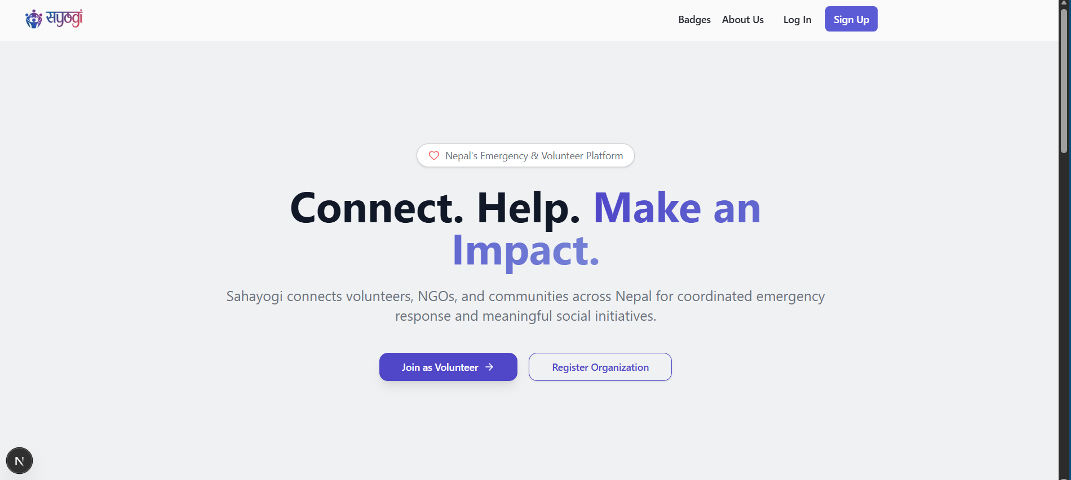
Landing Page
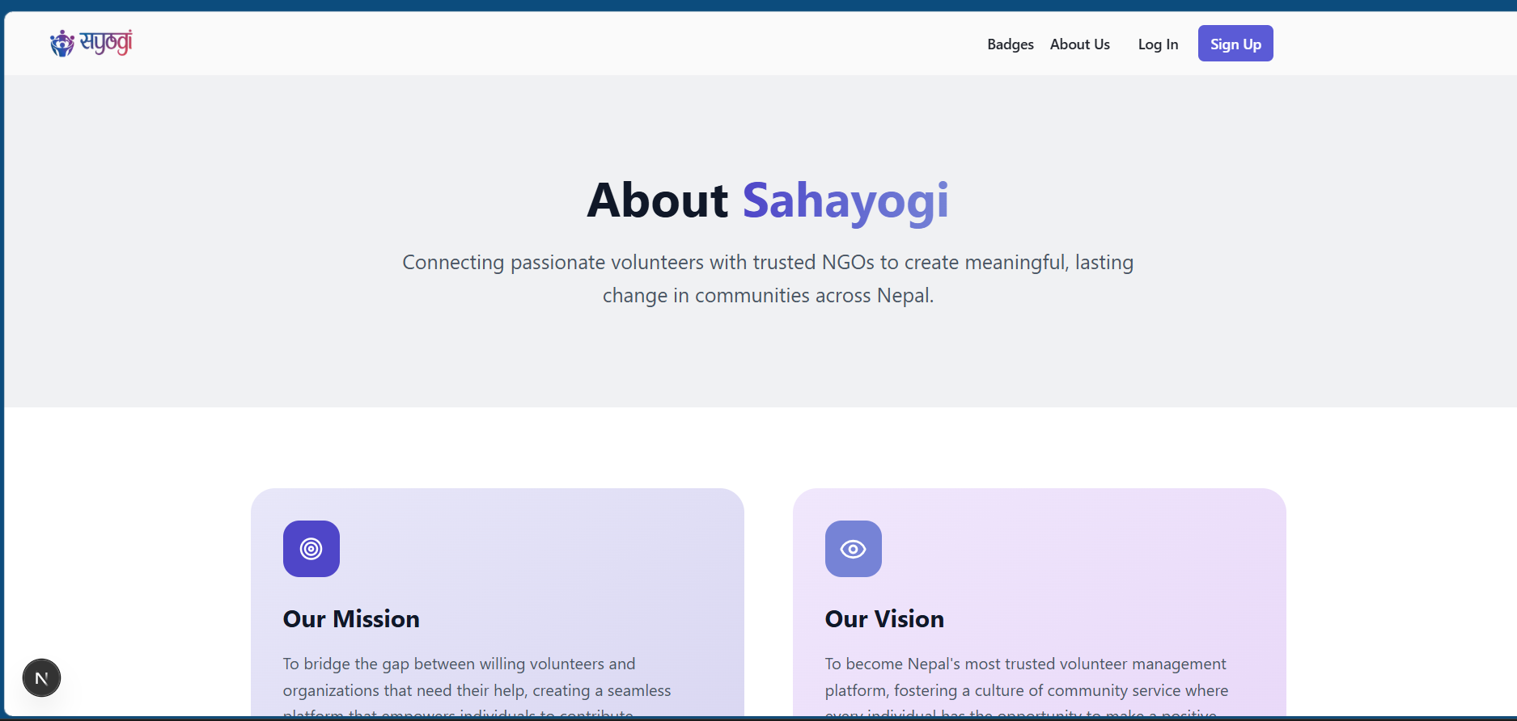
About Us Page
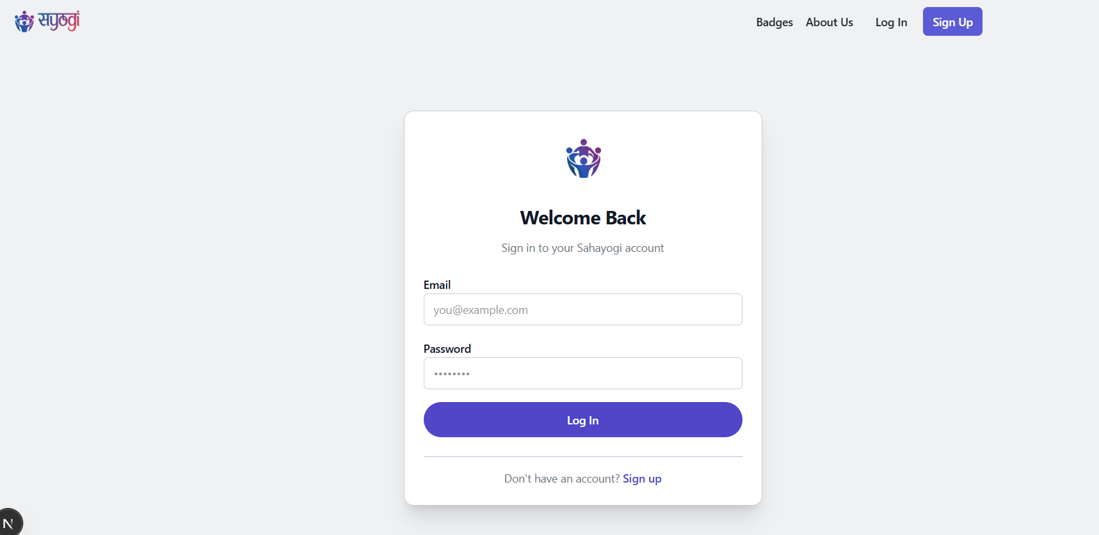
Login Page
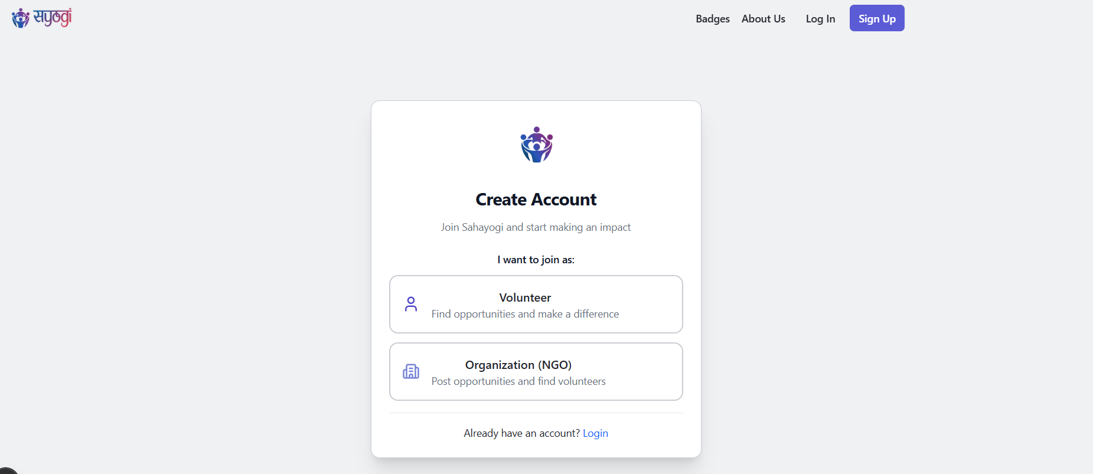
Sign Up Page
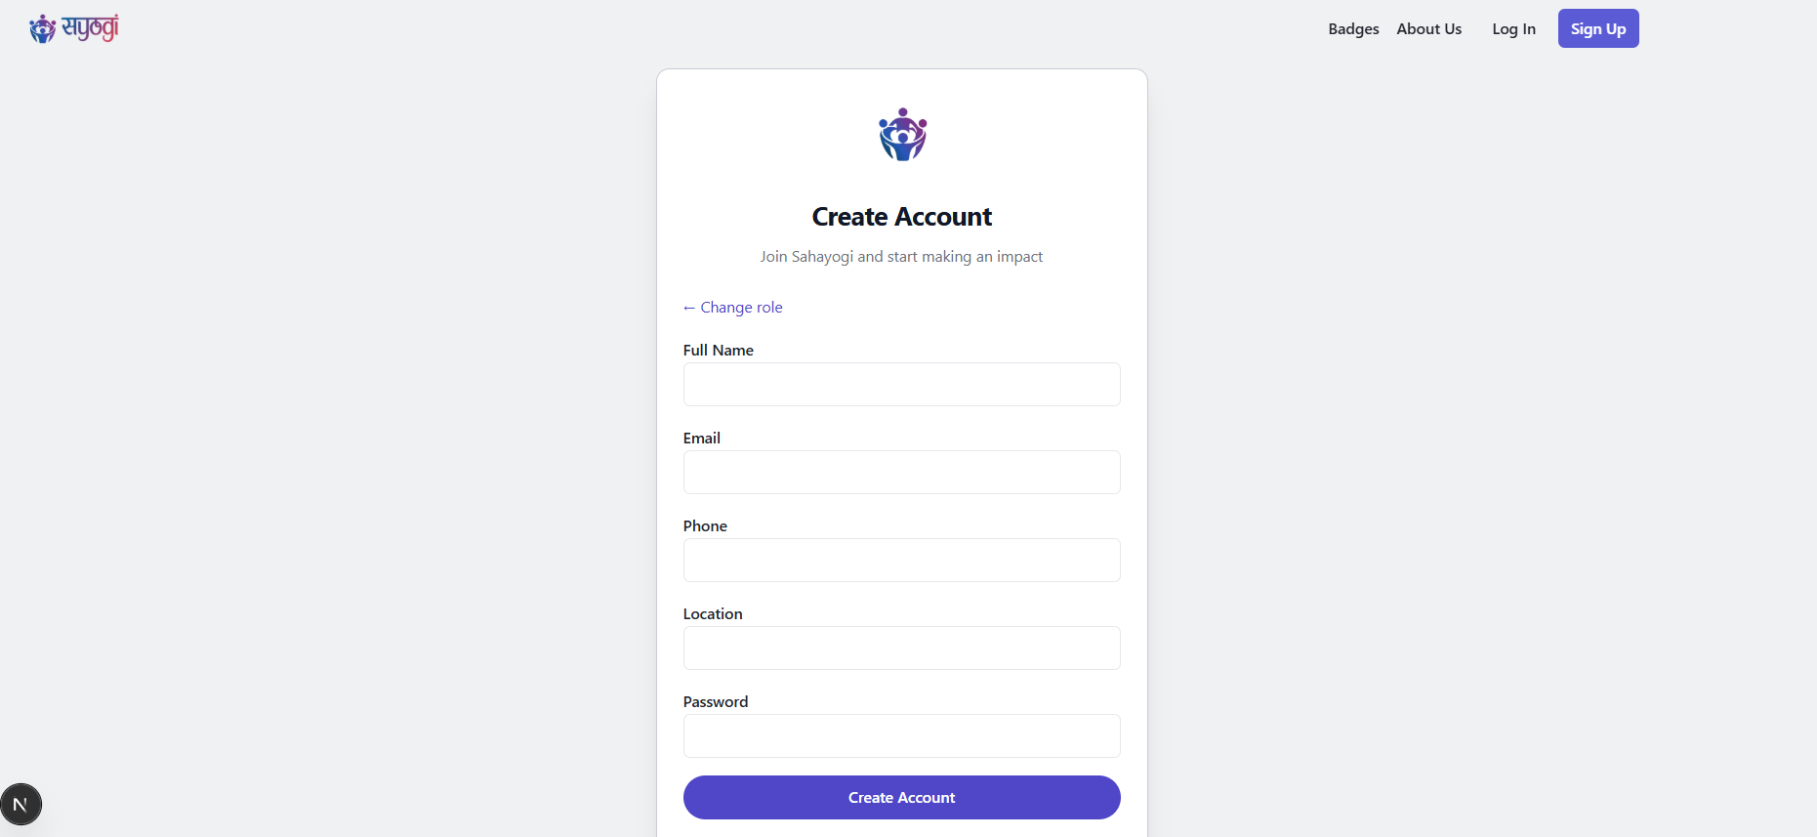
Sign Up – Volunteer
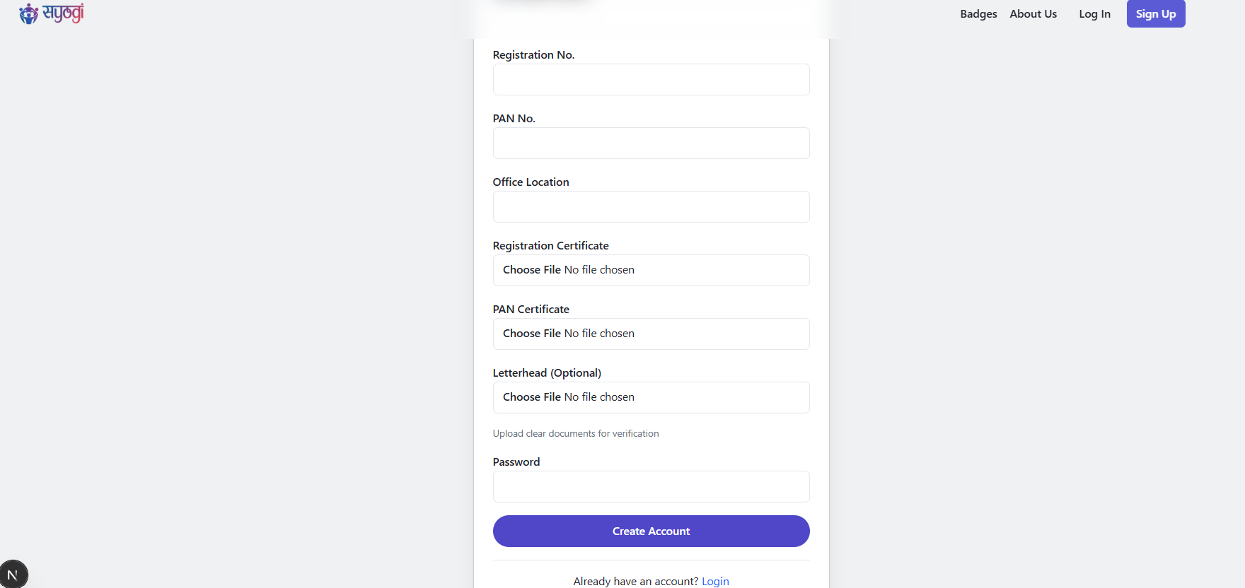
Sign Up - NGO
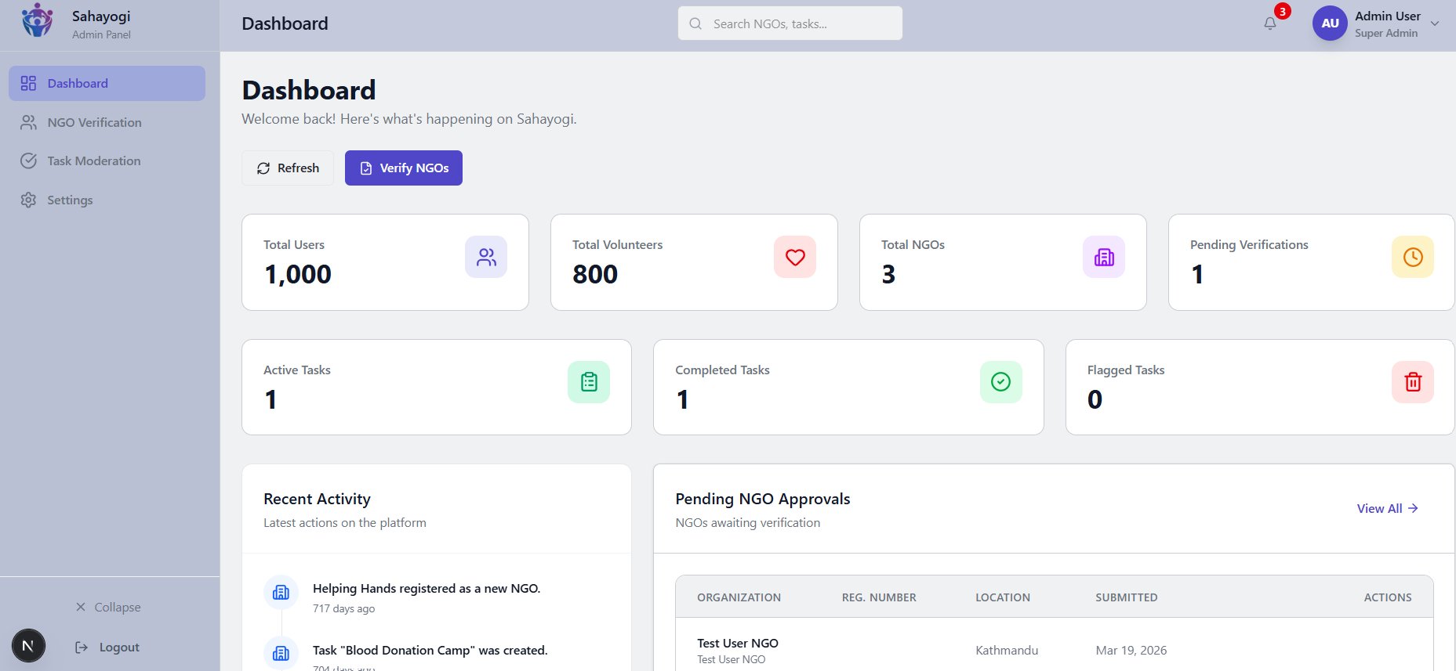
Admin Page
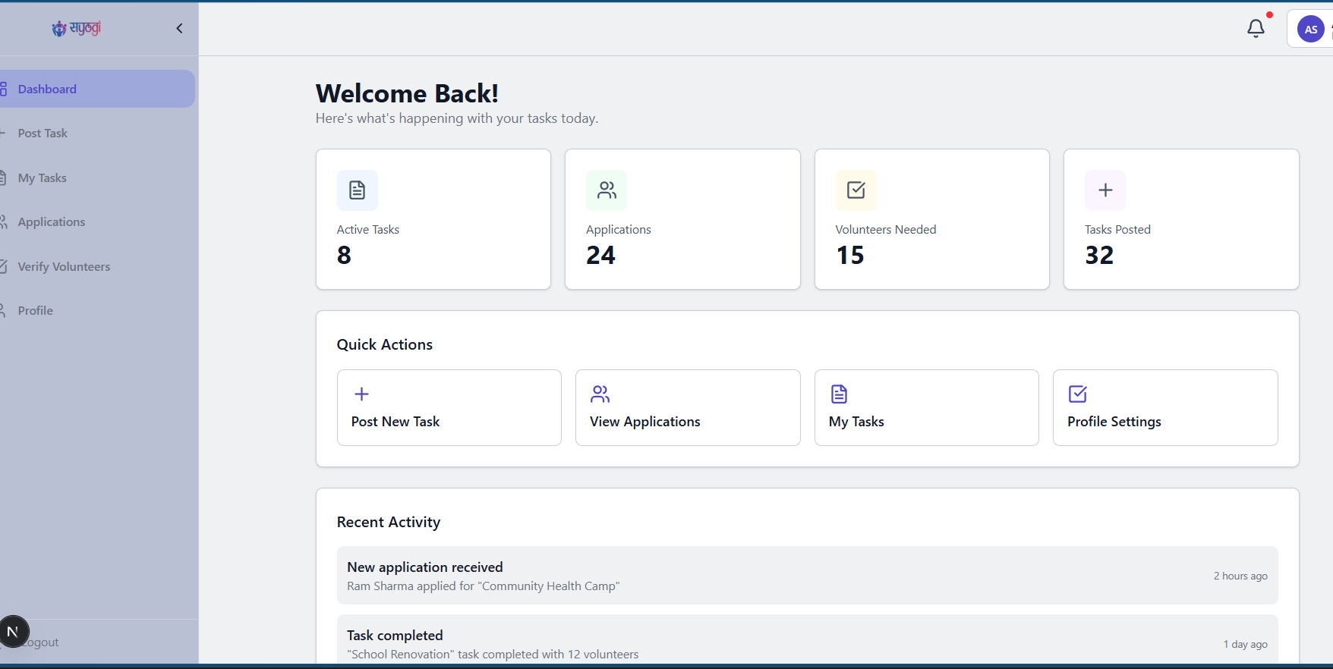
Organization Page
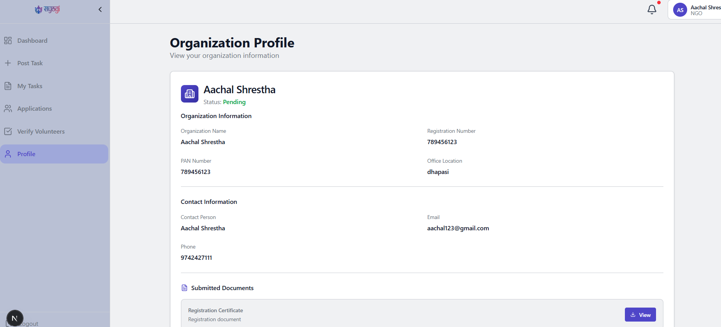
Profile Page

SUPERVISOR’S LOGS

S.N. | Date | Activity | Signature
1. | 01/15//2026 | Discussed project concept for a volunteer-NGO matching platform with verification features.
2. | 02/01/2026 | Submitted the proposal for the first time and received feedback.
3. | 02/5/2026 | Submitted the revised proposal and reviewed the report.
4. | 02/10/2026 | Reviewed and improved the proposal report.
5. | 02/13/2026 | Submitted the final proposal report.
6. | 02/15/2026 | Proposal defense.
7. | 02/25/2026 | Discussed further details about the project (architecture, service layer design).
8. | 03/13/2026 | Conducted project review.
9. | 04/02/2026 | Discussed the algorithms to be implemented.
10. | 05/05/2026 | Submitted the report for the second time.
11. | 05/28/2026 | Submitted the report for the third time.
12. | 07/21/2026 | Submitted the final report and received feedback.
13. | 07/23/2026 | Submitted the final report after incorporating all improvements.

SUPERVISOR LOGS EVIDENCE

