 | The Bombay Salesian Society’s  DON BOSCO INSTITUTE OF TECHNOLOGY  Department of Computer Engineering AY 26-27  25CE3CEP01 Community Engagement Project

Class: | Batch: Batch C | Group No.: Grp 04

Group Details:
S. No. | Roll No. | Name
1
2
3
4

Experiment No. 5
Prototype development using software tools
Aim: To develop a prototype of the solution as sections and provide proof of concept.
Theory: In Experiment No. 4, potential solutions were structured using UML modeling (Use Case, Activity, and State diagrams) along with a planned project timeline. Building upon the structural workflows established in the Activity and State diagrams, Experiment No. 5 transitions from logical architecture into visual implementation and human-computer interface design.
Prototyping:
Prototyping serves as a tangible Proof of Concept (PoC). The primary focus of this experiment is visual user interface (UI) design and interactive forward user flows (ensuring that clicking key action buttons advances the user sequentially through the service journey).
Students may implement their prototype using any one of the following tools:
1. Figma (Recommended for UI/UX): Utilizing components, frames, and interactive click-to-navigate prototyping connections.
2. Canva (Visual Mockup): Designing multi-page user journeys and linking interactive button elements directly to subsequent pages using the internal page hyperlinking feature.
3. Basic Front-End Web Development: Static multi-page HTML5/CSS3/JavaScript connected via hyperlinks (<a> tags) or simple view-switching logic.

1. Solution Flow and Architecture
Core User Journey (Step-by-step screen sequence):
Screen 1: Landing / Entry Screen (ConnectSphere Home Portal & Multi-Role Gateway)
Screen 2: Core Feature / Selection Screen (Problem Category Directory & Shared Spaces Hub)
Screen 3: Input / Action / Form Screen (Unified Assistance Request & Society Delivery Logistics)
Screen 4: Confirmation / Detail Review Screen (Pre-Dispatch Verification & Senior PIN Code Generation)
Screen 5 / Success Screen: Live Lifecycle Status & Real-Time Tracking Screen (Live Status Stepper & GPS Tracker)
Key Call-to-Action (CTA) Buttons & Forward Interactions:
• 'Explore Tasks & Spaces' / 'Request Assistance' CTA → Navigates from Landing Screen to Service Category Directory (Screen 2).
• 'Request Assistance' on Category Card → Carries preselected category into the Unified Assistance Form (Screen 3).
• 'Proceed to Review Details →' Button → Validates form inputs, serializes session data, and advances to Order Review (Screen 4).
• 'Confirm & Broadcast to Community →' Button → Commits errand, generates Senior Safety PIN, broadcasts to volunteers, and opens Live Tracker (Screen 5).
• 'Return to Dashboard' / 'Track My Errand' Button → Provides continuous real-time state feedback and returns senior to their home desk.

2. Prototype Design & Walkthrough
Screen 1: Landing / Entry Screen
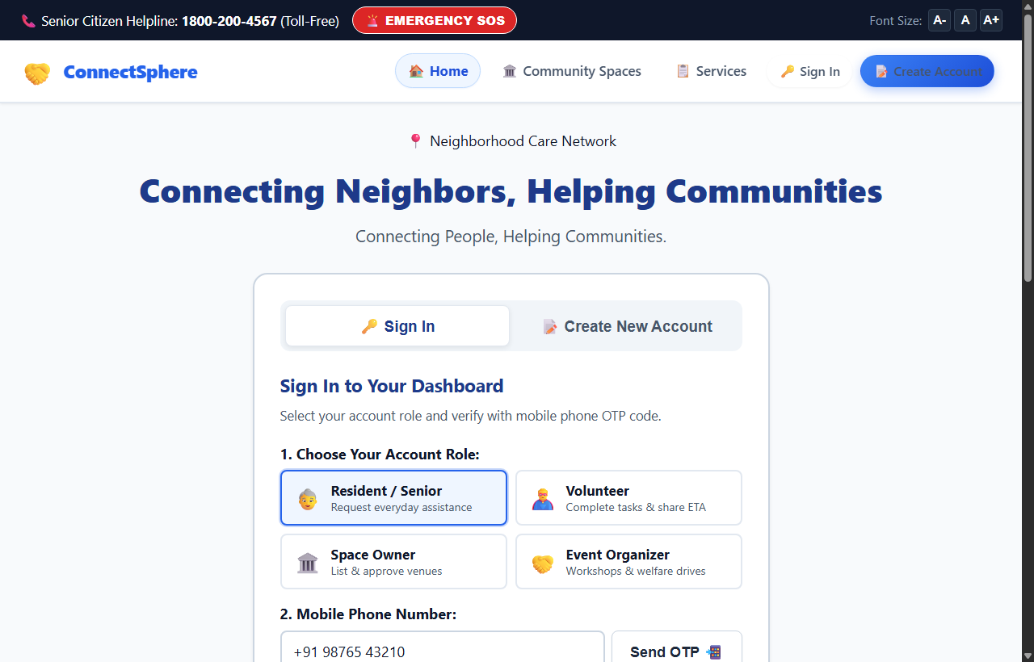
Description & Forward Interaction:
Purpose: This screen serves as the community gateway for ConnectSphere, introducing residents, senior citizens, and neighborhood volunteers to the dual-purpose platform. It provides quick emergency SOS access, senior helpline details, live community activity metrics, and immediate navigation to browse errands or reserve empty shared spaces.
Forward Trigger: Clicking the primary button "Explore Tasks & Shared Spaces" or selecting "Request Daily Assistance" navigates the user forward to Screen 2 (Categories & Service Directory).
Screen 2: Core Feature / Selection Screen
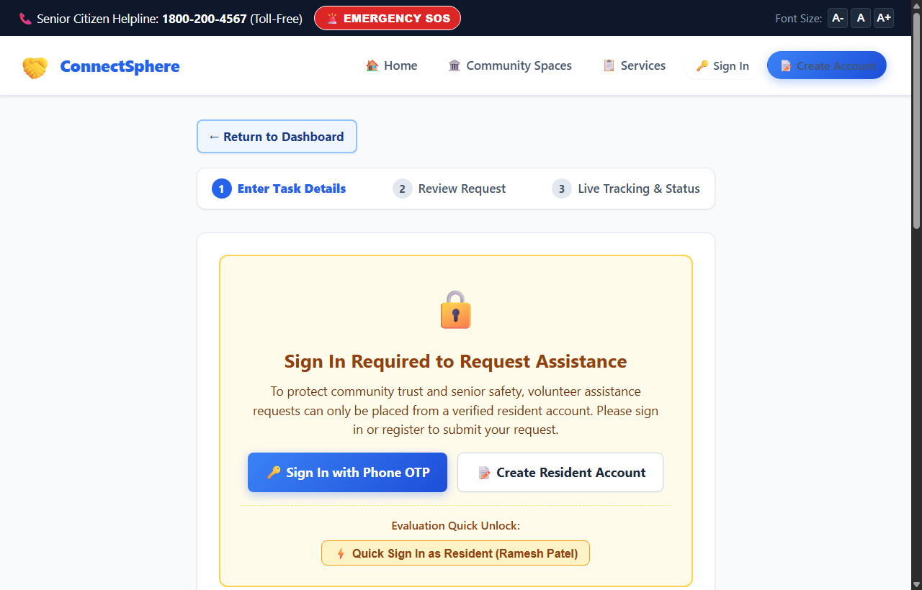
Description & Forward Interaction:
Purpose: Displays the core service categories organized into structured neighborhood assistance cards: Prescription Medicine Pickup, Fresh Groceries & Dairy, Student Tutoring, Pension App & Digital Life Certificate Guidance, and Companion Walks, alongside shared community space reservations.
Forward Trigger: Clicking on any dedicated category card button (e.g., "Request Medicine Help →" or "Request Grocery Help →") captures the category context and forwards the resident to Screen 3 (Input Request Form).

Screen 3: Input / Action / Form Screen
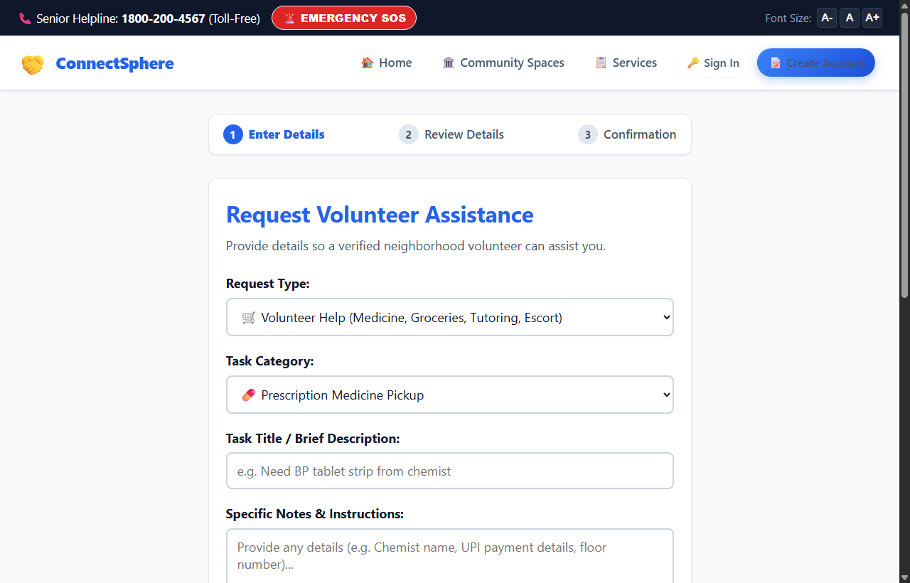
Description & Forward Interaction:
Purpose: Captures essential operational data required by neighborhood volunteers: resident contact details, building/flat address, preferred assistance time, urgency level, and specific notes (e.g., prescription slip details or stair climbing support).
Forward Trigger: Submitting the validated form via the "Proceed to Review Details →" button saves the active request draft and advances the flow to Screen 4 (Detail Review Screen).
Screen 4: Confirmation / Detail Review Screen
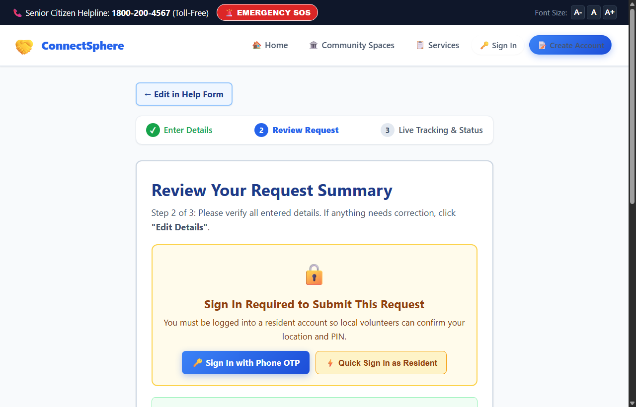
Description & Forward Interaction:
Purpose: Presents a comprehensive review slip displaying requester name, phone number, destination address, scheduled delivery window, and safety guidelines. It enables seniors to double-check their errand specifics or edit details prior to broadcast.
Forward Trigger: Clicking the prominent green button "Confirm & Broadcast to Community →" commits the request to the neighborhood pool, generates a 4-digit Senior Safety PIN, dispatches real-time broadcast pings, and opens Screen 5 (Real-Time Tracker).
Screen 5: Success / Status / Completion Screen
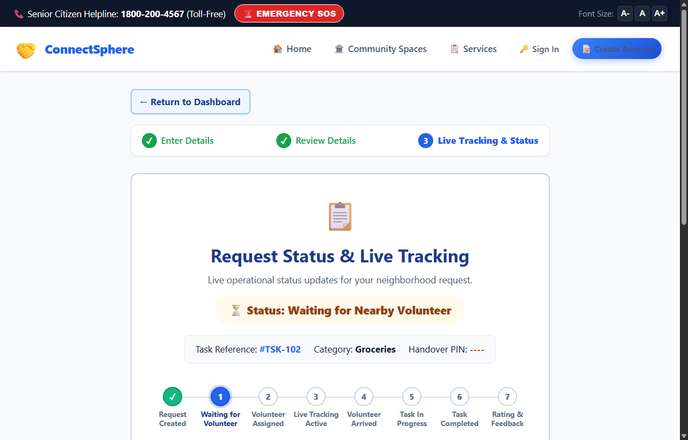
Description & Forward Interaction:
Purpose: Serves as the persistent live execution dashboard. It features an active 8-step lifecycle status tracker (Request Created → Waiting for Volunteer → Volunteer Assigned → Live Location Active → Arrived at Location → Task in Progress → PIN Verification → Feedback), dynamic live ETA, and the 4-digit Senior Safety Handover PIN.
Final State Displayed: Displays the unique tracking reference (e.g., #TSK-102), dynamic status badge (⏳ Status: Waiting for Nearby Volunteer transitioning dynamically upon acceptance to 🟢 Status: Volunteer Assigned & En Route), volunteer phone contact CTA, Senior Safety PIN code (e.g., 7153), and a "← Return to Dashboard" navigation button.

Prototype Access & Proof of Concept Links
Tool Selected (Figma / Canva / Front-End): Basic Front-End Web Development (HTML5, CSS3, JavaScript)
Public View/Prototype URL:
https://aanchalyadav-21.github.io/CMV-space/
(Ensure public access permissions are enabled: Fully accessible publicly via GitHub Pages)
Github Repository URL (if Front-End):
https://github.com/aanchalyadav-21/CMV-space
Resources
Sr. No. | Title | Link
1 | Figma Beginner Prototyping Guide | https://help.figma.com/hc/en-us/articles/360040314193-Guide-to-prototyping-in-Figma
2 | Video Tutorial: Figma Prototyping Basics | https://www.youtube.com/watch?v=1ucLq6JTxac
3 | Canva Interactive Hyperlinking Guide | https://www.canva.com/help/add-links/
4 | Video Tutorial: Clickable Presentations in Canva | https://www.youtube.com/watch?v=qO2Qfqz1Hks
5 | Web Basics: Multi-Page HTML/CSS Navigation | https://www.youtube.com/watch?v=iXSSHlOe47s

