Circuit Construction Breadboard

A circuit construction breadboard allows the user to conveniently build an experimental circuit (as opposed to a permanent one that is meant for repeated use) without having to solder components. Figure 1 shows a photograph of the PB-503 PROTO-BOARD breadboard used in this laboratory.

Figure 2(a) shows a portion of the breadboard outlined in Figure 1. The main part of the board consists of a sets of holes. The holes are actually sockets that have spring clips inside in order to make electrical contact with any component lead that may be inserted into the hole. Each set of holes is connected internally. Figure 2(b) schematically illustrates by means of lines which sets of holes are connected together internally. The two sets of horizontal sockets at the top of the board (designated by +5V, +1.5V, -1.5V and GND signs) are commonly called “power bars,” and are internally connected to the built-in power supplies. Notice that the socket interconnections for the “components fields” run only horizontally. Vertical connections exist only in “vertical bars” below the power bars. The vertical bars are used to supply power to your circuits; however, they are not internally connected to the built-in power supplies. Therefore you could use the vertical bars to supply power to your circuit both from the internal and the external power sources.

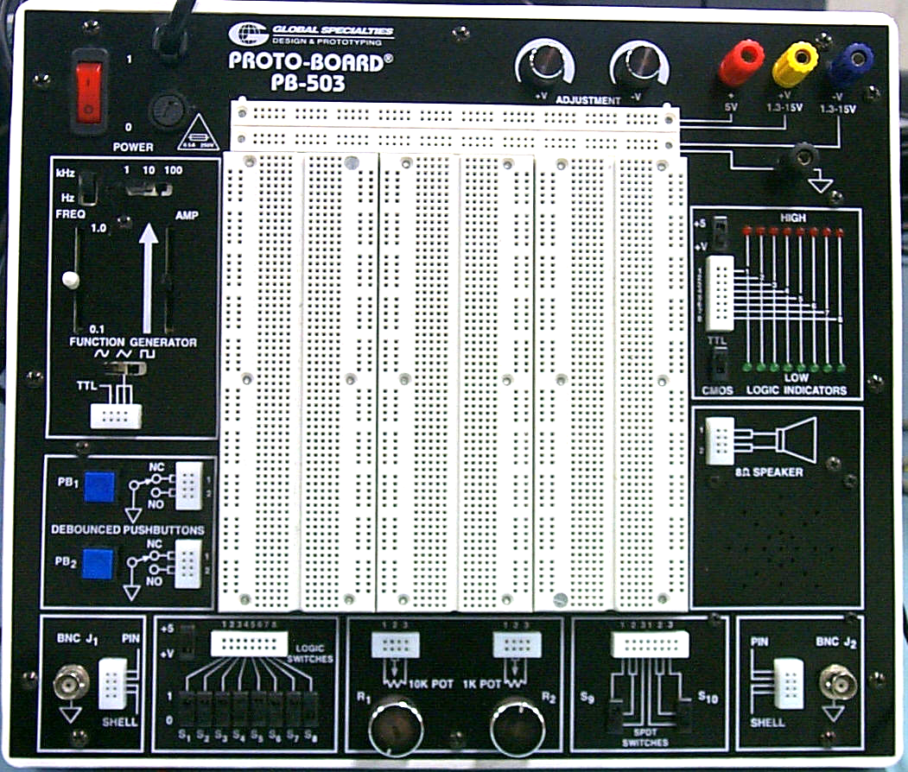

Figure 1: PB-503 proto-board

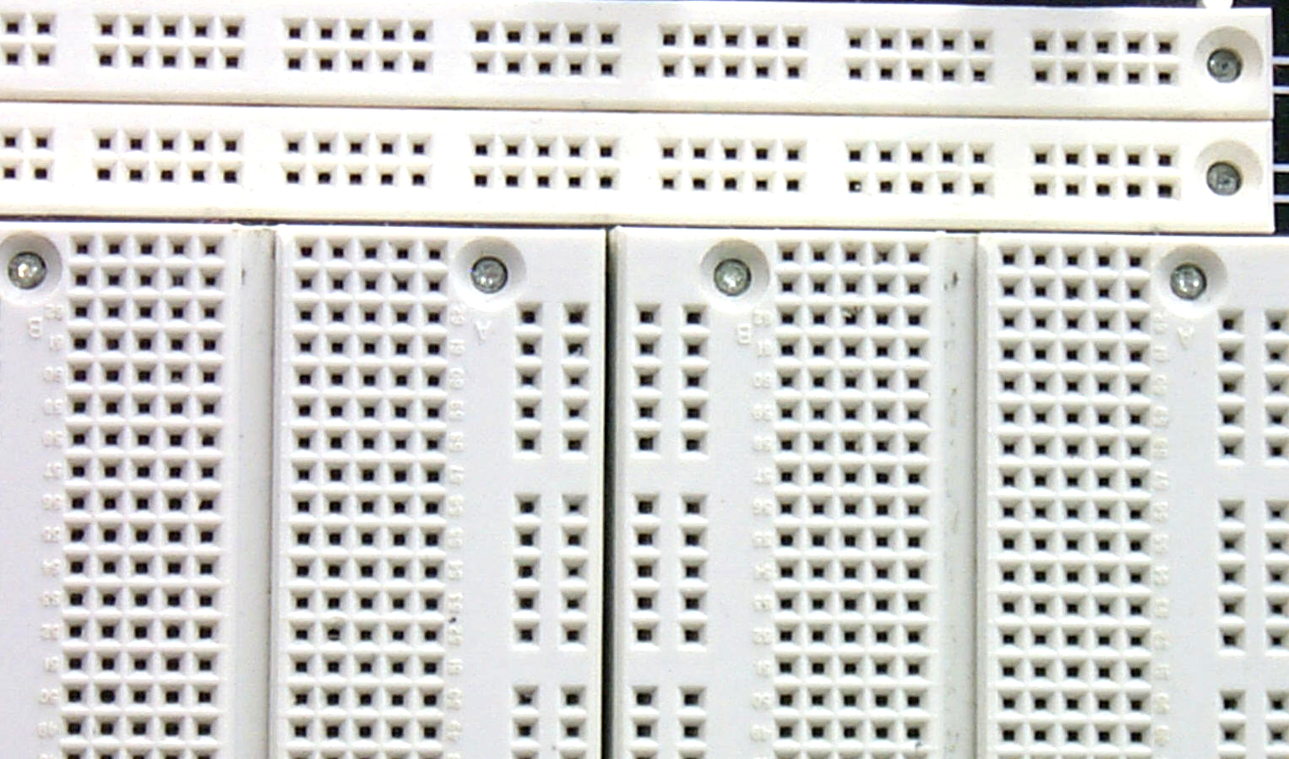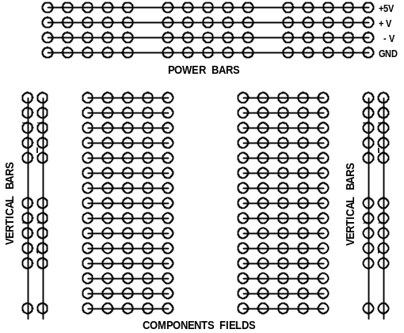

(a) Section of breadboard outlined in Figure 1. (b) Internal breadboard connections.

Figure 2: Schematic illustration of a generic circuit construction breadboard.

Key Features Of PB-503 PROTO-BOARD
The PB-503 PROTO-BOARD is a complete design workstation, including instrumentation, breadboarding, and a rugged DC regulated triple power supply.
The instrumentation features:

- eight individual selectable logic switches (offering settings of +5volts / +V and ground);
- eight individual red (high) and green (low) buffered logic LED indicators;
- 100KHz function generator with continuously variable sine, square, and triangle waveforms plus TTL pulse;
- triple output power supply (one fixed at +5VDC and two variable from ±1.3 to ±15VDC). All three supplies are short-circuit protected, automatically current limiting the output to a safe level.
- two digital pulse generators;
- audio experimentation 8 Ω speaker;
- SPDT switches;
- Potentiometers;
- debounced pushbutton switches.

The bread boarding area has a total of 2520 uncommitted tie points, enough space for circuits containing 24 IC's of 14 pins or equivalent.

Guidelines For Building Logic Circuits
Throughout these experiments we will use CMOS chips to build circuits. The steps for wiring a circuit should be completed in the order described below:

- Turn off the power of the PROTO-BOARD before you build anything!
- MAKE SURE THE POWER IS OFF BEFORE YOU BUILD ANYTHING!
- Plug the chips you will be using into the breadboard. Point all the chips in the same direction with pin 1 at the upper-left corner. (Pin 1 is identified by a notch next to it on the chip package.)
- Build the circuit neatly. It will be easier to troubleshoot the circuits if they are neatly built.
- Connect +5V and GND pins of each chip to the power and ground bus strips on top of the PROTO-BOARD.
- Select a connection on your schematic and place a piece of hook-up wire between corresponding pins of the chips on your breadboard. It is better to make the short connections before the longer ones. Mark each connection on your schematic as you go, so you do not attempt to make the same connection again at a later stage.
- If an error is made and is not spotted before you turn the power on. Turn the power off immediately before you begin to rewire the circuit.
- Tidy the area that you were working in and leave it in the same condition as it was before you started.

Common Causes Of Problems
- Not connecting the ground and/or power pins for all chips.
- Leaving out wires.
- Plugging wires into the wrong holes.
- Driving a single gate input with the outputs of two or more gates
- Modifying the circuit with the power on.

In all experiments, you will be expected to obtain all instruments, leads, components at the start of the experiment and return them to their proper place after you have finished the experiment. If you damage a chip, inform me, don't put it back in the box of chips for somebody else to use: Chips are inexpensive so it is best to discard chips that may cause problems.

Example Implementation of a Logic Circuit:
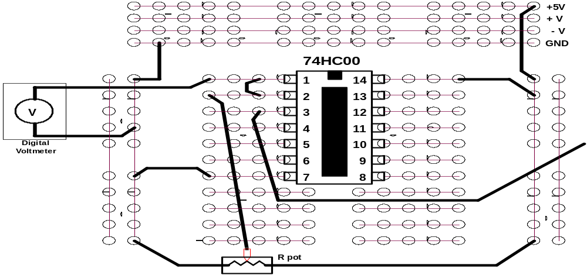
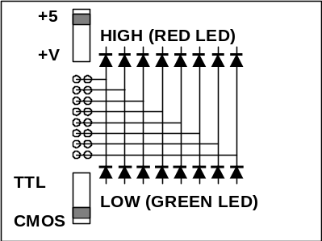

Figure 3: A completely designed and connected circuit.

Logic Level Indicators
There are digital logic level indicators built on the right side of your Proto-Board as shown in Figure 4. There are eight independently operating channels that are able to show the logic levels of digital signals connected to them. Each channel has two indicating LEDs. The Red LED will light up when the output voltage of the measured circuit is sufficiently high and it could be considered as a logic level of “1”. The green LED will light up when the output voltage of the measured circuit voltage is sufficiently low and it could be considered as a logic level of “0”.
There are two switches assigned to the logic indicator. One is to change the power supply of the indicator from +5(V) to +V(V) depending of what power supply source is connected to your circuit. The second switch position determines what kind of digital logic levels are supplied to the indicator. If the tested circuit is built using TTL ICs, the switch should be in the “TTL” position. If the tested circuit is built using CMOS ICs, the switch should be in the “CMOS” position. During the experiments, it is necessary to turn switch 1 to the “+5 V” position and switch 2 to the “CMOS” position.
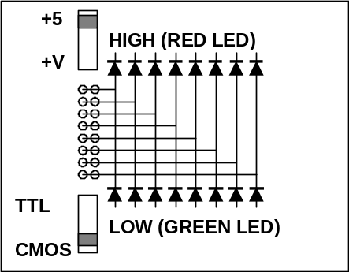

Figure 4: Logic level indicators on proto-board

Logic Switches
There are eight digital logic switches (SW1 to SW8) built on the bottom left of your Proto-Board as shown in Figure 5 and each one is able to apply logic levels of 0 and 1 to the connected digital circuits. Another switch is assigned to change the voltage levels of the logic signals from +5(V) to +V(V) depending on what power supply source is connected to your circuit. During the experiments, it is necessary to turn the switch to the “+5 V” position.

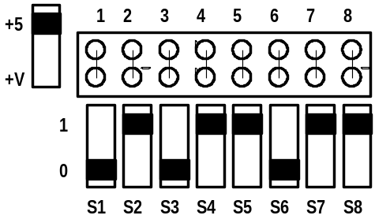

Figure 5: Logic switches on proto-board

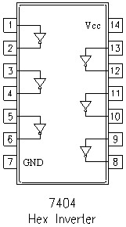 | 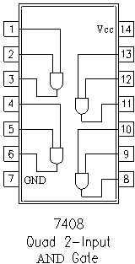 | 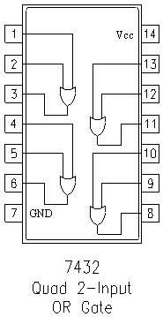

Figure 6: Pin configurations of three important IC chips

——————o——————

