Reading and Writing Variable Length Records
- How do we know how long the record is?
- How do we store the length?

All techniques use more space than the actual data
The designers have to understand how data will be used so they can choose the implementation with the least wasted space
Read about file dumps so you can use them in your program
The stuff about numbers is particularly important because you may want to store them as strings of digits rather than as numbers

Buffering: We need to do this first
When you read information from a file you don’t read a field as a time you read a buffer
This buffer usually contains at least one record
It may contain an integral multiple of records
It is in the buffer that the records are looked at as containing fields.
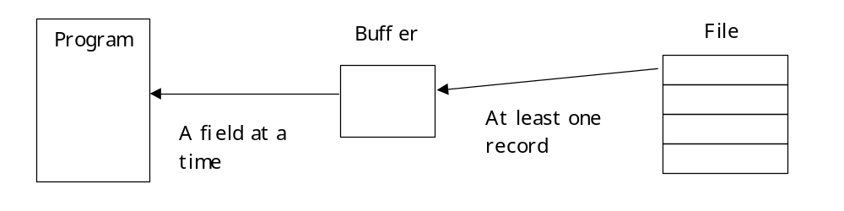

C++ Implementation of Buffers
Uses Inheritance for Record Buffer Classes
But first a reminder:
Public: Can be referenced directly from outside the class. Usually we make methods that change the state of the object public. We do not make the state public.
Private: Can be accessed only by methods within the class. The state variables in the class should be private.
Protected: Can be referenced directly by the class and all classes in the derived classes. We use this for methods. We do not make the state variables protected.
Virtual: Derived classes will supply their own version of the method. Binding occurs at run time. (i.e. the runtime system decides which version to run not the compiler)
=0 means the derived class must give its own version
Friend: if a class designates a method as a friend then that method has access to the private data of the class but is not a member of the classes. Classes can also be friends. (You see this in redefining << )
Static: when data members are static this means there is one per class and all objects in the class have access to that one data member
Static: when methods are static they are used to access static member data. They belong to the class and not the object so they are referenced using the class name.

Buffer Class Hierarchy
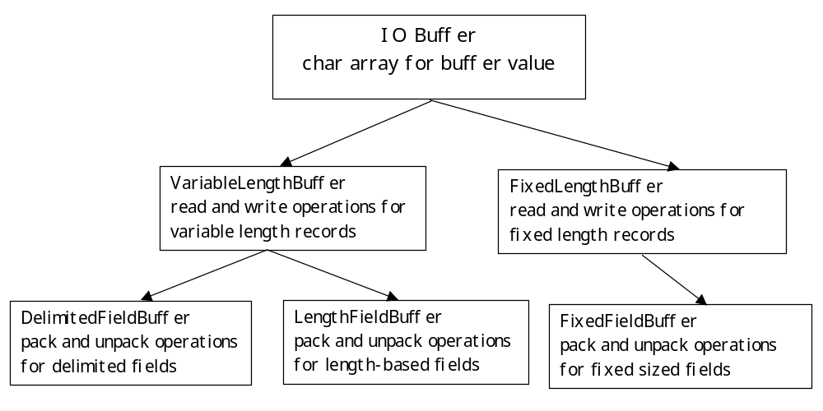
If we create 3 classes, one for each of the buffers we can make the implementation opaque to the user.
If we are lucky we can reuse some of the code.
Notice that VariableLengthBuffer and FixedLengthBuffer don’t really know anything about the individual fields in the record.
They just know how to write the entire record
So, we can change the fields without needing to change these classes

Class BufferFile in appendix F
Supports manipulation of files that are tied to a specific buffer type
Each object of class BufferFile represents a specific file that uses a specific buffer object. So each file has only one buffer.
We use this object of type BufferFile to create, open, read, and write records to the file.
The records are written to the file through the buffer
DelimFieldBuffer (buffer); //Creates buffer
BufferFile file(buffer); //Attaches the buffer to file
file.open( Myfile ); // opens the file named MyFile
file.read( ); // puts a copy of the next record
// into the buffer
buffer.Unpack( MyObject); // Unpacks the record just read into
// MyObject
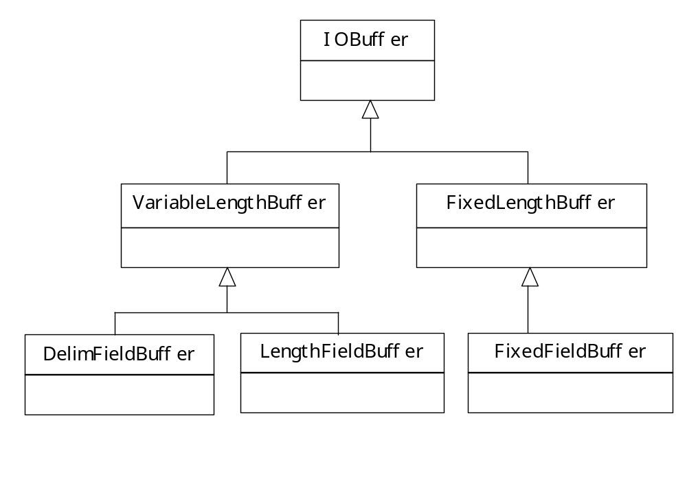
The buffer class hierarchy includes a class called FixedLengthBuffer even thought it may look like it is unnecessary.

IOBuffer
+IOBuffer( int maxBytes )
+IOBuffer & operator = ( const IOBuffer & ) | This class also indicates that
+virtual void Clear() | packing routines for putting
+virtual int Pack (const void * field, int size int size = -1 ) = 0 | the fields into the buffer
+virtual int Unpack ( void * field, int maxBytes = -1 ) = 0
+virtual void Print ( ostream & ) const | Notice that the fields are
+int Init ( int maxBytes ) | all derived from the super
+virtual int Read ( istream & ) = 0 | class field.
+virtual int Write ( ostream & ) const = 0
+virtual int DRead ( istream &, int recref )
+virtual int DWrite ( ostream &, int recref ) const
+virtual int ReadHeader ( istream & )
+virtual int WriteHeader ( ostream & ) const
-int Initialized
-char * Buffer
-int BufferSize
-int MaxBytes
-int NextBytes
-int Packing
FixedLenghtBuffer
+FixedLengthBuffer( int recodSize = 1000 )
+FixedLengthBuffer ( const FixedLengthBuffer & Buffer ) | Notice this class has no
+void Clear() | data members
+int Read ( istream & )
+int Write ( ostream & ) const | It is an abstract class
+int ReadHeader ( istream & )
+int WriteHeader ( ostream & ) const
+void Print ( ostream & ) const
+int sizeOfBuffer () const
#int Init ( int recordSize )
#int changeRecordSize ( int recordSize )
FixedFieldBuffer
+FixedFieldBuffer( int maxFields, int recodSize = 1000 )
+FixedFieldBuffer( int maxFields, int * fieldSize)
+FixedFieldBuffer ( const FixedLengthBuffer & )
+FixedFieldBuffer & operator = ( const FixedLengthBuffer & )
+void Clear()
+int addField ( int fieldSize )
+int ReadHeader ( istream & )
+int WriteHeader ( ostream & ) const
+int pack ( const void* field, int size = -1 )
+int unpack ( void* field, int maxBytes = -1 )
+void Print ( ostream & ) const
+int numberOfFields () const
#int Init ( int maxFields )
#int Init ( int numFields, int * fieldSize )
# int * fieldsize | Why are these protected?
#int maxFields
#int numFields
#int nextField

