This is a short description of the UML taken from Design Patterns Explained, A New Perspective on Object-Oriented Design by A. Shalloway and J. R. Trott
The UML is a language used to create visual models of our programs.
It is not sufficient in itself but must be accompanied buy a descriptive narrative of how the classes and other code is expected to work.
For example, you still need pre and post conditions for methods.
The UML consists of diagram showing the relations ships among the entities used to craft the solutions.
By the way, this is a wonderful book to read if you want an idea of what OO Design really involves.
INTERACTION DIAGRAM : show how specific objects interact with each other. Each diagram deals with a specific case. Use them to design test cases. The most popular interaction diagram is the Sequence Diagram.
CLASS DIAGRAM : detail the relationships between and among the classes. These are:
is-a : one class is a “kind-of” another class
has-a : one class “contains” another class
uses : one class uses another class
COMPOSITION : a class contains an object from another class as a part of it. As in status is part of the supplier record
AGGREGATION : a class is made up of things that can exist on their own. As in an airport will have airplanes.

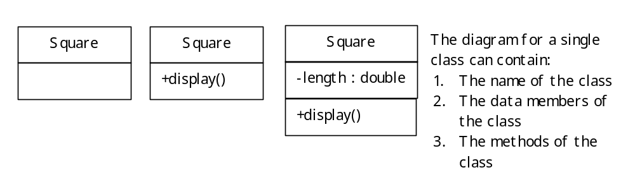
- When the method or data member is public it is preceded by a +
- When the method or data member is protected it is preceded by a #
- When the method or data member is private it is preceded by a -
You need one complete class diagram for each class. This one should be accompanied by a description of what each data member and method represents and how they are used in your solution.
When you use the class diagrams to show the relationships between the classes you should put in the relevant data members and methods.
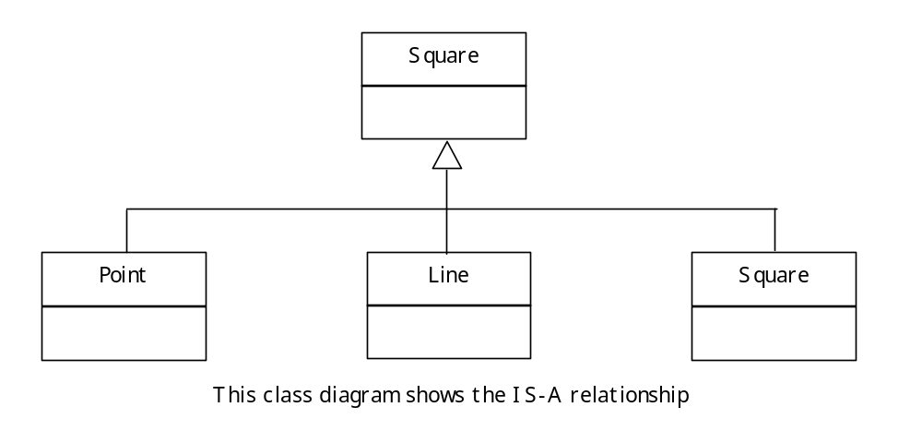
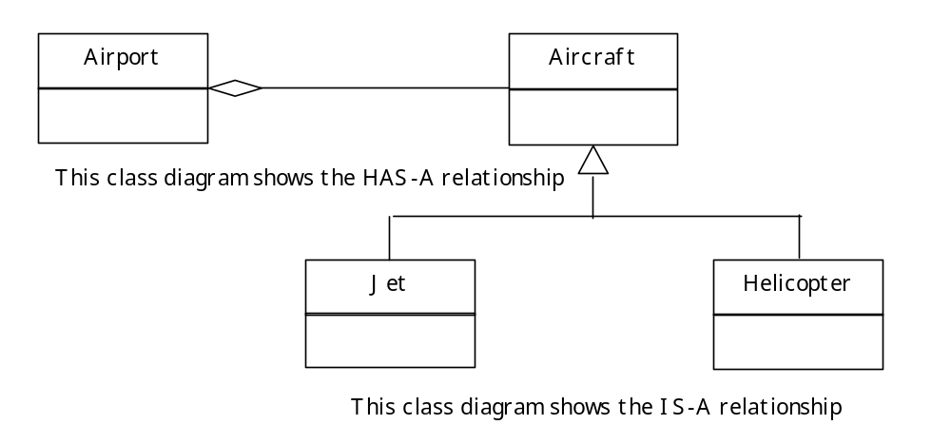

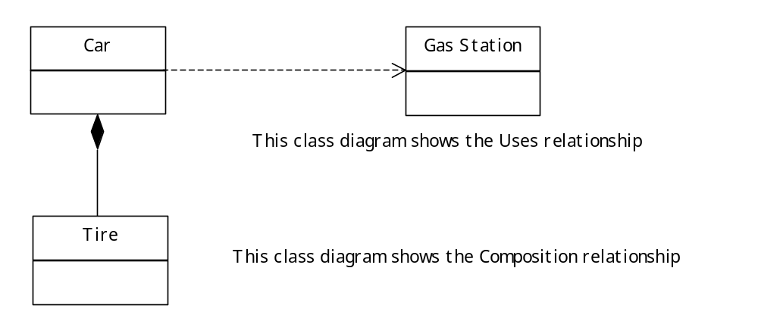

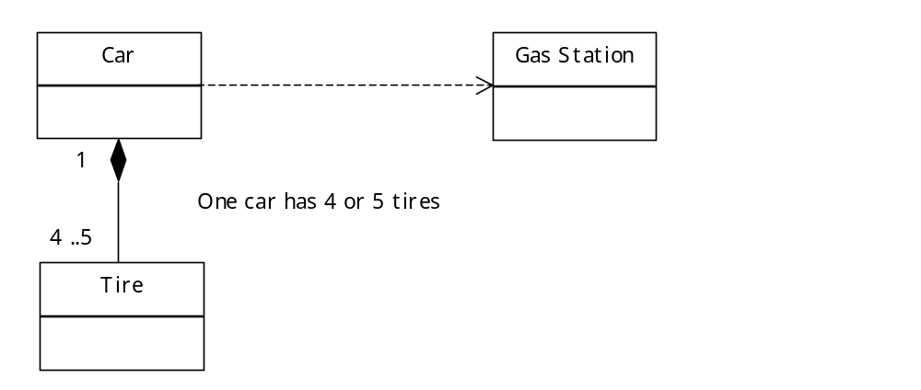

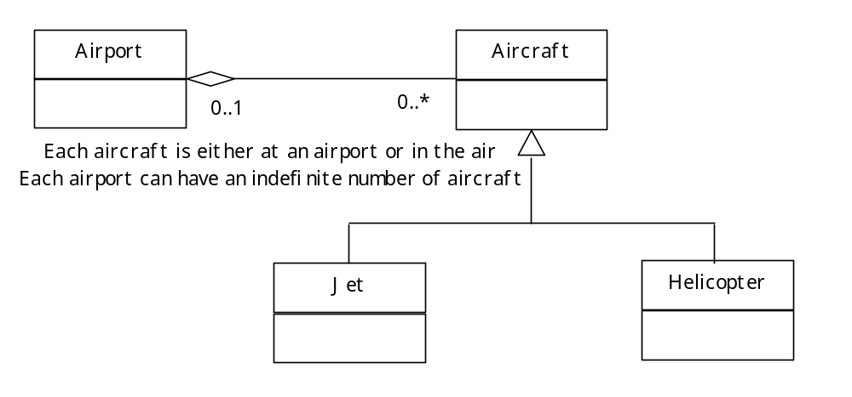

SEQUENCE DIAGRAMS : These show how the objects interact with each other.
- Each rectangle at the top represents a particular object. If more than one object from a given class is used in the diagram we name the objects. Otherwise we use the class name.
- The vertical lines represent the lifespan of the objects.
- The horizontal lines represent objects sending messages to each other.
- Returned values or objects are explicitly shown.
