Aandishah Tehzeeb Samara

IDCE 30262: Web Mapping and Open Source GIS

Professor Korde

2nd September 2021

**Lab 1: Setting Up Your First Website**

1. Link to GitHub Page:

https://github.com/aandishah/aandishah.github.io.git

1. Explain the following:
   1. What is Git? Explain the workflow of Git when you push changes to a repository.

Git is a distributed version control system.

When making changes to push from local to remote repository, Git workflow occurs in three simple steps- add, commit and push. This is given that the Git Bash have been setup with the files linking the correct local repo to the correct remote repo and also that the proper authorization has been given to GitHub.

When we add a file in the current level of commit we use the following code:

$ git add [file]

$ git add --all

When we add commit our content and then add a meaning messaging to explain the commit we use the following code:

$ git commit -m “Sample message”

When pushing from a local repository to the remote repo we use we use the following code:

$ git push -u origin main

* 1. What is Atom?

Atom is a text editor with interface development environment (IDE) capabilities.

* 1. What is GitHub?

GitHub is an online development platform that allows individuals and organizations to host and review code, manage projects, and build software. More than 36 million developers are subscribed to GitHub, with projects ranging from individual opensource initiatives to organizational projects with hundreds of contributors and thousands of files.

1. Find, explore, and evaluate **two** websites that you consider to be examples of web  
   mapping. You are required to provide a general assessment of the user experience  
   and the strengths and weaknesses of each website. In addition, your evaluation must  
   address the following characteristics of each web mapping application:
   1. What is the primary purpose of that web mapping application? (If the primary

purpose is unclear, comment on the lack of clarity.)

* 1. What GIS functionality does that application offer? (e.g., geocoding, shortest

path, type of spatial analysis)

* 1. For whom was that application designed? (e.g., researchers, policymakers,

general use)

* 1. How intuitive is the user interface of the application? (i.e., Please describe your

personal user experience when exploring the application.) If you were asked to

re-design the web mapping application, what would you change? (If you think

the application is perfect enough, justify why you would not change anything.)

1. Website 1:

* URL: https://www.shipmap.org/
* Name of Agency: [Kiln](https://www.kiln.digital/) based on data from the [UCL Energy Institute](http://www.bartlett.ucl.ac.uk/energy) (UCL EI)
* 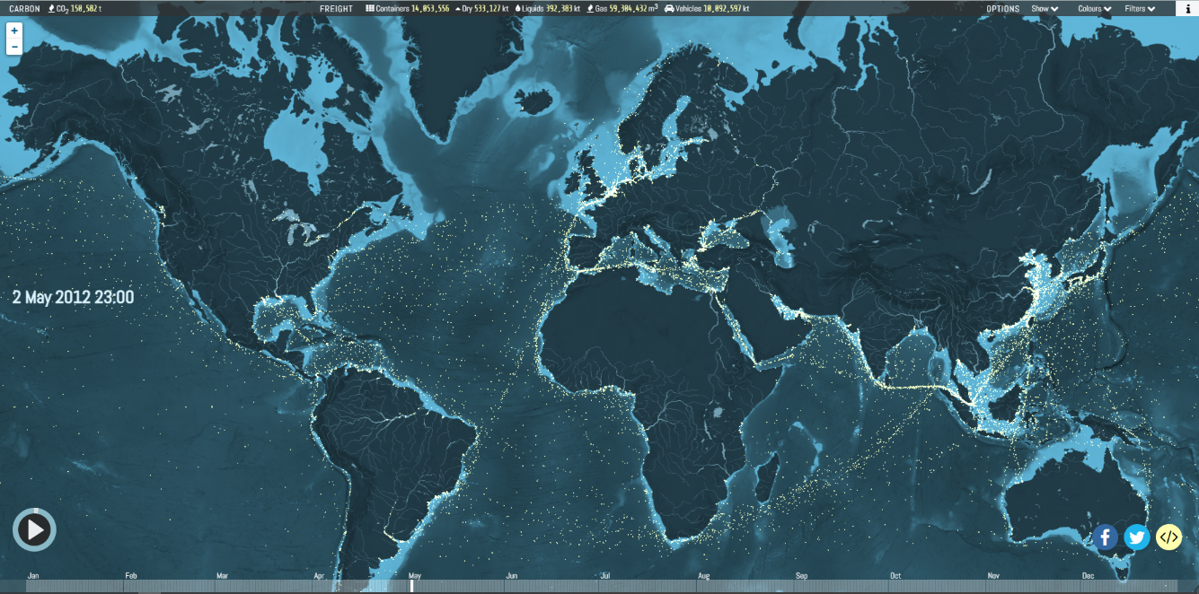Screenshot:

*Fig 1. website page for shipmap.org maps*

* Questions:

1. Shipmap.org is an ambitious interactive WebGL map of commercial shipping movements based on hundreds of millions of data points from throughout 2012 (the most recent year for which all the raw input data was available). The project's aim is to highlight for a broad audience the extraordinary scale of modern commercial shipping, the routes these huge vessels take around the world, the geographic spread of different types of cargo boats, and the amount of carbon dioxide they produce.
2. Its used for geocoding, and shows spatial analysis.
3. It is used for general use;
4. This website is absolutely stunning. Th proportions, the aesthetic and the audio commentary. It is a perfect role model for what a web mapping interface should look like. The only fallback, is that it is not updated. It showcases the movements for 2012 and nothing before or after.
5. Website 2:

* URL: https://www.splcenter.org/hate-map
* Name of Agency: Southern Poverty Law Center
* Screenshot:

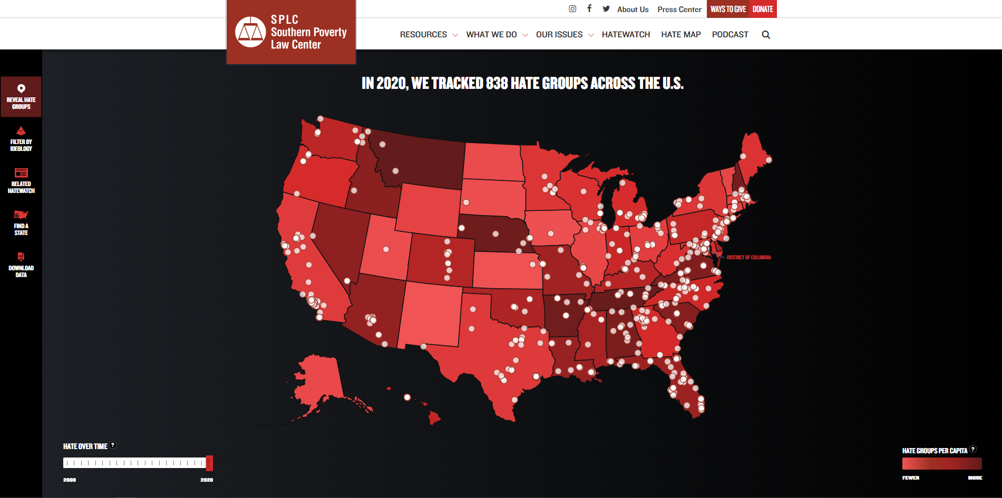

*Fig 2. Website page for tracking hate crime groups across USA.*

* Questions:

1. The Hate Map on the spl website gives a quick and easy to follow visual narrative of where the hates groups across the US is located. It can be filtered by ideology, state, and relevant news to these groups are provided.
2. It is a single choropleth map, that also shows the temporal analysis.
3. It is intended for genera use; education and outreach purposes but can also be used by researchers and policy makers.
4. While, very informative, this map does not give a very clear idea of what the definition of a hate group is. While it list the number of the hate groups – it does not show the affiliation size. For instance, while Utah might have one type of hate group might have a much larger following than a state that has 10 groups with much smaller following. This skews the narrative about the type and amount of hate groups there are in the USA.