Aandishah Tehzeeb Samara

IDCE 30262: Web Mapping and Open Source GIS

Professor Korde

14th September 2021

**Lab 2: HTML and CSS**

1. Link to GitHub Page:

https://aandishah.github.io/

1. Codecademy:

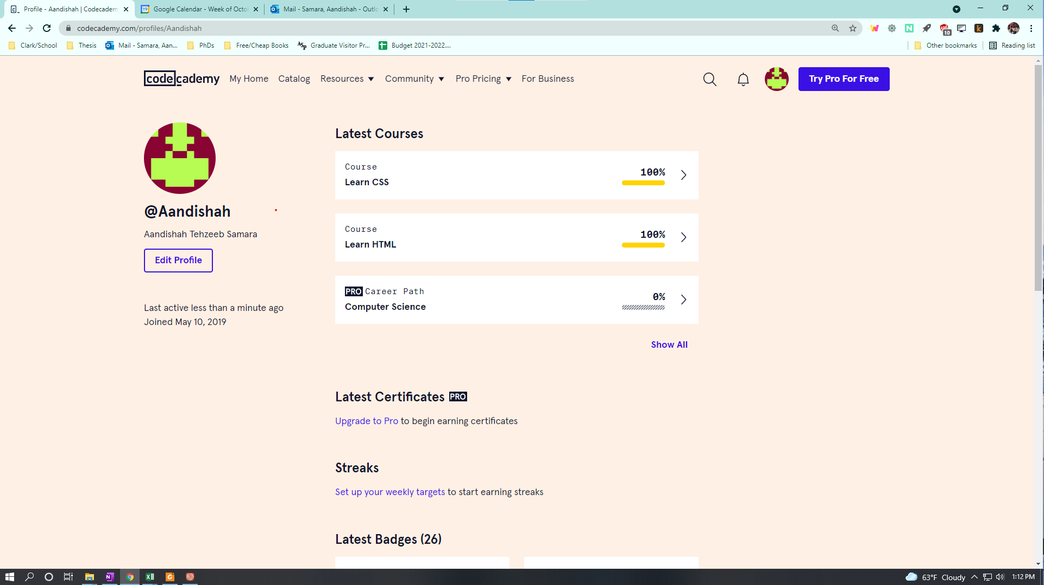

1. CSS Document:

Link to CSS File:

https://github.com/aandishah/aandishah.github.io/blob/main/css/main_style.css