**San Antonio Universities for Students Who don’t Own a Vehicle**

Adam Andre

April 10, 2020

1. **Introduction**

Which university in the San Antonio area have the most amenities within walking distance? I would have to leverage the Foursquare location data in a small radius around each campus. Answering this question can help potential students (stakeholders) who are planning on living on campus who do not have a vehicle choose a school.

1. **Data**

I will be utilizing a data set I put together containing eight San Antonio universities, their latitudes and longitudes, and their address. I will use this data set in combination with the Foursquare API to determine how many restaurants, grocery stores, parks, shops, and bus stations are within walking distance of each university. I will determine a weighted score for each category and determine which university is best for students living on campus without a vehicle.

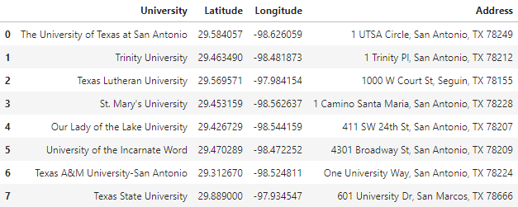

Table 1 – Universities data