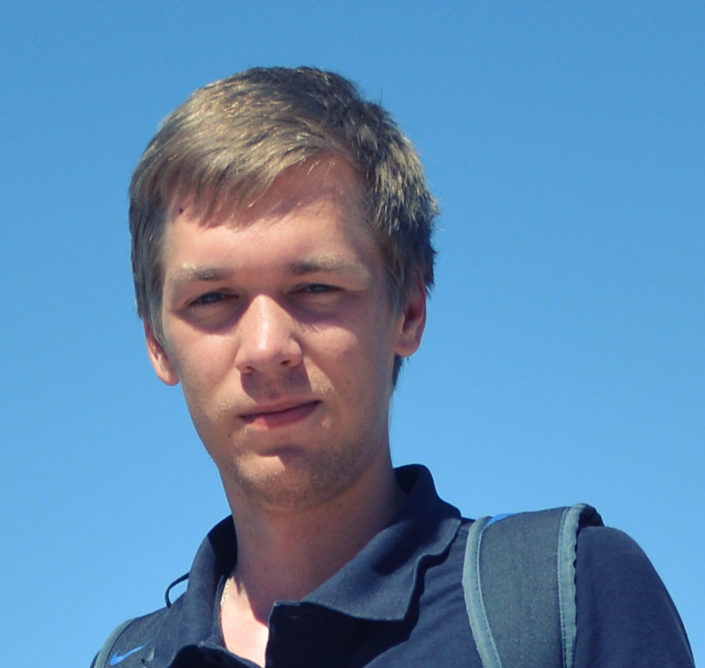**Full name:** ANDREI AUDZEYEU

**Date of Birth:** July 26, 1994

**City:** Minsk

**Email:**  [andrewww.avdeev@gmail.com](mailto:andrewww.avdeev@gmail.com)

**Phone:**  +37529 5418679

**Objective:** Full stack web developer

**Key competences:**

* 4 Years of Back-end Development experience
  + Professional working experience in PHP, NodeJS, SQL.
  + Participated in 5 projects.
  + Back-end web developer experience: PHP libraries(OAuth2, Swift Mailer, etc), frameworks (Yii, Laravel, Silex, personal php mvc framework), job queues (Gearman), CMS`s (Drupal, Joomla, Wordpress, DLE); template engines; NodeJS (Express, Socket.IO, Mongoose, etc); Ruby with ROR; databases (MySQL, SQLite, PostgreSQL, MongoDB); Server and environment settings (Ubuntu, CentOS); web servers (Apache, Nginx); version control services (bitbucket, github, gitlab); RESTfull API; highload;
  + DevOps experience: Virtualizations platforms (Vagrant); Containerization platforms (Docker); configuration management platforms (Chef, Puppet); continuous integration and deployment (capistrano, CircleCI, TravisCI); monitor infrastructure (Nagios, MySQL benchmark); Process Supervisors (Upstart, Supervisor).
* 4 Years of Front-end Development experience
  + Professional working experience in HTML, CSS, JS.
  + Participated in 5 projects.
  + Front-end web developer experience: CSS preprocessors (LESS, SASS, Stylus); front-end frameworks(Bootstrap, Foundation, Skeleton); JavaScript native, JavaScript libraries (Jquery, Prototype), frameworks (Angular, RequireJS); Coffescript; workflow (Bower, Grunt, Gulp, yeoman, etc);

**Education:**

(2011 - 2016) – Belarusian State University of Informatics and Radio electronics (information technologies engineer)

**Work Experience:**

(September 2014 – Present) – PeopleBank Australia

Position – Senior Web Developer

* Responsibilities
  + Servers support and setting
  + Project deployment
  + Backend development
  + Frontend development
  + Database support and maintenance
  + Regular meetings
  + Reports Writing
  + High load optimization
* Environment: CentOS, Apache, Nginx, PHP, MySQL, JS, CSS, HTML, Gearman, Capistrano, GIT, etc.
* Achievements:
  + Developed one of the biggest Australian online work platform, where businesses and independent professionals connect and collaborate.
  + Wrote several custom js and css libs.
  + Participated in 50th scientific conference at Belorussian State University of Informatics and Radio electronics on “Databases scaling” topic.
  + Wrote plenty shell scripts provisions for Vagrant

(September 2013 – September 2014) – Stone Labs Ltd

Position – Full Stack Web Developer

* Responsibilities
  + Backend development
  + Frontend development
  + Database support and maintenance
  + Projects estimation( at the sale stage)
  + Regular meetings
* Environment: GIT, PHP, NodeJS, MySQL, MongoDB, JS, CSS, HTML, etc.
* Achievements:
  + Developed custom lightweight PHP MVC framework.
  + Participated in inner conferences and Jams on various topics.

(January 2011 – September 2013) – Arsenal Belarus community

Position – Founder and lead developer of the official Belarusian Arsenal fan community.

* Responsibilities
  + Design and prototyping
  + SEO support
  + Frontend development
  + Backend development
  + Database support and maintenance
  + Content handling
  + Server support and setting
* Environment: PHP, MySQL, JS, CSS, HTML, Photoshop.
* Achievements:
  + Thousands of happy Belarusian Arsenal fans who can use the site to read news, watch games, see statistics and make bets, discuss the games and players etc.

**Additional Skills:**

* Driving license – Yes
* Languages:
  + English - Intermediate
  + Russian - Native or bilingual proficiency
* Hobbies:
  + Soccer (playing and watching)
  + Travelling
  + Cars