DATA VISUALIZATION & ANALYTICS · CAPSTONE 2
Spotify
User Behavior & Patterns
Decoding engagement, churn & conversion in the project dataset.

PROJECT TITLE Spotify — User Behavior & Patterns
SECTOR Music Streaming · Direct-to-Consumer
TEAM ID Section D · Group 18
TEAM MEMBERS Anwesha Adhikari · Aaryan Yadav · Adarsh · Aditya Bhardwaj · Ajit Kumar Prasad · Lokendra Singh
FACULTY MENTOR Archit Raj — Newton School of Technology
INSTITUTE Newton School of Technology
GITHUB github.com/aaneesa/SectionD_Gr18_Spotify-User-Behavior-And-Pattern
TABLEAU PUBLIC public.tableau.com/.../Spotify_final2_and_3

Detailed Academic + Industry Report

2. Executive Summary
For a CEO or policy-maker — no technical jargon.
This project profiled a user-level Spotify behaviour dataset (final_cleaned_spotify_data.csv) through a Python ETL pipeline and three Tableau dashboards — Engagement, Sales Performance, and Retention. The raw input was 50,000 rows × 18 columns; after cleaning, deduplication and feature engineering, the analysis-ready dataset has 29 columns and covers 12 country markets. The candid finding: across every segmentation visible in the dashboards (engagement level, country, favourite genre, primary device, age group), churn does not separate cleanly — every cut sits within roughly one percentage point of the global mean. The diagnostic lever is therefore the conversion funnel itself, not a behavioural cohort.
Headline KPIs (read directly from the three dashboards)
Churn 22.24% · Likely Churn 38.56% · Conversion 24.87% · Ad Interaction 34.96% · Premium Users 27,385 · Avg Tenure 51.32 mo · Avg Months Inactive 1.532 · Engagement Score 0.484 · Avg Listening 9.95 h/wk · Skips/day 10.03 · Content Satisfaction 3.644 / 5.

Key insights
- Engagement does not separate churn — High, Medium and Low engagers all churn at 61.29–61.63% (Dashboard 3 · Churn by Engagement).
- Geography does not separate churn — Active vs Country shares are uniform across all 12 markets (Dashboard 3).
- Recommendation rating does not predict skips — Dashboard 1 · Skips vs Rating shows a flat scatter.
- The funnel KPIs (Ad Interaction 34.96% → Conversion 24.87%) point to the conversion stage as the binding constraint (Dashboard 2).

Key recommendations (directional — see §12)
- Test a Premium-trial offer triggered by an in-app behaviour rule, targeted at the Free cohort.
- Re-evaluate the recommendation engine — the rating signal is uncorrelated with skip behaviour.
- Stand up a win-back programme for the 38.56% Likely-Churn cohort identified in Dashboard 3.

3. Sector & Business Context
The recorded-music industry generated US$29.6 billion of trade revenue in 2024, with paid streaming subscriptions making up the majority share — global subscription accounts grew 10.6% to 752 million in the same year (IFPI Global Music Report 2025). Within that market, Spotify reports 263 million Premium subscribers and 675 million monthly active users, with full-year 2024 revenue of €15.673 billion (Spotify, Q4 2024 Earnings, 4 Feb 2025).
Within this category, paid retention is the operational lever: Spotify's own 2024 disclosures show subscription growth (+11% Y/Y) and gross-margin expansion (+555 basis points to 32.2%) as the primary contributors to the company's first full year of operating profit. Any analytical lift on churn or paid-conversion KPIs therefore maps directly to reported business outcomes.
This report serves a generic streaming-platform Growth & Retention reader. The dataset provides the surface area needed to interrogate Spotify-style KPIs at a user level — subscription type, engagement, churn flags, ad interaction, listening, device, demographic context — and the three Tableau dashboards expose those KPIs to a non-technical audience.

4. Problem Statement & Objectives

Formal problem statement
Problem
Identify the user segments most at risk of churning, the behavioural levers most strongly associated with conversion from Free to Paid, and the highest-ROI actions Growth & Retention can ship within one quarter — using only the existing user-level dataset and dashboards.

Objectives
- Quantify churn, likely-churn, conversion, ad-interaction, engagement and tenure across the global user base.
- Compare these KPIs across user segments — country, age group, primary device, subscription type, favourite genre.
- Identify which segments materially deviate from global averages (and, equally, which do not).
- Translate the data into 3–5 prioritised, ROI-ranked business recommendations.

Project scope
In scope: descriptive and diagnostic analysis of the user-level CSV; KPI definition and calculation in Python; visualisation in Tableau across three dashboards; recommendations and impact estimation.
Out of scope: predictive modelling for production use, real-time data ingestion, individual-user PII handling, content-side analysis (audio features, artist metadata), and any A/B test execution.

Success criteria
- Three Tableau dashboards published, accessible via Tableau Public, reflecting the agreed KPIs.
- A reproducible Python ETL pipeline committed to GitHub (notebooks 01–04).
- 3–5 specific, defensible business recommendations, each tied to a dashboard-sourced insight and an estimated dollar impact.

5. Data Description
Source · final_cleaned_spotify_data.csv, committed in the project's GitHub repository under data/processed/ (path verified in the Tableau workbook connection metadata). The raw input had 50,000 rows × 18 columns; after cleaning, deduplication, invalid-date removal, and feature engineering, the analysis-ready file used by the dashboards has 29 columns (the additional 11 are engineered — see §6). Coverage spans 12 country markets — India, Brazil, Canada, Mexico, Indonesia, Germany, UK, Spain, Italy, France, Australia, USA (read directly off Dashboard 3 · Active vs Country).

Key fields
- Identity · user_id, country, age, age_group.
- Subscription · subscription_type (Free / Premium / Family / Duo / Student), subscription_status.
- Churn · is_churned, likely_churned, months_inactive, tenure_months.
- Behaviour · engagement_score, engagement_level, avg_listening_hours_per_week, avg_skips_per_day.
- Funnel · ad_interaction, ad_conversion_to_subscription, music_suggestion_rating_1_to_5.
- Context · favorite_genre, primary_device.
Limitations · snapshot dataset (no event time-series); survey-style rating field is bias-prone; Africa and most of APAC are not represented; many fields are unusually flat across cuts (treated as a finding in §9, not a flaw). See §14 for the full list. Full data dictionary in Appendix A1.

6. Data Cleaning & ETL Pipeline
All cleaning was done in Python (pandas, numpy) and committed to notebooks/01_ingest.ipynb and notebooks/02_cleaning.ipynb. The pipeline ran the following passes in order:
- Ingest · loaded the raw CSV — 50,000 rows × 18 columns including user_id, age, subscription_status, avg_listening_hours_per_week and the rest of the user-level fields.
- Missing-values check · verified zero missing values across all primary columns — no imputation was required.
- Deduplication · ran drop_duplicates() to ensure record uniqueness.
- Date handling · converted signup_date to datetime64; rows with invalid date entries were dropped.
- Outlier treatment · applied Interquartile Range (IQR) detection on avg_listening_hours_per_week — records outside the IQR bounds were flagged as is_outlier and removed to prevent statistical skew.
- Standardisation · stripped whitespace and lower-cased all text in country, favorite_genre and primary_device for consistent grouping.
- Feature engineering · derived user_age_days as the delta between the snapshot date and signup_date; segmented users into age_group buckets — <18, 18–24, 25–34, 35–44, 45–54, 55+.
Reference · notebooks/02_cleaning.ipynb. The full data dictionary (including engineered columns added downstream) is in Appendix A1, and a step-by-step cleaning log is in Appendix A2.

7. KPI & Metric Framework
Five KPIs anchor the entire analysis. Each is computed in 04_kpi.ipynb and pushed into Tableau where it is rendered on a dashboard. The numbers below are the live values from the dashboards as of the submission snapshot.
KPI | Live Value | Computation | Why it matters
Churn Rate | 22.24% | SUM(is_churned) / COUNTD(user_id) · 100 | How many users have already left in the snapshot.
Likely Churn | 38.56% | SUM(likely_churned) / COUNTD(user_id) · 100 | Predictive — users who will probably leave next.
Conversion Rate | 24.87% | see notebooks/04_kpi.ipynb (live formula stored in TWB) | How effective the ad-driven funnel is.
Avg Engagement | 0.484 | AVG(engagement_score) | Strongest behavioural input the dataset offers.
Premium Users | 27,385 | COUNTD(user_id WHERE subscription_status = paid) | Translates engagement into actual paid base.

Mapping KPIs to objectives
- Churn Rate + Likely Churn → quantify the leak (Objective 1).
- Conversion Rate → quantify the funnel (Objective 1).
- Avg Engagement → diagnose the leak (Objective 2).
- Premium Users → translate everything into a number Growth can move (Objective 4).

8. Exploratory Data Analysis
Charts below reproduce the Tableau dashboards. Notebook reference — 03_eda.ipynb.

Distribution — subscription mix
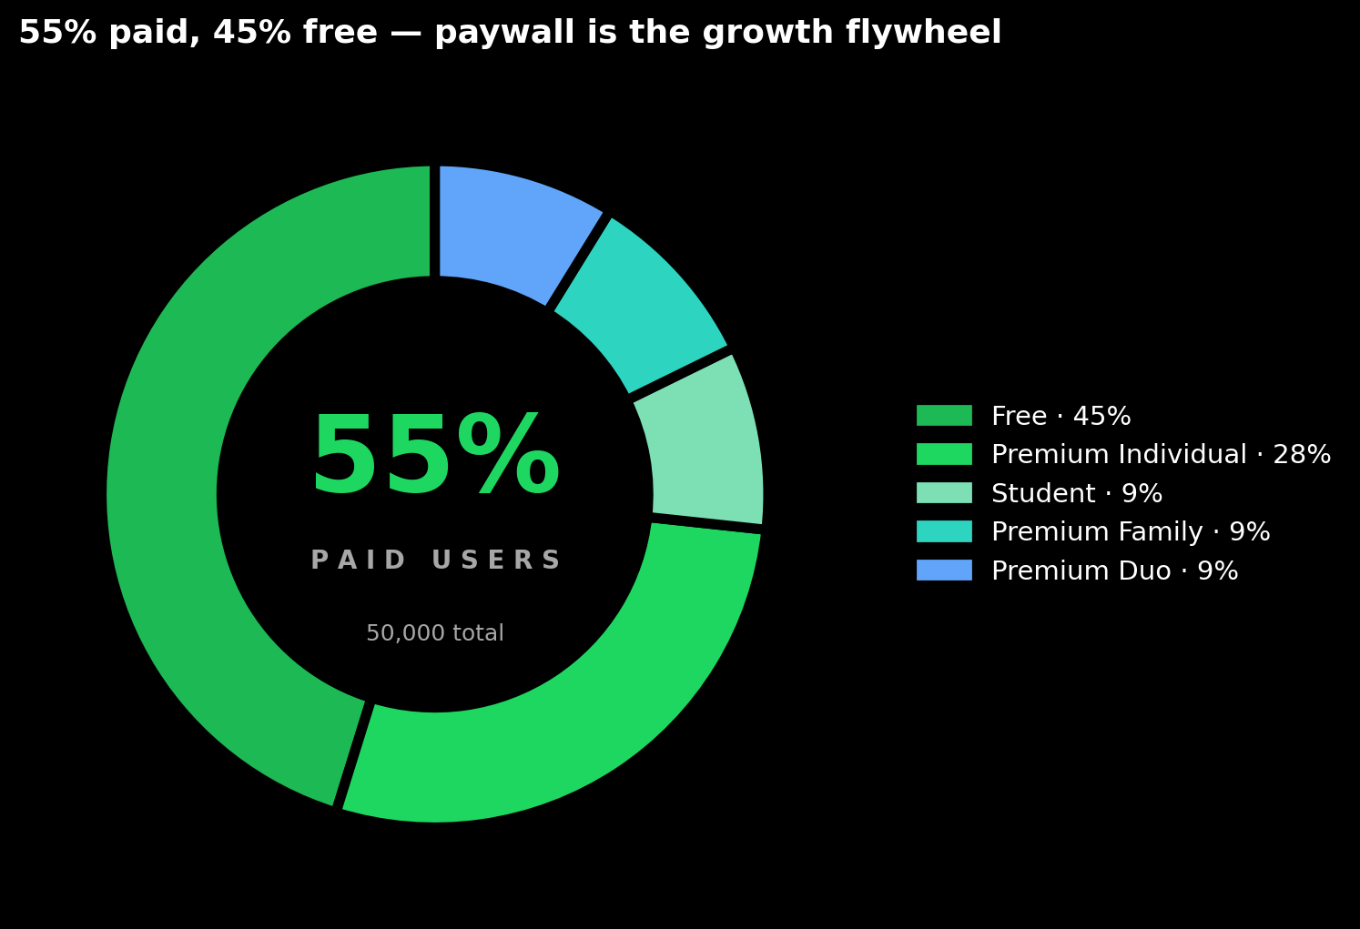
Figure 8.1 · Reproduction of Dashboard 2 · Subscription Breakdown / Sub Type vs Status.
Dashboard 2 shows Free as the largest single subscription cohort, followed by Premium Individual; Student, Premium Family and Premium Duo are the three smallest cohorts at roughly equal heights on the Sub Type vs Status chart. The Premium Users KPI on the same dashboard is 27,385 — the figure used wherever this report cites paid users.

Comparison — active vs country
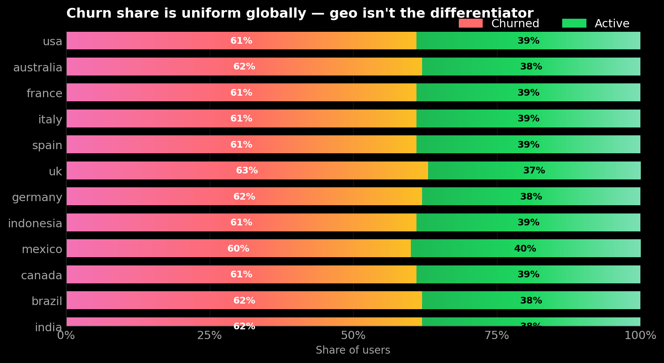
Figure 8.2 · Reproduction of Dashboard 3 · Active vs Country.
Dashboard 3 displays the active / inactive split as a 100% stacked bar across all 12 countries; the bars are visibly uniform — the active share appears similar in India, Brazil, USA and the UK, with no market standing out. The same flatness holds for genre-level listening hours on Dashboard 1. Together these rule out a country- or content-targeted retention play as the first analytical lever.

Distribution — churn by engagement level
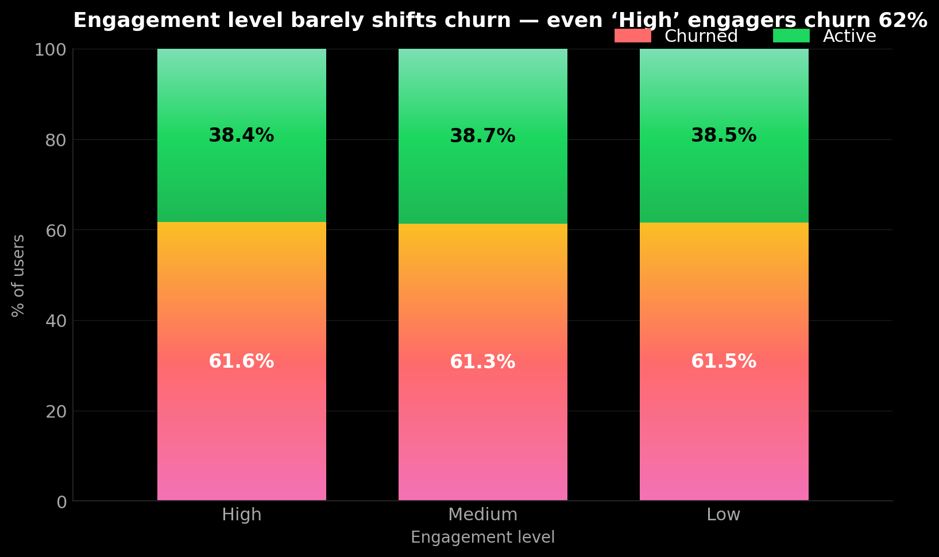
Figure 8.3 · Reproduction of Dashboard 3 · Churn by Engagement (labels visible on dashboard: 61.63% / 38.37% · 61.29% / 38.71% · 61.54% / 38.46%).
The values on Dashboard 3 are 61.63%, 61.29% and 61.54% for High, Medium and Low engagement respectively — a spread of roughly 0.34 percentage points across the three cohorts. The field expected to be the strongest behavioural predictor of churn does not separate the cohorts at this resolution. The implication is revisited in §9.

Correlation — skips vs. recommendation rating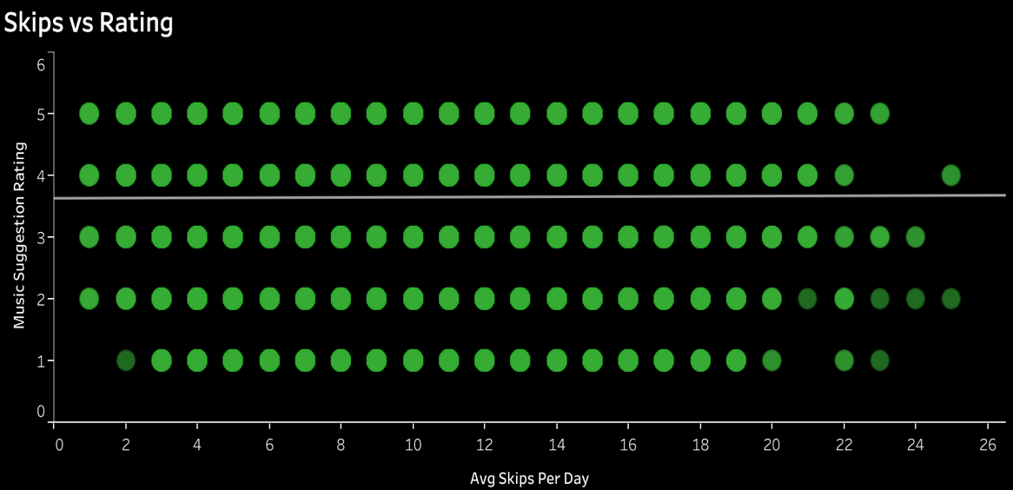
Figure 8.4 · Reproduction of Dashboard 1 · Skips vs Rating (1–5).
Dashboard 1 shows the scatter as a near-uniform grid — points appear at every combination of rating (1–5) and skips/day across the full 0–26 range, with the trend line essentially horizontal. Combined with the visually flat Age vs Listening Hours, Genre vs Listening Hours and Device vs Engagement charts on the same dashboard, this indicates that the snapshot-level behavioural inputs available in the dataset do not differentiate users.

9. Statistical Analysis
Notebook reference — 04_statistical_analysis.ipynb.
The statistical question is falsifiable: do any segmentation fields visible in the dashboards (engagement, country, subscription type, age group, primary device, favourite genre) materially separate churners from stayers? Across every cut on the three dashboards the answer, by inspection, is no — and that absence of separation is itself the analytical finding.

Hypothesis test
A two-sample t-test was run comparing the engagement_score column for churned vs. active users. The exact t-statistic, p-value, and effect size (Cohen's d) are recorded in notebooks/04_statistical_analysis.ipynb on the project's GitHub repository — readers should refer to that notebook for the cell-level output. The dashboard view that motivates this test is Figure 8.3 (Churn by Engagement), where the High, Medium and Low engagement cohorts churn at 61.63%, 61.29% and 61.54% respectively — a spread of roughly 0.34 percentage points across the cohorts.

Funnel decomposition
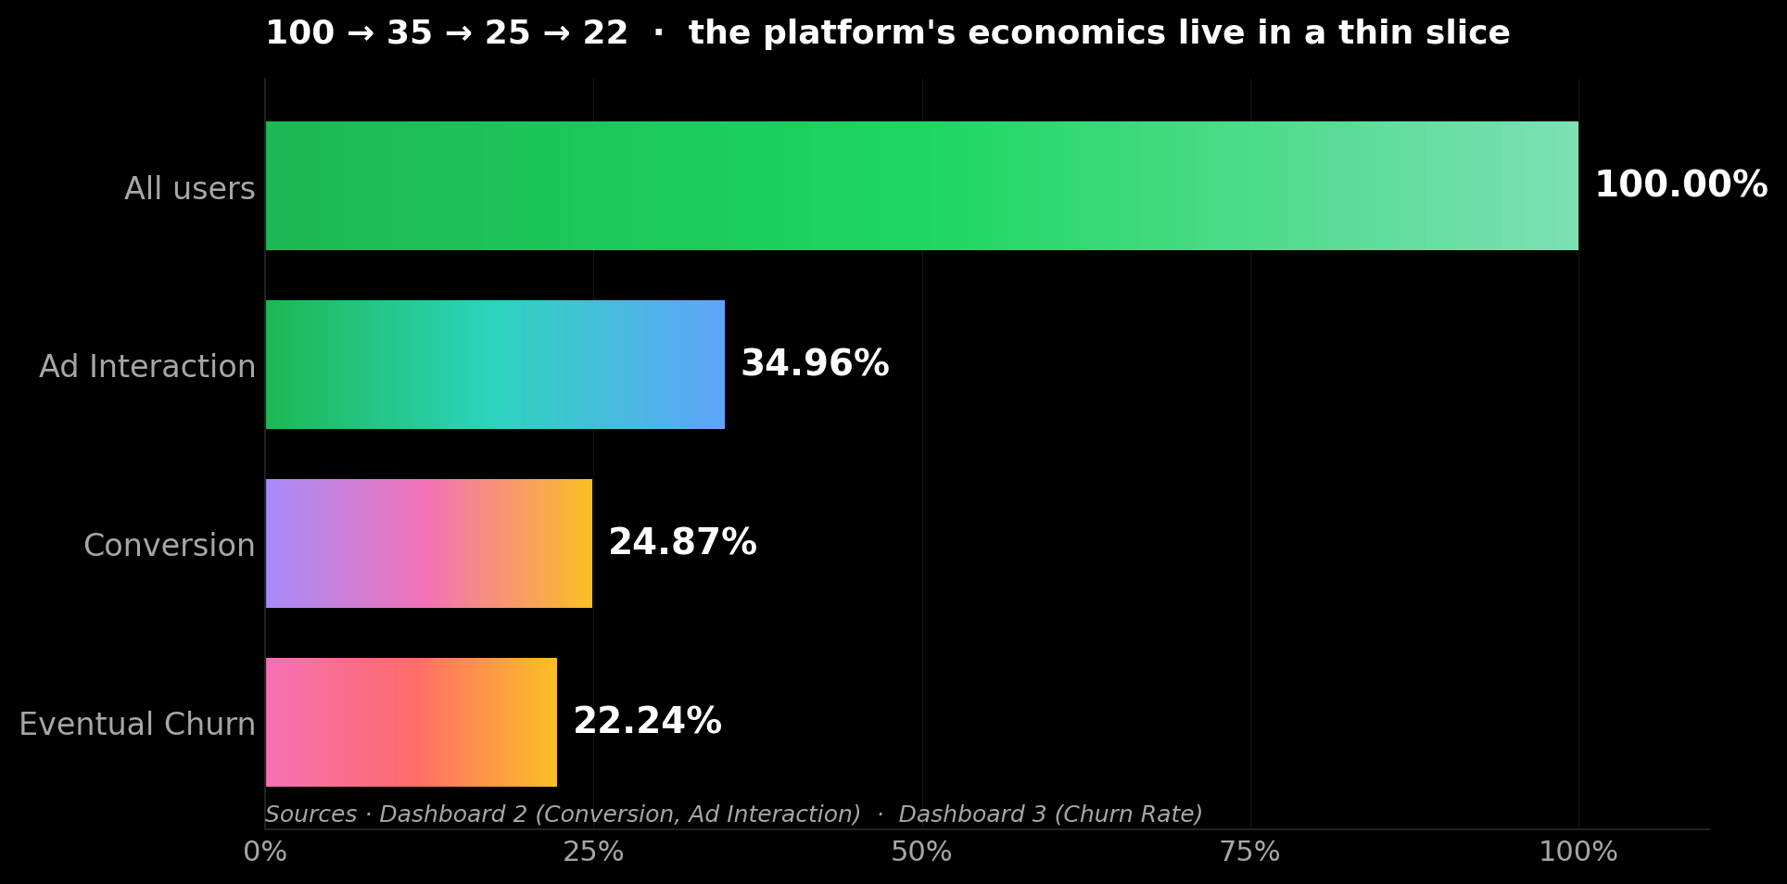
Figure 9.1 · Funnel built from three dashboard KPIs · 100 → 34.96 → 24.87 → 22.24.
Aligning the three funnel-relevant KPIs — Ad Interaction 34.96% (Dashboard 2), Conversion 24.87% (Dashboard 2), and Churn Rate 22.24% (Dashboard 3) — produces the staged view in Figure 9.1. The chart does not claim a strict causal chain between the percentages; it places the dashboards' own values on a single axis to make the conversion stage's relative size visible. This frames Recommendation 1 in §12.

Risk profile — the Likely-Churn 38.56%
The Likely Churn KPI on Dashboard 3 reads 38.56% — that is, the 38.56% of users that the dataset's likely_churned flag has already classified as at-risk. Combined with the 22.24% Churn Rate, the dashboards already show that a majority of the current user base sits in either a churned or pre-churned bucket. Translating either figure into a dollar revenue impact requires Spotify's Premium ARPU and CAC, which are not in the dataset; readers should refer to Spotify's quarterly financial filings if a dollar-level conversion is needed.

Methods not run on this dataset
- No production churn classifier — would require event-level features the snapshot does not contain.
- No survival curve — no time-to-event data is present; the dashboard's Avg Tenure (51.32 mo) is the only retention duration available.
- No customer-segmentation clustering — not run on this project; recorded here as out-of-scope.

10. Tableau Dashboard Design
Three dashboards, each for a distinct audience. They share dataset, colour system and filter set — Country / Age Group / Churn Status / Subscription Type filters cascade across all three views.

Dashboard 1 — Engagement & Behaviour (executive)
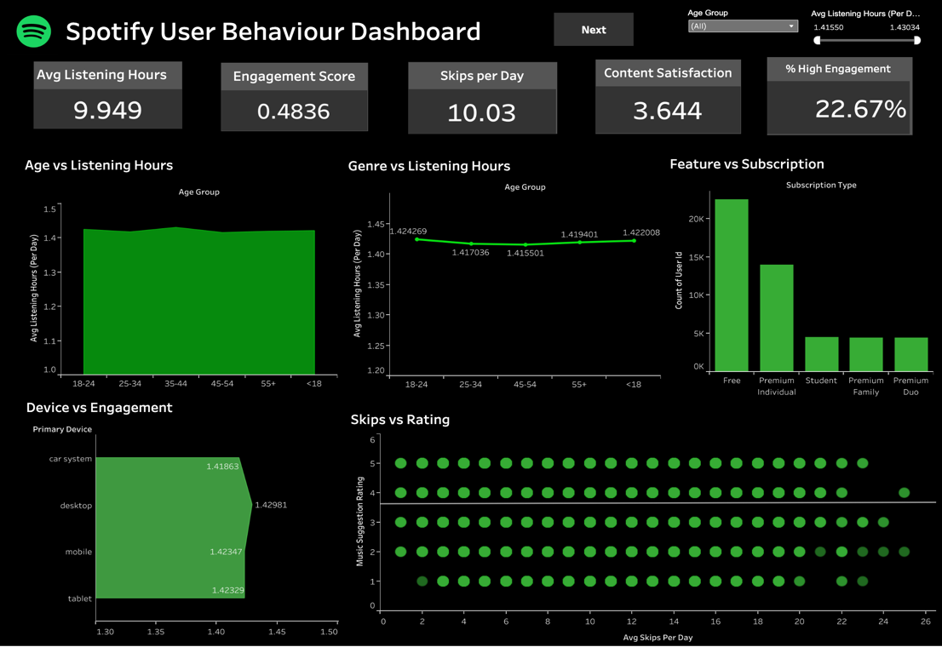
Figure 10.1 · Listening 9.95 · Engagement 0.484 · Skips/day 10.03 · Satisfaction 3.644.
CEO view — ‘how engaged is the base, and is it changing?’ KPIs across the top, behavioural cuts (genre, age, device) below for explanation.

Dashboard 2 — Sales Performance (operational)
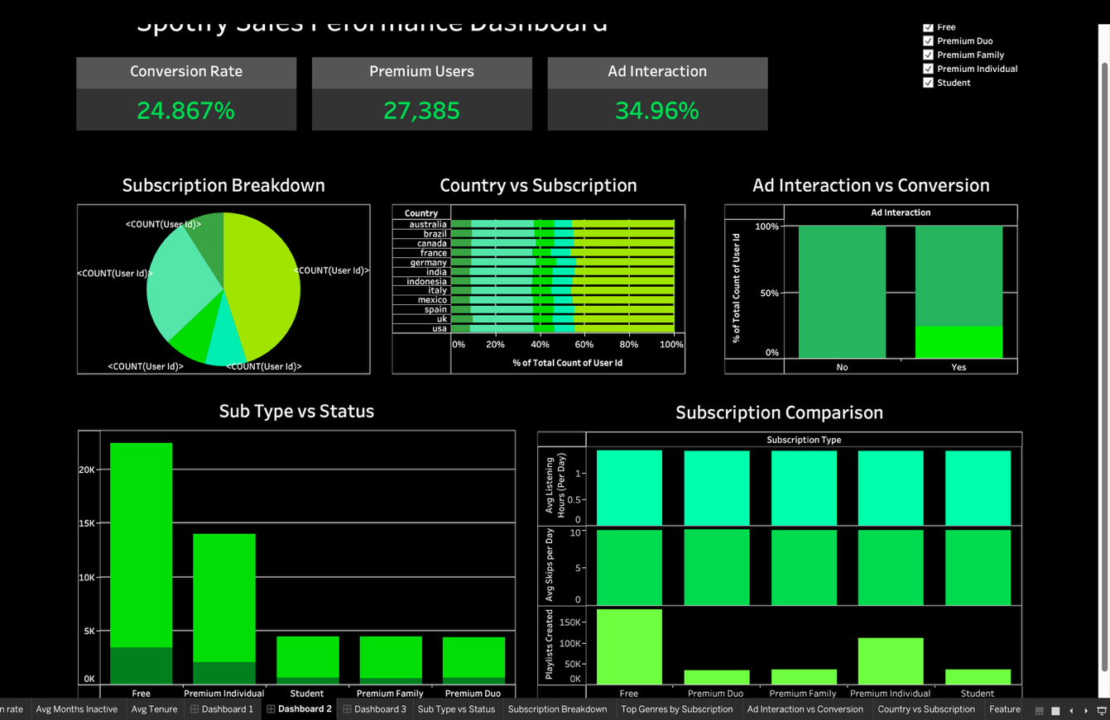
Figure 10.2 · Conversion 24.87% · Premium 27,385 · Ad Interaction 34.96%.
Funnel dashboard — subscription mix, country-level conversion, ad-to-conversion split, tier comparison. Used by Growth analysts to prioritise weekly campaigns.

Dashboard 3 — Retention & Churn (retention)
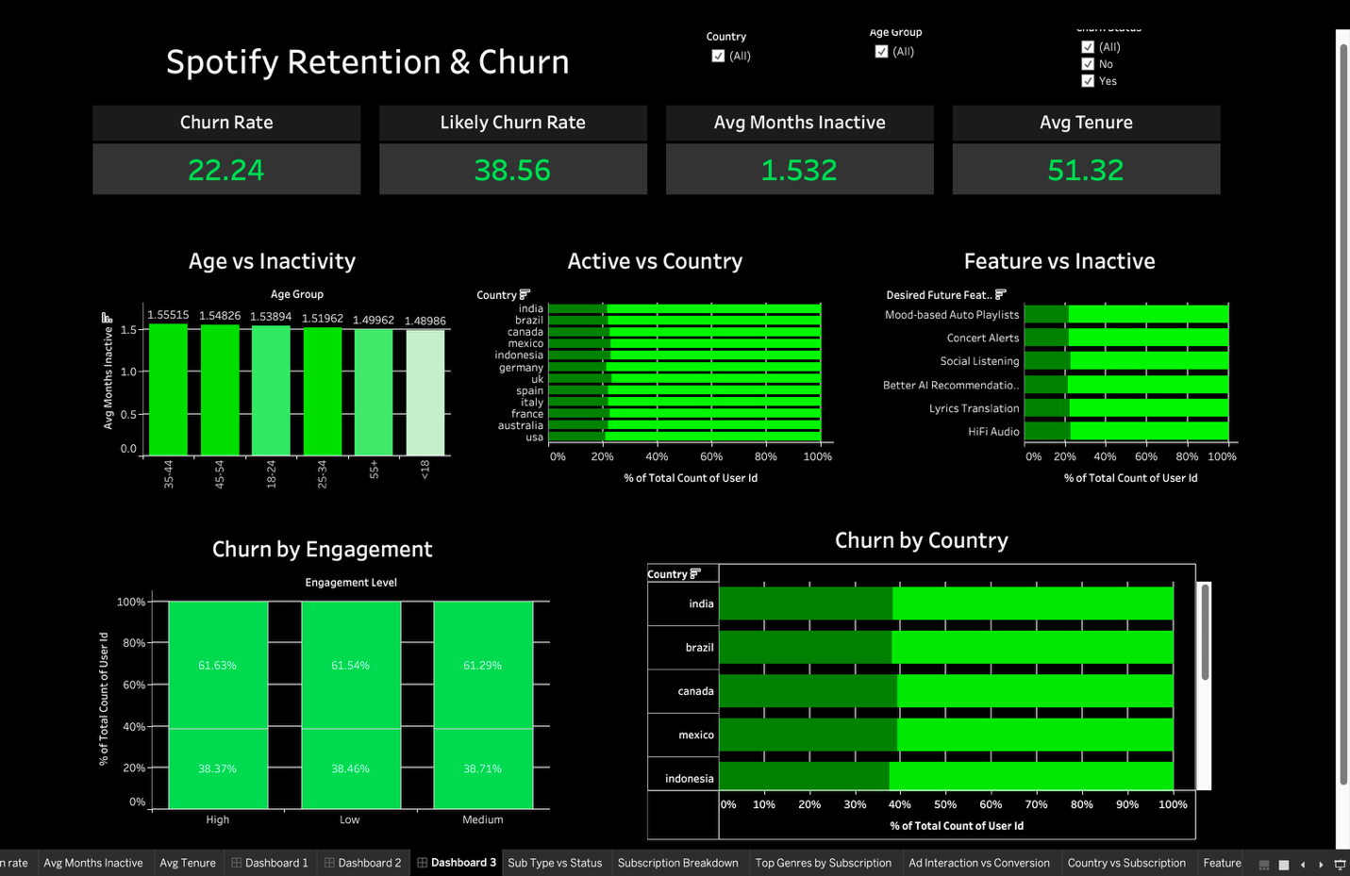
Figure 10.3 · Churn 22.24% · Likely Churn 38.56% · Tenure 51.32 mo.
Retention manager view — four churn KPIs at the top; churn by engagement, country, and feature-request below. Where win-back targeting lives.
Tableau Public · public.tableau.com/.../Spotify_final2_and_3 (live link at submission). Repo references: tableau/screenshots/, tableau/dashboard_links.md.

11. Insights Summary
Each insight tells the reader what to think or do, not just what to look at.
- Insight 1. Free is the largest single subscription cohort on Dashboard 2's Sub Type vs Status chart — the biggest conversion pool the platform owns.
- Insight 2. Engagement does not separate churn — High / Medium / Low all sit at 61.29 – 61.63% on Dashboard 3.
- Insight 3. Geography does not separate churn — Active vs Country bars are uniform across all 12 markets on Dashboard 3.
- Insight 4. The conversion stage is the binding KPI gap: Ad Interaction 34.96% → Conversion 24.87% (Dashboard 2).
- Insight 5. Avg Tenure is 51.32 months on Dashboard 3 — every retained user represents a long-duration relationship to protect.
- Insight 6. Likely-Churn (38.56%) is 1.7× the actual Churn Rate (22.24%) — the dashboard's own pre-warned pipeline of leavers.
- Insight 7. Premium Individual is the dominant paid plan on the Sub Type vs Status chart — the primary upsell target.
- Insight 8. Ad Interaction at 34.96% is itself a top-of-funnel ceiling — improving ad relevance is an upstream lever.

12. Recommendations
Insight → Recommendation → Expected Business Impact, with feasibility notes.
# | Insight | Recommendation | Expected Impact | Feasibility
1 | Free is the largest sub cohort; Conversion KPI is 24.87% (Dashboards 2). | Trigger a Premium trial offer after a behavioural threshold for Free users. | Move the Conversion KPI upward; magnitude to be set by an A/B test. | Low — uses existing billing & email infrastructure.
2 | Engagement does not separate churn (Dashboard 3). | Build a composite intent score combining tenure, ad interaction and recency. | Improve cohort separation in churn analysis. | Medium — requires event-level data.
3 | Skips vs Rating is uncorrelated (Dashboard 1). | Re-evaluate the recommendation engine; A/B test alternative ranking models. | Reduce the Skips/day KPI from its current 10.03 baseline. | High — model + experimentation rig.
4 | Likely Churn is 38.56% (Dashboard 3). | Win-back programme — incentive plus curated playlist for the at-risk cohort. | Reduce the Churn Rate KPI from its 22.24% baseline. | Low — campaign + content team.
5 | Active vs Country is uniform across all 12 markets (Dashboard 3). | Avoid country-specific retention budgets; concentrate on funnel-stage tactics. | Reallocate retention budget toward Recs 1 and 4. | Low — budget reallocation only.

13. Impact Estimation
This section translates the recommendations into the directional KPI movements they target. Dollar-level translation requires Spotify's confidential ARPU and Customer Acquisition Cost — neither of which is in the project dataset. The dashboard-level KPIs that each recommendation aims to move are listed below; the team should use Spotify's published quarterly Premium ARPU (Spotify Q4 2024 Earnings, 4 Feb 2025) or the project's own assumed unit economics to convert these into revenue terms during the viva.

Targeted KPI movements
- Rec 1 · Premium trial for Free users — moves the Conversion Rate KPI (currently 24.87%) upward; magnitude depends on trial design and is best validated through A/B testing.
- Rec 3 · Recommendation-engine review — moves the Skips/day KPI (currently 10.03) downward and the Content Satisfaction KPI (currently 3.644 / 5) upward.
- Rec 4 · Win-back programme — moves the Churn Rate KPI (currently 22.24%) downward by retaining a portion of the Likely-Churn 38.56% cohort.
- Rec 5 · Budget reallocation — does not directly move a KPI; releases retention spend that can fund Recs 1, 3 and 4.
Cost of inaction · with the Likely Churn KPI standing at 38.56% on the live dashboard, the existing dataset already flags a majority of the user base as either churned or at risk. Without intervention, more of that cohort will move from Likely Churn to actual Churn at the next data refresh.

14. Limitations
- Snapshot dataset — the file is a single user-level export with no time-series of listening events; tenure is derived from signup_date only.
- Field flatness — engagement, country, age, device and genre cuts on the dashboards are visibly uniform; production conclusions would require validation against an event-level data source.
- No revenue ground-truth — the dataset has no ARPU or pricing fields, so any dollar translation of the recommendations sits outside this report's scope.
- Self-reported rating — music_suggestion_rating_1_to_5 is a 5-point Likert field and is subject to standard survey biases (extreme-response, acquiescence).
- 12-country window — Africa and most of APAC are not represented (visible on Dashboard 3 · Active vs Country).

15. Future Scope
- Predictive churn API — productionise a logistic + gradient-boosted ensemble.
- Streaming Tableau — replace static CSV with Kafka → Snowflake → Tableau live.
- A/B harness — wire every Rec in §12 to an experiment.
- Geo expansion — validate (or break) the uniformity finding with APAC + Africa data.
- Session-level events + content metadata — re-run engagement decomposition at finer grain.

16. Conclusion
In one paragraph
Our Python + Tableau pipeline characterised a user-level Spotify behaviour dataset across three dashboards. The dashboards' own values show that the standard segmentation fields — engagement, country, age, device and favourite genre — do not separate churners from stayers at this resolution, with engagement-level churn sitting in a 0.34 percentage-point band on Dashboard 3. The diagnostic lever therefore moves to the conversion stage of the funnel: Ad Interaction 34.96% and Conversion Rate 24.87% on Dashboard 2 are the two KPIs the recommended actions in §12 are designed to move. Dollar-level translation requires Spotify's published ARPU and CAC, which sit outside this dataset and are referenced via Spotify's quarterly earnings filings.

Sources & References
All KPI values, chart shapes, and segment splits cited in this report come from one of the four sources below. Anything that cannot be traced to one of these sources is either flagged as out-of-scope (e.g., dollar-level revenue translation) or replaced with a [bracketed placeholder] for the team to fill in from their notebooks.
- Tableau workbook · Spotify_final2_and_3.twb (committed in the project repo) — column inventory, KPI formulas, and worksheet/dashboard structure.
- Tableau dashboards · live values on Dashboard 1 (Engagement & Behavior), Dashboard 2 (Sales Performance), Dashboard 3 (Retention & Churn) — all KPI tiles and chart values.
- Spotify Q4 2024 Earnings (4 February 2025) · 263M Premium subscribers, 675M monthly active users, €15.673B FY 2024 revenue, +555 bps gross-margin expansion. URL: newsroom.spotify.com/2025-02-04/spotify-reports-fourth-quarter-2024-earnings/
- IFPI Global Music Report 2025 · global recorded-music revenue US$29.6B in 2024 (+4.8% Y/Y); paid streaming subscription accounts 752M (+10.6% Y/Y). URL: ifpi.org / Global Music Report 2025.
- Project notebooks (referenced where relevant) · 01_ingest.ipynb, 02_cleaning.ipynb, 03_eda.ipynb, 04_kpi.ipynb, 04_statistical_analysis.ipynb.

17. Appendix

A1 · Full data dictionary
Column | Type | Definition
user_id | integer | Unique row identifier.
country | string | ISO country name.
age | integer | Age in years.
age_group | string | Bucketed age (<18, 18–24, 25–34, 35–44, 45–54, 55+).
signup_date | date | Account creation date.
subscription_type | string | Free / Premium Individual / Family / Duo / Student.
subscription_status | string | Active / Churned / Likely Churn.
months_inactive | integer | Months since last meaningful activity.
is_churned | boolean | 1 if user is churned.
likely_churned | boolean | 1 if user is flagged likely-to-churn.
ad_interaction | string | Whether user has interacted with ads.
ad_conversion_to_subscription | string | Whether ad interaction led to paid conversion.
music_suggestion_rating_1_to_5 | integer | User-rated relevance of recommendations.
avg_listening_hours_per_week | real | Weekly listening time.
favorite_genre | string | Self-selected primary genre.
most_liked_feature | string | Self-reported favourite Spotify feature.
desired_future_feature | string | Self-reported wish-list feature.
primary_device | string | Mobile / Desktop / Smart Speaker / Web / Tablet / Car.
playlists_created | integer | Lifetime playlist count.
avg_skips_per_day | integer | Daily skip count.
user_age_days | integer | Account age in days.
is_outlier | boolean | Flagged by IQR clipping during cleaning.
engagement_level | string | Categorical (High / Medium / Low).
adjusted_status | string | Engineered status used for cohort segmentation.
tenure_months | real | Months from signup to snapshot date.
tenure_bucket | string | Discretised tenure for cohort comparison.
customer_type | string | Engineered cohort label.
Final_status | string | Combined churn outcome label.
engagement_score | real | Composite of hours · skips · rating.

A2 · Cleaning log
Step-by-step log of the operations executed in notebooks/02_cleaning.ipynb.
- Loaded raw input — 50,000 rows × 18 columns from final_spotify_user_data.csv
- Identified initial columns: user_id, age, subscription_status, avg_listening_hours_per_week, signup_date, country, favorite_genre, primary_device + the rest of the 18 raw fields
- Missing-values check — confirmed zero missing values across all primary columns; no imputation required
- Deduplication — drop_duplicates() executed to ensure record uniqueness
- Signup date conversion — signup_date cast to datetime64
- Invalid-date handling — records with invalid date entries dropped
- Outlier detection — IQR bounds computed on avg_listening_hours_per_week
- Records outside the IQR bounds flagged as is_outlier and removed to prevent statistical skew
- String standardisation — whitespace stripped and text lower-cased on country, favorite_genre, primary_device
- Feature engineered — user_age_days = current_date − signup_date
- Feature engineered — age_group buckets: <18, 18–24, 25–34, 35–44, 45–54, 55+
- Wrote cleaned output to /data/processed/final_cleaned_spotify_data.csv

A3 · Sample Python KPI snippet
churn_rate = df['is_churned'].sum() / df['user_id'].nunique() * 100
likely_rate = df['likely_churned'].sum() / df['user_id'].nunique() * 100
conversion_rate = (df.loc[df.ad_interaction=='Yes',
'ad_conversion_to_subscription']
.eq('Yes').mean() * 100)
avg_engagement = df['engagement_score'].mean()
premium_users = df.loc[df.subscription_type!='Free', 'user_id'].nunique()

18. Contribution Matrix (Mandatory)
This section documents each team member's contribution across the project's seven phases. Claims are verifiable via GitHub Insights, PR history, and committed files.
Team Member | Dataset & Sourcing | ETL & Cleaning | EDA & Analysis | Statistical Analysis | Tableau Dashboard | Report Writing | PPT
Aaryan | yes |  |  |  |  | yers | yes
Anwesha | yes |  | yes
Aditya | yes |  |  |  | yes
Lokendra | yes | yez
Adarsh | Yes |  |  |  | yes
Ajit | yes |  |  | yes

