**ABB Java Development Training**

**Ant-Ivy-Spring MVC framework**

**Training Instructions**

1. ***Clone*** the ABB-JavaDev-Training001 source code from: <https://github.com/made-eka/ABB-JavaDevTraining-002>
2. Create a new ***Git branch*** on your local environment
3. Start working on that branch to complete the task (please refer to the **Task** and **Modifications** parts below)
4. When you finished the **Modifications**, ***commit-push*** your changes to Github
5. Create a new ***pull-request*** and assign: Made Eka (*made-eka*), Rizki (*rizkiabrar45*), and Kristianto (*kristiantoyanuar*) as the reviewers

**Task**

Execute the Ant task to perform WAR file deployment to your Standalone JBoss deployment folder.

If your WAR file deployment is successful.

* Start your JBoss Application Server on Standalone mode
* Open following URL with your web browser: <http://localhost:8080/ABBJavaDev-SpringMVC> or <http://127.0.0.1:8080/ABBJavaDev-SpringMVC>

Following **Welcome Page** will be presented.

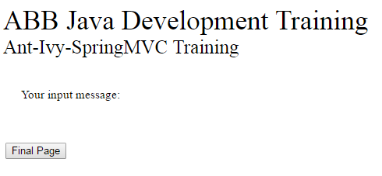

* Now type following URL: <http://localhost:8080/ABBJavaDev-SpringMVC/Guest> or <http://127.0.0.1:8080/ABBJavaDev-SpringMVC/Guest>

The error page will display following message.

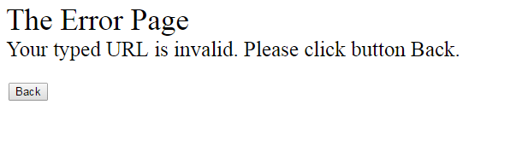

* Now click button **Back**. The **Welcome Page** will be displayed.
* Now click button **Final Page**. The screen will be navigated to the **Final Page.**

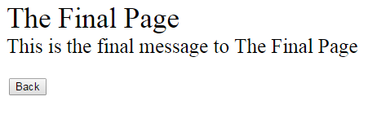

* Now click button **Back**. The **Welcome Page** will be displayed.

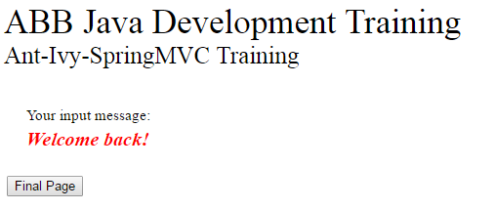

**Modifications**

1. Install MySQL database server on your local machine**.**
2. Create a table named: CREDENTIALS with following columns

|  |  |  |  |
| --- | --- | --- | --- |
| Column name | Data Type | Null | PK |
| username | Varchar(20) | No | Yes, FK to USERS |
| password | Varchar(20) | No | No |

Insert one record into the table.

1. Update index.jsp by adding:

* Literal: username
* Textfield: username
* Literal: password
* Textfield: password
* Button: Login

When button Login is clicked, there should be a validation on inputted credentials. If valid, user will be navigated to finalPage.jsp.

If invalid, there should be a literal displayed below the Password textfield as follows:

*Incorrect username/password combination. Please retry.*

1. Create a table named USERS with following columns

|  |  |  |  |  |
| --- | --- | --- | --- | --- |
| Column name | Data Type | Null | PK | Notes |
| username | Varchar(20) | No | PK | Free text |
| email | Varchar(20) | No | No | Free text |
| address | Varchar(50) | Yes | No | Free text |
| age | Int | Yes | No | Free integer |
| gender | Varchar(20) | No | No | Values: M or F |
| division | Varchar(20) | Yes | No | Free text |

Insert at least 5 records into the table.

1. Update the finalPage.jsp by adding:

* HTML table with columns represent the content of USERS table:
* Username
* E-mail

Column “Username” should be in form of HTML link. When it is clicked, it should display the detailPage.jsp in popup under: EDIT MODE.

* Button Add (rightmost). When the button is clicked, it should display the detailPage.jsp in popup under: ADD MODE.
* Button Back (leftmost). When the button is clicked, it should navigate user to index.jsp.

1. Create a new JSP page named: detailPage.jsp. Please display these elements on it:

* HTML table with columns represent all contents of USERS
* Under EDIT MODE, the table should be populated with the clicked user data, with all columns modifiable except the username
* Under ADD MODE, all columns should be modifiable
* Button Close (rightmost). When the button is clicked, it should close the popup page.
* Button Save (leftmost). When the button is clicked, all user input should be stored to the database, the popup page is also closed. Newly added record should automatically be displayed on the finalPage.jsp.

1. Please keep the behavior of the errorPage, with additiona that all exceptions should be navigated to it.

Good luck!

Regards,

-Made Eka-