A Comparative Scientometric Analysis of Digital Humanities, Computational Social Science, and Digital Methods

Alan César Belo Angeluci
Carolina Gois Falandes

School of Communications and Arts, University of São Paulo, Brazil
Research Report
April 2026

Table of Contents

1. Introduction 3
2. Search Strategy and Data Collection 4
3. Data Pre-processing 5
4. Topic Modeling (BERTopic) 7
5. Co-occurrence Network Analysis (VOSviewer) 9
5.1 Digital Humanities 10
5.2 Computational Social Science (Expanded) 12
5.3 Digital Methods (Expanded) 15
6. Cross-field Comparison 17
6.1 Shared Vocabulary Across All Fields 18
6.2 Pairwise Overlaps 18
6.3 Field-Specific Vocabularies 19
6.4 Bridging Terms 19
6.5 Summary of Cross-Field Relations 19
7. Temporal Analysis of Publications 22
7.1 Temporal Evolution of Publications (Digital Humanities) 22
7.2 Temporal Evolution of Publications (Computational Social Science) 23
7.3 Temporal Evolution of Publications (Digital Methods) 24
7.4 Comparative Temporal Trends Across Fields 25
8. Dominant Lexical Patterns 27
8.1 Digital Humanities 28
8.2 Computational Social Science (Expanded) 29
8.3 Digital Methods (Expanded) 30
8.4 Comparative Overview 31
9. Concluding Remarks 32
Appendix A – Search Queries 33
Appendix B – Topic Modeling Results 34
Appendix C – Network Construction Parameters 38

1. Introduction
This report presents a comparative scientometric analysis of three research domains: Digital Humanities (DH), Computational Social Science (CSS), and Digital Methods (DM).
The aim is to examine their thematic structures, lexical patterns, and temporal trajectories over the past two decades, identifying convergences, divergences, and potential areas of overlap.
The investigation is based on bibliographic data collected from the Web of Science Core Collection, focusing primarily on abstracts as the main unit of analysis due to their higher semantic density.
Methodologically, the study adopts a scientometric-semantic comparative approach, combining topic modeling, lexical analysis, co-occurrence network analysis, and temporal analysis. Each field is first analyzed independently in order to preserve its internal structure, followed by a comparative stage that examines shared vocabularies, thematic proximities, and differences in development trajectories. In addition, an exploratory integrated corpus analysis was conducted to examine deeper structural relations across fields.
Particular attention is given to the role of query design, especially in fields characterized by terminological variability. While Digital Humanities presents a relatively stable vocabulary, both Computational Social Science and Digital Methods require expanded search strategies to capture their broader conceptual scope.
In general terms, this document aims to provide a structured empirical basis for subsequent theoretical interpretation, supporting a wider discussion on how different research traditions articulate the relationship between digital technologies, computational methods, and knowledge production.

2. Search Strategy and Data Collection
The data collection process was conducted using the Web of Science Core Collection, selected for its comprehensive coverage of high-impact international publications. The search was performed on April 4, 2026, and focused on a 20-year period (2006-2025), aiming to capture the development and consolidation of the selected research domains over time.
Three independent search strategies were designed to represent the fields of Digital Humanities (DH), Computational Social Science (CSS), and Digital Methods (DM). Each query was constructed to reflect the main terminological conventions associated with each domain.
The initial queries returned substantially different volumes of results, highlighting variations in the level of consolidation and visibility of each field in bibliographic databases.
For Digital Humanities, the query (“digital humanities” OR “humanities computing”) returned 5,071 records, indicating a well-established and consistently indexed field.
For Computational Social Science, the query (“computational social science”) yielded 1,224 records, pointing to a growing but still consolidating domain.
In contrast, Digital Methods returned only 147 records using the query (“digital methods” AND (humanities OR “social sciences”)), suggesting a more limited and potentially underrepresented presence in bibliographic metadata.
Given the observed disparities, expanded queries were developed for Computational Social Science and Digital Methods to better capture terminological variations and broader conceptual usage. These searches were conducted on April 6, 2026. This step was particularly necessary for Digital Methods, where the initial query produced a comparatively small corpus.
The expanded query for Computational Social Science ("computational social science" OR "computational sociology" OR "social computing") returned 3,220 records, while the expanded Digital Methods query ("digital methods" OR "digital research methods" OR "digital methodologies") yielded 2,200 records.
This substantial increase indicates that the initial queries captured only a partial representation of these fields, particularly in the case of Digital Methods.
The search results were restricted to articles, reviews, and conference proceedings, ensuring a focus on peer-reviewed research outputs. Abstracts were selected as the primary textual corpus due to their higher semantic density, providing a richer basis for topic modeling and lexical analysis.
All queries were performed using the “Topic” field in Web of Science, which includes titles, abstracts, author keywords, and Keywords Plus.
Full search queries are detailed in Appendix A.

3. Data Pre-processing
The collected datasets were subjected to a series of pre-processing steps to ensure consistency, relevance, and suitability for subsequent analyses, based on objective metadata criteria.
Due to export limitations in the Web of Science Core Collection (maximum of 1,000 records per download), large datasets were retrieved in multiple batches and later merged into unified files for each corpus.
Duplicate records were identified and removed based on Digital Object Identifiers (DOIs), ensuring the uniqueness of each publication. Records lacking abstracts were excluded, as these were defined as the primary textual unit for topic modeling and lexical analysis.
The datasets were further filtered to include only articles, review articles, and conference proceedings, ensuring a focus on peer-reviewed research outputs.
For the temporal analysis, publications indexed as 2026 were excluded, as they correspond to early access records and fall outside the defined 20-year period (2006-2025). These records were retained for topic modeling and network analysis.
These steps resulted in cleaned and structured corpora suitable for topic modeling, lexical analysis, co-occurrence network analysis, and temporal analysis.
The initial datasets comprised 5,071 records for Digital Humanities, 1,224 for Computational Social Science, and 147 for Digital Methods.
After the application of filtering and cleaning procedures, the datasets were reduced to 420 records for Digital Humanities, 1,129 for Computational Social Science, and 132 for Digital Methods.
For the expanded queries, the Computational Social Science dataset was reduced from 3,220 to 2,450 records, while Digital Methods was reduced from 2,200 to 1,788 records, as shown in Table 1.

Table 1. Dataset sizes before and after pre-processing
Field | Query Type | Initial | Final
Digital Humanities | Original | 5,071 | 420
Computational Social Science | Original | 1,224 | 1,129
Digital Methods | Original | 147 | 132
Computational Social Science | Expanded | 3,220 | 2,450
Digital Methods | Expanded | 2,200 | 1,788

The reduction rates vary significantly across fields. Digital Humanities shows a substantial decrease, likely reflecting its broader publication culture, which includes books and book chapters not consistently indexed with abstracts. In contrast, Computational Social Science exhibits minimal reduction, indicating a more standardized publication structure.
Digital Methods presents a distinct pattern: while the original dataset remains relatively small, the expanded dataset reveals a substantially larger corpus with moderate reduction after cleaning. This contrast suggests that the visibility of Digital Methods is strongly dependent on query design, rather than reflecting a stable or consistently indexed field.
The cleaned datasets are available for further analysis and validation, and the overall methodological workflow of the study, encompassing data collection, dataset construction, preprocessing, and analytical procedures, is summarized in Figure 1.

Figure 1. Methodological workflow of the study
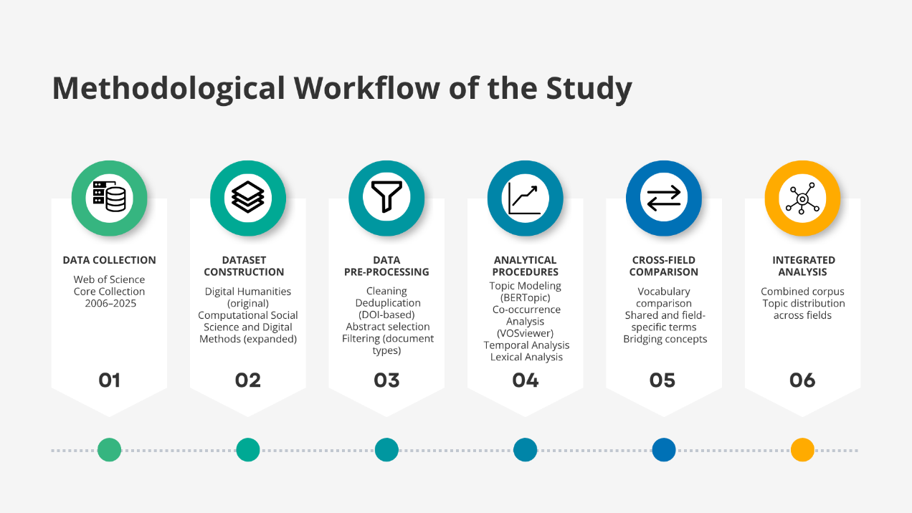

4. Topic Modeling (BERTopic)
Topic modeling was conducted using BERTopic (version 0.17.4), an embedding-based approach that leverages transformer models to identify semantically coherent document clusters. The process generated clusters based on semantic similarity, along with sets of representative terms for each topic, supporting interpretation and categorization.
The analysis was applied separately to each dataset in order to preserve the internal structure of the three domains – Digital Humanities (DH), Computational Social Science (CSS), and Digital Methods (DM). For CSS and DM, both original and expanded datasets were modeled independently, allowing for a comparative assessment of the impact of query design on thematic structures.
The resulting topics were interpreted and grouped into broader analytical categories reflecting different research orientations across the datasets, including methodological approaches, application domains, epistemological discussions, infrastructure-related topics, and other domain-specific dimensions. The classification was based on the most representative terms and documents for each topic.
A residual category (Topic -1) was identified across datasets, corresponding to documents that could not be reliably assigned to a coherent topic. These were treated as outliers and excluded from the thematic categorization.
In Computational Social Science, the topic distribution reveals a relatively balanced structure between methodological and application-oriented research. In the original dataset, four topics were classified as Applications and four as Methods, alongside one topic related to scholarly communication. This balance indicates an integrated field combining methodological development and empirical application.
In Digital Humanities, the thematic distribution is more diversified, encompassing a broader range of categories, including Applications (4 topics), Methods (3), Epistemology (2), Infrastructure (2), Regional studies (2), Education (1), and Scholarly Communication (1), totaling 15 topics. This diversity reflects the conceptual breadth of the field and its consolidation as a well-established area of research.
Digital Methods presents a markedly different pattern. In the original dataset, only four topics were identified, with a predominance of methodological orientation (3 Methods topics and 1 Applications topic). However, in the expanded version, the number of topics increases substantially to 26, with a strong predominance of Applications (16 topics), followed by Methods (6) and Humanities (4).
In the expanded Computational Social Science dataset, a similar pattern is observed, with 43 topics distributed across 19 Applications, 9 Methods, 7 related to Social Phenomena, 6 to Data and Infrastructure, and 2 to Ethics and Governance.
These results suggest that query expansion has distinct effects across fields. In Computational Social Science, it increases thematic coverage while preserving the balance between methodological and applied research. In contrast, in Digital Methods, expansion fundamentally reshapes the thematic structure, shifting it from a method-oriented corpus to a predominantly application-driven one.
Overall, these findings demonstrate that topic modeling outcomes are highly sensitive to query design, particularly in fields characterized by terminological variability. This sensitivity has direct implications for the interpretation of computationally derived research landscapes, as different query strategies may lead to substantially different representations of a field.
For visualization purposes, some thematic categories were grouped into broader analytical dimensions in order to enhance readability and comparability across datasets. Specifically, closely related categories – such as epistemology, regional studies, and humanities – were combined under broader dimensions, while categories related to data and infrastructure were also aggregated. Less frequent categories, including education, scholarly communication, and ethics, were grouped under a residual “Other” category.
Figure 2 illustrates the proportional distribution of topics across thematic categories for each dataset, highlighting the stability of Digital Humanities, the balanced structure of Computational Social Science, and the strong shift toward application-oriented topics in the expanded Digital Methods dataset.
Figure 2. Proportional distribution of topics across aggregated thematic categories for each dataset
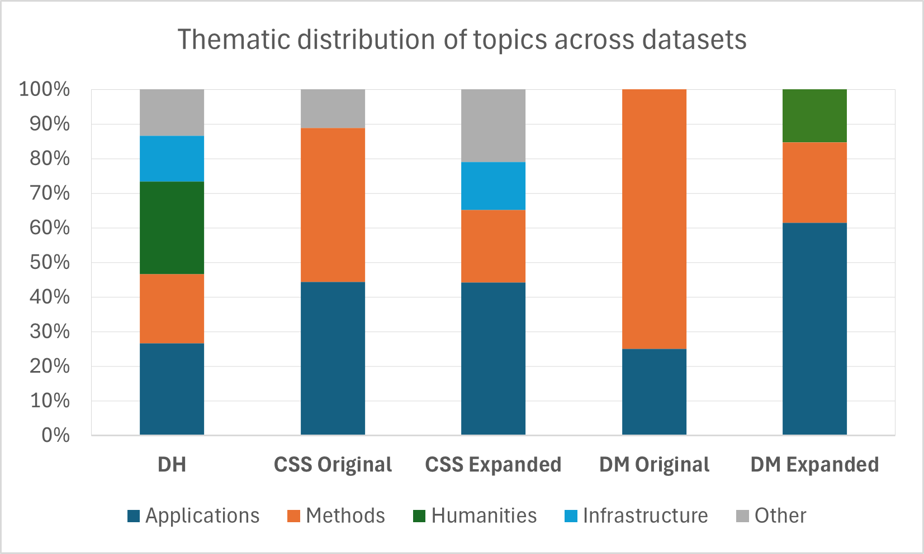

A detailed list of topics and their associated terms is provided in Appendix B for reference.

5. Co-occurrence Network Analysis (VOSviewer)
To complement the topic modeling results, a co-occurrence network analysis was conducted using VOSviewer (version 1.6.20). This approach enables the visualization of semantic relationships between terms based on their co-occurrence within titles and abstracts, revealing the structural organization of research themes across datasets.
The analysis was performed separately for each dataset in order to preserve their internal semantic structures. Titles and abstracts were used as input, and co-occurrence networks were generated using the software’s default parameters. Clusters were automatically identified, representing groups of closely related terms. Cluster interpretation was based on visual inspection of the network maps, considering the most prominent and representative terms.
For the purposes of this study, network visualizations are presented for Digital Humanities and for the expanded datasets of Computational Social Science and Digital Methods, as these provide a more comprehensive and representative view of each field, particularly in contexts characterized by terminological variability.
Additional network parameters and configuration details for all datasets are provided in Appendix C.

5.1 Digital Humanities
The Digital Humanities dataset exhibits a well-structured and densely interconnected network, composed of six clusters that reflect the field’s conceptual, methodological, and institutional diversity, as shown in Figure 3.

Figure 3. Co-occurrence network for Digital Humanities
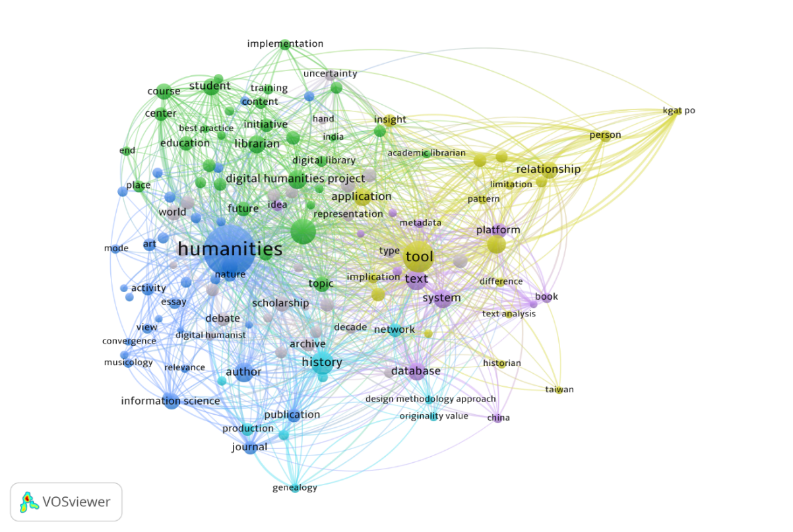
One of the central clusters is organized around the term humanities and encompasses epistemological and interdisciplinary dimensions, as well as aspects related to scholarly communication. It includes terms associated with academic production and dissemination (author, journal, publication), as well as interpretative and theoretical concepts (view, essay). The presence of computer science, information science, and social science highlights the interdisciplinary nature of the field, while references to cultural objects (art, musicology) reinforce its grounding in humanistic inquiry.
Another cluster is associated with institutional and educational infrastructures, including terms such as librarian, digital library, student, course, training, and education. This configuration reflects the role of academic institutions and support structures in sustaining Digital Humanities practices, as well as the importance of pedagogy and community-based initiatives.
A third cluster focuses on humanities practices, theory, and cultural dimensions, bringing together terms such as archive, scholarship, debate, world, and type. This pattern highlights processes of digitization, knowledge production, and critical reflection within the field.
A further cluster groups analytical and methodological approaches, combining terms related to computational tools and techniques (tool, application, text analysis) with relational and interpretative concepts (pattern, relationship, insight, limitation). This pattern suggests an integration between methodological development and analytical interpretation.
A distinct cluster is centered on data structures and textual systems, including terms such as text, metadata, database, system, and platform, indicating the technical infrastructures that support the organization and analysis of digital cultural data.
Finally, a smaller cluster points to networked knowledge and digital production, with terms such as history, production, genealogy, and network, reflecting the distributed and interconnected nature of knowledge in Digital Humanities.
Taken together, the network reveals a relatively coherent yet highly interconnected structure, in which conceptual, methodological, and infrastructural dimensions are closely integrated, reinforcing the interpretation of Digital Humanities as a consolidated and well-structured field. A summary of the identified clusters and their main characteristics is presented in Table 2.

Table 2. Summary of clusters – Digital Humanities
Cluster | Focus | Representative Terms | Interpretation
1 | Epistemological and interdisciplinary core | humanities, author, journal, publication, computer science | Conceptual and scholarly foundation of the field
2 | Institutional and educational infrastructures | librarian, digital library, student, training, education | Role of academic institutions and pedagogy
3 | Humanities practices and theory | archive, scholarship, debate, world | Knowledge production and critical reflection
4 | Analytical and methodological approaches | tool, application, text analysis, pattern, insight | Integration of methods and interpretation
5 | Data structures and textual systems | text, metadata, database, system, platform | Technical infrastructure for organizing data
6 | Networked knowledge and production | history, production, genealogy, network | Distributed and interconnected knowledge

5.2 Computational Social Science (Expanded)
The expanded Computational Social Science dataset reveals a large-scale and densely connected network composed of nine clusters (see Figure 4). The network structure is highly heterogeneous, reflecting the field’s broad engagement with computational approaches, social phenomena, and diverse application domains.

Figure 4. Co-occurrence network for Computational Social Science (Expanded)
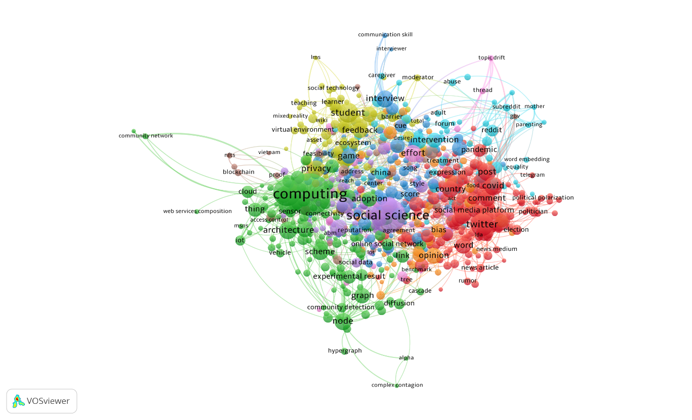

A prominent cluster is centered on political communication and public discourse in digital environments. This cluster is strongly associated with terms such as twitter, post, comment, election, and political polarization, as well as elements related to information circulation, including news article, news medium, and rumor. The presence of reddit and other platform-related terms highlights the central role of social media in shaping contemporary political and communicative dynamics.
A major cluster reflects the technical foundations of the field, organized around terms such as computing, architecture, cloud, graph, node, and diffusion. These elements indicate a strong emphasis on network-based modeling and computational infrastructures. The presence of terms such as IoT (Internet of Things), sensor, connectivity, and experimental result further suggests the integration of distributed systems and empirical validation within computational research.
A third cluster focuses on experimental and interaction-based research contexts, including terms such as interview, game, cue, and score. These elements suggest the use of controlled or semi-structured environments to investigate behavioral responses, perception, and interaction dynamics. This configuration highlights the role of experimental design and evaluative measures in studying social behavior within Computational Social Science.
A related cluster is associated with human-centered interaction and learning environments, including terms such as student, learner, feedback, teaching, and virtual environment. The presence of moderator and social technology further suggests the role of mediated interaction in shaping user experience and engagement.
The network also encompasses a cluster associated with the conceptual and disciplinary organization of the field, bringing together terms such as social science and ABM (agent-based modeling). This structure reflects the ongoing consolidation of the field, integrating methodological development with broader theoretical and disciplinary concerns.
A further cluster emphasizes socially situated applications and behavioral contexts, particularly in relation to everyday digital practices. Terms such as intervention, reddit, forum, adult, abuse, mother, and parenting indicate the analysis of individual and collective experiences within online environments. This configuration highlights the use of computational approaches to investigate socially embedded behaviors in digitally mediated settings.
Another cluster addresses opinion-related dynamics and social differentiation, including terms such as opinion and bias. Its composition points to broader concerns with how viewpoints are formed and structured within digital environments, particularly in relation to divisions in online spaces.
In addition, a cluster oriented toward emerging and distributed technologies is observed, including terms such as blockchain, nfts, proof, and access control. These are associated with implementation and evaluation processes, as indicated by terms such as feasibility, suggesting a focus on technical validation and applied contexts. This pattern highlights the role of these technologies in shaping new forms of digital infrastructure and governance.
As a final observation, a smaller cluster is associated with the organization of discussion and topic-oriented interaction, including terms such as thread, topic, brief, and effort. These elements suggest structured forms of communication and the articulation of ideas within digital or collaborative environments. This configuration points to the role of topic organization and communicative effort in shaping interaction and knowledge exchange.
Overall, the network reveals a highly diversified and densely interconnected field in which computational infrastructures, empirical research practices, and a wide range of socially situated applications are closely intertwined. The expanded dataset reinforces the heterogeneity of Computational Social Science, highlighting its capacity to integrate methodological innovation with the analysis of complex, digitally mediated social dynamics. The identified clusters and their main characteristics are summarized in Table 3.

Table 3. Summary of clusters – Computational Social Science (Expanded)
Cluster | Focus | Representative Terms | Interpretation
1 | Political communication and public discourse | twitter, post, comment, election, political polarization | Platform-mediated political dynamics
2 | Computational infrastructure and modeling | computing, architecture, cloud, graph, node, diffusion | Technical and network-based foundations
3 | Experimental and interaction-based research | interview, game, cue, score | Controlled and behavioral research settings
4 | Human-centered interaction and learning | student, learner, feedback, teaching, virtual environment | Educational and interactive environments
5 | Disciplinary organization | social science, abm | Consolidation of the field as a research domain
6 | Socially situated behaviors | intervention, reddit, forum, parenting, abuse | Everyday social practices in digital contexts
7 | Opinion and social differentiation | opinion, bias | Formation and structuring of viewpoints
8 | Emerging and distributed technologies | blockchain, nfts, access control, feasibility | Technological infrastructures and applications
9 | Topic organization and discussion | thread, topic, brief, effort | Structuring of communication and discourse

5.3 Digital Methods (Expanded)
The expanded Digital Methods dataset presents a large-scale and densely interconnected network composed of four clusters, as illustrated in Figure 5. The structure of the network is highly cohesive and shows a strong degree of connectivity, reflecting the operational and method-driven nature of the field.

Figure 5. Co-occurrence network for Digital Methods (Expanded)
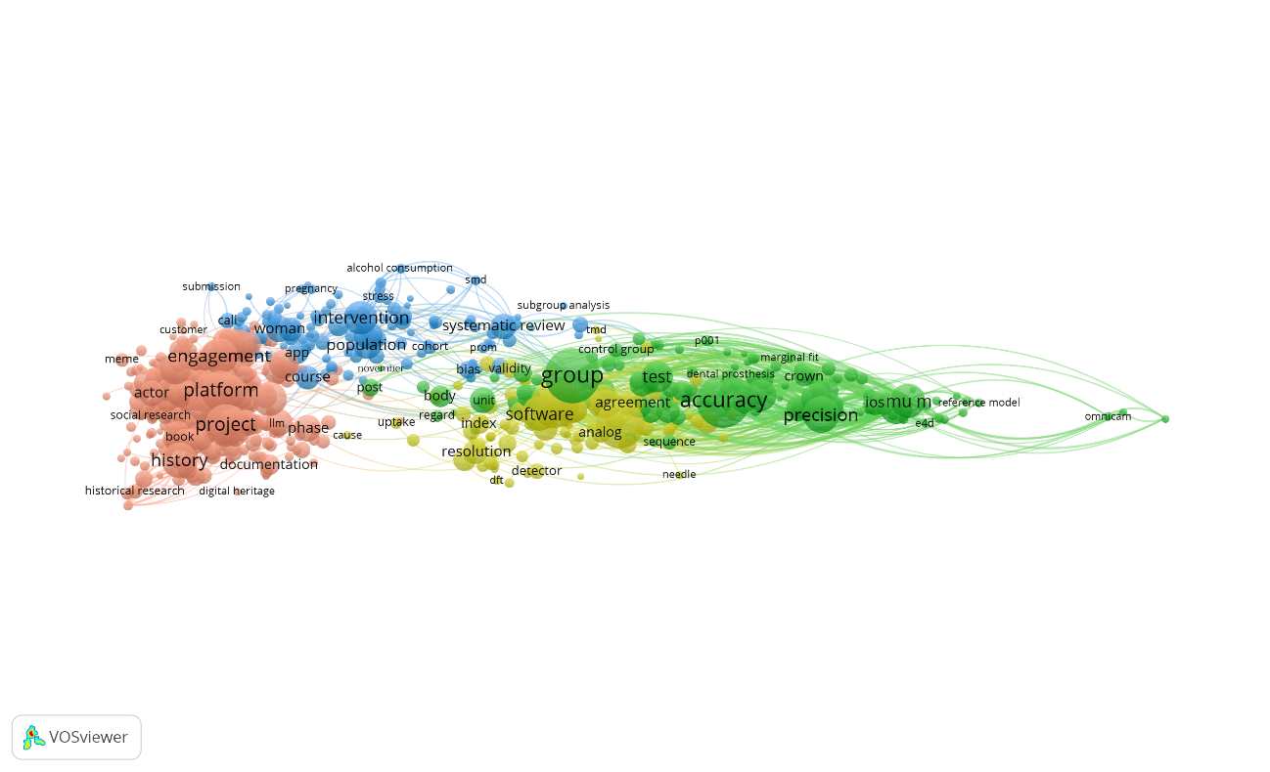
A central cluster is organized around project-based research and platform-oriented practices, including terms such as project, platform, engagement, history, and actor. Additional terms such as digital heritage, documentation, and social research indicate the application of digital methods in cultural and research-oriented contexts. This cluster highlights the role of platforms as both objects of study and infrastructures for data collection and analysis.
A second cluster is associated with empirical research designs and intervention-based approaches, including terms such as intervention, population, woman, app, and systematic review. The presence of terms such as cohort, stress, and bias suggests the incorporation of structured research designs and evaluative frameworks. This configuration reflects the use of digital methods in applied and data-driven research settings.
Another cluster focuses on computational tools and analytical procedures, bringing together terms such as software, resolution, index, and detector. These elements point to the operational dimension of Digital Methods, emphasizing the use of tools and technical processes for data processing, detection, and analysis.
A distinct cluster centers on validation, measurement, and model evaluation, including terms such as accuracy, precision, test, and group. The presence of reference model further reinforces the importance of benchmarking and validation procedures. This cluster emphasizes the centrality of evaluation metrics and performance assessment in the application of digital methods.
Collectively, the network reveals a highly integrated and methodologically oriented structure in which project-based practices, empirical research designs, computational tools, and validation processes are closely interconnected. This configuration suggests that Digital Methods operate as a structured analytical pipeline, linking data collection, processing, and evaluation within a unified methodological framework. A summary of the main clusters is presented in Table 4.

Table 4. Summary of clusters – Digital Methods (Expanded)
Cluster | Focus | Representative Terms | Interpretation
1 | Project-based and platform-oriented practices | project, platform, engagement, digital heritage | Research practices centered on platforms
2 | Empirical and intervention-based research | intervention, population, app, systematic review | Data-driven and applied research contexts
3 | Computational tools and processing | software, resolution, index, detector, unit | Operational and analytical procedures
4 | Validation and evaluation | accuracy, precision, test, group, reference model | Measurement, benchmarking, and performance

6. Cross-field Comparison
The cross-field comparison examines the relationships between Digital Humanities (DH), Computational Social Science (CSS), and Digital Methods (DM), with the aim of identifying convergences, divergences, and semantic bridges across these research traditions.
This analysis draws on the Digital Humanities dataset and the expanded datasets of Computational Social Science and Digital Methods, as these provide a more comprehensive and representative basis for comparison, particularly in contexts characterized by terminological variability.
Building on the results of topic modeling and co-occurrence network analysis, the comparison focuses on the distribution of vocabularies across fields, identifying shared terms, field-specific expressions, and bridging concepts that connect different domains.
To structure this comparison, four analytical zones are considered: (1) shared vocabulary across all fields; (2) pairwise overlaps; (3) field-specific vocabularies; and (4) bridging terms. Together, these zones provide a systematic framework for examining how the three fields relate to one another at the semantic level.

6.1 Shared Vocabulary Across All Fields
A set of core terms appears across all three fields, reflecting a shared engagement with digital research practices. These include data, platform, analysis, and method.
These terms indicate a common methodological grounding centered on the use of digital data and computational approaches. However, their meanings and applications vary across fields, reflecting distinct epistemological orientations and research objectives.

6.2 Pairwise Overlaps
- Digital Humanities and Digital Methods
The overlap between DH and DM is characterized by terms related to cultural analysis and interpretative practices, including heritage, history, text, and archive.
This intersection reflects a shared concern with cultural objects and qualitative analysis, particularly in relation to digital representations of historical and cultural materials.

- Computational Social Science and Digital Methods
CSS and DM share a vocabulary associated with applied and data-driven research, including platform, intervention, population, and health.
This overlap highlights the use of computational approaches to study real-world phenomena, particularly in socially embedded and empirical contexts.

- Digital Humanities and Computational Social Science
The overlap between DH and CSS is more limited, but includes terms such as information, communication, and system.
These terms suggest a shared concern with information structures and communicative processes, although approached from different methodological and epistemological perspectives.

6.3 Field-Specific Vocabularies
Each field presents a distinct vocabulary that reflects its specific orientation:

- Digital Humanities: humanities, scholarship, archive, journal, publication. These terms emphasize the field’s grounding in humanistic inquiry and scholarly communication.

- Computational Social Science: twitter, diffusion, graph, misinformation, election. This vocabulary highlights a strong focus on social media, network analysis, and contemporary societal phenomena.
- Digital Methods: project, engagement, accuracy, precision, software. These terms underscore the operational and method-driven nature of the field, with an emphasis on tools, validation, and platform-based research practices.

6.4 Bridging Terms
Certain terms function as bridges between fields, appearing across multiple contexts while assuming different meanings. These include platform, data, method, and analysis.
In Digital Humanities, these terms are often associated with interpretative and cultural analysis; in Computational Social Science, they relate to modeling and empirical research; and in Digital Methods, they are tied to operational procedures and platform-based practices.

6.5 Summary of Cross-Field Relations
The main zones of semantic overlap and differentiation identified in this analysis are summarized in Table 5.

Table 5. Cross-field vocabulary comparison across DH, CSS, and DM
Category | Terms
Shared (DH + CSS + DM) | data, platform, analysis, method
DH + DM | heritage, history, text, archive
CSS + DM | platform, intervention, population, health
DH + CSS | information, communication, system
DH only | humanities, scholarship, journal, publication
CSS only | twitter, diffusion, graph, misinformation, election
DM only | project, engagement, accuracy, precision, software
Bridging terms | platform, data, method, analysis

In addition, Figure 6 provides a visual synthesis of these relationships, highlighting the intersections and field-specific vocabularies across the three domains.

Figure 6. Venn diagram of shared and distinct vocabularies across DH, CSS, and DM
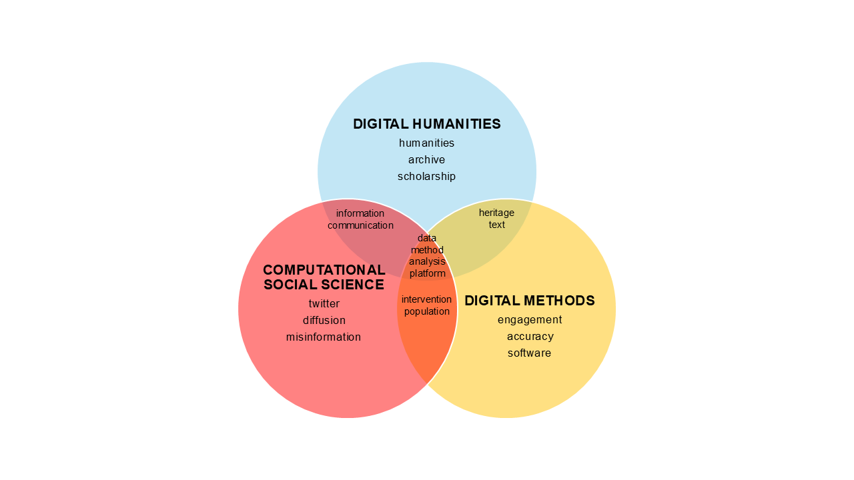

To further examine cross-field relationships beyond lexical overlap, an exploratory integrated corpus analysis was conducted using BERTopic. The integrated corpus was constructed by combining the Digital Humanities dataset with the expanded datasets of Computational Social Science and Digital Methods, to model shared thematic structures across the three fields.
The distribution of topics across fields (Table 6) reveals a dominant hybrid cluster in which Computational Social Science (CSS) and Digital Methods (DM) strongly converge, while Digital Humanities (DH) appears as a more contained component within this shared space. Notably, no cluster is exclusively dominated by DH, which instead remains embedded within broader computational contexts. In contrast, DM forms distinct, methodologically oriented clusters, reinforcing its operational and technical character.

Table 6. Distribution of topics across fields in the integrated corpus analysis
Topic | CSS | DH | DM | Interpretation
0 | 2450 | 421 | 1298 | Hybrid (CSS + DM dominant)
1 | 0 | 0 | 327 | DM (methodological)
2 | 1 | 0 | 113 | DM (applied)

To further support these findings, a semantic similarity matrix based on document embeddings was constructed to assess the proximity between the three fields (Table 7). The results indicate the strongest similarity between Digital Humanities and Digital Methods (0.73), followed by Computational Social Science and Digital Methods (0.61), while the lowest similarity is observed between Digital Humanities and Computational Social Science (0.51). This pattern reinforces the role of Digital Methods as a mediating space, bridging the conceptual orientation of Digital Humanities with the computational and data-driven approaches characteristic of Computational Social Science.

Table 7. Semantic similarity matrix across DH, CSS, and DM
 | DH | CSS | DM
DH | 1.00 | 0.51 | 0.73
CSS | 0.51 | 1.00 | 0.61
DM | 0.73 | 0.61 | 1.00
Overall, the results extend the preceding lexical comparison presented above, demonstrating that the observed vocabulary overlaps are reflected in deeper structural relationships across the three fields.

7. Temporal Analysis of Publications
This section examines the temporal evolution of publications across the analyzed fields, as well as the impact of query design on their visibility and representation. By comparing original and expanded datasets and observing longitudinal trends, this analysis provides additional insight into the development, consolidation, and differentiation of Digital Humanities (DH), Computational Social Science (CSS), and Digital Methods (DM).

7.1 Temporal Evolution of Publications (Digital Humanities)
The temporal evolution of publications in Digital Humanities (DH) reveals a relatively stable and moderate growth pattern over the period from 2006 to 2025, as shown in Figure 7. Publication counts remain consistently lower than those observed in Computational Social Science and Digital Methods, with gradual increases over time.
Figure 7. Digital Humanities publications by year (2006-2025)
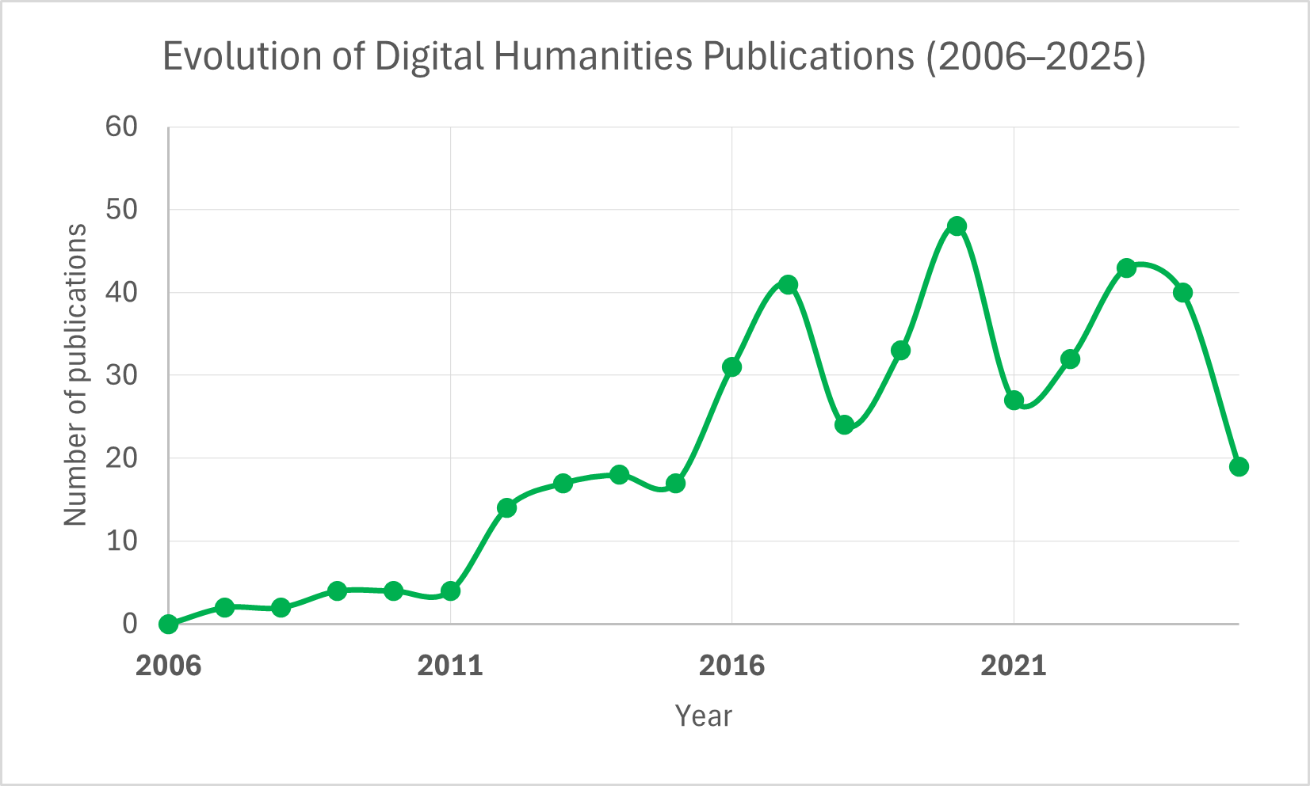

A period of modest growth can be observed between 2012 and 2017, followed by fluctuations in subsequent years. Unlike the sharp expansion observed in Digital Methods or the steady growth in Computational Social Science, Digital Humanities maintains a more stable trajectory, without pronounced peaks.
This pattern suggests that DH represents a more consolidated and conceptually stable research domain, characterized by steady scholarly production rather than rapid expansion.
The number of publications reaches a peak of 48 in 2020. Over the period from 2006 to 2025, the dataset shows an overall increase of approximately 850%, although this estimate is based on the first non-zero observation. This growth is not linear and is marked by fluctuations over time.

7.2 Temporal Evolution of Publications (Computational Social Science)
The temporal evolution of publications in Computational Social Science (CSS) illustrates a clear and sustained growth pattern over the period from 2006 to 2025, as shown in Figure 8. Both the original and expanded datasets exhibit a progressive increase in the number of publications, indicating the consolidation of CSS as an established research field.

Figure 8. Temporal comparison of publication counts in Computational Social Science (CSS): original vs. expanded datasets (2006-2025)
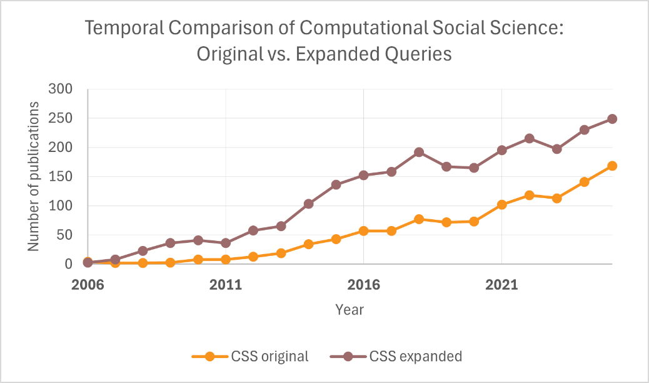

In the early years (2006-2010), publication counts remain relatively low in both datasets, reflecting the initial stages of the field’s development. From 2011 onwards, a more consistent upward trend becomes evident, with a marked acceleration between 2013 and 2016.
The expanded dataset consistently reports higher publication counts across all years, demonstrating the impact of query expansion in capturing a broader body of literature. While the overall growth trajectories of both datasets are similar, the expanded dataset amplifies the visibility of the field.
Between 2018 and 2020, a temporary stabilization can be observed, followed by renewed growth from 2021 onwards. Overall, query expansion enhances the representativeness of CSS without altering its fundamental temporal trajectory.
The expanded dataset reaches a peak of 249 publications in 2025, corresponding to an increase of approximately 8,200% over the period. In the final year, it exceeds the original dataset by approximately 48%, indicating that query expansion enhances coverage without fundamentally changing the field’s growth pattern.

7.3 Temporal Evolution of Publications (Digital Methods)
The temporal evolution of publications in Digital Methods (DM) presents a markedly distinct pattern when compared to Computational Social Science, as illustrated in Figure 9. While the expanded dataset shows substantial and continuous growth over time, the original dataset remains consistently limited in scale throughout the entire period.

Figure 9. Temporal comparison of publication counts in Digital Methods (DM): original vs. expanded datasets (2006-2025)
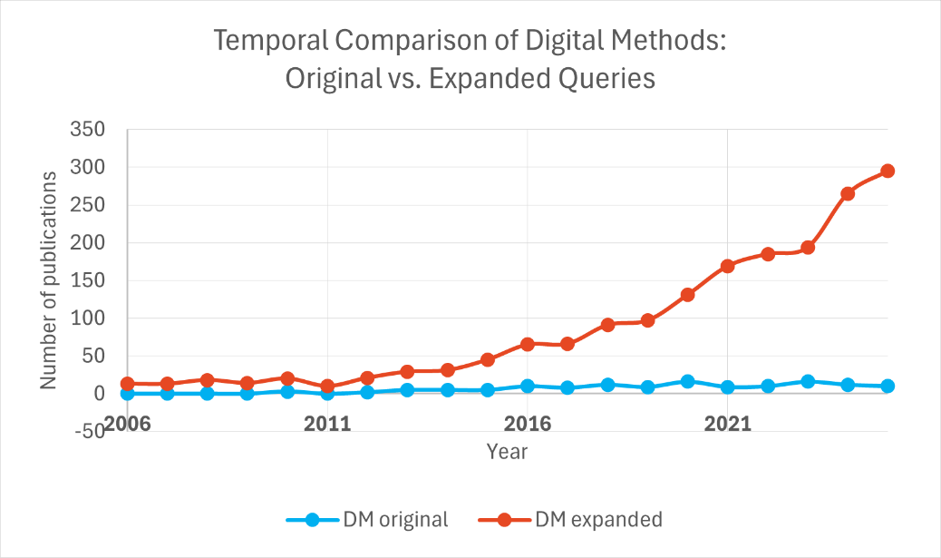

In the early years (2006-2011), the original dataset contains very few or no publications, indicating a limited capacity of the initial query to capture the field’s early development. In contrast, the expanded dataset already identifies a stable number of publications during this period.
From 2012 onwards, the expanded dataset exhibits a clear and accelerating growth trajectory, with a particularly sharp increase after 2018. This growth becomes even more pronounced between 2020 and 2025.
Unlike CSS, where expansion primarily amplifies an existing trend, in Digital Methods it fundamentally reshapes the temporal representation of the field. The original dataset substantially underrepresents the field across all years.
These results indicate that Digital Methods is highly sensitive to terminological variability, and that query expansion is essential for capturing its actual development.
The expanded dataset reaches a peak of 295 publications in 2025, corresponding to an increase of approximately 2,170% over the period, based on the first non-zero observation. In contrast, the original dataset remains limited, with only 10 publications in the final year. In 2025, the expanded dataset exceeds the original by approximately 2,850%, highlighting the critical role of query expansion in revealing the field’s actual scale.

7.4 Comparative Temporal Trends Across Fields
For comparative purposes, the expanded datasets are used, as they provide a more comprehensive and representative view of each field, particularly in the case of Digital Methods.
The temporal evolution of publications across Digital Humanities (DH), Computational Social Science (CSS), and Digital Methods (DM) demonstrates distinct growth trajectories, as illustrated in Figure 10.

Figure 10. Temporal evolution of publications across DH, CSS, and DM, based on expanded datasets (2006-2025)
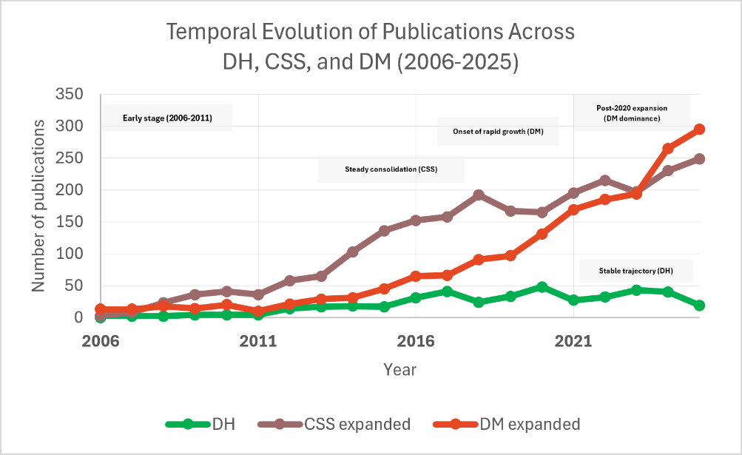

Computational Social Science exhibits the most consistent and sustained growth over the entire period, reflecting its consolidation as a mature research domain.
Digital Methods shows a delayed but sharply accelerating trajectory, with rapid growth after 2018 and a steep increase from 2020 onwards. By the final years of the period, DM surpasses CSS in publication volume, indicating its rapid expansion and increasing prominence.
Digital Humanities presents a more stable and moderate trajectory. Although gradual growth is observed, the field does not exhibit the same level of expansion as CSS and DM, suggesting a more consolidated and conceptually stable domain.
When considered together, the comparison highlights three distinct developmental patterns: steady growth in CSS, rapid expansion in DM, and relative stability in DH. These differences are also reflected in their respective growth rates and publication volumes. CSS reaches 249 publications in 2025, while DM surpasses it with 295 publications in the same year, and DH remains comparatively lower, with a peak of 48 publications in 2020.
These patterns point to different levels of consolidation and visibility across the fields, with Digital Humanities representing a more stable domain, Computational Social Science reflecting sustained expansion, and Digital Methods emerging as a rapidly growing field whose visibility is strongly influenced by query design.
This temporal configuration is consistent with the co-occurrence network analysis, which highlighted distinct structural characteristics across the fields, including the conceptual consolidation of Digital Humanities, the heterogeneous composition of Computational Social Science, and the method-driven configuration of Digital Methods.
A summary of these patterns is presented in Table 8.

Table 8. Summary of temporal evolution across fields
Field | Growth (%) | Peak | Key pattern
DH | ~850% | 48 (2020) | Stable, fluctuating
CSS | ~8200% | 249 (2025) | Sustained growth
DM | ~2170% | 295 (2025) | Accelerated, query-dependent

To complement this temporal perspective, a simplified exploration of dominant topics was conducted across three periods (2006-2012, 2013-2018, and 2019-2025), based on the integrated corpus. The results indicate a gradual shift in thematic emphasis over time. Early publications are characterized by more conceptual and exploratory uses of digital methods, often associated with modeling and foundational discussions. In the intermediate period, the vocabulary reflects a phase of consolidation, with stronger references to Digital Humanities, social media, and structured research practices. In the most recent period, the dominant terms indicate a shift toward applied and data-driven approaches, with an increasing emphasis on methods and empirical contexts. Although exploratory, this temporal perspective is grounded in topic modeling conducted separately for each period using the same parameter configuration, reinforcing the broader patterns identified in the comparative analysis.

8. Dominant Lexical Patterns
This section examines the most frequent terms across the three fields, focusing on their functional roles and their contribution to the overall configuration of each domain. The analysis is based on term frequencies extracted from the co-occurrence datasets and complements previous findings by highlighting dominant lexical patterns.
It should be noted that the terms presented here correspond to the most frequent items in each dataset and may not necessarily coincide with those most visually prominent in the co-occurrence network visualizations. While network representations emphasize relational structures between terms, frequency-based analysis highlights the dominant lexical anchors within each field.
Word cloud representations are included as complementary visualizations to illustrate the relative prominence of terms within each domain.

8.1 Digital Humanities
The lexical profile of Digital Humanities reflects a stable and conceptually grounded domain, as evidenced by the most frequent terms presented in Table 9.
Table 9. Most frequent terms – Digital Humanities
Rank | Term | Frequency | Role
1 | humanities | 475 | Conceptual anchor
2 | tool | 175 | Methodological instrument
3 | library | 119 | Institutional infrastructure
4 | text | 74 | Analytical object
5 | author | 68 | Scholarly production
6 | system | 61 | Technical infrastructure
7 | database | 56 | Data organization
8 | student | 55 | Educational context

Central terms such as humanities, author, and library indicate a strong connection to academic institutions and scholarly communication. At the same time, terms such as text and database point to the integration of computational approaches into the analysis of cultural materials.
This configuration reinforces the interpretation of Digital Humanities as a consolidated field in which computational tools are incorporated within a broader humanistic and interpretative framework. This pattern is also reflected in the word cloud representation (Figure 11).

Figure 11. Word cloud of most frequent terms in Digital Humanities
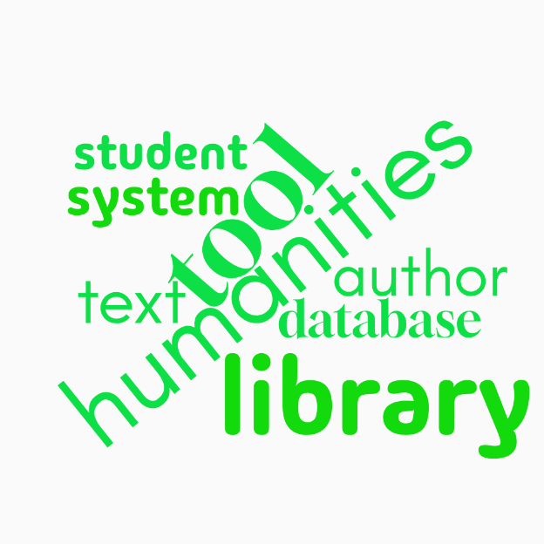

8.2 Computational Social Science (Expanded)
The most frequent terms in Computational Social Science reveal a hybrid lexical configuration, as evidenced by Table 10, combining computational infrastructures, analytical models, and social phenomena.

Table 10. Most frequent terms – Computational Social Science (Expanded)
Rank | Term | Frequency | Role
1 | computing | 873 | Computational infrastructure
2 | social science | 602 | Disciplinary foundation
3 | service | 376 | Digital ecosystem
4 | internet | 193 | Data environment
5 | simulation | 150 | Modeling approach
6 | misinformation | 111 | Social phenomenon
7 | classifier | 90 | Analytical model
8 | experimental result | 88 | Validation process

Terms such as computing, internet, and service reflect the technological environments in which research is conducted, while simulation, classifier, and experimental result indicate a strong methodological orientation.
At the same time, terms such as misinformation highlight the field’s engagement with contemporary social dynamics in digital environments. This pattern reinforces the interpretation of Computational Social Science as a heterogeneous and expanding domain. This configuration is further illustrated in the word cloud (Figure 12).

Figure 12. Word cloud of most frequent terms in Computational Social Science
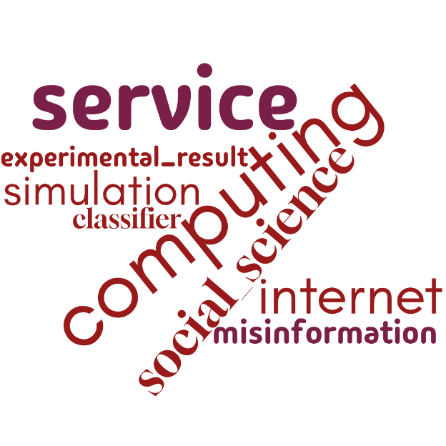

8.3 Digital Methods (Expanded)
The lexical configuration of Digital Methods is oriented toward operational and methodological processes, as shown in Table 11.

Table 11. Most frequent terms – Digital Methods (Expanded)
Rank | Term | Frequency | Role
1 | group | 498 | Experimental structure
2 | accuracy | 464 | Evaluation metric
3 | measurement | 385 | Validation process
4 | project | 294 | Organizational unit
5 | platform | 269 | Research environment
6 | precision | 225 | Performance metric
7 | software | 197 | Technical tool
8 | comparison | 192 | Analytical procedure

Terms such as accuracy, precision, and measurement highlight the centrality of evaluation and validation, while software and platform indicate the importance of computational tools and environments.
The presence of terms such as project and group further reflects the structured and often experimental nature of research practices in the field. This profile reinforces the interpretation of Digital Methods as a method-driven domain organized around analytical workflows and performance assessment. This methodological orientation is also captured in the word cloud (Figure 13).

Figure 13. Word cloud of most frequent terms in Digital Methods
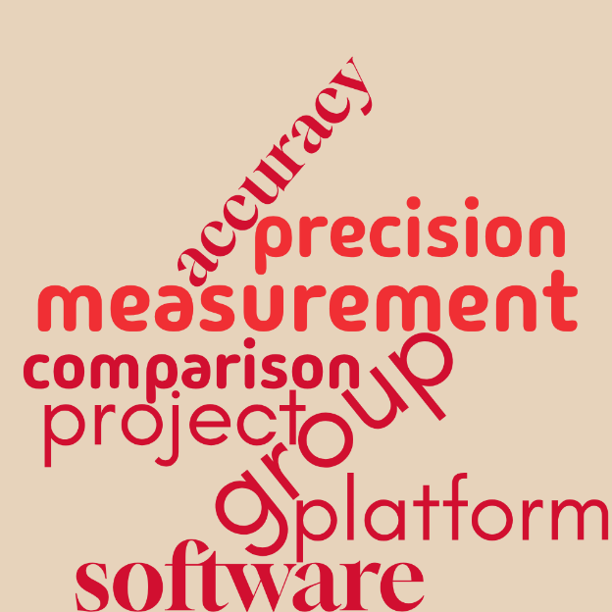

8.4 Comparative Overview
A comparison of dominant lexical patterns across the three fields reveals distinct configurations. Digital Humanities is characterized by a stable and conceptually oriented vocabulary, rooted in scholarly communication and humanistic inquiry. Computational Social Science presents a hybrid lexicon that integrates computational modeling with the analysis of social phenomena. Digital Methods, in contrast, is dominated by operational and evaluative terminology, reflecting its strong methodological orientation.
This overall profile is consistent with the co-occurrence network analysis, which highlighted the conceptual cohesion of Digital Humanities, the heterogeneity of Computational Social Science, and the method-driven structure of Digital Methods. It also aligns with the temporal analysis, reinforcing differences in growth dynamics, levels of consolidation, and degrees of terminological stabilization across the three fields.
The complete term lists associated with the co-occurrence analysis are available in an online repository.

9. Concluding Remarks
This report presented a comparative scientometric analysis of Digital Humanities (DH), Computational Social Science (CSS), and Digital Methods (DM), combining topic modeling, co-occurrence network analysis, lexical analysis, and temporal analysis to examine their thematic structures, vocabularies, and development trajectories. The results reveal distinct configurations across the three fields, with Digital Humanities characterized by conceptual stability, Computational Social Science by sustained and heterogeneous growth, and Digital Methods by an operational and rapidly expanding profile.
The findings highlight the central role of query design in shaping the representation of research fields, particularly in contexts marked by terminological variability. Across analytical dimensions, the results converge in indicating partial overlaps, distinct epistemological orientations, and the presence of bridging elements, with Digital Methods occupying an intermediate position between Digital Humanities and Computational Social Science. Overall, the analysis demonstrates how methodological choices influence the interpretation of research landscapes and contribute to a more nuanced understanding of the relationships between digital technologies, computational methods, and knowledge production.

Appendix A – Search Queries
All queries were performed in the Web of Science Core Collection using the “Topic” (TS) field, which includes titles, abstracts, author keywords, and Keywords Plus.

A1. Digital Humanities (DH)
Query (April 4, 2026):
TS=("digital humanities" OR "humanities computing" OR "humanistic computing")

A2. Computational Social Science (CSS)
Original query (April 4, 2026):
TS=("computational social science")
Expanded query (April 6, 2026):
TS=("computational social science" OR "computational sociology" OR "social computing")

A3. Digital Methods (DM)
Original query (April 4, 2026):
TS=("digital methods" AND (humanities OR "social sciences"))
Expanded query (April 6, 2026):
TS=("digital methods" OR "digital research methods" OR "digital methodologies")

Appendix B – Topic Modeling Results
This appendix provides an overview of the topics identified through topic modeling using BERTopic. For each dataset, the tables include the topic identifier, the number of documents associated with each topic, the most representative terms, and the assigned thematic category.
Topics labeled as -1 correspond to outliers, representing documents that could not be reliably assigned to a coherent semantic cluster. These topics were excluded from the thematic categorization presented in the main analysis.
The assignment of topics to thematic categories was based on the interpretation of the most representative terms and documents associated with each topic.
Due to space constraints, only a selection of representative topics is presented. The complete dataset, including all topics and associated metadata, is available in an online repository (link provided below): https://drive.google.com/drive/folders/1op2pgCixQmjfR2oCjtoFjNslXpxmlmBH?usp=drive_link.

B1. Digital Humanities
DATASET: DH
Topic ID | Count | Top Terms | Theme
0 | 42 | humanities, digital, black, projects, feminist | Epistemology
1 | 29 | data, tools, information, metadata, analysis | Methods
2 | 29 | librarians, libraries, dh, academic, collaboration | Infrastructure
3 | 21 | cultural, research, heritage, centers, development | Applications
4 | 21 | chinese, database, humanities, research, data | Regional
5 | 18 | history, historical, editing, technologies | Applications
6 | 17 | students, courses, teaching, education | Education
7 | 14 | literary, reading, literature, methodologies | Applications
8 | 13 | visualization, data, visual, research | Methods
10 | 11 | journals, publications, open science, authors | Scholarly Communication

B2. Computational Social Science – Original
DATASET: CSS ORIGINAL
Topic ID | Count | Top Terms | Theme
0 | 253 | social, data, computational, science, models | Methods
1 | 138 | language, models, llms, text, data | Methods
2 | 65 | political, media, news, election, polarization | Applications
3 | 47 | fake news, misinformation, online, content | Applications
4 | 46 | networks, social interactions, graph, structure | Methods
5 | 43 | mobility, urban, segregation, patterns | Applications
6 | 30 | scientists, publications, collaboration, career | Scholarly Communication
7 | 18 | personality, traits, behavior, prediction | Applications
8 | 17 | machine learning, models, policy, data | Methods

B3. Computational Social Science – Expanded
DATASET: CSS EXPANDED
Topic ID | Count | Top Terms | Theme
0 | 82 | health, support, online, digital | Applications
1 | 79 | mobility, urban, data, cities | Applications
2 | 69 | misinformation, media, news, covid | Applications
3 | 61 | political, news, media, election | Applications
4 | 58 | agent-based, simulation, models | Methods
5 | 54 | personality, behavior, interviews | Social Phenomena / Behavior
6 | 53 | learning, education, technologies | Applications
7 | 47 | privacy, security, data protection | Ethics / Governance
8 | 43 | social media, marketing, users | Applications
10 | 38 | LLMs, language models, stance | Methods
14 | 32 | cloud, IoT, computing | Data / Infrastructure
15 | 31 | ethics, research, data practices | Ethics / Governance
16 | 30 | community detection, networks | Methods

B4. Digital Methods – Original
DATASET: DM ORIGINAL
Topic ID | Count | Top Terms | Theme
0 | 43 | digital, humanities, methods, research, linguistics | Methods
1 | 25 | data, social, digital, research, big data | Methods
2 | 13 | analysis, data, manuscripts, text, workflow | Methods
3 | 8 | dance, history, digital methods, art, movement | Applications

B5. Digital Methods – Expanded
DATASET: DM EXPANDED
Topic ID | Count | Top Terms | Theme
0 | 381 | social, media, digital methods, platforms | Methods
1 | 90 | health, patients, digital interventions | Applications
2 | 74 | historical, texts, historiography | Humanities
3 | 66 | heritage, archaeology, 3D | Humanities
4 | 64 | soil, mapping, data, modeling | Applications
5 | 54 | pandemic, health research, covid | Applications
7 | 53 | signal, measurement, Fourier | Methods
8 | 50 | BIM, construction, infrastructure | Applications
9 | 43 | education, learning, students | Applications
10 | 41 | intraoral scanners, precision | Applications

Appendix C – Network Construction Parameters
This appendix provides detailed information on the parameters used to construction of the co-occurrence networks across the three datasets analyzed: Digital Humanities, Computational Social Science (Expanded), and Digital Methods (Expanded).
For all datasets, co-occurrence networks were generated based on terms extracted from titles and abstracts. A full counting method was applied, in which each co-occurrence is counted equally.
A minimum occurrence threshold of 10 was defined for term inclusion. Terms with fewer than ten occurrences were excluded in order to reduce noise and improve network interpretability.
The relevance score option in VOSviewer was used to select the most representative terms, prioritizing those that are more specific to the dataset rather than more general ones. This procedure ensured a balanced number of nodes, maintaining both network readability and analytical depth.
Network layouts were produced using the VOS mapping technique, in which the spatial distance between nodes reflects the strength of co-occurrence relationships. Node size represents term frequency, and links indicate co-occurrence connections.
Clusters were automatically identified using VOSviewer’s clustering algorithm, based on modularity optimization. Each cluster represents a group of terms more strongly connected to each other than to those in other clusters.
To ensure comparability across datasets, the same parameter configuration was applied.

C1. Digital Humanities
- Unit of analysis: Terms
- Counting method: Full counting
- Minimum number of occurrences: 10
- Number of terms selected: 130
- Number of clusters: 6
- Number of links: 4,703
- Total link strength: 26,479

C2. Computational Social Science (Expanded)
- Unit of analysis: Terms
- Counting method: Full counting
- Minimum number of occurrences: 10
- Number of terms selected: 815
- Number of clusters: 9
- Number of links: 54,022
- Total link strength: 192,748

C3. Digital Methods (Expanded)
- Unit of analysis: Terms
- Counting method: Full counting
- Minimum number of occurrences: 10
- Number of terms selected: 735
- Number of clusters: 4
- Number of links: 59,867
- Total link strength: 341,363

