IVCAM2.0 3D Imaging Camera
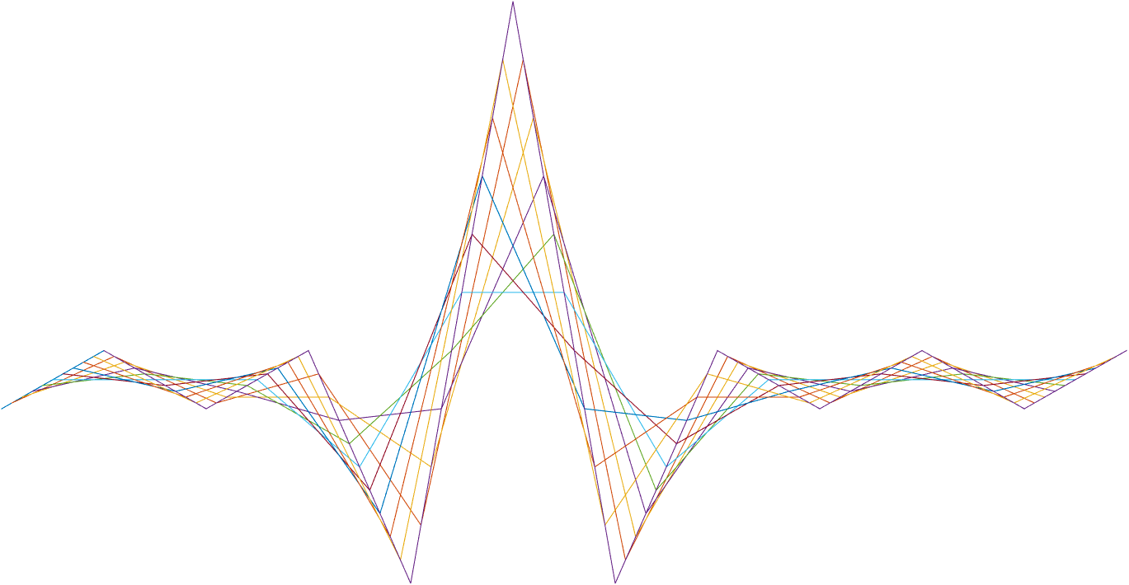

ASIC A0 Digital gateway specification

7 February 2017

Revision 0.7.2

Intel Top Secret

Table 1: Revision history
Matlab Version | Revision Number | Revised by | Description | Revision Date
TBD | 0.4.0 | Ohad Menashe | Initial Release | 3 Jun 2016
Matlab 2016a | 0.4.1 | Vitaly Surazhsky | NEST fixed | 20 Jun 2016
 | 0.4.11 | Ohad Menashe | Remove delay element
 | 0.51 | Ohad Menashe | LUT sizes, add filter constraint
 | 0.52 | Yoni Chechik | GENG integration | 7 Aug 2016
 | 0.53 | Ohad Menashe | Review,tidy | 8 Aug 2016
 | 0.54 | Yoni Chechik | Linear interp + memory | 9 Aug 2016
 | 0.55 | Yoni Chechik | undist | 20 Sep 2016
 | 0.56 | Yoni Chechik | Test plan+notch filter regs+test plans+roi | 21 Sep 2016
0.7.39 | 0.7 | Ohad Menashe | LUT explanation (no logic change) | 22 Sep 2016
0.7.39 | 0.7 | Omer Sella | Changed GAMMA lut from 128X12 to 64X12 | 22 Sep 2016
0.7.39 | 0.7 | Omer Sella | Added an explanation on Gamma calculation as well as a flow. | 28 Sep 2016
0.7.39 | 0.7 | Omer Sella | Minor corrections. | 28 Sep 2016
 | 0.71 | Yoni Chechik | undistX0 / Y0 | 9 oct 2016
0.7.42 | 0.71 | Ohad Menashe | Interface alignment | 13 Oct 2016
0.7.44 | 0.7.2 | Ohad Menashe | Add gamma LUT registers | 29 Oct 2016
0.7.46 |  | Ohad Menashe | Trigo funcs update | 10 Nov 2016
0.7.47 | 0.7.2 | Vitaly Surazhsky | NEST is updated | 17 Nov 2016
0.7.47 | 0.7.2 | Ohad Menashe | Added block: IPTG  (updated the block diagram) | 17 Nov 2016
 | 0.7.3 | Yoni Chechik | scale shift for undist+ ang2xy output single-> int32 | 17 Nov 2016
 | 0.7.31 | Yoni Chechik | Rewrite and tidy of inputs & outputs sizes and types of GENG block | 8 Dec 2016
0.8.50.B |  | Ohad Menashe | GENG block diagram update  ROI flag using angyQ | 13 Dec 2016
0.8.52.C |  | Ohad Menashe | NEST output zeros when bypassed | 21 Dec 2016
 |  | Yoni Chechik | DIGG notch explanation renew | 22 Dec 2016

Contents
1 Introduction 4
1.1 DIGG-IR 4
1.2 DIGG-GENG 4
2 Interfaces & Memory 8
2.1 Interfaces 8
2.1.1 Inputs 8
2.1.2 Outputs 8
2.2 Memory 9
2.2.1 Trigonometric functions 9
3 Detailed description 10
3.1 IPTG (internal pattern generator) 10
3.2 GAMMA 11
3.3 IRFE: IR frontend 12
3.3.1 Slow channel filtering 12
3.2.2. Digital IIR filter design 13
3.3.3 DIGG filter 13
3.3.4 Notch filter configuration 14
3.3.5 Delay 14
3.4 NEST: Noise estimation 14
3.5 GENG 15
3.5.1 Fixed2float 16
3.5.2 Ang2xy 17
3.5.3 ranger 21
3.5.4 ROI flag 21
4 Registers 23
5 Test plan 29
5.1 General randomization 29
5.2 Constraints 33

Tables
Table 1: Revision history 1
Table 2: Registers 6
Table 3: DCOR memory and bandwidths 7

Introduction
The DIGG (digital gateway) is the interface block of the input sampled (synced) data to the algorithmic pipeline. The block deals with the input of the slow channel (IR) and the x&y angles of the mirror.

DIGG-IR
The IR signal received from the sensor undergoes through amplitude detection circuit, following low pass filtration and sampling. As the relevant part of the spectrum depends on the output resolution, the filter cut-off frequency depends on the configuration (output image resolution).
The IR is sampled by 125 Mhz (configurable, yet advised not to be changed, due to frequency and time alignments).
These samples are passed to the Algo pipe through the analog sync block with decimation, interpolation, or “as-is”, depends on the configuration (each 64 “fast” samples are concatenated with a single IR sample).
The DIGG-IR has 2 main objectives
- Data filtration and artifacts removal
- Ambient noise estimation

DIGG-GENG
GENG is the geometric engine: In order to create a rasterized depth image, the mirror location at every given moment should be measured. The measuring device is composed of a piezo-resistor bridge, which (after calibration) yield the vertical angle $ϕ_{y}∈\left[-\frac{FOV_{y}}{2},\frac{FOV_{y}}{2}\right]$ and the horizontal angle $ϕ_{x}∈\left[-\frac{FOV_{x}}{2},\frac{FOV_{x}}{2}\right]$. In this block these angles are transformed to the rasterized coordinates x and y accordingly.
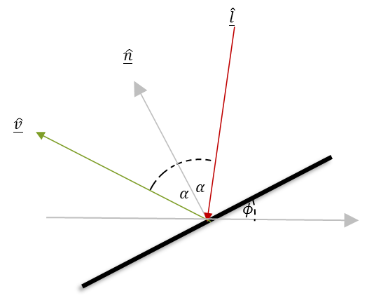

Figure 1: vector diagram

Given the projection angles, the mirror surface normal can be calculated as:
$$\underline{\hat{n}}=\left\{\sin{ϕ_{x}},\cos{ϕ_{x}\sin{ϕ_{y}}},\cos{ϕ_{x}\cos{ϕ_{y}}}\right\}$$
Assuming the laser beam illuminates the MEMS surface exactly at the pivot point with the direction $\underline{\hat{l}}$, the projected beam direction $\underline{\hat{v}}$ can be calculated as:

$$\hat{\underline{v}}=\underline{\hat{l}}+2\underline{\hat{n}}⋅\left\langle \underline{\hat{n}} | -\underline{\hat{l}}\right\rangle$$
While $\left\langle \underline{x} | \underline{y}\right\rangle$ is the dot product of the vectors $\underline{x} \& \underline{y}$.
The normalized coordinates $\hat{x},\hat{y}$ are given by:
$$\hat{x}=\frac{\frac{{\hat{v}}_{x}}{{\hat{v}}_{z}}}{\tan\left(\frac{FOV_{x}}{2}\right)},\hat{y}=\frac{\frac{{\hat{v}}_{y}}{{\hat{v}}_{z}}}{\tan\left(\frac{FOV_{y}}{2}\right)}$$
Note that even though the angles are limited inside the FOV, the normalized coordinate value range might be outside the range of $[-1,1]$ due to the vector addition of the laser incident direct.
Finally, the normalized coordinates are multiplied by the vertical and horizontal resolution to create the final output coordinates.
$$x=\hat{x}⋅RES_{H},y=\hat{y}⋅RES_{v}$$
Where regsDIGGresH and regsDIGGresV are used for $RES_{H}$ and $RES_{V}$ correspondingly.

As before, the values of the pixel coordinates exceeds the defined resolution due to the nature of the mirror movement.
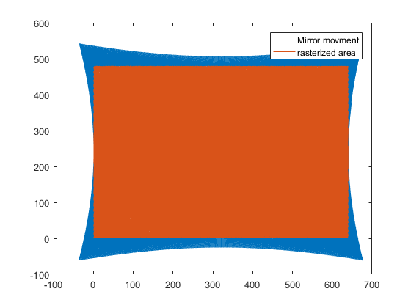
ROI + margins
ROI
resH
imageHsize
margin
Guard_band
Figure 2: laser projection over plane

Figure 3: block diagram

Interfaces & Memory

Interfaces

Inputs
- angxQ/angyQ– 2x12b sampled input angle (2’s complement)
  - 0x0000 0
  - 0x07FF +FOV/2
  - 0x0800 INVALID
  - 0x0801 -FOV/2
- pi_flags
- ir
- fast_bin

Outputs
- xS/yS – 15/12 signed image pixel coordinates
- pi_flags
- roi
- ir
- noise_est
- fast_bin

Memory

Trigonometric functions
Trigonometric functions are saved as a single precision (32bit) LUT over a quarter cycle of the sine function sampled over 128 points. Additionally the step $Δx=\frac{90}{127}=0.7086614$ is save as well. LUT size is $128⋅32+1=4kbit$ hard coded
[
0.000000 , 0.012368 , 0.024734 , 0.037097 , 0.049454 , 0.061803 , 0.074143 , 0.086471 , 0.098786 , 0.111087 , 0.123370 , 0.135634 , 0.147877 , 0.160098 , 0.172295 , 0.184465 , 0.196606 , 0.208718 , 0.220798 , 0.232844 , 0.244854 , 0.256827 , 0.268761 , 0.280654 , 0.292503 , 0.304308 , 0.316066 , 0.327776 , 0.339436 , 0.351044 , 0.362598 , 0.374097 , 0.385538 , 0.396921 , 0.408243 , 0.419502 , 0.430697 , 0.441826 , 0.452888 , 0.463881 , 0.474802 , 0.485651 , 0.496425 , 0.507124 , 0.517745 , 0.528287 , 0.538748 , 0.549126 , 0.559421 , 0.569630 , 0.579752 , 0.589785 , 0.599728 , 0.609579 , 0.619337 , 0.629000 , 0.638567 , 0.648036 , 0.657406 , 0.666676 , 0.675843 , 0.684908 , 0.693867 , 0.702720 , 0.711466 , 0.720103 , 0.728630 , 0.737045 , 0.745348 , 0.753536 , 0.761610 , 0.769566 , 0.777405 , 0.785125 , 0.792725 , 0.800204 , 0.807561 , 0.814793 , 0.821901 , 0.828884 , 0.835739 , 0.842467 , 0.849066 , 0.855535 , 0.861873 , 0.868079 , 0.874153 , 0.880093 , 0.885898 , 0.891567 , 0.897101 , 0.902497 , 0.907754 , 0.912873 , 0.917853 , 0.922692 , 0.927390 , 0.931946 , 0.936359 , 0.940629 , 0.944755 , 0.948737 , 0.952574 , 0.956265 , 0.959809 , 0.963207 , 0.966457 , 0.969560 , 0.972514 , 0.975320 , 0.977976 , 0.980482 , 0.982839 , 0.985045 , 0.987101 , 0.989006 , 0.990759 , 0.992361 , 0.993811 , 0.995109 , 0.996254 , 0.997248 , 0.998088 , 0.998776 , 0.999312 , 0.999694 , 0.999924 , 1.000000
]
Hex data:
00000000 , 3C4AA3D2 , 3CCA9FDB , 3D17F2EE , 3D4A8FFC , 3D7D251B , 3D97D828 , 3DB117D0 , 3DCA5089 , 3DE38155 , 3DFCA939 , 3E0AE39B , 3E176D2A , 3E23F0CB , 3E306E00 , 3E3CE44C , 3E495333 , 3E55BA37 , 3E6218DC , 3E6E6EA7 , 3E7ABB1B , 3E837EDF , 3E899B0A , 3E8FB1D1 , 3E95C2F8 , 3E9BCE42 , 3EA1D371 , 3EA7D24A , 3EADCA90 , 3EB3BC08 , 3EB9A677 , 3EBF899F , 3EC56548 , 3ECB3936 , 3ED1052E , 3ED6C8F7 , 3EDC8456 , 3EE23713 , 3EE7E0F3 , 3EED81BF , 3EF3193E , 3EF8A738 , 3EFE2B75 , 3F01D2DF , 3F048AED , 3F073DCB , 3F09EB5D , 3F0C9389 , 3F0F3633 , 3F11D341 , 3F146A99 , 3F16FC22 , 3F1987C0 , 3F1C0D5C , 3F1E8CDA , 3F210624 , 3F23791F , 3F25E5B3 , 3F284BC8 , 3F2AAB45 , 3F2D0414 , 3F2F561C , 3F31A146 , 3F33E57B , 3F3622A5 , 3F3858AD , 3F3A877D , 3F3CAEFE , 3F3ECF1C , 3F40E7C1 , 3F42F8D8 , 3F45024C , 3F47040A , 3F48FDFB , 3F4AF00E , 3F4CDA2F , 3F4EBC49 , 3F50964B , 3F526822 , 3F5431BB , 3F55F305 , 3F57ABEE , 3F595C65 , 3F5B0459 , 3F5CA3B9 , 3F5E3A74 , 3F5FC87C , 3F614DC1 , 3F62CA32 , 3F643DC2 , 3F65A862 , 3F670A03 , 3F686298 , 3F69B213 , 3F6AF867 , 3F6C3588 , 3F6D6968 , 3F6E93FD , 3F6FB539 , 3F70CD12 , 3F71DB7D , 3F72E06F , 3F73DBDF , 3F74CDC1 , 3F75B60D , 3F7694BA , 3F7769BF , 3F783513 , 3F78F6AF , 3F79AE8B , 3F7A5CA0 , 3F7B00E6 , 3F7B9B59 , 3F7C2BF1 , 3F7CB2A8 , 3F7D2F7A , 3F7DA262 , 3F7E0B5B , 3F7E6A61 , 3F7EBF71 , 3F7F0A86 , 3F7F4B9F , 3F7F82B8 , 3F7FAFD0 , 3F7FD2E4 , 3F7FEBF3 , 3F7FFAFD , 3F800000

Detailed description

IPTG (internal pattern generator)[DEPRECATED]
The internal pattern generator generates (when not bypassed) a set of input signals which generates a checkboard IR at a fixed range (that is, a checkerboard on a sphere).
- Fast channel uses sampling rate and transmision code from the current configuration (transmission code is based on the MSB of the first template in the ML bank).
- IR data is to generate a checkerboard image on the range plane. IR data packets are set to RegsDIGGiptgnIRlow , and alternate between RegsDIGGiptgnIRlow and RegsDIGGiptgnIRhi
Every:
- RegsDIGGiptgPktsPerCB samples (value is set such that the number of packets per scan line RegsDIGGiptgPktsPerScanLine is always a full division of the number of packets in a checker block).
- RegsDIGGipgnPktsPerScanLine( such that adjacent scans receives the same color)
- RegsDIGGipgnPktsPerScanBlock (creating alternating vertical blocks)
- X location data is incremented at a step of RegsDIGGiptgAngxDelta every RegsDIGGiptgAngxNpackets from intial value of -2048 and upto a value of 2047. When overflow (frame is over), x value is kept at -2048 for RegsDIGGnPackets packets, and restart incrementing.
- Y location data is incremented at a step of RegsDIGGiptgAngyDelta every RegsDIGGiptgAngyNpackets from intial value of -2048 and upto a value of 2047. When reaching 2047 (or over), the last sample is held for one more packet, and then location is decremented at a step of RegsDIGGiptgAngyDelta until reaching a value of -2048 (or below).
- pi_flags are generated with the following logic:
  - ld_on - set to logic 0 when Y location is either -2048 or 2047
  - tx_code_start - zero excluding first packet which is logic 1
  - scan_dir - alternating between 0 and 1 every RegsDIGGipgnPktsPerScanLine samples
  - Txrx_mode – constant 0.

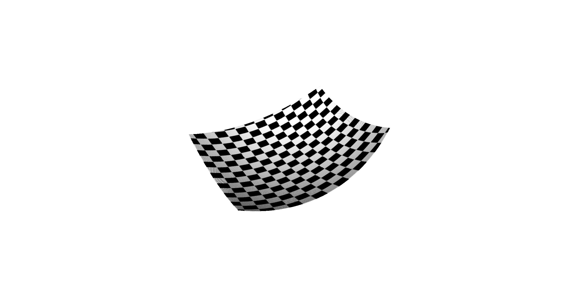
Figure 3: IPTG output

Firmware calculations

iptgMirrorFreq = 20000;

iptgNx = 19;

%ir
autogenRegs.DIGG.iptgNpPackets = double(regs.GNRL.sampleRate)*1e9/(double(regs.DIGG.iptgFrameRate)*64);
autogenRegs.DIGG.iptgPktsPerScanLine =floor( double(regs.GNRL.sampleRate)*1e9/(2*64*iptgMirrorFreq));

if(regs.GNRL.sampleRate==4)
iptgNy=22;
else
iptgNy=25;
end

autogenRegs.DIGG.iptgPktsPerCB = autogenRegs.DIGG.iptgPktsPerScanLine/iptgNy;
autogenRegs.DIGG.iptgPktsPerScanBlock = regs.DIGG.iptgPktsPerScanLine*iptgNx;

%xy
autogenRegs.DIGG.iptgAngxNpackets = autogenRegs.DIGG.iptgPktsPerScanLine;
autogenRegs.DIGG.iptgAngxDelta =ceil(2^12/(autogenRegs.DIGG.iptgNpPackets/autogenRegs.DIGG.iptgPktsPerScanLine-1));

autogenRegs.DIGG.iptgAngyDelta =ceil(2^12/autogenRegs.DIGG.iptgPktsPerScanLine );
autogenRegs.DIGG.iptgAngyNpackets =floor(autogenRegs.DIGG.iptgPktsPerScanLine*autogenRegs.DIGG.iptgAngyDelta/2^12 );

%chk
autogenRegs.DIGG.iptgAngyNpackets = convertChk(autogenRegs.DIGG.iptgAngyNpackets);
autogenRegs.DIGG.iptgAngyDelta = convertChk(autogenRegs.DIGG.iptgAngyDelta );
autogenRegs.DIGG.iptgAngxDelta = convertChk(autogenRegs.DIGG.iptgAngxDelta );
autogenRegs.DIGG.iptgAngxNpackets = convertChk(autogenRegs.DIGG.iptgAngxNpackets );
autogenRegs.DIGG.iptgPktsPerCB = convertChk(autogenRegs.DIGG.iptgPktsPerCB );
autogenRegs.DIGG.iptgPktsPerScanLine= convertChk(autogenRegs.DIGG.iptgPktsPerScanLine);
autogenRegs.DIGG.iptgNpPackets = convertChk(autogenRegs.DIGG.iptgNpPackets );
autogenRegs.DIGG.iptgTxCode = regs.FRMW.txCode;
regs = Firmware.mergeRegs(regs,autogenRegs);

GAMMA
The gamma block main role is to compensate the amplifier’s non linearity using the following formula and flow:
${SATURATE}_{12} \{ max\left(0,\frac{\left(a_{2}⋅LinearInterpolationLUT\left(\min\left(0xfff,maximum\left(\frac{a_{1}⋅x}{1024} +b_{1},0\right)\right)\right)\right)}{1024}+b_{2}\right) \}$
Equation 1 Equation for gamma calculation
The input $x$ is given in 12 bits of IR.
- The input $x$ is given in 12 bits of IR.
- $a_{1}$ is a 16 bit signed, so $a_{1}⋅x$ is calculated, and the bit shifted by 10 bits to produce an 18 bit number.
- Next we add $a_{1}⋅x+b_{1}$ where $b_{1}$ is a 16 bit signed number, so the result it 19 bits wide. The result may be a negative number, so we take the maximum between the result and 0.
- Of the 19 bit result, only the 12 least significant bits are used, where in case we have a result which value is larger than 0xfff we take 0xfff instead (saturate).
- The 12 bits are passed through a LUT containing 65 12bit values. A linear interpolation is used for “missing” values.
- Next we multiply by another 16 bit signed number $a_{2}$ to obtain $a_{2}⋅LinearInterpolationLUT\left(\min\left(0xfff,maximum\left(\frac{a_{1}⋅x}{1024} +b_{1},0\right)\right)\right)$ and bit shift by 10 bits which yields an 18 bit signed number.
- Next we add $b_{2}$ which is a 16 bit signed number and obtain a 19 bit signed number. We take the maximum between the result and 0 to obtain a non negative number.
- Of the 19 bit result, only the 12 least significant bits are used, where in case we have a result which value is larger than 0xfff we take 0xfff instead, which is the final result of the Gamma block and also the output.

The scale and shift registers are 16bit signed each and defined as follows:
Parameter | Matching register name | Number of bits (signed/unsigned)
$$a_{1}$$ | regsDIGGgammaScale[0:15] | 16, signed
$$a_{2}$$ | regsDIGGgammaScale[16:31] | 16, signed
$$b_{1}$$ | regsDIGGgammaShift[0:15] | 16, signed
$$b_{2}$$ | regsDIGGgammaShift[16:31] | 16, signed

LUT size is 64 x 12b, with linear interpolation.

IRFE: IR frontend

Slow channel filtering
As we would like to detect the envelope of the received IR signal, the received data undergoes through an envelope detection circuit. This circuit roughly is composed of absolute function and low pass filter. As out coding strategy is compressed pulse, the signal power is spread throughout the spectrum. The inherit IR data is modulated on top of the signal harmonics, and due to the absolute value circuit, they are being folded to the lower part of the spectrum for filtering.
Unfortunately, some of the harmonics are also folded into the area of the spectrum where the data resides (i.e. spectral leakage). This parasitic artifact can be visualized by an unwanted set of frequencies.
Figure 4: Signals in the TX/RX chain (TL) Transmitted signal(TR) received signal (ML) received signal – zoom (MR) after envelope detection (BL) after sampling (BR) after notch filtering
The number of deltas seen is a function of code length, and LPF cutoff frequency (hence, output resolution). Although an anti-aliasing filter exists before the sampler, due to the nature of the LPF, some frequencies leaks into the sampled domain, causing aliasing.
All of these parasitic frequencies are handled with surgeon precision using a set of narrow band notch filters. These filters are configured to filter the exact problematic frequencies with minimum impact on the data.
Notch filtering in the digital domain are implemented as FIR+IIR filter

3.2.2. Digital IIR filter design
In digital system one can make an IIR filter as a type 2 IIR.
Which is an implementation of the following discrete time transfer function:
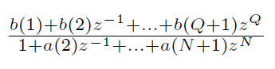
Equation 2: equation for a general rational function filter.
For our notch we get coefficients in the interval of [-2 2] in double form.
For computational speed we can do a fixed point IIR filter, in which we multiply the coefficients by 2^q where q is some “fixed Point Scale Factor”. After the summation we truncate it back to its original size using rounding like so:
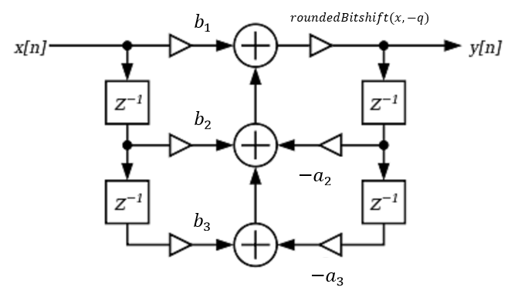

Figure 5
*while you scale down be aware to round the number to its best approximation- so not ordinary bitshift, but rounded bitshift (+lsb/2).

DIGG filter
In our case:
- We have 2 coefficients in the numerator and 2 in the denominator. Total of 4 coeffs each of int16 type.
- The first and last elements in the nominator are equal:
$$b\left(1\right)=b(3)$$
- for us q=13 because we save 16b with max value of signed $±2.$
- The registers of each individual filter is RegsDIGGnotch*A & RegsDIGGnotch*B where * is a number between 1 and 16 (since there are 16 filters) the register is 32b and is built like so (the left is the LSB):
  - RegsDIGGnotch*A = [-a(2) -a(3)].
  - RegsDIGGnotch*B = [ b(2) b(3)].

Notch filter configuration
Resolution | TX symbol  [nsec] | LPF- cutoff [MHz] | Code length  [nsec] | First harmonic  [MHz] | Num notch filters
QVGA | 1 | 15 | 128 | 7.8 | 4
QVGA | 4 | 15 | 128 | 7.8 | 16
VGA | 1 | 38 | 64 | 15.6 | 4
VGA | 2 | 38 | 64 | 15.6 | 8
HD | 1 | 62.5 | 32 | 31.25 | 4
- Transmitting in lower frequencies
- Requires total of 16 notch filters

Delay
As the slow channel is delayed relevant to the fast channel due to analog filtering, all the sync is performed in the analog sync in calibration time

NEST: Noise estimation
The purpose of the Nest (noise estimation) sub-block is to estimate ambient IR when the laser is not illuminating. This happens at the edges of each scan line when the mirror reaches its max opening and LD_ON is low. This will give us an ambient light level estimation which will be used for the fast channel.
NEST computes the sum of 2^ RegsDIGGNestNumOfSamplesExp (e.g 256) 12-bit IR samples of the input chunks when ld_on is ’0. The sum accumulation starts after RegsDIGGNestLdOnDelay IR values after LD_ON falls to ’0. This is to enable TOF return of the last transmission to be away from our assumed range – e.g. for a typical IVCAM2.0 system ~100nsec == 20m of range.
When 2^ RegsDIGGNestNumOfSamplesExp IR samples have been accumulated, the output Nest value is computed and stored, and the accumulation starts from the beginning. The output Nest value is the sum of the samples divided by 2^ RegsDIGGNestNumOfSamplesExp by truncating of RegsDIGGNestNumOfSamplesExp least significant bits. Every chunk that comes out of DIGG receives the maximum between the last computed Nest value and 1, namely, 0 is never outputted.
When RegsDIGGnestBypass is set, the NEST block outputs ones.
We assume that the Nest value, which represents the ambient light level, changes slowly (at most it will change in 50/60Hz in the presence of electrical network based light of warm light (e.g.; incandescent light). So there is a lot of redundancy attaching this value to each chunk – however this simplifies the uArchitecture significantly for a small 12-bit addition to every chunk (<1% addition)
Notes:
- NEST gets IR samples from Analog Sync that depends on the depth sampling rate, either :
  - At the original sampling rate
  - Decimated by 2
  - Interpolated by block filtering
- We assume that we always have at least 256 IR samples with ld_on=0 after proper delay at the edge of a scanline. The assumption is based on the fact that the time without transmission between the scanlines is about 5μs. Since IR samples are received from analog sync at a minimum of 62.5MHz rate, we have at least 306 IR samples.

GENG
The main role of the GENG block is to convert the MEMS spherical coordinates to the camera projected plane space. The conversion is takes under consideration several factors, whether optical, mechanical or geometric. Mixing all these factors together yields a polynomial fraction, with the coefficients calculated per mode by firmware.

Figure 5: block diagram

Ang2xy
The transformation from angular data to rasterized grid over the projected plane preformed in this sub-block, making it the core component in the Geometric engine block.
The calculation in this block can be divided into three parts. Input to this block is single and output as fixed point int32 which is shifted by regs.DIGG.bitshift.

Pre calculations
The pre calculations produces 18 floating point coefficients for the runtime calculations, and 4 output registers for other blocks in the pipe. These coefficients are calculated in the firmware based on input data from the MEMS (e.g. opening angle, guard bands etc.), and input from the UI (e.g. output resolution, ROI, etc.). Due to the fact that these coefficients should be updated once a frame, all these registers should be double buffered.
The polynomial coefficients are calculated per configuration and depend on the following parameters:
- Mechanical opening (vertical/horizontal) - the vertical and horizontal mirror minimal rotation range across the frame.
- Laser angle (vertical/horizontal) - the vertical and horizontal angular offset of the laser incident from the mirror normal from zero state.
- marginT/ marginR/ marginB/ marginL – top/right/bottom/left margin to define ROI in the image
- resV/resH - (vertical/horizontal) vertical/horizontal resolution (before ROI)
- Guard band - (vertical/horizontal) - vertical/horizontal margin on the rasterized domain.
- Vertical\Horizontal Flip

These parameters are passed to this block per configuration, resulting in an 18 floating point coefficients (preformed in firmware, NOT ASIC calcultaions):
- k0 = resVN*csd(RegsDIGGlaserangleH);
- k1 = resHN*cosd(RegsDIGGlaserangleH);
- k2 = sqrt(RegsDIGGprojectionYshear*RegsDIGGprojectionYshear+1.0);
- k3 = cosd(RegsDIGGlaserangleH)*sind(RegsDIGGlaserangleV)*k2;
- k4 = cosd(RegsDIGGlaserangleH)*cosd(RegsDIGGlaserangleV)*k2;
- k5 = sind(RegsDIGGlaserangleH)*k2;
- k6 = rangeR-rangeL;
- k7 = rangeB-rangeT;
- k8 = (rangeB*resVN-k7*marginTN);
- k9 = (rangeL*resHN+k6*marginLN);

- nx6 = k1*sind(RegsDIGGlaserangleV)*RegsDIGGprojectionYshear;
- nx1 = -resHN*sind(RegsDIGGlaserangleH);
- nx2 = -k9*k4;
- nx3 = (k1*cosd(RegsDIGGlaserangleV)+(rangeL*resHN+k6*marginLN)*k5);
- nx4 = -resHN*sind(RegsDIGGlaserangleH)*RegsDIGGprojectionYshear+k1*sind(RegsDIGGlaserangleV);
- nx5 = k1*cosd(RegsDIGGlaserangleV)*RegsDIGGprojectionYshear-k9*k3;
- dx2 = k6*k4;
- dx3 = -k6*k5;
- dx5 = k6*k3;
- ny6 = k0*sind(RegsDIGGlaserangleV);
- ny1 = resVN*sind(RegsDIGGlaserangleH)*RegsDIGGprojectionYshear;
- ny2 = - k8*k4;
- ny3 = k8*k5-k0*cosd(RegsDIGGlaserangleV)*RegsDIGGprojectionYshear;
- ny4 = -(resVN*(sind(RegsDIGGlaserangleH)+ RegsDIGGprojectionYshear*cosd(RegsDIGGlaserangleH)*sind(RegsDIGGlaserangleV)));
- ny5 = (k0*cosd(RegsDIGGlaserangleV)-k8*k3);
- dy2 = -k7*k4;
- dy3 = k7*k5;
- dy5 = -k7*k3;

Additionally, this block calculates a set of coefficients, for usage in external blocks (RAST, NEST)
$$RegsGNRLimgHsize= RegsDIGGresH-RegsDIGGmarginR-RegsDIGGmarginL \\ RegsGNRLimgVsize = RegsDIGGresV-RegsDIGGmarginB-ReDIGGmarginV$$

Trigonometric function implementation
Trigonometric functions are saved as a single precision (32bit) LUT over a quarter cycle of the sine function sampled over 128 points, and additional input$Δx$. LUT size is $(128+1)⋅32=4kbit$ hard coded.
Data points between the sampled points are linearly interpolated using 3 floating addition operation and 2 floating point multiplication. Additional assumption on the input data can be given due to the nature of the trigonometric function.
Since the number of samples and LUT range are hard coded (128 and 90 accordingly), the save variable $f_{s}=\frac{1}{Δx}$ is hard coded as well and its value is 0.7086614 (D66A353F)
The trigonometric function is implemented using the above LUT, where
While:
x = input in degrees.
Fs = 90/127;
And the actual sin and cosine functions:
sinINTRP = @(x) sign(single(x)).*triFunc.at(abs(single(x)));
cosINTRP = @(x) triFunc.at(90-abs(single(x)));

LUT implementation
This section elaborates the implementation of a float to float LUT with linear interpolation.
Given N sampling point (i.e. LUT data) lut, with the LUT frequency fs (inverse of the distance between each of the LUT sampling points), the interpolated result of input data x is given as:
ii = x * fs; % index of the input x
i0 = max(floor(ii),0); % the index round down (cannot be negative)
i1 = min(i0+1,length(lut)-1); % the index rounded up (cannot exceed lut size-1)
y0 = lut(i0+1); % LUT value of index i0
y1 = lut(i1+1); % LUT value of index i1
val=(y1-y0).*(ii-i0)+y0; %weighted mean of the two points (linear interp)
As can be seen in the figure below, the values between two data point is linearly interpolated, and the error peaks in the midpoint between the lut sample data.

Runtime calculations
These coefficient are multiplied by variant multiplications of the sine/cosine of the input horizontal and vertical angles, to create 4 polynomial equations which creates the resulting x and y coordinates using wo floating point divisions.

csx = (cosINTRP(angx));
csy = (cosINTRP(angy));
sny = (sinINTRP(angy));
sn2x = (sinINTRP(2*angx));
cs2x = (cosINTRP(2*angx));
csx2 = (1 + cs2x)/2;

sn2y = (sinINTRP(2*angy));
cs2y = (cosINTRP(2*angy));

pc1 = -cs2x;
pc2 = csx2 *(1 + cs2y ) - 1;
pc3 = sn2x.* csy;
pc4 = sn2x.* sny;
pc5 = csx2.*sn2y;
pc6 = csx2 - csx2.*cs2y - 1;

xnum = single( pc1*regs.DIGG.nx1 + pc2*regs.DIGG.nx2 + pc3*regs.DIGG.nx3 + pc4*regs.DIGG.nx4 + pc5*regs.DIGG.nx5 + pc6*regs.DIGG.nx6);
ynum = single( pc1*regs.DIGG.ny1 + pc2*regs.DIGG.ny2 + pc3*regs.DIGG.ny3 + pc4*regs.DIGG.ny4 + pc5*regs.DIGG.ny5 + pc6*regs.DIGG.ny6);

xden = single(pc2*regs.DIGG.dx2 + pc3*regs.DIGG.dx3 + pc5*regs.DIGG.dx5);
yden = single(pc2*regs.DIGG.dy2 + pc3*regs.DIGG.dy3 + pc5*regs.DIGG.dy5);

x = xnum./xden;
y = ynum./yden;

shift = single(2^double(regs.DIGG.bitshift));
x = int32(x*shift);
y = int32(y*shift);

Undist
If the register RegsDIGGundistBypass is set to 1, we bypass this block.
undist receives x & y in int32 fixed, and with bicubic interpolation output the x & y after the correction of the lens (if exist). We make all the calculation in fixed point so we have a register for this as well regsDIGGbitshift. We save all calculations in 32 bit registers (int32 out).

For x (y is the same): we have x LUT from firmware of the size 32X32 (lutsDIGGxLensModel).
We also have the 1/step_size of the lut which we call regsDIGGundistFx.
Because our indexes of each LUT starts from (0,0) we need the corresponding (x0,y0) of that point. This is saved in the registers DIGGundistX0 & DIGGundistY0. For all x,y the comes into the LUT, we do a subtraction with those initial values.
The actual calculation is straight forward- if we have an input point $(t_{x},t_{y})$ we calculate the columns around it in a 4X4 neighborhood, and then we do the same in the x dimension. When the given point is near the margin (so we don’t have enough neighbors in 4X4 area) we take the nearest existing neighbor and copy him to the missing place.
Mathematically it is like so:
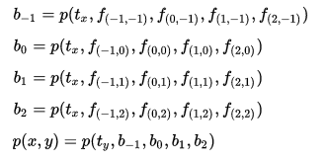
The function p itself is:
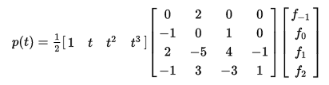
The output $p(x,y)$ is the result in int32.

The same exact calculation is done with the y LUT.
Wrapping the Undist (but still inside this sub-block) is shift and scale of x & y input (before undist)
And output (after undist). Total of 8 register of int32 which are given in fixed point format (the same bitshift as of regs.DIGG.bitshift). Example:
x = int32(bitshift(int64(x).*int64(regs.DIGG.xScaleOut),-shift)) + regs.DIGG.xShiftOut;
%%%%%%we cast to int64 so to not cause overflow.%%%%%%
The 8 registers are:
DIGGxShiftIn
DIGGyShiftIn
DIGGxScaleIn
DIGGyScaleIn
DIGGxShiftOut
DIGGyShiftOut
DIGGxScaleOut
DIGGyScaleOut

ranger
Since the output of resolution of this block should be 15bits for x and 12bits for y, data is divided accordingly:
shift = double(regs.DIGG.bitshift);
x_out = int16(bitshift(x,-shift+2));
y_out = int16(bitshift(y,-shift));

ROI flag
In addition to x/y output, this block also indicates additional data which is encoded in a single binary flag. The ROI flag is a binary flag, indicates frame valid area. Go to logic “1” when x/y is within a single scan line from the actual scan area. Go to logic “0” when x/y is within a single scan line from the actual scan area. More formally the logic can be written as:
$$logic_go_high=\left|ang_{y}Q\right|<RegsDIGGycrossThr ∩x≥-1 \\ logic_go_low =\left|ang_{y}Q\right|<RegsDIGGycrossThr∩x≥RegsFRMWxres$$

While $thr$ is an angular threshold value ensuring a sample in close proximity to the central axis.
Since the time interpolation is an integer multiplication of the input data, the flags do not undergo the up sampling process and are passed “as is” to the output. Input to the roi block is int16 x,y from the ranger block. Output is the ROI flag
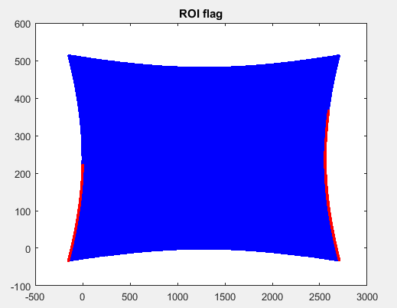

Bypass mode
In bypass mode the 12angles bits are mapped into the output 15/12bits using simple scale shift.
Scale is applied differently on X and Y, since X has 3 extra resolution bits:
- Both X and Y are added DIGGgengBypassShift
- X scale is set to 3-DIGGgengBypassScaleExp+2
- Y scale is set to 3-DIGGgengBypassScaleExp
- Both values goes converted with saturation to 15/12 bits

Range finder mode
In this mode, the Y value goes through as is, while the X coordiantes is passed through a LUT
Xout = RegsDIGGgengRangeFinderLUT[Xin]
HDR mode
 | long range sequence |  | short range sequence
 | nest period | gain setting |  | training sequence | depth sequence | backup | ldon deassert |  | gain setting |  | training sequence | depth sequence | backup | ldon deassert
ld_on | 0 | 0 |  | 1 | 1 | 1 | 0 |  | 0 |  | 1 | 1 | 1 | 0
PI loc x | 0 | 0 |  | 0 | 0 | 0 | 0 |  | 1 |  | 1 | 1 | 1 | 1
PI loc y | 0 | 1 |  | 2 | 3 | 4 | 5 |  | 5 |  | 4 | 3 | 2 | 1
LUT index | 0 | 1 |  | 2 | 3 | 4 | 5 |  | 21 |  | 20 | 19 | 18 | 17
Algo loc x | -1 | -1 |  | -1 | 0 | -1 | -1 |  | -1 |  | -1 | 1 | -1 | 2
Algo loc y | 0 | 0 |  | 0 | 0 | 0 | 0 |  | 0 |  | 0 | 0 | 0 | 0
Long range mode
 | long range sequence |  | short range sequence
 | nest period | gain setting |  | training sequence | depth sequence | backup | ldon deassert |  | gain setting |  | training sequence | depth sequence | backup | ldon deassert
ld_on | 0 | 0 |  | 1 | 1 | 1 | 0 |  | 0 |  | 1 | 1 | 1 | 0
PI loc x | 0 | 0 |  | 0 | 0 | 0 | 0 |  | 1 |  | 1 | 1 | 1 | 1
PI loc y | 0 | 1 |  | 2 | 3 | 4 | 5 |  | 5 |  | 4 | 3 | 2 | 1
LUT index | 0 | 1 |  | 2 | 3 | 4 | 5 |  | 21 |  | 20 | 19 | 18 | 17
Algo loc x | -1 | -1 |  | -1 | 0 | -1 | 2 |  | -1 |  | -1 | 0 | -1 | 2
Algo loc y | 0 | 0 |  | 0 | 0 | 0 | 0 |  | 0 |  | 0 | 0 | 0 | 0

Registers

Table 2: Registers
Name | Size | Default | Range | Special values/ description
Firmware
RegsFRMWgaurdBandH | 8 | 5 | [0-255] | %=X/255*100
RegsFRMWgaurdBandV | 8 | 2 | [0-255] | %=X/255*100
RegsFRMWprojectionYshear | 32 | 1.5 | [0-2]
RegsFRMWlaserangleH | 32 | 0
RegsFRMWlaserangleV | 32 | 0
General
RegsGNRLimgHsize | 12
RegsGNRLimgVsize | 11
RegsGNRLxoffset | 12
RegsGNRLyoffset | 11
RegsDIGGmarginLT | 32 | 0 | 2x[0-2^16-1] | Two concatenated 16bit unsigned
RegsDIGGmmarginRB | 32 | 0 | 2x[0-2^16-1] | Two concatenated 16bit unsigned
DIGG-IPTG
DIGGiptgBypass | 1 | 0
DIGGiptgDepthOffset | 16 | 100
DIGGiptgFrameRate | 16 | 50
DIGGiptgnIRoff | 16 | 10
DIGGiptgnIRlow | 16 | 100
DIGGiptgnIRhi | 16 | 1000
DIGGiptgNpPackets | 32 |  |  | autogen
DIGGiptgPktsPerCB | 32 |  |  | autogen
DIGGiptgPktsPerScanLine | 32 |  |  | autogen
DIGGiptgPktsPerScanBlock | 32 |  |  | autogen
DIGGiptgAngxNpackets | 32 |  |  | autogen
DIGGiptgAngxDelta | 32 |  |  | autogen
DIGGiptgAngyNpackets | 32 |  |  | autogen
DIGGiptgAngyDelta | 32 |  |  | autogen
DIGG-notch filters
RegsFRMWnumNotches | 8 | 4 | 0-16
RegsDIGGnotch1A | 32 | 0 | 0-2^32-1 | [a1 a2]
RegsDIGGnotch1B | 32 | 0 | 0-2^32-1 | [b0 b1]
RegsDIGGnotch2A | 32 | 0 | 0-2^32-1
RegsDIGGnotch2B | 32 | 0 | 0-2^32-1
RegsDIGGnotch3A | 32 | 0 | 0-2^32-1
RegsDIGGnotch3B | 32 | 0 | 0-2^32-1
RegsDIGGnotch4A | 32 | 0 | 0-2^32-1
RegsDIGGnotch4B | 32 | 0 | 0-2^32-1
RegsDIGGnotch5A | 32 | 0 | 0-2^32-1
RegsDIGGnotch5B | 32 | 0 | 0-2^32-1
RegsDIGGnotch6A | 32 | 0 | 0-2^32-1
RegsDIGGnotch6B | 32 | 0 | 0-2^32-1
RegsDIGGnotch7A | 32 | 0 | 0-2^32-1
RegsDIGGnotch7B | 32 | 0 | 0-2^32-1
RegsDIGGnotch8A | 32 | 0 | 0-2^32-1
RegsDIGGnotch8B | 32 | 0 | 0-2^32-1
RegsDIGGnotch9A | 32 | 0 | 0-2^32-1
RegsDIGGnotch9B | 32 | 0 | 0-2^32-1
RegsDIGGnotch10A | 32 | 0 | 0-2^32-1
RegsDIGGnotch10B | 32 | 0 | 0-2^32-1
RegsDIGGnotch11A | 32 | 0 | 0-2^32-1
RegsDIGGnotch11B | 32 | 0 | 0-2^32-1
RegsDIGGnotch12A | 32 | 0 | 0-2^32-1
RegsDIGGnotch12B | 32 | 0 | 0-2^32-1
RegsDIGGnotch13A | 32 | 0 | 0-2^32-1
RegsDIGGnotch13B | 32 | 0 | 0-2^32-1
RegsDIGGnotch14A | 32 | 0 | 0-2^32-1
RegsDIGGnotch14B | 32 | 0 | 0-2^32-1
RegsDIGGnotch15A | 32 | 0 | 0-2^32-1
RegsDIGGnotch15B | 32 | 0 | 0-2^32-1
RegsDIGGnotch16A | 32 | 0 | 0-2^32-1
RegsDIGGnotch16B | 32 | 0 | 0-2^32-1
DIGG-NEST
RegsDIGGnestNumOfSamplesExp | 4 | 8 | 2..10 | Exponent of the number of IR samples for noise estimation
RegsDIGGnestLdOnDelay | 8 | 25 | 0..255 | Delay in the number of chunk to start accumulating ambient IR values
RegsDIGGnestBypass | 1 | 0 | 0,1 | NEST bypass
DIGG-GENG-ang2xy
RegsDIGGangXfactor | 32
RegsDIGGangYfactor | 32
RegsDIGGnrmFovH | 32
RegsDIGGnrmFovV | 32
RegsDIGGverticalMirror | 1 | 0
RegsDIGGnx1 | 32
RegsDIGGnx2 | 32
RegsDIGGnx3 | 32
RegsDIGGnx4 | 32
RegsDIGGnx5 | 32
RegsDIGGnx6 | 32
RegsDIGGdx2 | 32
RegsDIGGdx3 | 32
RegsDIGGdx5 | 32
RegsDIGGny1 | 32
RegsDIGGny2 | 32
RegsDIGGny3 | 32
RegsDIGGny4 | 32
RegsDIGGny5 | 32
RegsDIGGny6 | 32
RegsDIGGdy2 | 32
RegsDIGGdy3 | 32
RegsDIGGdy5 | 32
RegsDIGGYcrossThr | 8 | 1 | 0-255 | degrees
DIGG-GENG-undist
RegsDIGGbitshift | 8 | 15 | 0-255
RegsDIGGundistFx | 32 | 0 | 0-2^32-1
RegsDIGGundistFy | 32 | 0 | 0-2^32-1
RegsDIGGundistBypass | 1 | 1 | 0-1
RegsDIGGundistX0 | 32 | 0 | -2^31-2^31-1
RegsDIGGundistY0 | 32 | 0 | -2^31-2^31-1
RegsDIGGxShiftIn | 32 | 0 | -2^31-2^31-1
RegsDIGGyShiftIn | 32 | 0 | -2^31-2^31-1
RegsDIGGxScaleIn | 32 | 1*2^ RegsDIGGbitshift | -2^31-2^31-1
RegsDIGGyScaleIn | 32 | 1*2^ RegsDIGGbitshift | -2^31-2^31-1
RegsDIGGxShiftOut | 32 | 0 | -2^31-2^31-1
RegsDIGGyShiftOut | 32 | 0 | -2^31-2^31-1
RegsDIGGxScaleOut | 32 | 1*2^ RegsDIGGbitshift | -2^31-2^31-1
RegsDIGGyScaleOut | 32 | 1*2^ RegsDIGGbitshift | -2^31-2^31-1
DIGG gamma
regsDIGGgammaBypass | 1 | 0 | {0;1} | bypass
regsDIGGgammaScale[0:15] | 16 | 0x0400 | [(-2^15-1)-(2^15-1)] | $a_{1}$ in GAMMA calculation.
regsDIGGgammaScale[16:31] | 16 | 0x0400 | [(-2^15-1)-(2^15-1)] | $a_{2}$ in GAMMA calculation.
regsDIGGgammaShift[0:15] | 16 | 0x0000 | [0-(2^16-1)] | $b_{1}$ in GAMMA calculation
regsDIGGgammaShift[16:31] | 16 | 0x0000 | [0-(2^16-1)] | $b_{2}$ in GAMMA calculation
regsDIGGgamma_000  …  regsDIGGgamma_032 | 12 | 0x000 | [0-2^12-1] | Gamma LUT

Test plan

General randomization
The general test randomization distribution.
Table 5: General randomization distribution
Name | Value | Distribution
DIGG-notch filters
RegsFRMWnumNotches | 0 | 10%
 | 4 | 30%
 | 8 | 30%
 | 16 | 30%
RegsDIGGnotch1A | 0-2^32-1 | 100%
RegsDIGGnotch1B | 0-2^32-1 | 100%
RegsDIGGnotch2A | 0-2^32-1 | 100%
RegsDIGGnotch2B | 0-2^32-1 | 100%
RegsDIGGnotch3A | 0-2^32-1 | 100%
RegsDIGGnotch3B | 0-2^32-1 | 100%
RegsDIGGnotch4A | 0-2^32-1 | 100%
RegsDIGGnotch4B | 0-2^32-1 | 100%
RegsDIGGnotch5A | 0-2^32-1 | 100%
RegsDIGGnotch5B | 0-2^32-1 | 100%
RegsDIGGnotch6A | 0-2^32-1 | 100%
RegsDIGGnotch6B | 0-2^32-1 | 100%
RegsDIGGnotch7A | 0-2^32-1 | 100%
RegsDIGGnotch7B | 0-2^32-1 | 100%
RegsDIGGnotch8A | 0-2^32-1 | 100%
RegsDIGGnotch8B | 0-2^32-1 | 100%
RegsDIGGnotch9A | 0-2^32-1 | 100%
RegsDIGGnotch9B | 0-2^32-1 | 100%
RegsDIGGnotch10A | 0-2^32-1 | 100%
RegsDIGGnotch10B | 0-2^32-1 | 100%
RegsDIGGnotch11A | 0-2^32-1 | 100%
RegsDIGGnotch11B | 0-2^32-1 | 100%
RegsDIGGnotch12A | 0-2^32-1 | 100%
RegsDIGGnotch12B | 0-2^32-1 | 100%
RegsDIGGnotch13A | 0-2^32-1 | 100%
RegsDIGGnotch13B | 0-2^32-1 | 100%
RegsDIGGnotch14A | 0-2^32-1 | 100%
RegsDIGGnotch14B | 0-2^32-1 | 100%
RegsDIGGnotch15A | 0-2^32-1 | 100%
RegsDIGGnotch15B | 0-2^32-1 | 100%
RegsDIGGnotch16A | 0-2^32-1 | 100%
RegsDIGGnotch16B | 0-2^32-1 | 100%
DIGG-NEST
RegsDIGGNestNumOfSamplesExp | 2-4 | 50%
 | 5,6 | 30%
 | 7,8 | 20%
RegsDIGGNestLdOnDelay | 20-220 | 80%
 | 0-19 | 10%
 | 221-255 | 10%
DIGG-GENG-ang2xy
RegsDIGGangXfactor |  | FW
RegsDIGGangYfactor |  | FW
RegsDIGGnrmFovH
RegsDIGGnrmFovV
RegsDIGGverticalMirror
RegsDIGGnx1
RegsDIGGnx2
RegsDIGGnx3
RegsDIGGnx4
RegsDIGGnx5
RegsDIGGnx6
RegsDIGGdx2
RegsDIGGdx3
RegsDIGGdx5
RegsDIGGny1
RegsDIGGny2
RegsDIGGny3
RegsDIGGny4
RegsDIGGny5
RegsDIGGny6
RegsDIGGdy2
RegsDIGGdy3
RegsDIGGdy5
RegsDIGGYcrossThr | 0-255 | 100%
DIGG-GENG-undist
RegsDIGGbitshift | 0-255 | 100%
RegsDIGGundistFx | 0-2^32-1
RegsDIGGundistFy | 0-2^32-1
RegsDIGGundistBypass | 0 | 50%
 | 1 | 50%
DIGG gamma
regsDIGGgammaScale[0:15] | -2^15-2 - -3000 | 15%
 | -4096 – 4096 | 70%
 | 4096-2^15-1 | 15%
regsDIGGgammaScale[16:31] | -2^15-2 - -3000 | 15%
 | -4096 – 4096 | 70%
 | 4096-2^15-1 | 15%
regsDIGGgammaShift[0:15] | -2^15-2 - -3000 | 15%
 | -4096 – 4096 | 70%
 | 4096-2^15-1 | 15%
regsDIGGgammaShift[16:31] | -2^15-2 - -3000 | 15%
 | -4096 – 4096 | 70%
 | 4096-2^15-1 | 15%

Constraints

