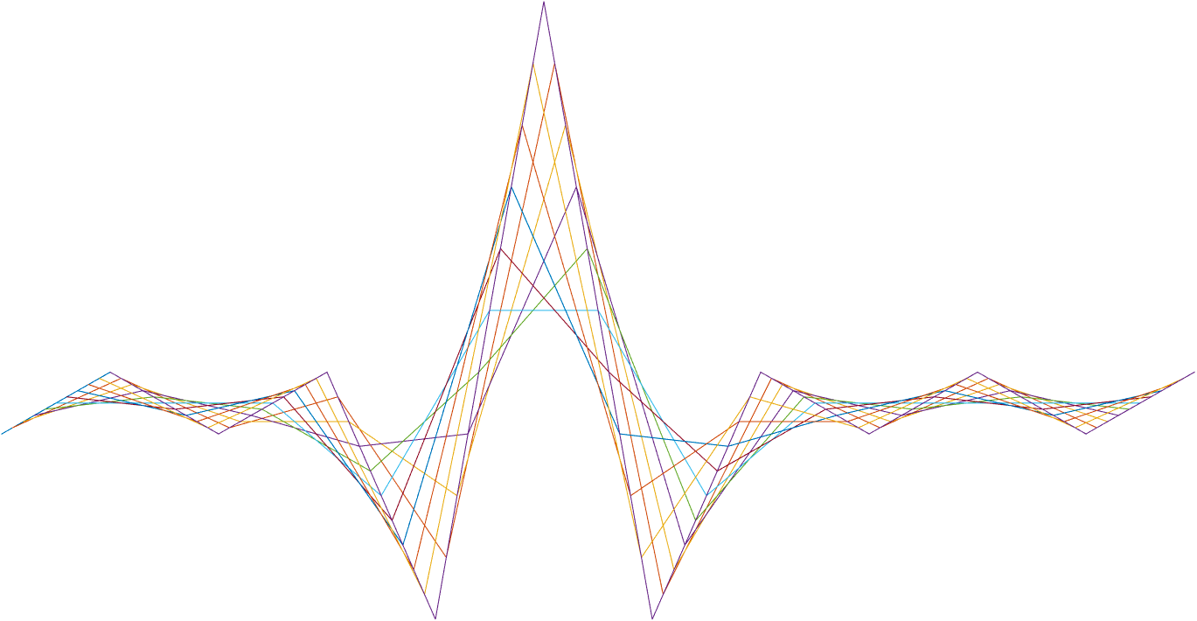

ASIC A0 EPTG specification

23 March 2017

Revision 0.1.0

Intel Top Secret

Table 1: Revision history
Matlab Version | Revision Number | Revised by | Description | Revision Date
2016B | 0.1.0 | Yoni Chechik | Initial version | March 23, 2017

Contents
1 Introduction 3
2 Interfaces 4
3 Detailed description 5
4 Registers 6
5 Memory 8
6 Performance 9
7 Test plan 10
7.1 General randomization 10
8 Constraints 12

Tables
Table 1: Revision history 1
Table 2: Registers 7

Introduction
EPTG stands for ‘external pattern generator’ and it’s a class of registers (not an actual block) designed to simulate different inputs to the ASIC pipe.
The registers configure different parts of the input in the Pipe.patternGenerator function and builds *.ivs + config.csv + calib.csv files that can later be used in the pipe itself.

Interfaces
NA

Detailed description
NA

Registers

Name | Size | Default | Range | Special values/ description
EPTGseed | 1 | 1 | 0:2^32-1 | Seed to control randomness (e.g. added noise) so results could be duplicate
EPTGzImageType | 1 | 2 | 1:5 | Generate z image to scan:  - Plane in height EPTGmaxZ  - 16 cubes with face perpendicular to plane  3:5- faces not perpendicular to plane
EPTGmaxZ | 1 | 3000 | 0.0:8000.0 | Max distance of z image
EPTGminZ | 1 | 500 | 1.0:4000.0 | min distance of z image
EPTGnoiseLevel | 1 | 0.4 | 0.0:10.0 | Amount of system noise. assuming max rx signal = 1 (distance 0)
EPTGframeRate | 1 | 60 | [2.0:66.0]; [100.0:140.0]; 1000.0 | pattern generator output frame rate (1000 value for debug only)
EPTGmirrorFastFreq | 1 | 2000 | 18000.0:22000.0 | mirror fast frequency
EPTGslowscanType | 1 | 2 | 0:2 | Type of scan in slow axis:  - Linear  - Sine  - atan
EPTGirImageType | 1 | 3 | 1:3 | Generate IR image to scan:  - Wall  - Checkerboard  - Random cubes
EPTGmultiFocalROI_00[0:4] | 1 | 0.0 | -2048.0:2047.0 | ---
EPTGnMaxSamples | 1 | 1600000000 | 1000000.0:16000000000.0 | Max number of scanned data points (number of fast channel samples). The actual number of samples will be the minimum between this register and EPTG.frameRate*1e9*chunkFreq  When chunkFreq is  double(regs.GNRL.sampleRate)/(64*double(regs.MTLB.txSymbolLength))
EPTGslowCouplingFactor | 1 | 0 | 0.0:0.002 | Coupling percentage to fast axis: x axis will be change as a function of the fast frequency for values larger than 0.
EPTGsampleJitter | 1 | 0.1 | 0.0:1.0 | fast path sampling jitter rms(nsec)
EPTGinputAsRange | 1 | 0 | 0:1 | set input as range
EPTGldonFallIncidents | 1 | 0 | 0:4 | number of times ld_on falls during frame
EPTGldonmaxFallTime | 1 | 5000 | 0:100000 | max fall time in nsec
EPTGirSampleFreq | 1 | 125 | 62.5;125.0 | ir(slow channel) sample frequency [Mhz]
Table 2: Registers

Memory
NA

Performance
NA

Test plan

General randomization
Table 3 describes the general test randomization distribution.
Name | Value | Distribution
Table 6: General randomization distribution
TBD

Constraints

- [EPTGminZ] <=[EPTGmaxZ]
- [EPTGminZ] >=0
- [EPTGnMaxSamples] == floor([EPTGnMaxSamples])

