IVCAM2.0 3D Imaging Camera
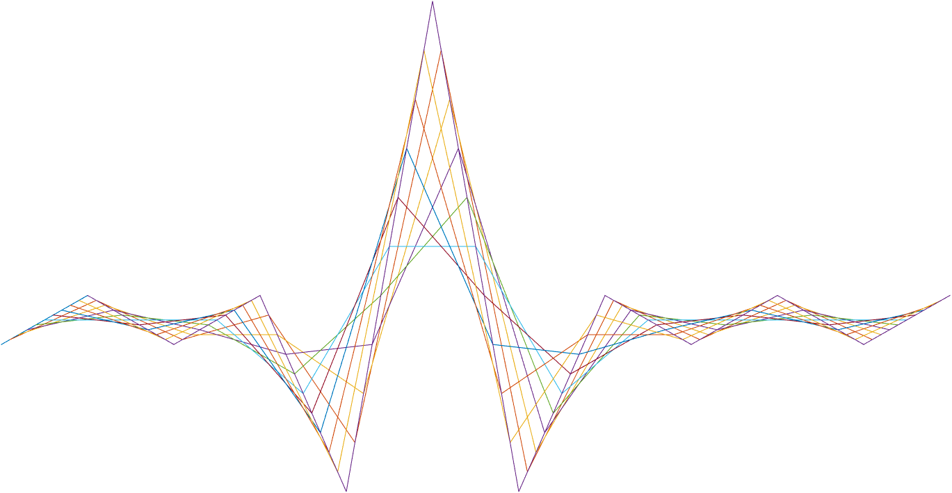

ASIC A0 STT specification

5 October 2016

Revision 0.5.0

Intel Top Secret

Table 1: Revision history
Matlab Version | Revision Number | Revised by | Description | Revision Date
2016A | 0.3.0 | Aviad Zabatani | Initial version | June 13, 2016
2016A | 0.5.0 | Aviad Zabatani | Change icon size, add integral image | August 8, 2016
0.6.37 |  | Omer Sella | - Changed register names (from En to bypass)  - Added explanation on integral image double buffer.  - Added test plan
0.7.39 |  | Omer Sella | Corrected register names.
0.8.54 | 0.5.2 | Aviad Zabatani | - add constraints  - change cell size register size  - fix test plan | December 27, 2016

Contents
1 Introduction 3
2 Interfaces 4
2.1.1 Input (Per Engine) 4
2.1.2 Output (Per Engine) 4
3 Detailed description 5
3.1 Changes compared to IVCAM 1.5 STAT 5
4 Appendix A: Stuff that goes in the appendix 6
5 Registers 7
6 Memory 9
7 Performance 10
8 Test plan 11

Tables
Table 1: Revision history 1
Table 2: Registers 7

Introduction
This document assumes knowledge of IVCAM 1.5 STAT, and will mostly describe the changes applied to the STAT compared to the IVCAM 1.5 STAT. please refer to IVCAM 1.5 STAT MAS\HAS documentation for further details.

The STAT Block is responsible to calculate statistics of the data received from the following four sources:
- Depth.
- IR.
- CAM A.
- CAM B.

Two types of statistics are generated:
- Histogram of spatial statistics – counting the number of occurrences, of each pixel values within the incoming frame.
- Histogram of temporal statistics - counting the number of occurrences, of the difference between the pixel values for the incoming and the previous frames.

In addition an integral image may be written to the memory using a double buffer and alternate writing.

The data can either be the pixels value or the validity of the pixels.

The STAT is based on the IVCAM 1.5 STAT block, with several modification, including duplication of the engine to 2 overall engines that works concurrently and independently (STT1, STT2), enlarging the icon size, receiving the data transposed compared to the data received in IVCAM 1.5, and several minor modification enlisted in this document.
Figure 1: Block diagram of a single STAT engine

Interfaces

Input (Per Engine)
The input can be received from the following 3 options
- Depth: 16 bit data + 1 bit valid
- IR: 12 bit data + 1 bit valid
- RGB: 8 bit data
For each of the above options, there is a second selector that can be controlled internally in the block they are coming from, e.g. the depth can be before filters, after filters, etc.

Output (Per Engine)
There is no output from the STAT that goes to other blocks. There is however DMA interface that allows the controller to read the following from each STAT engine:
- 4 icon images
- 4 spatial histogram memory
- 4 temporal histogram memory
- 1 integral image (using a double buffer).

Detailed description

Changes compared to IVCAM 1.5 STAT
- 2 independent stat engines that get inputs from the depth IR and RGB
- Icon size is increased to 160x160, which requires the following modifications:
  - Histogram cell size is increased to allow values of up to 25600 (160x160)
  - Maximum values for the following registers:
    - LeftUp\RightDownY* - 160
    - LeftUp\RightDownX* - 160
- Each stat work on just one image per output frame. No sequence handling.
- Add vertical margin: start the icon sampling form a configurable row and not row 0.
- Add validity bit to the IR icon generation
- Interfaces:
- depth size 16 bit + validity 1 bit
- IR size 12\8 bit + validity 1 bit
- CAM A - ??
- CAM B - ??
- Modification to the Registers:
  - Multiply by 2, rename from RegsStt to RegsSTT1, RegsSTT2 in order to accommodate the 2 stat engine
  - Removed RegsSttPatMaskVec
  - Renamed RegsSttRUVMotInvCntEn to RegsSttRInvCntEn
  - Renamed RegsSttRzScaleMode to RegsSttScaleMode
  - RegsSttSrc has different meaning:
0 – depth
1 – IR
2 – CAM A
3 – CAM B
  - Add STTSkipVsize for implementation of vertical margin
- Secondary source (RegsSttAlgSecSrc) will choose the secondary source according to the main source inside the JFIL block. Full definition will be given with the JFIL block.
- Invalid bit will be determine using a bit mask on the image value and the flags. Full definition will be given with the JFIL block.

Integral image
An integral can be calculated from the current icon and saved to memory (in addition to the icon itself). The integral image is calculated using the following formula:
$$Integ\left(x,y\right)=\sum_{\begin{aligned}i=0:x \\ j=0:y\end{aligned}}{I(i,j)}$$
This is equivalent to:
$$Integ\left(x,y\right)=Integ\left(x-1,y\right)+Integ\left(x,y-1\right)-Integ\left(x-1,y-1\right)+I(x,y)$$

Thus, for each pixel in the integral images, it is enough to look at its 3 neighbors and the corresponding pixel in the icon image to determine its value.

Registers

Name | Size | Default | Range | Special values/ description
STATstt*Bypass | 1 | 0 | 0-1 | Enable Statistics block
STATstt *Src | 2 | 0 | 0-3 | Selects the source of the block 0-depth 1-IR 2-CAM A 3-CAM B
STATstt *CellVsize | 4 | 8 | 1-8 | Icon pixel vertical size (in image pixels)
STATstt *CellHsize | 4 | 8 | 1-8 | Icon pixel horizontal size (in image pixels)
STATstt *ScaleMode | 4 | 0 | 0-8 | Choose input bits in depth\IR input mode
STATstt *SkipHsize | 11 | 0 | 0-1919 | Horizontal margins,  left=right=SkipHsize/2
STATstt *SkipVsize | 11 | 0 | 0-1919 | Vertical margins,  up=SkipVsize, down drives form the sampling rate and the image size
STATstt *NormMult | 10 | 1 | 0-1023 | Multiplier before divide factor for CAM A\B mode
STATstt *LinearReference | 1 | 1 | 0-1 | 0 – Linear Mode. 1 – Reference Mode.
STATstt *LowThrPxlNum | 7 | 20 | 0-64 | The minimal number of valid pixels in a cell. If lower – the icon pixel is invalidated by setting to 0xFF. Depth\IR mode only.
STATstt *InvCntBypass | 1 | 1 | 0-1 | 0-Don’t Count.
STATstt *InvalOrPxl | 1 | 0 | 0-1 | 0- The Statistics is generated over the binned frame of pixels.1- The Statistics is generated over the number of valid pixels acquired per cell.
STATstt *LowerThr | 16 | 0 | 0-65535 | Each pixel that carries 16b Depth\IR value that is beyond or below two configurable values is ignored. The rest of the calculation is similar to the "invalid pixel" scheme.
STATstt *UpperThr | 16 | 0xffff | 0-65535
STATstt *IconCellCoord** | 8 | N/A | Each byte 0-159 | Left Up X Y Right Down X Y coordinates (0…11) of the icon cell.
STATstt *IntegralImageBypass | 1 | 0 | 0-1 | Enable\disable integral image calculation for the current icon. 1 Means bypass, 0 means enable.
STATstt *tCamOutFormat | 8 | 0 | 0,1,2,3,4,7 | 0 – RGB555 / RGB565  1 – RGB 888  2/3 – YUV422  4,7 – RAW10
* - [1-2]: duplicate for STT1\STT2
** - [0-11]: duplicate for 12 regions
Table 2: Registers

Memory

- 4 icon images, 160x160x8 bit each
- 4 spatial histogram memory, 12x256x15 bit each
- 4 temporal histogram memory, 12x256x15 bit each
- 2 integral images (due to double buffer), 160X160X23 bit each.

Performance

Test plan

General randomization
Table 3 describes the general test randomization distribution.
Name | Value | Distribution
STATstt *Bypass | 0 | 95%
STATstt *Bypass | 1 | 5%
STATstt *Src | 0 | 45%
STATstt *Src | 1 | 45%
STATstt *Src | 2 | 5%
STATstt *Src | 3 | 5%
STATstt *CellVsize | 1-5 | 20%
STATstt *CellVsize | 6-8 | 80%
STATstt *CellHsize | 1-5 | 20%
STATstt *CellHsize | 6-8 | 80%
STATstt *ScaleMode | 0-4 | 80%
STATstt *ScaleMode | 5-8 | 20%
STATstt *SkipHsize | 0-20 | 50%
STATstt *SkipHsize | 21-1920 | 50%
STATstt *SkipVsize | 0-20 | 50%
STATstt *SkipVsize | 21-1920 | 50%
STATstt *NormMult | 0-32 | 25%
STATstt *NormMult | 33-1023 | 75%
STATstt *LinearReference | 0 | 50%
STATstt *LinearReference | 1 | 50%
STATstt *LowThrPxlNum | 0-19 | 25%
STATstt *LowThrPxlNum | 20 | 25%
STATstt *LowThrPxlNum | 21-63 | 50%
STATstt *InvCntBypass | 0 | 50%
STATstt *InvCntBypass | 1 | 50%
STATstt *InvalOrPxl | 0 | 50%
STATstt *InvalOrPxl | 1 | 50%
STATstt *LowerThr | 0 – 300  301 – 1000  1001 – 40000  40001 - 65535 | 50%
STATstt *LowerThr | 0 – 300  301 – 1000  1001 – 40000  40001 - 65535 | 35%
STATstt *LowerThr | 0 – 300  301 – 1000  1001 – 40000  40001 - 65535 | 10%
STATstt *LowerThr | 0 – 300  301 – 1000  1001 – 40000  40001 - 65535 | 5%
STATstt *UpperThr | 0 – 1000 | 5%
STATstt *UpperThr | 1001 - 3000 | 25%
STATstt *UpperThr | 1001 - 40000 | 25%
STATstt *UpperThr | 41000 - 65535 | 45%
STATstt *IconCellCoord** | Left Up X Y Right Down X Y coordinates (0…11) of the icon cell. | 100%
STATstt *IntegralImageBypass | 0 | 50%
 | 1 | 50%
STATstt *tCamOutFormat | 0,1,2,3,4,7 | 100%
Table 6: General randomization distribution

Constraints

- STATstt *SkipHsize and STATstt *SkipVsize should be smaller than the input image resolution.
- IconCellCoord: Left up x/y must be smaller than right down x/y respectively
- STATstt *LowerThr must be smaller than STATstt *UpperThr

