IVCAM2.0 3D Imaging Camera

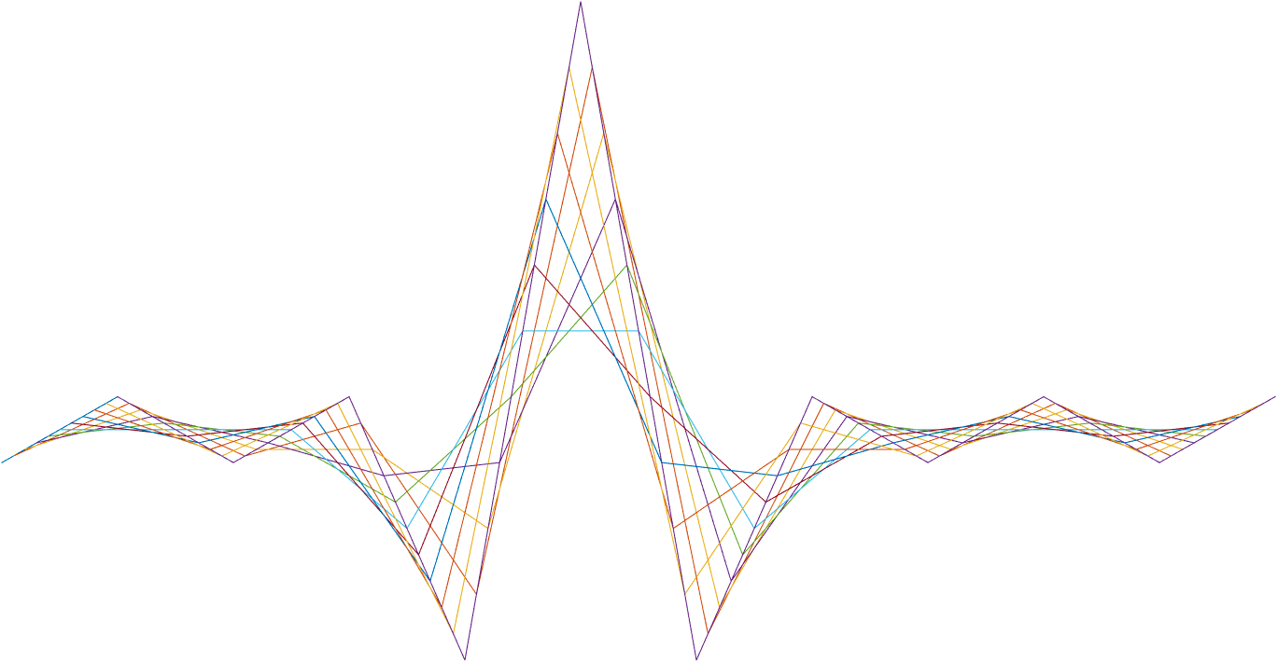

ASIC A0 JFIL Gradient filter specification

20 February 2017

Revision 0.6.0

Intel Top Secret

Table 1: Revision history

|  |  |  |  |  |
| --- | --- | --- | --- | --- |
| Matlab Version | Revision Number | Revised by | Description | Revision Date |
| 2016a | 0.5.0 | Vitaly Surazhsky | Initial release | July 6, 2016 |
| 2016a | 0.5.1 | Vitaly Surazhsky | Fixed bug in estimations of minima | August 18, 2016 |
| 2016a | 0.6.0 | Vitaly Surazhsky | Invalidation of depth remove, test plan added | September 26, 2016 |
|  | 0.6.1 | Yoni Chechik | RegsJFILgrad1NNBypass depreceted | 10.11.16 |
| 0.91 | 0.91 | Vitaly Surazhsky | Fixed bud is estimation of minima (bit 4 and 5) | February 20, 2017 |

Contents

1 Introduction 3

2 Interfaces 4

2.1.1 Input 4

2.1.2 Output 4

3 Detailed description 5

3.1 Gradient filter 5

3.1.1 Thresholds 6

4 Memories and computations 7

5 Registers 8

6 Test plan 10

Tables

Table 1: Revision history 1

Table 2: LUTs 7

Table 3: Registers 8

Introduction

The Gradient filter invalidates pixels by detecting strong depth gradients and spikes, and by estimating deviation of the pixel depth from the average depth of its neighboring pixels. The filter operates on the pixels of the 3x3 window around every pixel. JFIL block consists of two exactly the same Gradient filters. One is close to the beginning of the JFIL pipe, and the second is close to the end of the pipe. See the general JFIL doc.

Interfaces

Input

1. depth: 16-bit of depth data
2. IR: 12-bit of IR data
3. conf: 4-bits of confidence
4. flags: 4-bit of flags

Output

1. depth: 16-bit of depth data
2. IR: 12-bit of IR data
3. conf: 4-bits of confidence
4. flags: 4-bit of flags

Detailed description

Gradient filter

The filter detects gradients by performing a series of various depth-based computations and comparing the resulting values against the corresponding thresholds. If at least one of the comparisons is successful, a gradient is detected and depending on register configuration, an invalidation of the pixel occurs.

Register naming convention: ‘X’ after ‘Grad’ in the name of the register denotes the number gradient block that can be either 1 or 2. For example, RegsJFILgrad2ConfUpdVal is the register of the 2nd gradient filter block. All the thresholds in depth DN of the form GradXThrXX are computed from their corresponding register value in mm. The thresholds computations are defined in Section ‎3.1.1.

The output confidence is set to RegsJFILgradXConfUpdVal.

We denotes the depth values of the pixel neighbors as follows:

|  |  |  |
| --- | --- | --- |
| d0 | d1 | d2 |
| d3 | d | d5 |
| d6 | d7 | d8 |

The neighboring pixel weight *wi* is a binary value, which is set to 1, when the confidence of the neighboring pixel is greater or equal to RegsJFILgradXConfLevel.

The various threshold comparisons are controlled by 10-bit register RegsJFILgradXMask and defined in the table below. *Dmax* is equal to 2^16 – 1.

|  |  |
| --- | --- |
| RegsJFILgradXMask | Computation of *thresholds* GradXThrXX |
| Bit 0 is set | |d3 – d|*w3+ |d5 – d|*w5 > (w3 + w5) * *GradXThrAveDx* |
| Bit 1 is set | |d1 – d|*w1+ |d7 – d|*w7 > (w1 + w7) * *GradXThrAveDy* |
| Bit 2 is set | |d0 – d|*w0+ |d8 – d|*w8 > (w0 + w8) * *GradXThrAveDiag* || |d2 – d|*w2+ |d6 – d|*w6 > (w2 + w6) * *GradXThrAveDiag* |
| Bit 3 is set | (*Dmax* – max((*Dmax* –|d3-d|)*w3, (*Dmax* –|d5-d|)*w5))*(w3 | w5) > *GradXThrMinDx* |
| Bit 4 is set | (*Dmax* – max((*Dmax* –|d1-d|)*w1, (*Dmax* –|d7-d|)*w7)) *(w1 | w7) > *GradXThrMinDy* |
| Bit 5 is set | (*Dmax* – max((*Dmax* –|d0-d|)*w0, (*Dmax* –|d2-d|)*w2,  (*Dmax* –|d6-d|)*w6, (*Dmax* –|d8-d|)*w8))*(w0 | w2 | w6 | w8) > *GradXThrMinDiag* |
| Bit 6 is set | max(|d3-d|*w3, |d5-d|*w5) > *GradXThrMaxDx* |
| Bit 7 is set | max(|d1-d|*w1, |d7-d|*w7) > *GradXThrMaxDy* |
| Bit 8 is set | max(|d0-d|)*w0, |d2-d|*w2, |d6-d|*w6, |d8-d|*w8) > *GradXThrMaxDiag* |
| Bit 9 is set |  |

Thresholds

All the thresholds GradXThrXX are adaptively computed for every pixel based on the corresponding 16-bit register RegsJFILgradXThrXX (e.g. RegsJFILgrad1ThrAveDx, RegsJFILgrad2ThrMinDiag), the central pixel confidence and its depth. There are 4 modes to compute GradXThrXX depending on RegsJFILgradXThrMode. The computation requires LUTJFILgradXThrFactor, which is a LUT of 6 bit to 6 bit.

|  |  |
| --- | --- |
| RegsJFILgrad1ThrMode | Computation of *thresholds* GradXThrXX |
| 0 | *bitshiftLeft*(RegsJFILgradXThrXX, RegsGNRLZMaxSubMMExp) |
| 1 | bitshiftRight(*bitshiftLeft*(RegsJFILgradXThrXX, RegsGNRLZMaxSubMMExp) * LUTJFILgradXThrFactor [(15-conf)*4], 6) |
| 2 | bitshiftRight(*bitshiftLeft*(RegsJFILgradXThrXX, RegsGNRLZMaxSubMMExp) * LUTJFILgradXThrFactor [bitshiftRight(depth,10)], 6) |
| 3 | bitshiftRight(*bitshiftLeft*(RegsJFILgradXThrXX, RegsGNRLZMaxSubMMExp) * LUTJFILgradXThrFactor [bitshiftRight(depth*(15-conf),14)], 6) |

Memories and computations

Every gradient filter block works on 3x3 pixel patches and thus requires 2 column buffers. The buffer includes all the depth, IR, confidence, flags data: 36-bit word

Memory size: (960*2+5) X 36 == 1925 X 36

Table 2: LUTs

|  |  |  |  |  |
| --- | --- | --- | --- | --- |
| Name | Entries | Entry size | Fixed | Description |
| LUTJFILgrad1ThrFactor LUTJFILgrad2ThrFactor | 2^6 | 6 | no | Adaptive factor for thresholds depending on depth and confidence |

Registers

Table 3: Registers

|  |  |  |  |  |
| --- | --- | --- | --- | --- |
| Name | Size | Default | Range | Special values/ description |
| General |  |  |  |  |
| RegsGNRLImgHsize | 12 | 640 | 1-1280 | Horizontal resolution |
| RegsGNRLImgVsize | 12 | 480 | 1-960 | Vertical resolution |
| RegsGNRLZMaxSubMMExp | 3 | 3 | 0..7 | Sub-mm precision exponent of the depth dynamic range |
| JFILBilt |  |  |  |  |
| RegsJFILgrad1ConfLevel  RegsJFILgrad2ConfLevel | 4 | 2 | 1-15 | Lowest confidence level which is considered valid by gradient filters |
| RegsJFILgrad1ThrMode  RegsJFILgrad2ThrMode | 2 | 0 | 0,1,2,3 | Adaptive mode:  0: not adaptive  1: confidence based  2: depth based  3: conf and depth based |
| RegsJFILgrad1ConfUpdVal  RegsJFILgrad2ConfUpdVal | 4 | 2 | 1-15 | Confidence level assigned to pixels with gradient |
| RegsJFILgrad1Mask  RegsJFILgrad2Mask | 10 | 0x3ff | 0..1023 | Mask to enable various gradient detections |
| RegsJFILgrad1ThrAveDx  RegsJFILgrad1ThrAveDy  RegsJFILgrad1ThrAveDiag  RegsJFILgrad1ThrMinDx  RegsJFILgrad1ThrMinDy  RegsJFILgrad1ThrMinDiag  RegsJFILgrad1ThrMaxDx  RegsJFILgrad1ThrMaxDy  RegsJFILgrad1ThrMaxDiag  RegsJFILgrad1ThrSpike  RegsJFILgrad2ThrAveDx  RegsJFILgrad2ThrAveDy  RegsJFILgrad2ThrAveDiag  RegsJFILgrad2ThrMinDx  RegsJFILgrad2ThrMinDy  RegsJFILgrad2ThrMinDiag  RegsJFILgrad2ThrMaxDx  RegsJFILgrad2ThrMaxDy  RegsJFILgrad2ThrMaxDiag  RegsJFILgrad2ThrSpike | 16 | 10 | 0-0xffff | Thresholds in mm |
| RegsJFILgrad1Bypass  RegsJFILgrad2Bypass | 1 | 0 | 0,1 | Bypass |

Test plan

|  |  |  |
| --- | --- | --- |
| **Name** | **Values** | **Distribution** |
| RegsJFILgrad1ThrMode  RegsJFILgrad2ThrMode | 0 | 20 |
| 1 | 25 |
| 2 | 25 |
| 3 | 30 |
| RegsJFILgrad1ConfLevel  RegsJFILgrad2ConfLevel | 1..2 | 5 |
| 3..5 | 40 |
| 6..11 | 30 |
| 2..15 | 25 |
| RegsJFILgrad1ConfUpdVal  RegsJFILgrad2ConfUpdVal | 1 | 40 |
| 2 | 30 |
| 3..5 | 20 |
| 6..15 | 10 |
| RegsJFILgrad1Mask RegsJFILgrad2Mask | 0..0x3fe | 60 |
| 0x3ff | 40 |
| RegsJFILgrad1ThrAveDx RegsJFILgrad1ThrAveDy RegsJFILgrad1ThrAveDiag RegsJFILgrad1ThrMinDx RegsJFILgrad1ThrMinDy RegsJFILgrad1ThrMinDiag RegsJFILgrad1ThrMaxDx RegsJFILgrad1ThrMaxDy RegsJFILgrad1ThrMaxDiag RegsJFILgrad1ThrSpike RegsJFILgrad2ThrAveDx RegsJFILgrad2ThrAveDy RegsJFILgrad2ThrAveDiag RegsJFILgrad2ThrMinDx RegsJFILgrad2ThrMinDy RegsJFILgrad2ThrMinDiag RegsJFILgrad2ThrMaxDx RegsJFILgrad2ThrMaxDy RegsJFILgrad2ThrMaxDiag RegsJFILgrad2ThrSpike | 0..3 | 5 |
| 4..15 | 25 |
| 16..63 | 30 |
| 64..255 | 25 |
| 256..2^16-1 | 15 |
| RegsJFILgrad1Bypass RegsJFILgrad2Bypass | 0 | 5 |
|