Polynomial Regression Assignment

Machine Learning (CS F464)

Name: Aangir Doshi
Roll Number: BT2024078
Assignment: Polynomial Regression – Phase 1 & Phase 2

1. Introduction
This report covers my work on the two polynomial regression problems assigned for this course. For each problem I had to build a model that predicts a continuous output y from the given input features, using only the training data provided. The goal was to pick the right polynomial degree and keep overfitting under control so the model generalises well to the test set.
The two problems are set in the context of a geothermal power plant project. The first one (var1) asks you to predict the Net Power Score of a steam turbine based on six operational parameters. The second one (var2) involves predicting a Thermal Anomaly Score at different 3D coordinates, which is used to find the best spots for drilling. Both datasets were individually generated per roll number, so the polynomial structure is unique to my data.

2. Looking at the Data
Before doing anything else I spent some time just looking at both datasets to understand what I was working with. A few things stood out immediately:
Both datasets were already clean — no missing values at all, and the input features were already normalised to lie in the range [-1, 1]. That was convenient because it meant I didn't have to worry about scaling before building polynomial features. Polynomial regression can go badly wrong if features are on very different scales, so having them pre-normalised saved a step.
The target variable y in var1 ranges from about -9.8 to +12 with a standard deviation of 3.2 and almost no skew (0.04), so the distribution is fairly symmetric. Var2 has a much wider range (-29.8 to +39.3, std = 7.3) and a mild positive skew of 0.65 — nothing dramatic enough to warrant any transformations, but worth noting.

 | Var1 (Steam Turbine) | Var2 (Thermal Reservoir)
Features | 6 (x1 to x6) | 3 (x1, x2, x3)
Training rows | 1000 | 1000
Test rows | 1000 | 1000
Feature range | [-1, 1] | [-1, 1]
y range | -9.80 to +11.99 | -29.82 to +39.30
y mean | 0.76 | 1.81
y std | 3.21 | 7.27
y skew | 0.04 | 0.65
Missing values | 0 | 0

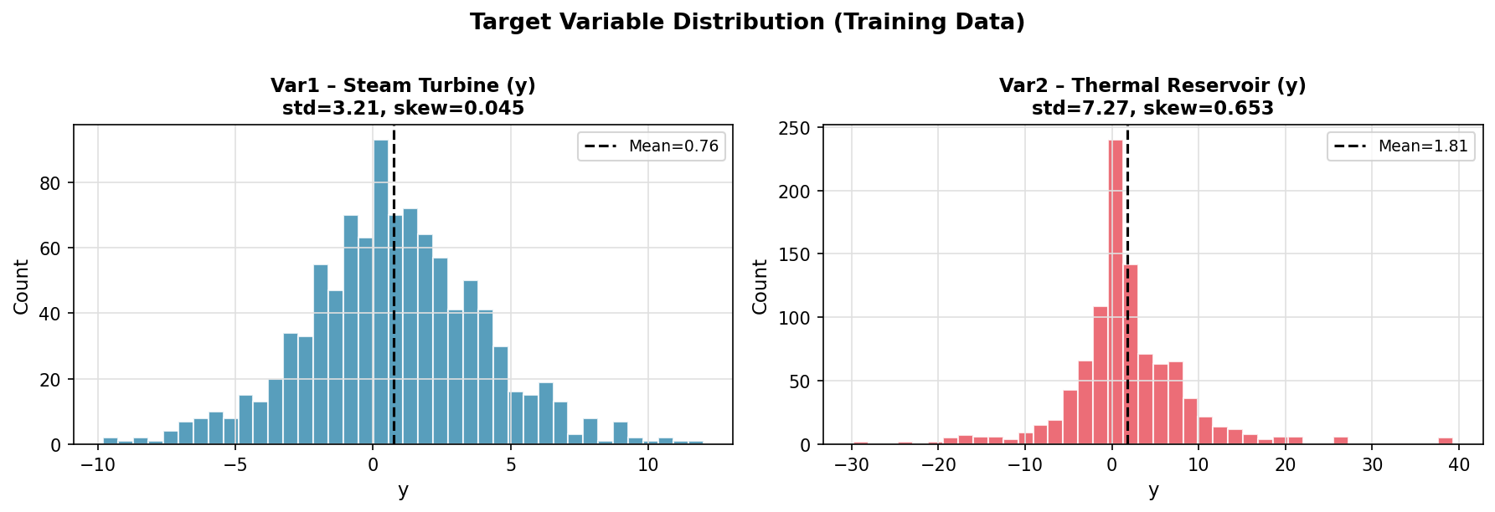
Figure 1. Distribution of y in both training sets.

3. Approach

3.1 Why polynomial regression with Ridge?
The assignment says to use polynomial regression, so the core idea is to take the original features and expand them into all possible products and powers up to some degree d — for example with two features x1 and x2 and degree 2 you'd get x1, x2, x1^2, x1*x2, and x2^2. Then you fit a linear model on top of these expanded features. I used sklearn's PolynomialFeatures for this.
The tricky part is that as the degree goes up, the number of features explodes fast. At degree 5 with 6 input features you already have 461 polynomial features for 1000 training samples. Plain linear regression (ordinary least squares) becomes unstable in this kind of situation — it tends to find extreme coefficients and overfit badly. So I used Ridge regression instead, which adds an L2 penalty on the coefficient magnitudes. This keeps things from going haywire and usually generalises much better.
I considered using Lasso as well, but decided against it. Polynomial features are inherently correlated with each other (e.g., x1^2 and x1*x1 are literally the same), and Lasso tends to behave unpredictably when features are strongly correlated. Ridge handles this more gracefully.

3.2 How I picked the degree and regularisation strength
There are two things to tune: the polynomial degree d, and the Ridge penalty strength alpha. I treated this as a two-dimensional search problem and used 5-fold cross-validation to evaluate each combination. The idea was to start broad and then zoom in.
First I ran a coarse grid search — for var1 I tried degrees 2 through 6, and for var2 degrees 4 through 13, each combined with 13 log-spaced alpha values spread from very small to very large. This gave me a rough sense of where the best region was. Then I did a much finer sweep of alpha values around the winner from the coarse search, and also checked whether neighbouring degrees (±1 for var1, ±2 for var2) did better at that alpha. Finally I ran sklearn's RidgeCV as an independent check — it has its own efficient built-in cross-validation for alpha selection — and I used whichever alpha gave the lower validation MSE.
Once I had the final (degree, alpha) pair, I retrained the model on the full 1000 training samples and generated predictions for the test set.

4. Degree Selection and Results

4.1 Var1 – Steam Turbine
For var1 the coarse search made it pretty clear that the data has a degree-5 structure. At lower degrees the model noticeably underfits — degree 2 barely gets an R2 of 0.69 and degree 3 sits around 0.91. Things improve steadily through degree 4 and 5. Degree 6 actually starts getting worse again despite having more features, which tells you the model is starting to overfit.
One thing that surprised me a bit: at a very low alpha, degree 5 actually performs worse than degree 4. But once you crank the regularisation up to around alpha = 2.5, degree 5 clearly wins. The 461 polynomial features need a fairly strong penalty to stay in check. The fine alpha sweep confirmed that the sweet spot is around 2.47.

Degree | Best alpha tried | CV MSE | CV R2 | No. of features
2 | 1.0 | 3.21 | 0.69 | 27
3 | 1.0 | 0.91 | 0.91 | 83
4 | 3.16 | 0.69 | 0.93 | 209
5 | 2.477 | 0.49 | 0.95 | 461
6 | 3.16 | 0.54 | 0.95 | 923

Final choice for var1: degree 5, alpha = 2.477.

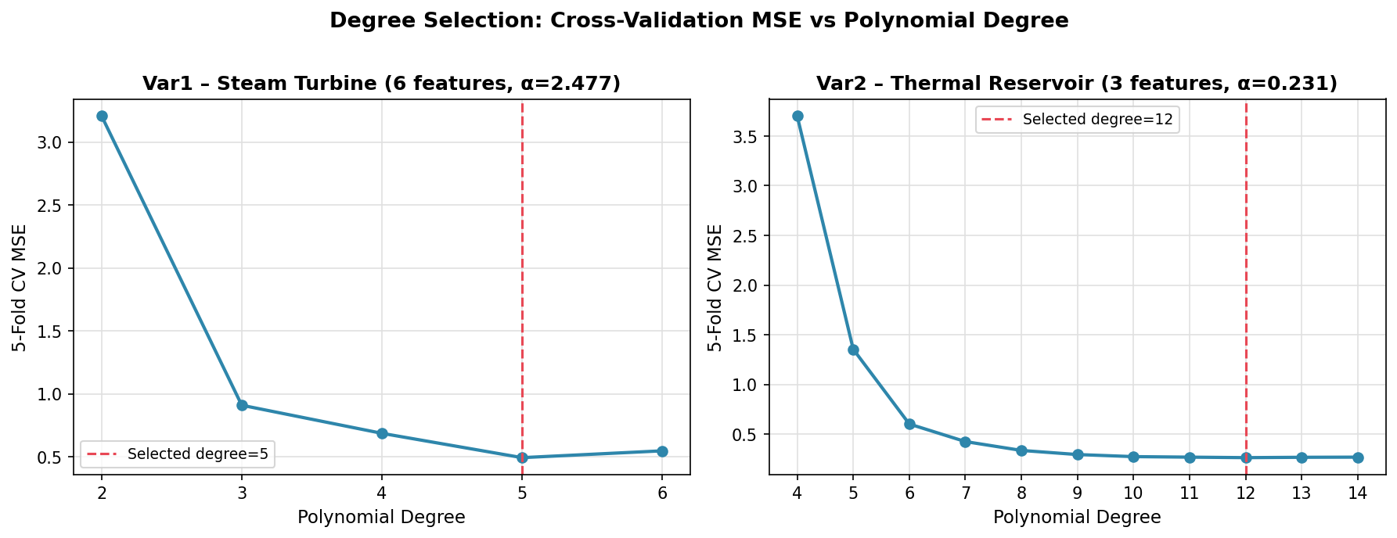
Figure 2. How CV MSE changes with polynomial degree for both problems. The dashed line marks the selected degree.
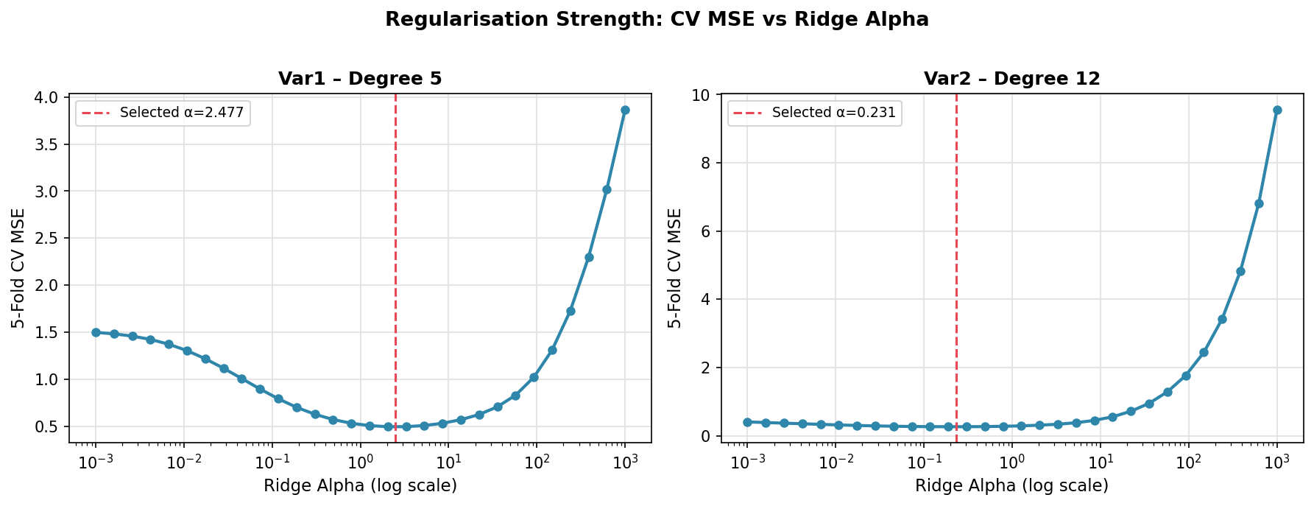
Figure 3. CV MSE as a function of Ridge alpha at the chosen degree. The dashed line marks the selected alpha.

4.2 Var2 – Thermal Reservoir
Var2 is different because there are only 3 input features, so polynomial features grow much slower. At degree 12 you still only have 454 features, which is very manageable. This meant I could go to much higher degrees without things blowing up.
The search showed a steady and clear improvement all the way from degree 4 up to degree 12. After that the validation MSE starts creeping back up, so degree 12 is where things peak. The R2 at degree 12 is 0.9949 which is really quite good — the model is capturing almost all the variance in the data. I also noticed that for this problem, the optimal alpha is much smaller (around 0.23) because the features are fewer and less redundant at each degree.

Degree | Best alpha tried | CV MSE | CV R2 | No. of features
7 | 0.01 | 0.33 | 0.994 | 120
8 | 0.01 | 0.28 | 0.994 | 165
9 | 0.01 | 0.27 | 0.995 | 220
10 | 0.10 | 0.27 | 0.995 | 286
11 | 0.10 | 0.27 | 0.995 | 364
12 | 0.231 | 0.26 | 0.995 | 454
13 | 0.316 | 0.27 | 0.995 | 559
14 | 0.316 | 0.27 | 0.995 | 680

Final choice for var2: degree 12, alpha = 0.231 (confirmed by RidgeCV).

5. Results

5.1 Cross-validation summary
Here is a quick summary of the final cross-validation numbers for both models:

Problem | Degree | Alpha | 5-fold CV MSE | 5-fold CV R2 | Poly features
Var1 (Steam Turbine) | 5 | 2.477 | 0.4925 | 0.9516 | 461
Var2 (Thermal Reservoir) | 12 | 0.231 | 0.2627 | 0.9949 | 454

5.2 Per-fold breakdown
To make sure the results were consistent and not just lucky on one particular split, here are the numbers across each of the 5 folds:

Fold | Var1 train MSE | Var1 val MSE | Var1 val R2 | Var2 train MSE | Var2 val MSE | Var2 val R2
1 | 0.185 | 0.452 | 0.953 | 0.170 | 0.249 | 0.994
2 | 0.187 | 0.433 | 0.950 | 0.165 | 0.291 | 0.995
3 | 0.196 | 0.447 | 0.965 | 0.169 | 0.269 | 0.996
4 | 0.180 | 0.620 | 0.944 | 0.172 | 0.227 | 0.996
5 | 0.189 | 0.510 | 0.946 | 0.167 | 0.278 | 0.995
Mean | 0.187 | 0.493 | 0.952 | 0.169 | 0.263 | 0.995

For var1, fold 4 gave a slightly higher validation MSE (0.62) compared to the others, but overall the results are pretty consistent across folds which suggests the model isn't just getting lucky on a particular data split. For var2 the results are very stable across all folds which is reassuring.
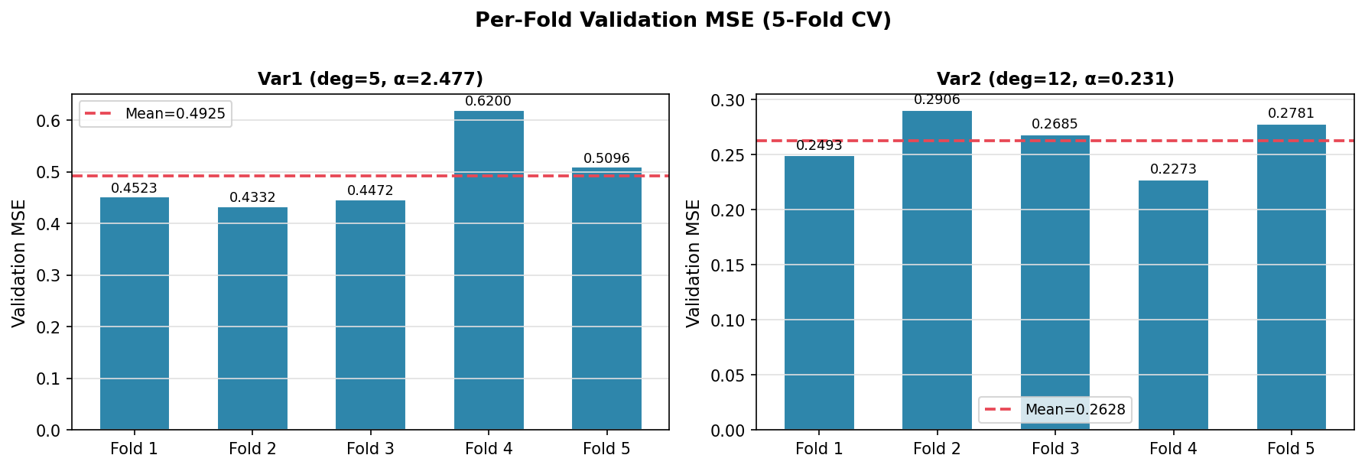
Figure 4. Validation MSE for each fold. The dashed line is the mean.

5.3 Fit on the full training data
After picking the hyperparameters through cross-validation, I refitted each model on the complete training set of 1000 samples and generated predictions for the test set.

Problem | Train MSE | Train R2
Var1 (Steam Turbine) | 0.1995 | 0.9807
Var2 (Thermal Reservoir) | 0.1745 | 0.9967

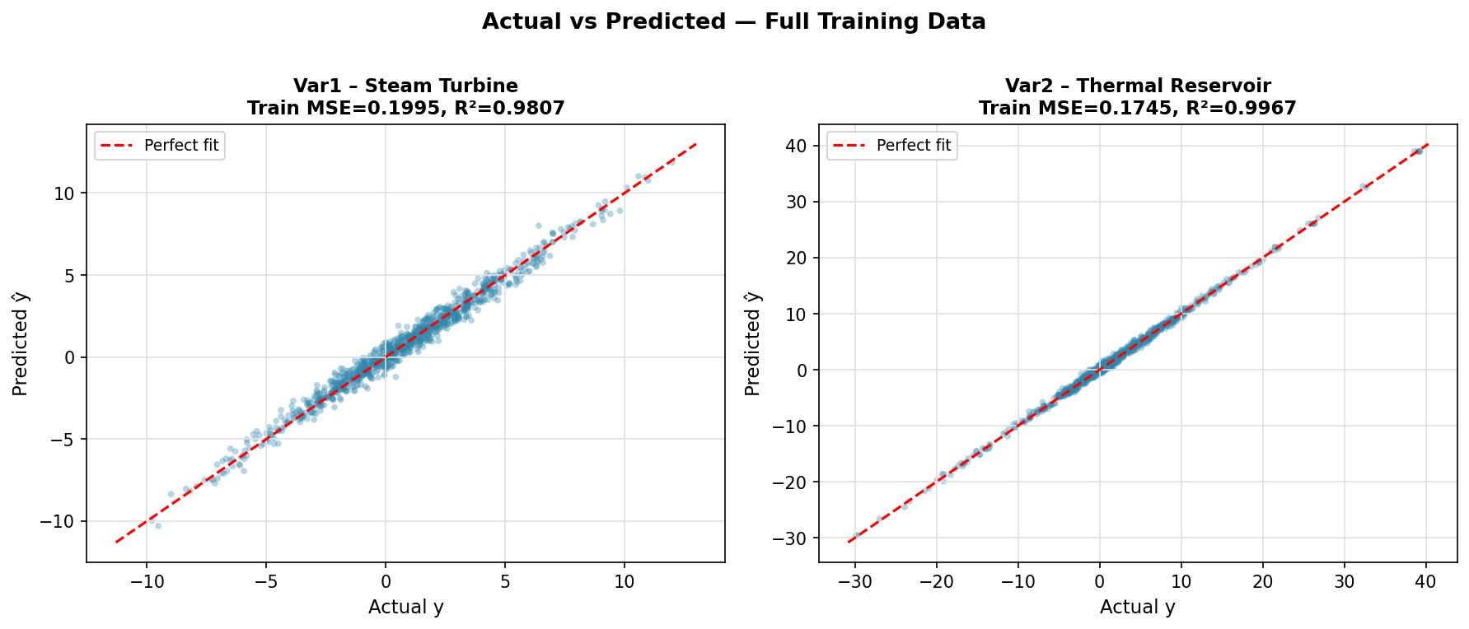
Figure 5. Actual vs predicted y on the full training set for both models. Points close to the diagonal line mean accurate predictions.
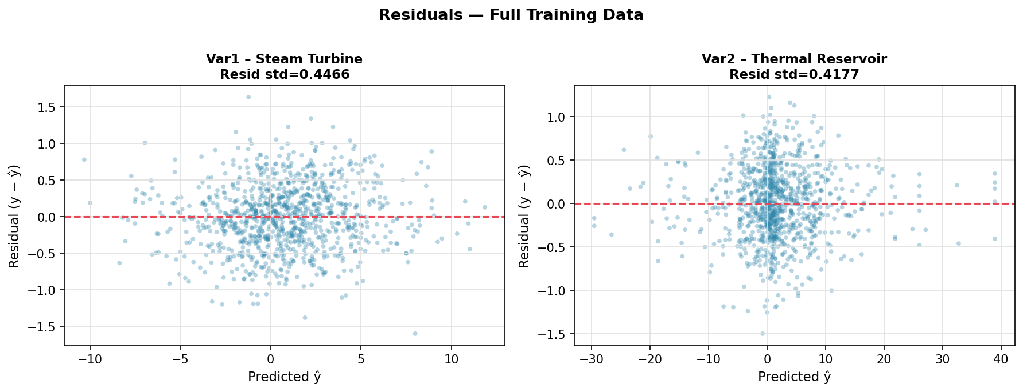
Figure 6. Residuals (actual minus predicted) plotted against predicted values. The spread looks roughly even with no obvious pattern, which is a good sign.
The train R2 for var1 is 0.98 and the validation R2 was 0.95, so there is a small gap but nothing alarming — it just means the model fits training data a little better than unseen data, which is completely normal. For var2 the gap is even smaller (train R2 = 0.997, val R2 = 0.995), suggesting the model has found the underlying structure very well.

6. Discussion
A few things are worth reflecting on from this assignment.
For var1, I initially expected degree 4 to be the answer based on some quick manual checks I ran at the start. But the full grid search showed that degree 5 with proper regularisation actually does noticeably better. The key was that at low regularisation degree 5 overfits heavily (CV MSE jumps to 1.5), but once you increase alpha to around 2.5, it outperforms degree 4 by about 30% in terms of MSE. This really drove home the importance of tuning both hyperparameters together rather than fixing one and only searching over the other.
For var2, the high degree (12) was a bit unexpected but makes sense in context. The thermal anomaly score is trying to capture a complex 3D heat map which can have all sorts of peaks and valleys — a high-degree polynomial in three spatial coordinates is actually a reasonable way to model that. And because we only have 3 input features, even degree 12 only gives 454 features, which is well within what Ridge can handle with 1000 training points.
One thing I would do differently if I had more time is look into whether some of the 461 (var1) or 454 (var2) polynomial features are actually contributing meaningfully to the model, or whether a lot of them are near-zero after regularisation. That could be interesting to explore with something like Lasso or by looking at which monomials have the largest coefficients after the Ridge fit.

7. Conclusion
To summarise, I built two polynomial Ridge regression models for the two assigned problems. The approach was to do a proper grid search over both degree and regularisation strength using 5-fold cross-validation, rather than just picking values by intuition.

Problem | Degree | Alpha | CV MSE | CV R2
Var1 – Net Power Score | 5 | 2.477 | 0.493 | 0.952
Var2 – Thermal Anomaly | 12 | 0.231 | 0.263 | 0.995

Both models ended up with strong cross-validation scores, particularly var2 which hit an R2 of 0.995. The residual plots look well-behaved and the train-val gap is small for both, so I'm fairly confident the models will generalise well to the hidden test data.
Prediction files (BT2024078_pred_var1.csv and BT2024078_pred_var2.csv) are submitted alongside this report.

