1. **Introduction**
   1. **Introduction**:

This project mainly deals with the development of a 3D game application with the Unreal 4 game engine for Windows OS. Recently, the video game market appears to be of an unprecedented stage, which means the springing up of more platforms lead to more competition. The video game market is not just serviced for PC, PS3 and Xbox. The mobile platforms basis on iOS, Android and Windows Phone rise sharply. As a result, “cross-platform” come into people’s eyes.

Real time 3D games have existed for approximately ten years now. We have played them, created assets in the style of our favourites, and maybe even “moded” a few of them. However until recently, the cost of licensing one of the premier game engines has ranged from several hundred thousand to several million dollars per title, relegating the dream of creating one’s own 3D game to an unattainable fantasy. With Unreal’s bold move to offer a robustly featured free version of their engine, a radical change in the pricing models of the high-end engines has rocked the industry which be willing to take high cost to make games or CG (Computer Graphics). Unreal 3D game engine is the most professional, steady and efficient game engine, and Unreal 3D game engine supports Web, PC, Mac, iOS, Flash, Android, Xbox360, PS3 and Wii platforms. The project used the Unreal 3D game engine to develop a 3D game, which the case of the game is a first person shooter ( FPS) game.

“Chronosphere” is a game based on FPS which includes different stages to play with and to kill enemies with different weapon. The main concept of the game is time slowing feature which means that when the person moves then entire game slows down. It also has different stages and it is time dependent game where you can compare your time of completion to the best time. It is full of fun game that anyone can enjoy.

**1.2 Scope**:

**1.2.1 Current Scope**:

This game currently includes knife and primary weapon that can be used by player to destroy obstacles and to kill enemies. He can even dash forward quickly and also jump through many obstacles. There are enemies and boss in each stage that counter attack the player and knock him down with single shot.

**1.2.2 Future Scope**:

In future we would like to create this game in multiple platforms like android,ios and many others. We would also like to add more features to the game like multiplayer so that user can also play the game with their friends as well.

* 1. **Project Summary and purpose:**

**1.3.1 Project Summary:**

* There are 3 different stages in the game.
* This game contains one shot kill potential in which player and enemy both can kill each other with single bullet. But there are boss in last two stages which needs multiple shots to be killed.
* Each stage completes only after killing all enemies in that stage.
* It is time dependent game where you can compare your given time of completion to the best time.

**1.4 Objective:**

There are objectives that specify how the system should work for fulfilling the purpose of developing it. Below are the objectives for Chronosphere:

* The system should provide good user interface.
* This system should minimize complexity and should provide efficiency.
* The application should consume less memory space and should fit in any device without taking much time for loading.
* This system should run without any kind of lag issues.

1. **System Requirement Study**

**2.1 User Characteristics**

Analysing user characteristics is an important aspect of any project. It allows us to clearly define and focus on who the end users are for the project. Also, it allows checking the progress of the project to ensure that we are still developing the system for the end users. The user must have following characteristics:

* User must play with epic settings for great game experience.
* User should use mouse instead of touchpad in laptop.
* User must go through all tips mentioned in first stage.

**2.2 Software and Hardware Requirements**

Software and Hardware Requirements are used to describe the minimum hardware and software requirements to run the Software. These requirements are described below.

**2.2.1 Software Requirements**

* **User:**
* Operating System: Windows 7,8.8.1 & 10
* Direct X 9.0
* Microsoft Visual C++ 2013 Redistributable

**2.2.2 Hardware Requirements**

* **User:**
* 512 MB of RAM
* 128 GB of Hard disk
* 510 MB of Hard disk space

**2.2.3 Functional Requirements**

The basic features available in the system are as follows:

* It has four views namely low, medium, high and epic.
* It has different weapons :- knife, pistol and shotgun.
* It has bullet box where bullets can be reloaded.

**2.2.4 Non-Functional Requirements**

Following is a list of non-functional requirements:

* **Performance**:

This system is providing good performance by consuming less memory and providing different graphic options for various PCs.

* **Reliability:**

It is highly reliable as it does not contain any bugs and no lag issues. It also has zero crash reports.

* **Availability:**

Game is available whenever needed.

* **Portability:**

This game can run in any PC’s that contains all the hardware and software requirements mentioned above.

**2.3 Assumptions and Dependencies**

**2.3.1 Assumptions:**

* Game is assumed to be bug free and lag free.
* User is the person having enough knowledge for their own device’s operation.
* We will provide a user-friendly interface so that any user can easily navigate through the game.

**2.3.2 Dependencies:**

• The game is dependent upon the user’s playing abilities. If user die before killng all enemies then user cannot move to next stage.

• The weapon contains only three bullets so player has to move to bullet box for reloading bullets.

1. **System Analysis**

**3.1 Study of current system**

**Functionalities:**

* In the game first stage includes instructions on how to move, dash, jump, and reload weapon.
* After reaching in third stage as enemies progresses to hard level, shotgun is provided instead of pistol.

**Problems:**

* It requires minimum specification requirements to run smoothly.
* Player have to complete one stage to progress to another.

**3.2 Usecase Diagram**

A use case diagram shows the relationship among actors and use cases within a system. Hence it provides the characteristics of the actors whose behavior and relationships can be well understood using the diagrams elaborated here.

An user can login and take a photograph on the application. On the other hand, the system would respond to the operations done by the user.

Here the rectangle indicates system boundary, out of which there are actors found who perform various operations on the system which are the end-user and the system here. An elliptical shape shows the use-case while the connecting links between an actor and a use case are said to be communicates.

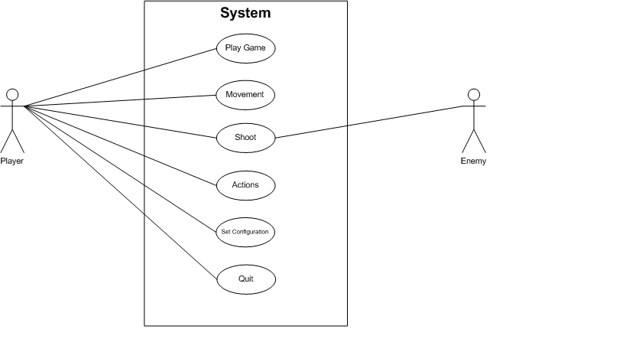

**3.2.1 Use Case Scenarios For Game:**

1. **Play Game**

Use to provide way to enter through game.

1. **Movement**

Use to provide various movements like forward, backward,etc.

1. **Shoot**

Use to shoot enemy and player.

1. **Actions**

Use to perform various actions like jumping,dashing,etc.

1. **Set Configuration**

Use to set configuration for video quality.

1. **Quit**

Use to exit from game.

.

**4. Project Planning and Estimation**

**4.1 Technologies Required for System**

**4.1.1 Unreal Engine 4:**

Unreal Engine 4 is a complete suite of development tools made for anyone working with real-time technology. From enterprise applications and cinematic experiences to high-quality games across PC, console, mobile, VR and AR, Unreal Engine 4 gives you everything you need to start, ship, grow and stand out from the crowd.  
  
A world-class toolset and accessible workflows empower developers to quickly iterate on ideas and see immediate results without touching a line of code, while full source code access gives everyone in the Unreal Engine 4 community the freedom to modify and extend engine features.

**4.2 Project Planning**

**4.2.1 Project Development Approach:**

The model that is referred for the development of the project is INCREMENTAL model. It combines elements of the waterfall model applied in an iterative fashion. In this process the phases are same as waterfall but the advantage is that when first phase is done it is incremented and then the other phases are carried with the same cycle. Here in this add once on each phase can be added according to the need of the client and the project.

Phases are as follows:

1. Planning

2 .Modeling: Includes Designing

3. Construction

4. Deployment: Feedback, Delivery

Each phases are iteratively carried out. Main reason for using this then any other is waterfall has the drawback of iterations, if there is any other requirement added later on then this is not possible to add up in it, Spiral model has disadvantage that it need more manpower and even it is for multiple transactions or multiple tasks handling projects and so does the time consumption is more in it for those projects.

Planning is essential cause multiple software teams works in parallel on different system functions. Scalability should be obtained in any of the project selected but it is not available in waterfall cause of few drawbacks

**5. System Design**

**5.1 Activity Diagram**

An activity diagram is a special case of a state diagram in which all (or at least most) of the states are action states and in which all (or at least most) of the transitions are triggered by completion of the actions in the source states.

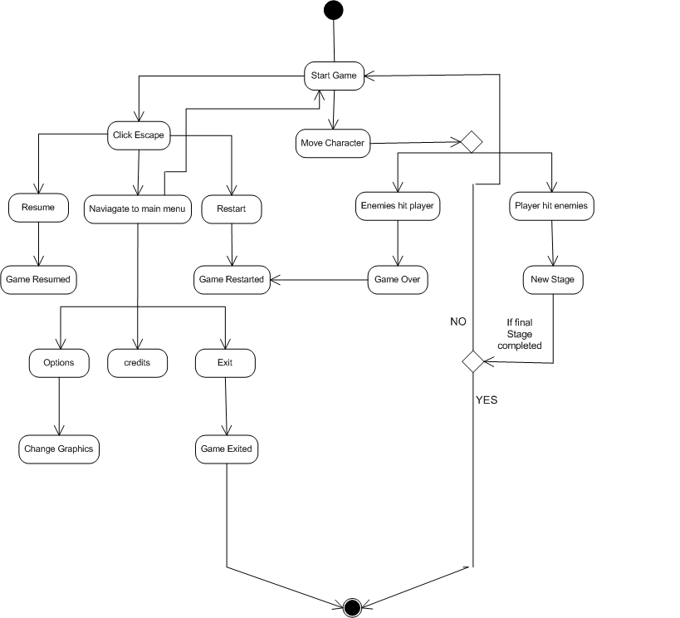

**5.2 Statechart Diagram**

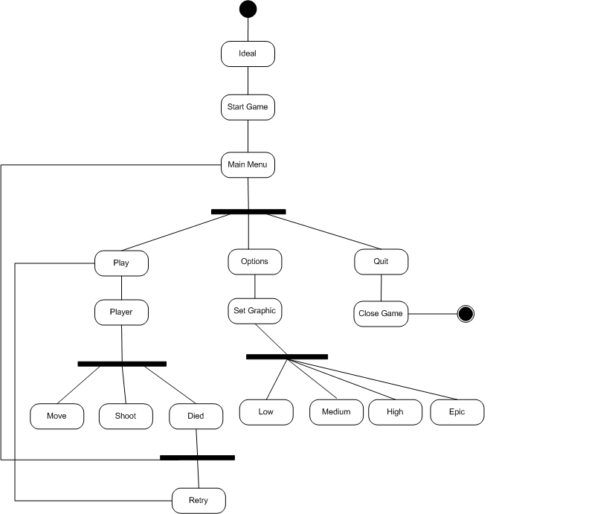

1. **Experience, Limitations and Future Enhancement**

**6.1 Experience during project development**

During the project development, we learn some new technologies and also explored variety of things and also learn various aspects of game development.

**6.2 Limitations**

Following are the limitations of Chronosphere: -

* There are only stages in the game.
* Player is killed by only single bullet shot.

**6.3 Future Enhancement**

In future, we can add new and more stages that has more features and also new boss. Stage may include new weapons, more enemies, more attractive look. Graphics look more realistic. Player has health bar and can even get medikit at different locations in the map. More and more bullet loops in the weapons to play more.

**7. BIBLIOGRAPHY**

**7.1 Bibliography**

**Web Resources**

* https://www.unrealengine.com
* https://m.youtube.com/user/UnrealDevelopmentkit
* https://forums.unrealengine.com

‎