http://10.10.3.16:8080/escm/melody

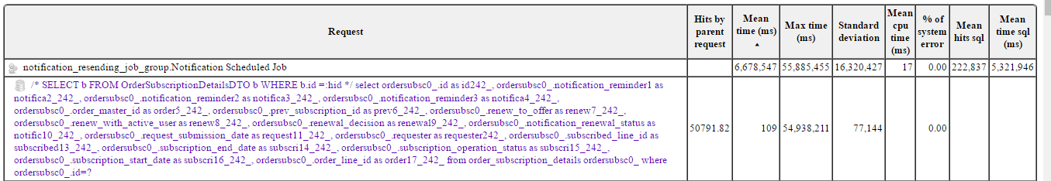

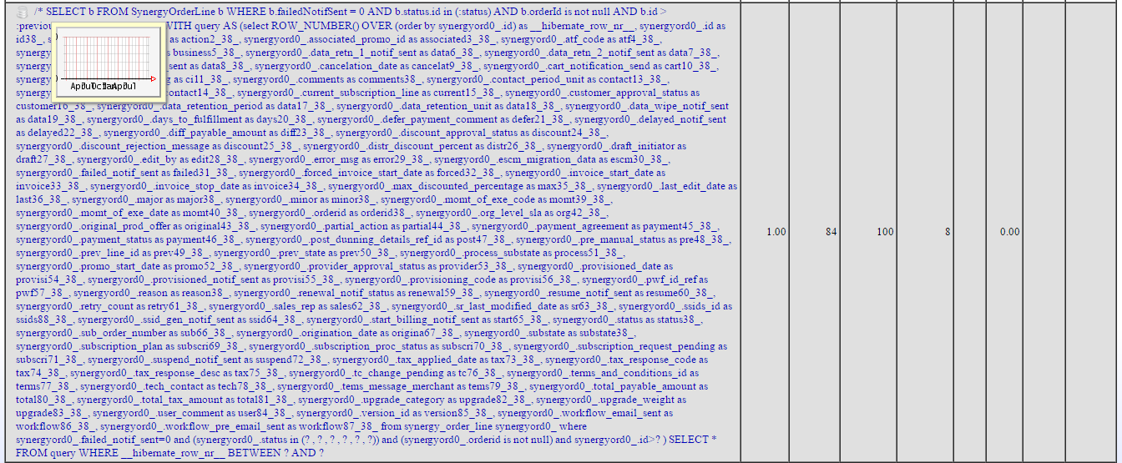

---------------
/* load one-to-many com.ensim.customer.CustomerOrganizationDTO.customerDNSNamesDTOs */ select customerdn0_.customer_id as customer12_81_1_, customerdn0_.id as id1_, customerdn0_.id as id174_0_, customerdn0_.cname_prefix as cname2_174_0_, customerdn0_.cname_host as cname3_174_0_, customerdn0_.customer_id as customer12_174_0_, customerdn0_.domain_name as domain4_174_0_, customerdn0_.error_message as error5_174_0_, customerdn0_.registered_by as registered6_174_0_, customerdn0_.registration_process as registra7_174_0_, customerdn0_.registered_time as registered8_174_0_, customerdn0_.registration_status as registra9_174_0_, customerdn0_.requested_time as requested10_174_0_, customerdn0_.self_registered as self11_174_0_ from customer_dns_names customerdn0_ where customerdn0_.customer_id=?

Action: Index required on customer_id table

---------------
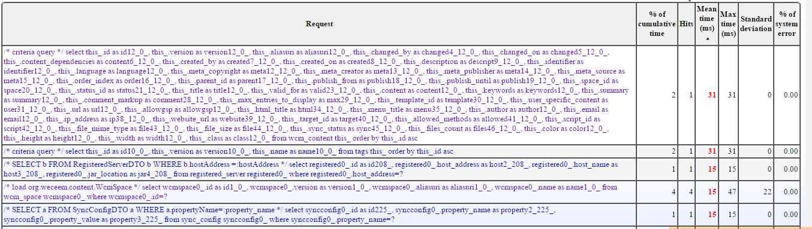

----------------------

Index Applied
---------------

Index Applied
------------------

[Index Applied]
--------------
String sql_query = " SELECT b FROM PhoneInventoryDTO b" +
" WHERE b.orderId = :orderID order by b.phone_number";

I and Raju found that index of orderID column is no set. This might be the cause.

@Raju: Add below index in DB
CREATE INDEX phone_inven_orderID_idx
ON phone_num_inventory
USING btree
(order_id);

[Index Applied]
--------------

[Index Applied]

-------------------
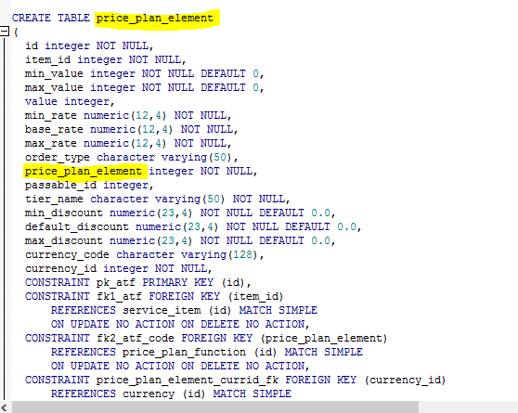

-----------------
SELECT row_.*,
rownum rownum_
FROM
(
/* criteria query */
SELECT this_.id AS y0_,
this_.owner_type AS y1_,
this_.org_id AS y2_,
this_.owner_base_org_id AS y3_
FROM customer_organization this_
WHERE
(
this_.enable_user_mgmnt_notif=:1
AND
(
this_.pwd_expiry_notif_state=:2
AND
(
this_.pwd_expiry_last_sync_date <:3
OR this_.pwd_expiry_last_sync_date IS NULL
)
)
)
)
row_
)
WHERE rownum_ <= :4
AND rownum_ > :5

[Index Applyed] enable_user_mgmnt_notif
------------------

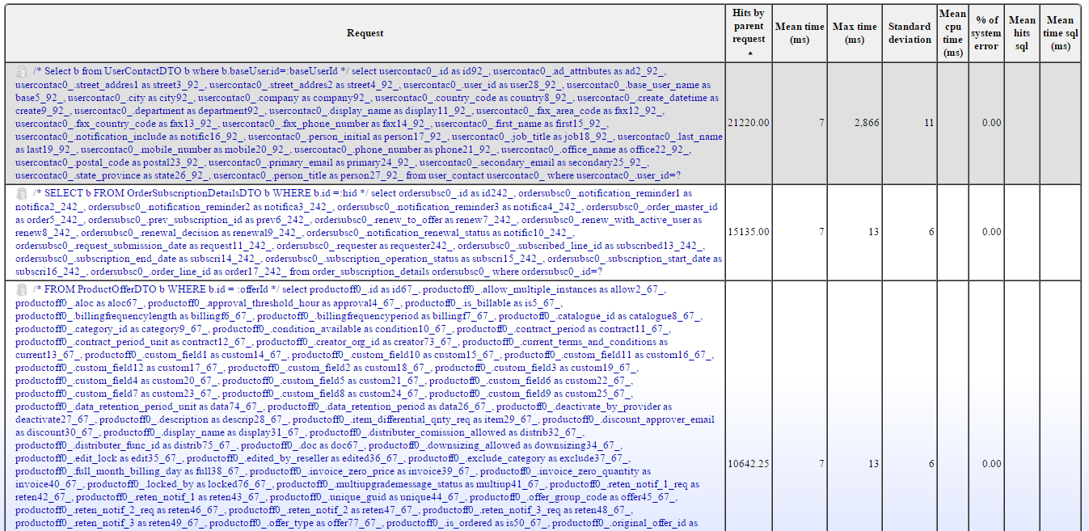

----------------
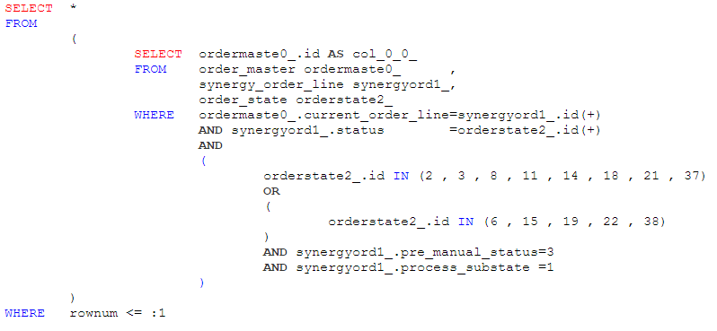

Index Required: pre_manual_status, process_substate
------------------------
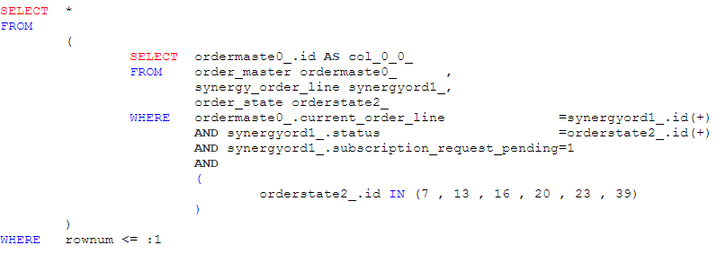

Index Required: subscription_request_pending
--------------------------------------------------
PhoneNumInv search:

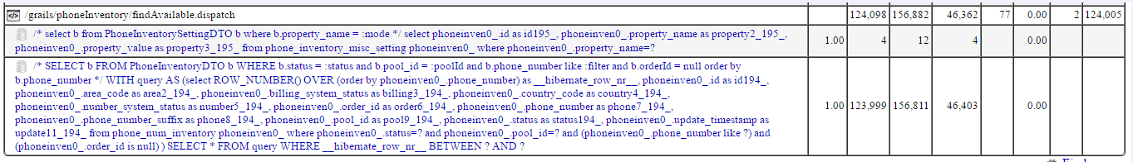

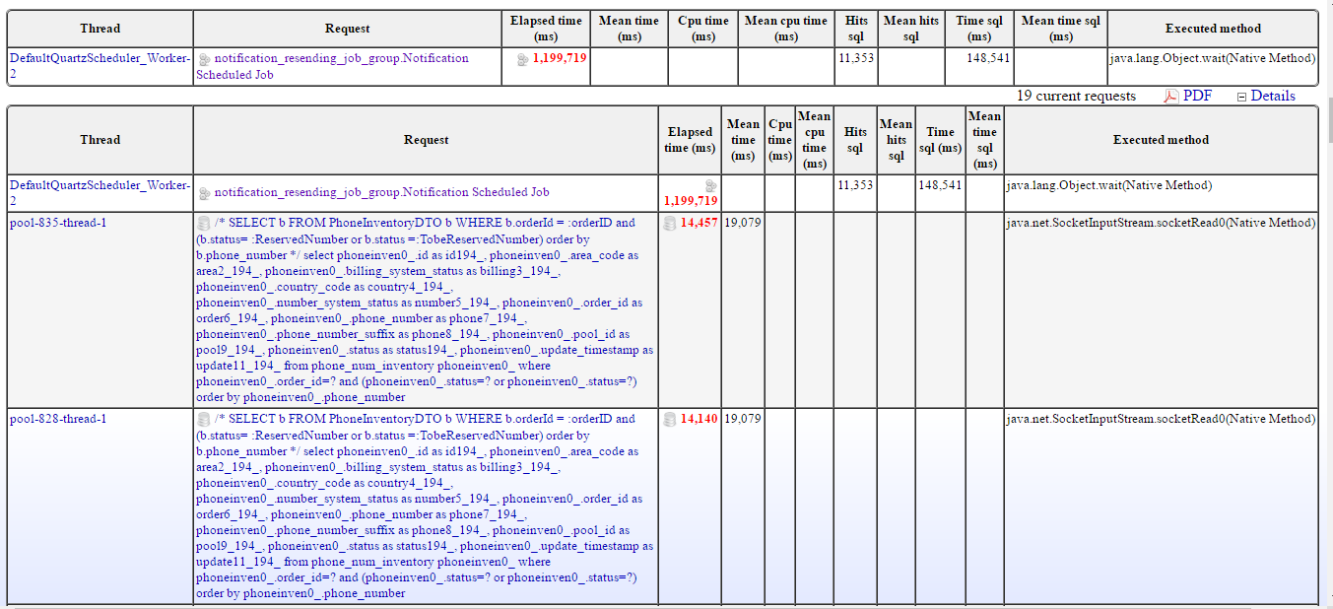
Fixed in Notification Schedule Job: removed order by

