**JECRC – 45 Days In-campus Training (4 Semester)**

**Subject – Full Stack Web Development**

# Day 8: 20th May, 2024

# Topic – float

**Assignment 8:-**

1.make the navigation bar given below



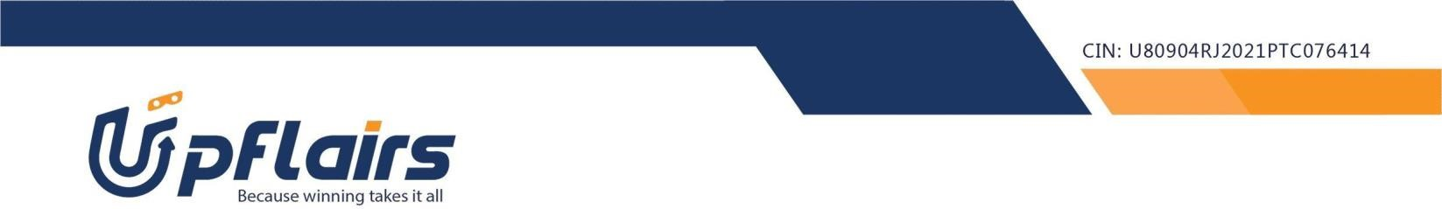

Note:- write the code in single html file

Assignment submission form link –https://forms.gle/PgzY4T3d1T6ieUZg9