RESULTS AND DISCUSSION

Some texts here...

Table 1.Statistics for solutions generated by the algorithms using 2nd Sem 2004.

ALGO | WRITE-IN | NO WRITE-IN | APL | NSFL | NSU | NSO | NSZL | APCS | GTE15 | LT15
REGIST | 8603 | 362 | 88.18 | 3540 | 4089 | 908 | 66 | 72.91 | 6008 | 2595
IA | 8603 | 0 | 86.66 | 3364 | 5193 | 0 | 46 | 71.20 | 6008 | 2595
IAMBM | 8603 | 0 | 87.57 | 3533 | 4986 | 33 | 51 | 71.80 | 6164 | 2439

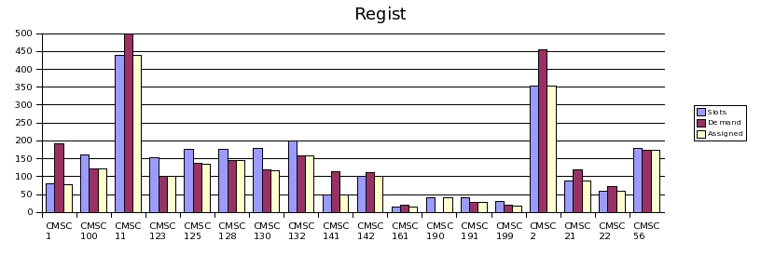

Figure 1. Available slots, demand, and assigned slots for CMSC subjects using REGIST

