**UI/UX Testing Report**

**Project Name: LeapifyTalk**

**Tested By: Afreen**

**Date: 04/04/2025**

**Test Environment: Ipad mini**

**Browser: Safari**

**Device: Ipad mini(5th generation IOS version:18.3.2)**

**1. Objective:**

The objective of this testing is to identify UI/UX issues such as font inconsistencies, spacing, alignment, icon placements, and navigation problems.

1. **Actual**  **Expected**



The text beside the logo have different color compared to the design and it should be uppercase.

The hamburger button color is different and also the size.

The logo, text and humburger button are not sticky.

The line height is incorrect.

1. **Actual Expected**

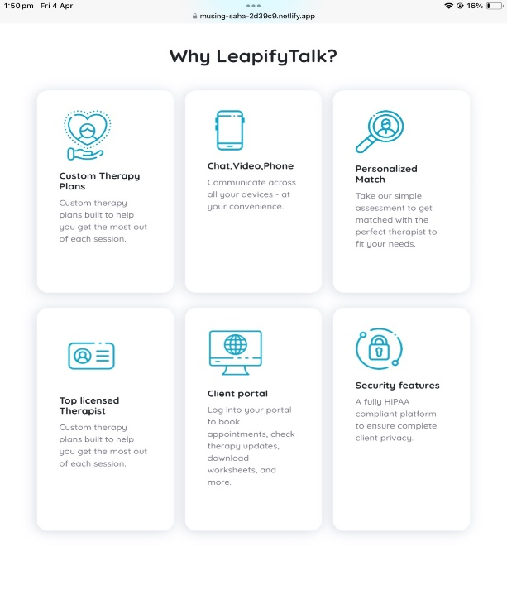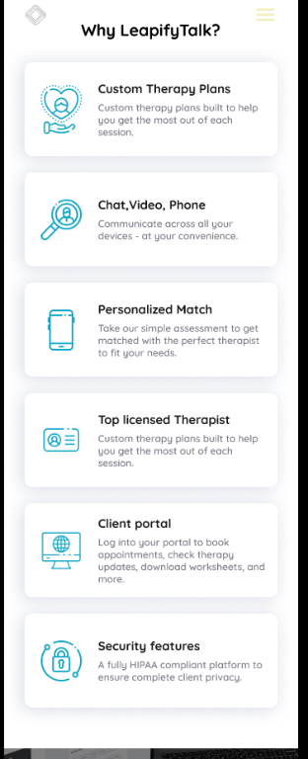

The cards content and images are not aligned properly.

The image in the second and third card are incorrect.

1. **Actual Expected**

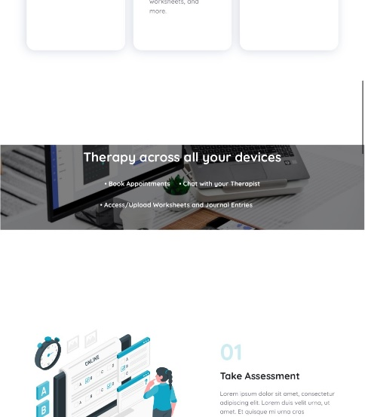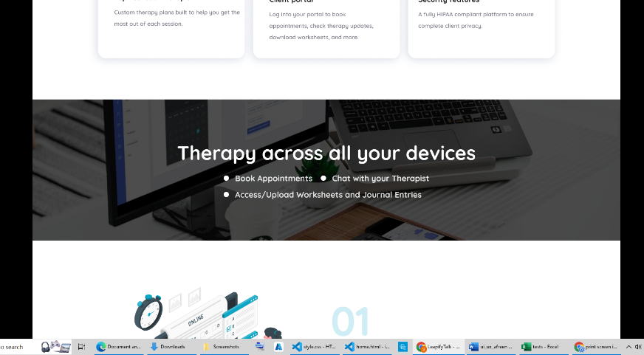

There is no padding across ‘therapy across all your devices’

Alignment is incorrect of the bullet points.

1. **Actual Expected**

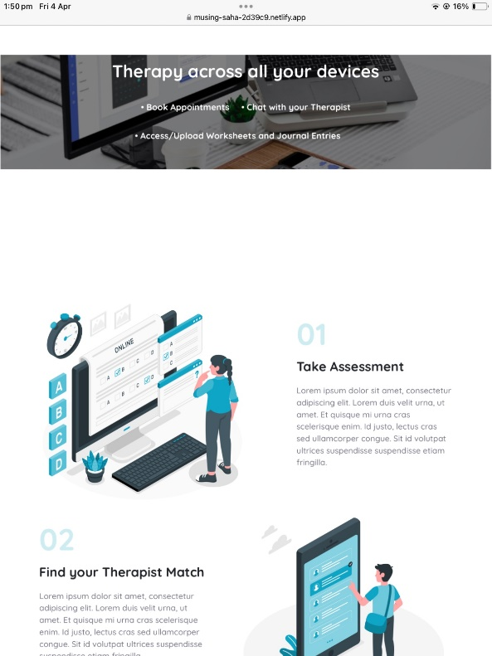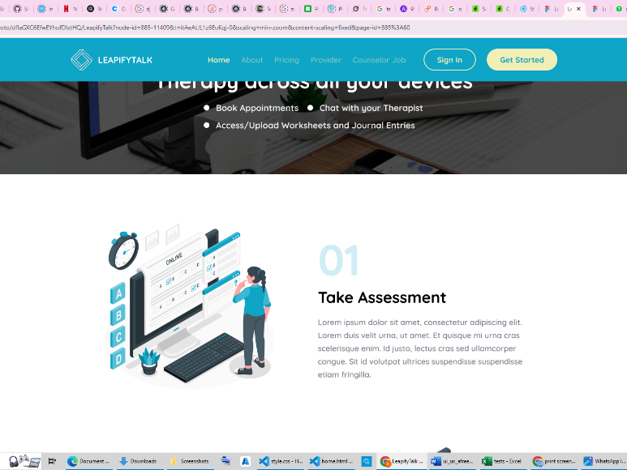

There is more spacing between ‘therapy across all your devices’ and the ‘take assessment’

1. **Actual Expected**

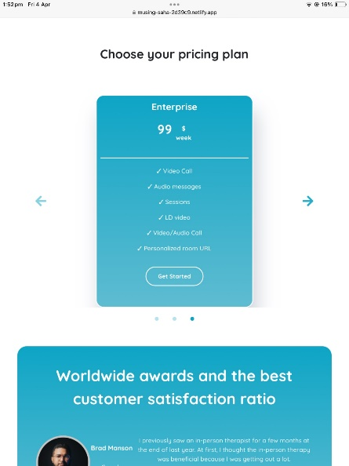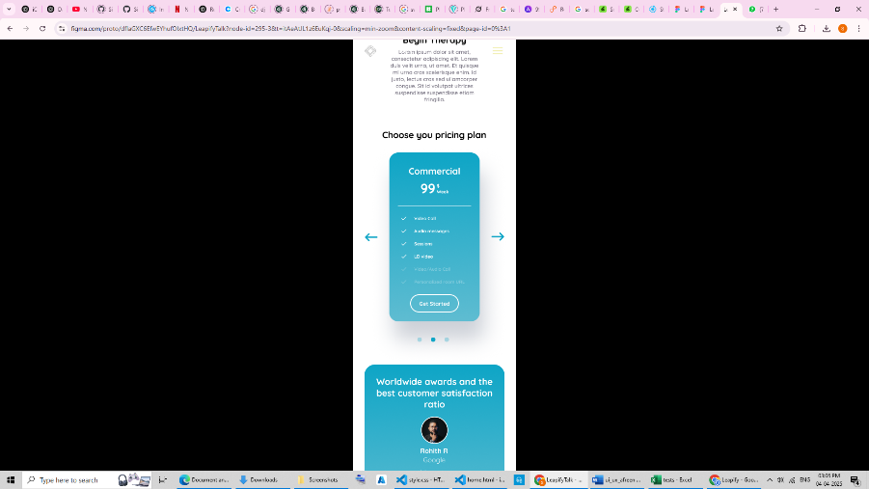

Dollar sign is not properly aligned.

Same with all the three pricings.

1. **Actual Expected**

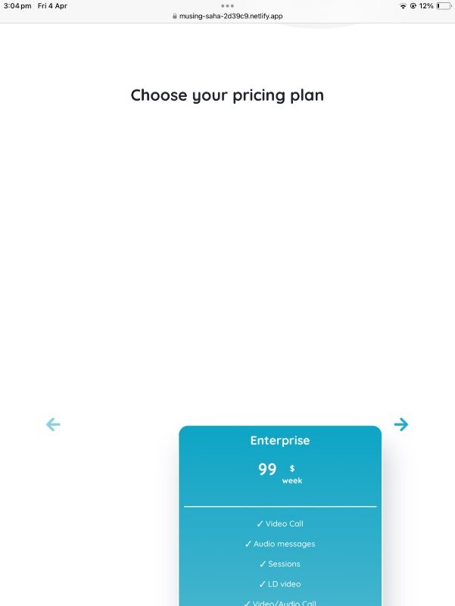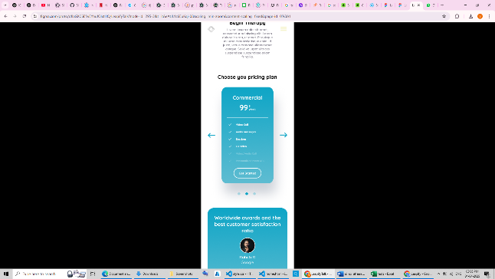

The cards are not aligned when trying to move to other pricing. The card moves downwards and then comes back to its original position.

1. **Actual Expected**

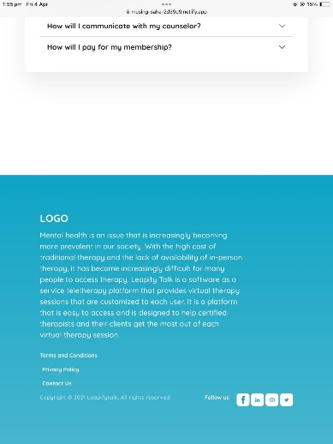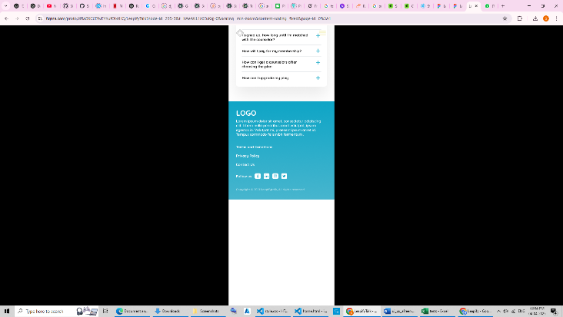

The spacing between the faq and the footer is incorrect.

The copyright is not aligned properly.

Social media buttons are not working.

1. **Actual Expected**

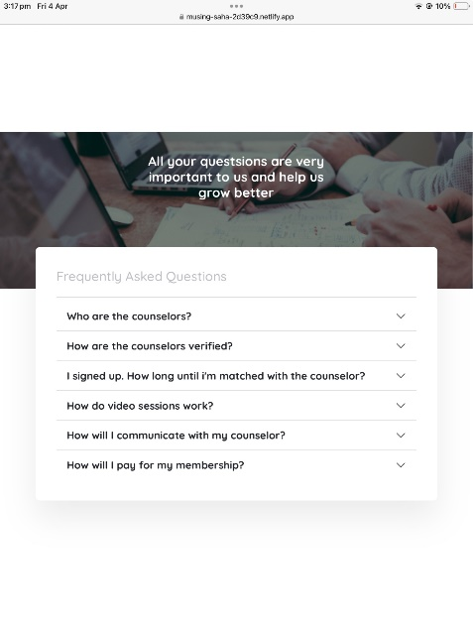 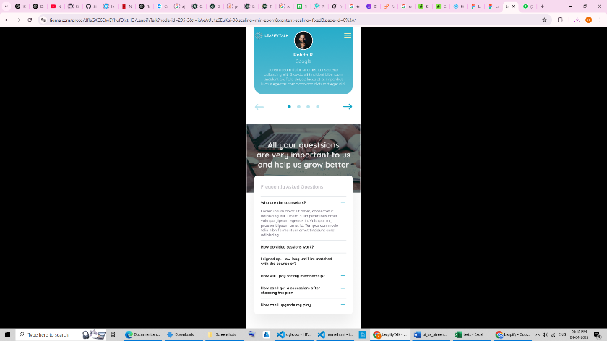

The text is not aligned at the center. And the spellings are incorrect.

The icons are different.

1. **Actual Expect**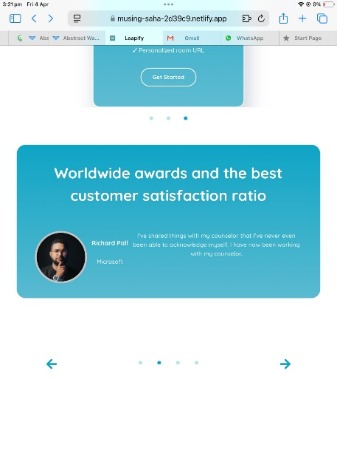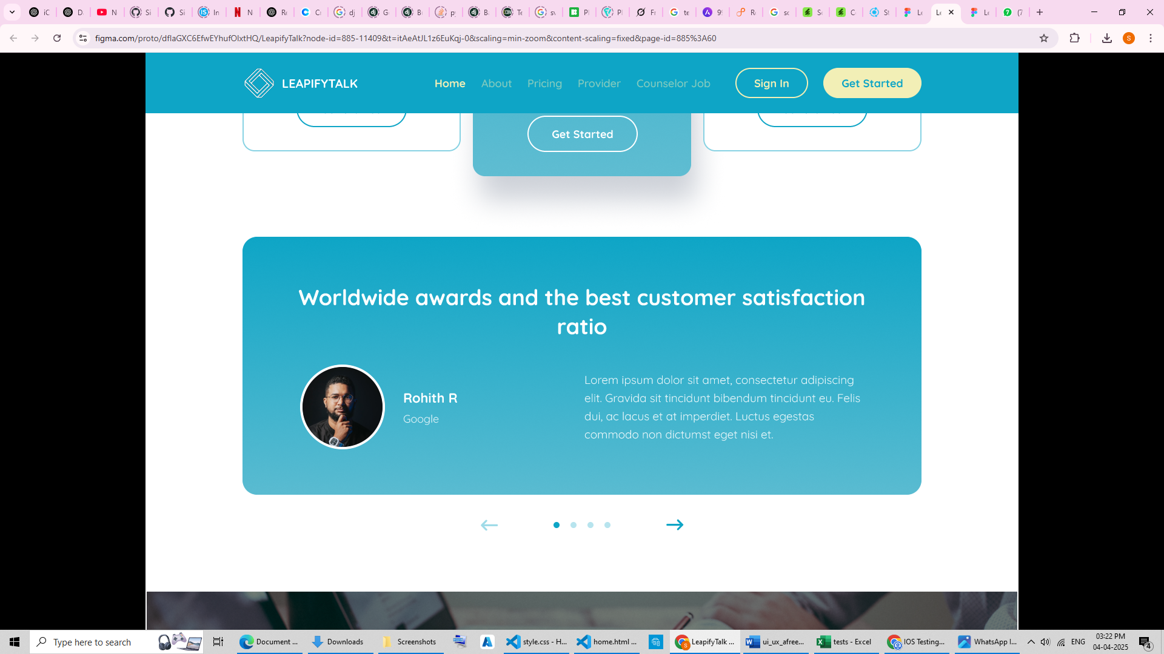

Incorrect alignment of the content.

1. **Actual Expect**

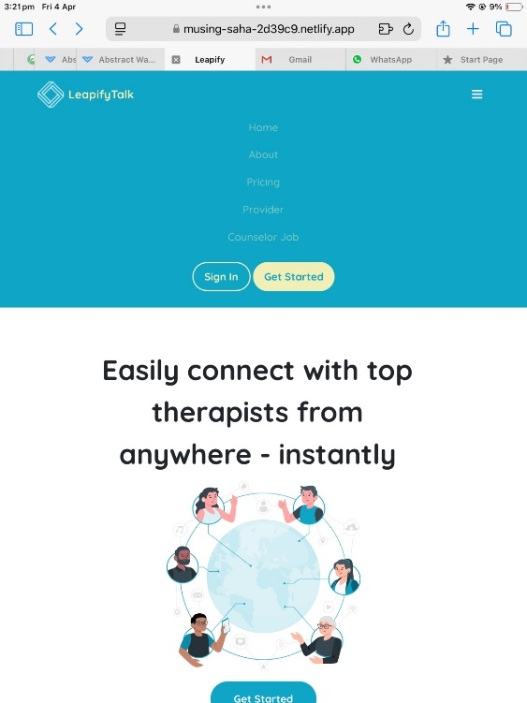

Sign in button is not working.

1. **Actual Expect**

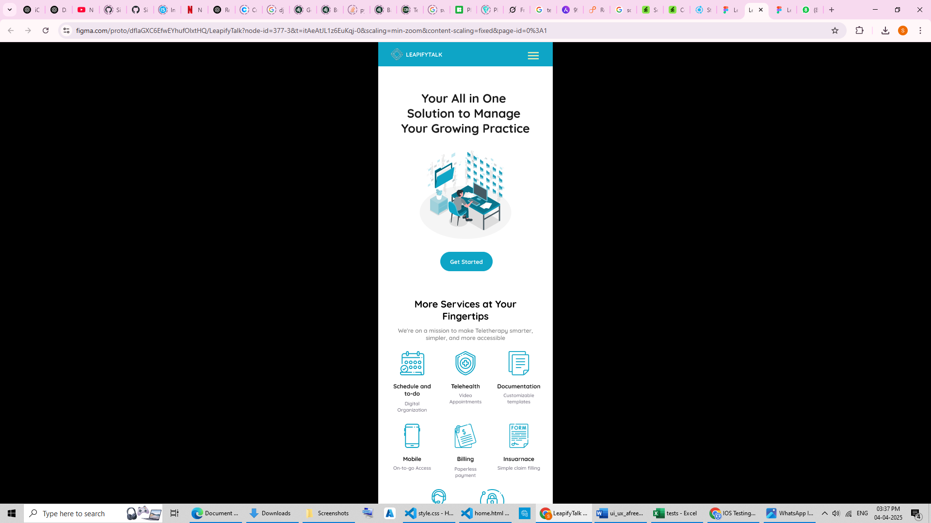

Hamburger is not shown

1. **Actual Expect**

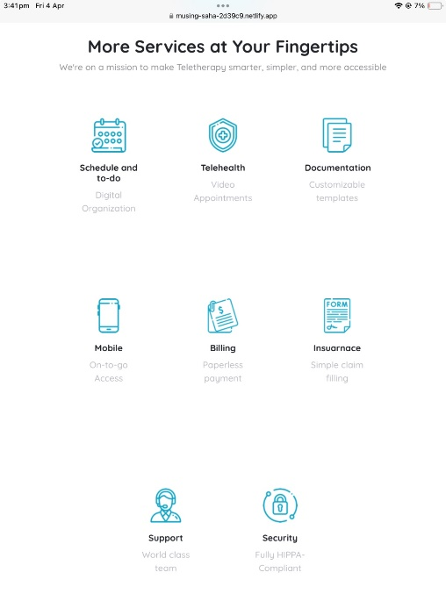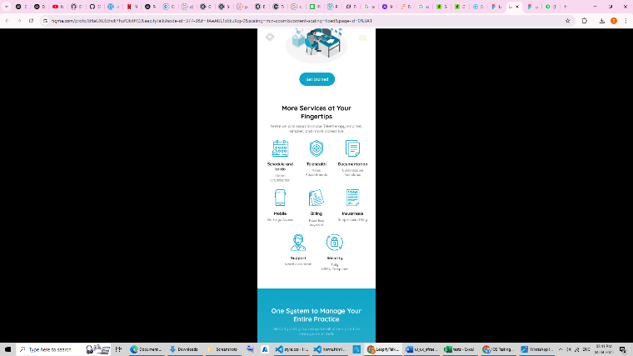

Spacing between the row is incorrect.

1. **Actual Expect**

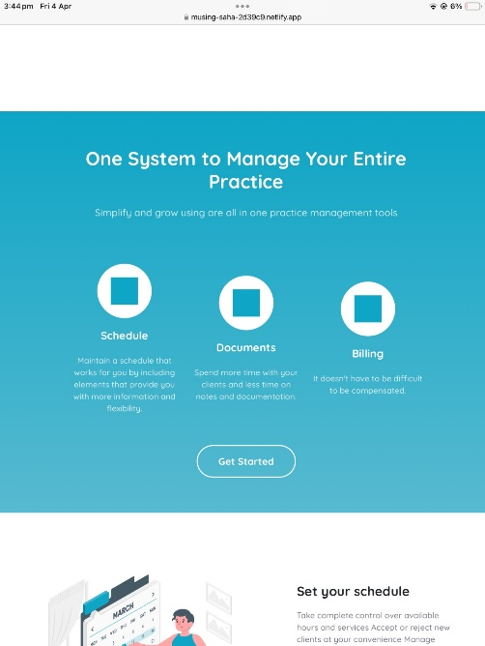 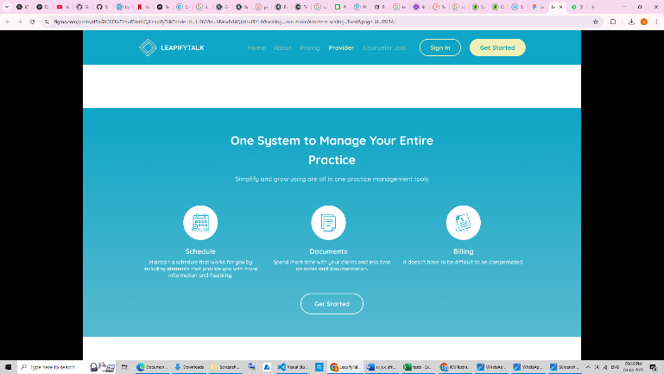

Icons are missing.

No proper alignment.

1. **Actual Expect**

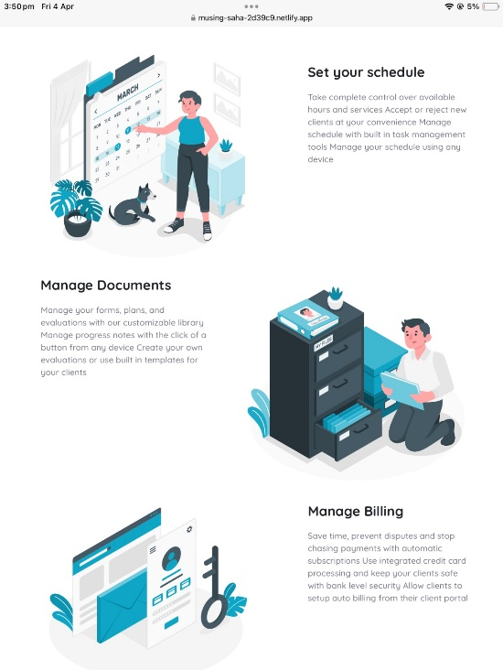 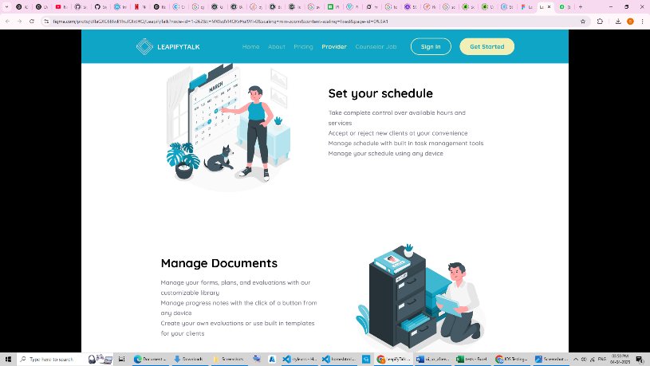

Content is not aligned at the center.

Text alignment is also not correct. Each sentence should start in a new line.

1. **Actual Expect**

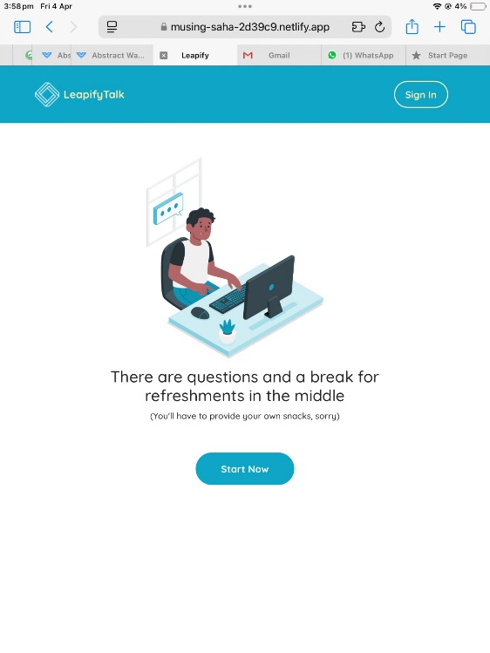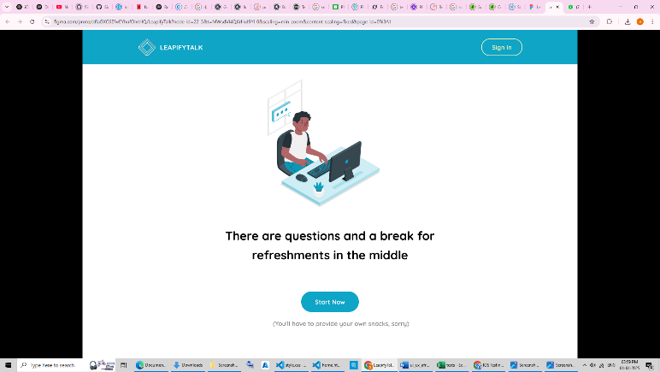

The sign in button is not working

The text should be bold ‘ there are questions and a break’

1. **Actual Expect**

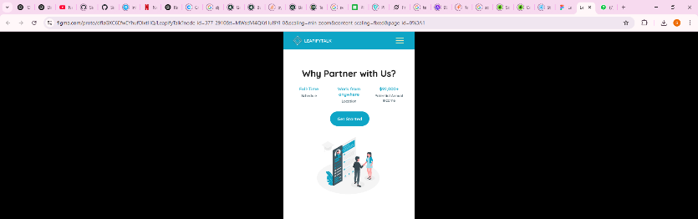

The spacing is more between the elements.

There is not hamburger button.

1. **Actual Expect**

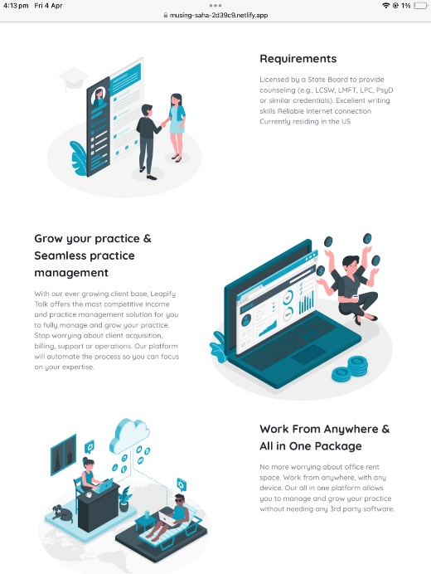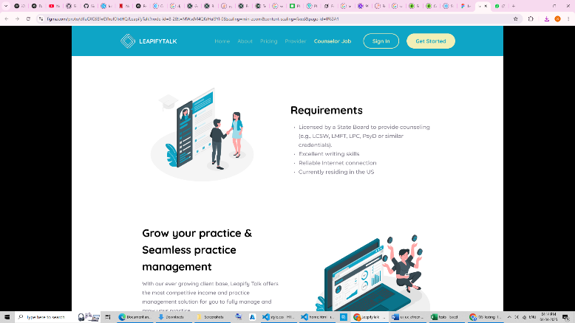

The content should be aligned properly. It is not centered.

The requirements should be bullet points.

1. **Actual Expect**

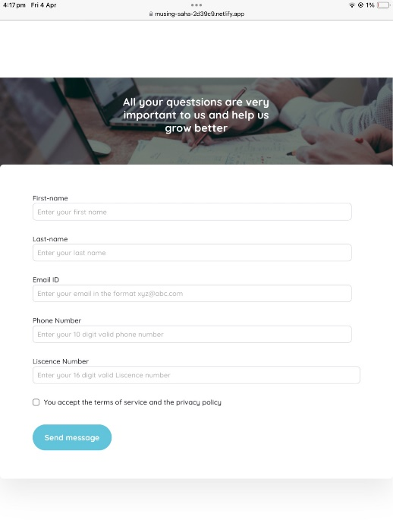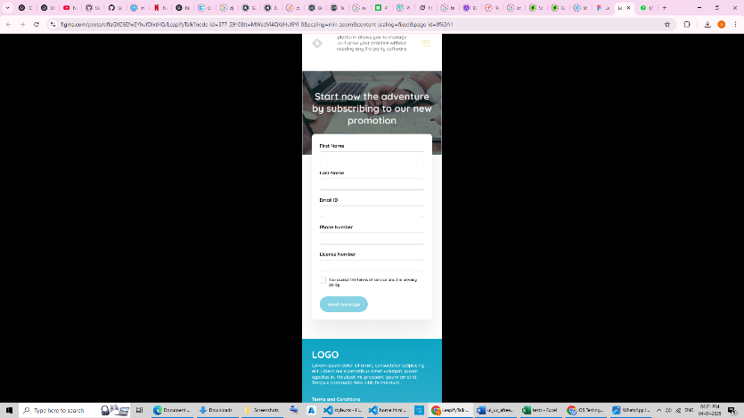

Form should overlap with the above content.

There should be no placeholders.

1. **Actual Expect**

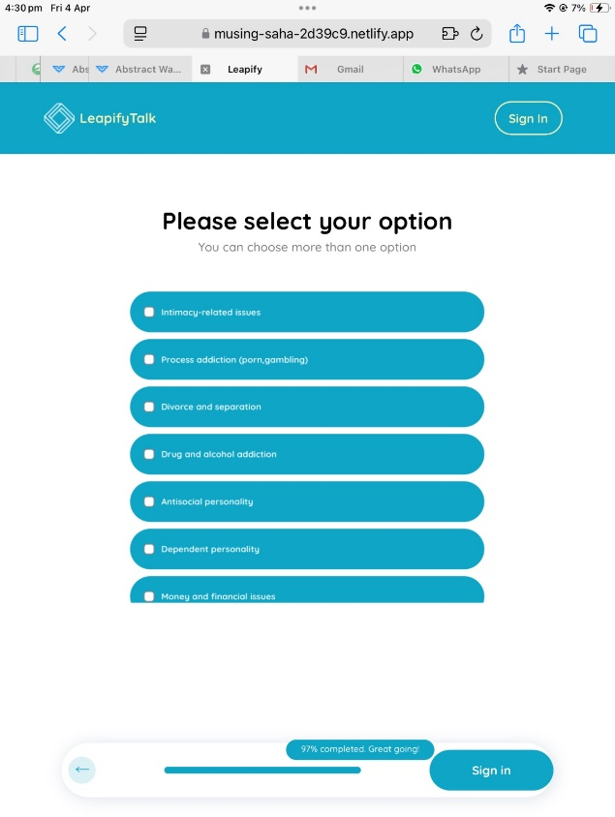

Sign in button is not working