API Integration – Weather Information System

1. Objective

The objective of this project is to create a Python program that fetches real-time weather information using an online Weather API. The program accepts a city name from the user and displays temperature, humidity, and wind speed.

2. Project Description

This project is a simple Weather API Integration system developed using Python. It uses the Requests library to send API requests and receives weather data in JSON format.

The program first finds the location details of the entered city and then retrieves its current weather information.

3. Technologies Used

- Python 3.x
- Requests Library
- REST API
- JSON
- Open-Meteo Weather API
- VS Code

4. Features

- Accepts city name from the user
- Fetches weather information through an API
- Parses JSON response
- Displays temperature
- Displays humidity
- Displays wind speed
- Handles API request errors
- Handles unexpected API data

5. How It Works

1. The user enters a city name.
2. Python sends a request to the geocoding API.
3. The API returns the latitude and longitude of the city.
4. Python sends these coordinates to the weather API.
5. The weather API returns current weather data in JSON format.
6. Python extracts temperature, humidity, and wind speed.
7. The information is displayed in the terminal.

6. API Integration

The project uses the Open-Meteo API to obtain weather information. The Python Requests library is used to send HTTP GET requests and receive the API response.

7. Result

The program was successfully executed in VS Code.

Test Input:
Delhi

Output:

- City: Delhi
- Temperature: 27 °C
- Humidity: 79 %
- Wind Speed: 1.1 km/h

8. Screenshots / Project Evidence

The following screenshot provides evidence of the successful API integration and program execution.
[Insert Task2_API_Result.png here]
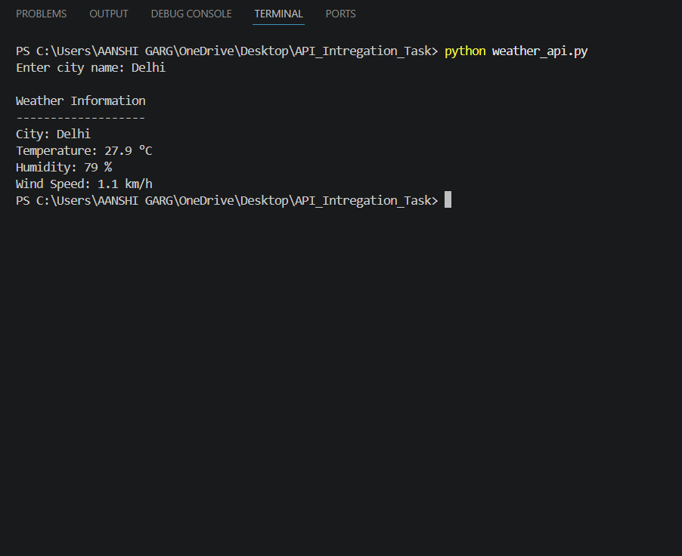

9. GitHub Repository

The complete source code of this API Integration project will be uploaded to GitHub for version control and internship submission.

GitHub Repository Link: To be added

10. Conclusion

This project demonstrates how Python can be used to integrate an external API, send requests, process JSON data, and display useful information. It also provides practical experience with API integration, exception handling, and Python programming.

