Data Analysis Project

1. Objective

The objective of this project is to analyze student performance data using Python and Pandas. The program calculates total marks, average marks, identifies the highest-scoring student, and calculates average marks for each subject.

2. Project Description

This project is a simple student performance analysis system developed using Python and the Pandas library. The student data is stored in a CSV file. Pandas is used to read, process, and analyze the dataset.

The program calculates the total and average marks of each student and identifies the student with the highest total marks.

3. Technologies Used

- Python 3.x
- Pandas
- CSV
- VS Code

4. Features

- Reads student data from a CSV file
- Calculates total marks
- Calculates average marks
- Identifies the highest-scoring student
- Calculates average marks by subject
- Displays the analyzed data in the terminal

5. Dataset

The dataset contains student marks for the following subjects:

- Python
- Data Analytics
- AI & ML
- English

The dataset contains six student records.

6. How It Works

1. The program imports the Pandas library.
2. The student data is read from the CSV file using "pd.read_csv()".
3. Total marks are calculated for each student.
4. Average marks are calculated for each student.
5. The student with the highest total marks is identified.
6. Average marks for each subject are calculated.
7. The results are displayed in the terminal.

7. Result

The program was successfully executed in VS Code.

The highest-scoring student was:

- Name: Sneha
- Total Marks: 366
- Average Marks: 91.50

The program also successfully calculated the average marks for each subject.

8. Screenshots / Project Evidence

Insert the screenshot "Task3_Analysis_Result.png" here.

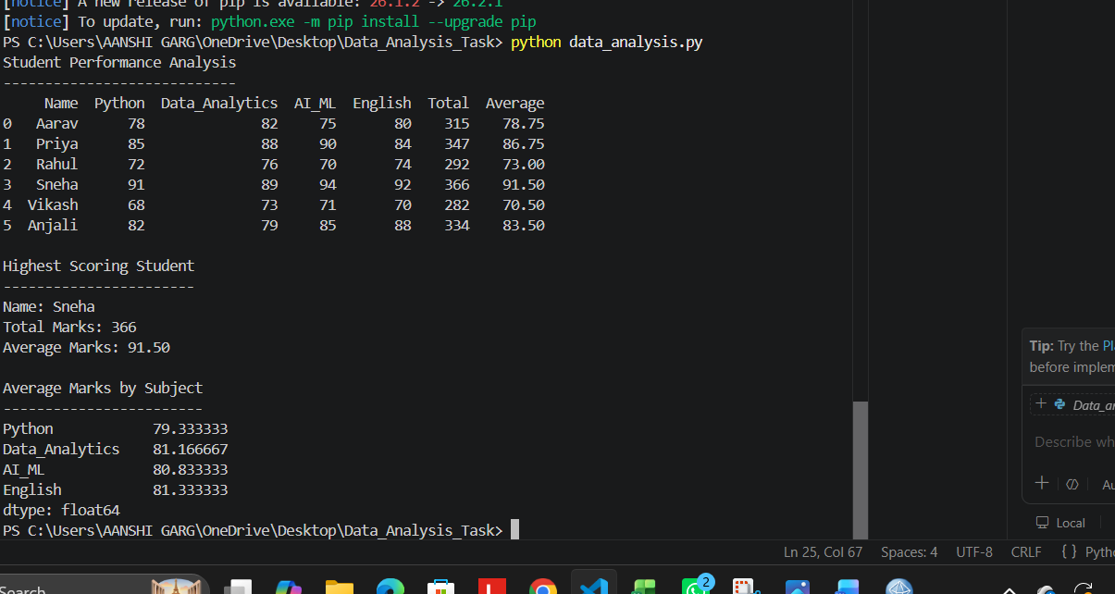

9. GitHub Repository

The complete source code and project files will be uploaded to GitHub for version control and internship submission.

GitHub Repository Link: To be added

10. Conclusion

This project demonstrates the use of Python and Pandas for basic data analysis. It provides practical experience with CSV files, data processing, calculations, and extracting useful information from a dataset.

