Python Automation Script – File Organizer

1. Objective

The objective of this project is to create a Python automation script that automatically organizes files into different folders based on their file extensions.

2. Project Description

This project is a File Organizer Automation Script developed using Python. The script checks the files inside the Test_Files folder and automatically moves them into appropriate categories such as Documents, Images, Videos, Spreadsheets, and Others.

3. Technologies Used

- Python 3.x
- os module
- shutil module
- File handling
- VS Code

4. Features

- Automatically detects file extensions.
- Creates category folders automatically.
- Moves files into the appropriate folder.
- Handles different file types.
- Displays the operation status in the terminal.
- Uses basic exception/file existence checking.

5. How It Works

The user places files inside the Test_Files folder. The Python script checks each file, identifies its extension, selects the appropriate category, creates the required folder if it does not already exist, and moves the file into that folder.

For example, a .txt file is automatically moved to the Documents folder.

7. Screenshots / Project Evidence
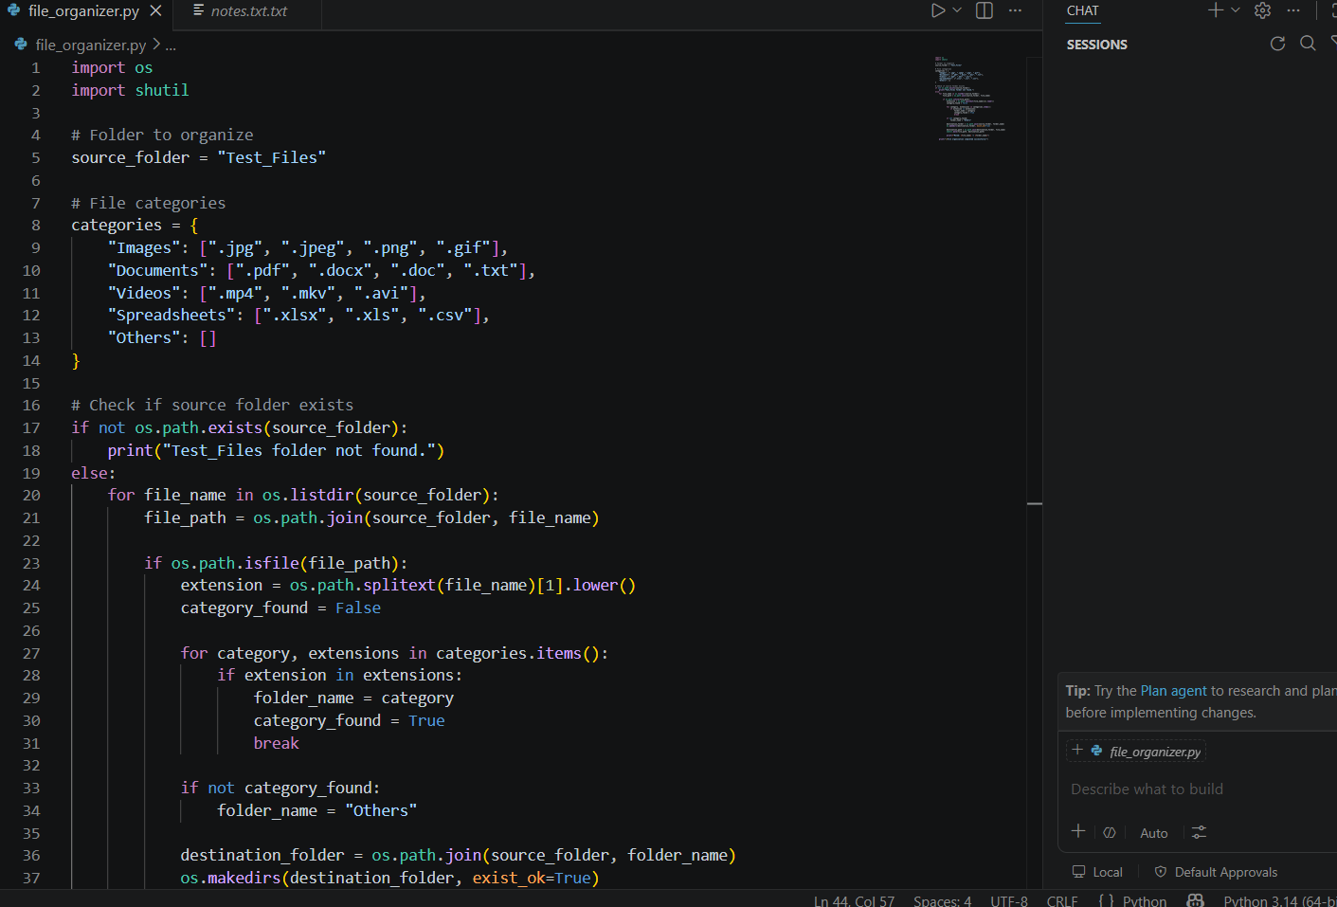

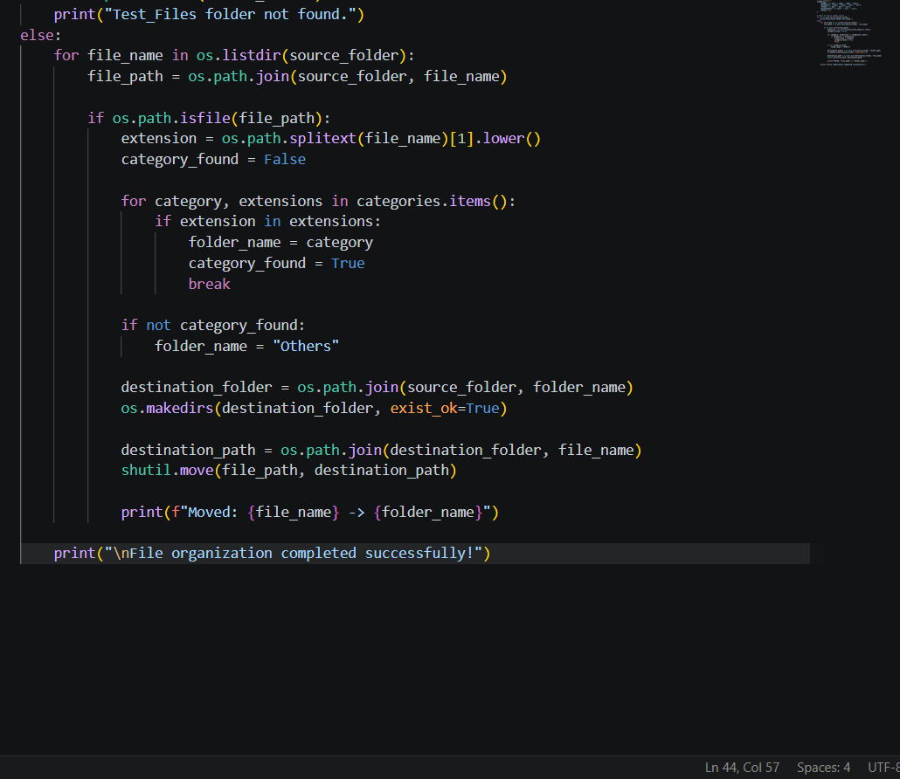

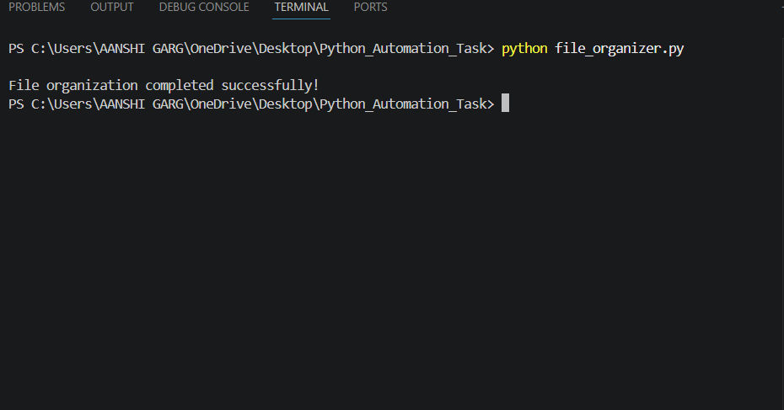

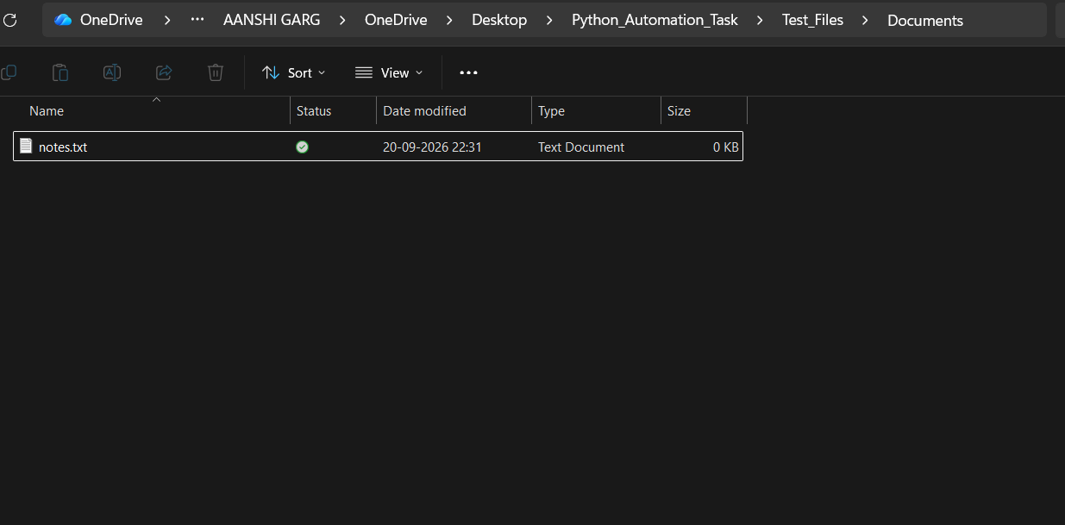

8. GitHub Repository

The complete source code of this Python automation project will be uploaded to GitHub for version control and submission.

GitHub Repository Link: To be added

9. Project Result

The Python automation script successfully detected the file type and automatically moved the "notes.txt" file into the Documents folder.

10. Conclusion

This project demonstrates the use of Python for automating file-management tasks. It provides practical experience with file handling, folders, loops, conditions, the "os" module, and the "shutil" module.

11. Result

The automation script successfully organized the test file. The notes.txt file was automatically moved from the Test_Files folder to the Documents folder.

12. Conclusion

This project demonstrates how Python can be used to automate a simple file-management task. It helped in understanding Python modules, file handling, folders, loops, conditions, and automation using the os and shutil modules.

