Project 1: Static Foundations
Feedback for Arvind Anthey's portfolio site
Student: Arvind Anthey Course: CSC 436, Fall 2026 Reviewed at: f4bd512
Repo: github.com/aanthey/portfolio-site Live: arvindanthey.netlify.app

Grade: 86 / 100
Category | Points | Earned | One line
Semantic HTML | 20 | 16 | Right elements, clean headings; two validator errors, one card is a div
CSS layout | 25 | 25 | Bootstrap is allowed; your Grid rule is the best in the class so far
Responsive design | 15 | 13 | No horizontal scroll anywhere; zero media queries of your own
JavaScript interaction | 15 | 13 | Accessible toggles done right, written twice
Repository and deployment | 15 | 11 | Real history over 12 days; README missing half its required items
Content and polish | 10 | 8 | Real projects, real photo, alt text; 3.7 MB of images
Total | 100 | 86 | Good process, thoughtful details, strong CSS

How this review was made
Your instructor reviewed this project with Claude (Anthropic's AI) as a second set of eyes. Claude cloned the repo, read every line, loaded the live site at phone, tablet and desktop widths, ran the W3C validator, opened the hamburger menu, and clicked both toggles. Every note and every point in this document was read and approved by your instructor. Same standard, same rubric, just more time spent looking at your code than one human has in a grading week.

The short version
This is a real portfolio. Real projects with real repos, a real photo with real alt text, a time element with a datetime attribute, aria-expanded kept in sync by hand, a focus-visible style you wrote yourself. Those are details most students do not know exist yet. And your commit history is what the brief asked for: eleven commits across twelve days, each one a feature.
So where did the points go? Not the CSS. Bootstrap is allowed for this project, and the CSS you wrote on top of it is deliberate and clean. The deductions are smaller things that add up: a README that stops at the description, two validator errors, zero media queries of your own, a JavaScript file written twice, and 3.7 MB of images for three pictures. Every one of those is under an hour of work.

What Claude measured on the live site
Check | Result
Horizontal scroll at 375 / 768 / 1280 px | None at any width
Project grid columns at 375 / 768 / 1280 | 1 / 2 / 2
Hamburger menu at 375px | Opens, shows 4 links, closes
Both "My contributions" toggles | Work; hidden, aria-expanded and label all update
Console errors | 0
W3C HTML validator | 2 errors (favicon type, duplicate id)
Heading order | h1 > h2 > h3, no skipped levels
display: flex in styles.css | 0 rules
@media in styles.css | 0 rules
Image weight used by the page | 3.7 MB (photo 1.07 MB, logo 1.54 MB, favicon 1.13 MB)
Commits | 11, from Sep 3 to Sep 15

The site at three widths
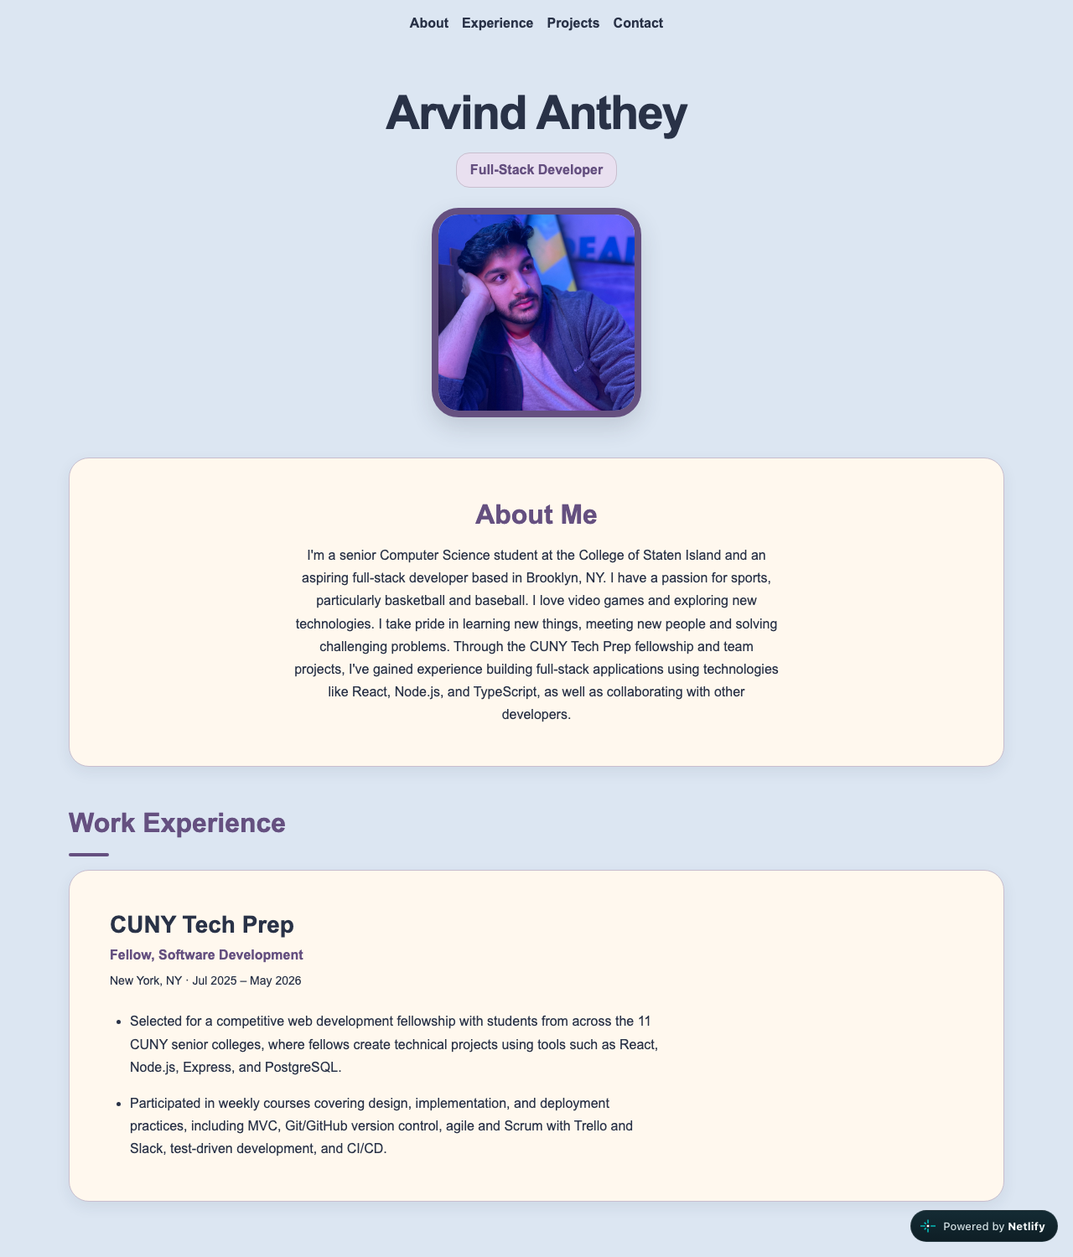
Desktop, 1280px wide. Bootstrap navbar, centered header, card sections.
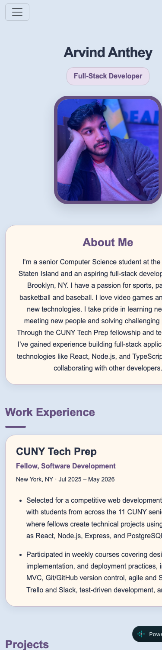  Phone, 375px. No horizontal scroll; hamburger menu. | 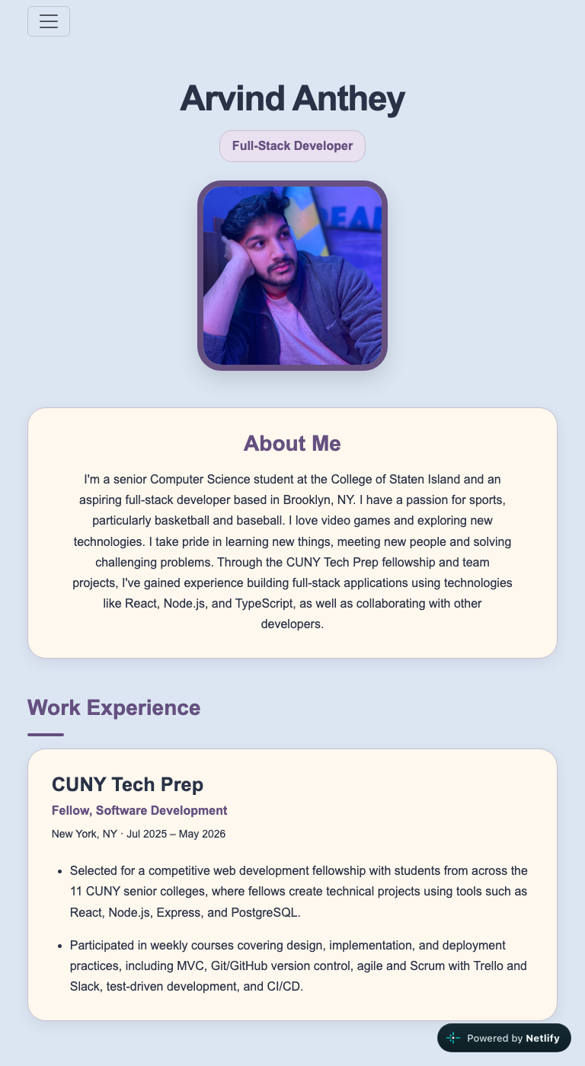  Tablet, 768px. Two project columns via auto-fit.

Semantic HTML: 16 / 20

What is working
- header, nav, main, section, article, footer all present and correctly placed. Nav is a real ul > li > a. One h1, then h2 per section, h3 per card. No skipped levels.
- <time datetime="2025-07"> (index.html lines 54 to 55). Nobody asked for that. It is the right element and you used it.
- The toggle buttons carry aria-expanded and aria-controls (lines 76, 101), and the hidden paragraphs use the hidden attribute instead of a CSS hack. rel="noopener noreferrer" on every external link. A meta description in the head. This is careful work.

What to change
- Two validator errors. Line 10: type="AA Lofi Icon" is not a MIME type. The type attribute on a favicon link wants image/png, or just leave it off. Line 111: id="supabase-badge" appears twice (line 87 is the first). An id must be unique on the page. This one happened because you are styling badges by id instead of by class.
- Style with classes, not ids. #react-badge, #node-badge, #supabase-badge (styles.css lines 193 to 207) means you can never use the same badge twice without a validator error. You already did it right once: .project-tech on line 110. Make them all .badge-react, .badge-node, and so on.
- One card is a div, one is an article. PAWS is <div class="card"> (line 68), SquadCheck is <article class="card"> (line 94). They are the same kind of thing. Both should be article.
- div.page wrapping everything (line 14) so you can put font-family, background-color and margin: 0 on it (styles.css lines 2 to 7). That is what body is for. Move those rules to body and delete the wrapper.

CSS layout: 25 / 25

What is working
- The project grid is exactly right. repeat(auto-fit, minmax(min(100%, 280px), 1fr)) (styles.css lines 39 to 44). The min(100%, 280px) guard is a detail most tutorials skip, and it is the reason your cards never overflow a narrow phone. align-items: start so cards do not stretch to match each other. This is the best Grid rule in the class so far.
- Spacing and type are deliberate: clamp() for the name and section padding, 65ch and 75ch max widths on prose, a consistent card treatment reused across About, Experience and Projects. The h2 underline is a nice touch.
- You wrote a :focus-visible style (lines 185 to 188). Keyboard users thank you.

What to change
- Bootstrap is doing your Flexbox, and that is allowed. Every flex layout on the page is a Bootstrap utility class: d-flex flex-column align-items-start gap-2 (index.html lines 82, 107), d-flex gap-3 (line 121), and the entire navbar. No points lost for that. But you clearly can write layout CSS, because your Grid rule proves it. As a learning step, not a grading one, try writing the navbar yourself (display: flex; justify-content: center; gap). You will see exactly what navbar-expand-lg has been doing for you, and Project 2 gets easier.
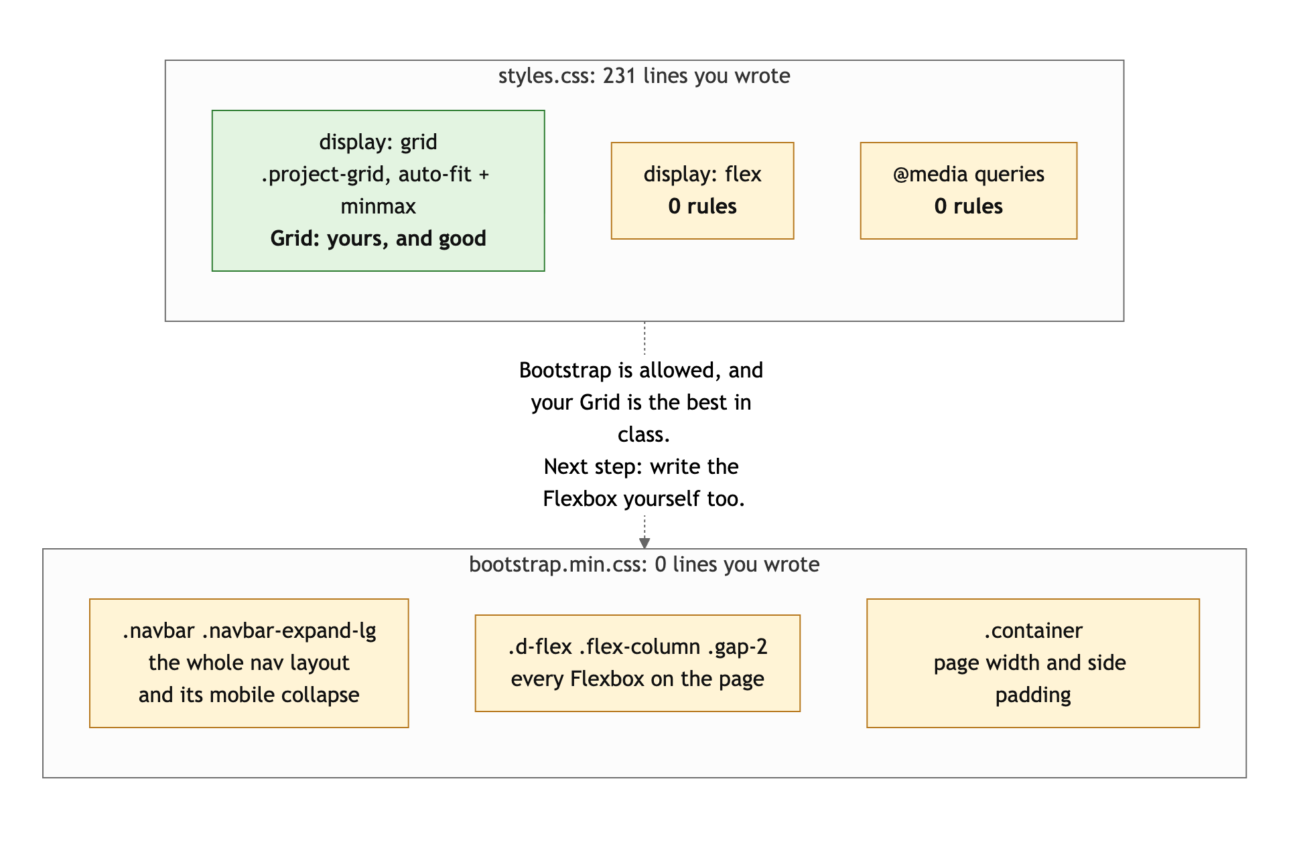
Diagram 1. Where the layout on your page comes from. Bootstrap is allowed; the Grid you wrote is excellent.
- display: table to shrink-wrap the title pill (line 28). It works, but it is a 2008 trick. width: fit-content is what you mean.
- Bootstrap is loaded twice. The page uses the CDN (index.html lines 7, 133), and package.json also installs it from npm, which nothing references. Pick one. For a static site with no build step, the CDN is the one to keep, so remove the npm dependency, or delete package.json and package-lock.json entirely.

Responsive design: 13 / 15

What is working
- No horizontal scroll at 375, 768 or 1280. Cards go from one column to two. The hamburger appears under 992px, opens, shows all four links, closes. The profile photo is max-width: 100% with aspect-ratio: 1 and object-fit: cover, so it never distorts.
- The min(100%, 280px) trick means your grid is responsive with zero breakpoints. The brief explicitly allows intrinsic patterns like this, so you get credit for it.

What to change
- Zero media queries. The brief says "mobile-first media queries." The only thing on your page that changes behavior at a breakpoint is Bootstrap's navbar, and Bootstrap wrote that. Write at least one: the header is a good candidate (smaller photo and tighter padding under 600px), and once you own the navbar you will need one for it anyway.
- The grid tops out at two columns on a 1280px desktop because there are only two projects. Fine for now, but when you add a third, check that the 280px minimum still gives you the layout you want.

JavaScript interaction: 13 / 15

What is working
- The toggle is the right design: flip the hidden attribute, update aria-expanded, change the button label. Screen readers get the state, sighted users get the label, and there is no CSS class juggling. Arrow functions, const, comments that explain why. Zero console errors.
- Using hidden instead of toggling a .show class is the correct choice and most students get this wrong.

What to change
- The whole file is written twice. Lines 2 to 15 and 17 to 28 are the same code with different ids. When you add a third project you would copy it again. You already gave every button the same class and an aria-controls that names its target, so the loop writes itself:
document.querySelectorAll('.contribution-toggle').forEach((button) => {
const details = document.getElementById(button.getAttribute('aria-controls'));
button.addEventListener('click', () => {
details.hidden = !details.hidden;
button.setAttribute('aria-expanded', String(!details.hidden));
button.textContent = details.hidden ? 'My contributions' : 'Hide my contributions';
});
});

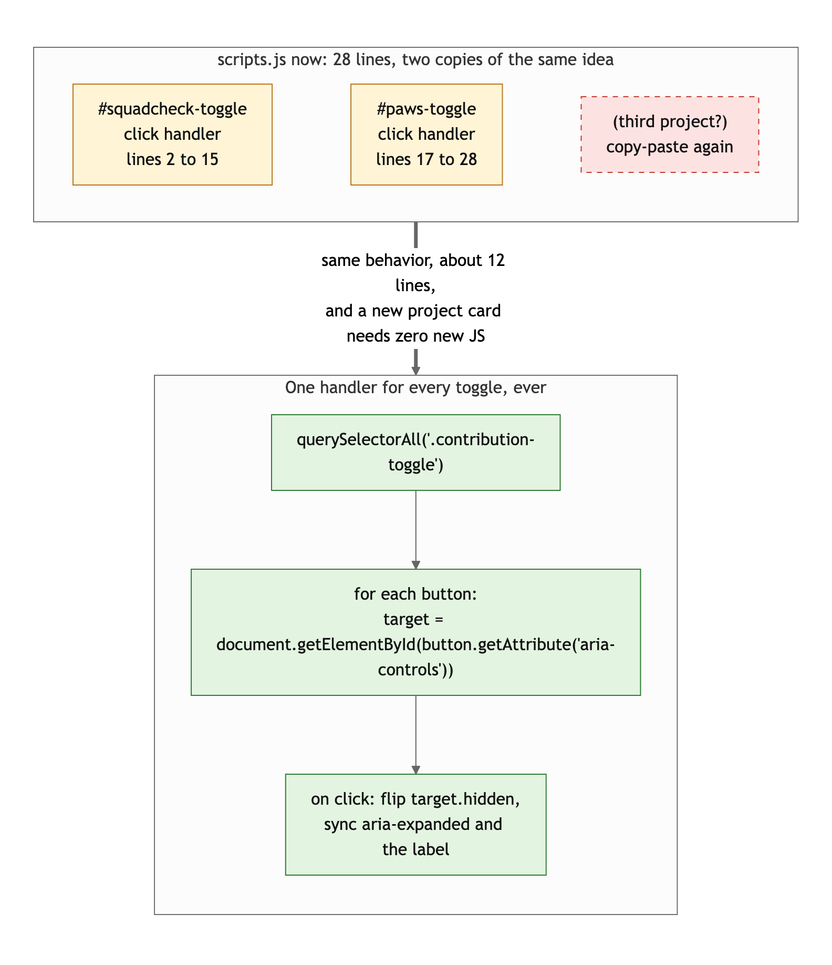
Diagram 2. Two copies of one handler (top) versus one loop that covers every toggle (bottom).
- Small: the label strings live in two places (the HTML and the JS). If you ever rename the button, you will rename it in one and not the other. Consider a data-label attribute on the button, or accept it for now and just know it is there.

Repository and deployment: 11 / 15

What is working
- The history is what the brief asked for. Eleven commits from September 3 to 15: skeleton, then Bootstrap and the first project, then SquadCheck, then Experience, then the toggles, then favicon, then tweaks. Anyone reading the log can watch the site get built. That is the point, and you did it.
- .gitignore covers node_modules. Live URL works in a private window and matches the repo at f4bd512. Netlify deploys on push.

What to change
- README is half done. The brief lists four required items: title, description, how to run locally, live URL. You have the first two. The README has not been touched since September 3, before there was a site to run or a URL to link. Add a "Run locally" section (clone, open index.html or use Live Server) and the Netlify URL. Ten minutes.
- Commit messages are past tense. "Added favicon logo", "Added a Work Experience section". The brief asked for present tense: "add favicon", "add work experience section". It is a convention, and it is the one the rest of the industry uses, so build the habit now.
- Repo clutter. .vscode/settings.json is your editor's preference, not the project's, and belongs in your global gitignore. package.json and package-lock.json install a dependency the page never loads. Either use them or remove them.

Content and polish: 8 / 10

What is working
- It is real. Two projects with links to real repos and honest, specific "my contributions" text. A real bio. A real photo. Every image has meaningful alt text. A favicon. Consistent palette (the purple, cream and slate work together) and consistent card treatment. The focus ring matches the brand color. This is a site you could actually send to a recruiter.

What to change
- 3.7 MB of images. The profile photo is 3024 by 4032 pixels and 1.07 MB, displayed at 250px. The PAWS logo is 1024 by 1024 and 1.54 MB, displayed at 350px. The favicon is 1254 by 1254 and 1.13 MB, displayed at 16px. That is a full second or two on a phone connection for a page that has three images. Resize them to roughly twice their display size, export the photo as JPEG or WebP, and the whole assets folder drops under 200 KB.
- The two project cards do not match. PAWS has a logo, SquadCheck has nothing. Either give SquadCheck an image (a screenshot works) or take the PAWS logo out of the card and let both stand on text. Uneven cards read as unfinished.

Your next three moves
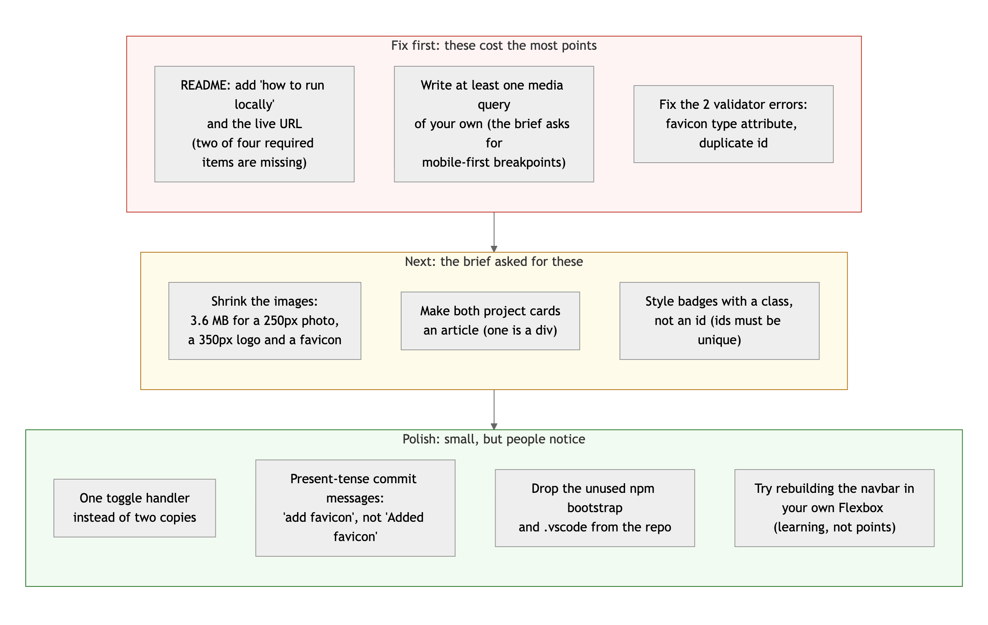
Diagram 3. Priority order. Top row first: it is where the points are.
- Finish the README. Two sections, ten minutes, and it is the biggest single deduction left on the sheet.
- Write one media query of your own. The header under 600px is the natural place. If you want the bigger lesson, rebuild the navbar with your own Flexbox while you are in there.
- Fix the validator errors and shrink the images. Both are quick, and both are things a recruiter's browser will notice before they read a word.

Your instincts on accessibility, layout and process are ahead of the class. Tighten the loose ends and this is a 90s project.
This review lives in a pull request on your repo. It only adds feedback files and does not touch your code. Merge it, close it, or just read it. Questions go to office hours or the Brightspace board.

