Final Project Assets Delivery

1. **Title**

Bigfoot Hunters

1. **Logo**

1. **Home Page Introduction**

Welcome to the Bigfoot Hunters home page! (Provide background information on bigfoot/sightings/personal opinion.)

1. **About Section**

On this page, you’ll find personal stories, sightings, discussions, and events all related to Bigfoot himself.

1. **“Memorial” Requirement**

(What does this mean?)

1. **Three Pieces of Research**

<https://www.bfro.net/>

<https://mil.wa.gov/the-legend-of-bigfoot> (Organization with sightings/audio/discussions)

<https://www.britannica.com/topic/Sasquatch>

1. **Images**

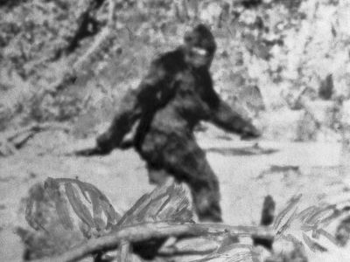

<https://cdn.britannica.com/33/256733-050-92FE3E79/Sasquatch-Bigfoot-Abominable-Snowman-Patterson-1967.jpg>

(Taken by Roger Patterson in 1967, short film.)

1. **Videos or Audio**

<https://youtu.be/VcnQKG9OMOE?feature=shared> (YouTube/History)

<https://youtu.be/XBLmmyFEhvw?feature=shared> (YouTube/Gravitas Documentaries)

1. **Recruitment/Membership Process**

You can follow us on Twitter, Instagram, and Discord to learn and interact with our Bigfoot-hunting community.

1. **A product**

To join the Sasquatch crew, you can follow us on Patreon for 4.99 a month to gain exclusive access to merchandise and content. Donations are not required but are very appreciated.

1. **Conclusion**