**A Simple Point-of-Sale (POS) System**

**OBJECTIVE**

The objective of this assignment is to get you familiar with all (mostly) Python basics and some advance concepts, which include the proper syntax, Python input/output, loops, lists, dictionaries, classes, objects, inheritance. After performing this assignment, you should be able to master these python concepts. You NEED to use either Spyder or PyCharm for this assignment.

**TASK**

In this assignment, the overall task is to develop an application that does two things 1) provide ability for the cashier to perform sales type activities like selling an item, accepting returns, records sales, handle payments. etc. and 2) manage the backroom stock inventory by placing replenishment orders etc.

Study the **POS Project Requirements** below. You will write your application as a console application which means it will not have a GUI (Graphical User Interface).

1. In this POS system, a cashier will be asked to log in the system using his/her user id and password. (Maximum tries of incorrect passwords or userId is 3 after which the system will not allow this user to logon). The system logs in the cashier if proper credentials are provided otherwise a message is displayed to reenter the credentials. (If the user id or password is wrong, the cashier will be asked to re-enter).

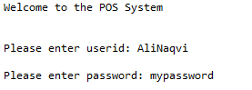

1. You need to load the inventory data from a file called RetailStoreItemData file into your newly created item object. Item objects need to become part of a collection. This file is provided to you with this assignment. This file contains all the items that are sold in your store. (Please look at the file to understand the data). The file has the following data.

|  |  |
| --- | --- |
| **Field** | **Description** |
| UPC | UPC (unique key of the item) |
| Description | The description of the item |
| Item_Max_Qty | Max quantity that the shore should hold |
| Order_Threshold | New order needs to be place for replenishment once items_on_hand drop below the order_threshold |
| replenishment_order_qty | When a new order is placed a minimum of replenishment_order_qty has to be ordered |
| Item_on_hand | total items in store |
| Unit price | item price |

1. **POS Project Requirements**

Point of Sale System is developed to support supermarket-type store operations. In particular software shall:

1. Allow the cashier to start a new sale and allow add/remove items to a new sale.
2. Once all items are added to the sale the cashier will request for cash to finalize the sale.

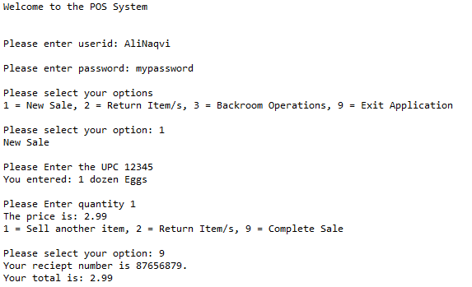



1. The system will keep track of the total sales amount at the register.
2. Registers will record the register number, the user (cashier), the dates and times of sale, sale items, and the amount of sales.
3. For returns - Support cancellation of the entire sale as well as return of an individual item.

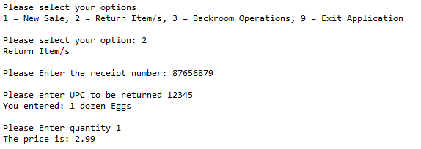

1. Keep track of the inventory, including quantity, price, and outstanding backroom inventory orders. Example of inventory: subtract number of items sold from the master file (RetailStoreItemData) which contains Item_on_hand.
2. Support inventory management (add/remove item to/from inventory, setting threshold for re-ordering. Threshold is when the system should signal the management to order a product if on hand count goes below the threshold.)

You are free to design the UI experience for this requirement.

1. Support report generation:

Inventory report (listing off al inventory items with name, quantity, threshold, and quantity of items in pending orders. Pending orders mean – the order has been placed however the items have not been received as yet to be put on the shelves or backroom.

You are free to design the UI experience for this requirement.