**LEC9Q16)**

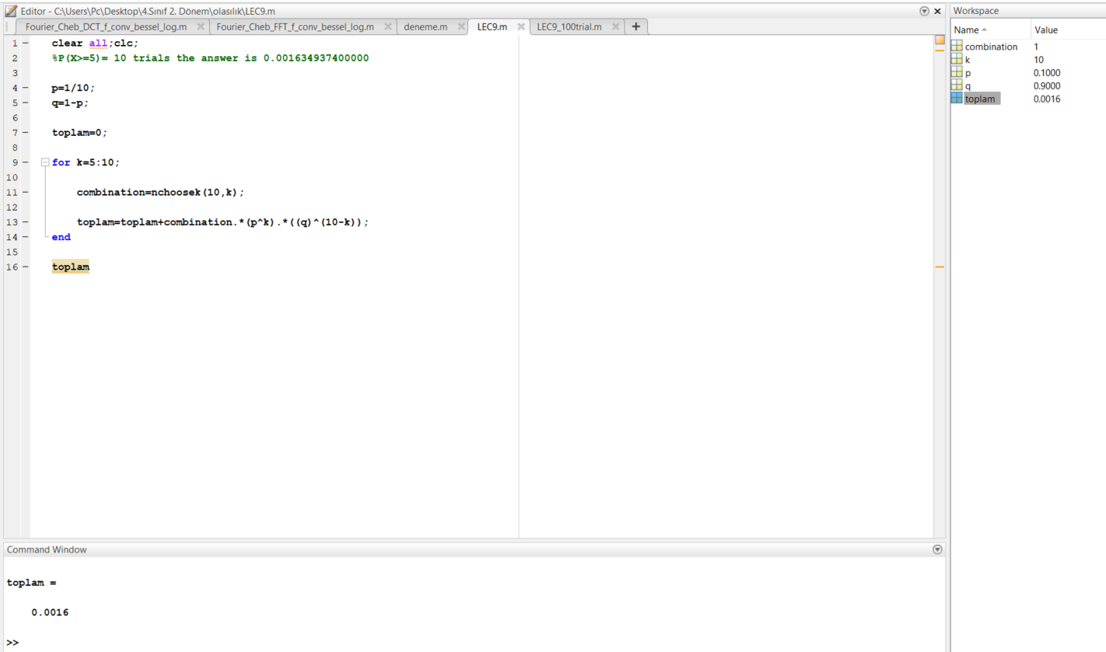

**(fig.1 (n=10))**

**Numerical answer is::::** **0.001634937400000**

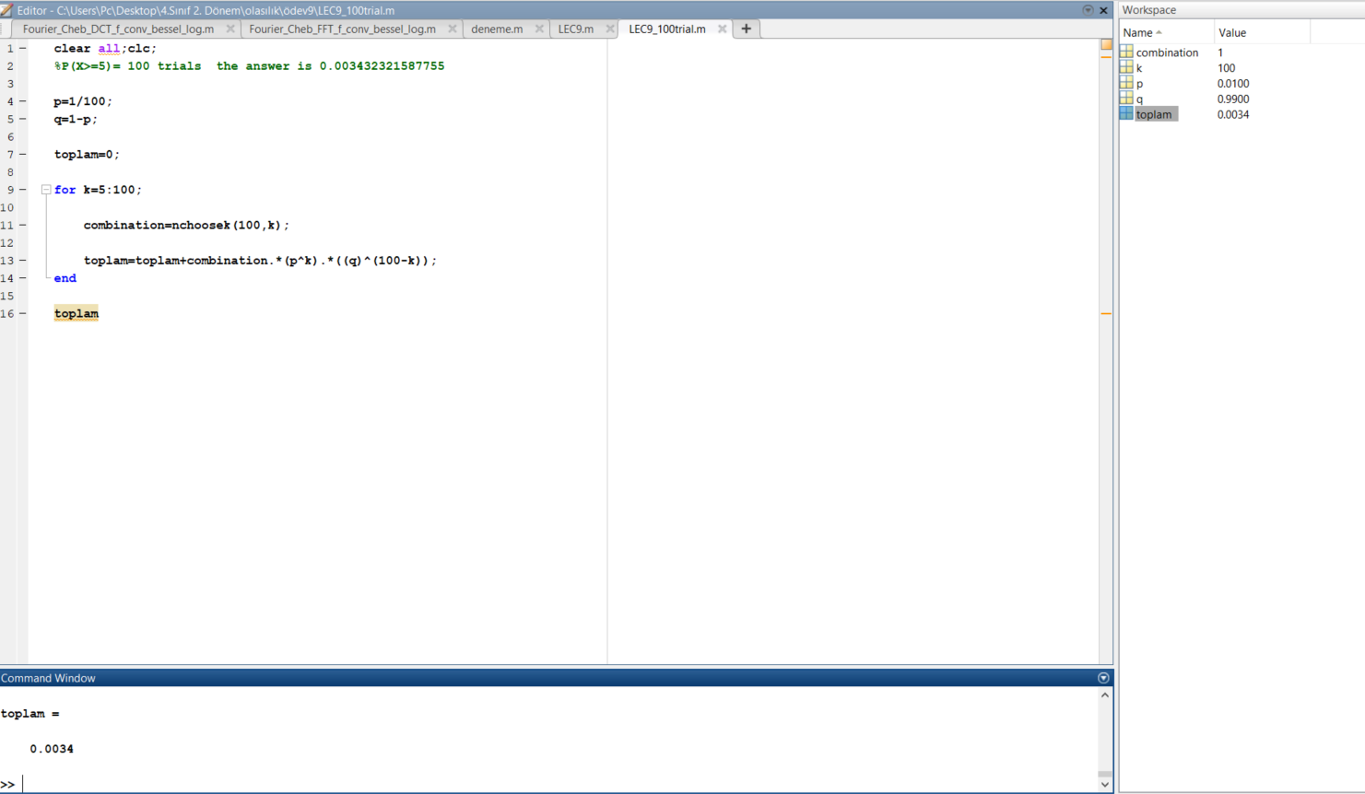

**(fig.1 (n=100))**

**Numerical answer is::::** **0.003432321587755**