**Project Proposal**

**For**

**“Cards Against Telegram”**

|  |  |
| --- | --- |
| **Instructor:** | Professor Augenblick |
| **Team Members:** | |  | | --- | | Jessica Hoban | | Amir Omidi | | Balaji Lakshmanan | | Sagar Patel | | Tanfe Aderemi | |
| **Cycle:** | 1 |
| **Date Submitted:** | 13 October 2016 |

Document template copyright 2015, CCI Faculty, Version 2.0. Use permitted under Creative Commons license CC-BY-NC-SA. See http://creativecommons.org/licenses/by-nc-sa/3.0/

**Grading Rubric – Project Proposal**

This rubric outlines the grading criteria for this document. Note that the criteria represent a plan for grading. Change is possible, especially given the dynamic nature of this course. Any change will be applied consistently for the entire class.

|  |  |  |  |  |
| --- | --- | --- | --- | --- |
| **Achievement** | **Minimal** | **Exemplary** | **Pts** | **Score** |
| **Content** | Section(s) missing, not useful, inconsistent, or wrong. | Provides all relevant information correctly and with appropriate detail |  |  |
| Project |  |  | 30 |  |
| Team |  |  | 10 |  |
| Timeline |  |  | 30 |  |
| **Grammar and Spelling** | Many serious mistakes in grammar or spelling | Grammar, punctuation, and spelling all correct | 10 |  |
| **Expression** | Hard to follow or poor word choices | Clear and concise. A pleasure to read | 10 |  |
| **Tone** | Tone not appropriate for technical writing | Tone is consistently professional |  |  |
| **Organization** | Information difficult to locate | All information is easy to find and important points stand out | 10 |  |
| **Layout** | Layout is inconsistent, visually distracting, or hinders use | Layout is attractive, consistent, and helps guide the reader |  |  |
| **Late Submission** |  |  |  |  |
| **Total** |  |  | 100 |  |

**Project Proposal**

**Project**

## **Project Name:** Cards Against Telegram

## **Abstract:**

Cards Against Telegram is an implementation of the popular game, Cards Against Humanity, inside Telegram. We will implement an interface to play Cards Against Humanity with your friends and other users who use telegram. The user will be able to select card packs, invite other players and see game related statistics on the website and on the bot.

The motivation for this project is that, since chatbot games are gaining popularity and momentum, there is a public demand for this project. Our target audience is people in their late teens.

## **Project Deliverables:**

A Telegram bot created using Telegram’s bot API. This bot will create a multiplayer platform to play cards against humanity with your friends who use Telegram.

## **Resources:**

* Hardware: Desktop/Laptop when using Telegram through the computer or smartphone with touch responsiveness for mobile accessibility
* Software: Telegram’s bot API, Internet browser access to see website. Access to database for scores, user records, etc.

## **Expertise**

* Programming languages and frameworks:
  + Java
  + Redis (Key->Value, Pubsub)
  + Python
  + Flask
  + HTML
  + CSS
  + JS
* Tools:
  + git
  + Maven
  + lombok

**Team**

## **Team Members and Roles**

Figure 1, below, identifies all the team members and the initial role assigned to each person.

|  |  |
| --- | --- |
| **Name** | **Role** |
| Jessica Hoban | Project Manager |
| Amir Omidi | Telegram Backend |
| Balaji Lakshmanan | Telegram Backend |
| Sagar Patel | Website Backend |
| Tanfe Aderemi | Website Frontend |

**Figure 1 - Team Members and Roles**

**Timeline**

The figure below shows the initially identified set of activities for this cycle.

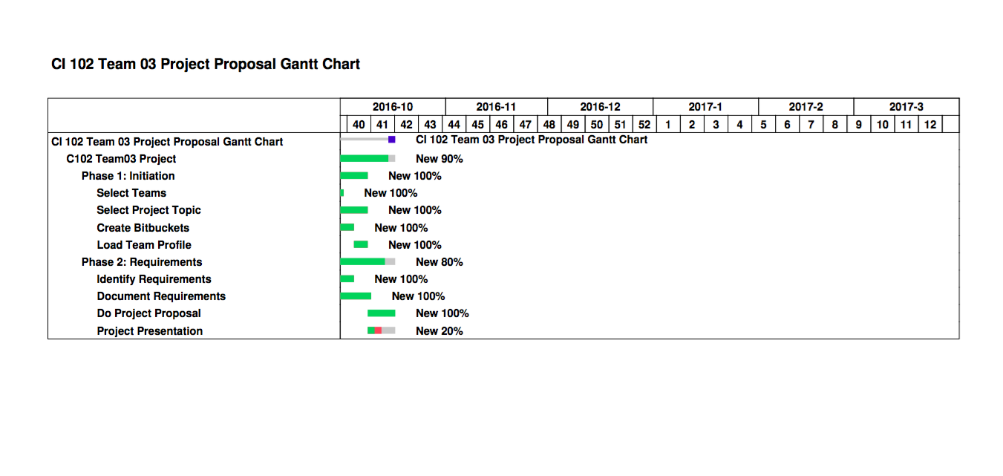

**Figure 2 – Project Timeline**