**Software Requirements and Design Document**

**For**

**Group 21**

Version 2.0

**Authors**:

Leylanni Quijano-Shafer

Felipe Bergano

Liz Parra

Andres Paz Vicca

Raymond Chen

* **Overview**

We aim to create a mobile app that allows a group of people that are headed for a night out to remain connected all in one place. The app would allow users to make groups through which they can share their location and chat with the other members.

* **Functional Requirements**

1) User is able to create an account that will allow them access to groups that they are in. High Priority

2) System allows for the creation of groups of users. High Priority

3) System tracks user in real time and uploads their location to the database

4) Groups of users can chat with others in the group and also see the locations of group members. High Priority

5) System has a button that sends an SOS message to others in the group. High Priority

6) User is able to upload a profile picture. Low Priority

**Non-functional Requirements**

1) Ensuring that the user’s location is only visible to other users in the same group

2) Making sure that the user exists in the database when trying to log in

3) Verify e-mail is unique and belongs to the user

4) Messages shared between users will be private

5) Verify phone number when creating a chat and registering

**Use Case Diagram**

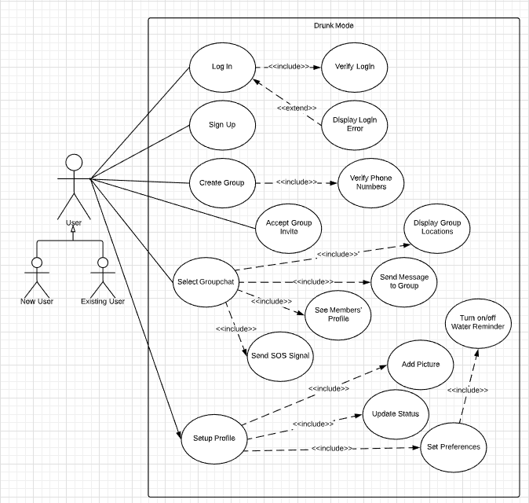

* **Class Diagram and/or Sequence Diagrams**

**Operating Environment**

The system will operate on Android phones, from Android API16 forward.

**Assumptions and Dependencies**

For user testing purposes, we expect users to use a real phone number since it needs to be verified. For our first iteration we expect the user to use a valid email and name. We are also assuming that the phone number will be a U.S number and that it will stay logged in until the app is deleted.