**Module -02: GIT Assignment -1**

Based on what you learn in the class, do the following steps:

* Create a new folder
* Put the following files in the folder
  1. Code.txt
  2. Log.txt
  3. Output.txt
* Stage the Code.txt and Output.txt files
* Commit them
* And finally push them to github

Please share the commands for the above points

* Open the Git Bash terminal from windows OS
* mkdir assignment1 (Making directory)
* cd assignment1 (Change directory)
* git init (Initialized empty Git repository)
* touch Code.txt Log.txt Output.txt (Create empty files)
* git status (To check the status of the files)

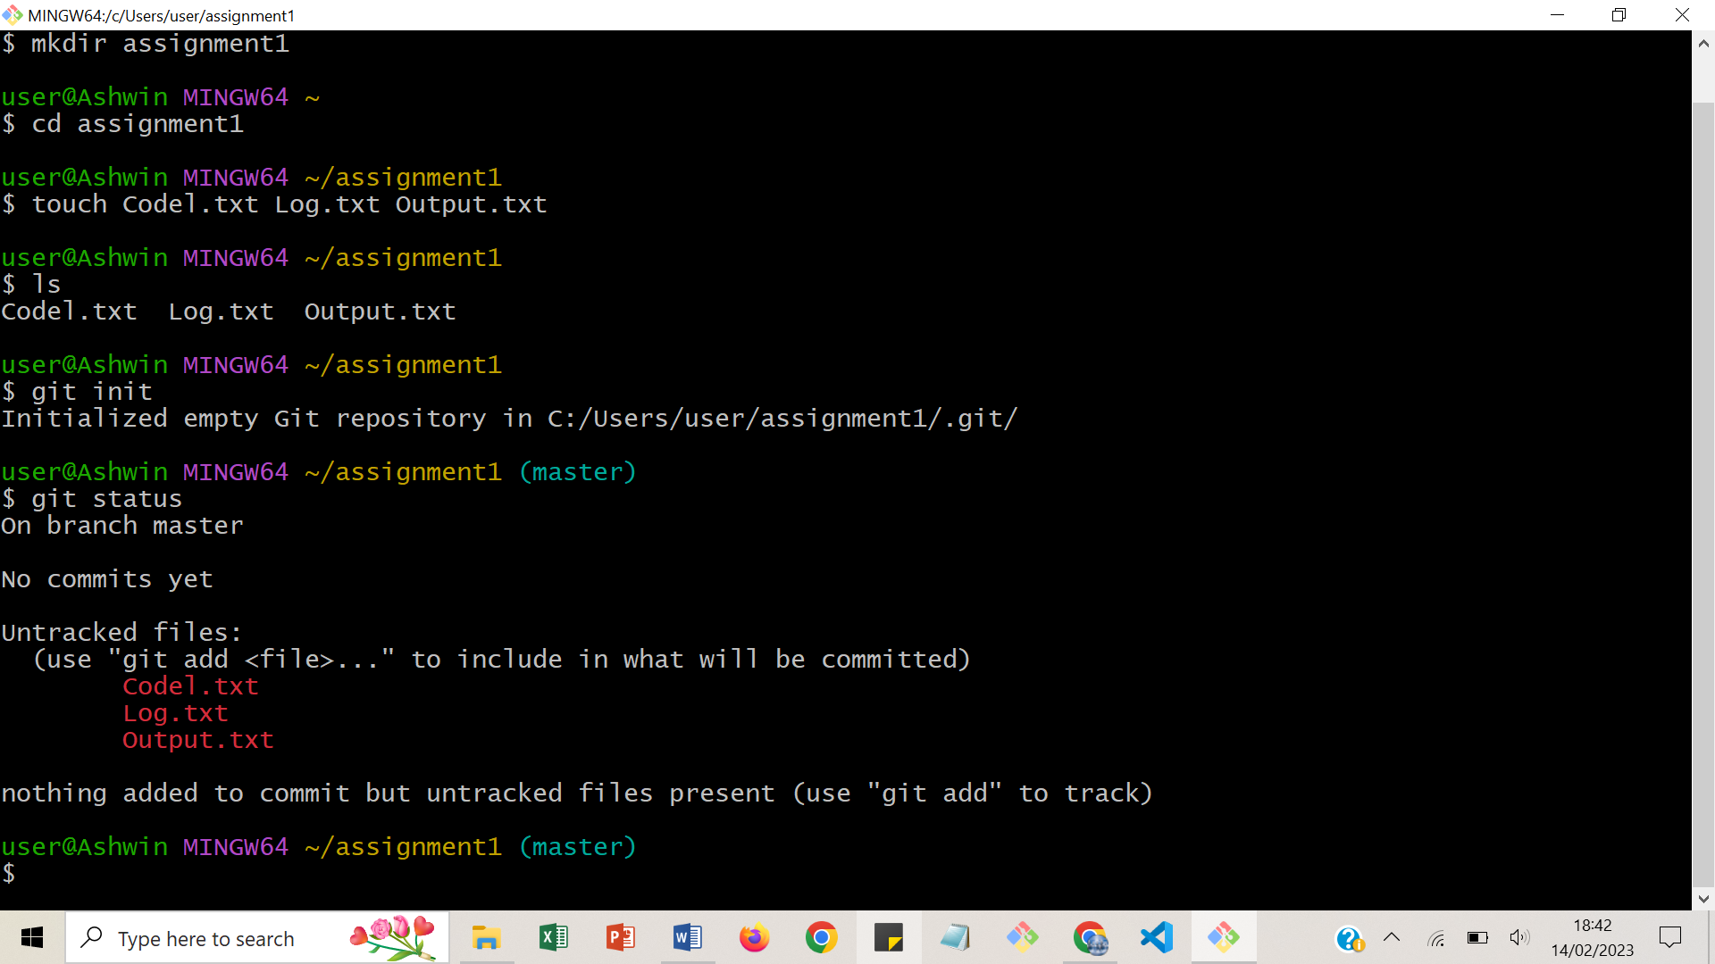

* git add Code.txt Output.txt (To add file in staging area)
* git status

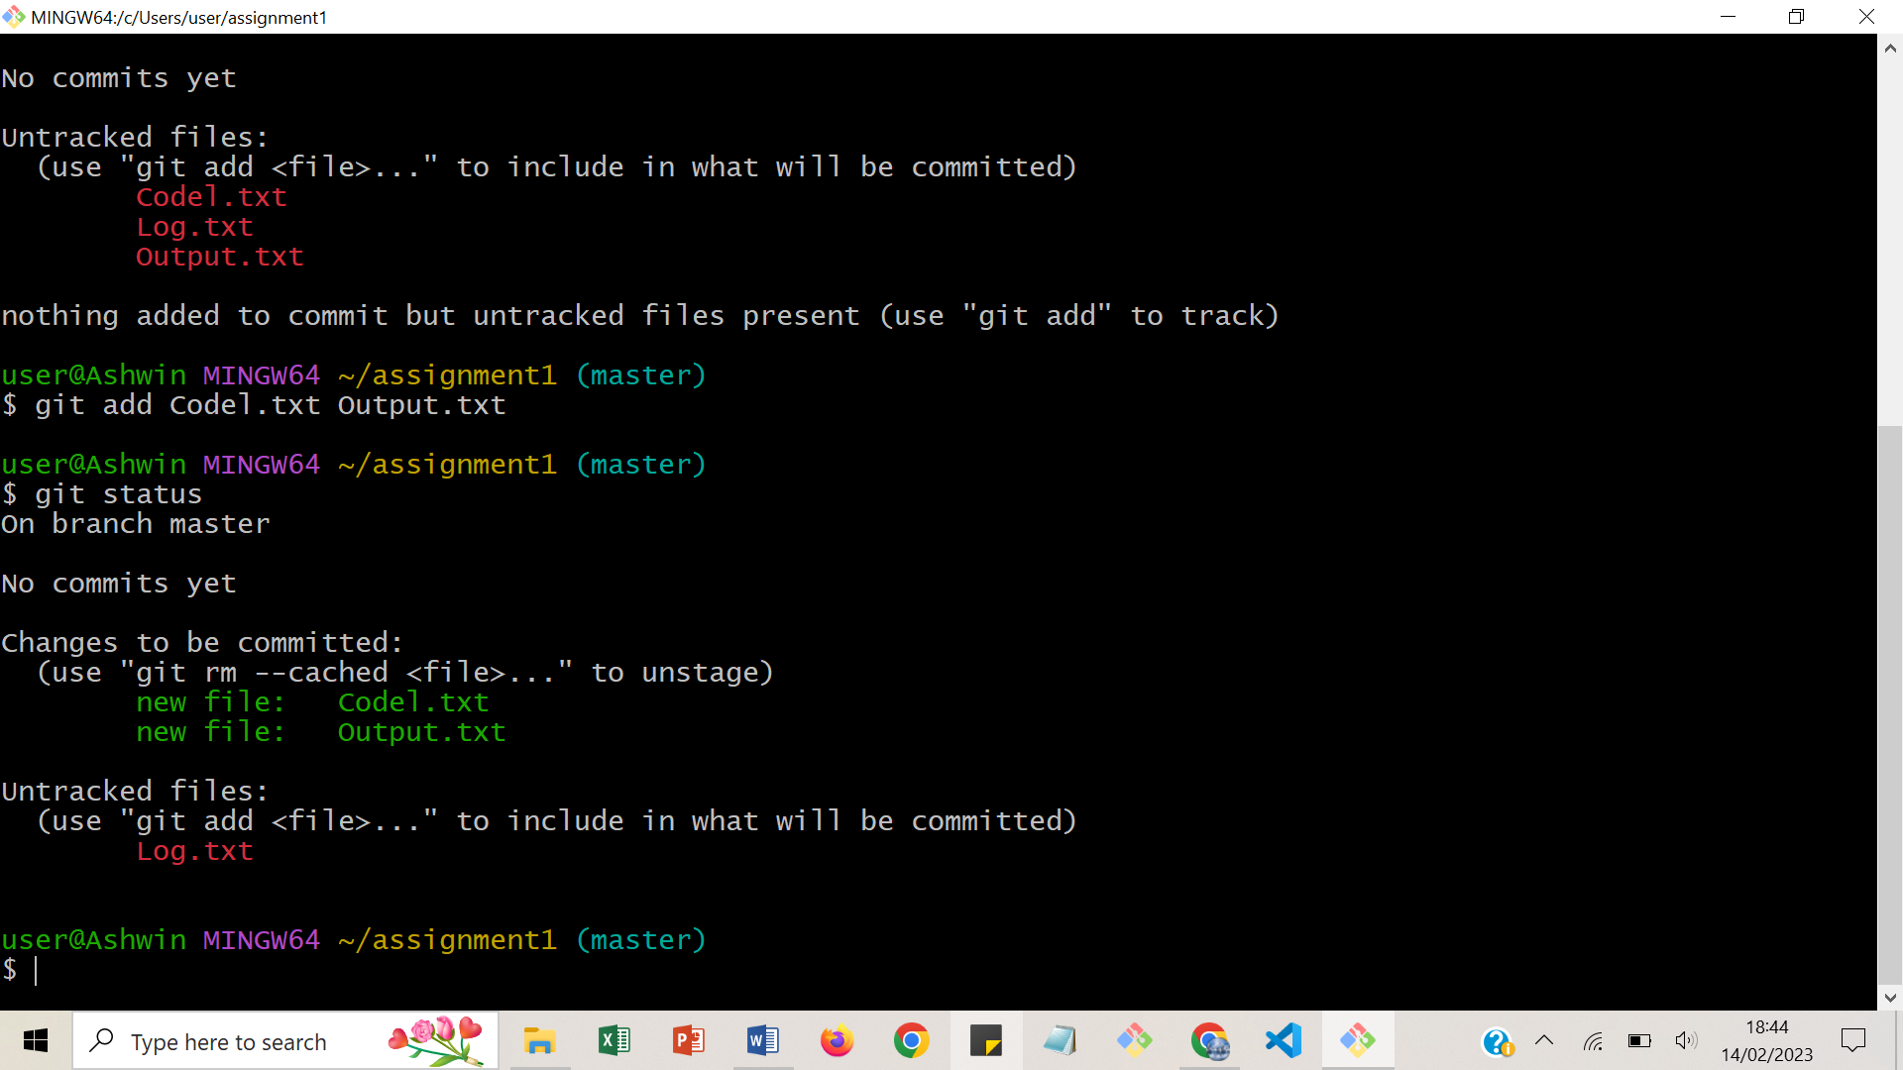

* git commit –m “First commit to adding Code.txt and Output.txt file”
* (To save the files in git repository)
* git status
* git log –graph –pretty --oneline

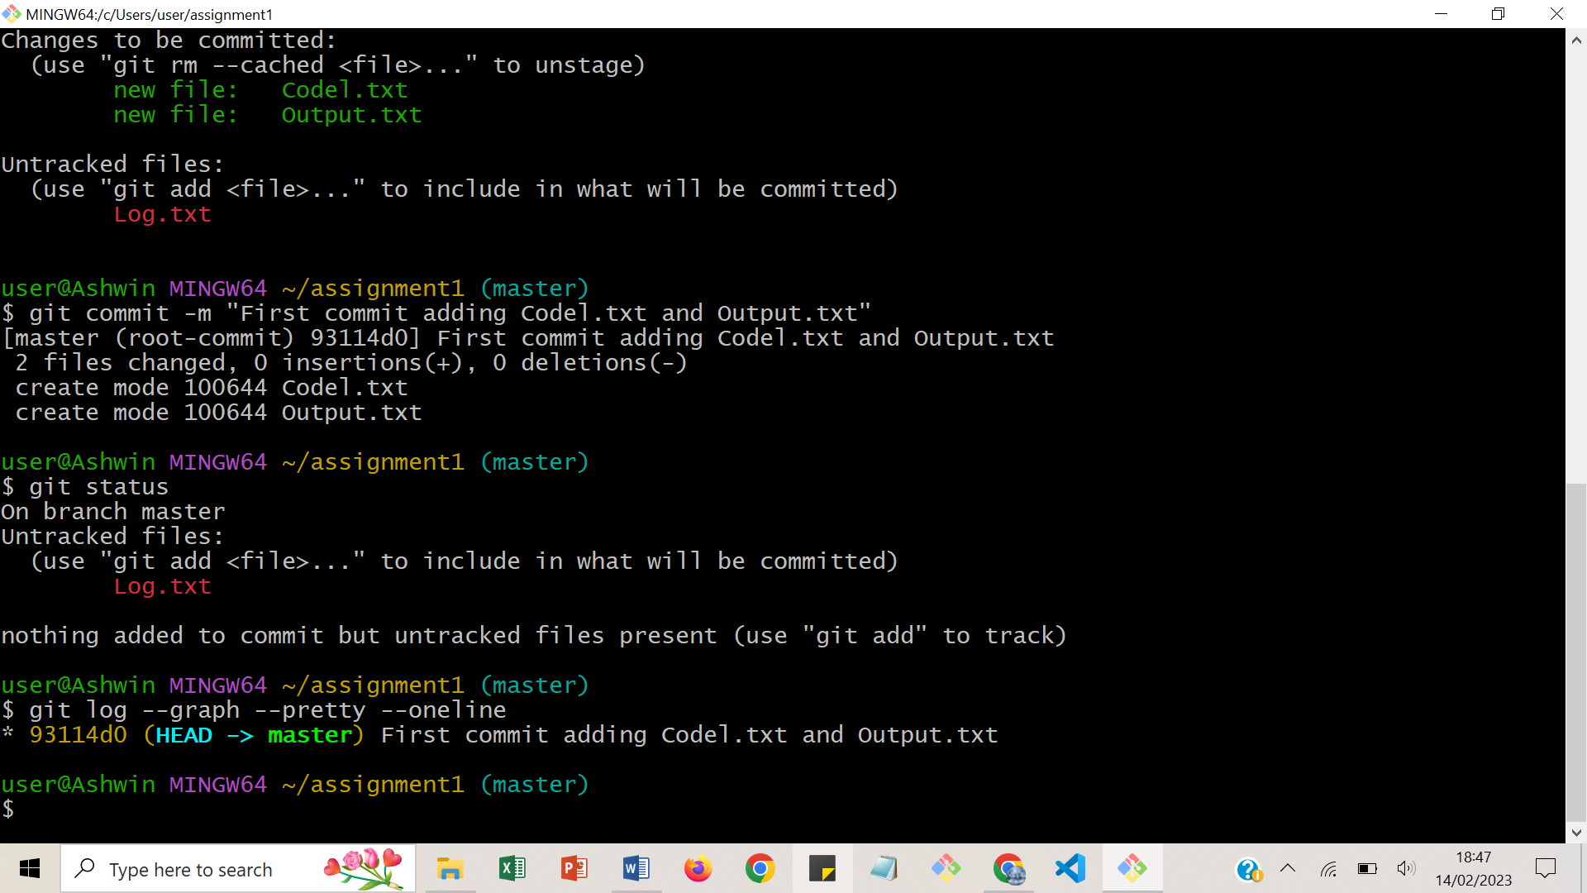

* Go to GitHub 🡪 login 🡪 Create a new repository 🡪 Copy HTTPS link
* Go back to git bash

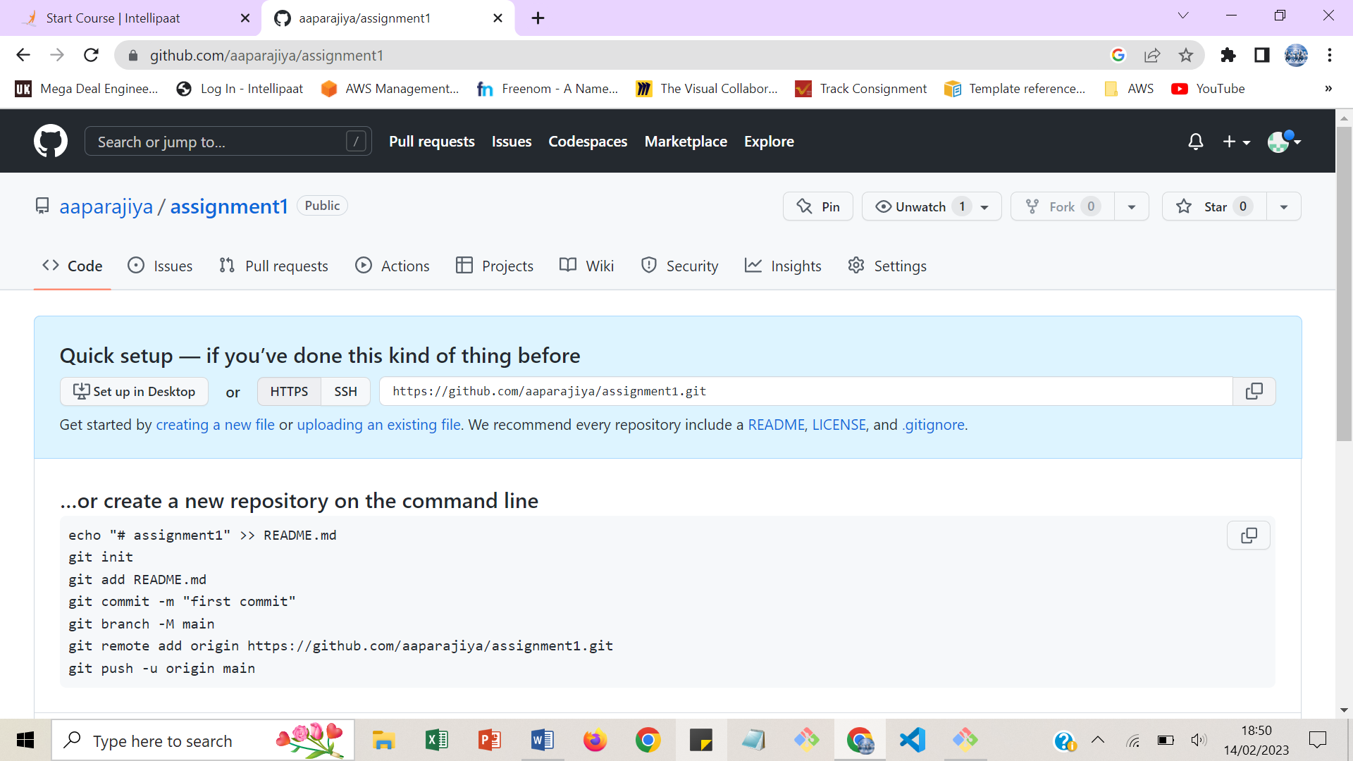

* git remote add origin https://github.com/aaparajiya/assignment1.git
* git push origin master (To push the changes to repository)
* git status
* Go back to GitHub and refresh page and see files are updated to git repository

