**Software Project**

**SpaceZ** industries is in the business of launching rockets and satellites in space for their customers. Every **SpaceZ** space-craft launch has two parts a launch vehicle or the "Rocket" and the payload which could be a satellite. **SpaceZ** has a Deep Space Network (**DSN**) facility containing a Mission-Control system and communication system from which they launch and communicate with their spacecrafts.

**SpaceZ wants you to design a software system to run their operations. This software system can be classified as follows:**

**1) DSN Software Component Features:**

1. Able to show dashboard for

1. All current active spacecrafts.

2. All spacecrafts waiting to be launched.

2. Able to select a specific active spacecraft and look at its data.

3. Able to send command to a specific spacecraft.

4. Able to launch a new spacecraft.

**2) Launch-Vehicle Software Component Features:**

1. Able to receive and process commands from DSN.

2. Able to send real-time telemetry of itself back to DSN.

**3) Payload/Satellite Software Component Features:**

1. Able to receive and process commands from DSN.

2. Able to send real-time telemetry of itself back to DSN.

3. Able to send its Data back to DSN.

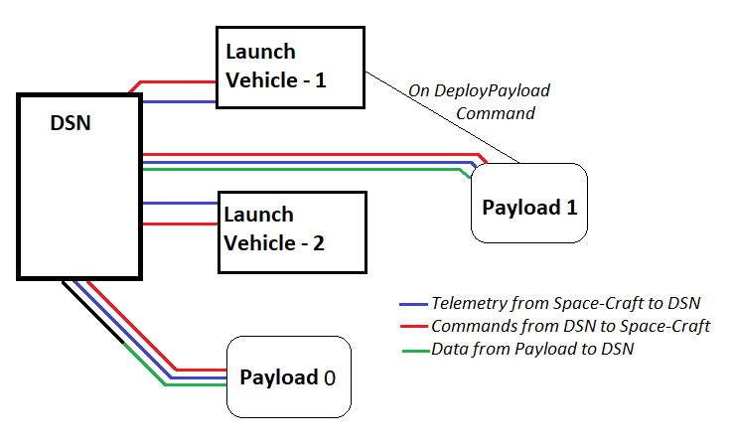

*Example software components and communication interfaces between them:*

*DSN launched LV-1 and Deployed its Payload, DSN launched LV-2 and not yet deployed its Payload and DSN has Payload 0 with its LV-0 already Deorbited*

**Design Rules:**

**Configuration:**

* A **Launch-Vehicle** configuration should be defined in a config-file with following information

1. Name: Name of launch vehicle.
2. Orbit Info: Radius of orbit in (km).
3. Payload Config-File: Pointer to the configuration file for payload.

* A **Payload** configuration should be defined in a config-file with following information

1. Name: Name of payload
2. Type: Type of payload (Possible Values: Scientific, Communication, Spy)

Data sent by actual "Payload" can be modeled randomly as follows:

***Scientific:*** Periodic scientific data of your choice and format

Example,

Solar-Activity in solar-flares per second every 3 seconds *or*

Weather-data (%Rain, %Humidity, %Snow) every 1 min.

***Communication:*** Periodic communication utilization data of your choice and format

Example,

Bandwidth utilization (Uplink and downlink data rates) every 5 seconds.

***Spy:*** Periodic image data of your choice and format

Example:

An image every 10 seconds.

**Launch Sequence:**

**DSN** launches a **Launch-Vehicle** as follows:

* User should be able to select a **Launch-Vehicle** configuration file and launch.
* **DSN** software should then start the program/executable for Launch-Vehicle with the selected configuration-file.
* Using the orbit info in the configuration Launch-Vehicle will "fly" till the orbit is reached. This needs to be simulated as follows:
  + Using orbit info launch vehicle will calculate time-to orbit as follows:

t = (Orbit Radius in km / 3600 + 10) seconds

* After t seconds have elapsed only then **Launch-Vehicle** can then accept “***DeployPayload***” command from **DSN**.
* After t seconds have elapsed **Launch-Vehicle** needs to "update" **DSN** that it has reached its orbit.

**Commands:**

**Launch-Vehicle** software should accept following Commands from **DSN**:

* ***DeployPayload***: Start the **Payload** software program/executable with the configured **Payload** Config-File.
* ***Deorbit***: End the **Launch-Vehicle** software program to simulate that **Launch-Vehicle** has been de-orbited.
* ***StartTelemetry***: Start sending (random/realistic up to you) telemetry data every second to **DSN**.
* ***StopTelemetry***: Stop sending telemetry data to **DSN**.

**Payload** software should accept following Commands from DSN:

* ***StartData***: Start sending data configured according to "*Type*" in **Payload** Config-File to **DSN**.
* ***StopData***: Stop sending data to **DSN**
* ***Decommission***: End **Payload** software program to simulate that **Payload** has ended its mission.
* ***StartTelemetry***: Start sending (random/realistic up to you) telemetry data every second to **DSN**.
* ***StopTelemetry***: Stop sending telemetry data to **DSN**.

**Telemetry:**

* Telemetry data sent by either Launch-Vehicle or Payload can be random or realistic.
* Each piece of telemetry can include following information
  + Altitude: in km
  + Longitude: in degrees (-90 deg (South) to +90 deg (North))
  + Latitude: in degrees (-180 deg (West) to 180 deg (East))
  + Temperature: in kelvin
  + **Time to Orbit**: in seconds counting down to 0 (This must be the from above t calculation)
* Example:

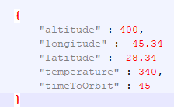

*Example guidelines:*

Configuration for a Launch-Vehicle and its payload can be as follows:

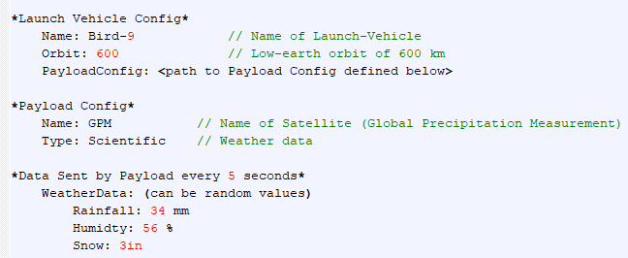

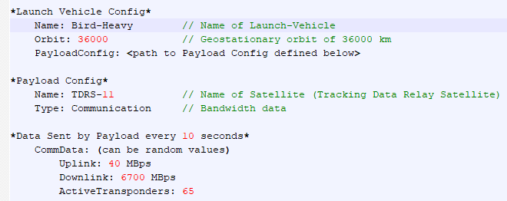

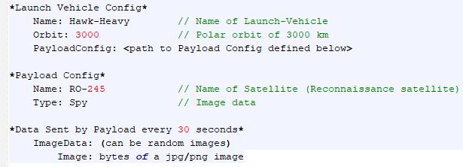

**Submission Criteria:**

* Implementation can be done in any choice of language/platform provided it can be run and tested easily on a Windows Machine.
  + Preferred option is .NET platform with C# language and Visual Studio for solution. WPF for UI side, WCF for inter-process communication.
* Please provide a **complete working solution** and instructions on how to run.
* If you are using any third-party dependencies or libraries, please provide instructions on how to set them up before we can run and test your submission. Please include them in your submission as well.
* Your submission must have ***distinct programs/executables*** for DSN, Launch-Vehicle and Payload and demonstrate the required communication between them.
* Your submission must include **complete source-code** and instructions on how to compile and build it.
* Only the DSN software component has some user-interface requirements, the other two components need not have user-interface.