STA5030-Project.R

aaronpopyk

2021-12-14

setwd("/Users/aaronpopyk")  
data = read.csv("fredgraph.csv", header=T)  
  
cpi = data$CPILFESL_PC1  
mb = data$BOGMBASE  
  
n = length(cpi)  
CPI = c()  
for(i in 1:n-1) {  
 CPI[i] = cpi[i+1] - cpi[i]  
}  
  
m = length(mb)  
MB = c()  
for(i in 1:m-1) {  
 MB[i] = mb[i + 1] - mb[i]  
}  
  
  
# Maximize Pearson's r   
  
t = (25:440)  
  
r = cor(MB[t], CPI[t])  
  
for (i in 1:24){  
 r[i] = cor(MB[t-i], CPI[t])  
}  
  
plot(r, xlab="Monthly Observation (i)", ylab="Pearson's Coefficient (r)", main="Correlation Plot of (M0 - i) and CPI")

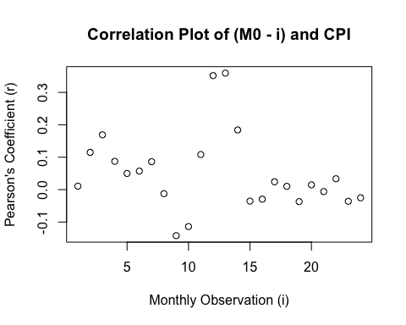

max(r)

## [1] 0.3593724

which.max(r)

## [1] 13

# 1985-2021  
  
plot(mb, cpi, xlab="Monetary Base ($)", ylab="Consumer Price Index (%)", main="M0 & CPI (Jan.1985-Sept.2021, before adj.)")

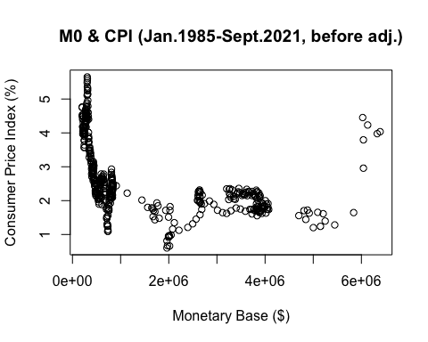

LM1 = lm(CPI~MB)  
summary(LM1)

##   
## Call:  
## lm(formula = CPI ~ MB)  
##   
## Residuals:  
## Min 1Q Median 3Q Max   
## -0.41032 -0.08653 -0.00771 0.06887 1.36894   
##   
## Coefficients:  
## Estimate Std. Error t value Pr(>|t|)   
## (Intercept) 3.174e-03 7.486e-03 0.424 0.67180   
## MB -2.989e-07 9.796e-08 -3.051 0.00242 **  
## ---  
## Signif. codes: 0 '***' 0.001 '**' 0.01 '*' 0.05 '.' 0.1 ' ' 1  
##   
## Residual standard error: 0.1543 on 438 degrees of freedom  
## Multiple R-squared: 0.02081, Adjusted R-squared: 0.01857   
## F-statistic: 9.308 on 1 and 438 DF, p-value: 0.00242

plot(MB, resid(LM1), xlab="Adj.Monetary Base (Jan.1985-Sept.2021)")

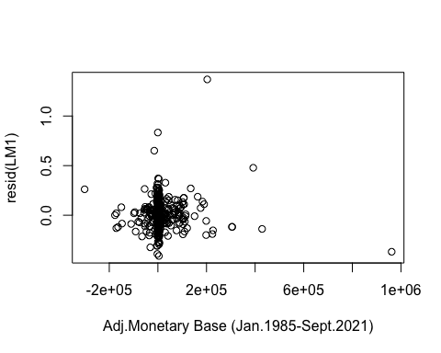

plot(resid(LM1), xlab="Monthly Observation (Jan.1985-Sept.2021)")

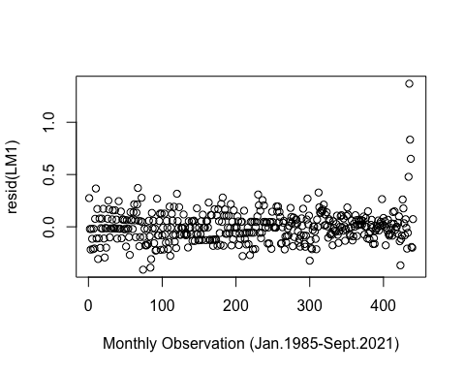

qqnorm(resid(LM1))

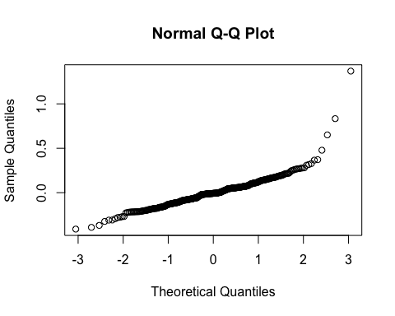

# 1985-2008  
  
t2 = (1:285)  
plot(mb[t2],cpi[t2], xlab="Monetary Base ($)", ylab="Consumer Price Index (%)", main="M0 & CPI (Jan.1985-Aug.2008, before adj.)")

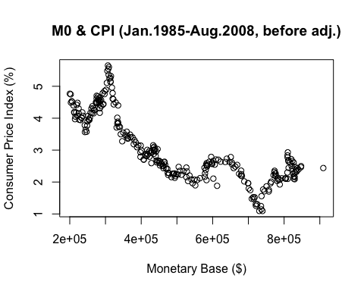

MB2 = MB[1:272]  
CPI2 = CPI[14:285]  
  
plot(MB2,CPI2, xlab="Monetary Base ($)", ylab="Consumer Price Index (%)", main="M0 & CPI (Jan.1985-Aug.2008, after adj.)")  
  
LM2 = lm(CPI2~MB2)  
summary(LM2)

##   
## Call:  
## lm(formula = CPI2 ~ MB2)  
##   
## Residuals:  
## Min 1Q Median 3Q Max   
## -0.38330 -0.09056 -0.00288 0.07603 0.38215   
##   
## Coefficients:  
## Estimate Std. Error t value Pr(>|t|)  
## (Intercept) -1.253e-02 9.104e-03 -1.377 0.170  
## MB2 2.326e-06 1.865e-06 1.248 0.213  
##   
## Residual standard error: 0.1325 on 270 degrees of freedom  
## Multiple R-squared: 0.005731, Adjusted R-squared: 0.002049   
## F-statistic: 1.556 on 1 and 270 DF, p-value: 0.2133

plot(MB2, CPI2, xlab="Monetary Base ($)", ylab="Consumer Price Index (%)", main="M0 & CPI (Jan.1985-Aug.2008, after adj.)")  
abline(LM2)

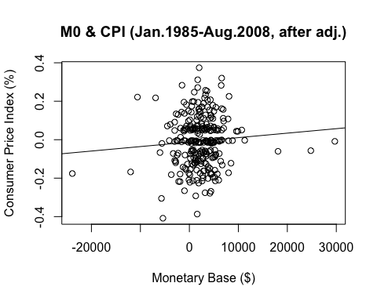

plot(MB2, resid(LM2), xlab="Monetary Base ($)", main="Residual Plot (Jan.1985-Aug.2008, after adj.)")  
abline(0,0)

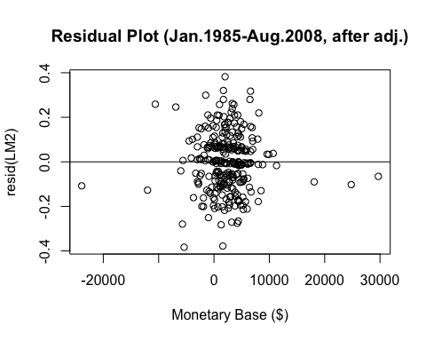

plot(resid(LM2), xlab="Monthly Observation (Time)", main="Residual Index Plot (Jan.1985-Aug.2008)")  
abline(0,0)

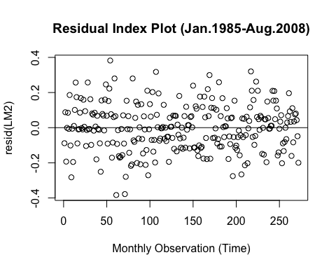

qqnorm(resid(LM2), main="Normal Q-Q Plot (Jan.1985-Aug.2008)")

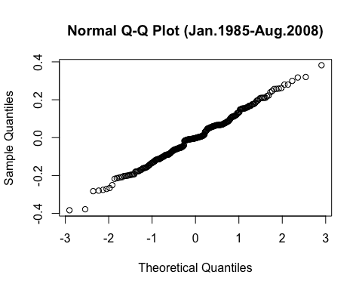

# 2008-2021  
  
t3 = (286:441)  
plot(mb[t3],cpi[t3], xlab="Monetary Base ($)", ylab="Consumer Price Index (%)", main="M0 & CPI (Sept.2008-Sept.2021, before adj.)")

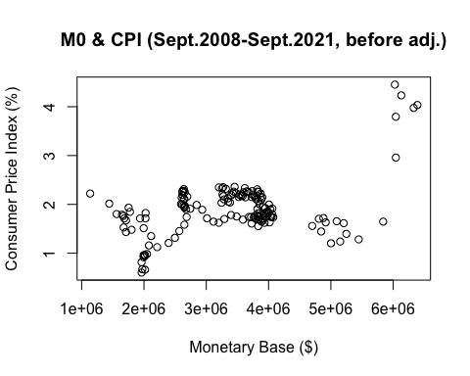

MB3 = MB[285:427]  
CPI3 = CPI[298:440]  
  
plot(MB3,CPI3, xlab="Monetary Base ($)", ylab="Consumer Price Index (%)", main="M0 & CPI (Sept.2008-Sept.2021, after adj.)")  
  
LM3 = lm(CPI3~MB3)  
summary(LM3)

##   
## Call:  
## lm(formula = CPI3 ~ MB3)  
##   
## Residuals:  
## Min 1Q Median 3Q Max   
## -0.66932 -0.08230 -0.01016 0.07930 0.99230   
##   
## Coefficients:  
## Estimate Std. Error t value Pr(>|t|)   
## (Intercept) -4.325e-03 1.417e-02 -0.305 0.761   
## MB3 7.546e-07 1.138e-07 6.632 6.53e-10 ***  
## ---  
## Signif. codes: 0 '***' 0.001 '**' 0.01 '*' 0.05 '.' 0.1 ' ' 1  
##   
## Residual standard error: 0.1654 on 141 degrees of freedom  
## Multiple R-squared: 0.2378, Adjusted R-squared: 0.2324   
## F-statistic: 43.99 on 1 and 141 DF, p-value: 6.535e-10

plot(MB3, CPI3, xlab="Monetary Base ($)", ylab="Consumer Price Index (%)", main="M0 & CPI (Sept.2008-Sept.2021, after adj.)")  
abline(LM3)

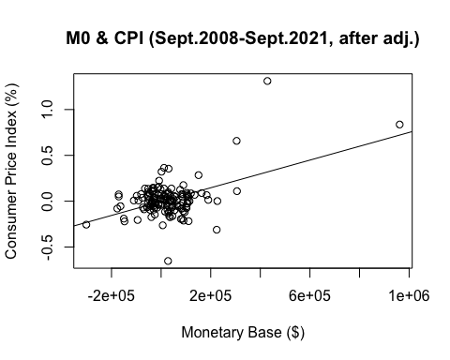

plot(MB3, resid(LM3), xlab="Monetary Base ($)", main="Residual Plot (Sept.2008-Sept.2021, after adj.)")  
abline(0,0)

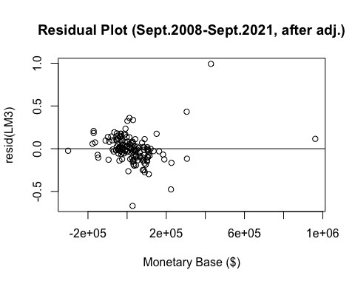

plot(resid(LM3), xlab="Monthly Observation (Time)", main="Residual Index Plot (Sept.2008-Sept.2021)")  
abline(0,0)

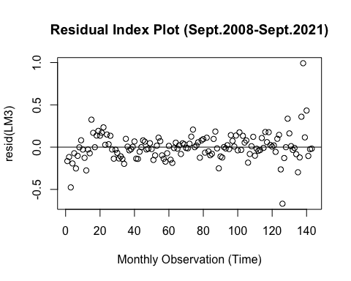

qqnorm(resid(LM3), main="Normal Q-Q Plot (Sept.2008-Sept.2021)")

