MAT-5740–HON-Option-.R

aaronpopyk

2022-03-23

# MAT 5740 Honors Credits Assignment  
  
#2.)  
D = read.csv("daily-treasury-rates.csv", header=TRUE)  
D = subset(D, select = -Date)  
  
n = c(52, 303, 554, 804, 1053, 1303, 1553, 1804, 2054, 2304, 2554, 2804, 3056, 3306, 3557, 3808, 4058, 4308, 4558, 4808)  
n = rev(n)  
  
x = c(1/12, 2/12, 3/12, 6/12, 1, 2, 3, 5, 7, 10, 20, 30)  
  
plot(x, D[52,], xlab="Maturity (years)", ylab="Yield Rate (%)", type="b", main="2021")

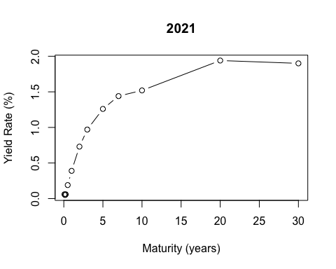

plot(x, D[303,], xlab="Maturity (years)", ylab="Yield Rate (%)", type="b", main="2020")

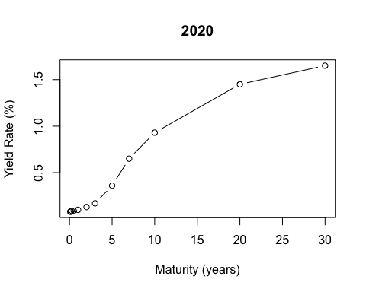

plot(x, D[554,], xlab="Maturity (years)", ylab="Yield Rate (%)", type="b", main="2019")

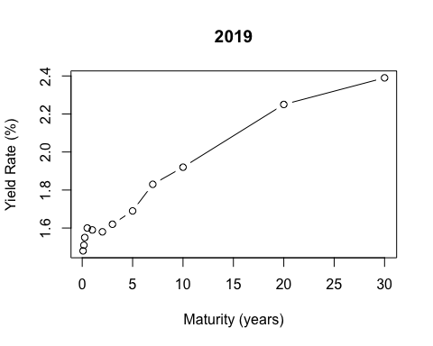

plot(x, D[804,], xlab="Maturity (years)", ylab="Yield Rate (%)", type="b", main="2018")

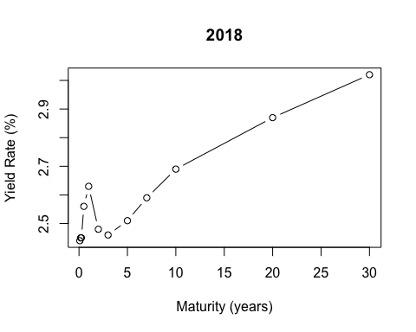

plot(x, D[1053,], xlab="Maturity (years)", ylab="Yield Rate (%)", type="b", main="2017")

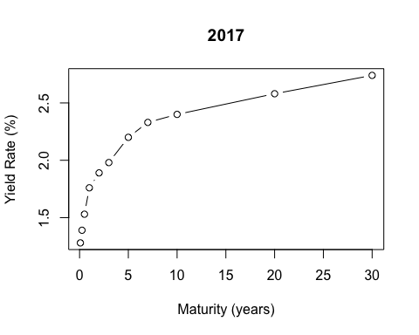

plot(x, D[1303,], xlab="Maturity (years)", ylab="Yield Rate (%)", type="b", main="2016")

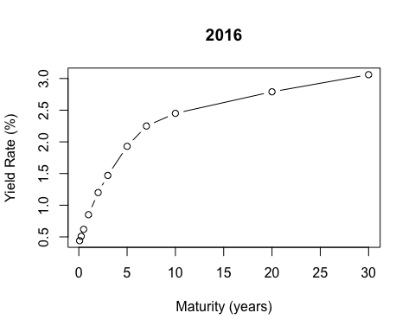

plot(x, D[1553,], xlab="Maturity (years)", ylab="Yield Rate (%)", type="b", main="2015")

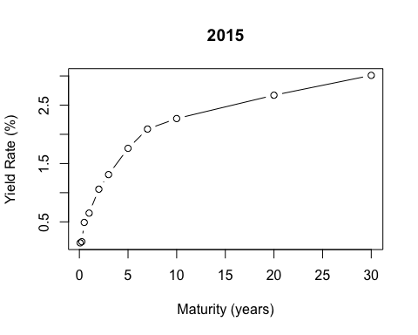

plot(x, D[1804,], xlab="Maturity (years)", ylab="Yield Rate (%)", type="b", main="2014")

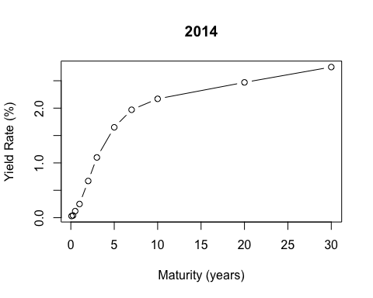

plot(x, D[2054,], xlab="Maturity (years)", ylab="Yield Rate (%)", type="b", main="2013")

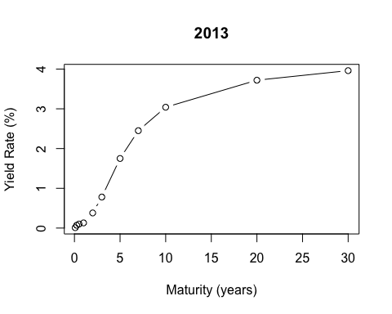

plot(x, D[2304,], xlab="Maturity (years)", ylab="Yield Rate (%)", type="b", main="2012")

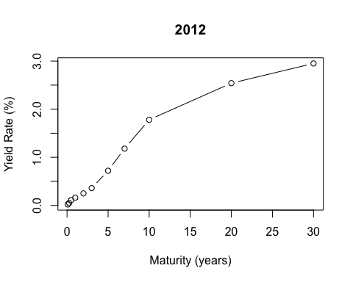

plot(x, D[2554,], xlab="Maturity (years)", ylab="Yield Rate (%)", type="b", main="2011")

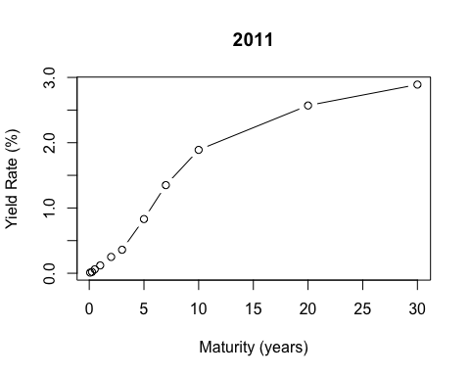

plot(x, D[2804,], xlab="Maturity (years)", ylab="Yield Rate (%)", type="b", main="2010")

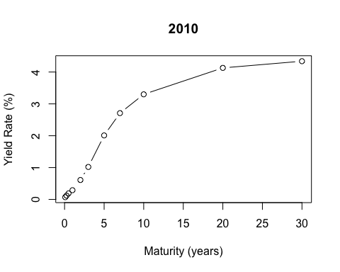

plot(x, D[3056,], xlab="Maturity (years)", ylab="Yield Rate (%)", type="b", main="2009")

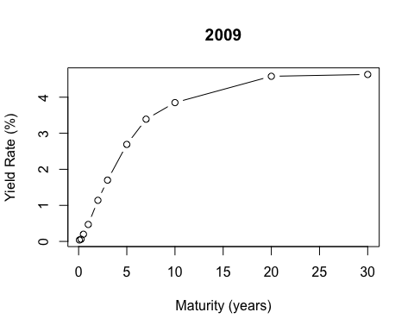

plot(x, D[3306,], xlab="Maturity (years)", ylab="Yield Rate (%)", type="b", main="2008")

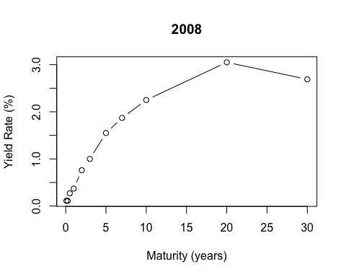

plot(x, D[3557,], xlab="Maturity (years)", ylab="Yield Rate (%)", type="b", main="2007")

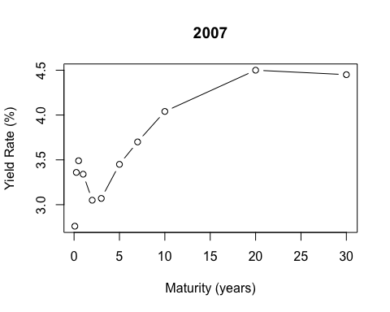

plot(x, D[3808,], xlab="Maturity (years)", ylab="Yield Rate (%)", type="b", main="2006")

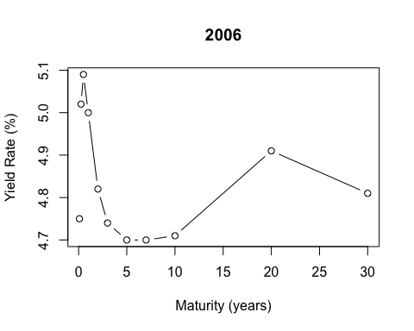

plot(x, D[4058,], xlab="Maturity (years)", ylab="Yield Rate (%)", type="b", main="2005")

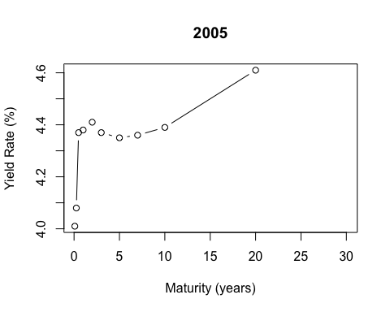

plot(x, D[4308,], xlab="Maturity (years)", ylab="Yield Rate (%)", type="b", main="2004")

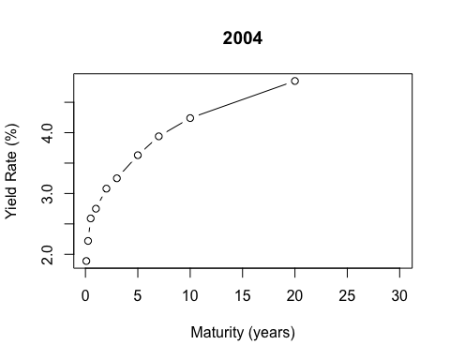

plot(x, D[4558,], xlab="Maturity (years)", ylab="Yield Rate (%)", type="b", main="2003")

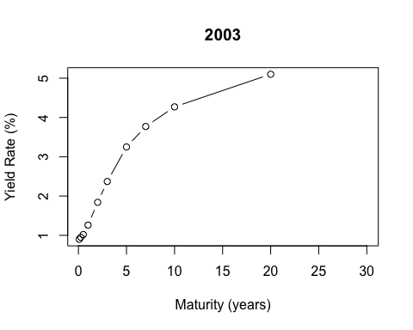

plot(x, D[4808,], xlab="Maturity (years)", ylab="Yield Rate (%)", type="b", main="2002")

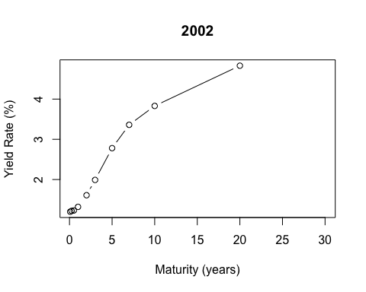

#3.) y = ((x2-x)/(x2-x1))*%+((x-x1)/(x2-x1))*%, 4,6,8,9 years, where n[1] = 2002...n[20] = 2021  
  
#4 years  
  
Y4 = ((5-4)/(5-3))*D[n,7]+((4-3)/(5-3))*D[n,8]  
for (i in 1:20) {  
 Y4[i] = ((5-4)/(5-3))*D[n[i],7]+((4-3)/(5-3))*D[n[i],8]  
}  
Y4

## [1] 2.385 2.810 3.440 4.360 4.720 3.260 1.275 2.195 1.515 0.595 0.540 1.265  
## [13] 1.375 1.535 1.700 2.090 2.485 1.655 0.265 1.115

#6 years   
  
Y6 = ((7-6)/(7-5))*D[n,8]+((6-5)/(7-5))*D[n,9]  
for (i in 1:20) {  
 Y6[i] = ((7-6)/(7-5))*D[n[i],8]+((6-5)/(7-5))*D[n[i],9]  
}  
Y6

## [1] 3.070 3.510 3.785 4.355 4.700 3.575 1.710 3.040 2.360 1.090 0.950 2.100  
## [13] 1.810 1.925 2.090 2.265 2.550 1.760 0.505 1.350

#8 years  
  
Y8 = ((10-8)/(10-7))*D[n,9]+((6-5)/(7-5))*D[n,10]  
for (i in 1:20) {  
 Y8[i] = ((10-8)/(10-7))*D[n[i],9]+((8-7)/(10-7))*D[n[i],10]  
}  
Y8

## [1] 3.5166667 3.9366667 4.0400000 4.3700000 4.7033333 3.8133333 1.9966667  
## [8] 3.5433333 2.9066667 1.5300000 1.3800000 2.6466667 2.0366667 2.1500000  
## [15] 2.3166667 2.3533333 2.6233333 1.8600000 0.7433333 1.4666667

#9 years  
  
Y9 = ((10-9)/(10-7))*D[n,10]+((9-7)/(10-7))*D[n,11]  
for (i in 1:20) {  
 Y9[i] = ((10-9)/(10-7))*D[n[i],10]+((9-7)/(10-7))*D[n[i],11]  
}  
Y9

## [1] 4.496667 4.823333 4.646667 4.536667 4.843333 4.346667 2.783333 4.336667  
## [9] 3.853333 2.343333 2.286667 3.493333 2.370000 2.536667 2.676667 2.520000  
## [17] 2.810000 2.140000 1.276667 1.800000

#4.)   
  
A = matrix(nrow=10, ncol=20)  
  
A[1,] = D[n,5]  
A[2,] = D[n,6]  
A[3,] = D[n,7]  
A[4,] = Y4  
A[5,] = D[n,8]  
A[6,] = Y6  
A[7,] = D[n,9]  
A[8,] = Y8  
A[9,] = Y9  
A[10,] = D[n,10]  
A

## [,1] [,2] [,3] [,4] [,5] [,6] [,7] [,8]  
## [1,] 1.320000 1.260000 2.750000 4.380000 5.000000 3.340000 0.370000 0.470000  
## [2,] 1.610000 1.840000 3.080000 4.410000 4.820000 3.050000 0.760000 1.140000  
## [3,] 1.990000 2.370000 3.250000 4.370000 4.740000 3.070000 1.000000 1.700000  
## [4,] 2.385000 2.810000 3.440000 4.360000 4.720000 3.260000 1.275000 2.195000  
## [5,] 2.780000 3.250000 3.630000 4.350000 4.700000 3.450000 1.550000 2.690000  
## [6,] 3.070000 3.510000 3.785000 4.355000 4.700000 3.575000 1.710000 3.040000  
## [7,] 3.360000 3.770000 3.940000 4.360000 4.700000 3.700000 1.870000 3.390000  
## [8,] 3.516667 3.936667 4.040000 4.370000 4.703333 3.813333 1.996667 3.543333  
## [9,] 4.496667 4.823333 4.646667 4.536667 4.843333 4.346667 2.783333 4.336667  
## [10,] 3.830000 4.270000 4.240000 4.390000 4.710000 4.040000 2.250000 3.850000  
## [,9] [,10] [,11] [,12] [,13] [,14] [,15] [,16]  
## [1,] 0.290000 0.120000 0.160000 0.130000 0.250000 0.650000 0.850000 1.760000  
## [2,] 0.610000 0.250000 0.250000 0.380000 0.670000 1.060000 1.200000 1.890000  
## [3,] 1.020000 0.360000 0.360000 0.780000 1.100000 1.310000 1.470000 1.980000  
## [4,] 1.515000 0.595000 0.540000 1.265000 1.375000 1.535000 1.700000 2.090000  
## [5,] 2.010000 0.830000 0.720000 1.750000 1.650000 1.760000 1.930000 2.200000  
## [6,] 2.360000 1.090000 0.950000 2.100000 1.810000 1.925000 2.090000 2.265000  
## [7,] 2.710000 1.350000 1.180000 2.450000 1.970000 2.090000 2.250000 2.330000  
## [8,] 2.906667 1.530000 1.380000 2.646667 2.036667 2.150000 2.316667 2.353333  
## [9,] 3.853333 2.343333 2.286667 3.493333 2.370000 2.536667 2.676667 2.520000  
## [10,] 3.300000 1.890000 1.780000 3.040000 2.170000 2.270000 2.450000 2.400000  
## [,17] [,18] [,19] [,20]  
## [1,] 2.630000 1.590 0.1000000 0.390000  
## [2,] 2.480000 1.580 0.1300000 0.730000  
## [3,] 2.460000 1.620 0.1700000 0.970000  
## [4,] 2.485000 1.655 0.2650000 1.115000  
## [5,] 2.510000 1.690 0.3600000 1.260000  
## [6,] 2.550000 1.760 0.5050000 1.350000  
## [7,] 2.590000 1.830 0.6500000 1.440000  
## [8,] 2.623333 1.860 0.7433333 1.466667  
## [9,] 2.810000 2.140 1.2766667 1.800000  
## [10,] 2.690000 1.920 0.9300000 1.520000

FR = matrix(nrow=10, ncol=20)  
for (k in 1:20) {   
for (j in 1:10) {  
 if (j < 2) {  
 FR[j,k] = (A[j,k]**1/1)-1}  
 else {  
 FR[j,k] = ((A[j,k]**j)/(A[j-1,k]**j-1))-1}  
}  
}  
FR

## [,1] [,2] [,3] [,4] [,5] [,6]  
## [1,] 0.3200000 0.2600000 1.7500000 3.380000000 4.000000e+00 2.34000000  
## [2,] 2.4915140 4.7617427 0.4455467 0.069493632 -3.198333e-02 -0.08400291  
## [3,] 1.4834230 1.5455670 0.2165281 -0.015485762 -4.040131e-02 0.05705766  
## [4,] 1.2037215 1.0408930 0.2665157 -0.006397446 -1.481946e-02 0.28597862  
## [5,] 1.1799508 1.0814749 0.3111229 -0.010787554 -2.058958e-02 0.33103224  
## [6,] 0.8176210 0.5882221 0.2857171 0.007065035 9.277974e-05 0.23879470  
## [7,] 0.8818080 0.6493233 0.3244983 0.008098404 1.973893e-05 0.27214888  
## [8,] 0.4399989 0.4135429 0.2220490 0.018504395 5.692086e-03 0.27302441  
## [9,] 8.1377798 5.2225675 2.5224343 0.400553325 3.021103e-01 2.24837867  
## [10,] -0.7990533 -0.7043308 -0.5998310 -0.280092637 -2.435756e-01 -0.51888326  
## [,7] [,8] [,9] [,10] [,11] [,12]  
## [1,] -0.6300000 -0.5300000 -0.7100000 -0.8800000 -0.8400000 -0.8700000  
## [2,] -1.6692156 -2.6680786 -1.4062671 -1.0634131 -1.0641420 -1.1468823  
## [3,] -2.7824549 9.2025983 -2.3728097 -1.0473966 -1.0473966 -1.5021034  
## [4,] Inf 2.1573788 62.9077976 -1.1274748 -1.0864831 -5.0656066  
## [5,] 2.7759171 1.8196610 3.6995466 -1.4256460 -1.2028038 6.3295254  
## [6,] 0.9430818 1.0886976 1.6603079 -3.4917556 -1.8540768 2.0936922  
## [7,] 0.9151255 1.1451805 1.6391705 8.8692812 -11.5597207 1.9583226  
## [8,] 0.7006926 0.4246999 0.7520917 1.9931360 3.7676367 0.8560941  
## [9,] 18.9158476 5.1617095 11.6474062 46.4068358 98.6608133 11.1600450  
## [10,] -0.8808241 -0.6958785 -0.7877859 -0.8834897 -0.9182886 -0.7509210  
## [,13] [,14] [,15] [,16] [,17] [,18]  
## [1,] -0.7500000 -0.3500000 -0.1500000 0.76000000 1.63000000 0.5900000  
## [2,] -1.4788267 -2.9456277 -6.1891892 0.70294622 0.03946323 0.6336627  
## [3,] -2.9035034 10.7691241 3.3633558 0.34968335 0.04447796 0.4439801  
## [4,] 6.7019239 1.8543951 1.2760936 0.32782975 0.07050561 0.2742742  
## [5,] 2.1239246 1.2450685 1.0288954 0.32559689 0.06253690 0.2075651  
## [6,] 0.8333326 0.7716251 0.6444450 0.20149116 0.10392357 0.3329334  
## [7,] 0.8381954 0.7966579 0.6855981 0.22302797 0.11670118 0.3395273  
## [8,] 0.3108366 0.2575694 0.2650566 0.08422758 0.10826659 0.1480518  
## [9,] 2.9190102 3.4347294 2.6711546 0.85203873 0.85673274 2.5460141  
## [10,] -0.5858177 -0.6706453 -0.5871988 -0.38602730 -0.35364107 -0.6618649  
## [,19] [,20]  
## [1,] -0.9000000 -0.6100000  
## [2,] -1.0170707 -1.6284939  
## [3,] -1.0049238 -2.4937781  
## [4,] -1.0049357 -14.4743812  
## [5,] -1.0060545 3.3903811  
## [6,] -1.0166224 1.0168039  
## [7,] -1.0494364 0.7901442  
## [8,] -1.0962793 0.2243361  
## [9,] -10.6801469 5.5241519  
## [10,] -0.9539154 -0.8151034

t = (1:10)  
for (i in 1:20) {  
 plot(t,FR[,i], xlab="time (years)", ylab="Forward Rate (%)", type="b")  
}

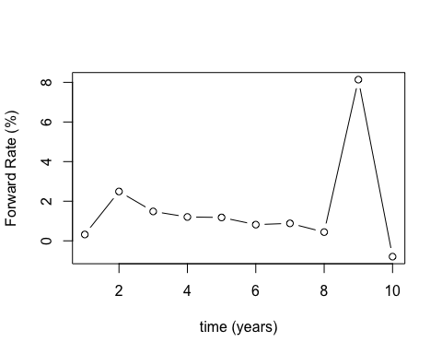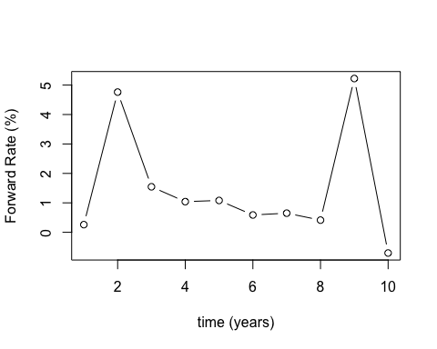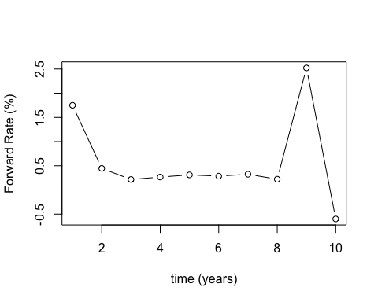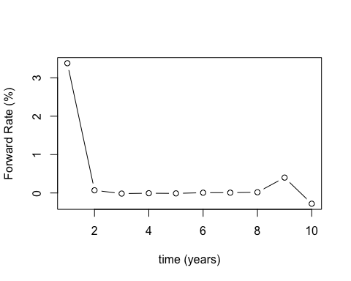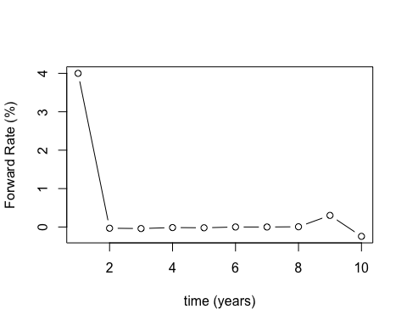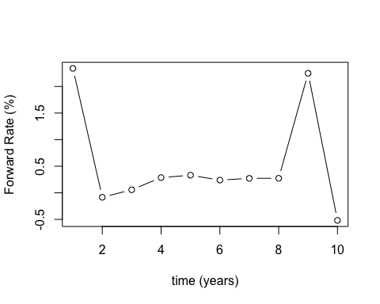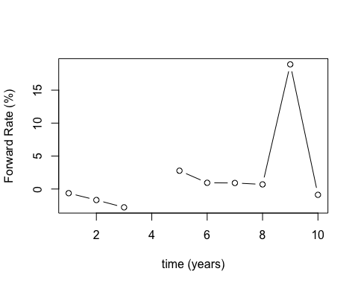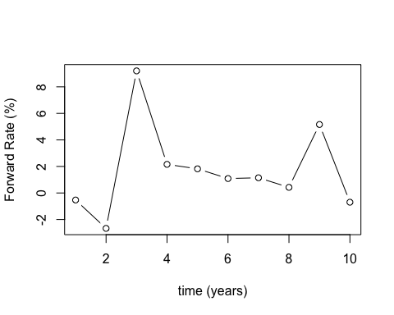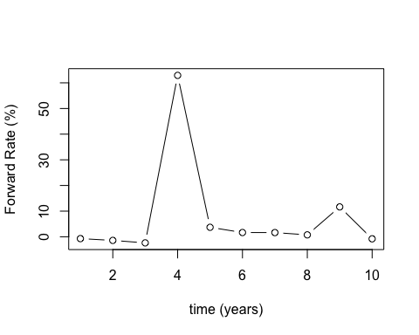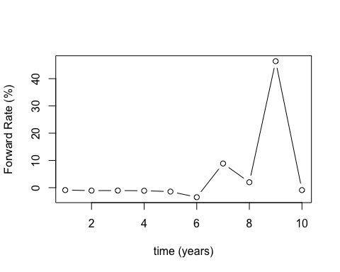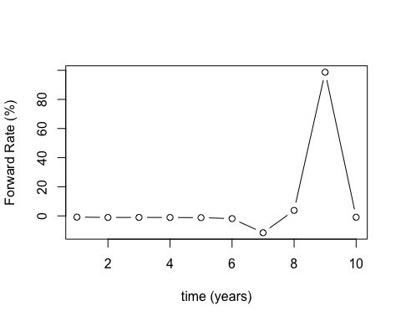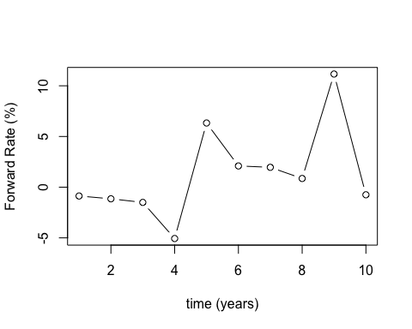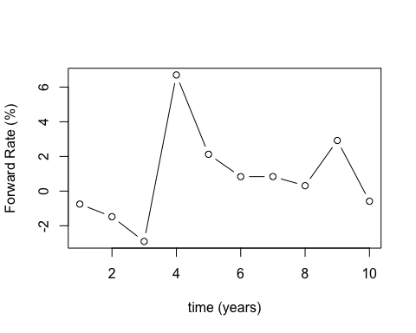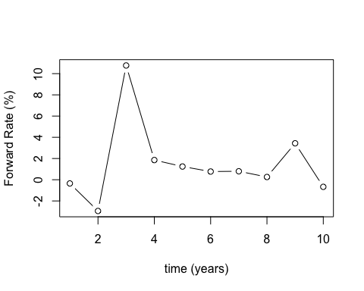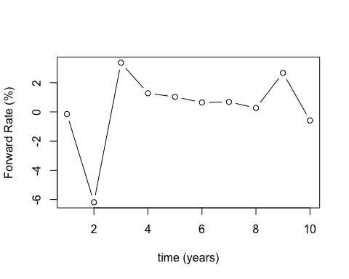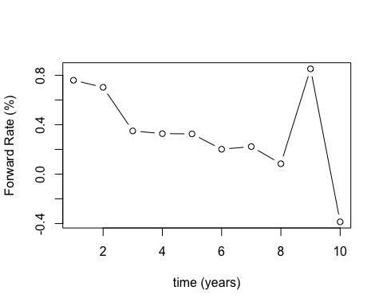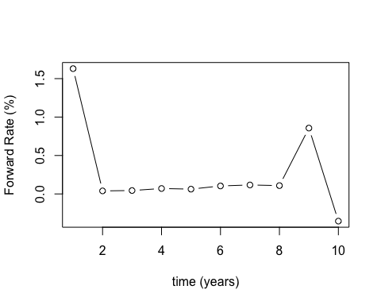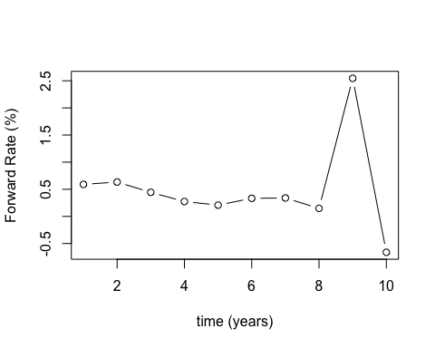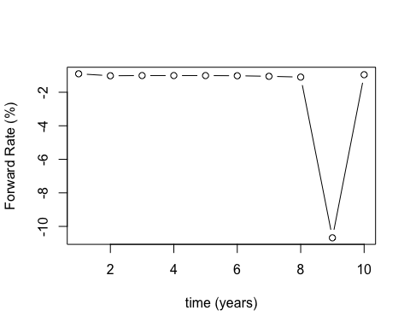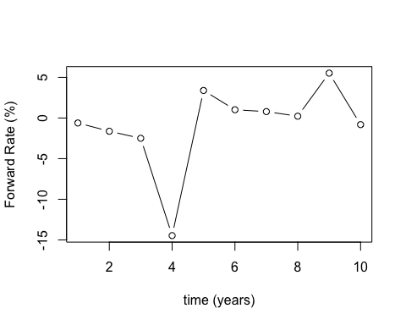

#5.) ROR = (7 yr yield * 7) / (6 yr yield * 6) for all 20 years  
ROR = c()  
for (i in 1:20) {  
 ROR[i] = (FR[7,i]*7)/(FR[6,i]*6)  
}  
ROR

## [1] 1.2582554 1.2878536 1.3250216 1.3373094 0.2482088 1.3296234  
## [7] 1.1320824 1.2271947 1.1518138 -2.9634075 7.2738847 1.0912348  
## [13] 1.1734746 1.2045153 1.2411679 1.2913683 1.3101107 1.1897733  
## [19] 1.2043236 0.9066005

#6.) Xt = Unemployment Rate, CPI (Less F&E) (2002-2021), Yt = 10 yr yield - 'h' yr yield   
  
UNRATE = read.csv("UNRATE.csv", header=TRUE)  
UNRATE = UNRATE$UNRATE  
  
  
r = c()  
for (h in 1:9){  
 r[h] = cor(UNRATE, A[10,]-A[h,])  
}  
max(r)

## [1] 0.7921136

which.max(r)

## [1] 5

plot(r, xlab="Index", ylab="Correlation", type="b")

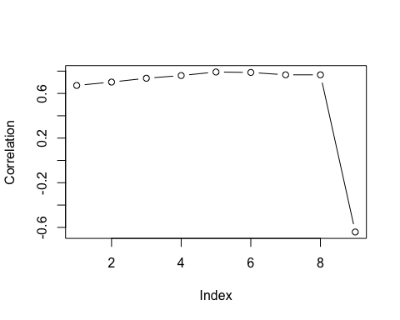

# Use 10 yr - 5 yr yield because it has the strongest correlation  
  
Yt = A[10,] - A[5,]  
  
cor(UNRATE, Yt)

## [1] 0.7921136

LM1 = lm(Yt~UNRATE)  
summary(LM1)

##   
## Call:  
## lm(formula = Yt ~ UNRATE)  
##   
## Residuals:  
## Min 1Q Median 3Q Max   
## -0.4336 -0.1244 0.0150 0.1062 0.4676   
##   
## Coefficients:  
## Estimate Std. Error t value Pr(>|t|)   
## (Intercept) -0.47304 0.21107 -2.241 0.0379 *   
## UNRATE 0.18249 0.03314 5.506 3.15e-05 ***  
## ---  
## Signif. codes: 0 '***' 0.001 '**' 0.01 '*' 0.05 '.' 0.1 ' ' 1  
##   
## Residual standard error: 0.2618 on 18 degrees of freedom  
## Multiple R-squared: 0.6274, Adjusted R-squared: 0.6067   
## F-statistic: 30.31 on 1 and 18 DF, p-value: 3.148e-05

# Relationship of Unemployment rate and 10 yr - 5 yr yield rate is highly significant with a strong positive correlation  
  
CPI = read.csv("CPILFESL.csv")  
CPI = CPI$CPILFESL_PC1  
  
cor(CPI, Yt)

## [1] -0.5336332

LM2 = lm(Yt~CPI)  
summary(LM2)

##   
## Call:  
## lm(formula = Yt ~ CPI)  
##   
## Residuals:  
## Min 1Q Median 3Q Max   
## -0.54529 -0.26228 0.02256 0.26939 0.53872   
##   
## Coefficients:  
## Estimate Std. Error t value Pr(>|t|)   
## (Intercept) 1.5133 0.3349 4.519 0.000266 ***  
## CPI -0.4319 0.1613 -2.677 0.015383 *   
## ---  
## Signif. codes: 0 '***' 0.001 '**' 0.01 '*' 0.05 '.' 0.1 ' ' 1  
##   
## Residual standard error: 0.3628 on 18 degrees of freedom  
## Multiple R-squared: 0.2848, Adjusted R-squared: 0.245   
## F-statistic: 7.167 on 1 and 18 DF, p-value: 0.01538

# Relationship of Consumer Price Index and 10 yr - 5 yr yield rate is still significant but with a weaker negative correlation