Second Synopsis
On
INDIAN MESSENGER
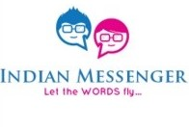
Submitted To: Submitted By:
Mr. Palwinder Singh (Guide) Guneet Singh
Dr. Parminder Kaur (Co-Guide) 2013 CSC 1031
Dr. Rajinder Singh Virk (HOD) MCA(FYIC)- VI Sem

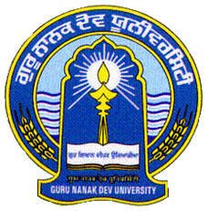
Department of Computer Science
GURU NANAK DEV UNIVERSITY
AMRITSAR
Table of Contents

Sr. No. | Topic | Page No.
 | Organization Profile | 3
 | Front End | 6
 | Back End | 13
 | Hardware & Software Requirements | 15
 | Introduction to Project | 17
 | Model Used | 19
 | Data Flow Diagrams | 21
 | ER Diagram (if required) | 24

ORGANIZATION PROFILE

VMM Education’s journey started in January 2005 with a vision of bringing computer education of global standard to the holy city of Amritsar. To turn this dream into reality we create a talent pool of bright young minds who would power the engines of growth of the global economy. Today seven years later VMM Education or VMM, as it is popularly known, is the largest and the most trusted computer centre of the region, with annual turn out of more than 1000 students. The reason for the success of VMM is simply the “Hard work” that our team has put in these seven years.

VMM Education:

VMM Education provides world class training in global technologies such as .Net and Linux, while keeping our syllabus up to date with the current industry standard. We have managed to successfully train more than 7000 engineers who are currently working in Global Multinationals like TCS, Tech Mahindra, Infosys, CSC etc.

VMM is today the favorite choice of students of various engineering college for pursuing their six months or six weeks industrial training .A unique “industry-endorsed curriculum,” crafted by professionals of VMM which enhances the job-readiness and employability of learners and equips them for the IT Industry.

To provide IT education which can match with the global IT standards, VMM also undertakes industrial projects from UK & USA under the banner of Venus Software Solutions like im4schools.co.uk and many more. This allows our students to work on the live projects and make projects for the industry. Some of our products include Point of sale software for Super Markets with barcode reader support, Finger print attendance Management System that works for schools, colleges and other institutes, Remote LAN Controller which is used to view remote desktops on LAN or WAN.

VMM has the world class computer labs that are equipped with the latest Hardware and software so that the students can do practical without any hindrance.We continuously upgrade our hardware and software’s every 6 months.

Attendance of students is one of the major features of VMM, students are required to record their day to day attendance using Biometric Finger-print Recognition device. This allows us to provide accurate attendance of students to their parents and college during their training time
.
Some Key learning solutions for Individuals include the following:

Foundation course
This course includes two languages C and C++ that allows us to build a strong foundation of programming for the beginner and First year & Second year engineering graduates.

Six Weeks Industrial training
This training program which is of 42 working days allows the 3rd year engineering graduates to get hands on experience on either of the following technologies VB.Net ,C#.Net & SQL. This training is pretty intensive as the students are required to spend 4-8 hours at the institute learning any one of the above languages along with developing a project by working in team. This allows students to learn how to work as team member and also gets hands on training on the latest technology.

Six Months Industrial Training
Doing your six months industrial training at VMM is a very special experience for any engineering graduate as it allows the students to nurture his / her of knowledge by working on Technologies like ASP.Net, Silverlight, AJAX etc. The candidate is required to spend almost whole day at institute doing their Lab practical or attending their tutorial lecture and developing a project which they can submit in their college as a part of dissertation.

7 Months Project Training
This program is for the final year BCA students who can learn latest technologies like VB.Net, C#.Net, ASP.Net and make their project.

Individual Skill enhancement programs
Apart from above training program VMM provides a bouquet of courses in windows application development using VB.Net/C#.Net, Web Development using ASP.Net .

Front End
Java is a general purpose and the most popular object-oriented programming language. Java was developed by James Gosling and his colleagues at Sun Microsystems in the early 1990’s.
Due to its simplicity and easy to learn and advanced features, we opted this language for our six months industrial training. This language supports many interesting features that make it an ideal language for software development. In addition to the object oriented features, it also provides features such as platform independence, security, multithreading, portability; etc which makes it well suited for the web and networked services, applications, platform-independent desktops, robotics and any other embedded devices.

Features of Java:

JAVA FEATURES
Object-oriented
Portable
Compiled and Interpreted
Distributed
Robust
Simple
Secure
Architectural Neutral
Dynamic & Extensible

Multi Threaded

High Performance

- Simple: Java is a compact and simple language. Programs are easy to write and debug as it omits many clumsy, poorly understood and confusing features of other programming languages such as C++.
- Object-oriented: Java is purely object-oriented language because programming in java is centered on creating objects; manipulating objects and making objects work together.
- Distributed: Java is a distributed language which means that the programs can be designed to run on computer networks. Java provides an extensive library of classes for communicating using TCP/IP protocols such as HTTP and FTP. This makes creating network connections much easier.
- Robust: Java is designed for writing programs that are highly robust. By robust, we mean reliable.
- Secure: As java is intended to be used in networked/distributed environments so it implements several security mechanisms to protect you against malicious code that might try to invade your file system.
- Architectural Neutral: This means that the programs written on one platform can run on any other platform without having to rewrite or recompile them. It follows ‘Write-once-run-anywhere’ approach.
- Portable: In Java, the size of the primitive data types is machine independent. These consistencies make java program portable among different platforms such as Windows, UNIX and Mac.
- Interpreted: Java is such a language that is both compiled and interpreted. The two steps of compilation and interpretation allow extensive code checking and improved security.
- High performance: Java programs are complied with portable intermediate form known as byte codes, rather than to native machine level instructions and JVM executes java byte codes on any machine on which it is installed. This architecture means that java programs are faster.
- Multithreaded: Java is also a multithreaded programming language. It allows you to write a program that can do many tasks simultaneously.
- Dynamic: Java is designed to be dynamic. Classes are stored in separate files and are loaded into the Java Interpreter only when they are needed.

SOCKET PROGRAMMING IN JAVA
Clients and Servers establish connections and communicate via sockets. Connections are the communication links that are created over the Internet using TCP. Some client/server applications are also building around the connectionless UDP. These applications also use sockets to communicate.
A Socket is an abstraction through which an application, may send and receive data.
There are two types of sockets used in socket programming in java:
- Stream Socket: A Stream Socket is a connection oriented socket. Thus a connection has to be established before it can send or receive data. Data that one end of the connection writes to the socket is available for reading at the other end of the socket connection. The Stream Sockets use TCP protocol for data transmission.
- Datagram Socket: Datagram Socket is a connectionless socket, thus no actual connection is established between two communicating hosts. The datagram socket use UDP protocol for data transmission. Since UDP does not guarantee that all packets are received in the correct order or not. Also with UDP the packets can even be lost or dispatched.
- Raw Sockets: Some protocols such as ICMP or OSPF that directly us the services of IP, use neither stream nor datagram sockets. Raw Sockets are designed for these types of applications.

Android :

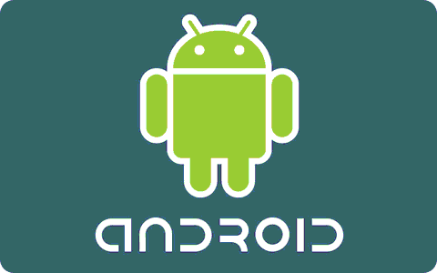

What is Android?
Android is a software stack for mobile devices that includes an operating system, middleware and key applications. The Android SDK provides the tools and APIs necessary to begin developing applications on the Android platform using the Java programming language.

Features
- Application framework enabling reuse and replacement of components
- Dalvik virtual machine optimized for mobile devices
- Integrated browser based on the open source WebKit engine
- Optimized graphics powered by a custom 2D graphics library; 3D graphics based on the OpenGL ES 1.0 specification (hardware acceleration optional)
- SQLite for structured data storage
- Media support for common audio, video, and still image formats (MPEG4, H.264, MP3, AAC, AMR, JPG, PNG, GIF)
- GSM Telephony (hardware dependent)
- Bluetooth, EDGE, 3G, and WiFi (hardware dependent)
- Camera, GPS, compass, and accelerometer (hardware dependent)
- Rich development environment including a device emulator, tools for debugging, memory and performance profiling, and a plugin for the Eclipse IDE

Android Architecture
The following diagram shows the major components of the Android operating system. Each section is described in more detail below.
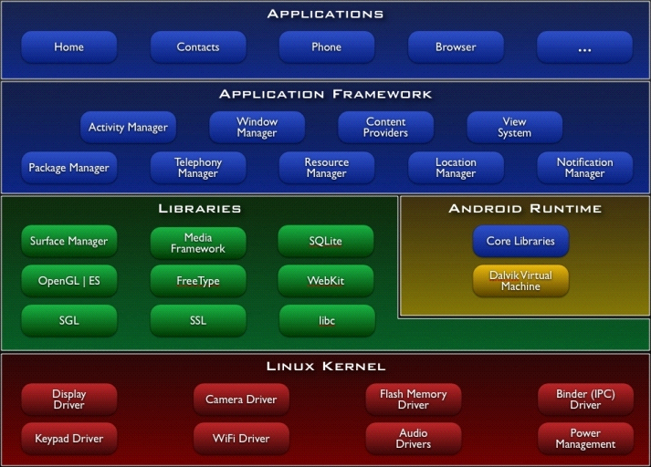
Applications
Android will ship with a set of core applications including an email client, SMS program, calendar, maps, browser, contacts, and others. All applications are written using the Java programming language.

Application Framework
By providing an open development platform, Android offers developers the ability to build extremely rich and innovative applications. Developers are free to take advantage of the device hardware, access location information, run background services, set alarms, add notifications to the status bar, and much, much more.
Developers have full access to the same framework APIs used by the core applications. The application architecture is designed to simplify the reuse of components; any application can publish its capabilities and any other application may then make use of those capabilities (subject to security constraints enforced by the framework). This same mechanism allows components to be replaced by the user.
Underlying all applications is a set of services and systems, including:
- A rich and extensible set of Views that can be used to build an application, including lists, grids, text boxes, buttons, and even an embeddable web browser
- Content Providers that enable applications to access data from other applications (such as Contacts), or to share their own data
- A Resource Manager, providing access to non-code resources such as localized strings, graphics, and layout files
- A Notification Manager that enables all applications to display custom alerts in the status bar
- An Activity Manager that manages the lifecycle of applications and provides a common navigation back stack
Libraries
Android includes a set of C/C++ libraries used by various components of the Android system. These capabilities are exposed to developers through the Android application framework. Some of the core libraries are listed below:
- System C library - a BSD-derived implementation of the standard C system library (libc), tuned for embedded Linux-based devices
- Media Libraries - based on PacketVideo's OpenCORE; the libraries support playback and recording of many popular audio and video formats, as well as static image files, including MPEG4, H.264, MP3, AAC, AMR, JPG, and PNG
- Surface Manager - manages access to the display subsystem and seamlessly composites 2D and 3D graphic layers from multiple applications
- LibWebCore - a modern web browser engine which powers both the Android browser and an embeddable web view
- SGL - the underlying 2D graphics engine
- 3D libraries - an implementation based on OpenGL ES 1.0 APIs; the libraries use either hardware 3D acceleration (where available) or the included, highly optimized 3D software rasterizer
- FreeType - bitmap and vector font rendering
- SQLite - a powerful and lightweight relational database engine available to all applications

Android Runtime
Android includes a set of core libraries that provides most of the functionality available in the core libraries of the Java programming language.
Every Android application runs in its own process, with its own instance of the Dalvik virtual machine. Dalvik has been written so that a device can run multiple VMs efficiently. The Dalvik VM executes files in the Dalvik Executable (.dex) format which is optimized for minimal memory footprint. The VM is register-based, and runs classes compiled by a Java language compiler that have been transformed into the .dex format by the included "dx" tool.
The Dalvik VM relies on the Linux kernel for underlying functionality such as threading and low-level memory management.
Linux Kernel
Android relies on Linux version 2.6 for core system services such as security, memory management, process management, network stack, and driver model. The kernel also acts as an abstraction layer between the hardware and the rest of the software stack.

Back End
MySQL
MySQL is a open source Relational Database Management System. MySQL is very fast reliable and flexible Database Management System. It provides a very high performance and it is multi threaded and multi user Relational Database management system.
MySQL is one of the most popular relational database Management System on the web. The MySQL Database has become the world's most popular open source Database, because it is free and available on almost all the platforms. The MySQL can run on Unix , window, and Mac OS. .
MySQL source code is available that's why now you can recompile the source code.

Features:
The following list describes some of the important Features of MySQL Database Software.
- Internals and Portability
    - Written in C and C++.
    - Tested with a broad range of different compilers.
    - Works on many different platforms.
    - The MySQL code is tested with Purify (a commercial memory leakage detector) as well as with Valgrind, a GPL tool
    - The server is available as a separate program for use in a client/server networked environment. It is also available as a library that can be embedded (linked) into standalone applications. Such applications can be used in isolation or in environments where no network is available.

- Column Types
    - Many column types: signed/unsigned integers 1, 2, 3, 4, and 8 bytes long, FLOAT, DOUBLE, CHAR, VARCHAR, TEXT, BLOB, DATE, TIME, DATETIME, TIMESTAMP, YEAR, SET, ENUM, and OpenGIS spatial types.
    - Fixed-length and variable-length records.

- Statements and Functions
    - Full operator and function support in the SELECT and WHERE clauses of queries. For example:
    - Full support for SQL GROUP BY and ORDER BY clauses. Support for group functions (COUNT(), COUNT(DISTINCT ...), AVG(), STD(), SUM(), MAX(), MIN(), and GROUP_CONCAT()).
    - Support for LEFT OUTER JOIN and RIGHT OUTER JOIN with both standard SQL and ODBC syntax.
    - Support for aliases on tables and columns as required by standard SQL.
    - DELETE, INSERT, REPLACE, and UPDATE return the number of rows that were changed (affected). It is possible to return the number of rows matched instead by setting a flag when connecting to the server.
- Security
    - A privilege and password system that is very flexible and secure, and that allows host-based verification. Passwords are secure because all password traffic is encrypted when you connect to a server.

- Scalability and Limits
    - Handles large databases. We use MySQL Server with databases that contain 50 million records. We also know of users who use MySQL Server with 60,000 tables and about 5,000,000,000 rows.
    - Up to 64 indexes per table are allowed (32 before MySQL 4.1.2). Each index may consist of 1 to 16 columns or parts of columns. The maximum index width is 1000 bytes (500 before MySQL 4.1.2). An index may use a prefix of a column for CHAR, VARCHAR, BLOB, or TEXT column types.

- Connectivity
    - Clients can connect to the MySQL server using TCP/IP sockets on any platform. On Windows systems in the NT family (NT, 2000, XP, or 2003), clients can connect using named pipes. On Unix systems, clients can connect using Unix domain socket files.
    - In MySQL versions 4.1 and higher, Windows servers also support shared-memory connections if started with the --shared-memory option. Clients can connect through shared memory by using the --protocol=memory option.
    - The Connector/ODBC (MyODBC) interface provides MySQL support for client programs that use ODBC (Open Database Connectivity) connections. For example, you can use MS Access to connect to your MySQL server. Clients can be run on Windows or Unix. MyODBC source is available. All ODBC 2.5 functions are supported, as are many others.
    - The Connector/J interface provides MySQL support for Java client programs that use JDBC connections. Clients can be run on Windows or Unix. Connector/J source is available.

- Localization
    - The server can provide error messages to clients in many languages.
    - Full support for several different character sets, including latin1 (ISO-8859-1), german, big5, ujis, and more. For example, the Scandinavian characters 'â', 'ä' and 'ö' are allowed in table and column names. Unicode support is available as of MySQL 4.1.
    - All data is saved in the chosen character set. All comparisons for normal string columns are case-insensitive.

HARDWARE REQUIREMENTS:
Hardware requirements include that hardware which is required for its working. It includes:
- Pentium 4 Computer
- 512 MB RAM
- High Speed Internet Connection(DSL/Cable)
- Any Smartphone with Android API 2.3 or 4.0

SOFTWARE REQUIREMENTS
The technical specifications of requirements for the software are as follows:
- Any Operating System (Windows, Linux, MAC)
- Java run time environment
- Eclipse (Java IDE with Android development plugins)
- Android SDK (Android software development kit)
- Android API (2.3)
- AVD (Android Virtual Device) plugin for Testing Application on desktop
- Any web browser(Chrome , Firefox , etc)
INTRODUCTION TO PROJECT

Project Name: - Indian Messenger
= = = = = = = = = = = = = = = = = = = = = = = = = = = = = = = = = = = = = = = = = = = = = = = =

Objective: - Communication over a network is one field where this tool finds wide ranging application. Indian Messenger is a messaging app available for Android. It uses your phone’s Internet connection (4G/3G/2G/EDGE or Wi-Fi, as available) to message friends and family. Switch from SMS to Indian Messenger to send and receive messages, photos, videos, and voice Messages. . This user friendly software also has a separate web chat client.

= = = = = = = = = = = = = = = = = = = = = = = = = = = = = = = = = = = = = = = = = = = = = = =
Features of the Project: -
App Interface:
1. Creating android based chatting client.
2. Signup module for android app through phone number.
3. Auto Login for android app.
4. Updating user profile photo and status.
5. Getting list of other messenger users from my phone contacts
6. User also gets to know about statuses of other messenger contacts
7. Sending text messages to contacts
8. Sending photo messages from phone's gallery
9. Sending Instant photo by using rear/front camera
10. Sending recorded audio/video files from phone gallery
11. Sending Live recorded video to friends
12. Sending Live recorded audio to friends
13. Saving photos, audios and videos locally
14. Creating photos/messages/videos Notification area
15 Sending stickers to contacts

Website Interface:
1. Creating a chat server.
2. Creating messenger website based client.
3. Signup module for android app through email.
4. Updating user profile photo and status.
5. Getting list of other messenger users from my phone contacts
6. Sending text messages to contacts
7. Sending photo messages from system's hard drive
8. Sending recorded audio/video files from system's hard drive
9. Saving photos, audios and videos locally
NOTE:-Features List may upgrade at Beta stages.
= = = = = = = = = = = = = = = = = = = = = = = = = = = = = = = = = = = = = = = = =

Model Used
Iterative Model
An iterative lifecycle model does not attempt to start with a full specification of requirements. Instead, development begins by specifying and implementing just part of the software, which can then be reviewed in order to identify further requirements. This process is then repeated, producing a new version of the software for each cycle of the model. Consider an iterative lifecycle model which consists of repeating the following four phases in sequence:
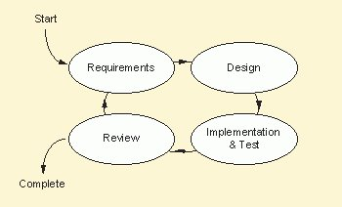
- A Requirements phase, in which the requirements for the software are gathered and analyzed. Iteration should eventually result in a requirements phase that produces a complete and final specification of requirements.
- A Design phase, in which a software solution to meet the requirements is designed. This may be a new design, or an extension of an earlier design.
- An Implementation and Test phase, when the software is coded, integrated and tested.
- A Review phase, in which the software is evaluated, the current requirements are reviewed, and changes and additions to requirements proposed.
- For each cycle of the model, a decision has to be made as to whether the software produced by the cycle will be discarded, or kept as a starting point for the next cycle (sometimes referred to as incremental prototyping). Eventually a point will be reached where the requirements are complete and the software can be delivered, or it becomes impossible to enhance the software as required, and a fresh start has to be made.
- The iterative lifecycle model can be likened to producing software by successive approximation. Drawing an analogy with mathematical methods that use successive approximation to arrive at a final solution, the benefit of such methods depends on how rapidly they converge on a solution.
- The key to successful use of an iterative software development lifecycle is rigorous validation of requirements, and verification (including testing) of each version of the software against those requirements within each cycle of the model. The first three phases of the example iterative model is in fact an abbreviated form of a sequential V or waterfall lifecycle model. Each cycle of the model produces software that requires testing at the unit level, for software integration, for system integration and for acceptance. As the software evolves through successive cycles, tests have to be repeated and extended to verify each version of the software.
Data Flow Diagrams:

OVERVIEW OF WORKING :
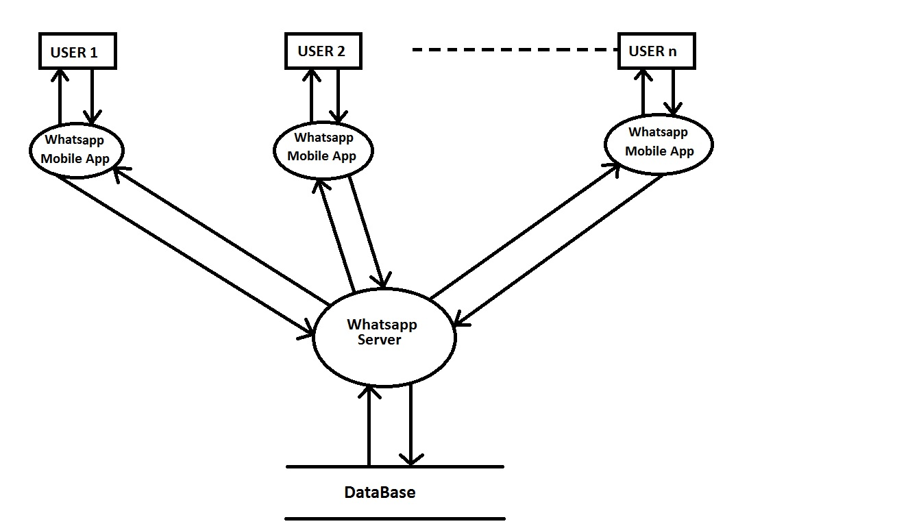
SIGN UP (ADDING NEW USER):
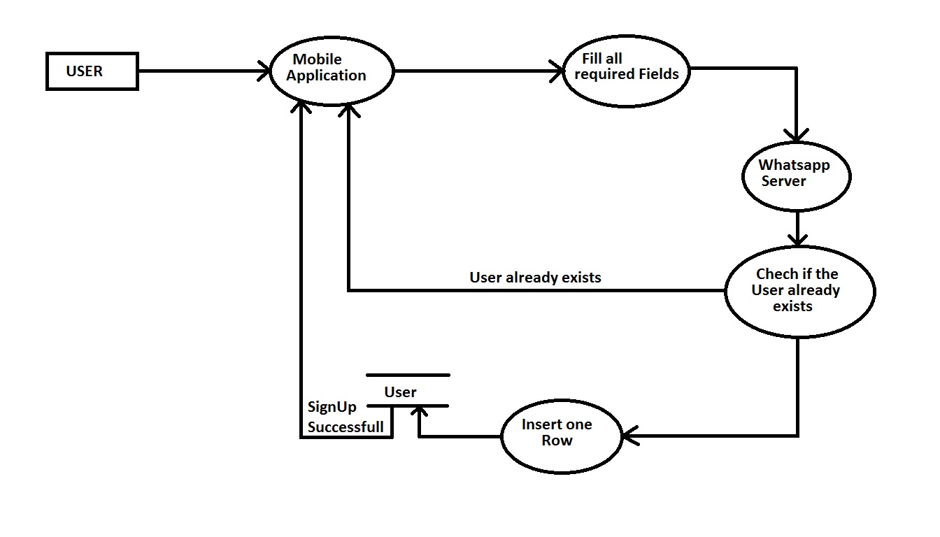
USER CHECKING {LOGIN VALIDAT OR} 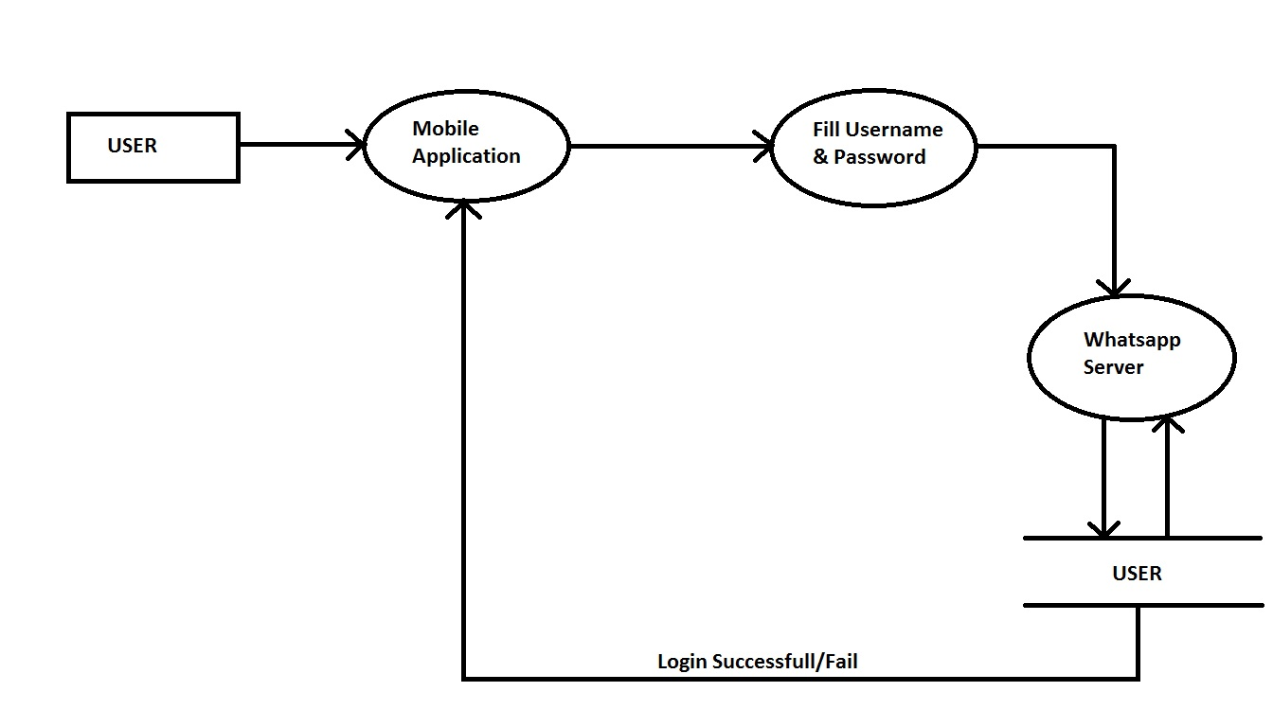

CONTACTS { CHECKING USERS }
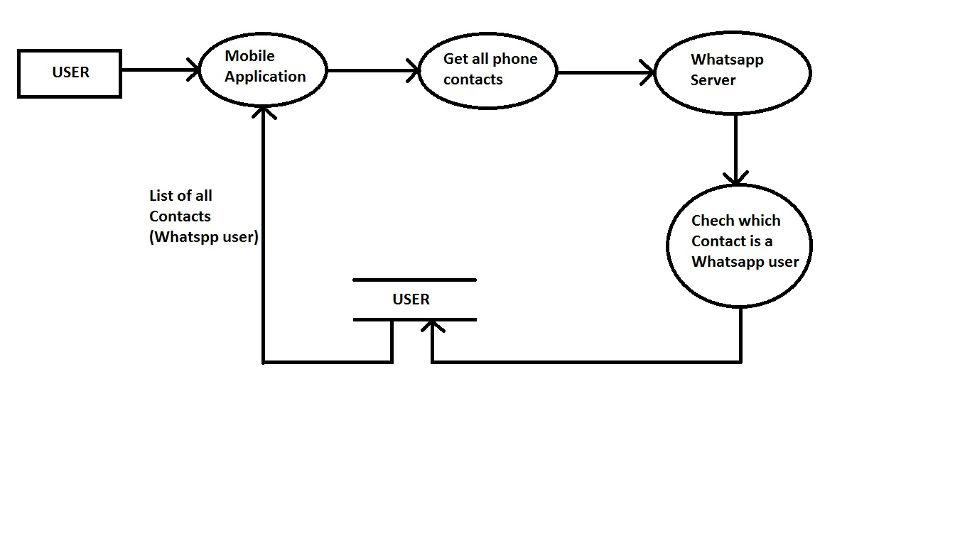
MAIN SENDING AND RECEIVING OF MESSAGES
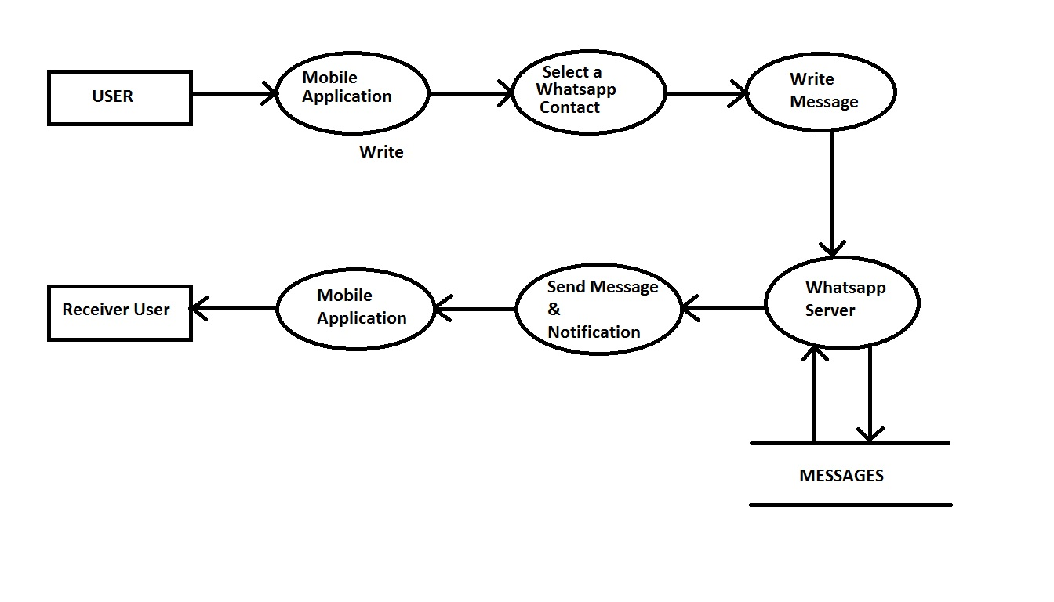
ER Diagram :
