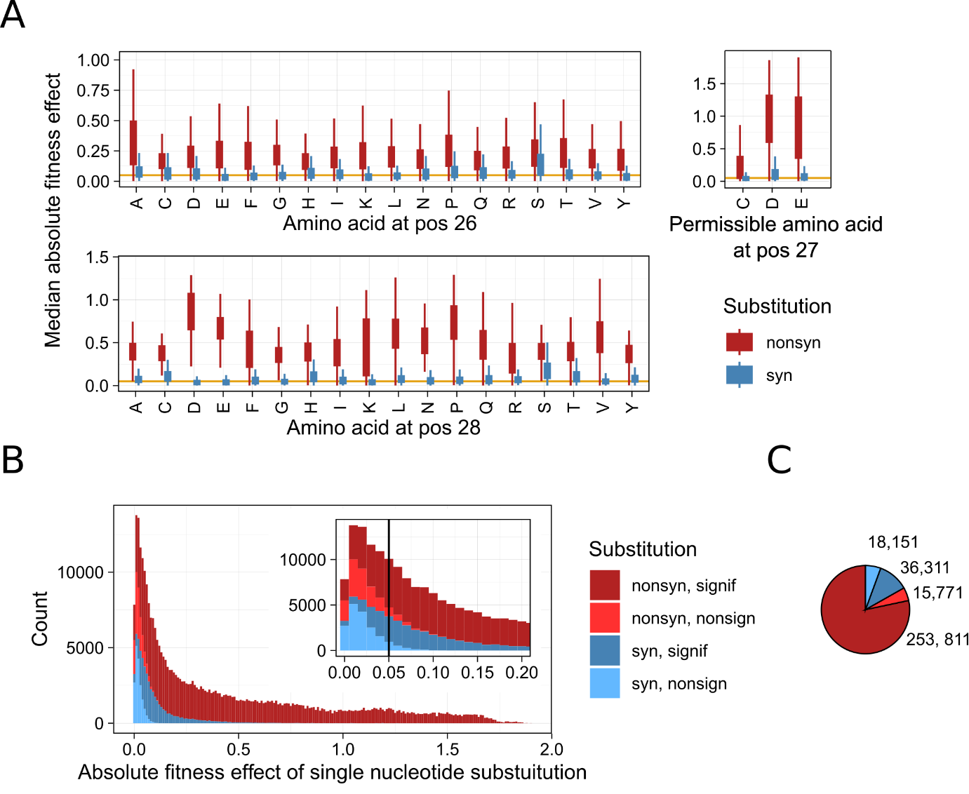

**Figure. Fitness effect of synonymous and non-synonymous substitutions in the folA gene.**

**A**. Median absolute fitness effects of synonymous (blue) and non-synonymous (red) substitutions at different codon positions in the folA gene. The orange horizontal line represents a 5% fitness effect threshold.

**B.** Distribution of absolute fitness effects of single nucleotide substitutions in the fitness landscape. Red bars represent substitutions resulting in an amino acid change and blue bars represent those resulting in no change. Dark red and dark blue bars indicate statistically significant fitness effects at p < 0.05 using the Wald test (adjusted for multiple comparisons using the Benjamini-Hochberg method), while light red and light blue bars indicate non-significant fitness effects (p ≥ 0.05).

**C.** Pie chart showing the total number of synonymous and non-synonymous single nucleotide substitutions in the landscape. The colors correspond to those used in panel B.

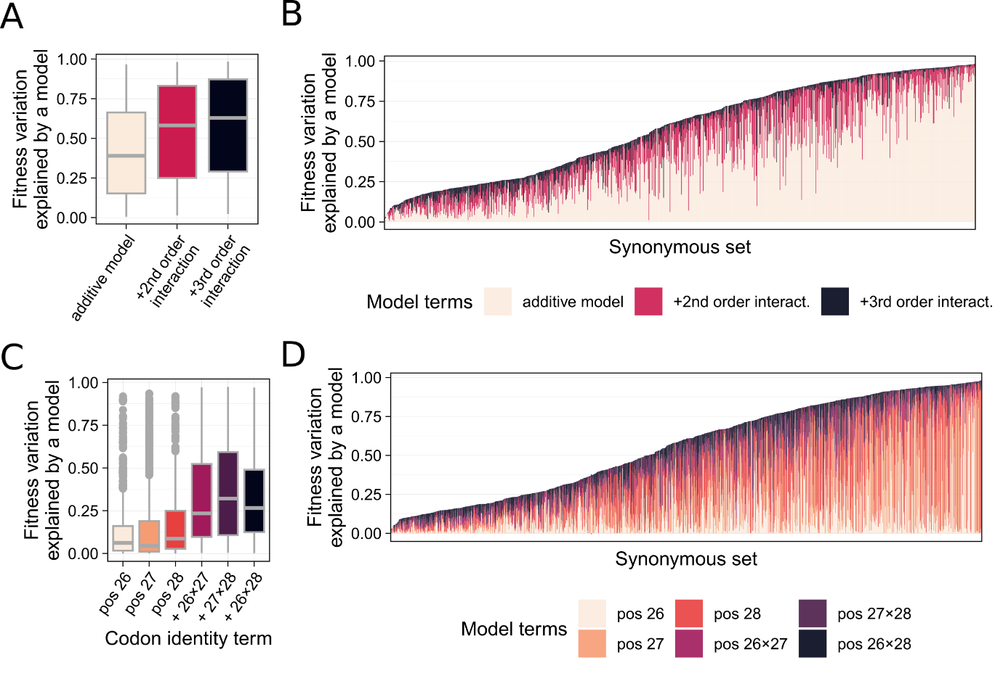

**Figure. Codon identity and their interactions explain variation in fitness.** To determine if fitness differences between synonymous variants (encoding the same amino acid sequence) can be explained by codon identity, we fitted generalized linear model using identity of codons as predictors of fitness. In addition, we included the interaction of codon identities across different codon positions. The analysis was performed individually for 926 synonymous set (926 models).

**A.** Boxplots showthe fraction of variation explained by different model terms: codon identities with no interaction between different codon positions (pink), second (red) and third (black) order interactions between codon identities at different codon positions.

**B.** The fraction of fitness variation explained by different model terms shown for 926 synonymous sets (ranked by total amount of variation explained).

**C.** The three leftmost boxplots showthe fraction of variation explained by considering codon identities at different positions (position 26, 27 and 28). The three rightmost boxplots show the variation explained by considering codon identity at two (out of three) codon positions and their second order interactions (combinations 26×27, 27×28, and 26×28)

**D.** The fraction of fitness variation explained by different model terms for 926 synonymous sets (ranked by total amount of variation explained).

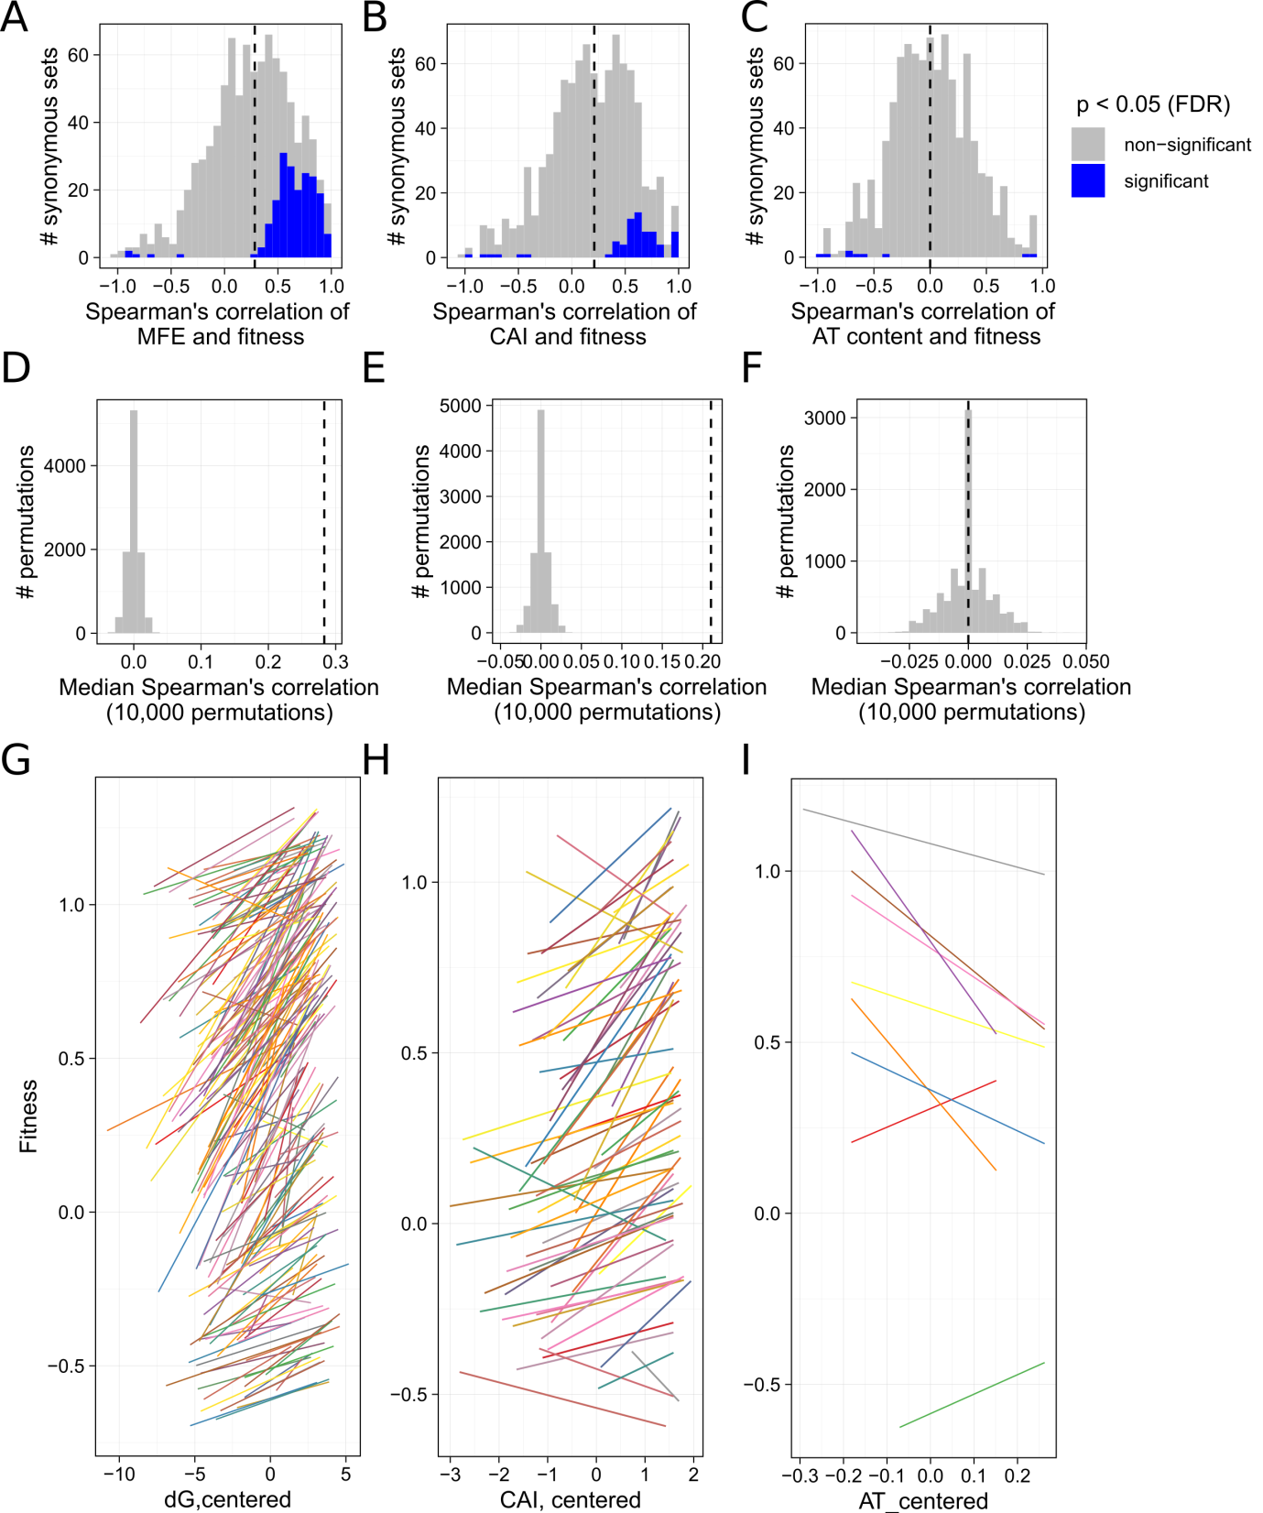

**Figure. Fitness in many synonymous sets correlates with mRNA folding energy and codon adaptation index.**

**A.** Distribution of Spearman’s correlation coefficients between fitness and minimum folding energy of mRNA. Correlation analysis was performed separately for synonymous variants from 926 synonymous sets. P-values were adjusted by the Benjamini-Hochberg method. Statistically significant coefficients (p-value < 0.05) are mostly positive (shown in blue color). Non-significant coefficients are shown in grey color. The vertical line indicates the median value of Spearman’s coefficient for all 926 synonymous sets.

**B.** Similar analysis as in panel A, but testing the correlation between fitness and codon adaptation index.

**C.** Similar analysis as in panel A, but showing the correlation between fitness and AT-content.

**D-F.** Permutation test of correlation analyses from panel A-C. We permutated the values of correlates within each of 926 synonymous sets, estimated Spearman’s correlation coefficients and obtained the median of all coefficients. Each panel shows the distribution of median correlations from 10000 permutations (grey bars) and the median observed in experimental data (the dashed line). This analysis shows that correlation of fitness with minimum folding energy and codon adaptation index are highly unlikely to be observed by chance alone.

**G-I.** Panels show significant trends between fitness and mRNA minimum folding energy (**G**), codon adaptation index (**H**) and AT content (**I**). Each line shows the trend of liner regression fitted to the data for the synonymous sets, in which the Spearman’s correlation was found significant (after adjusting p-values using the Benjamini-Hochberg method).

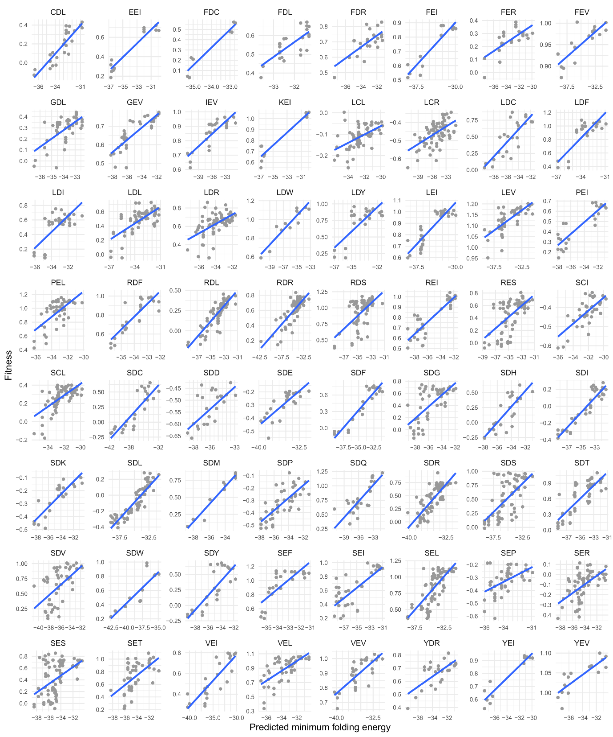

**Figure. Examples of synonymous sets with significant Spearman’s correlation between fitness (vertical axis) and predicted minimum folding energy of mRNA transcript (horizontal axis).** In each panel, grey circles show synonymous variants. The blue line shows linear regression fit. Three-letter sequences on top of each panel show amino acid sequence at positions 26, 27 and 28.

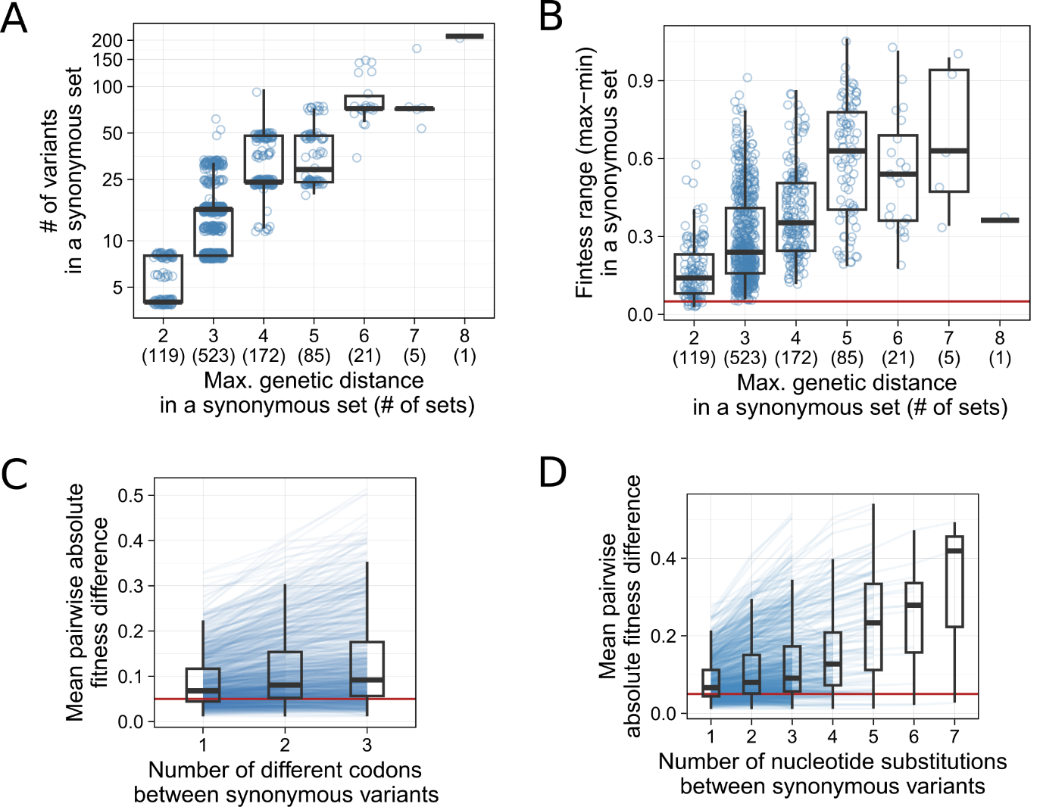

**Figure. Synonymous sets consist of genetically distinct variants that encode the same protein and can vary in fitness.**

**A.** Synonymous variants encode the same amino acid sequence by using different combinations of synonymous codons. In the landscape, we identified 926 such synonymous sets. Synonymous sets (shown as circles) differ in the number of variants (vertical axis) and genetic differences among these variants.

**B.** Synonymous sets show non-trivial differences in fitness. Synonymous sets with more genetically distinct variants tend to show larger fitness differences.

**C.** Pairwise differences in fitness between synonymous increases with genetic distance (measured as the number of different codons)

**D.** Pairwise differences in fitness between synonymous variants increases with genetic distance (measured as the number of different nucleotides)

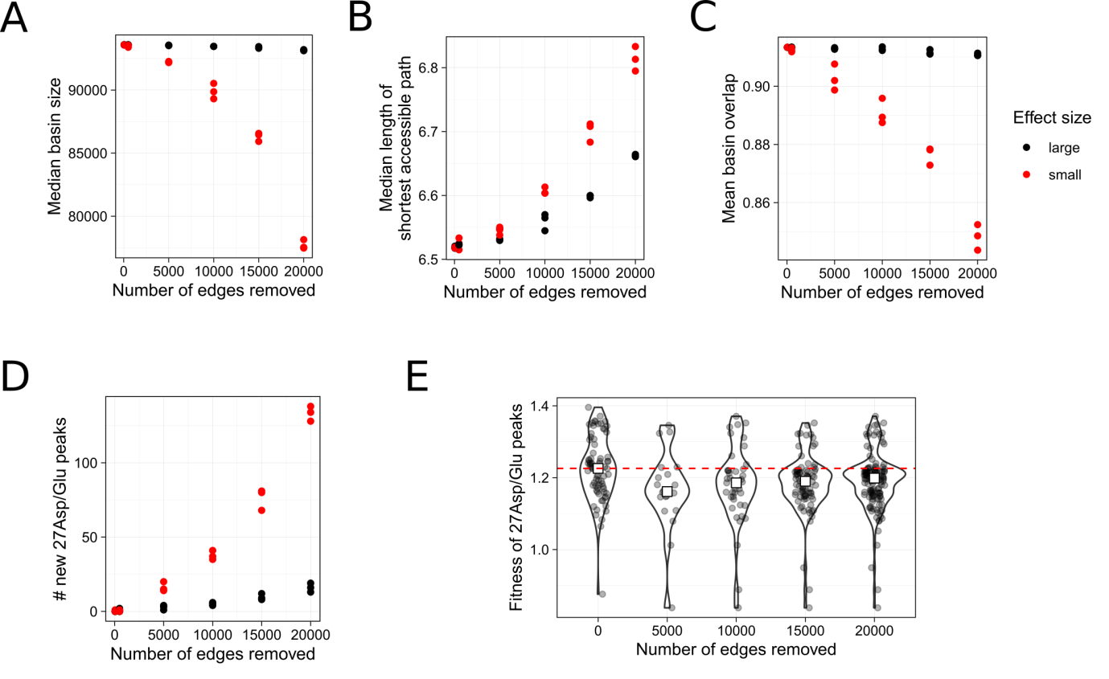

**Figure. Landscapes with fewer synonymous small effect edges are more rugged.**

**A.** Effect of removing small effect synonymous edges (red circles) and large effect synonymous edges (black circles) on the size of basins of attraction of the 74 high fitness peaks.

**B.** Effect of removing small effect synonymous edges (red circles) and large effect synonymous edges (black circles) on the length of shortest accessible path leading to 74 high fitness peaks.

**C.** Effect of removing small effect synonymous edges (red circles) and large effect synonymous edges (black circles) on the overlap between basins of attraction of 74 high fitness peaks.

**D.** Creation of new 27Asp/Glu fitness peaks as a result of removing small effect synonymous edges (red circles) and large effect synonymous edges (black circles).

**E.** Fitness of new 27Asp/Glu fitness peaks. Violin plot with no edges removed (x=0) shows the distribution of fitness in the 74 high fitness peaks. Other violin plots (x>0) show the distribution of fitness for the newly formed peaks (as a result of removing synonymous edges).

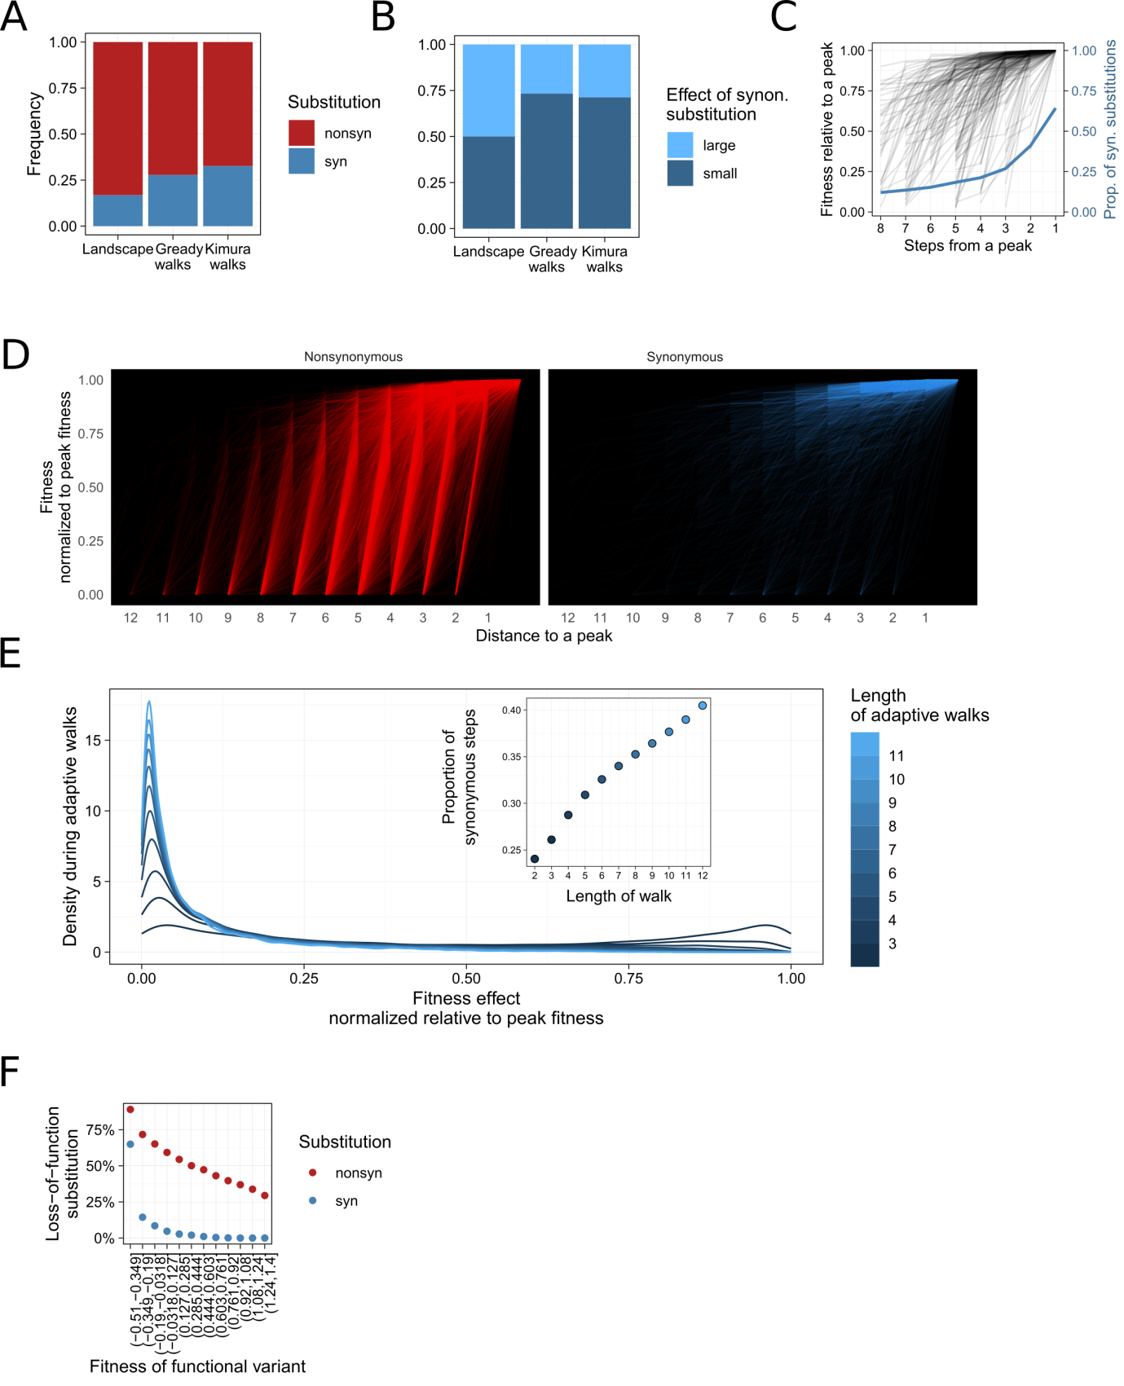

**Figure. Synonymous and small effect mutations are preferentially used by adaptive walks.**

**A.** Frequency of synonymous mutations in the landscape and during simulation of adaptive walks.

**B.** Frequency of small effect mutations (<5% fitness) among synonymous mutations in the landscape and during simulation of adaptive walks.

**C.** Synonymous mutations are more common in the proximity of high fitness peaks.

**D.** Synonymous and nonsynonymous mutations shown for a set of adaptive trajectories. common

**E.** Synonymous and small effect mutations are more common in longer walks

**F.** Synonymous mutations are less likely to cause loss-of-function than non-synonymous mutations